Strengthening of Zirconia by Glassy Phase

Marwa Merza Salman
Department of Ceramic and Building Materials Engineering, Materials Engineering College, University of Babylon
Marwa_Marza@yahoo.com
Abstract:
The ceramic industry has been concentrating on the reduction of energy usage during manufacturing because of serious global environmental problems and cost. In this research, we have investigated low-energy processing techniques for ceramic components.
The samples were prepared by mixing zirconia with glass (soda lime glass) in different percentages by using powder technology. The samples sintered at 1100 ºC. The following mechanical properties (compressive strength and hardness) and physical properties (density and porosity) were calculated for all samples. The results show the increasing of compressive strength, hardness and density with the increasing of added percentage of glass to the samples. Also it shows the decreasing of porosity with increasing of added percentage of glass to the samples.
This study shows the ability of sintering ceramic powders have high melting point, by mixing it with ceramic powders have low melting point, by gathering from the liquid phase (glassy phase) which interpenetrate between the grains of the ceramic material that cause to increase the bonding and strengthening of the samples.
Keywords: zirconia, sintering, glassy phase, soda lime glass.
الخلاصة:
تركز صناعة السيراميك على تقليل استعمال الطاقة خلال عمليات التصنيع بسبب المشاكل البيئية والكلفة. وفي هذا البحث نتحقق من تقنية تصنيع للأجزاء السيراميكية باقل طاقة.
تم هذا البحث باستخدام تكنولوجيا المساحيق لإنتاج نماذج سيراميكية من خلط مادتي الزركونيا والزجاج (soda lime glass) وبنسب وزنيه مختلفة للزجاج. لبدت النماذج عند درجة حرارة C)º 1100). وتم قياس الخواص الميكانيكية وتشمل (مقاومة الانضغاط والصلادة) والخواص الفيزياوية وتشمل (الكثافة والمسامية) لجميع النماذج المحضرة. وقد اظهرت النتائج زيادة كل من مقاومة الانضغاط, الصلادة والكثافة مع زيادة النسبة المئوية للزجاج في النماذج, ونقصان المسامية مع زيادة النسبة المئوية للزجاج في النماذج.
يبين هذا البحث امكانية تلبيد مساحيق سيراميكية ذات درجات انصهار عالية ( بخلطها بمواد سيراميكية ذات درجة انصهار واطئة بالاستفادة من الطور السائل ( الزجاجي) الذي يتغلغل بين حبيبات المادة السيراميكية مساعدا" على تقويتها وزيادة تماسكها
الكلمات المفتاحية: الزركونيا، التلبيد، الطور الزجاجي، زجاج الصودا لايم.
Introduction:
Ceramics are used in the field of industrial machines, and have spread to various other fields including semiconductors and electronic parts, electronic devices, automobiles, processing, environment, energy and biotechnology. They are recognized as important materials for supporting industry, together with metals and polymers. Since ceramic manufacturing consists of multiple steps, the development of a manufacturing process involves not just the technological development of a single step, but must involve the steps before and after as well as the preliminary steps. For example, in a case where the sintering temperature of the powder is very high, or the formability of the powder is extremely low, it is necessary to investigate the material factors such as raw powder, binder, as well as the process control factors of mixing, dispersing, drying and firing (Oilo, 2008).
One of the ways is to reduce the total amount of energy needed for heating by using the existing sintering equipment by developing a low-temperature sintering technology. To promote low-temperature sintering of ceramics, it is necessary to mobilize nanoparticle handling technology, low melting point sintering additive technology, dispersion technology, high-density forming technology and others. All technologies work effectively for low-temperature sintering, and enable production of dense sintered body at firing temperature lower than conventional sintering. In this research, we use low melting point sintering additive technology(Koji, 2009).
Zirconia (zirconium dioxide ZrO₂) is found in natural state in the form of baddeleyite, but is more frequently prepared from zirconium silicate sands (zircon: ZrSiO₄) by high temperature heat treatments, accompanied by chemical treatments, which eliminate the siliceous fraction from the zircon. Zirconia is an oxide with very high melting temperature (T≈2880ºC), which solidifies in cubic phase (ZrO₂-c) , then transforms (T< ≈2370ºC) to tetragonal phase (ZrO₂-t) and finally, below ≈1170ºC, becomes monoclinical (ZrO₂-m). This last transition t→m is accompanied by considerable dimensional variations (shear strain of ≈0.16 and increase in volume of ≈4%). A zirconia part sintered at temperatures that the refractarity of this oxide requires –sintered at about 1600ºC- breaks up and is destroyed during cooling, during the t→m transition. This means that pure zirconia can be used only powder form, and therefore for uses that do not require consolidation into a massive part. To produce zirconia sintered pieces, ZrO₂ must be combined with other oxides known as “stabilizers” (M_{x}O_{y} = primarily CaO, MgO or Y₂O₃). In the ZrO₂-CaO diagram, it is observed that for 20 mol% CaO, the material remains in cubic phase from room temperature to practically the melting temperature (Philippe, 2007).
During sintering dwell temperature and time significantly affect the grain size and final density(Laberty, 2003). In order to control grain growth in a ceramic body during processing, a profound knowledge of the grain growth parameters is needed. Grain growth of zirconia alloys depends very strongly on composition and is related to the phase content. The growth of cubic grains in zirconia doped with Y3+ is 30-250 times faster than that of tetragonal grains alloyed with the same cation. Grain growth is strongly suppressed if both phases are coexistent (Allemann, 1995).
The mechanical properties of zirconia based ceramics depend on the microstructure and composition and can be controlled to obtain the required properties. Zirconia has a high melting point, a high ductile to brittle transition temperature and is a good thermal insulator. At room temperature it is an electrical insulator but when alloyed with trivalent oxides it becomes an ionic conductor at high temperatures. Zirconia is colorless, transparent and has a high refractive index. These combinations of properties and the ability to manipulate its structure, makes zirconia useful in various applications including refractories, medical implants, catalysts, ionic conductors in solid fuel cells and in toughening components in nano-composites (Schwartz, 2002).
Glass is a homogeneous material with a random, non-crystalline (liquid-like) molecular structure. Glass is a fourth state of matter that combines the rigidity of crystals with the random molecular structure of liquids. It is often described as a vitreous or glassy state. Glass should be about five times as strong as steel because of the nature of its atomic bonds. Soda-lime glass is the most common (90% of glass made), and least expensive form of glass. It usually contains 60-75% silica, 12-18% soda, and 5-12% lime. Resistance to high temperatures and sudden changes of temperature are not good and resistance to corrosive chemicals is only fair. The glass transition temperature for soda-lime glass is (520-600)°C, while melting temperature is (1000)°C (Frank, 1998).
Experimental work
This study includes the process of making samples from the zirconia (3-mol% yttria stabilized zirconia with particle size approximately 40-60nm) with different percentages of glass (soda lime glass with particle size approximately 16 μm) by using powder technology and then making tests on the produced samples which include mechanical and physical tests.
-Materials preparation.
Five types of mixes from the zirconia with different percentages of glass (soda lime glass) are made in this study. These types are explained in table (1). The mix process was made by using electrical mixer.
Table (1) shows the percent and the weight of zirconia and glass in samples
Sample no. | Sample weight (gm) | Zirconia weight (gm) | Glass weight(gm) | Zirconia % | Glass %
1 | 5 | 5 | 0 | 100 | 0
2 | 5 | 4.75 | 0.25 | 95 | 5
3 | 5 | 4.65 | 0.35 | 93 | 7
4 | 5 | 4.5 | 0.5 | 90 | 10
5 | 5 | 4.25 | 0.75 | 85 | 15

-Samples compaction.
Single direction dry pressing method was used in samples formation by using hydraulic uniaxial pressing machine at a pressure of (48) MPa. Press force for all samples was (15 KN) by using steel die with (d= 20mm). After that the samples were dried at temperatures (105)ºC for three hours to remove the moisture from the samples.
-Sintering.
All samples were sintered at temperatures (1100)ºC for three hours in electrical furnace and then cooled in the furnace. In order to achieve dense zirconia-based materials.
-Tests.
The produced samples tests include mechanical and physical tests as follows:
-Mechanical properties:-
-Compressive strength
Compressive strength measured using general testing machine. Each test result is the average of three test samples. This test is done according to the ASTM (C 773-88) standard (ASTM Annual book of standards, 1988).
Compressive strength is calculated from the equation below:
б_{c} = F / A_{r} ................. (1)
Where:
б_{c}= Compressive strength in (MPa).
F = Applied load until fracture (N).
A_{r}= Cross section area (mm²).
-Hardness
Vickers hardness values were measured on polished surfaces using a Vickers hardness diamond indenter at a 10kg, load applied for (10) seconds. The hardness values were obtained from an average of (3) indents on each of the three samples.
The equation used to calculate Vickers hardness is:
Hv = 1.854 x P/a²
Where:
Hv = the Vickers hardness;
P = the indentation load (kg);
a = half the indentation diagonal (mm).
-Physical properties:-
- Density and porosity:
The sintered samples density were determined by the Archimedes technique. The sintered samples were boiled in water for (4) hr in order to fill the pores with steam. The samples were cold to ambient temperature. The suspended sample mass in water was then determined (m_{s}), followed by the water-saturated mass (m_{w}). The water-saturated mass was done by drying the surface of the sample with a paper towel then determining its mass. An average of three readings was taken for each mass (both m_{s} and m_{w}). The samples were then dried in the furnace at 100°C for (20) minutes and the dry samples mass was measured (m_{d}). Density values were obtained from an average of three samples. The density and open porosity were calculated using the equations in below (Kaya 2013):

where ρ is the bulk density (g/cm³); m_{d} is the dry mass (g); m_{s} is the mass of the samples suspended in water (g); m_{w} is the water saturated mass (g); and ρ_{water} is the density of water (g/cm³) which equal (1g/cm³) at temperature (25)ºC; and P_{o} is the percentage open porosity
Results and discussion:
Sintering conditions are played a major role in the properties obtained for the ceramic as all these conditions had an effect on grain size, phase composition, and relative density and porosity.
This work assesses the possibility of obtaining for the sintering samples of zirconia powders at temperature less than it̛s sintering temperature which approximates (1600)ºC.
The purpose of measurement compressive strength to find the yield point for ceramic materials (when it is subjected to external stresses) and change it by the factors of manufacture processes which are firing temperature , formation press and binder material.
When we study the change in compressive strength for the sintering samples of zirconia with different percentages of glass (soda lime glass), we show the increasing of compressive strength with increasing of additive percentage of glass which reaches (50) (N/m²) at 15% glass as shown in figure (1).
Also the values of hardness for samples increase with increasing of additive glass percentage. The bigger hardness value was (7.9) (GPa) at 15% glass as shown in figure (2).
When we mix zirconia powder with glass powder at high temperature (firing temperature which is less than zirconia sintering temperature and higher than melting point of glass),liquid phase was taken from and penetrated between the grain boundaries and form glassy phase that causes to bound the grains of ceramic material by filling the space between them which lead to increase cohesion force between the grains of material. As result of that improving the mechanical properties and strengthening of the samples.
The change of density is shown in figure(3) as function for additive percentage of glass. The density of samples increases with increase additive percentage of glass which arrived to (5.1) g/cm³ at 15% glass. While figure (4) shows sharp decreasing in the porosity values of samples with increasing additive percentage of glass, the less value of the porosity is (5%) at 15% glass.
Diffusion of the liquid phase between particles of ceramic material which greatly assists in reducing of pores number, addition of the difference of grain sizes for the different forming phases that assist of diffusion the small particles between the big particles which causes decreasing in the porosity and increasing in the density of the sintering samples.

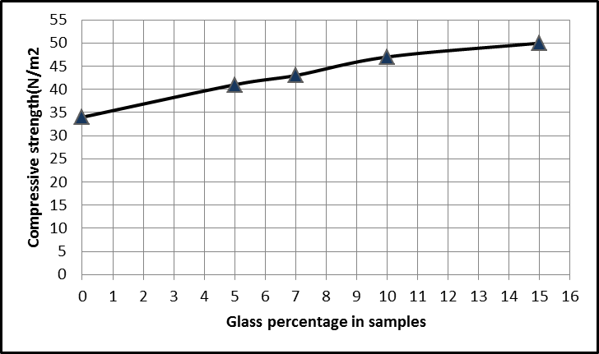

Figure(1) Effect of additive percentage of glass on compressive strength for the sintered samples.
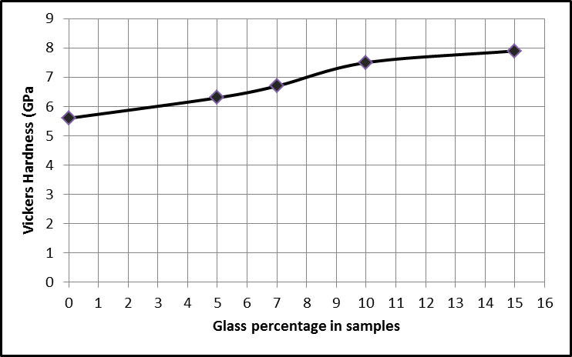
Figure(2) Effect of additive percentage of glass on Vickers hardness for the sintered samples.
Permeability of filter samples
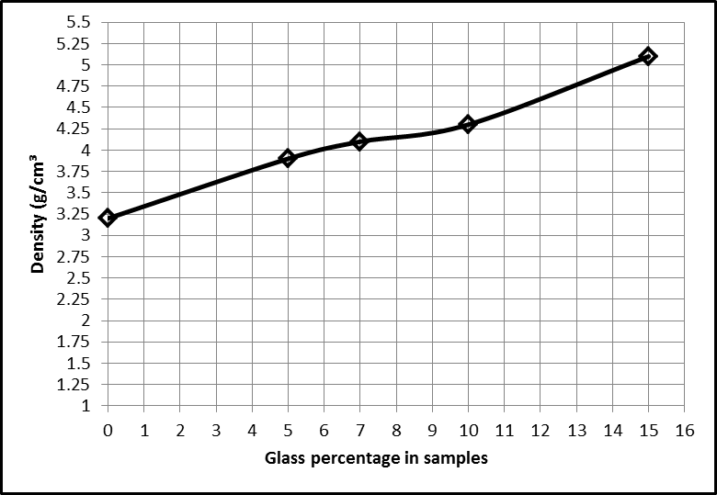
4- The values of hardness for samples increase with increasing of additive glass percentage. The bigger hardness value was (7.9) (GPa) at 15% glass.
5- The density of samples increase with increase additive percentage of glass which arrived to (5.1) g/cm³ at 15% glass.
6- The porosity values of samples decrease with increasing additive percentage of glass, the less value of the porosity is (5%) at 15% glass.
2- Reducing the total amount of energy needed for heating by using binder materials and improving the properties of basic material.
3- Compressive strength of the samples increases with increasing of additive percentage of glass and which reach to (50) (N/m²) at 15% glass.
4- The values of hardness for samples increase with increasing of additive glass percentage. The bigger hardness value was (7.9) (GPa) at 15% glass.
5- The 2- Reducing the total amount of energy needed for heating by using binder materials and improving the properties of basic material.
3- Compressive strength of the samples increases with increasing of additive percentage of glass and which reach to (50) (N/m²) at 15% glass.
density of samples increase with increase additive percentage of glass which arrived to (5.1) g/cm³ at 15% glass.
6- The porosity values of samples decrease with increasing additive percentage of glass, the less value of the porosity is (5%) at 15% glass.
2- Reducing the total amount of energy needed for heating by using binder materials and improving the properties of basic material.
3- Compressive strength of the samples increases with increasing of additive percentage of glass and which reach to (50) (N/m²) at 15% glass.
4- The values of hardness for samples increase with increasing of additive glass percentage. The bigger hardness value was (7.9) (GPa) at 15% glass.
5- The density of samples increase with increase additive percentage of glass which arrived to (5.1) g/cm³ at 15% glass.
6- The porosity values of samples decrease with increasing additive percentage of glass, the less value of the porosity is (5%) at 15% glass.
Njhg 4- The values of hardness for samples increase with increasing of additive glass percentage. The bigger hardness value was (7.9) (GPa) at 15% glass.
5- The density of samples increase with increase additive percentage of glass which arrived to (5.1) g/cm³ at 15% glass.
6- The porosity values of samples decrease with increasing additive percentage of glass, the less value of the porosity is (5%) at 15% glass.
2- Reducing the total amount of energy needed for heating by using binder materials and improving the properties of basic material.
3- Compressive strength of the samples increases with increasing of additive percentage of glass and which reach to (50) (N/m²) at 15% glass.
4- The values of hardness for samples increase with increasing of additive glass percentage. The bigger hardness value was (7.9) (GPa) at 15% glass.
5- The 2- Reducing the total amount of energy needed for heating by using binder materials and improving the properties of basic material.
3- Compressive strength of the samples increases with increasing of additive percentage of glass and which reach to (50) (N/m²) at 15% glass.
density of samples increase with increase additive percentage of glass which arrived to (5.1) g/cm³ at 15% glass.
6- The porosity values of samples decrease with increasing additive percentage of glass, the less value of the porosity is (5%) at 15% glass.
2- Reducing the total amount of energy needed for heating by using binder materials and improving the properties of basic material.
3- Compressive strength of the samples increases with increasing of additive percentage of glass and which reach to (50) (N/m²) at 15% glass.
4- The values of hardness for samples increase with increasing of additive glass percentage. The bigger hardness value was (7.9) (GPa) at 15% glass.
5- The density of samples increase with increase additive percentage of glass which arrived to (5.1) g/cm³ at 15% glass.
6- The porosity values of samples decrease with increasing additive percentage of glass, the less value of the porosity is (5%) at 15% glass.
Njhg

Figure(3) Effect of additive percentage of glass on bulk density for the sintered samples.
Permeability 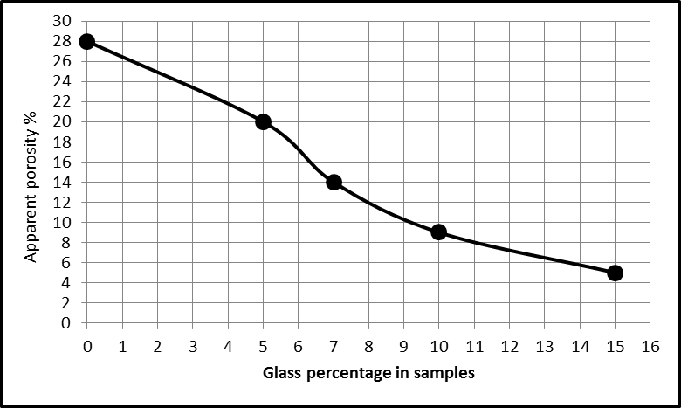 of filter
casting technique gives weak mechanical properties but using the heat treatment and the binder material (30 %) in this method have improved these properties.
Figure(4) Effect of additive percentage of glass on apparent porosity for the sintered samples.

Conclusions
1- This study shows the ability of sintering high melting point ceramic powders, by mixing it with low melting point ceramic powders, by gathering from the liquid phase (glassy phase) which interpenetrates between the grains of the ceramic material that causes to increase the bonding and strengthening of the samples.
2- Reducing the total amount of energy is needed for heating by using binder materials and improving the properties of basic material.
3- Compressive strength of the samples increases with increasing of additive percentage of glass, so value was (50) (N/m²) at 15% glass.
4- The values of hardness for samples increase with increasing of additive glass percentage. The bigger hardness value was (7.9) (GPa) at 15% glass.
5- The density of samples increases with increase additive percentage of glass which reaches (5.1) g/cm³ at 15% glass.
6- The porosity values of samples decrease with increasing additive percentage of glass, the less value of the porosity is (5%) at 15% glass.
References:
Allemann, J.A. 1995,"Grain growth of differently doped zirconia”, Journal of the European Ceramic Society, volume 15 issue 10, p 951-958.
Arias-Maya and Luz S. 2014. "Free and constrained sintering of 3-mol% Yttria stabilized zirconia”,Dyna, vol.81, pp.158- 167. Universidad Nacional de Colombia.
ASTM annual book of standards, C 773-88, 1988 , pp.245-247
Frank S. 1998," Science A Resource for Glass”, The Corning Museum of Glass Education Dept. Education Coordinator.
Kaya and Guray.2013."production and characterization of self- colored dental zirconia blocks ”, Ceramics International.
Koji, W.,Takaaki, N., Kimiyasu, S., and Yuji, H. 2009,"A Strategy to reduce energy usage in ceramic fabrication”.
Laberty-Robert,C.2003,"Dense Yttria stabilized zirconia: sintering and microstructure”, Ceramics International.
Oilo, M., Gjerdet, N.R., and Tvinerreim, 2008."The firng procedure influences
Properties of a zirconia core ceramic”. Dental Materials 24, p 471-475.
Philippe B. and Jean C.N. 2007. "Alumina, Mullite and Spinel, Zirconai”, Ceramic Materials, p199- 230.
Schwartz,. 2002. :Z”, Encyclopedia and Handbook of Materials parts and Finishes.

