Evaluation of the Yield and Water Use Efficiency of the Cucumber Inside Greenhouses

Ahmed Abied Hamza Sabah AnwerAlmasraf
College of Engineering College of Engineering- University of Baghdad
albabele.ahmed@yahoo.com Sabah_dawood@yahoo.com
Abstract
The need to provide fresh and good quality products during long periods throughout the year lead to the adoption of using greenhouses technology, so protected cropping has become a very popular production system in horticulture especially nowadays in Iraq. Evaluation the crop’s yield, water use efficiency and the irrigation system performance became essential. The main objectives of this research were to evaluate the yield index and the water use efficiency for the cucumber inside the greenhouses, and evaluate the performance of the drip irrigation efficiency inside the greenhouses. To accomplish these goals an experiment was conducted in the field located in AL-Mahawil Township in Babylon province .A set of measurements were recorded daily inside the greenhouses planting with cucumber for two consecutive seasons 2014 and 2015 related to weather parameters, crop evapotranspiration, drip system’s performance, and crop’s production. From the conducted field work inside the greenhouses and the analysis of the field data, the following conclusions were withdrawn: daily cucumber’s crop evapotranspiration was measured using the watermarks sensors, the total crop evapotranspiration for the seasons 2014 and 2015 were: 218.21mm and 281.86mm, respectively. The increasing in the crop evapotranspiration was due to change in weather parameters inside the greenhouses. The cucumber’s yield index for seasons 2014 and 2015 was: 8.87 and 8.53 kg/m², respectively, which was close values between the two seasons. In this study, the yield index was high comparing with others approaches. The water use efficiency for the seasons 2014 and 2015 were: 23.23 and 18.22 kg/m³, respectively, which were low values comparing with other approaches. The reduction in the water use efficiency was due to the huge quantities of water applied through the seasons. Additionally, the irrigation efficiency for the drip system in this study for the seasons 2014 and 2015 were: 65.8% and 65%, respectively, these efficiencies were low comparing with recommended values. Managing water and schedule irrigation were the main factors affecting on crop’s growth and then on production. Additionally, saving water was important to obtain high irrigation efficiency, best distribution of fertilizers and reduced crop’s diseases.
Key words: cucumber, yield, water use efficiency, greenhouse, crop evapotranspiration
الخلاصة
أن الحاجة الى توفير منتجات زراعية طرية وذات نوعية جيدة خلال فترة طويلة من السنة, يتطلب هذا الى تبني استخدام تكنولوجيا البيوت الخضراء. لذلك أصبح حماية المحاصيل باستخدام هذه التكنولوجيا من المنظومات الاكثر قبولا او استخداما في العلوم الزراعية, وخاصة اليوم في العراق. لذلك من المهم تقييم حاصل الإنتاج, كفاءة استخدام المياه و كفاءة منظومة الري. أن أهداف البحث الرئيسية هي تقييم مؤشر الحاصل وكفاءة أستخدام المياه لنبات الخيار داخل البيوت الخضراء وكفاءة أداء منظومة الري. ولغرض أنجاز هذه الأهداف, أجريت الدراسة في حقل زراعي تابع الى قضاء المحاويل في محافظة بابل. دونت مجموعة من القياسات الحقلية اليومية داخل البيوت الخضراء لموسمين متعاقبين 2014 و 2015, تتعلق هذه القياسات بالمتغيرات الجوية, الاستهلاك المائي للنبات, أداء منظومة الري بالتنقيط وانتاجية النبات.تم التوصل من خلال العمل الحقلي داخل البيوت الخضراء وتحليل المعلومات الحقلية, الاستنتاجات التالية: تم قياس الاستهلاك المائي اليومي لنبات الخيار باستخدام متحسسات الرطوبة الجبسية ووجد ان مقدار الاستهلاك المائي للنبات الكلية للموسمين 2014 و2015 كانت 218.21 و281.86 ملم على التوالي. أن الزيادة في قيمة الاستهلاك المائي للنبات كانت بسبب تغيير في المعاملات الجوية داخل البيوت الخضراء.أن مؤشر حاصل الخيار للموسمين 2014 و2015 كانت 8.78 و8.53 على التوالي, وهي قريبة جدا من بعضها للموسمين. في هذه الدراسة كان مؤشر حاصل النبات عالي مقارنة مع بقية البحوث والطرق.أن كفاءة استخدام المياه للموسمين 2014 و2015 كانت 23.23 و 18.22 كغم \ م³ على التوالي. في هذه الدراسة كانت قيم كفاءة أستخدام المياه قليلة مقارنة مع بقية البحوث. هذا النقصان بمقدار كفاءة الاستخدام كان نتيجة كميات المياه الكثيرة المضافة خلال الموسمين. بالإضافة الى ذلك, كانت قيم كفاءة منظومة الري بالتنقيط للموسمين 2014 و 2015 : 65.8% و 65% على التوالي, وقيم الكفاءات هذه قليلة مقارنة بكفاءة المنظومة المقررة لها. أن أدارة وجدولة المياه هي من العوامل المهمة التي تؤثر على نمو النبات وبالتالي على إنتاجيته. أضافة الى ان من المهم أدخارالمياه للحصول على اعلى كفاءة ري واعلى توزيع للأسمدة وتقليل اصابة النبات بالإمراض.
الكلمات المفتاحية: الخيار, الحاصل, كفاءة أستخدام المياه, البيوت الخضراء, الاستهلاك المائي للنبات.
1- Introduction
The utilization of greenhouses, mainly for cultivation of vegetables and ornamental is undergoing transformation for renewal that gives the chance to improve yield. The term Water Use Efficiency (WUE) has been widely used in irrigation crop production to describe the efficiency of irrigation with respect to crop yield. It is partially important in comparing crop production from the standpoint of water conservation and production cost. Cantliffe and VanSickle (2002) stated in their study that the yield of vegetable crops in greenhouses is orderly increasing throughout the world. Also, Lorenzo et. al., (2006) found that green-house shading improved the quality of tomato and increased yield of cucumber. Al-Omran et. al.,(2010,2012) found in Saudi Arabia, both farmers and governmental agencies started variable irrigation strategies by moving from open field to greenhouses and by using surface and subsurface drip irrigation. This could enhance irrigation water savings while maintaining a satisfactory production level. Hashem et al., (2011) stated that the effect of different green-house cover treatments on WUE. Using the white net will increased the WUE. This work is conducted during two growing seasons. The interaction between green-house cover and irrigation treatment for WUE was significant. The highest WUE was obtained by white net treatment combined with 80% ET_{o}. The level of 120% from reference evapotranspiration (ET_{o}) combined with black net treatment had the lowest WUE during the two seasons. The obtained results demonstrate that the growth characters (plant height, total leaf area, total fresh weight and total dry weight) and fruit yield are increased by using white net cover throughout the growing season, which stimulated and encouraged cucumber plant growth. Al-Omran et al., (2013) found that the full irrigation at the early and late stages and then irrigation with 80% of ET_{c}was the most appropriate treatment in terms of crop water productivity (CWP) and final the yield. The increase of irrigation quantity over 80% ET_{o} led to decrease in water use efficiency for all irrigation treatments, while the highest WUE was obtained with 80% ET_{o}. Iqbal et. al.,(2014) concluded that no considerable yield differences between two irrigation systems(under drip irrigation as compared to furrow system) higher water use efficiency was observed for crops irrigated by drip irrigation compared to those irrigated by furrow system. Maisiri et. al.,(2005) also reported no significant difference in vegetable yield between drip and surface irrigation systems. It can therefore be further concluded that for conditions where high WUE is an characteristic being a marker for low water use, selection for the preferred crop type can be done by directly choosing for small plant size, small leaf area, or reduced growth duration. These results are confirmed by Bajracharya and Sharma (2005) who presented the same hypothesis to explain the amplification of water use efficiency for cucumber and tomato. The results in their study also indicated that surface drip irrigation gave better establishment of the crop and higher yields than subsurface drip method. Mady and Derees (2007) found that irrigation at 80% from field capacity increased cucumber yield and water use efficiency better than using 40, 60 and 100% from the field capacity. The objectives of this study were: Evaluates the yield index and the water use efficiency for the cucumber inside the greenhouses,Compares the values in the case study with different approaches, Evaluates the performance of the drip irrigation efficiency inside the greenhouses.
2- Materials and Methods
2-1 Location of the Greenhouses Field Study
The research field for this study located within AL-Mahawil Township,70 km away from south of Baghdad. The greenhouses field located at (latitude: 32° 76' N,longitude: 44° 59' E, altitude: 27m).Figure (1) shows Google map for the greenhouses.

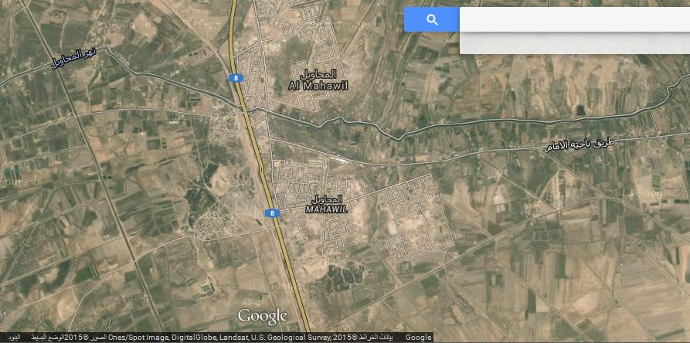
Main Road
Babylon-Baghdad
Greenhouse Field Study

Figure 1.Google map for the research site work.
field site location. The main source of the water is from a water pond charged continuously from the local stream from Al- Mahawil River. Three soil samples were taken from the two locations in the greenhouse fields of cucumber at depths (0-20 cm), (20- 40 cm) and (40- 60 cm). Laboratory analyses of soil samples were conducted in the laboratories of the College of Agriculture-University of Babylon. The goal of the analysis is to identify the physical characteristics of the soil in order to determine soil texture and physical properties of the soil which included bulk density, soil texture, field capacity, and permanent wilting point. The soil texture type of the two greenhouse fields is classified as loam soil for the cucumber’s root zone depths as shown in table (1).
Table (1) Physical properties for the soil of cucumber greenhouses.
Type of the test | Specifications of the soil
Type of the test | Average for the two fields  depth(0-20 cm)and (20-40 cm) | Average for the two fields depth(40-60 cm)
Bulk (apparent) density (gm/cm³) | 1.25 | 1.37
Soil texture | Loam | Clay loam
Water content at field capacity (% by volume) | 29.5 | 34.5
Water content at permanent wilting point (% by volume) | 19 | 21.5
2-2 Watermarks soil water sensor
Watermark sensors are widely available and have a number of favorable technical characteristics on farm use, due to its low cost, ease of installation and durability. These sensors typically require site calibration of the threshold soil-moisture content to which the soil will be allowed to dry before irrigation will be permitted. The patented watermark sensors a solid-state electrical resistance sensing device that is used to measure soil water tension. This type of sensor consists of two electrodes embedded in a reference matrix material, which is confined within a corrosion-proof and highly permeable case (unit range from (0kPa-wet- to 200 kPa-dry).The matrix material includes gypsum to buffer against the effects of salts and fertilizers , but these sensors do not dissolve like gypsum block sensors. Soil moisture is constantly absorbed or released from the sensor as the surrounding soil moisture conditions change. As the soil moisture changes, the sensor moisture reacts as reflected by the change in electrical resistance between the electrodes. Granular matrix sensors operate on the same electrical resistance principle as gypsum blocks. As the moisture level increases,conductivity increases, and the sensor is calibrated to output the moisture level in terms of soil tension(McCready et. al.,2009).Total of three numbers of watermarks sensors were used in each of the greenhouse within the root zone of cucumber at depths 15, 30 and 40 cm for seasons 2014 and 2015.
2-3 Description of the Greenhouse
In this study two greenhouses were used in the research each was 56m in long, 9m in wide and 3m in height (for each area of about 500 m²). They were covered by 100µm transparent polyethylene film treated against ultraviolet radiation. The greenhouse was without heating and no air ventilation was provided, the greenhouse was classified as low technology greenhouse. Drip irrigation system has been used in the two greenhouses. Figure (2) shows the internal layout of the greenhouse. The drip system consists of five double irrigation lines of 55m long (each).Each line consists of two drip tapes; the distance between two drip tapes was 0.3m. The drip tape contains 500 dripper points along its total length. The dripper points were spaced at 0.1m apart. The discharge of each dripper point was about 17cm³ /min. Cucumber (Cucumissativus)was planted at a distance (0.3-0.4 m) between one and other and the planted point will form rows running parallel to the lines. The irrigation date and duration were scheduled by agricultural advisor responsible for managing the greenhouses. In other word, the greenhouse conditions were not controlled in the study. However, in each irrigation process, date, flow rate from the dipper and duration time of the irrigation were recorded when possible.

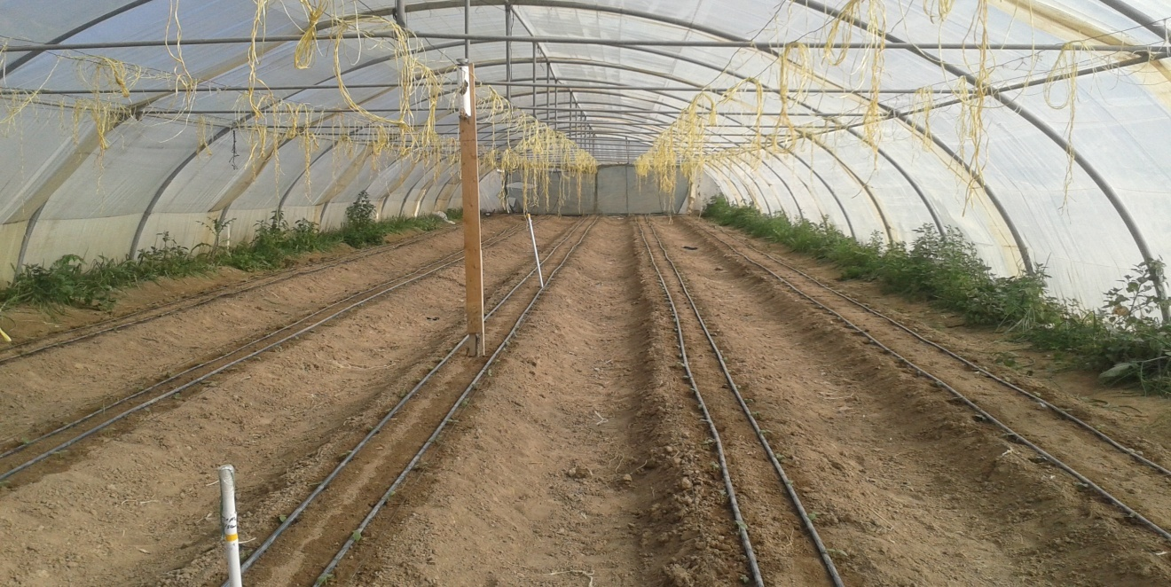
Figure (2) Internal layout of the greenhouse

2-4 Estimation of Crop Evapotranspiration for the Cucumber in the Greenhouse
Daily crop (or actual) evapotranspiration (ET_{c}) values for the cucumber in the greenhouse were calculated when no irrigation water was applied and according to the following equation (Israelsan and Hansen, 1979).
${\text{ET}}_{c}=(θ_{p}−θ_{n})∗\text{RD}$ …………………………… (1)
Where:
: soil moisture in the previous reading (% by volume),
soil moisture in the next reading (% by volume), and
RD: rooting depth (mm).
2-5 Depth of Applied Water
Applied depth of irrigation water was calculated by using the following equation:
Q * T = d_{g} * A ………………………………… (2)
Where:
Q: applied discharge from the drip system (cm³/min.),
T: time of irrigation (min.),
A: wetted area (cm²), and
d_{g}: applied depth of water (cm).
The wetted area under the emitter was assumed to be circle in a shape. Figure (3) showed the measurement of the wetted area under the emitter.
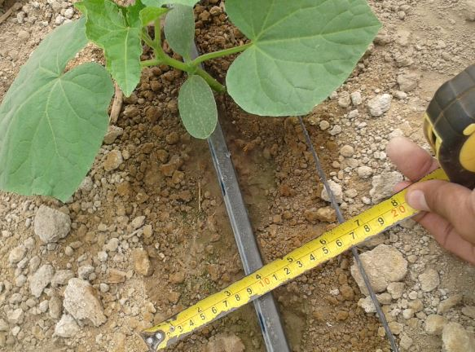
Figure (3) measurement of the wetted area under drip system.

2-6 Yield and Water Use Efficiency ( WUE)
The sum of all pickings crop’s production was expressed as a total fruit yield. It is important in all areas of plant production. The yield (in kg/m²) was expressed as described by Mady and Derees (2007):
$$\text{Yield}=\frac{\text{Total} \text{weight} \text{of} \text{the} \text{ceop}(\text{kg})}{\text{total} \text{area} \text{of} \text{crop}(m^{2})} \text{.}\text{.}\text{.}\text{.}\text{.}\text{.}\text{.}\text{.}\text{.}\text{.}\text{.}\text{.}\text{.}\text{.}\text{.}\text{.}\text{.}\text{.}\text{.}\text{.}\text{.}\text{.}\text{.}\text{.}\text{.}\text{.}\text{.}\text{.}\text{.}\text{.}\text{.}\text{.} (3)$$
Additionally, the water use efficiency (WUE) is the outcome of an entire suite of plant and environmental processes operating over the life of a crop to determine both yield and water use. Or the yield is a measure of crop’s capacity to convert water into plant biomass or grain. The following equation was used for calculating the WUE (kg/m³) (FAO, 1982):
$$\text{WUE}=\frac{\text{Yield}(\frac{\text{kg}}{m^{2}})}{\text{total} \text{depth} \text{of} \text{applied} \text{water}(m)} \text{.}\text{.}\text{.}\text{.}\text{.}\text{.}\text{.}\text{.}\text{.}\text{.}\text{.}\text{.}\text{.}\text{.}\text{.}\text{.}\text{.}\text{.}\text{.}\text{.}\text{.}\text{.}\text{.}\text{.}\text{.}\text{.}\text{.}\text{.}\text{.} (4)$$
2-7 Irrigation Efficiency
The term of irrigation efficiency (IE) was used to define the effectiveness and the irrigation system in delivering all the water beneficially used to produce the crop. IE as a percentage was expressed as:
$$\text{IE}=\frac{\text{total} \text{water} \text{requirement}}{\text{total} \text{applied} \text{water}}∗\text{100} \text{.}\text{.}\text{.}\text{.}\text{.}\text{.}\text{.}\text{.}\text{.}\text{.}\text{.}\text{.}\text{.}\text{.}\text{.}\text{.}\text{.}\text{.}\text{.}\text{.}\text{.}\text{.}\text{.}\text{.}\text{.} (5)$$
3- Results and Discussions
Daily cucumber’s crop evapotranspiration values were measured by using watermarks sensors through the root zone depths starting from the date of planting to the end of the season, where Eq. (1) was applied. Moreover, for the date of irrigation process, depth and volume of water applied were calculated by applying Eq. (2). Table (2) and Table (3) showed the month, depth and volume of applied water and crop evapotranspiration of the cucumber for the season 2014 and 2015, respectively. The total cucumber’s crop evapotranspiration in season 2014 was 218.23 mm, while in 2015 was 281.86 mm. The increasing in the value of ET_{c} was due to the increasing in temperature recorded inside greenhouse during the months March and April 2015 comparing in the months October to December 2014. The recorded temperature inside the greenhouse in season 2014 was ranged between 15 to 25 ºC and the relative humidity was between 65 to 85%. In these conditions of cold and high humidity, the soil was holding the moisture for long time. While in the second season 2015, the temperature was ranged between 25 to 35 ºC and the relative humidity between 45 to 65%.

Table (2) Month, depth and volume of applied water and crop evapotranspiration of cucumber for season 2014.
Month | Depth of  applied water  (mm) | Volume of applied water (cm³) | Crop evapotranspiration ET_{c} (mm)
September | 106.3 | 3077.5 | 10.04
October | 156.5 | 6179.12 | 82.23
November | 87.4 | 2930.5 | 72.22
December | 31.5 | 1015 | 53.74
Total Sum | 381.7 | 13162.12 | 218.23

Table (3) Month, depth and volume of applied water and crop evapotranspiration of cucumber for season 2015.
Month | Depth of  applied water  (mm) | Volume of applied water (cm³) | Crop evapotranspiration ET_{c} (mm)
January | 47.1 | 1139 | 4.47
February | 79.1 | 1441 | 35.03
March. | 151 | 3557.22 | 102.47
April | 190.8 | 7337 | 139.89
Total Sum | 468 | 13474.22 | 281.86

Figures (4) and (5) showed the daily trend of the soil water content in the crop’s root zone through the growing seasons 2014 and 2015, respectively. The soil water content in some days was more the field capacity limit; the soil was in saturation conditions. Additionally, the depth of applied water in season 2014 was 381.7 mm, while in season 2015 was 468 mm.

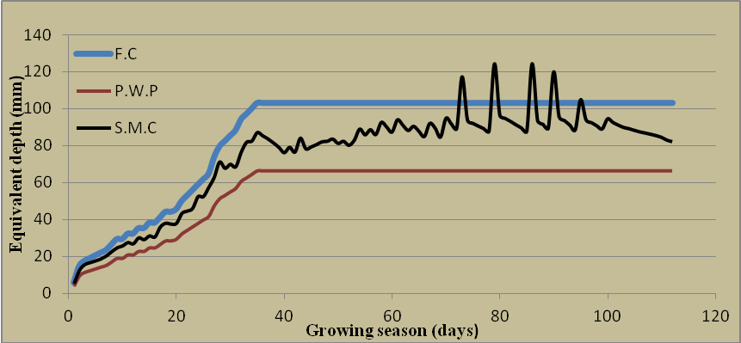
Figure (4) Trend of the daily soil water content among filed capacity and permanent wilting point through the growing season of the cucumber for the season 2014.
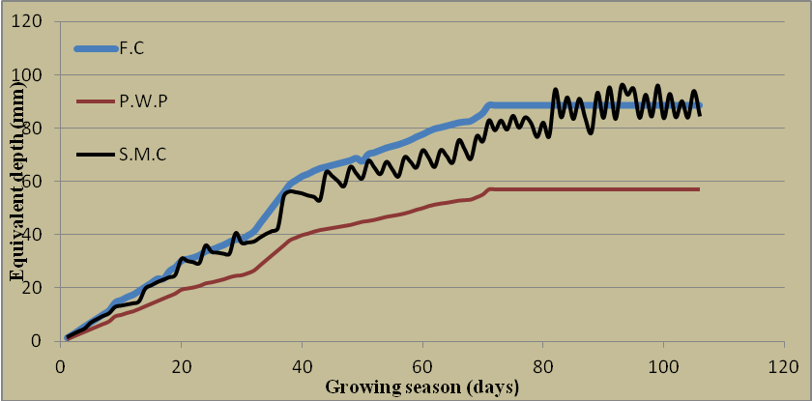
Figure (5) Trend of the daily soil water content among filed capacity and permanent
The values of yield and water use efficiency were calculated for the cucumber inside the greenhouses for the seasons of 2014 and 2015.Tables (4) and (5) showed the summary of the yield index and water use efficiency of the cucumber for each month and the total sum for the seasons 2014 and 2015, respectively. The yield and the water use efficiency for the cucumber in season 2014 were: 8.87kg/m² and 23.23kg/m³, respectively. While, in season 2015, the yield and water use efficiency were: 8.53kg/m² and 18.22kg/m³, respectively. The reductions in yield and water use efficiency in 2015 were: 4% and 27.5%, respectively. The reduction in yield was not significant, due to the area of the greenhouse was the sane for both seasons, but the reduction in water use efficiency was significant, due to the total depth of applied water in season 2015 was more than in season 2104 by about 18.44%.
Table (4) Month, yield and water use efficiency of the cucumber and the total sum for season 2014.
Month | Production (Yield) (kg/m²) | Water use efficiency (kg/m³)
September | 0 | 23.23
October | 3.07 | 23.23
November | 3.40 | 23.23
December | 2.40 | 23.23
Total Sum | 8.87 | 23.23

Table (5) Month, yield and water use efficiency of the cucumber and the total sum for season 2015.
Month | Production (Yield) (kg/m²) | Water use efficiency (kg/m³)
January | 0 | 18.22
February | 0 | 18.22
March | 2.72 | 18.22
April | 5.81 | 18.22
Total Sum | 8.53 | 18.22

3-1 Comparison the Yield and the Water Use Efficiency for the Cucumber
In this study the calculated value of the yield index and the water use efficiency for the cucumber inside greenhouses were compared with different available approaches. Table (6) showed the yield and water use efficiency for the cucumber inside greenhouses conducted by different approaches. In this study the average yield index for the seasons 2014 and 2015 was 8.7 kg/m², which was almost with second order of the comparison. While the average value of WUE in this study was 20.73 kg/m³, which was the last approach in the comparison with the others. The reduction of the average value of WUE in this study was more than the twice from the highest approach. The reason for this reduction in this study was due to the amount of the applied water for the seasons 2014 and 2015:381.7mm and 468mm, respectively, comparing with the total water requirements of the cucumber for the seasons 2014 and 2015: 251.21mm and 304.36mm, respectively.
Table (6) Yield and water use efficiency (WUE) for the cucumber inside greenhouses conducted by different approaches.
 |  | Irrigation  method | Country | Approach
Yield (kg/m²) | WUE (kg/m³) | Irrigation  method | Country | Approach
8.87 | 23.23 | Drip | Iraq | Present study (2014)
8.53 | 18.22 | Drip | Iraq | Present study (2015)
8.10 | 36.80 | Drip | Egypt | Hakkim and Chand (2011)
8.72 | 25.74 | Drip | Egypt | Mady and Derees (2007)
6.39 | 26.23 | Drip | Syria | Yaghi et. al., (2013)
15.00 | 42.30 | Drip | Saudi Arabia | AL-Omran et. al., (2013)
Figure (6) showed the comparison of the water use efficiency and the yield of the cucumber for the seasons 2014 and 2015 inside greenhouses with different approaches. The management practice and irrigation schedule were main factors affecting on the yield and water use efficiency. No relation was found between the high yield and low WUE. Bajracharya et. al., (2005) and Condon et. al., (2002) were confirmed this statement in their works for the cucumber and tomato crops.

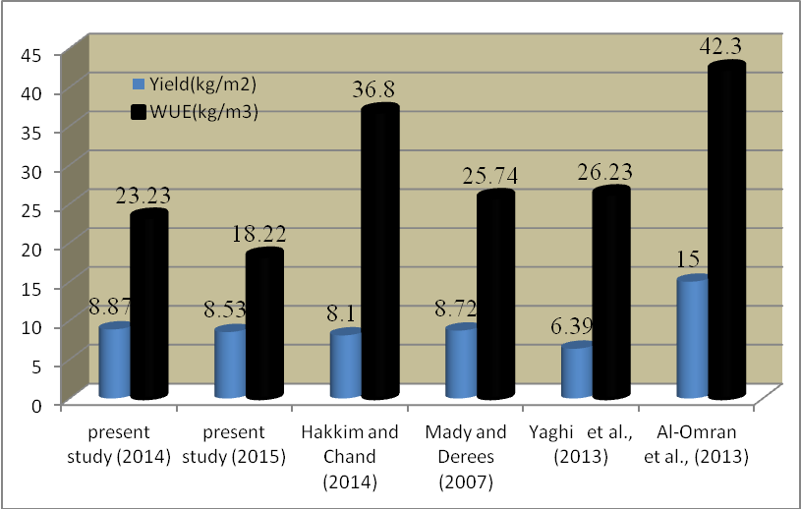
Figure (6) Comparison of the water use efficiency and the yield of the cucumber for the seasons 2014 and 2015 inside greenhouses with different approaches.

3-2 Evaluation of the Irrigation Efficiency
The total sum of ET_{c} for the growing seasons 2014 and 2015 were: 218.21mm and 281.86mm, respectively. The first irrigation was required to convert the soil condition from dry to field capacity. The soil water content after irrigation was measured to be at filed capacity for seasons 2014 and 2015, and the depth of applied water for season 2014 and 2015 were: 120mm and 150mm, respectively, (assumed that all the applied depth of water was stored in the soil). Therefore, water requirements use for this irrigation was:
(29.5-2)% * 120=33mm (season 2014)
(29.5- 14.4)% *150 = 22.5mm ( season 2015)
Where:
2 and 14.5 = water content before irrigation (% by volume), and
120 and 150 = depth of seed and seedling (mm), respectively.
The total water requirements for seasons 2014 and 2015 were: 251.21mm and 304.36mm, respectively. The irrigation efficiency for the drip system in this study for the seasons 2014 and 2015 were: 65.8% and 65%, respectively, these efficiencies were very low comparing with the normal operation and range of the system (85-95%) (Irmak et al., 2011). Following irrigation schedule, avoiding over irrigation and management the field well, will increased the system’s efficiencies. Figure (7) showed water surface runoff caused by bad top leveling and the surrounding deck along with crop’s strip.

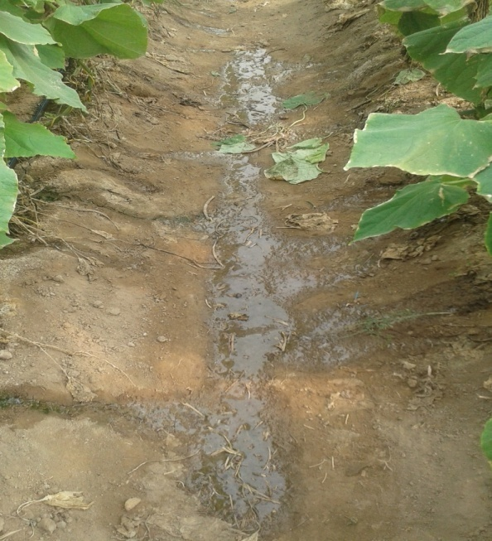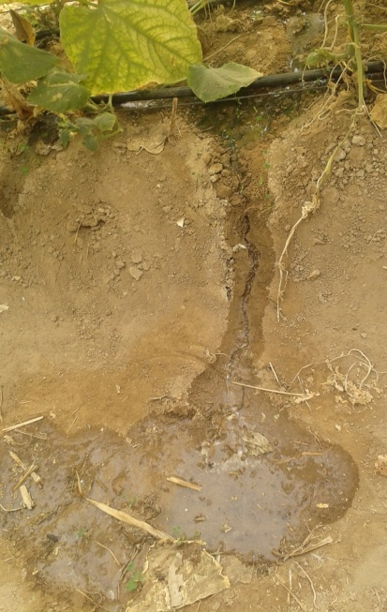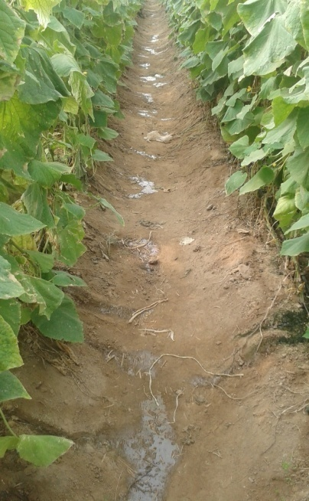
Figure (7) Surface runoff water from the drip irrigation system.

4- Conclusions
The conclusions from this study works were:
- The depth of applied water through the growing seasons was more than the consumptive use of the cucumber.
- The soil water content in some days through the growing season was in saturation conditions.
- The yield index was significant value; the production was almost high in the two seasons comparing with other approaches.
- The water use efficiency values of the cucumber for the two seasons were very low comparing with other approaches, due to the huge application of water, The irrigation efficiency of the drip system inside the greenhouses for the two seasons was very low, due to losses of water as surface runoff and deep percolation.
5- References
Al-Omran, A. M., Al-Harbi, A. R., Wahb-Allah, M. A., Nadeem, M. and Eleter, A.,2010, “Impact of irrigation water quality”,Irrigation Systems, Irrigation Rates and Soil Amendments on Tomato Production in Sandy Calcareous Soil. Turk. J. Agric. For.,Vol. 34, pp. 59 –73.
Al-Omran, A. M., Al-Harbi, M. A., Wahb-Allah, M. A., Alwabel, M., Nadeem, M. and Al-Eter, A., 2012,“Management of irrigation water salinity in greenhouse tomato production under calcareous sandy soil and drip irrigation”.J. Agri. Sci. Tech., Vol. 14(4), pp. 939-950.
Al- Omran, A. M., I. I. Louki, A. A. Aly, and M. E. Nadeem.,2013,“Impact of deficit irrigation on soil salinity and cucumber yield under greenhouse condition in an arid environment” .J. Agr. Sci. Tech. Vol. 15, pp. 1247-1259.
Bajracharya, R. M., and Sharma, S.,2005,“Influence of drip-irrigation method on performance and yields of cucumber and tomato”,Int.J.Appl.Sci.Eng.Tech.1,pp.1-7.
Cantliffe, DJ and Vansickle, J. J., 2002, “A sleeping giant: Can Florida compete with the Spanish and Dutch greenhouse industries Practical Hydroponics and Greenhouses”, Vol. 67, pp. 30-36.
Condon, A.G., R.A Richards, G.J Rebetzke and G.D Farquhar,2002, “Improving intrinsic water -use efficiency and crop yield”, Crop Sci., Vol. 42, pp. 122–131.
FAO, 1982,“Crop Water Requirements Irrigation and Drainage”, Paper No. 24, FAO, Rome, Italy.
Hakkim,. V.M. Abdul, and Chand , A.R. Jisha, 2014, “ Effect of drip irrigation levels on yield of salad cucumber under naturally ventilated playhouse” IOSR Journal of Engineering, vol.5, pp. 18-21.
Hashem, F. A., M. A. Medany, E.M. Abd El-Moniem, and M. M. F. Abdallah.,2011, “Influence of green-house cover on potential evapotranspiration and cucumber water requirements” .Annals of Agricultural Science, Vol. 56, pp. 49–55.
Iqbal, Mazher, Fayyaz-ul-Hassan Sahi,Tamoor Hussain, Nasrullah Khan Aadal, Muhammad Tariq Azeem1 and Muhammad Tariq,2014, “Evaluation of comparative water use efficiency of furrow and drip irrigation systems for off-season vegetables under plastic tunnel”,Intl.J.Agri.Crop Sci.Vol.,7 (4), pp. 185-190.
Irmak,S., Lameck O.,Odhiambo, and William L.Kranz,2011, “Irrigation efficiency and uniformity,and crop water use Efficiency”,Extension of Institute of Agriculture and Natural Resources, University of Nebraska Lincoln.
Israelsen, O.W. and V.E Hansen, 1979, “Irrigation principles andpractices”, 3rd Ed. John Wily and Sons. New York.
Lorenzo, P.,Garcia,M.L.,Sanchez-Guerrero,M.C.,Medrano, E.,Caparros, I., and Gimenez, M.,2006,“Influence of mobile shading on yield, crop transpiration and water use efficiency”. Acta Hort. 719, pp. 471–478.
Mady,A.A., and Derees,Abd.H.,2007, “Effect of water stress and application of compost on water use efficiency and productivity of cucumber in plastic house under trickle irrigation system ”, Vol. 24(1), pp. 182-197.
Maisiri N, Senzanje A, Rockstrom J, and Twomlow S.J.,2005,“On farm evaluation of the effect of low cost drip irrigation on water and crop productivity compared to conventional surface irrigation system”, Physics and Chemistry of the earth, part A/B/C. Vol. 30, pp. 783-791.
McCready, M.S., Dukes, M.D.,and Miller,G.L., 2009,“Water conservation potential of intelligent irrigation controllers on St. Augustine grass”, Agric.Water Manage, Vol. 96, pp. 1623-1632.
Yaghi,T., A.Arslan, and F.Naoum, 2013,“Cucumber water use efficiency under plastic mulch and drip irrigation”, Agricultural Water Management, Vol. 128, pp. 149-157.

