Evaluation of Moisture Damage and Stripping of Asphalt Concrete Prepared With New Additives of Polymer Modified Bitumen

Basim H. Al-Humeidawi
University Lecturer-Roads and Transport Engineering Department
College of Engineering, University of Al-Qadissiyah
Basim.alhumeidawi@yahoo.com
Haider H. Aodah
University Lecturer, Civil Engineering Department
College of Engineering, Thiqar University, Nassiriyah
alshweily@yahoo.com .
Kassim k. Hameed
University Lecturer, Chemical Engineering Department
College of Engineering, University of Al-Qadissiyah
K_alshemary@yahoo.com .
Haneen A. Merawi Safa S.Al-Ogaili
Civil Engineer, Roads and Transport Engineering Department
College of Engineering, University of Al-Qadissiyah
Abstract
The moisture induced damage and stripping are two of common reasons of premature failure of flexible pavement. The current research involved an extensive experimental investigation on two types of polymers (Novolac and PVA) as modifiers in order to produce Polymer Modified Bitumen (PMB). Different ratios of both additives were investigated for rheological properties of binder and mechanical properties of Hot Mix Asphalt (HMA). The rheological properties of PMB were evaluated by penetration, softening point, ductility and thin film oven tests. The mechanical properties of HMA were assessed by Marshall Stability test, Retained Marshall Stability test, indirect tensile strength test, Tensile Strength Ratio (TSR), and striping test. The results of tests showed that the Novolac modifier improves the cohesion properties of binder and the adhesion of binder to aggregate. The PVA modifier mainly improves the adhesion of binder to aggregate with less degree of that of using Novolac. Both modifiers significantly improve moisture sensitivity and decrease the stripping of HMA. Also, the results showed that the addition of 2% of Novolac to binder to produce PMB represents the optimum option. The HMA with PMB _{Novolac 2%} improves the Marshall Stability, Retained Marshall Stability, and TSR by 45%, 14% and 44% respectively. The very small amount of these additives compared with mix components and their reasonable price make them a superior and practical solution for premature failure of flexible pavement.
Keywords:- Novolac, Polyvinyl alcohol, Moisture sensitivity, Stripping, Indirect tensile strength, Tensile Strength Ratio, Hot mix asphalt.
الخلاصة :
ان الضرر الناتج عن تأثير الرطوبه وانفصال مكونات الخلطة الاسفلتيه يمثلان سببين رئيسيين في الفشل المبكر للتبليط الاسفلتي. البحث الحالي يتضمن دراسه عملية تفصيليه لاختبار نوعين من البوليمرات (هما النوفولاك والبوليفانيل الكحول) كمضافات لانتاج البتيومن المعدل بأستخدام البوليمرات. نسب مختلفه من هذيين المضافيين تم اختبارهما لتحديد مدى التحسن في الخواص الريولوجيه للبتيومين بمفرده والخواص الميكانيكيه للخلطة الاسفلتيه. الخواص الريولوجيه للبتيومين تم تحديدها عن طريق فحص الاختراق وفحص نقطة السيوله وفحص المطيليه وفحص طبقة الاسفلت الرقيقه. اما الخصائص الميكانيكه للخلطه الاسفلتيه فقد تم تقييمها عن طريق فحص ثبات مارشال للنموذج و فحص الثبات المتبقي و فحص الشد غير المباشر وفحص نسبة مقاومة الشد بالاضافة الى فحص الانفصال لمكونات الخلط الاسفلتيه. نتائج الفحوصات اظهرت ان النوفولاك حسَن بشكل كبير خواص التماسك للبتيومين وكذلك خاصية التلاصق للبتيومن مع الركام في الخلطه الاسفلتيه. اما بوليفانيل الكحول فقد حسَن خاصية التلاصق بين البتيومن والركام و لكن بدرجة اقل من النوفولاك. كلا المضافيين حسنا من تقليل حساسية الخلطة الاسفلتيه للرطوبه و كذلك قللا من انفصال مكونات الخلطة الاسفلتيه. النتائج اظهرت ان اضافة 2% من النوفولاك الى البتومين يمثل النسبة المثالية لانتاج البتيومن المعدل باستخدام البوليمرات. حيث اظهرت النتائج ان اضافة هذه النسبة للبتيومن يحسن قوة ثبات مارشال للنموذج وقوة الثبات المتبقي ونسبة مقاومة الشد الغير مباشر بالنسب الاتيه 45% و 14% و 44% على التوالي. ان النسب القليله جداً من هذه المضافات مقارنة بكميات المكونات الاخرى للخلطه الاسفلتيه و السعر المعتدل لهذه المضافات يجعل منها حل ممتاز وعملي لمشاكل الفشل المبكر في التبليط الاسفلتي.
الكلمات المفتاحيه: نوفولاك, بوليفانيل الكحول، الحساسيه للرطوبة, الانفصال, فحص الشد غير المباشر, نسبة الشد غير المباشر, الخلطه الاسفلتيه.
- Introduction
The premature failures of Asphalt Concrete Pavement (ACP) have several reasons. Most of these reasons are related to environmental conditions and/or traffic loads i.e. durability or stability failures. Some of the environmental conditions such as water or moisture, temperature and air have detrimental effects on the pavement performance of Asphalt Concrete Pavement (ACP). The environmental conditions detrimental effects are usually related to durability failures of ACP. The most environmental factors influencing the durability of Hot Mix Asphalt (HMA) are the moisture induced damaged and the stripping of its components due to loss bitumen- aggregate adhesion (Fromm 1974; Gorkem and Sengoz 2009; Kandhal et. al., 1989; Taylor and Khosla 1983). Moisture damage represents the action of degradation of HMA strength and their durability due to presence of moisture or water, and may be evaluated by losing of mechanical properties of HMA (McGennis et. al., 1994). The phenomenon of moisture damage in HMA can generally be categorized in two mechanisms:(a) loss of adhesion between the aggregate and the bitumen due to presence of water at aggregate-binder interface,(b) loss of cohesion of bitumen itself due to the softening action (Lottman, 2001).
The amount and types of moisture damage are affected by several factors; some of these factors are associated with components of HMA such as bitumen and aggregate. Others factors are associated with the processes of design, production and construction of HMA (Hicks,1991).
Recently, the use of some additives as antistripping agents has been considered a widespread method of improving the moisture susceptibility of HMA. The main objective of using antistripping agents is to prevent the moisture susceptibility of HMA by improving and protecting the bond between the HMA components (binder and the aggregate).Among these additives, polymers were a versatile materials proposed to alleviate moisture damage and improved the mechanical properties of HMA; consequently, allowing the building of durable roads and reducing the maintenance costs by increasing the stiffness of the asphalt and improves its temperature susceptibility (Awwad and Shbeeb 2007; Polacco et. al., 2005; Vacin 2004). These polymers were used as additive to the aggregate such as polyethylene crystalline material (Nejad et. al., 2013), or to bitumen to produce Polymer Modified Bitumen (PMB) such as SBS (styrene–butadiene–styrene), EVA (ethylene–vinyl-acetate), SBR (styrene–butadiene–rubber), etc…(Aguiar-Moya et. al., 2013; AlataÅŸ and Yilmaz 2013; Iskender et. al., 2012; Kok and Yilmaz 2009). The polymers can be classified into two groups according to their behaviour under heating and pressure: thermoplastic and thermosets. Thermoplastic polymers can be repeatedly softened or melted under heating or pressure (Goodman 1986); whereas, thermosets react irreversibly so that the application of additional heat or pressure does not cause flow or softening for them (Mandel 1988). Due to their nature the thermosets polymers are stiffer than thermoplastic but the thermoplastics are more elastic.
Most of antistripping agents were added to bitumen (asphalt binder) for several reasons such as easier mixing and control, improving the cohesion properties of asphalt binder in addition to improving the adhesion between the aggregate and asphalt binder. Novolac (Phenol formaldehyde solid resin) was tested in the current research as antistripping agent due to their good adhesive properties (Danielson and Simonson 1998). Very limited researches have been conducted on using Novolac as additive to asphalt binder. One of these researches investigated the use of Novolac as an additive to enhance asphalt binder properties and HMA (Deef-Allah and Mohamady 2014); however that research did not investigate the effect of this additive on moisture susceptibility of HMA. The other material tested in this research was polyvinyl alcohol (PVA), this material was selected as an adhesive material has more elasticity than Novolac.
The current research focused on investigation the effect of two new polymers modifiers (polyvinyl alcohol (PVA) and Novolac) as additives to bitumen used in HMA to control moisture induced damaged and stripping phenomena. Several laboratory tests with different percentage of additives were conducted to evaluate the response of polymer modified bitumen alone and with HMA.
- Materials
  - Asphalt (Bitumen) and aggregate
The bitumen binder used in this research was 40/50 grade, which is more suitable for hot weather such that of Iraqi weather conditions. Their properties were determined through some of conventional tests including penetration, softening point, ductility and thin film oven tests. These properties are listed in Table 1 below. The aggregates gradation used in the research are shown in Figure 1; where, the mid limit of ASTM specifications (ASTM D 2940 2003) for dense aggregate gradation was adopted in preparing the HMA.
  - Additives
Two types of additives were used in the current research; Novolac (Phenol formaldehyde solid resin) and polyvinyl alcohol (PVA). Novolac was grinded and mixed as dry material with cross-linking agent Hexamine (H.T.M.A) then added to asphalt material according to mixing process coming later. The other material used was PVA; the chemical composition of this material makes it more elastic so, it may improve the elasticity of mix especial when used with Novolac. According to previous mentioned classification Novolac is classified as thermosets polymer and PVA as thermoplastic polymer.
The Figure 2 shows pictures and chemical composition for both additives used in the current research.
- Experimental set up and procedure
  - Mix design
Standard Marshall Mix design method was used to prepare asphalt mixtures. Five trial mixes (15 samples) were prepared with different binder contents (4 – 6) % , without any additives, and the optimum binder content was selected according to the results in Figure 3. The optimum asphalt content (AC) was adopted from these drawing as 4.95%.
  - Preliminary test of PMB
As mentioned before, an asphalt binder of 40/50 penetration grade was used in experimental investigation as confirmed by some conventional test conducted on the sample. These conventional tests (penetration, softening point, ductility and thin film oven tests) were also implemented on PMB with different ratios of Novolac, PVA and Novolac plus PVA. The additives were mixed with binder using proper shear mixer. The asphalt binder was heated to 150 ºC for 1hr with mixer speed, after the mixing temperature of 180 ºC was reached, the modifier was added slowly in the required amount to avoid agglomeration of polymer and the mixing was continued for next 1.5 hr. The test results of PMB are shown in Table 1.

Table 1. Results of the experiments conducted on 40/50 penetration grade asphalt binder and PMB.
Property | Standard | Result
Property | Standard | Pure asphalt | Asphalt + 1% Novolac | Asphalt + 2% Novolac | Asphalt + 3% Novolac | Asphalt + 4% Novolac | Asphalt + 1% PVA | Asphalt + 2% PVA | Asphalt + 0.5 % PVA + 2% Novolac
Penetration (100 g, 5 s, 25 ⁰C), 0.1 mm | ASTM D5-13 | 47 | 27.5 | 25.3 | 19.6 | 17.1 | 40.6 | 42.7 | 36.9
Softening point, ⁰C | ASTM D36-12 | 52 | 55 | 60 | 65 | 65 | 53 | 58 | 59
Ductility (25 ⁰C, 5 cm/min), cm | ASTM D113-07 | >100 | >100 | >100 | 91 | 75 | >100 | 90 | 63
Elastic Recovery in ductil-ometer at 15 ⁰C, %. Min | ASTM D113-07 | 51 | 62 | 78 | 80 | 77 | 60 | 74 | 78
Flash point (⁰C) | ASTM D92-12b | 255 | 250 | 240 | 235 | 231 | 250 | 245 | 233
After Thin Film Oven Test
Loss in weight, %. | ASTM D1754 -09 | 0.2 | 0.3 | 0.3 | 0.3 | 0.2 | 0.2 | 0.2 | 0.2
Increase in softening point 0C, Max. | ASTM D1754 -09 | 2.2 | 1.7 | 1.8 | 1.8 | 1.9 | 2 | 2.3 | 2.4

The results of testing PMB in Table 1 clearly show that adding Novolac to binder significantly improve the cohesion properties of binder. The stiffness of binder was significantly increased by adding Novolac to binder. This response is observed by decreasing the penetration distance of standard in the sample. The soften point and ductility tests also indicate a similar response. On the other hand, adding PVA to binder did not show a great improvement in binder properties, but the investigation of adding it to binder in HMA is continue to see the possibility of improving the adhesion between the aggregate and binder in HMA. Since the ratios of 1%, 2% Novolac; 1%, 2% PVA, and 2% Novolac plus 0.5% PVA gave more practical results, the investigation of HMA with PMB is limited by these ratios only.
  - Marshall Stability and flow
Eighteen samples were prepared from the six mixes (control, PMB _{Novolac 1%}, PMB_{Novolac 2%}, PMB _{PVA 1%}, PMB _{PVA 2%}, and PMB _{2%} _{Novolac plus 0.5 % PVA}) under investigation by compacted these sample using Marshall hammer with 75 blows on each cylindrical sample. These samples were tested according to conventional Marshall Method described in ASTM D 1559-89 (ASTM D 1559 1989), by immersion them in water bath with 60 C⁰ for 30 minutes then loaded each sample until the failure and recorded failure load and flow.
The results presented in Figure 4 show that the Marshall Stability of HMA is greatly improved due to using PMB _{Novolac}. The increment reached up to 45 % for PMB _{Novolac 2%} compared with control mix. The increasing of Novolac ratio leads to more stiffness and stability of HMA. The development of Marshall Stability of the mix may attribute to cross-link action between aggregate and binder due to presence of Novolac. The harding of Novolac leads to form a cross-linking chains between aggregate and binder and act on increasing the cohesion of binder itself.
On the other hand, using PVA with binder to produce PMB shows a slight improvement in Marshall Stability and stiffness. The increasing in stability magnitude reached up to 15 % compared with control mix. The gained stability is related to water-resistant plastic film initiated around the aggregates. The increasing in quantity of PVA within the binder has insignificant effect on the stability value. The response may be attributed to thermoplastic nature of PVA; where, the material is softened and flow under pressure. The last sample (PMB _{2%} _{Novolac plus 0.5 % PVA}) shows a practical behaviour resulted in between value of Marshall Stability, where, a reduction in stability value can be seen for this mix compared mix containing PMB _{Novolac 2%} due to the effect of thermoplastic nature of PVA under pressure.
Marshall Flow values are presented in Figure 5 for all mixes under consideration. Compatible values can be observed from that figure; where, the flow value is maximum for the mix containing PMB _{PVA 2%}.
  - Retained Marshall Stability
The Retained Marshall Stability for the six mixes was testes according to ASTM D 1075 (ASTM D 1075 2011). Six Marshall Samples were prepared for each mix; three were cured in water bath with 60 C⁰ for 24 hours and three were left at room temperature. The samples were tested according to conventional Marshall Method and the percent of retained stability was calculated as shown below:
………....(1)
Figure 6 presents the results of Retained Marshall Stability for all six mixes. The results generally show that both polymers are improved Retained Marshall Stability, especially for mix containing PMB _{Novolac 2%}. Percent of Retained Marshall Stability increased from 78 % for control mix to 89 % for mix containing PMB _{Novolac 2%}. This response may be attributed to that generally all polymers and especially Novolac did not absorb water. Their addition to binder may reduce reaching water to aggregate-binder interface and consequently protect the adhesion between the binder and aggregate and prevent the separation.
  - Indirect Tensile Strength (ITS)
To evaluate the moisture induced damage of HMA prepared with different types of PMB, the Modified Lottman AASHTO T 283 (AASHTO T283 1989) test has been conducted on the six mixes. The test involved preparation of six samples (two sets) for each mix with air void ratio between 6-8 % to accelerate aging process. Three samples (first set) from each mix were conditioned in water bath with 60 C⁰ for 24 hours, while the other three samples (second set) were kept at room temperature as control samples. The two sets of each HMA samples are subjected to a split tensile test as shown in Figure 7. The splitting indirect tensile strength was computed for each set as following:
……………….(2)
Where:
ITS = Indirect tensile strength (MPa)
P = Applied load (N)
h = Average height of specimens (mm)
d = Average diameter of specimens (mm)
Then the Tensile Strength Ratio (TSR) was calculated according to following:
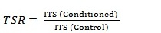 …………………. (3)

Figure 8 and Figure 9 respectively present the results of tensile strength and TSR for all mixes. The results in these figures confirmed the effect of the two additives in prevention water absorption and glassing the aggregate; consequently, protect the adhesion between aggregate and binder. The addition of Novolac to binder shows superior improvement in TSR. The TSR for mix containing PMB _{Novolac 2%} increased to 91% compared with 63 % for control mix. The TSR for mix containing PMB _{PVA 2%} also increased to 77% which represents improvement by about 22% compared with control mix. The improvement of TSR for mix containing PMB _{PVA 2%} may be attributed to initiation of plastic film resistance to water at aggregate-binder interface due to presence of PVA.
  - Stripping test
Texas boiling test (ASTM D 3625 2012) was used to evaluate the effectiveness of antistripping additive to reduce stripping potential. The hot mix asphalt was placed in boiling water for 10 minute during, which the mix was stir for ten seconds every three minutes, using glass rode. Then the mix was removed from water and spread on white paper, the degree of stripping is determined by visual observation. Two types of antistripping agents were used in this study with different percents; (PMB _{Novolac 1%} , PMB _{Novolac 2%} , PMB _{PVA 1%}, PMB _{PVA2%}, and PMB _{2% Novolac plus 0.5 % PVA} ).
Test results, shown in figure 10 indicated that the all mixes have a significant effect on reducing stripping potential, without causing a significant negative impact on reducing asphalt’s ductility and penetration except that PMB 2% Novolac plus 0.5 % PVA which reduce ductility up to 63 also was found the PMB Novolac 2% has a better resistance to stripping than those obtained from other mixes. On the other hand the mixes prepared with PVA have a slightly lower antistripping effect compared to those of Novalac additive this can be explained by the strong interaction between the Novalac and the aggregate surface.
- Summary and conclusions
The current research involved investigation both the rheological and mechanical properties of asphalt and HMA modified by two types of polymers (Novolac and PVA). Two ratios (1% and 2% from binder content) were used for each additive. Also, the ratio of 2% Novolac plus 0.5% PVA together was used. The results of test showed that:
- The preliminary results of tests showed a significant improvement due to using Novolac as modifier, especially the penetration test results which decreases to about 50%.
- The mechanical properties and moisture susceptibility of HMA are also greatly improved due to using these polymers where the HMA with PMB _{Novolac 2%} improves the Marshall Stability, Retained Marshall Stability, and TSR by 45%, 14% and 44% respectively.
- The research results showed that the optimum modifier is the Novolac with ratio of 2% of binder content.
- The addition of PVA also improved the mechanical properties of HMA; especially, when, the moisture damage is a concern issue with HMA.
- The very small amount of these additives compared with mix component and their reasonable price make them a superior and practical solution for premature failure of flexible pavement.
- Recommendations
Based on the results of this study, the following points can be recommended:-
- The effect of the PMB _{Novolac 2%} on rutting, fatigue cracking and other HMA properties needs to be evaluated.
- Trial job mix with PMB _{Novolac 2%} for 10 meters long section is strongly recommended to evaluate the actual behaviour of Novalac.
- References:
AASHTO T283.1989." Resistance of Compacted Bituminous Mixture to Moisture Induced Damage." American Association of State Highway and Transportation Officials.
Aguiar-Moya, J. P., Loria-Salazar, L., Salazar, J., Villegas, E., Corrales-Azofeifa, J. P., Hajj, E. Y., and Center, W. R. S. "Evaluation of Adhesion Properties of Costa Rican Asphalt Mixtures using the Bitumen Bond Strength (BBS) and 2 Contact Angle Measurement Tests 3." 92th Annual meeting of the transportation research board, Washington, USA.
AlataÅŸ, T., and Yilmaz, M. 2013. "Effects of different polymers on mechanical properties of bituminous binders and hot mixtures." Construction and Building Materials, 42, 161-167.
ASTM D 1075. (2011). "Standard Test Method for Effect of Water on Compressive Strength of Compacted Bituminous Mixtures."
ASTM D 1559.1989."Standard Test Method for Resistance to Plastic Flow of Bituminous Mixtures Using Marshall Apparatus."
ASTM D 2940. 2003."Standard Specification for Graded Aggregate Material For Bases or Subbases for Highways or Airports." American Society for Testing and Materials (ASTM).
ASTM D 3625. 2012."Standard Practice for Effect of Water on Bituminous-Coated Aggregate Using Boiling Water."
Awwad, M. T., and Shbeeb, L. 2007."The use of polyethylene in hot asphalt mixtures." American Journal of Applied Sciences, 4(6), 390-396.
Danielson, B., and Simonson, R. 1998. "Kraft lignin in phenol formaldehyde resin. Part 1. Partial replacement of phenol by kraft lignin in phenol formaldehyde adhesives for plywood." Journal of Adhesion Science and Technology, 12(9), 923-939.
Deef-Allah, E. M. M., and Mohamady, A. 2014. "Performance Evaluation of Polymer Modified Asphalt Mixtures." International Journal of ICT-aided Architecture and Civil Engineering, 2, 33-50.
Fromm, H. J. 1974. The mechanisms of asphalt stripping from aggregate surfaces, Ministry of Transportation and Communications.
Goodman S.H. 1986. HandBook of Thermoset Plastics, Noyees Publications, New Jersey.
Gorkem, C., and Sengoz, B. 2009. "Predicting stripping and moisture induced damage of asphalt concrete prepared with polymer modified bitumen and hydrated lime." Construction and Building Materials, 23(6), 2227-2236.
Hicks, R. G. 1991. "Moisture damage in asphalt concrete." 0309049245, Transportation Research Board, Washington, DC.
Iskender, E., Aksoy, A., and Ozen, H.2012."Indirect performance comparison for styrene-butadiene-styrene polymer and fatty amine anti-strip modified asphalt mixtures." Construction and Building Materials, 30, 117-124.
Kandhal, P. S., Lubold, C. W., and Roberts, F. L.1989."Water damage to asphalt overlays: case histories." National Center for Asphalt Technology.
Kok, B. V., and Yilmaz, M. 2009."The effects of using lime and styrene-“butadiene-styrene on moisture sensitivity resistance of hot mix asphalt." Construction and Building Materials, 23(5), 1999-2006.
Lottman R.P. (2001). "Predicting moisture-induced damage to asphaltic concrete." Transportation Research Board, Washington, DC.
Mandel, M. 1988."Encyclopedia of polymer science and engineering." by HF Mark, N. Bikales, CG Overberger, G. Menges, and JI Kroschwitz, Wiley, New York, 16.
McGennis, R. B., Anderson, R. M., Kennedy, T. W., and Solaimanian, M.1994. Background of SUPERPAVE asphalt mixture design and analysis, Federal Highway Administration, Washington, DC
Nejad, F. M., Arabani, M., Hamedi, G. H., and Azarhoosh, A. R.2013."Influence of using polymeric aggregate treatment on moisture damage in hot mix asphalt." Construction and Building Materials, 47, 1523-1527.
Polacco, G., Berlincioni, S., Biondi, D., Stastna, J., and Zanzotto, L.2005."Asphalt modification with different polyethylene-based polymers." European Polymer Journal, 41(12), 2831-2844.
Taylor, M. A., and Khosla, N. P. 1983. "Stripping of Asphalt Pavements: State of the Art " Transportation Research Record (911), 150-158.
Vacin, O. "Investigation of polymer modified asphalt by shear and tensile compliances." Material Characterization for Inputs into AASHTO 2002 Guide Session of the 2004 Annual Conf, Transportation Assoc., Canada, Québec City.

Figures:
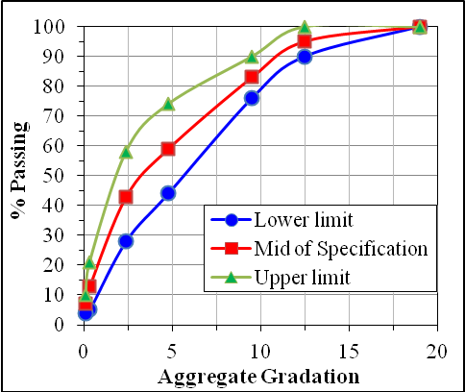
Figure 1. Aggregate gradation
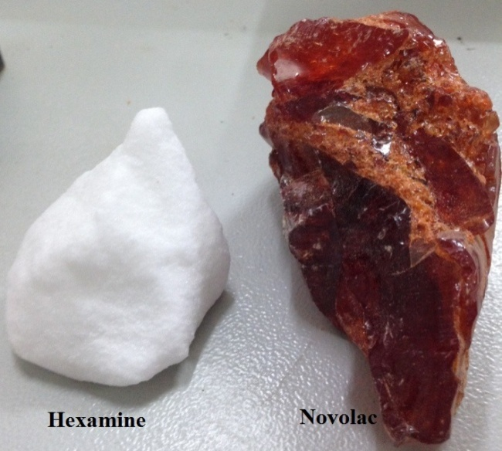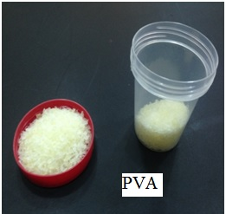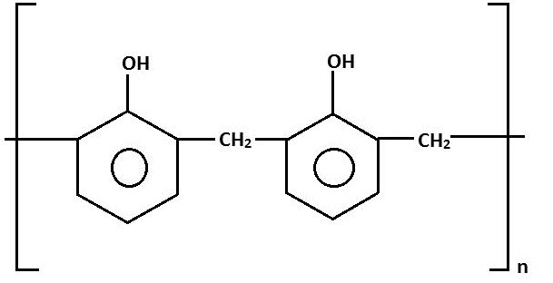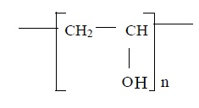
- (b)
Figure 2. Polymers that are used as additives: (a) Novolac , (b) PVA

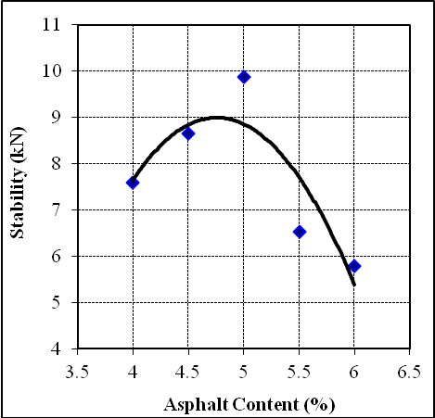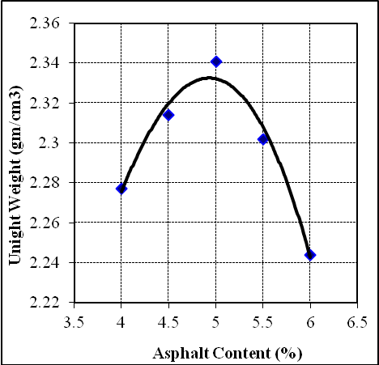
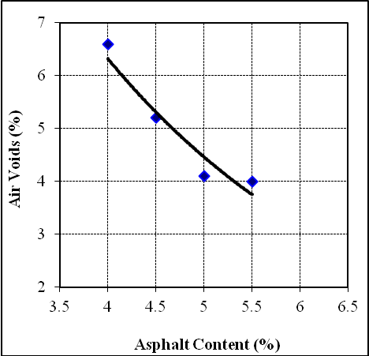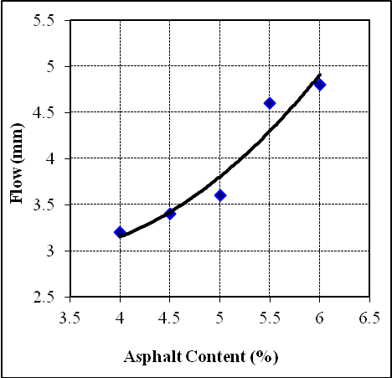
Figure 3. Determination of optimum AC
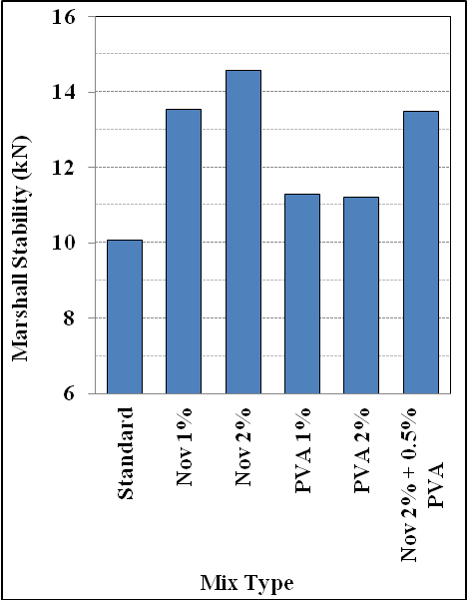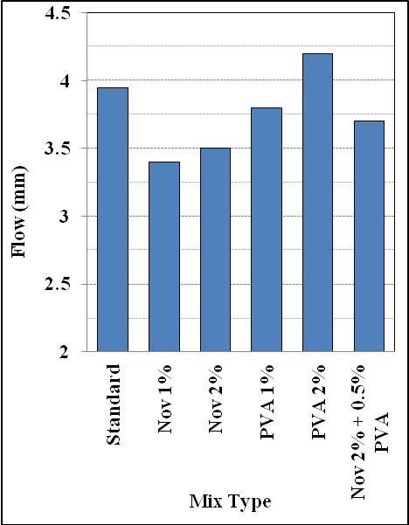
Figure 4. Marshall Stability Figure 5. Marshall Flow
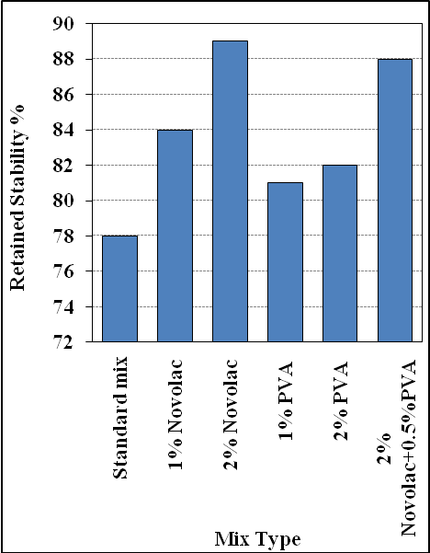
Figure 6. % Retained Stability
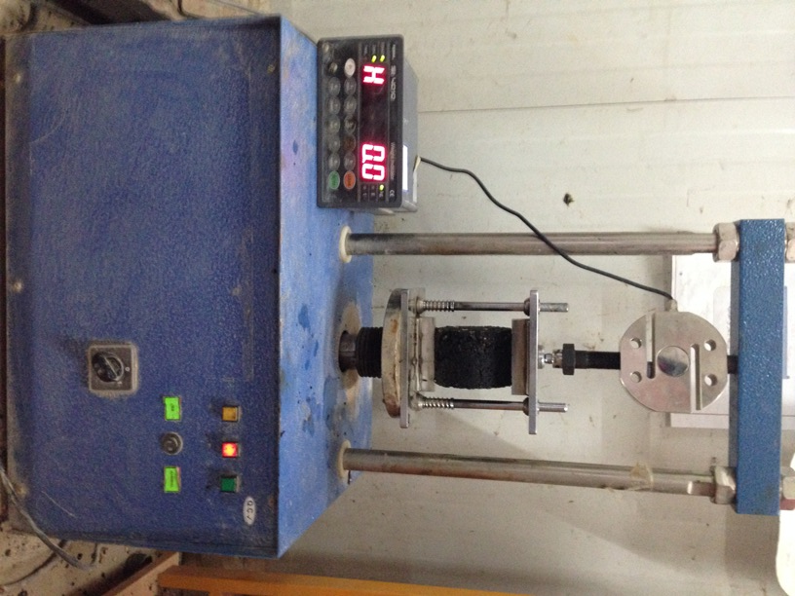
Figure 7. Tensile strength test
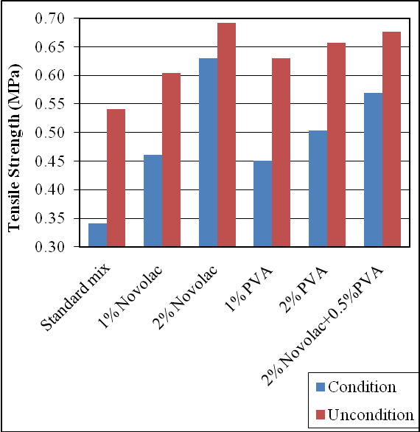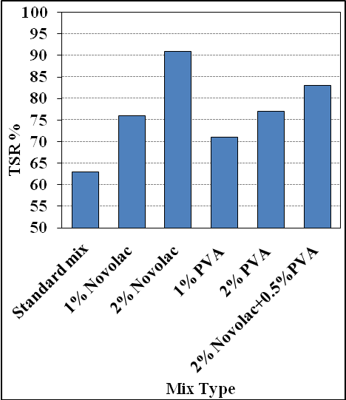
Figure 8. Indirect tensile strength for all mixes Figure 9. TSR for all mixes
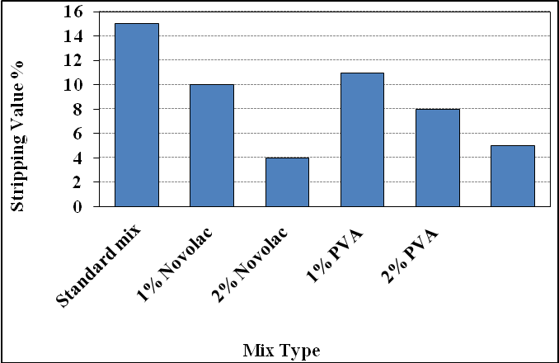
Figure 10. Stripping test results

