Effect of Sulfate in Sand on Some Mechanical Properties of Nano Metakaolin Normal Concrete

Zainab Hashim Abbas Alsallami
Civil Engineering, Al-Mustaqbal University College, Iraq
Z198995@yahoo.com
Abstract
This study aims to obtain the influence of adding Nano metakaolin on some mechanical properties of hardened concrete. Three levels of SO₃ in sand were investigated, these levels were (0.27 (reference SO₃), 0.5 and 1% by weight of fine aggregate). One level of Nano metakaolin replacements (1 % by weight of cement) were used in this work.
Nano metakaolin and SO₃ contents were the only variables among the mixtures. Sulfates had its detrimental effect on properties of concrete. The presence of Nano metakaolin in normal concrete (NC) mixes played a vital role in reducing the deterioration due to sulfates action.
The experimental results show that there is an optimum gypsum content in sand (SO₃ = 0.5% by weight of fine aggregate) which gives the highest results in compressive strength, splitting strength and modulus of elasticity of NC. As gypsum content increases beyond this limit, the above mechanical properties will be decreased.
Keywords: normal concrete, Nano metakaolin, compressive strength, splitting tensile strength, modulus of elasticity.
الخلاصة
تهدف هذه الدراسة إلى الحصول على تأثير اضافة الميتاكؤلين متناهي الصغر على بعض الخواص الميكانيكية للخرسانة المتصلدة. تم التحقق لثلاثة مستويات من الكبريتات في الرمال، وكانت هذه المستويات (0.27 (SO₃ المرجعية)، 0.5 و 1٪ وزنا من الركام الناعم). استخدم مستوى واحد من بدائل الميتاكؤلين متناهي الصغر (10٪ وزنا من الأسمنت) في هذا العمل. كان النانو ميتاكؤلين ومحتوى SO₃ المتغيرين الوحيدين بين الخلطات. كان للكبريتات تأثير ضار على خواص الخرسانه, ولعب النانو ميتاكؤلين في خلطات الخرسانة الاعتيادية (NC) دورا حيويا في الحد من التدهور بسبب تاثير الكبريتات.
واظهرت النتائج التجريبية أن هناك محتوى أمثل للجبس في الرمال (SO₃ = 0.5 ٪ وزنا من الركام الناعم) والذي أعطى أعلى النتائج في مقاومة الانضغاط ومقاومة الشد الانقلاقي ومعامل المرونة من NC. كلما يزداد محتوى الجبس خارج هذا الحد سيتم انخفض الخواص الميكانيكية المذكورة أعلاه.
كلمات المفتاحية: خرسانة اعتيادية, ميتاكؤلين متناهي الصغر, مقاومة الانضغاط, مقاومة الشد الانفلاقي, معامل المرونة.
1.Introduction
Nano metakaolin is supplementary cementitious materials that react with cement in present of water to form cementitious compounds and these materials improve concrete durability, workability and mechanical properties (Joy, 2005).
Morsy at. el., 2008 mentioned that NMK effect as filler into interstitial spaces inside the skeleton of hardened microstructure of cement mortar and thus increasing its density as well as the strength.
A very important problems of concrete manufacture in Iraq and middle east countries because it is difficult to find fine aggregate complying with Iraq specifications for sulfate limits.
Neville, 1995 mentioned that gypsum from different internal sources reacts with tricalcium aluminate (C₃A) to produce ettringite (3CaO.Al₂O₃.3CaSO₄.31H₂O), this product volume greater than the reactants volume. Internal stresses will appear by these volumetric changes which have negative effect on mechanical properties of concrete.
Continuous ettringite formation after concrete hardens is harmful to the concrete structure (Al-Rawi, 1985).
It has been suggested that the surface of pozzolan can adsorb many Ca+2 ions and that lowering of the concentration of the calcium ions accelerates the rate of dissolution of C3S that increases the rate of hydration (Zelic et. al., 2000).
There was an optimum sulfate content in fine aggregate at which the compressive strength was maximum and it decreases beyond this content (Hussain, 2008).The optimum gypsum content in his research was (0.5% by weight of fine aggregates) where his sulfate ratios were (0.16%, 0.5%, 1%, 1.5% by weight of fine aggregates).
The effect of internal sulfates in fine aggregate on compressive strength, splitting tensile strength, and modulus of elasticity was investagated in this work for normal concrete (NC) with adding Nano metakaolin by partial replacement by weight of cement. In this study, the percentages of sulfate in concrete ingredients are obtained by adding natural gypsum to the fine aggregate as a partial substitution by weight of sand.
All specimens were placed in water until the test time and curing time are (28, 60 and 90 days). Percentage of Nano metakaolin that used in this study as partial replacement with cement is (10%) by weight of cement and percentages of sulfates in fine aggregate (by weight of fine aggregate) are (0.27%, 0.5%, and 1.0%).
2. Materials
2-1: Cement:
Ordinary Portland cement (OPC) according to (ASTM C150-Type I) was utilized in this research.
2-2: Fine Aggregate
fine aggregate that utilized throughout this work is brought from AL-Ekhadir region. Results indicate that the grading and sulfate content are conformed to the requirements of (IQS No.45/ 1984).
2-3: Coarse Aggregate
Rounded gravel of 12 mm maximum size from Al-Nebai quarry was used. The coarse aggregate was washed, and then stored in air to dry. The grading and the physical properties of this aggregate agreed with the Iraqi specification (IQS No.45/ 1984).
2-4: Natural Gypsum
The natural gypsum was bringing from Kufa cement factory. It was grinned by the hammer and passed through the same sieve set of fine aggregate used in the mix of internal sulfate attack to avoid the affect of large surface area of particles and used as a partial substitution by weight of sand with limited percentage.
2-5: Nano Metakaolin
Nano metakaolin was imported from English Indian Clays Limited (EICL). The Nano metakaolin used in this work conforms to the requirements of (ASTM C618, 2002) Class N pozzolan. Plate (1) shows Nano Metakaolin powder that used in this study.

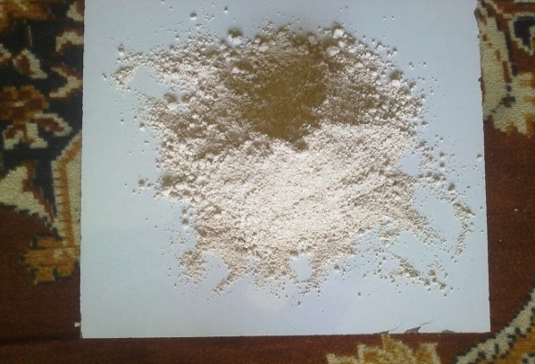

Plate (1) Nano Metakaolin
3. Experimental Work
3-1: Concrete Mixes
In order to achieve the scopes of this study, the total of 6 NC mixtures were made, all based on the same control mixture. Table (1) provides the proportions of the reference mixture, from which all other mixtures were developed. The mix proportions and w/p ratio kept constant for all mixes, the only variations in the mixture were the Nano metakaolin contents and SO₃ contents in sand so as to investigate only the effect of sulfates on NC with various Nano metakaolin contents on its properties in hardened state and compared its behavior with the behavior of plain NC. The ratio of w\p was 0.5 to give slump 80 ±10 %.
Curing time was for three ages (28, 60, 90) days. Table (2) shows concrete mix designations.
Table (1) Proportions of reference mixture
Material | Amount
Cement (kg/m³) | 450
Water (L/m³) | 230
Sand (kg/m³) | 650
Gravel (kg/m³) | 970
w/c or w/p | 0.5

Table (2) Concrete mix designations
Mix No. | Mix symbol | So₃%by weight of sand | Nano-metakaolin (%by weight of cement)
1 | M1 | 0.27% | Mix without (NMK)
2 | M 2 | 0.27% | Mix with 10% of (NMK)
3 | M 3 | 0.5% | Mix without (NMK)
4 | M 4 | 0.5% | Mix with 10% of (NMK)
5 | M 5 | 1% | Mix without (NMK)
6 | M 6 | 1% | Mix with 10% of (NMK)

3-2: Hard Concrete Properties
The mechanical properties studied were compressive strength, splitting tensile strength and static modulus of elasticity. The compressive strength test was performed in accordance with (BS.1881:Part 116:1989), the splitting tensile strength test was carried out according to (ASTM C496-2004) and the static modulus of elasticity test was performed in accordance with (ASTM C469-2002).
Average of three (150x150x150mm) cubes were used for compressive strength test, average of three (100x200mm) sylinders were used for splitting tensile strength test and average of two (150x300mm) sylinders were used for modulus of elasticity test.
4. Result and Discussion
4-1: Compressive Strength
Table (3) shows the average of the results of compressive strength at 28, 60 and 90 days gained from cubes. The results indicated that the optimum SO₃ content for mixes is about (0.5% by weight of fine aggregate), beyond this optimum value the compressive strength decreased with the increase of sulfates content for all mixes, at all ages of test.
The increase percentage in copressive strength due to add Nano metakaolin replacements were (25.71, 17.5 & 11.63%) at ages (28, 60 & 90) days respectively for mixes with (SO₃ 0.27% by weight of fine aggregate) in fine aggregate. While for mixes with (SO₃ 0.5% by weight of fine aggregate) in fine aggregate, these increases were (26.32, 19.05 & 15.91 %) at ages (28, 60 & 90) days respectively . Finally the increases were (21.88 ,10.53 &7.32 %) for mixes with (1% SO₃) (% by weight of fine aggregate) in fine aggregate at ages (28, 60 & 90 ) days respectively .
it was clear from the results that the compressive strength increased with adding Nano metakaolin at all mixes and at all ages.
That improves in the compressive strength of concrete due to the more consumption of Ca(OH)₂, better pore refinement, micro filling action, early gain of strength, higher pozzolanic reaction. (Naji, 2011).
The effect of increasing SO₃ content on compressive strength is shown in figures (1, 2 & 3) at ages (28, 60 & 90) respectively. Plate (2) explains compressive strength test.

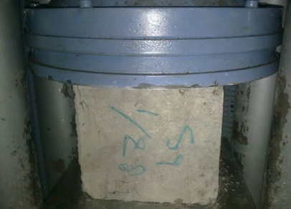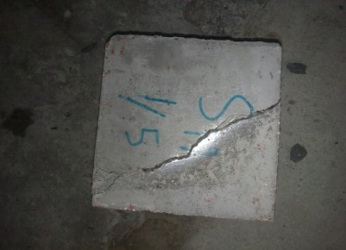
Plate (2): compressive strength test

4-2: Splitting Tensile Strength
Table (3) shows the average of the results of splitting tensile strength at 28, 60 and 90 days gained from sylinders. The results indicated that the optimum SO₃ content for mixes was about (0.5%) (% by weight of fine aggregate), beyond this optimum value the splitting tensile strength decreased with the increase of sulfates content for all mixes, at all ages of test. The increase percentage in splitting tensile strength due to add Nano metakaolin were (24.32,17.77 & 15.10%) at ages (28 ,60 & 90) days respectively for mixes with (0.27% SO₃ ) (% by weight of fine aggregate) in fine aggregate, but for mixes with (0.5% SO₃) (% by weight of fine aggregate) in fine aggregate, this increase was (25.87, 24.00 & 23.17%) at ages (28 ,60 & 90 ) days respectively . lastly the increase was (14.29,15.45 & 16.71%) for mixes with (SO₃ 1% by weight of fine aggregate) in fine aggregate at ages (28 ,60 & 90) days respectively.
The results indicated also that all specimens exhibited a continuous increase in splitting tensile strength with progress in age because the NMK enhanced the interfacial transition zone of hardened cement mortar by two mechanisms, its finess and its chemical composition.
The effects of increasing SO₃ content on splitting tensile strength are shown in figures (4,5 & 6) at ages (28, 60 & 90) respectively.
4-3: Modulus of Elasticity
Table (3) shows the results of modulus of elasticity at 28, 60 and 90 days. The results indicated that the optimum SO₃ content for mixes was about (0.5%) (% by weight of fine aggregate), beyond this optimum value the modulus of elasticity decreased with the increase of sulfates content for all mixes, at all ages of test. The results indicated also that all specimens exhibited a continuous increase in modulus of elasticity with progress in age. The increase percentage in modulus of elasticity due to add Nano metakaolin were (32,29.63 & 28.57%) at ages (28, 60 & 90) days respectively for mixes with (SO₃ 0.27% by weight of fine aggregate) in fine aggregate, but for mixes with (SO₃ 0.5% by weight of fine aggregate) in fine aggregate, this increase was (33.33, 31.03 & 30.00%) at ages (28, 60 & 90 ) days respectively . Ultimately the increase was (30.43, 28.00 & 26.92%) for mixes with (SO₃ 1% by weight of fine aggregate) in fine aggregate at ages (28, 60 & 90 ) days respectively
It was clear from the results that the modulus of elasticity increased with adding Nano metakaolin at all mixes and at all ages, this was agreement with (Alsallami, 2013).
The effects of increasing SO₃ content on modulus of elasticity are shown in figures (7, 8 & 9) at ages (28, 60 & 90) respectively. Plate (3) explains modulus of elasticity test.

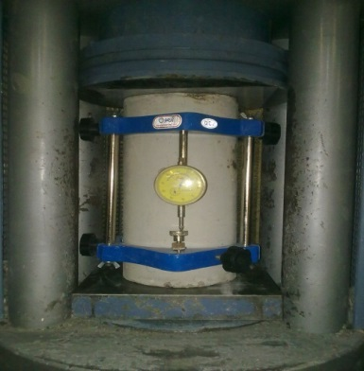
Plate (3) modulus of elasticity test

Table (3) Result of compressive strength, splitting tensile strength and modulus of elasticity tests
Mixes | So₃%by weight of sand | Nano-metakaolin (%by weight of cement) | Compressive strength (MPa) |  |  | Splitting tensile strength  (MPa) |  |  | Modulus of elasticity  (GPa)
Mixes | So₃%by weight of sand | Nano-metakaolin (%by weight of cement) | 28  Day | 60  Day | 90  Day | 28  Day | 60  Day | 90  Day | 28  Day | 60  Day | 90  Day
M1 | 0.27 | 0 | 35 | 40 | 43 | 3.7 | 3.94 | 4.04 | 25 | 27 | 28
M2 | 0.27 | 10 | 44 | 47 | 48 | 4.6 | 4.64 | 4.65 | 33 | 35 | 36
M3 | 0.5 | 0 | 38 | 42 | 44 | 3.75 | 4.00 | 4.10 | 27 | 29 | 30
M4 | 0.5 | 10 | 48 | 50 | 51 | 4.72 | 4.96 | 5.05 | 36 | 38 | 39
M5 | 1 | 0 | 32 | 38 | 41 | 3.50 | 3.56 | 3.59 | 23 | 25 | 26
M6 | 1 | 10 | 39 | 42 | 44 | 4.00 | 4.11 | 4.19 | 30 | 32 | 33

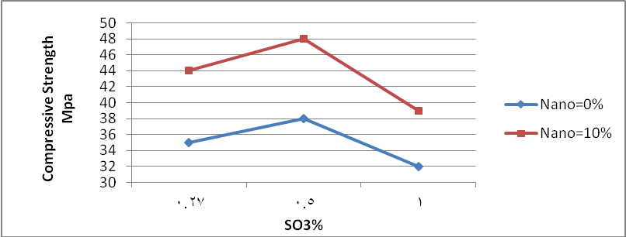

Figure (1): Effect of icreasing SO₃ content on compressive strenght at 28 days

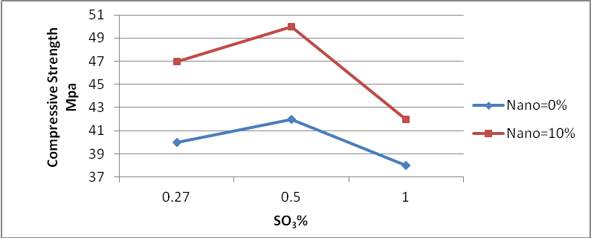

Figure (2): Effect of icreasing SO₃ content on compressive strenght at 60 days

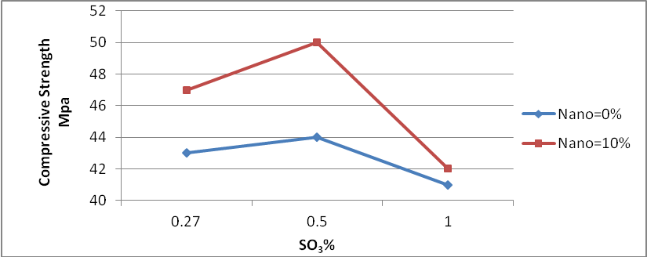

Figure (3): Effect of icreasing SO₃ content on compressive strenght at 90 days

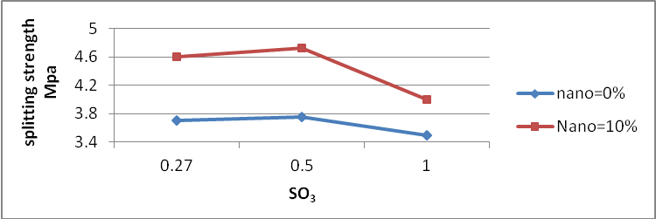

Figure (4): Effect of icreasing SO₃ content on splitting tensile strenght at 28 days

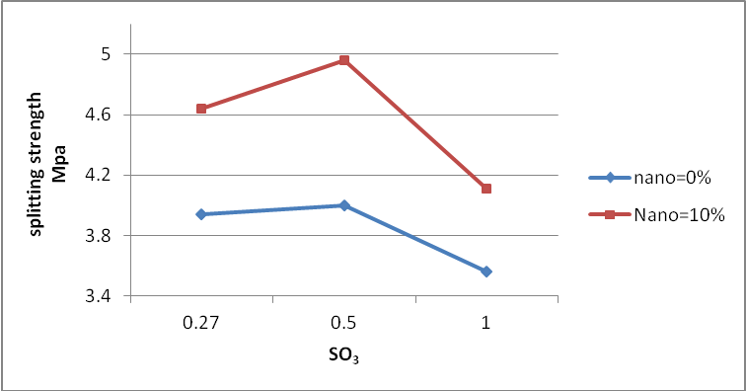

Figure (5): Effect of icreasing SO₃ content on splitting tensile strenght at 60 days

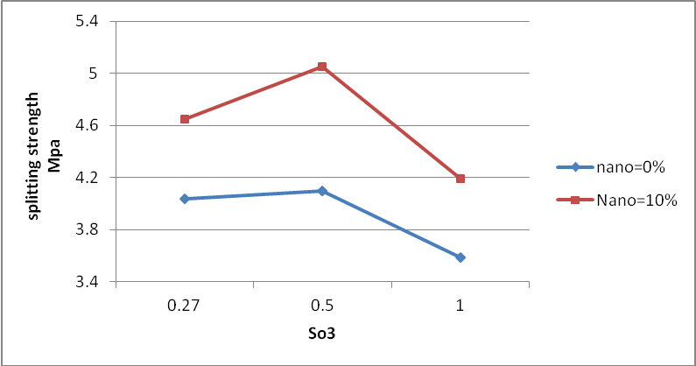

Figure (6): Effect of icreasing SO₃ content on splitting tensile strenght at 90 days

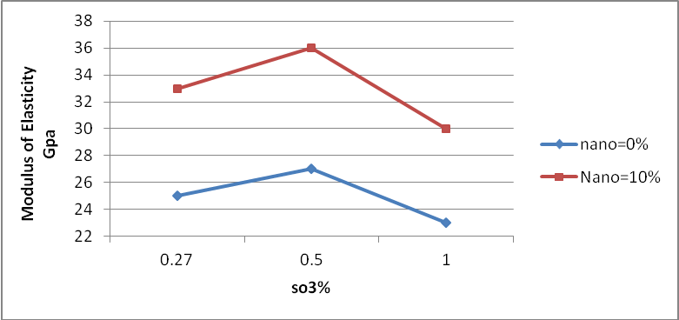

Figure (7): Effect of icreasing SO₃ content on modulus of elasticity at 28 days

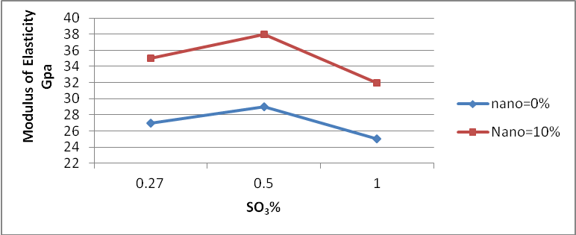

Figure (8): Effect of icreasing SO₃ content on modulus of elasticity at 60 days

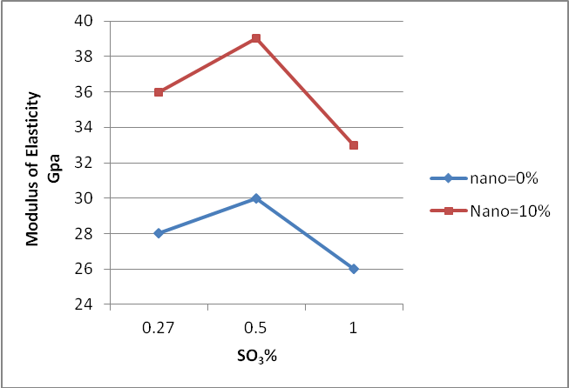

Figure (9): Effect of icreasing SO₃ content on modulus of elasticity at 90 days

5. Conclusions
- The optimum SO₃ content, at which a higher mechanical properties was equal to (0.5% by weight of fine aggregate).
- The presence of sulphates in sand of NC (higher than 0.5 % SO₃ by weight of sand) decreases compressive strength, splitting tensile strength and modulus of elasticity.
- Mixes without Nano metakaolin are less resistant than mixes with Nano metakaolin that means Nano metakaolin played actual role to improve restant of mixes to internal sulfate attack.
- The increase percentage in copressive strength due to add Nano metakaolin was (26.32%) at age 28 days for mixe with (0.5% SO₃ by weight of sand), The increase percentage in splitting tensile strength due to add Nano metakaolin was (25.87%) at age 28 days for mixe with (0.5% SO₃ by weight of sand) and the increase percentage in modulus of elasticity due to add Nano metakaolin was (33.33%) at age 28 days for mixe with (0.5% SO₃ by weight of sand).
- All mixes were increasing in compressive strength, splitting tensile strength and modulus of elasticity with progressive in age.
6. Recommendations
- Study the resistance of Nano metakaolin normal concrete to internal sulfate attack by using sulfate resisting Portland cement.
- Research to study the effect of sulfates on the other hardened properties of normal concrete such as ultrasonic pulse velocity, length change, impact strength, dynamic modulus of elasticity, toughness, ductility and microstructure of the damaged concrete by X-ray diffraction.
- Research to study the resistance of Nano metakaolin normal concrete to thaumasite attack.
- Research to study the durability of Nano metakaolin normal concrete exposed to both internal and external sulfate attack.
- Study the resistance of normal concrete containing different level of Nano metakaolin replacement.
References
Al-Rawi R.S.,1985,“Internal sulfate attack in concrete related to gypsum content of cement with pozzolan addition“, ACI-RILEM, Joint Symposium, Monterey, Mexico, pp. 543.
Alsallami Zainab,2013,"The Effect of Sulfate in Sand on Some Mechanical Properties of Nano Metakaolin Self compacting concrete", M.Sc. Thesis, Babylon University, Iraq.
ASTM C150, 2005,''Standard Specification for Portland Cement'', American Society for Testing and Materials.
ASTM C469,2002,''Standard Test Method for Static Modulus of Elasticity and Poisson's Ratio of Concrete in Compression'', American Society for Testing and Materials.
ASTM C496,2004,''Standard Test Method for Splitting Tensile Strength for Cylindrical Concrete Specimens'', American Society for Testing and Materials.
ASTM C618,2002,''Standard Specification for Coal Fly Ash and Raw or Calcined Natural Pozzolan for Use in Concrete'',American Society for Testing and Materials.
BS 1881:Part 116,1989,''Method for Determination of Compressive Strength of Concrete Cubes'', British Standards Institution.
Hussain, T.H., 2008,"Effect of sulfates in fine aggregate on some mechanical properties of self-compacting concrete", M.Sc. Thesis, University of Babylon.
Iraqi Specification, No.45/1984,''Aggregate from Natural Sources for Concrete and Construction''.
Joy,M.Justice,2005,"Evaluation of Metakaoline for Use as Supplementary Cementitious Material", MSc., thesis, The Academic Faculty, Malaysia, pp.(1,2,4).
Morsy, M. S., Al-Sayed, S.H., and Aqel, M.,2008,"effect of Nano-clay on Mechanical properties and Microstructure of ordinary Portland cement Mortar", International Journal of Civil & Environmental Engineering IJCEE –IJENS VOL: 10N:01, Egypt.
Naji, Z. H., 2011,"The Effect of Nano Metakaolin Material on Some Properties of Concrete", M.SC. thesis, Technology University.
Neville, A.M, 1995,"Properties of Concrete", Fourth and Final Edition, Wiley, New York and Longman, London.
Zelic J., rusic, D.,veza, D., krstulovic, R., 2000,"The role of silica fume in the kinetics and mechanisms during the early stage of cement hydration" Cement and Concrete Research.30: 1655-1662.

