Modified Fault Diagnosis Method For Power Transformers Using Fuzzy Logic Technique
Ali A. Albakry
Technical College - Almusyeib / Electrical Power Engineering Techniques

Abstract
The most commonly diagnosis method for power transformer faults is the dissolved gas analysis (DGA) of transformer oil. Although various methods have been developed to interpret DGA results such as IEC gas ratio code method, and key gas method, they sometimes fail to determine the faults. Although Dissolved Gas Analysis (DGA) has widely been used in ‘the industry, but in some cases, this conventional method fail to diagnosis. This normally happens for those transformers which have more than one type of fault. Also, in some cases, the DGA results cannot be matched by the existing codes making the diagnosis unsuccessful in multiple faults.
This paper presents integration between software Programming using fuzzy logic technique (intelligent technique) and IEC gas ratio code (classical technique) to diagnose multiple faults in a transformer. This modified approach is recommended for fault transformer diagnosis and the advisable actions to be taken. It has been proved to be a very useful tool for transformer diagnosis and maintenance planning. For instance, in fact, the gas ratio boundary may not be clear, especially when more than one type of fault exist. Therefore, between different types of faults, the code should not change sharply across the boundaries. The proposed method has been implemented using C⁺⁺, version 6.0 language, where several case studies are tested.
الخلاصة
الطريقة الأكثر شيوعا لتشخيص الأعطال في محولات القدرة الكهربائية تتم بواسطة تحليل الغاز المذاب في زيت المحولات (DGA) و لكن هذه الطريقة التقليدية تفشل في بعض الاحيان في تشخيص العطل. على الرغم من ذلك فأن هناك طرق عديدة تم تطويرها لمحاكاة نتائج طريقة (DGA), مثل طريقة ترميز النسب الغازية (IEC) و طريقة المفتاح الغازي و رغم ذلك فان هذه الطرق تفشل ايظا عند تشخيص بعض انواع الاعطال التي تحدث في هذه المحولات. على الرغم من ان طريقة تحليل الغاز المذاب في زيت المحولات (DGA) تستخدم بصورة واسعة صناعيا فأنها تفشل في بعض الاحيان في تشخسص العطل. هذا يحصل طبيعيا عندما تتعرض المحولة لأكثر من نوع واحد من الأعطال, لذا فأن التشخيص بهذه الطريقة لايعطي النتائج الصحيحة. اضافة لذلك فان التشخيص بهذه الطريقة في بعض الاحيان لا يتطابق مع بعض الرموز الموجودة فعليا و يتسبب هذا بنتائج غير صحيحة. يعرض هذا البحث طريقة معدلة تنتج عن التكامل بين التقنيات البرمجية باستخدام منطق ضبابي (تقنية ذكية) و طريقة ترميز النسب الغازية IEC (الأسلوب الكلاسيكي) لتشخيص اعطال متعددة في المحولات. هذا النهج او المقاربة المعدلة مطلوبة لتشخيص اعطال المحولات التي تحث فيها مثل هذه الحالات فهي اضافة لتشخيص العطل فانها تعطي التوصية المطلوبة الواجب اتخاذها عند المعالجة. وقد اثبتت هذه الطريقة جدارتها لتشخيص انواع مختلفة من الاعطال اضافة لفائدتها في تخطيط الصيانة من خلال التوصيات المعطاة لتكون أداة مفيدة جدا. على سبيل المثال ، في الواقع ، أن حدود النسبة الغازية لا يكون واضحا ، وخصوصا عندما يكون هنالك أكثر من نوع واحد من ألأعطال موجود في المحولة ولذلك ، بين أنواع مختلفة من ألأعطال ، ينبغي أن لا يتغيير الرمز بحدة عبر الحدود. الطريقة المقترحة قد نفذت باستخدام لغة C⁺⁺ الإصدار 6.0 ، حيث تم اختبار و دراسة العديد من الحالات.
1- Introduction
The distribution part in any electrical power system represents 70% of all the system, while the main part in any distribution system is the power transformers, so the power transformers are the most important key elements in any power system [Stevenson, 1982]. Failure of one power transformer may causes long interruptions in supply, costly repairs and loss revenue., Various techniques both on-line (i.e. winding vibration, acoustic measurement of corona, temperature monitoring, gas in oil monitoring using Hydran and DGA) and off-lint (i.e. PD, transfer function, recovery voltage measurements, DP and furan analysis of cellulose insulation) do exist to assist in condition assessment of power transformers. Among these techniques, the dissolved gas in oil analysis technique is quite simple, non-intrusive and inexpensive method. The conventional diagnostic methods are based on the ratio of gases generated from a single fault or from multiple faults but with one of dominant nature in a transformer [Dukarm, 1993] . When gases from more than one fault in a transformer are collected, the relation between different gases becomes too complicated which may not match the codes predefined. For instance, the IEC codes are defined from certain gas ratios. When the gas ratio increases across the defined Limits (boundaries), the code changes suddenly between 0, 1 and 2. In fact, the gas ratio boundary may not be clear (i.e. ambiguous or fuzzy), especially when more than one type of fault exist [Zhang, 1996]. Therefore, between different types of faults, the code should not change sharply across the boundaries. This paper is organized as follows: after the introduction, dissolved gas analysis (DGA) will explain , IEC Code ratio method explained with its tables , Fuzzy IEC Codes Integration method structures (FIEC) demonstrated , result and Diagnosis Example are taken and the conclusion for the work .

2- Dissolved Gas Analysis (DGA)
Most of power transformers are filled with oil that serves several purposes. The oil acts as dielectric media which is an insulator and as heat transfer agent. During normal use, there is usually slow degradation of the mineral oil to yield certain gases that dissolve in the oil. However, when an electrical fault happens inside the transformer, the oil start to degrade and temperature will rise abnormally which generate various gases at rapid rat . To begin, consider the widely used chemical test for power transformers of insulating oil called dissolved gas analysis (DGA). The DGA method as it is commonalty known is one of the most accepted methods for detecting incipient fault condition in power transformers [Hooshmand and Banejad, 2006; Zhang, 1996].
There are several ways to diagnosis the transformer fault using the DGA method which include the key gas Analysis , Rogers Ratio Method, IEC gas ratio code , Doernenberg Ratio Method , Duval Method , etc. All these methods are quite similar where different patterns and concentration of gases are matched with the fault types [Haupert et al., 1989]. Among these methods the Key Gas Method and Rogers Ration Method are the most popular [Rogers, 1978] .The Chromatographic analysis of the insulation oil shows that it contains concentrations (PPM in volume) of dissolved hydrogen (H₂),methane(CH₄),ethane (C₂H₆),ethylene (C₂H₄),acetylene (C₂H₂),carbon monoxide (CO),and carbon dioxide (CO₂). DGA techniques can determine the condition of the transformers according to the concentration of the dissolved gases, their generation rate, ratios of specific gases, and the total amount of combustible gas in the oil [Haupert et al., 1989].

3- IEC Gas Ratio Code
In dissolved gas analysis, the IEC codes (International Electric Committee) have been used for several decades and considerable experience accumulated throughout the world to diagnose incipient faults in transformers [Rogers, 1978; Senior et al., 2000]. Early interpretations were concentrated on specific gas components such as hydrogen and methane for the determination of discharges in the oil. The ratios of certain gases to establish more comprehensive diagnostic techniques [Haupert et al., 1989, Jakob, 1989]. These techniques were standardized by IEC in 1978 in “Guide for Interpretation of the Analysis of Gases in Transformer and Other Oil Filled Electrical Equipment in Service” .The individual gases used to determine each ratio and its assigned limits are shown in Tables (1) and (2). Codes are then allocated according to the value obtained for each ratio and the corresponding fault characterized [Rogers, 1978; Senior et al., 2000].

Table (1): IEC Ratio Codes [Senior Su.Q, et al., 2000]
IEC Code
Sharply Defined range of the gas ratio | Codes of different gas ratios
 | C₂H₂/ C₂H₄ | CH₄/H₂ | C₂H₄/C₂H₆
< 0.1 | 0 | 1 | 0
0.1 - 1 | 1 | 0 | 0
1 - 3 | 1 | 2 | 1
> 3 | 2 | 2 | 2

Table (2): Fault classification according to the IEC Gas Ratio Codes [Senior Su.Q, et al., 2000]
No | Fault type | C₂H₂/ C₂H₄ | CH₄/H₂ | C₂H₄/C₂H₆
0 | No Fault | 0 | 0 | 0
1 | Partial discharges of low energy density | 0 | 1 | 0
2 | Partial discharges of high energy density | 1 | 1 | 0
3 | Discharges of low energy | 1or 2 | 0 | 1or 2
4 | Discharges of high energy | 1 | 0 | 2
5 | Thermal Fault of low temperature <150 ⁰C | 0 | 0 | 1
6 | Thermal Fault of low temperatures  150-300 ⁰C | 0 | 2 | 0
7 | Thermal Fault of medium temperatures  300-700 ⁰C | 0 | 2 | 1
8 | Thermal Fault of high temperatures  > 700 C | 0 | 2 | 2

Although IEC code method is useful for the assessment of transformer insulation, no quantitative indication for the possibility of each fault is given. Also, in some cases, the DGA results cannot be matched by the existing codes making the diagnosis unsuccessful [Duval, 1989]. In multiple fault conditions, gases from different faults are mixed up resulting in confusing ratios between different gas components. This could only be dealt with by the aid of more sophisticated analysis methods such as the fuzzy diagnosis method presented in this paper.

4 -Fuzzy IEC Codes Integration method structures (FIEC)
The diagnosis is based on the predominant dissolved gases and their proportions relative to Total Dissolved Combustible Gas (TDCG). TDGA is the sum of the concentration of Hydrogen, Methane, Ethane, Ethylene, Acetylene, and Carbon Monoxide dissolved in oil. The absolute dissolved gas concentration (in PPM) and generation rates (PPM /DAY) are used to judge the severity of any faults identified. For example according to [Huang,2003] and [Domerberg et al., 1974] if the absolute level of TDCG is over 720 PPM and consists about 63%of ethylene, then there is an indication of overheated oil. Close monitoring is advised if the TDCG generation rate exceeds 10 PPM/DAY. Table (3) shows the gases concentrations in PPM for dissolved key gases method.

Table (3): Concentration (PPM) for dissolved key gases

Danger level | Hydrogen | Methane | Acetylene | Ethylene | Ethane | Carbon  Monoxide | Carbon  Dioxide
Normal | 100 | 120 | 35 | 50 | 65 | 350 | 2500
Moderate | 101 - 700 | 121 - 400 | 36 - 50 | 51 - 100 | 66 - 100 | 351 -570 | 2500-4000
High | 701 - 1800 | 401 -1000 | 51 -80 | 101-200 | 101-150 | 571-1400 | 4001-1000
Severe | $$\text{1800}$$ | $$\text{1000}$$ | $$\text{80}$$ | $$\text{200}$$ | $$\text{150}$$ | $$\text{1400}$$ | $$\text{10000}$$
*PPM : Part Per Million

The general structure for this method is demonstrated in Figure (1).

Calculate Gases Ratios
R1= C2H2/C2H4
R2= CH4/H2
R3= C2H4/C2H6
H₂
CH₄
C₂H₄
C₂H₂
C₂H₆
R₃
R₂
R₁
TDCG
Normal
Abnormal
IEC Code Method
F₂(i)
Fuzzy IEC Code Method F₁(i)
F(i)= αF₁(i)+ βF₂(i)
Fault Type and maintenance
Figure1: Block diagram of diagnostic approach

Output screen
(The Transformer is OK)
Figure (1): Block diagram of diagnostic approach

According to the IEC codes in Table (1), the three gas ratios (C₂H₂/C₂H₄, CH₄/H₂ and C₂H₄/C₂H₆) can be coded as 0, 1 and 2 for different ranges of ratios. Table (1) is rearranged to give a clear relationship between the ranges of each gas ratio and the corresponding IEC code, as shown in Table (4).

Table (4): The rearranged IEC codes [Senior Su. Q. et al., 2000]
Code 2 | Code 1 | Code 0 | Ratio – Code
<3 | 0.1-3 | <0.1 | C₂H₂/C₂H₄
>1 | 0.1> | 0.1-1 | CH₄/H₂
3< | 1-3 | 1> | C₂H₄/C₂H₆

According to Table (2). Transformer faults can be identified by the IEC codes of three gas ratios (R₁= C₂H₂/C₂H₄, R₂= CH₄/H₂, R₃= C₂H₄/C₂H₆) For example, if the codes for a set of gas concentration are R₁=0, R₂=2 and R₃=1, the transformer is diagnosed to have a No.7 fault, (i.e. thermal fault of medium temperature 300 - 700'c.). In the IEC code diagnosis, actually the conventional logic (AND) and (OR) are used. For example, the seventh fault is represented by:

F(7) = code _{zero}(R₁) AND code _{Two} (R₂) AND code _{One}(R₃)

Where code _{zero}(R₁), code _{Two} (R₂) and code _{One}(R₃)are the coded values of gas ratio R₁,R₂ & R₃ respectively. They are either one (true) or zero (false) according to Table (3). Therefore, fault F(7) will be either one (true) or zero (false) by means of logic operation. Also (α and β) are random probability (0 to 1) and the best value are (0.73 and 0.27) respectively (trail and error method). In the fuzzy diagnosis method developed, however, the IEC codes 0, 1 and 2 are reconstructed as fuzzy sets ZERO, ONE and TWO. Each gas ratio r can be represented as a fuzzy vector [µ _{ZERO} (R₁), µ_{ONE} (R₁) , and µ _{TWO} (R₁) ].Where:
µ _{ZERO} (R₁), µ_{ONE} (R₁), and µ _{TWO} (R₁) are the membership functions of fuzzy code ZERO, ONE and TWO respectively.
The input for FIEC method calculated from the chromatographic. Data to diagnose 8 conditions. Since 5 values of different gases are input to this method (Methane, Hydrogen, Acetylene, Ethylene, and Ethane) and the three features are ratios of gas concentrations:
MH = methane / hydrogen
AE = acetylene / ethylene
EE = ethylene / ethane
These three features, MH, AE, and EE are classified as low (low), medium (med), and high (hi) according to their membership in intervals as follows:
MH =low: Any value below 0.1.
MH = med: Between 0.1 and 1 .0
MH=hi : Above 1.0.
AE=low: Below 0.1.
AE=hi : Between 0.1 and 3.0.
EE=low: Below 1.0.
EE=med: Between I .0 and 3.0.
EE=hi : Above 3.0.
The IEC Codes Ratio method matches certain combinations of input classifications with diagnostic outcomes as shown in Table (5). The diagnoses are:
OK: Unit normal.
PD: Partial discharge.

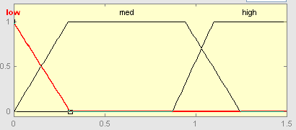
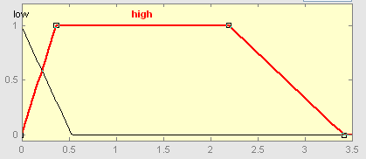
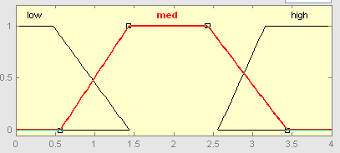
Methane / Hydrogen

Figure (2): Fuzzy memberships functions for Classifying Methane/Hydrogen ratio .
Acetylene / Ethylene

Figure (3): Fuzzy memberships functions for Classifying Acetylene/Ethylene ratio .
Ethylene/ Ethane

Figure (4): Fuzzy membership functions for classifying Ethylene/Ethane ratio
Membership
Membership
Membership
.

TL: Low-temperature thermal
TM : Medium-temperature thermal (below 700 C).
TH : High-temperature thermal (above 700 C).
ARC: Arcing.

Table (5): IEC code ratio table
 |  | EE=low | EE=med | EE=high
MH=low | AE=low | PD | ---- | ----
MH=low | AE=high | ---- | ---- | ----
MH=med | AE=low | OK | TL
MH=med | AE=high | ---- | ---- | ARC
MH=high | AE=low | ---- | TM | TH
MH=high | AE=high | ---- | ---- | ---

For the enhanced IEC method, the input classifications MH=L, AE=H, and so on are given confidence factors calculated as the degree of membership of the gas ratio in fuzzy versions of the intervals shown above. Then the rules implicit in Table 4 are applied to derive confidence factors for all the IEC diagnoses [IEEE Std. C57, 1992]. The fuzzy membership functions for IEC input classifications are graphed in Figure (2) for MH, figure (3) for AE., and figure (4) for EE. To ensure consistency with the standard IEC method, the membership functions of the fuzzy intervals are defined so that they equal 0.5 at the endpoints of the corresponding "crisp" intervals. This ensures that the cf of a diagnosis is greater than 0.5 if and only if the standard Rogers method produces that diagnosis. Since the cf is only a rough "strength of assertion" indicator and not a probability, the exact shape and width of the membership function graphs is not critical [IEEE Std. C57, 1992].

5 -Result and Diagnosis Examples
The fuzzy systems described above were implemented in computer software using C++ program and tested on historical practical examples supplied by industrial clients. A few of them are presented here.

Practical Example - 1:
A 132/66 kV 18 MVA transformer is in service for (41) year. Transformer oil volume is 21UOO 1. This transformer developed a serious power arc between top of HV coil and coil clamping ring. DGA data obtained in PPM after the fault are as shown in Table (6), [Islam S. M., et al., 2000]. While figure (5) illustrate the output program results.

Table (6): Transformer DGA data obtained in PPM after fault
Gas Symbol | CH₂ | C₂H₆ | C₂H₄ | C₂H₂ | H₂
Value (in ppm ) | 13 | 5 | 43 | 319 | 24

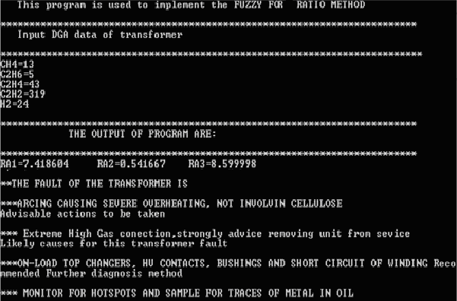
Figure (5): C⁺⁺ Execution Screen Program of transformer -1

From Figure (5): The program inputs are 5 gases values in PPM and the outputs are:
- Gases ratios (since RA1= C₂H₂/C₂H₄, RA2= CH₄/H₂, and RA₃= C₂H₄/C₂H₆)
- The fault of the transformer is:
**Absolutely yes in arcing causing server overheating, and not involve cellulose
- Advisable actions to be taken
**Extreme High Gas concentration, strongly advice removing unit from service
- Likely causes for this transformer fault
**on –load top changers, HV contacts, Bushing and short circuit of winding
- Recommended further diagnosis method
** Monitor for hotspots and sample for traces of metal in oil

Practical Example -2:
The first example is the one cited in the [IEEE Std. C57, 1992] IEEE DGA standard, where several abnormal gas levels are observed here for the following two cases:

Case One:
The input DAG data obtained in PPM after fault for this transformer is shown in Table (7). While Figure (6) illustrates the C⁺⁺ Execution Screen Program output results of case one.

Table (7): Transformer DGA data obtained in PPM after fault
Gas Symbol | CH₄ | C₂H₆ | C₂H₄ | C₂H₂ | H₂
Value (in ppm ) | 6 | 1 | 15 | 0 | 0

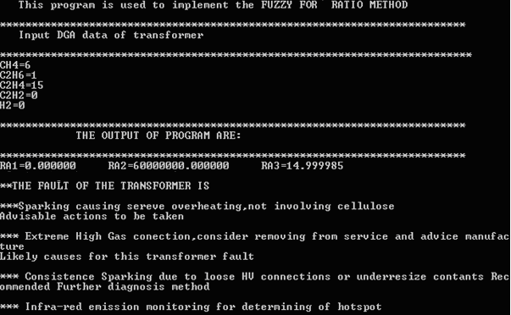

Figure (6): C⁺⁺ Execution Screen Program of case one

Case Two:
In this case, the input DAG data obtained in PPM after fault for this transformer is shown in Table (8). While figure (8) illustrates the C⁺⁺ Execution Screen Program output results of case two.

Table (8): Transformer DGA data obtained in PPM after fault

Gas Symbol | CH₄ | C₂H₆ | C₂H₄ | C₂H₂ | H₂
Value (in ppm ) | 17 | 5 | 3 | 0 | 192

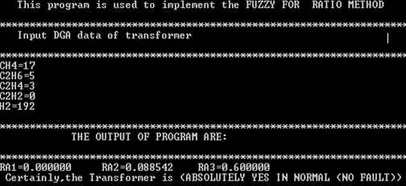

Figure (8): C⁺⁺ Execution Screen Program of case two

The transformer is tested under two cases, in case (1) the transformer has a sparking fault which causing severe overheating but for case (2) the transformer is in normal case (no fault).

6 - Conclusions
The IEC code method developed and implemented for many cases in this paper, and has been successfully used for the diagnosis of several faults in different transformers. It has been proved that using the fuzzy diagnosis method, more detailed information about the faults inside a transformer can be obtained in addition to providing enhanced information for the maintenance engineer while remaining faithful to the original method.
The enhancements in the conventional IEC code method are due to the more realistic representation of the relationship between the fault type and the dissolved gas levels with fuzzy member ship function as shown in the output results, where in addition to determining the fault in transformer, the recommended and the advisable actions are demonstrated in the program for this method. Also, the multiple faults can be diagnosed using this method, while, it may not be possible for any conventional method.

7- References
Domerburg E., Strittmatter W., 1974, "Monitoring oil cooling transformers by gas analysis”, Brown Boveri Review, vol 61. 238-247.
Dukarm, J. J. 1993, "Transformer Oil Diagnosis Using Fuzzy and Neural Networks", Canadian Conference on Electrical and Computer Engineering, Canada, 170-175.
Duval, M., 1989, "Desolved gas analysis, It can save your transformer", IEEE Electrical Insulation Man., Vo.5, No.6, 22-27.
Haupert T. J., Jakob F., and Hubacher E. J., 1989, "Application of a new technique for the interpretation of dissolved gas analysis data" 1lth Annual Technical Conference of the International Electrical Testing Association, 43-51.
Hooshmand R., Banejad M., 2006 "Application of Fuzzy Logic in Fault Diagnosis in Transformers using Dissolved Gas based on Different Standards", World Academy of Science, Engineering and Technology,No.17.
Huang Y.C., 2003, "Condition assessment of power transformers using genetic-based neural networks" IEE Proc.-Sci. Meus. Techiol, Vol. 1.50, No. 1.
IEEE Std C57.104-199, 1992, "IEEE Guide for the Interpretation of Gases Generated in Oil Immersed Transformers". IEEE Press, New York.
Islam S.M., Wu T. and Ledwich G., 2000, "A Novel Fuzzy Logic Approach to Transformer Fault Diagnosis" IEEE Transactions an Dielectrics and Electrical Insulation Vol. 13, NO. 2, 284-291.
Rogers R. R., 1978, "IEEE and IEC code to interpret incipient faults in transformers using gas in oil analysis ", IEEE transaction electrical Insulation., ,Vo.13,No.5, 349-354.
Senior Su.Q , Senior L.L.Lai and Austin P. Austin, 2000, "A fuzzy Dissolved Gas Analysis Method For The Diagnosis of Multiple Incipient Fault in A Transformer" , 5th International conference in power system control , operation and management APSCOM2000, Hong Kong, 344-346.
Stevenson W. D., 1982, "Elements of Power System Analysis", Fourth Edition, McGraw Hill Higher Education, USA, New York.
Zhang, Y, Ding, X. and Liu, Y, 1996, "An artificial Neural network Approach to Transformer fault diagnosis", IEEE Transactions on power Delivery, Vol. 11, No. 4, 64-66.

