Performance Evaluation of A Jet Impingement Cooling for A Compact Shell and Tube Evaporator

Hasan Shakir Majdi
Al-Mustaqbal University College
info@mustaqbal-college.com
Abstract
An investigation into flow fields and heat transfer characteristics of a round turbulent jet impinging on a shell and tube evaporator at constant temperatures is numerically conducted in this study. The continuity, momentum, and energy equations are solved using the finite volume method (FVM). Different geometrical parameters are analyzed to determine the optimal design, such as nozzle hydraulic diameter in the range of 1-3 mm, nozzle height from 16 to 32 mm, the number of nozzles from 1 to 3, jet Reynolds number from 3,000 to 25,000, and other independent design variables upon heat transfer, such as tube arrangement and pitch ratio. Results show that the variations of local Nusselt numbers along the pipe surface decreases monotonically from its maximum value at the stagnation point. It is shown that the Nusselt number increases with larger hydraulic diameters, higher nozzle heights, and larger number of nozzles. The optimum tube arrangement that affords the highest heat transfer rate is found in a staggered tube arrangement, with small longitudinal pitches. It is observed that using liquid re-circulator spray nozzles reduces the flow length element of size and shape. Therefore, it is concluded that the impinging jet heat transfer will be augmented using three nozzles to the shell and a tube evaporator.
Keywords: shell and tube evaporators, round jet impinging, heat transfer characteristics.
الخلاصة
في هذه الدراسة تم اجراء التحقيقات النظرية لخصائص جريان السائل خلال النوزلات ( البخاخات ) ذات الفوهات المستديرة ومعدل انتقال الحرارة عل سطح الانابيب في المبخرات من نوع الانبوب والاسطوانة (shell&tube ) عند درجة حرارة ثابتة . تم حل معادلات الاستمرارية و الزخم كذلك الطاقة باستخدام طريقة الحجوم المحددة (FVM) . تم دراسة وتحليل عدد من البرامترات لايجاد التصميم الامثل للمبادلات الحرارية التي تستخدم هذه النوزلات ومثال على هذه البرامترات (القطر الهيدروليكي للبخاخ من 1-3 ملم ، ارتفاع النوزل 16-32 ملم ، عدد النوزلات 1-3 ملم ، رقم رينولد من 3000 الى 25000 ) وعوامل اخرى تؤثر على انتقال الحرارة مثل ترتيب الانابيب والمسافة بينهما . وقد بينت النتائج ان هناك تبياين في قيمة رقم نسلت حول سطح الانبوب حيث تكون اعلى قيمة في القمة ومن ثم يبداء بالنقصان تدريجيان الى ان يصل الى نقطة الانفصال (stagnation point). وقد وجد ان رقم نسلت يزداد مع زيادة القطر الهيدروليكي ومع ارتفاع المسافة بين النوزل وسطح الانابيب كذلك مع زيادة عدد النوزلات . ان الترتيب الامثل بين الانابيب الذي يعطي افضل انتقال حرارة قد وجد في (staggered tube arrangement) وايضا مع تقليل الخطو الطولية بين الانابيب (small longitudinal pitches). وقد لوحظ ان استخدام النزولات (البخاخات) يقلل من حجم وطول المبادل الحراري التي تستخدم كمبخر. ولذلك يمكن الاستنتاج بان انتقال الحرارة بواسطة هذه النوزلات سوف يتعزز اكثر باستخدام ثلاثة فوهات في المبادلات الحرارية من نوع (shell and tube) .
الكلمات المفتاحية :المبخرات نوع (shell and tube ), النوزلات ( البخاخات ) ذات الفوهات المستديرة, خصائص نقل الحرارة
- Introduction
In impact spray, cooling, liquid droplets are sprayed directly onto a heated surface. The main difficulty faced by spray evaporators is the tendency to induce non-uniform distribution of the feed ammonia in the form of films on the outer part of the tubes. Uniform feed distribution is highly critical towards keeping a continuous liquid film; the flow to each tube must be uniform, and the spray liquid must be uniformly distributed around the circumference of each tube. Different types of devices, such as spray nozzles, cribriform plates, and weir-type distributors have been developed for feed distribution in numerous studies (Chang, 2006;Yang and Wang,2011). Numerous investigators have studied the effects of the nozzle’s height, type, configurations, and tube arrangements. Zeng et al. (1995,2001) experimentally studied the effects of heat flux, saturation temperature, spray flow rate, nozzle height, and nozzle type (standard angle or wide-angle) with 3-2-3 triangular – pitch, 1.25 pitch ratio, plain-tube bundle (0.75 in) diameter. Lee et al.(2007) experimentally investigated the effects of nozzle exit configurations on turbulent heat transfer enhancements. The results showed that the stagnation region, which is the sharp-edged orifice jet, yields significantly higher heat transfer rates compared to both a standard-edged orifice jet or a square-edged orifice jet.Lin et al.(2012) experimentally investigated the effect of spray incident angle on the heat transfer performance of rhombus-pitch shell-and-tube interior spray evaporator.Huadon Li(1998)experimentally studied the local heat transfer coefficients on the outer surface of the tubes in shell-and-tube heat exchangers in the staggered tube arrangement. It was shown that the circumferential distribution depends on the Reynolds number. Jet impingement is an effective cooling technique by directing the cooling fluid on the hot target surface. (Aksenov et al.,1997) studied the effects of jet air-cooling on bundles finned tube heat exchanger. The results indicated that jet air-cooling is an effective means of intensifying heat exchange in bundles of fumed tubes. Previous work was focused on understanding the physical characteristics of heat and mass transfer of the impinging jet via experimental and numerical means (Sarioglu et al.,2008;Katti and Prabhu,2008;Choo and Kim, 2010; Draksler and Končar,2011;Chiu et al.,2013).Their results indicate that the heat transfer increases with higher Reynolds number, and the jet-to-surface distance (H/d) is found to hold a heat transfer maximum. Furthermore, computational fluid dynamics (CFD) is a powerful numerical technique that is becoming widely used to simulate many processes. It has been used for modeling flow and heat transfer in jet impinging by numerous studies (Ahrné et al., 2004, 2005; Sharif and Ramirez,2013; Premachandran et al., 2013).They showed that the SST model predicts the heat transfer rate better than the other models. The impinging jet is an interesting flow in practice, as it provides a demanding test case for turbulence modeling due to the complexity in the flow and simple geometry, which can be easily managed from a mathematical perspective. As a result of this, in the design and development of this equipment, the utilization of numerical simulation can be an alternative technique for performance studies on top of experimental work. To the best of our knowledge, no numerical investigation has been done either on jet impingement with liquid re-circulator component or the effect of geometric parameters in evaluating the behavior of the nozzle functioning as a liquid re-circulator component. The principal objective of this work is to accurately evaluate the performance of the spray shell and tube evaporator with liquid re-circulator effects.
2. Physical model and assumptions
Fig.1. shows the schematic illustration of the jet impingement and tubes arrangements in the evaporator shell-and-tube spray system.To save the computational simulation, the geometric symmetry is applied as the investigation domain in the numerical solution. The jet target was modeled as a pipe of constant temperature. The shell diameter was set to =160 mm. The plain tube bundle made of stainless steel had a diameter of = 10 mm. The geometrical parameters for this study are listed in Table 1.
  - Grid generation
The meshing of the domain was achieved using GAMBIT V2.4.6 software. A uniform triangular mesh, with fine mesh size, is used to provide high resolutions, with maximum in the wall region ranging between 2 and 5.5. The grid independence test is conducted via the adoption of different grid distributions of 33000, 69132, and 220240. The test indicated that a grid system of 69132 ensures a satisfactory solution, as shown in Fig.2. It was discovered that post-69132 cells, any further increase would result in a variation of less than 3 % variation in the average Nusselt number’s value, which is an important criterion in relation to grid independence.
3. Mathematical Modeling
3.1 Governing Equations
The single-phase model is utilized for solving the fluid flow and the heat transfer from the impinging jet to the tube bundle. This model will calculate one transport equation for the momentum and one for continuity,and then energy equations are solved to study the thermal behavior of the system. The velocity and temperature are time –averaged and divided into a mean and a fluctuating value, + and + .Associated with the boundary conditions, they constitute the governing equations for incompressible flow.The fundamental governing equations (Ahrné et al.,2004;Premachandran et al.,2013)can be written in the following form:
Continuity equation:
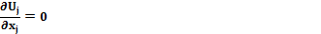
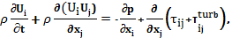  = 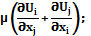 = - ρ | (3.2.1)
In order to close Eq. (3.2), Reynolds stresses, - ρ are calculated using the Boussinesq hypothesis is used.
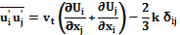 | (3.2.2)
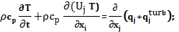
=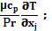 = - ρ | (3.3.1)
where ,T and P are the average velocity components,temperature and pressure respectively, besides and are the fluctuating velocity and temperature components, respectively.
  - Boundary Conditions
(a) Nozzle exit: The velocity boundary condition is applied on the nozzle’s exit. Turbulence intensity (I) of 1% is designated on the exit of the nozzle,while the saturation temperature of ammonia at the same place was designated as 278.15 K.
(b) Target wall: the boundary conditions imposed on the target wall are no slip for momentum equations, while the energy equation defines the corresponding constant temperature.
(c) The outer surface of the evaporator: Is defined as an adiabatic wall and a pressure boundary condition utilized at the outlet. The boundary conditions for a steady-state two-dimensional flow rate are:
at the pipe wall
where, are the radial velocities.
Initial conditions:
At the nozzle exit, the uniform profiles for all the properties are as follows:
at the pressure outlet
P =
To represent the results and characterize the heat transfer and flow in the shell and tube evaporator, the following variable and parameters are presented:
The average Nusselt number along the pipe Nu,_{are} can be calculated by integrating local results over appropriate surface area. The resulting correlations are reported as (F.P. Incropera and Dewitt 2002):
where.
At the nozzle cross section, velocity is calculated as (F.P. Incropera and Dewitt 2002):
The characteristic length is the hydraulic diameter of the nozzle, which is computed as (F.P. Incropera and Dewitt 2002):
where is the cross section area of the jet and P is the wet perimeter of the jet nozzle wall .
.
  - Numerical Computation
The numerical work is conducted using a commercial CFD solver, FLUENT 6.3, for the purpose of solving the conservation equations of mass, momentum, and energy. The ﬁnite volume method has been used to discretize the governing equations of ﬂow, with the SIMPLE algorithm of Patankar (1980) to couple the pressure-velocity system. First–order upwind scheme and structure uniform grid system are employed to discretize the main governing equation. The solutions are regarded as convergent when the normalized residual values are) for all of the variables.
  - Selection and Code Validation of the Model
The simulations of a pipe in cross flows were done by comparing the Nusselt number predicted by different turbulence models, such as k- ε, k-ω, SST, and RSM models with the correlation available for predicting heat transfer on a cylindrical target over a range of parametric variables, based on the varying fluid properties i.e. (Zuckerman and Lior 2006, 2007).
(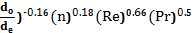
Fig.3 shows the average Nusselt number for ammonia flow cross tube bundle using different turbulent models and compared with the correlation presented by Zuckerman and Lior (2007). It is noted that the results obtained by SST k– ω model for individual pipes agrees with Zuckerman’s correlation results. To create a model that accurately illustrate the present problem, the k- ε, k-ω, and RSM models are under–predicted compared to the correlation results of Zuckerman and Lior (2007). In the present study, a SST k-ω model simulates both the heat transfer and fluid flow characteristics, based on its close agreement with the values reported by Zuckerman and Lior (2007).
4. Results and Discussion
4.1 Jet flow characteristics
The flow in the computational domain of the first pipe at the center of the evaporator is shown in Fig.4. The flow of a round jet nozzle to the circular surface of the pipe can be divided into the following regions, namely free jet, stagnation point, cylinder flow, the recirculation region around the pipe, with the wall jet being shown in Fig.1 (view.b).
4.2. Distribution of Heat Transfer Rate on the Pipe Surface
The distribution of the local Nusselt numbers around the circumference of the pipe for multiple Reynolds number is shown in Fig.5. The local Nusselt number is high at the top of the pipe; the highest value is a few degrees away from the stagnation region due to the behavior of the turbulence model. The stagnation point induces high degrees of turbulence, which in turn induces a high heat transfer rates (Ahrné et al., 2004).It is also common knowledge that local heat transfer is largest at the front stagnation point, although it decreases in tandem with distance along the curvature as the boundary layer thickness increases. This is due to the fact that the turbulence levels in the stagnation region changes the flow near the wall via virtuosity amplifications. The turbulence level is probably reduced in the separation region. Due to this, the heat transfer rate is low in the separation region.
4.3 Effect of Nozzle Height on the Tube Bundle
Fig.6a illustrates the effects of nozzle height over the tube bundle for different Reynolds numbers at H= 16 mm and = 2mm. The first three rows are used to calculate the heat transfer rate, which are vital in the interpretation of the current study due to symmetry. It can be ascertained that the average Nusselt number increases with the increase of Reynolds number for all individual tubes. It is also noted that the average Nusselt number of tubes in the downstream jet impingement encompasses all cases, the highest among all tubes due to the impingement of high momentum liquid droplets generated by both the nozzles and turbulence levels. This trend is also evident in a spray evaporator, which was observed by Zeng et al. (1995, 2001, 2001). Fig.6b shows the variance of the Nusselt number with Reynolds number at a nozzle height of 32 mm. It can see from the two figures that the data for tubes in the lower rows are adjacent to each other. However, the data for the tubes on the top rows for H=16 mm slightly differs from H=32. Fig.6c shows the comparison of different nozzle height on the first three rows for different Reynolds number at =2 mm and Te=278 K. It is observed that the data in the lower rows for H= 16 mm are lower than that for H=32 mm. The smaller H may cause the flows to collide, resulting in another local stagnation region or boundary layer separation, and a turning of the flow away from the wall. It can also be seen that the will decline, beginning from the top row and ending at the bottom row. This phenomenon is attributed to the impingement of liquid droplet and movements at lower velocities. The lower speed of the liquid droplet impingement resulted in a thick boundary layer, which precipitates low heat transfer rates (Zuckerman and Lior 2006).
4.4 The Effect of Nozzle Diameter (de)
Fig.7 indicate the influence of different nozzle diameters on the tube bundle for different Reynolds number at H=32 mm and 15 mm. It is observed that the Nusselt number is directly proportional to the Reynolds number. It is also noted that the larger nozzle diameter results in higher, due to a stronger liquid droplet impingement effect. It should be noted that the enhancement in heat transfer increases with the increase of nozzle diameter at the same value of Reynolds number, but this leads to enhanced spray flow rates, which implies the need for higher pumping powers.
4.5 Effect of Liquid Re-Circulator Component
Numerical simulations are calculated using multiple jets functioning as liquid re-circulator component and distributing the liquid re-circulator on the tube’s bundle. The effect of three jets impingement on the tube bundle at nozzle hydraulic diameter of 2 mm is shown in Fig.8a, and it is observed that the average Nusselt number is directly proportional to the Reynolds number. The results for the tube in the first row mirrors the case of individual tubes, as shown in Fig.8a, b, but with different magnitudes. Fig.8b shows the effect of three nozzles on the first three rows for different Reynolds number at =2 mm and different mass flow rates. The Nusselt number increases via the utilization of three jets impingement. The recirculation region can be a vortex as well, and is characterized by the highest turbulence in the flow field. Fig.9 shows the streamlines and isotherms contour for a case with Re= 3000, n=3, =2mm and 15 mm. It can be seen that the three jets tends to increase the vortices that were induced underneath the pipes. These vortices will transport energy away from the wall without the hindrance of a thick developed boundary layer.
4.6 The Effect of Tube Arrangements
The result of three jets impinging on the different tube bundle arrangements with different Reynolds number is shown in Fig. 10.It is illustrated that the distribution of liquid along the tubes is better than that in the single jet impingement. This is due to the increase in the heat transfer rate over the circumference surface of the pipes, which is in turn due to the increase generated by the turbulence (Zuckerman and Lior 2005, 2007). The decrease in the Nusselt number in the second and third of the pipes is due to decreases in the heat transfer rate and the turbulence level. Fig.10a shows that the Nusselt number distribution for the staggered arrangement exceeds that of the aligned arrangement. An increase in the Reynolds number causes an increase in heat transfer in the range of Reynolds number, from 10000, to 25000. To calculate the optimum tube arrangement that affords the highest heat transfer rate, the staggered tube arrangements give the highest Nusselt number among the type of tube arrangements, shown in Fig 10b. Generally, heat transfer enhancement is favored by the more tortuous flow of a staggered arrangement (F.P. Incropera and Dewitt 2002).
4.7 Effect of Longitudinal Tube Pitch
Fig.11a shows the variation of Nusselt number with different Reynolds number for different longitudinal pitch().It is observed that as Re increases increases, with sharper increasing occurring at higher Re. The tubes of the first few rows acts as a turbulence–generating grid, which increases the heat transfer coefficient for the tubes in the following rows. A similar trend is shown in Fig 11 b, where the Nusselt number increases with small values of . This is due to the influence of fluid acceleration and the reattachment of flow over the cylinder. Moreover, the zigzag passages between the tubes led to the increase in the turbulence level (Incropera and Dewitt, 2002).
5. Conclusions
Numerical models were used to evaluate heat transfer on a horizontal tube bundle of ammonia, distributed by single impinging jet with a liquid re-circulator nozzle. The effects of spray flow rate, nozzle height, nozzle hydraulic diameter, tube bundle arrangements, and longitudinal pitch on the thermal and hydraulic behavior of spray evaporator was examined. The following are the findings from the work:
- It is found that the average Nusselt number and the stagnation point Nusselt number around the surface of the pipe is directly proportional to the Reynolds number.
- The results indicated that in the case of the shell and tube evaporator using jet impingement, the tube bundle effect is more significant at a larger nozzle height and hydraulic diameter, which gives a higher spray flow rate.
- It is found that the aligned arrangements demonstrate a larger tube bundle effect than that in staggered arrangements when using single jet impingement, while the staggered arrangements is more significant when using three jet impingements.
- The comparison shows that the use of three nozzles tends to provide a higher Nusselt number, approximately 14 % than that of single nozzle at the same flow rate. Besides, the distribution of liquid along the tubes is better than that in a single jet impingement.
- The effect of Reynolds number is dominant over the effect of the number of jets when trying to increase the average Nusselt number.
Table 1. Dimensions of the computation domain of the spray nozzle evaporator
Nozzle height (H), mm | Nozzle width(), mm | Number of nozzles | Tube arrangement | Longitudinal pitch (S_{L}) mm
16 mm | 2 mm | 1 | Staggered | 15
32 mm | (1,2,3) mm | 1 | Staggered  Aligned  Radial | 15
32 mm | 2 mm | 3 | Staggered  Aligned  Radial | 12.5,15,17.5

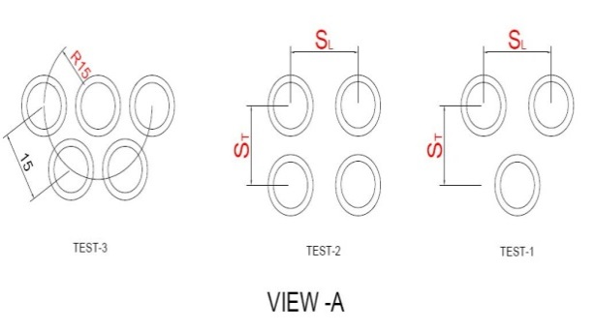  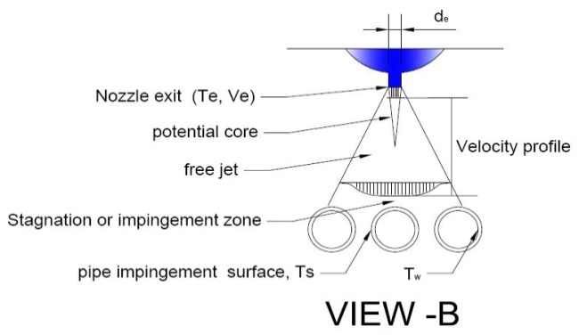 | 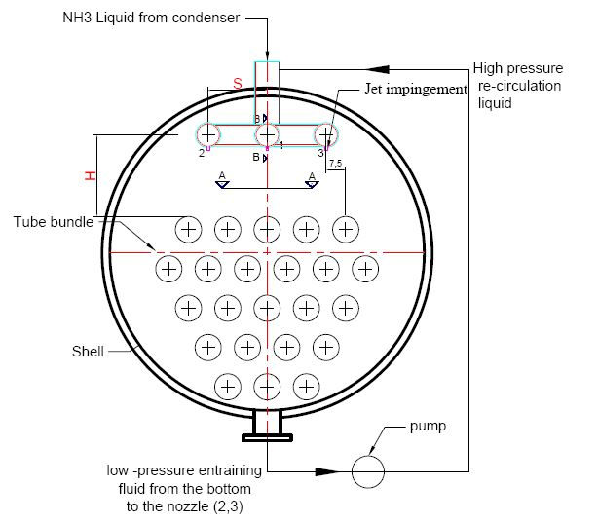
Fig. 1. Schematic Diagram of the Spray evaporator: view –A (tube pitch arrangements), view –B (jet impingement)



Fig.2. Schematic Diagram of the Structured Uniform Grid System.
Fig .3: Comparison of the Average Nusselt Number for various turbulent models tested with the Zuckerman and Lior correlation results(Zuckerman and Lior 2007) for Different Reynolds Numbers.
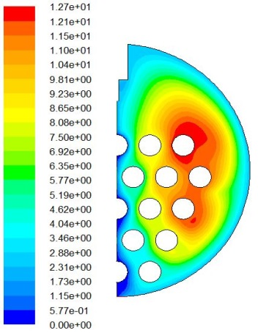
Fig.4. Streamlines of the velocity profile in the computational domain for the Re= 25000, H=16mm and =2mm.
Fig. 5. local Nusselt number around the cylinder for different Reynolds numbers, H=16 mm, de=2mm and 15 mm.

(a)
(c) ( b)
Fig.6. Variation of Nusselt number with Reynolds number for15 mm and = 2mm on the staggered tube bundle at , (a) H=16 mm , (b) H=32 mm and (c) H=16, 32 mm, for first three rows.
Fig.7. Nusselt number Versus Reynolds Number of Different nozzle Diameters.

(a) (b)
Fig.8. Effect of three nozzles on the Nusselt Number with Various Reynolds Numbers at H= 32 mm, =2mm and15 mm. (a) on the individual tube (b) for first three rows.
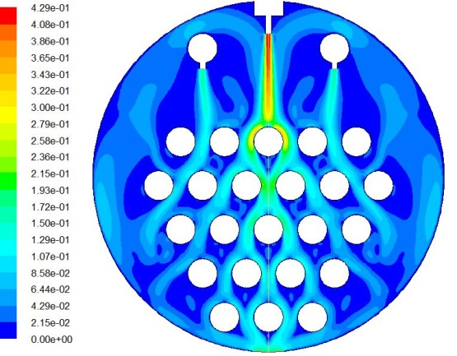 | 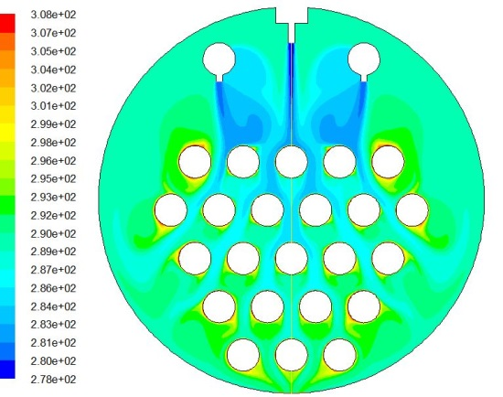
Fig .9. Streamlines (left) and Isotherms (right) Contours for multiple jets impingements at Re=3000.
(a) (b)
Fig.10. Comparison between different tube arrangements of three jets impingement for different Reynolds number (a) aligned and staggered (b) aligned, radial and staggered

- (b)
Fig.11. Variation of Nusselt number with Reynolds number at H= 32 mm, 15 mm and =2mm for different longitudinal pitch (), ( a)-comparison of for first row,( b) comparison of for second row.
References
Akansu,Y.E., Sarioglu,M.,Kuvvet,K.and Yavuz,T., 2008."Flow field and heat transfer characteristics in an oblique slot jet impinging on a flat plate."International Communications in Heat and Mass Transfer 35(7): 873-880.
Chang,T.-B.,2006."Effects of nozzle configuration on a shell-and-tube spray evaporator with liquid catcher." Applied Thermal Engineering 26(8-9): 814-823.
Choo, K. S. and Kim, S. J, 2010."Heat transfer characteristics of impinging air jets under a fixed pumping power condition." International Journal of Heat and Mass Transfer 53(1-3): 320-326.
Draksler, M. and Končar, B., 2011."Analysis of heat transfer and flow characteristics in turbulent impinging jet." Nuclear Engineering and Design 241(4): 1248-1254.
Incropera, F.P. and Dewitt, D.P.,2002. Fundamentals of Heat and Mass Transfer., John Wiley & Sons, Inc.,.
Huadon Li,V.K.,1998."Visualization and Determination of Local Heat Transfer Coefficients in Shell-and-Tube Heat Exchangers for Staggered Tube Arrangement by Mass Transfer Measurements." Experimental Thermal and Fluid Science 17: 210-216.
Jang, J.-H., Chiu, H.-C. and Yan,W.-M.,2013."Impinging cooling of film hole surface using transient liquid crystal thermograph." International Communications in Heat and Mass Transfer 44: 23-30.
Katti, V. and Prabhu, S.V. ,2008."Heat transfer enhancement on a flat surface with axisymmetric detached ribs by normal impingement of circular air jet." International Journal of Heat and Fluid Flow 29(5): 1279-1294.
Lee, C. H., Lim, K. B., Lee, S. H., Yoon,Y. J. and Sung, N. W.,2007."A study of the heat transfer characteristics of turbulent round jet impinging on an inclined concave surface using liquid crystal transient method." Experimental Thermal and Fluid Science 31(6): 559-565.
Lin, R.-L., Chang, T.-B. and Liang, C.-C. ,2012. "Effects of spray axis incident angle on heat transfer performance of rhombus-pitch shell-and-tube interior spray evaporator." Journal of Mechanical Science and Technology 26(3): 681-688.
Olsson, E. E. M., Ahrné, L.M. and Trägårdh, A. C. ,2004."Heat transfer from a slot air jet impinging on a circular cylinder. "Journal of Food Engineering 63(4) : 393-401.
Olsson, E. E. M., Ahrné, L.M. and Trägårdh, A.C. ,2005. "Flow and heat transfer from multiple slot air jets impinging on circular cylinders." Journal of Food Engineering 67(3): 273-280.
Patankar, S.V.,1980. Numerical Heat Transfer and Fluid Flow. Washington,DC, Hemisphere Publishing Corporation, .
Sharif, M. A.R. and Ramirez, N.M.,2013."Surface roughness effects on the heat transfer due to turbulent round jet impingement on convex hemispherical surfaces." Applied Thermal Engineering 51(1-2): 1026-1037.
Singh, D., Premachandran,B. and Kohli,S.,2013."Experimental and numerical investigation of jet impingement cooling of a circular cylinder." International Journal of Heat and Mass Transfer 60: 672-688.
Kuntysh,V.B., Aksenov,V.V. and Roshchin,S. P., 1997."Intensification of heat exchange in bundles of finned tubes by the method of jet air cooling." Chemical and Petroleum Engineering 33(2): 120-124.
Zeng,X., Chyu,M.-C. and Ayub, Z. H. ,1995."Evaporation Heat Transfer Performance of Nozzle –Sprayed Ammonia on a Horizontal tube ." ASHRAE Transactions 101(1): 136-149.
Zeng, X.,Chyu, M.-C. and Ayub,Z. H.,2001."Experimental Investigation on Ammonia Spray Evaporator with Triangular-Pitch Plain-Tube Bundle, Part II Evaporator Performance." International Communications in Heat and Mass Transfer 44: 2299-2310.
Zeng, X.,Chyu, M.-C. and Ayub,Z. H.,2001."Experimental Investigation on Ammonia Spray Evaporator With Triangular -Pitch Plain-Tube Bundle, Part II:Evaporator Performnce" International Communications in Heat and Mass Transfer 44: 2081-2092.
Yang, L. and Wang,W.,2011."The heat transfer performance of horizontal tube bundles in large falling film evaporators." International Journal of Refrigeration 34(1): 303-316.
Zuckerman,N. and Lior,N., 2005."Jet impingement heat transfer on a circular cylinder by radial slot jets." ASME Paper IMECE2005- 79565: 67-78.
Zuckerman, N. and Lior, N., 2006. "Jet Impingement Heat Transfer: Physics, Correlations, and Numerical Modeling."Advances in Heat Transfer 39:565-631.
Zuckerman,N.and Lior,N.,2007."Radial slot jet impingement flow and heat transfer on a cylindrical target."Journal of Thermophysics and Heat Transfer 21(3):
548-561.

