Numerical Investigation in a Circular Tube To Enhance Turbulent Heat Transfer Using Opened Rings -Triangular Cross Section

Arkan Altaie Moayed R. Hasan Farhan Lafta Rashid
University of Technology-Iraq
arkanaltaie@yahoo.com uotmed_deputy@yahoo.com engfarhan71@gmail.com
Abstract
In this study; heat transfer and thermal performance characteristics are numerically investigated in a steel tube of 50 cm long , outside diameter of 60 mm and inside diameter of 30 mm with constant outside surface temperature of 1000, 1200 and 1400 Kº. The renormalization group k-ε model is used to simulate turbulence in ANSYS - FLUENT 14.5. The opened ribs assembly (5x5 mm triangular cross section) were fitted in the tube and separated by 8cm pitch. Results of temperature and velocity distribution along the tube center line for the case of tube with internal ribs were compared with that of plain tube , these results show that the use of internal ribs enhance the heat transfer rate and found to possess the highest performance factors for turbulent flow.
Keywords: heat transfer enhancement, cooling enhancement, internal ribs, turbulators and turbulent flow.
الخلاصة
في البحث الحالي تم التطرق الى خصائص الاداء والانتقال الحراري لانبوب من الستيل بطول 50 سم وبقطر خارجي 60 ملم وقطر داخلي 30 ملم وبتثبيت درجة حرارة السطح على 1000 و 1200 و1400 درجة مطلقة. تم استخدام مجموعة كي-ابسلون كنموذج في برنامج فلونت 14.5. وقد تم وضع حلقات مفتوحة ذات مقطع عرضي مثلثي داخل الانبوب وعلى مسافات متساوية مقدارها 8 سم. استحصلت النتائج النظرية المستحصلة بالبحث لحالة الانبوب بوجود حلقات داخلية وتم مقارنتها مع حالة الانبوب بدون حلقات. تبين النتائج ان انتقال الحرارة في حالة الانبوب بوجود الحلقات اكبر بكثير وايضا تعطي اضطرابا اكثر للجريان عن حالة الانبوب بدون حلقات.
الكلمات المفتاحية: زيادة الانتقال الحراري , زيادة التبريد , العوائق الداخلية ,الجريان المضطرب والمضطربات.
Introduction
Heat transfer enhancement technology has been improved and widely used in heat exchanger applications;such as refrigeration, automotives, process industry, chemical industry, etc. One of the widely-used heat transfer enhancement technique is inserting different shaped elements with different geometries in channel flow [Khaled -2007, Shoji -2003, Zimparov -2001,Tandiroglu-2006]. In recent years, the high cost of energy and material has resulted in an increased effort aimed at producing more efficient heat exchange equipment .The major challenge in designing a heat transfer is to make the equipment compact and achieve a high heat transfer rate using minimum pumping power. The subject of heat transfer growth in heat exchanger is serious interest in the design of effective and economical heat exchanger [Udaya at al., 2008; Chang et al., 2007 ;Udaya-2007; Chang-2007] studied the heat transfer enhancement in a tube fitted with serrated twisted tapes and broken twisted tapes.
Promvonge [Promvonge,2008] studied the effect of a conical ring tabulator arrangement on the heat transfer rate and friction factor. It was shown that the conical-ring with a diverging conical ring array provided superior thermal performance factor compared to those with the converging conical ring and converging-diverging conical-ring arrays.[Shabanian et al.,2011] studied the heat transfer enhancement in an air cooler equipped with different tube inserts.
Bergles and Champagne [Champagne,2001] proposed the idea of variable roughness which can be obtained by using a wire-coil insert made of a shape memory alloy (SMA) that alters its geometry in response to change in temperature. Shyy Woei Chang, Ker-Wei Yu, and Ming Hsin Lu [R.K. Rajput] investigated the effect of three test tubes fitted with single, twin, and triple twisted-tapes on heat transfer. The tubes fitted with twin and triple twisted-tapes could offer the higher values of heat transfer augmentation with the similar levels of performance factor as those found in the tube fitted with single twisted tape. Sivashanmugam and Nagarajan [Sivashanmugam-2007,2006] studied circular tube fitted with right–left helical screw inserts of equal length, unequal length of different twist ratio and full-length helical screw element at different twist ratio.
[Guo et al., 2011] studied the heat transfer and friction factor characteristics of laminar flow in a circular tube fitted with center-cleared twisted tape.
Bergles and Webb [Bergles,1985;Webb,1994] have reported comprehensive reviews on techniques for heat transfer enhancement. For a single-phase heat transfer, the enhancement has been brought using roughened surfaces and other augmentation techniques, such as swirl /vortex flow devices and modifications to duct cross sections and surfaces.
In this paper, the effect of fitting opened triangular cross section rings in a steel pipe with internal air flow and constant wall surface temperature will be investigated.
CFD Methodology
In this investigation a 3-D numerical simulation of the conjugate heat transfer was conducted using the CFD code FLUENT 14.5. The CFD modeling involves numerical solutions of the conservation equations for mass, momentum and energy. These three equations are used to model the convective heat transfer process with the following assumptions, (a) steady 3-D fluid flow and heat transfer, (b) incompressible fluid and flow, and (c) physical properties of cooling fluid are temperature dependent. These equations for incompressible flows can be written as follows:
- mass conservation:
$\frac{∂(u_{i})}{∂x_{i}}=0\text{.}\text{.}\text{.}\text{.}\text{.}\text{.}\text{.}\text{.}\text{.}\text{.}\text{.}\text{.}\text{.}\text{.}\text{.}\text{.}\text{.}\text{.}\text{.}\text{.}\text{.}\text{.}\text{.}\text{.}\text{.}\text{.}(1)$

- momentum conservation:

$\frac{∂(u_{i})(u_{j})}{∂x_{j}}=−\frac{∂p}{∂x_{i}}+\frac{∂}{∂x_{j}}[μ(\frac{∂(u_{i})}{∂x_{j}}+\frac{∂(u_{j})}{∂x_{i}})−ρ(u_{i}^{}u_{j}^{})]+{ρg}_{i}\text{.}\text{.}\text{.}\text{.}\text{.}\text{.}\text{.}\text{.}\text{.}\text{.}\text{.}(2)$

- Energy Conservation:
$\frac{∂}{∂x_{i}}((u_{i})(ρE+p))=\frac{∂}{∂x_{i}}(K_{\text{eff}}\frac{∂T}{∂x_{i}}+u_{j}(τ_{\text{ij}})_{\text{eff}})\text{.}\text{.}\text{.}\text{.}\text{.}\text{.}\text{.}\text{.}\text{.}\text{.}\text{.}\text{.}\text{.}\text{.}\text{.}\text{.}\text{.}\text{.}\text{.}\text{.}\text{.}\text{.}\text{.}\text{.}\text{.}(3)$
Boundary conditions:
The boundary zone location is specified in the GAMBIT itself; the inlet, outlet and the wall condition location is specified.
Fluid entry boundary condition:
The inlet air flow velocity is 10 m/s with constant temperature of 300 Kº.
Wall Boundary Conditions:
The pipe wall is provided with wall boundary condition, a constant heat flux is provided for plain and ribbed tube. The outside surface wall temperature is varied from 1000 to 1200 and 1400 Kº.
Detailed geometry of the Test Section
The test section shown in fig. (1) is steel tube with outside diameter of 60 mm and inside diameter of 30 mm at which the air is flow in, and having steel square cross section opened rings (5x5 mm) located at each 8 mm along the tube. The test section was drawn using AUTO CAD 2013.
Ribs
Tube Wall
Air Flow
Constant Heat Flux


Fig.(1) Geometry of the Test Section

Results and Discussion
Figures (2),(3) and (4) show the contours of temperature distribution along the whole test section geometry at constant surface wall temperatures of 1000, 1200 and 1400 K^{O}, respectively.
Figures (5),(6) and (7) show the contours of velocity distribution along the whole test section geometry at constant surface wall temperatures of 1000, 1200 and 1400 K^{O}, respectively.
Figure (8).shows the temperature distribution along the pipe center line for two cases , one without ribs and the other with ribs at surrounding surface temperature of 1000Kº. It shows that the pipe with ribs has highest outlet air temperature. This means that the pipe with ribs, has highest surface area resulted in enhancing the heat transfer.
Figure (9).shows the temperature distribution along the pipe center line for two cases , one without ribs and the other with ribs at surrounding surface temperature of 1200Kº. It shows that the pipe with ribs has highest outlet air temperature. This means that the pipe with ribs, has highest surface area resulted in enhancing the heat transfer.
Figure (10).shows the temperature distribution along the pipe center line for two cases, one without ribs and the other with ribs at surrounding surface temperature of 1400Kº. It shows that the pipe with ribs has highest outlet air temperature. This means that the pipe with ribs, has highest surface area resulted in enhancing the heat transfer.
Figure (11) shows the velocity distribution along the pipe center line for two cases, one without ribs and the other with ribs at surrounding surface temperature of 1000 Kº. It shows that the pipe with internal ribs having more velocity distribution than the case of plain pipe. This because of the swirls generated from the use of opened rings.
Figure (12) shows the velocity distribution along the pipe center line for two cases, one without ribs and the other with ribs at surrounding surface temperature of 1200 Kº. It shows that the pipe with internal ribs having more velocity distribution than the case of plain pipe. This because of the swirls generated from the use of opened rings.
Figure (13) shows the velocity distribution along the pipe center line for two cases , one without ribs and the other with ribs at surrounding surface temperature of 1400 Kº. It shows that the pipe with internal ribs having more velocity distribution than the case of plain pipe. This because of the swirls generated from the use of opened rings.

Conclusions
Numerical simulation has been presented on heat transfer characteristics for the flow of cooling air in heated tube under steady state turbulent flow using FLUENt 14.5. The CFD predictions for the case of tube with ribs were compared against the tube without ribs.
The following conclusions can be drawn from the present study:
- CFD predictions were shown to reproduce the enhancement in heat transfer for the use of internal ribs, with respect to the plain tube.
- Based on CFD analysis, higher thermal hydraulic performance were obtained for the tube with ribs than the tube without ribs.
- tube with ribs gave more velocity disturbance than the tube without ribs.
- The temperature of the plain pipe was found to be approximately un affected for cases of 1000,1200 and 1400 Kº. While when ribs are used , the effect was to increase the temperature by 275,375, and 475 Kº for the cases above, respectively.

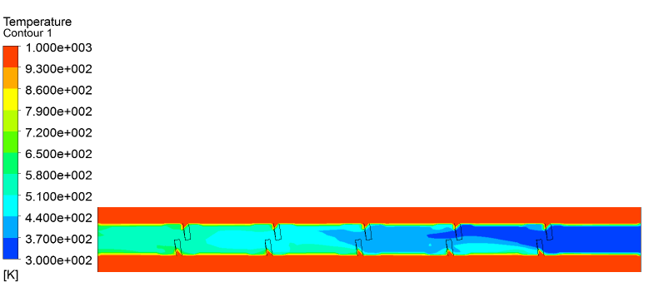
(A)
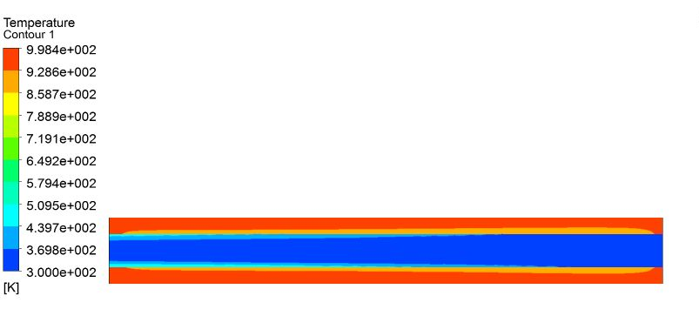
(B)
Fig.(2) Contour of Temperature Distribution at Constant Surface Temperature
(1000 kº)
A: With Ribs B: Without Ribs

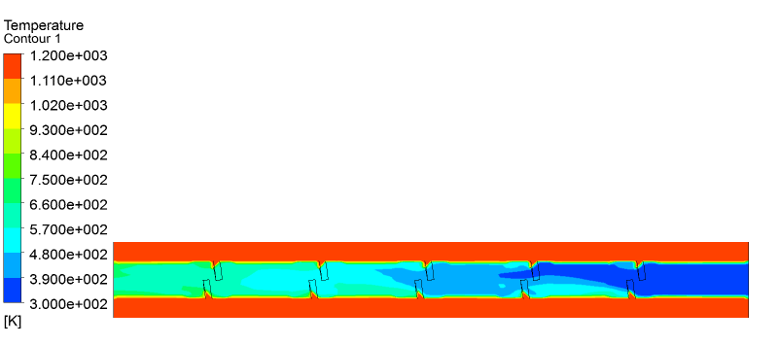
(A)
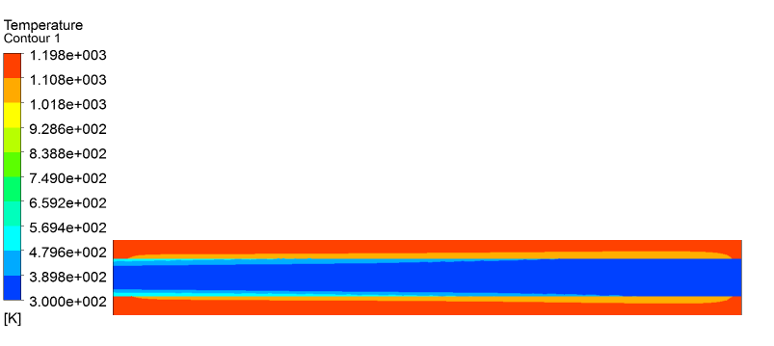
(B)
Fig.(3) Contour of Temperature Distribution at Constant Surface Temperature
(1200 kº)
A: With Ribs B: Without Ribs

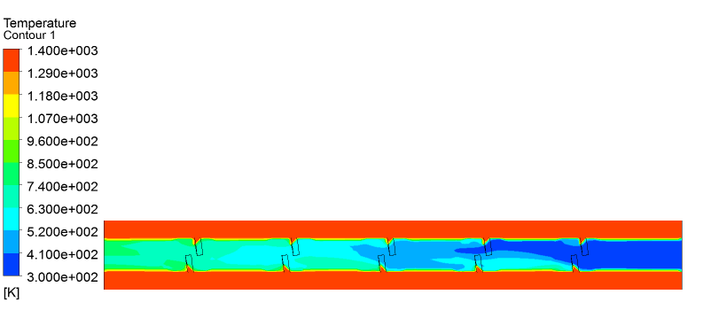
(A)
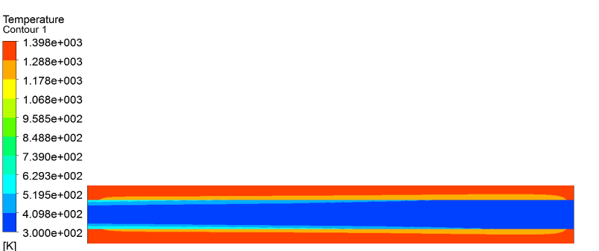
(B)
Fig.(4) Contour of Temperature Distribution at Constant Surface Temperature (1400 kº)
A: With Ribs B: Without Ribs
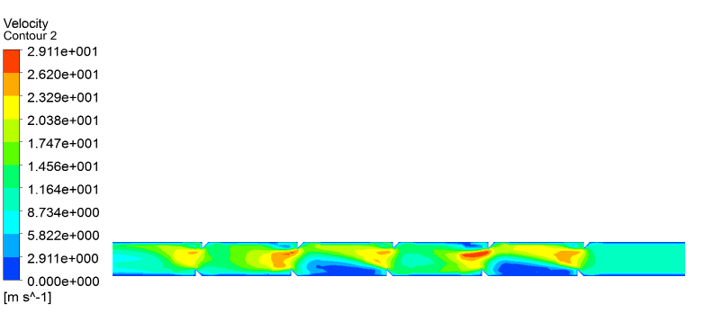
(A)
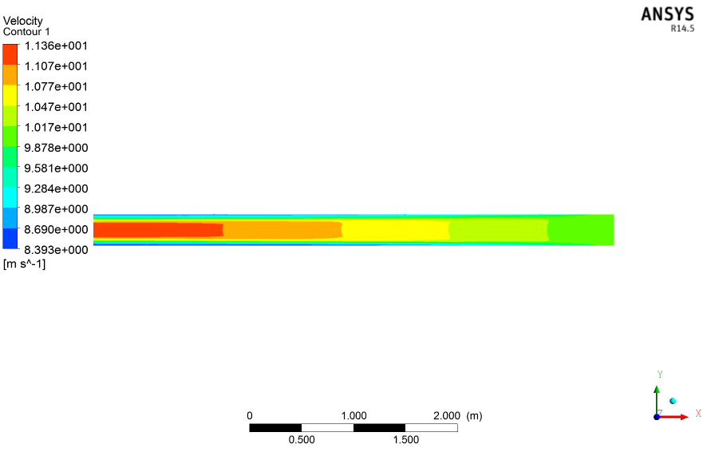
(B)
Fig.(5) Contour of Velocity Distribution at Constant Surface Temperature (1000 kº)
A: With Ribs B: Without Ribs

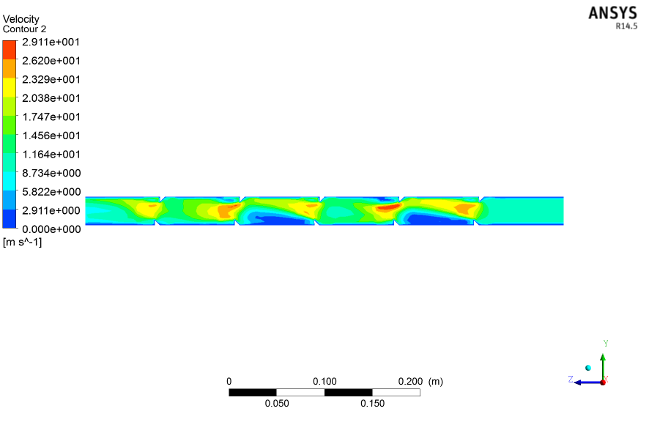
(A)
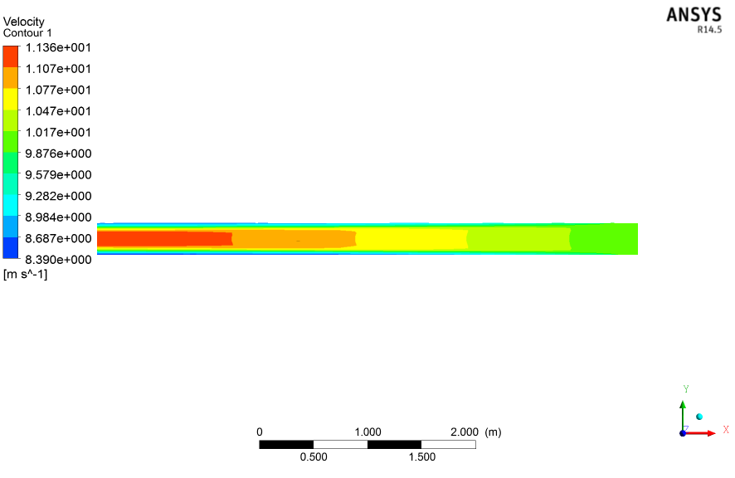
(B)
Fig.(6) Contour of Velocity Distribution at Constant Surface Temperature (1200 kº)
A: With Ribs B: Without Ribs

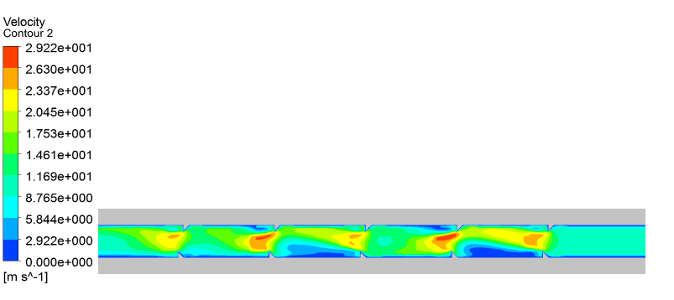
(A)

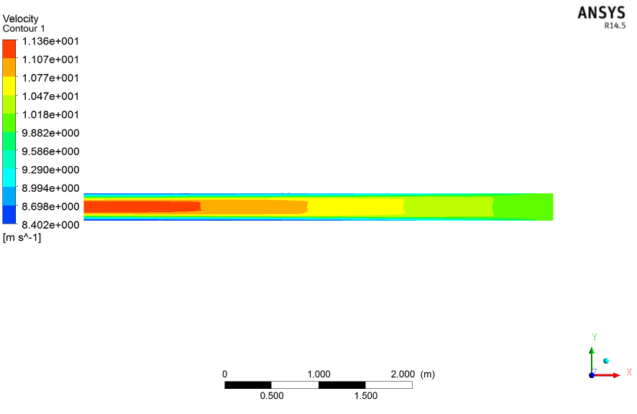

(B)
Fig.(7) Contour of Velocity Distribution at Constant Surface Temperature (1400 kº)
A: With Ribs B: Without Ribs
Temperature (Kº)
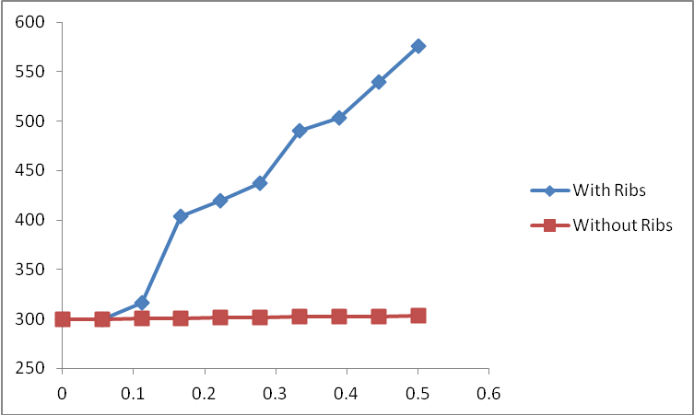
Distance (m)

Fig. (8) Variation of Temperature Along the Center line of Tube at Constant Surface Temperature (1000 Kº)
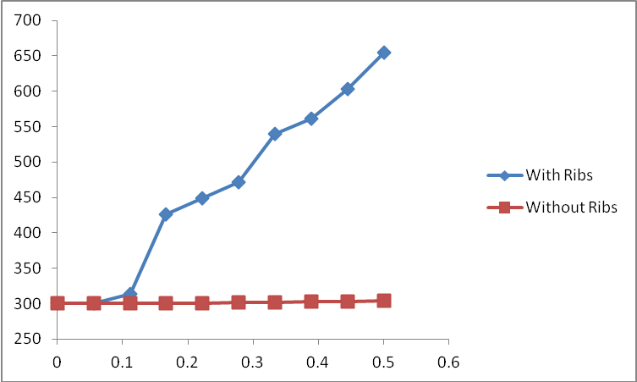
Temperature (Kº)
Distance (m)

Fig. (9) Variation of Temperature Along the Center line of Tube at Constant Surface Temperature (1200 Kº)
Temperature (Kº)
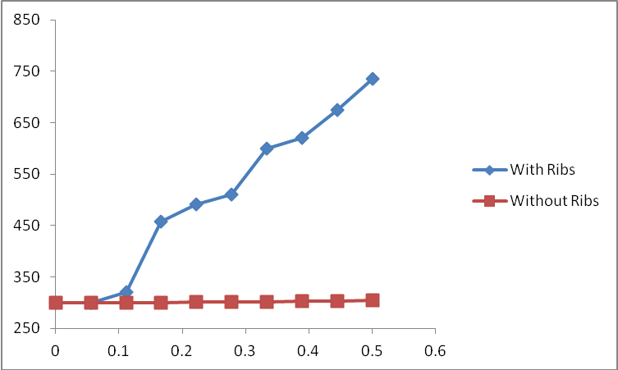
Distance (m)

Fig. (10) Variation of Temperature Along the Center line of Tube at Constant Surface Temperature (1400 Kº)
Velocity(m/s)
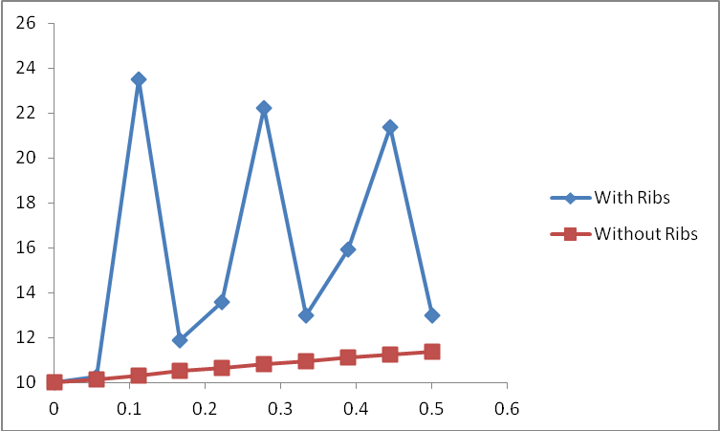
Distance (m)

Fig. (11) Variation of Velocity Along the Center line of Tube at Constant Surface Temperature (1000 Kº)

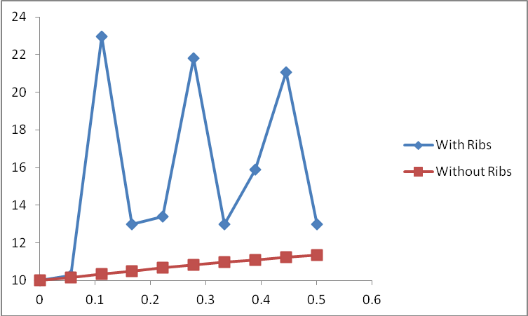
Velocity(m/s)
Distance (m)

Fig. (12) Variation of Velocity Along the Center line of Tube at Constant Surface Temperature (1200 Kº)
Velocity(m/s)
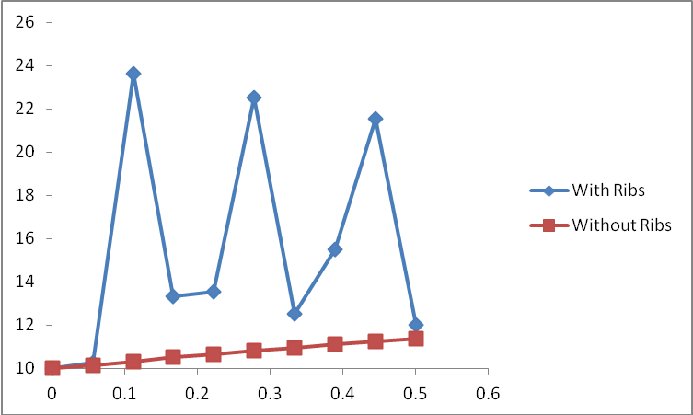
Distance (m)

Fig. (13) Variation of Velocity Along the Center line of Tube at Constant Surface Temperature (1400 Kº)
References
Distance (m)
Bergles, A. E.,“Techniques to augment heat transfer,” in Handbook of Heat Transfer Applications, J. P. Hartnett,W.M. Rohsenow, and E. N. Ganic, Eds., chapter 1, McGraw-Hill, New York, NY, USA, 2nd edition, 1985.
Champagne, P.R. and Bergles, A.E. "Development and testing of a novel, variable
Chang SW, Jan YJ, Liou JS. Turbulent heat transfer and pressure drop in tube fitted with serrated twisted tape. Int. J. Therm. Sci. 2007;46:506–518.
Chang SW, Yang TL, Liou JS. Heat transfer and pressure drop in tube with broken twisted tape insert. J Exp. Therm. Fluid Sci. 2007;32:489–501.
exchanger." Journal of Enhanced Heat Transfer 8, Vol 5 (2001) 341-352.
Guo, J, Fan A, Zhang X, Liu W. A numerical study on heat transfer and friction factor characteristics of laminar flow in a circular tube fitted with center-cleared twisted tape. International Journal of Thermal Sciences 2011;50:1263–70.
Khaled, RA. Heat transfer enhancement in hairy fin systems. Appl Therm Eng 2007;27:250–7.
Promvonge P. Heat transfer behaviors in round tube with conical ring inserts. Energy Convers Manag 2008;49:8–15.
Rajput, R.K. a text book of ―Heat and Mass Transfer.
roughness technique to enhance, on demand, heat transfer in a single-phase heat
Shabanian SR, Rahimi M, Shahhosseni M, Alsairafi AA. CFD and experimental studies on heat transfer enhancement in an air cooler equipped with different tube inserts. Int. Commun. Heat Mass Transfer 2011;38:383–390.
Shoji Y,Sato K, Oliver DR. Heat transfer enhancement in round tube using wire coil influence of length and segmentation. Heat Transfer-Asian Res 2003;32(2):99–107.
Sivashanmugam P, Nagarajan PK. Studies on heat transfer and friction factor characteristics of laminar flow through a circular tube fitted with right and left helical screw-tape inserts. Experimental Thermal and Fluid Science 2007;32: 192–7.
Sivashanmugam P, Suresh S. Experimental studies on heat transfer and friction factor characteristics of laminar flow through a circular tube fitted with helical screw-tape inserts. Applied Thermal Engineering 2006;26:1990–7.
Tandiroglu A, Ayhan T. Energy dissipation analysis of transient heat transfer for turbulent flow in a circular tube with baffle inserts. Appl. Therm. Eng. 2006;26:178–85.
Udaya kumar , M. Manzoor Hussian ,M. Yousaf Ali. Md., Review of Heat Transfer Enhancement Techniques in Square Ducts with Inserts. International Journal of Emerging Technology and Advanced Engineering , 2008; Volume 3, Issue 8.
Webb,R. L., Principle of Enhanced Heat Transfer, John Wiley, New York, NY,USA, 1994.
Zimparov V. Enhancement of heat transfer by a combination of three-start spirally corrugated tubes with a twisted tape. Int J Heat Mass Transfer 2001;44:551–74.

