Methyl Red Dye Removal From Aqueous Solution by Adsorption on Rice Hulls

Hadeel Ali Abdulhussein  College of Engineering/University of Babylon  saadalkhazali@yahoo.com | Afrah Abood Hassan  College of Engineering/University of Babylon  Afrah@yahoo.com
Abstract In the present study agricultural waste, grounded rice hulls was examined as sorbent material for removing methyl red dye from solutions. Batch studies were performed to evaluate various parameters effects:( time of contact, pH, the initial concentration of the dye, adsorbent dose and particle size of the sorbent material), on adsorption capacity of the dye.
Rice hulls was found to be effective in removing methyl red dye and equilibrium was reached in (100 min) time. The amount of dye adsorbed was found to be pH dependant and it increases as the dose of rice hull and initial dye concentration increasing. The capacity of adsorption decreases with increasing of particle size of the rice hulls.
The equilibrium isotherms were examined using Langmuir and freundlich isotherms by using the coefficients of correlation. sorption data were well described by Langmuir and freundlich models. The outcomes of the study showed that rice hulls could be a good alternative material rather than another more costly adsorbent materials intended for dye removal.
Keywords: Rice Hulls, Methyl red, Isotherm models.
الخلاصة:
في هذه الدراسة استخدمت الفضلات الزراعية وهي قشور الرز المطحونة كمادة مازة (مزيلة) في ازالة صبغة المثيل الاحمر من المحاليل المائية. تم دراسة نظام الدفعات في تخمين تأثير معاملات مختلفة: )وقت التلامس, قيم pH للمحاليل, التركيز الاولي للصبغة, كمية المادة المازة وحجم حبيبات المادة المازة( على قابلية امتزاز صبغة المثيل الاحمر.
وجد ان قشور الرز فعالة وتصل حد التوازن بعد (100) دقيقة. ان سعة الامتزاز تعتمد على pH للمحلول وتزداد هذه السعة بزيادة كمية المادة المازة والتركيز الاولي للصبغة, وتقل قابلية الامتزاز بزيادة حجم حبيبات قشور الرز.
تم مقارنة معامل التوازن مع معادلتي فرندليش ولانكمير بالاعتماد على معامل الترابط (R²). بيانات التوازن والامتزاز مترابطة مع معادلتي فرندليش ولانكمير. اوضحت النتائج ان قشور الرز ممكن ان تكون مادة بديلة لكثير من المواد المازة (المزيلة) ذات الكلفة العالية في ازالة الصبغة.
الكلمات المفتاحية: قشور الرز، صبغة المثيل الاحمر، موديلات التوازن.
1. Introduction
Many materials can cause pollution like inorganic salts, acids, alkaline, organic matters, suspended solids, floating (solid or liquid), heat , color, toxic materials, microorganisms, radioactive materials and foam-reducing matters (Nemerow, 1971).
Pure water is free from colors, however water in nature usually colored with foreign materials. Color remains after removing suspended materials is caused by dissolved solids and known as real color. Highly colored water is unsuitable for laundry, dying, paper making, dairy production and other industries. Thus the color in water effect its suitability for both domestic and industrial uses (Peavy et al., 1986).
Man used water as one of the most significant wares than other resources for his sustenance of life. Water regarded polluted when its quality or components gets changed naturally or from human activities (Goel, 2006).
Most of dyes are inactive and not-toxic at the concentration released into the water bodies, they give unwanted color to the water consumer. The discharge of these waters in the waterbodies is an intense source of esthetic pollution and disorder in the aquatic life (Mane et al., 2007).
Colored waste water can be treated by several techniques; coagulation, membrane separation, adsorption, chemical oxidation and bio treatment. Among these methods, adsorption is included in almost all wastewater treatment facilities as an improving stage for meeting the discharge effluent standards (Sarkar and Bandyopadhyay, 2010).
Colour is one of the wastewater characteristics, and can easily be noticed. One of the main problems of the environment is the colour elimination from dyebearing wastewater, due to the difficults in treating such wastewaters by traditional approaches, because of most of the dyes are not affected by heat and oxidizing factors. Potential toxicity and turbidity problems may be caused by Colour pollution, as a consequent significantly contributes to the pollution of aquatic ecological systems (Adowei et al., 2012).
Recently, use of naturally occurring low cost and harmless material for removing of trace contaminants from colored wastewater has attracted extensive attention (Noroozi et al., 2004). Raw materials, which are either wastes from industrial and agricultural operations or abundant, can be used as biosorbents. Consequently, various potential adsorbents such as silkworm pupa, orange peel, rice husk ash, sugarcane bagasse and peel waste have been implemented for dyes removal and other specific types of pollutants from water (Noroozi et al., 2004; Velmurugan et al., 2011; Gullpalli et al., 2011; Azhar et al., 2005 and Adowei et al., 2012).
Rice hulls is an agricultural waste. In the present study, it was exploited as low-cost adsorbent for methyl red removing from its solutions without any additives.
Rice hulls (husks) are the hard covers protecting grains of rice, an agricultural waste material (Morcali et al., 2013; Noor and Rohasliney, 2012). their composition consist of lignin and opaline silica to protect the seeds throughout the season of growing due to their hardness. Husks in most cases are complex to be digested by humans. Their removing from the grains is during the milling process so as to produce brown rice, further, it becomes white rice by removing the bran layer (Noor and Rohasliney, 2012).
Batch experiments were carried out to compute the adsorption capacity of rice hulls and its behavior at different conditions such as pH, initial adsorbate concentration, time of contact, the dosage of adsorbent used, and the size of adsorbent particles. The equilibrium of adsorption was modeled. Outcomes of this study will be helpful for other studies in the future using low-cost rice hulls as adsorbent for removing similar dyes.
El-Maghraby and EL Deeb.,(2011) described the using of rice hulls as adsorbent material. Methylene blue solutions of different concentrations (5-25 mg/l) shaked with definite quanties of adsorbents to compute the capacity of adsorption. They used treated and untreated rice hulls for the adsorption of the dye. The effects of sorbent dose, dye concentration, PH value and contact time on dye removal have been investigated. Treatment of rice hulls with citric acid did not make any valuable influence. The grounded rice hulls, as the results showed, can be considered as a prospective adsorbent for removing methylene blue from aqueous solutions.
Morcali et al., (2013) investigated Rice hulls, a biomass waste product, and Lewatit TP 214, a thiosemicarbazide sorbent, as adsorbents in the adsorption of platinum(IV) ions from diluted chloroplatinic acid solutions synthetically prepared. The different adsorption parameters effects on the percent sorption were studied extensively for batch sorption. The adsorption equilibrium isotherm were well fitted with Langmuir isotherm. The ultimate monolayer capacities of adsorption at 25 °C were 42.02, 33.22 mg/g for rice hulls and Lewatit TP 214. The results revealed that rice hulls can effectively used for removing of platinum from solutions.
Gulipalli et al., (2011) in his study investigates the adsorption of Se(IV) onto rice husk ash (RHA). The adsorbent was treated with solution of ferric chloride for removing of selenium Se(IV) effectively. The effect of various factors (adsorbent dosage (w), pH values, temperature (T) and contact time (t)) was determined by conducting batch experiments on adsorption process. At low pH values, Se(IV) adsorption is high and decreased as pH value get rising. Temperature investigation showed that at 293 K the adsorption of Se(IV) is more within the range of temperature studied. Isotherms of equilibrium have been analyzed using Langmuir, Freundlich and Temkin isotherms.
Taha et al., (2012) used activated rice husk for removing Janus Green B dye from industrial wastewater. Adsorption studies were conducted in batch process with varying dose of adsorbent , contact time , pH , dye concentration and adsorbents’ particle size at ambient temperature . Equilibrium adsorption data were applied to Langmuir and Freundlich isotherm models and isotherm parameters were computed .
2. Aim of study
The main aims of this work can be summarized by:
-Identify the capability of using rice hulls as adsorbent for removing methyl red dye from solutions.
-Determination the effect of various adsorption factors like: adsorbent dose, contact time, pH of solution, concentration of dye, and adsorbent particle size on the adsorption capacity.
-Calculation of the adsorption capacity for the adsorbent by using isotherm models of Langmuir and Freundlich.
3. Materials and methods:
3.1. Adsorbent (Rice Hulls):
Rice hulls is a widely available waste , obtained from the rice mills throughout the milling process for the separation of rice from the grain .In the present study, rice hulls with fresh biomass was collected from nearby rice mill. This obtained rice hulls was grounded into fine powder and washed four times with tap water. The rice hulls were dried at 105ºC for 2hr in the oven (EL-Maghraby and EL Deeb, 2011). The rice hulls was sieved to (> 1.18mm) and used for Batch experiment.
3.2. Adsorbate (Methyl red):
Methyl red (MR) is an azo dye (known as (2-{(E)-[4-(dimethylameno) pheonyl]diazenyl}benzoic acid) as well, it is a pH indicator, it is yellow in pH more than 6.2, red in pH values under 4.4 and orange in between. It was selected as a model system due to its intense colour in aqueous systems and low biodegradability because of the benzene rings. The molecular structure of Methyl red is depicted in Figure (1), (Adawei et al., 2012). The chemical formula of methyle red is C₁₅H₁₅N₃O₂ with molecular weight 269.31g/mole and between 179-182 °C melting Point
(Azhar et al., 2005).

Fig. (1): Methyl red dye Molecular structure (Adawei et al., 2012)
3.3. Dye solution preparation :
(0.5)g of Methyl red dye was dissolved in 1000ml of distilled water to prepare a stock solution of 500 mg/L of the dye. Then certain volumes of the stock solution were diluted to get the required concentrations for the experiment. A UV.VIS double beam spectro-photometer (JENWAY) was used for absorbance measurements.
3.3. Adsorption parameters studied:
- Adsorbent dosages are (5, 7, 10, 12, 15) gm.
- contact times are (20, 40, 60, 80, 100, 120, 140, 160, 180) min.
- Solution pH (3, 4, 6, 8, 9).
- Initial concentrations of the dye are (100, 200, 300, 400 and 500) mg/l.
- Adsorbents particle size (0.4, 0.6, 1.18 and 2.38) mm.
4. Experimental procedure
All batch experiments were implemented in a set of conical flasks of (250 ml) in volume, containing different amounts are (5, 7, 10, 12 and 15 ) gm. of rice hulls with the particle size of (0.5-2.38 ) mm mixed with 100ml of methyl red solution of 500 mg/l initial concentration. The whole set was then placed on a wrist shaker for 100 min at 26 ºC for reaching equilibrium. The pH of the solution was equal to 3. Methyl red dye examined using a UV/Visible spectrophotometer at 450 nm wavelength, then the dye concentrations were calculated from calibration curve.
Methyl red adsorption capacity was obtained by using the following general formula: (Azhar et al., 2005; Gulipalli et. al., 2011; Morcali et al., 2013).
$q_{e}=\frac{V}{m}∗(C_{ο}−\text{Ct})$ ………1
Where
q_{e} : The amount of methyl red adsorbed at equilibrium per unit weight of sorbent (mg /g)
C_{o} , C_{t} : The dye concentrations before and after adsorption (mg /L)
V : The solution volume (in liter (L))
m : The amount of sorbent (in gram (g)) used experiment.
The percent dye removal (%) was calculated by using the equation below:
$E=\frac{C_{ο}−\text{Ct}}{C_{ο}}∗\text{100}$ ………..2
5. Results and Discussion
5.1. Effect of adsorbent dose:
The effect of rice hulls dose on the uptake of methyl red was investigated with methyl red concentration of (500 mg/L) at different adsorbent dosages (5-15) gm., and at a fixed agitation speed (150 rpm) for an equilibrium time of (100 min). The results obtained from this study are presented in fig.(2). The amounts of dye sorbed per gram of the rice hulls q_{e} (mg/g) (5.89, 4.6, 3.57, 3.08, 2.54), decreased as the dosage of the adsorbent increase.
The increasing in the percentage removal of the dye with the increasing of adsorbent dose can be attributed to the increasing of adsorbent surface area and abundance of more sites for adsorption. Dye removal rate by rice hulls was fast at the beginning of the process, and then decreased gradually.(EL-Maghraby and
EL Deeb, 2011).

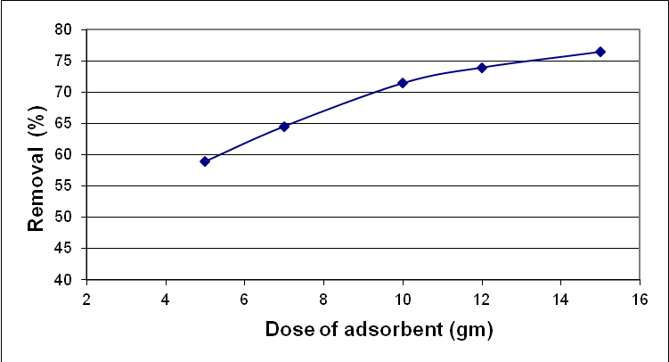

Fig. (2): Effect of sorbent dose on the removal of the Methyl red

5.2 Effect of contact time :
To investigate the contact time effect, an experiment was conducted by mixing (100)ml of methyl red solution of (500)mg/L concentration with (10)gm. of rice hulls adsorbent for (20, 40, 60, 80, 100, 120, 140, 160 and 180)min with agitation speed of 150 (rpm) at pH 3.
The contact time effect on the methyl red adsorption onto rice hulls is depicted in Fig.(3) which represents the relation between the percentage adsorption and adsorption time. The figure shows that the removal efficiency is equilibrium time dependent . It is evident that the extent of adsorption is rapid in the primary stages and becomes slow in later stages till saturation of the adsorbent is permitted. After (100 min.) from the beginning of adsorption process, the final dye concentrating did not vary significantly. This indicates that the equilibrium can be supposed to be accomplished after (100 min.).
This is understandable from the fact that throughout the initial stage, a large number of empty surface sites are available for adsorption, when time passes, the empty surface sites remaining are difficult to be occupied because of the forces of repulsion between the molecules of solute on the solid and in the bulk liquid phases (Gulipalli et al., 2011).
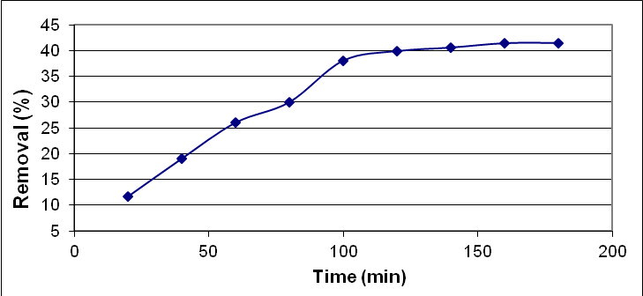

`

Fig.(3): Contact time effect on the Methyl red removal (C_{o}=500mg/L)

5.3. Effect of Initial concintration of MR:
A dosage of (10) grams from the adsorbent material were mixed with 100ml of methel red solutions of different concentrations (from 100 to 500)mg/L agitated for 100 min. in time and pH equal to 3.
The amounts of dye adsorbed versus varying initial dye concentrations were plotted in figure.(4). It was discovered that the adsortion capacity was improved with the increases in initial concentration of the adsorbate (0.36, 1.08, 1.88, 2.68, 3.68, and 3.67) mg/g. As well, the dye percentage removal had decreased when the dye concentration increased.
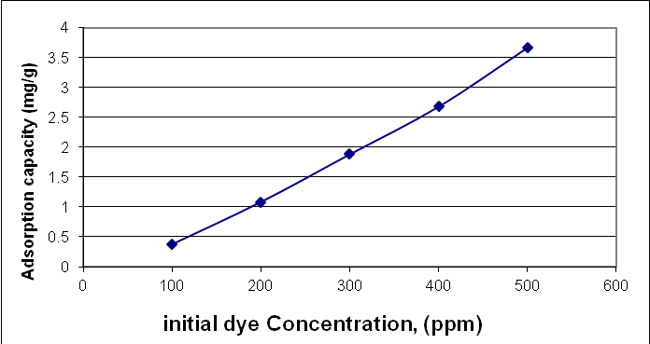

Fig. (4): Effect of Initial methyl red dye concentration on the capacity of adsorption of rice hulls
5.4. Effects of pH :
To investigate the effect of pH on the methyl red dye adsorption, a solutions of (500)mg/L concentration and varying pH values (3-9)was prepared and mixed for (100) min. with (10)gm. from rice hulls adsorbent of particle size (1.18)mm.
The uptake may be enhanced or depressed by the initial pH value. This is attributable to the charge of the adsorbent surface with the changes in pH value. The effect of solution pH on methyl red adsorption was studied and the results are illustrated in Figure(5).
It is obvious from the figure that the percentage adsorption decreased when PH increasing, reaching minimum value at pH equals 6. And beyond that the percentage adsorption begin to increase with pH increasing, reaching maximum value at pH equals to 9. The pH of the system exerts profound effects on the adsorptive up take of adsorbate molecules possibly because of its effect on the characteristics of the surface of the adsorbent and dissociation/ ionization of the adsorbate molecule. The increasing in the adsorption of the dye with decreasing of pH values is because of the attraction between the excess H⁺ ions in the dye solution and the dye
(Santhi et al., 2010).

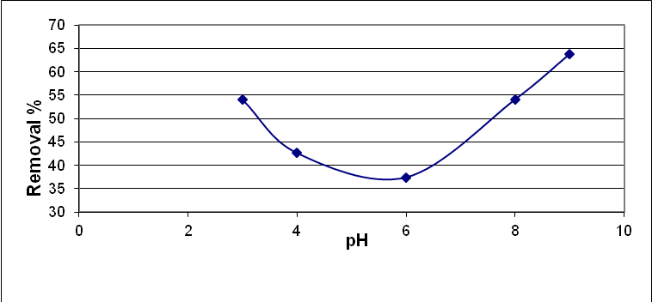

Fig. (5): Effects of pH on the utake of Methyl red dye

5.5. Effect of particle size:
The influence of the particle sizes (2.38, 1.18, 0.6 and 0.4)mm of the adsorbent in 100 ml methyl red solution of pH 3 and dye solution concentration of 500 mg/L for 100 min mixing time on the adsorption rate was studied .
Figure (6) shows the effects of rice hulls particle size on the adsorption uptake. The higher uptake of dye (3.33 mg/g) obtained by using (0.4 mm) particle size diameter comparing with the other particle sizes (0.6, 1.18, 2.38) mm which gave (2.99, 2.95, 2.63) mg/g respectively.
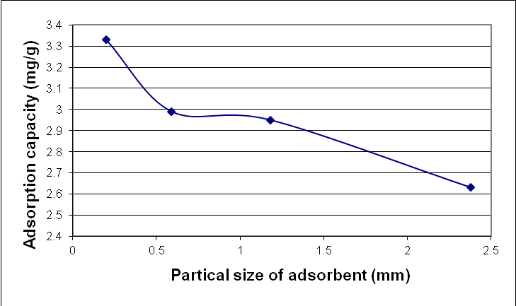
A larger surface for adsorption is offered by lower particle sizes, which have a tendency for increasing the dye sorption rate at the initial stages (Ofomaja, 2008), therefore, increasing the up take by smaller particles was attributed to the greater surface area for adsorption per unit mass of the adsorbent and the greater access to pores (Krishna and Swamy, 2012).

Fig. (6) : Effect of rice hulls Particle size on the adsorption rate of Methl red
6.Adsorption Isotherms:
At constant temperature the relation describing the amount of adsorbate adsorbed as a function of the amount of adsorbate remaining in solution in the equilibrium is called the adsorption isotherm.It has an importance from theoretical and practical points of view. For improving an adsorption system design for dye removal, it is significant for each system to find the correlations of the equilibrium data that are most convenient.Experimental adsorption data are described by equilibrium isotherms. An essential informations on the mechanisms of adsorption and the surface properties and tendencies of the adsorbent are offered by parameters acquired from various models. For single solute systems, Lingmuir and Freundlich models are the most extensively used surface adsorption models (Santhi et al., 2010), figure (7) represents the equilibrium adsorption isotherms of methyl red on rice hulls adsornent.
Adsorption isotherms are important in describing how adsorbate ions or molecules correlate with the sites of adsorbent surface, as well, are critical in determining the optimal adsorbent usage. Therefore, it is necessary for the adsorption explanation and forecasting of the extant of adsorption to use either an empirical or theoretical equations for correlating equilibrium data (Ozacar et al., 2008).
Isotherms of Freundlich and Langmuir (Freundlich, 1906; Langmuir, 1916) as cited in (Nasuha et al.,2011) are widely used in describing the equilibrium characteristic of adsorption.
Langmuir isotherm indicates to a homogeneous adsorption, in which at a finite number of certain sites, each site can only accommodate one molecule, with no transmission of the adsorbate in the plane of the surface. Langmuir model can be written as:
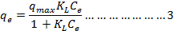
The above equation can be written in linear form to compute the value of the maximum capacity, q_{max} from the plot of C_{e}/q_{e} versus. C_{e}.
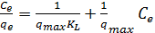………...4
where
q_{e} : The amount of dye adsorbed per gram of the adsorbent at equilibrium (mg/g).
C_{e} :The concentration in equilibrium of Methyl Red (mg /L).
q_{max}:The maximum monolayer adsorption capacity (mg/g)
K_{L} : Langmuir isotherm adsorption constant associated to energy.
R_{L}, equilibrium parameter, a dimension less constant, used to decide whether an adsorption is favourable or unfavourable (Reddy et al., 2013, Noroozi et al., 2004) and is calculated by
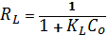…………………..5
Isotherm Nature | RL Values
Linear | RL =1
Favorable | 0< RL <1
Unfavorable | RL >1
Irreversible | RL =0
The linearized formula of the Freundlich isotherm model is derived to describe the characteristics of a heterogeneous surface of adsorption capacity and intensity with a nonuniform distribution of adsorption heat. The Freundlich equation can be written as:
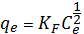…………………….6
Linearizing equation 6 in a logarithim form of Freundlich isotherm equation , we have
………6
Where
K_{F} : Freundlich isotherm constant indicates the capacity of adsorption (mg/g) (1/mg).
1/n : Related to the intensity of adsorption.
Ploting log q_{e} values vs. log C_{e} values producing a straight line, its slope and intercept represent 1/n and K_{F} respectively, fig.(8) represents the adsorption equilibrium isotherm of Methel red dye on rice hulls.
The suitable R_{L} values were found to be between 0 and 1. In this study, the calculated R_{L} value is ranged between 0-1, specifying that the equilibrium sorption was of a favorable nature for the adsorbent.
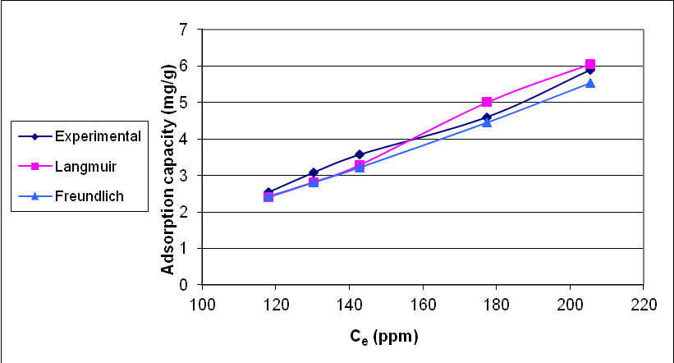

Fig. (7): equilibrium adsorption isotherms of methyl red on Rice hulls

7.Conclusions
This paper revealed that Rice hulls can used effectively as a cheap abundant for dyes removal from solutions under different operating parameters. The experimental data were fitted well with Langmuir as well Freundlich isotherms, and the type of methyl red dye adsorption on rice hull was favorable. The methyl red dye removal increased by increasing of adsorbent dose used and initial dye concentrations.
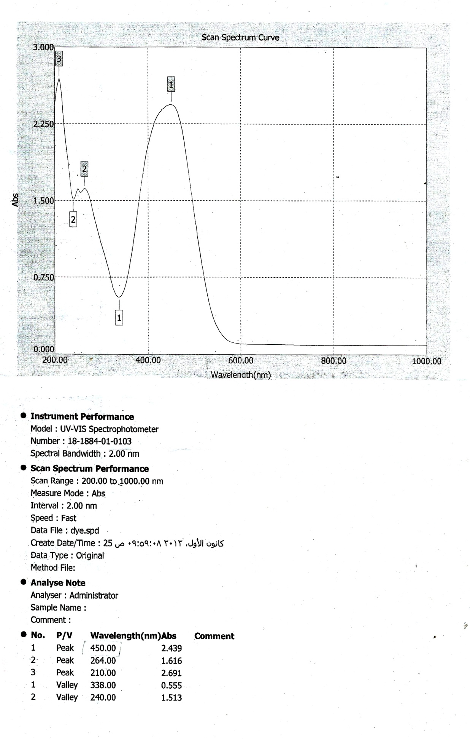

Fig.( 8): Scan Spectrum Curve of methyl red dye

8.References
Adowei, P., Horsfall jnr M. and Spiff A. I., 2012,“Adsorption of Methyl Red from Aqueous Solution by Activated Carbon produced from Cassava (Manihot esculenta Cranz) Peel Waste” Innovations in Science and Engineering 2,24-33.
Azhar,S. S,Liew A.G., Suhardy, D., Hafiz, K. F, Hatim,M. D. I., 2005,“Dye Removal from Aqueous Solution by using Adsorption on Treated Sugarcane Bagasse”, American Journal of Applied Sciences 2 (11): 1499-1503.
EL-Maghraby,A. and EL-Deeb,H.A.,2011,“Removal of A Basic Dye From Aqueous Solution By Adsorption Using Rice Hulls”, Global NEST Journal, Vol 13, No 1, pp 90-98.
Goel, P. K, 2006, “Water pollution–couses, effects, and control”, New Age International Publishers , New Delhi , India .
gulipalli1,CH. S.,Prasad B. and Wasewar,K.,2011,” Batch Btudy, Equilibirum and Kinetics of Adsorption of Selenium Using Rice Husk Ash (RHA)”, Journal of Engineering Science and Technology, Vol. 6, No. 5, 586 – 605.
Krishna, R.H. and Swamy,A.V.V.S., 2012,“Investigation On The Effect Of Particle Size and Adsorption Kinetics For The Removal Of Cr(vi) From The Aqueous Solutions Using Low Cost Sorbent”, Eur.Chem.Bull., 1(7), 258-262.
Mane1, V. S., Mall, I. D., and Srivastava,V.Ch.,2007,“Kinetic and equilibrium isotherm studies for the adsorptive removal of Brilliant Green dye from aqueous solution by rice husk ash”, Journal of Environmental Management, Vol. 84, Issue 4, 390-400.
Morcali,M. H., Zeytuncu, B. and Yucel, O., 2013, “Comparison of The Adsorption By Rice Hulls and Lewatit TP 214 of Platinum From Chloroplatinic Solution”, Journal of The Serbian Society, 78 (6) 811–826.
Nasuha,N., Zurainan, H.Z., Maarof, H.I., Zubir, N.A. and Amri N., 2011,“Effect of cationic and anionic dye adsorption from aqueous solution by using chemically modified papaya seed”, International Conference on Environment Science and Engineering IPCBEE vol.8 , IACSIT Press, Singapore.
Nemerow, N. L, 1971, “Industrial water pollution-origins, characteristics and treatment” , Wesley publishing company , Canada .
Noor,S. S, Rohasliney H., 2012, “ Rice Husk as Biosorbent: A Review”, Health and the Environment Journal, Vol. 3, No. 1.
Noroozi,B., Arami M. and Bahrami S.H., 2004, “ Investigation on the Capability of Silkworm Pupa as a Natural Adsorption for Removal of Dyes from Textile Effluent”, Iranian Journal of chemical engineering, vol.1, No.2, summer & autumn 2004, IACHE.
Ofomaja,A. E., 2008, “Kinetic Study And Sorption Mechanism of Methylene Blue And Meththyl Violet Onto Mansonia (Mansonia Altissima) Wood Sawdust”, chemical Engineering journal 143 , 85-95.
Ozacar,M., Ssngil I. A. and Turkmenler H., 2008, “Equilibrium and Kinetic Data, and Adsorption Mechanism for adsorption of Lead onto Valonia Tannin Resin”, Chemical Engineering Journal 143, 32-42.
Peavy, H.S, Rowe, D. R, and Techobanoglous, G, 1986,“Environmental Engineering”, MCG raw – Hill book company , New York , USA .
Reddy, MC. S., Ahmed Md S. M. and Aswini C., 2013,“Adsorption of Congo Red Dye from Aqueous Solution by Neem Leaf Powder”, Journal of Engineering and Technology (International Conference and Exhibition on Integrated Water, Wastewater, and Isotope Hydrology, Volume 2 | Issue 3.
Santhi,T., Manonmani,S. and Smitha,T.,2010,“Removal of Methyl Red from Aqueous Solutions by Activated Carbon Prepared from the Annona Squmosa Seed by Adsorption”, Chemical Engineering Research Bulletin 14, 11-14.
Sarkar, D. and Bandyopadhyay A., 2010, “Adsorptive Mass Transport of Dye on ice Husk Ash “ J. Water Resource and Protection, 2, 424-431.
Taha, D.N.,Mohammed L.A. and Samaka I.S.,2012,“Investigation on using rice–husk as low cost adsorbent for dye removal from industrial wastewater”, The First Scientific Conference the Collage of Education for Pure Sciences.
Velmurugan, P, Rathina, k.V. and Dhinakaran,G.,2011,“Dye removal from aqueous solution using low cost adsorbent”, International Journal of Environmental Sciences, Volume 1, No 7.
Fig.( 9): Scan Spectrum Curve

Fig.( 9): Scan Spectrum Curve

