Glazing and Coloring of Cellular Concrete Blocks

Samir H. Awad Elham Abd Al-Majeed Mohammed Al-Issawi
College of materials engineering ,nonmetallic department
ceramics and building materials , Babylon university

Ceramicengsamir2003@yahoo.com drelham_2003@yahoo.com englulu59@yahoo.com

Abstract

Thermostone is one of the important materials which have been spraying glazed using different glass mixtures based on alkaline (A₅), lead glasses (A₄) and their composition at different glass/water (G/W) ratios using a special holder have been designed to keep the glazing on top of thermostone and thereby, protect the other surfaces from damage. Physical and mechanical properties, color, roughness and other properties have been investigated with the aid of microscopic analysis. Duplex layers of A₅-glazed layer on pre-coated A₄-layer (total thickness of 1.4mm) proved their superiority among A₄-glazed layer (0.2mm) and unglazed surfaces, especially those glazed at G/W ratio of 30/70 where the standard thickness (1.5mm) for glazing of pours bodies due to the action of composition of A₅- glaze mixture and its effects in sealing the pores and thereby, improving all the properties. The glazing process in this study introduced a glazed thermostone with improved properties using spray technique by means of compressive strength ,porosity, hardness , water absorption and bulk density aspects.
الخلاصة
ان الكتل الخرسانية الخلوية او ما يسمى بالثرمستون اصبح له استخدامات كثيرة في السنوات الاخيرة في عمليات البناء والانشاءات والتقطيع في الدور و العمارات نظرا لتميزه بمواصفات مثل العزل الحراري الخاص للاستخدام في البنايات من الداخل والخارج , خفة وزنه و كبر حجم المقاطع المستخدمة.
ان مقاومة الانضغاط لهذه المادة والمسامية العالية تحد من استخدام الثرمستون لبعض التطبيقات علاوة على ان سطوح الثرمستون بعد البناء تحتاج عمليات تشطيب وانهاء باستخدام السمنت او السيراميك والمواد الاخرى لحماية السطوح ولغرض الحصول على الديكور والمنظر المناسب. تم في هذا البحث تزجيج سطوح عينات من الثرمستون المجهز من قبل معمل ثرمستون كربلاء بطريقة الرش وباستخدام خلطات زجاجية مختلفة ,قلوية (خلطة A₅ بدرجة 920C°) , وزجاج الرصاص (خلطة A₄ بدرجة 550C°) وخلطات اخرى مركبة من مزيجهما عند نسب زجاج/ماء (G/W) مختلفة وباستخدام حواضن خاصة لغرض تزجيج السطح العلوي فقط وحماية بقية السطوح من التلف.
المواصفات الفيزيائية والميكانيكية ,اللون ,خشونة السطح وفحوصات بصرية تم دراستها بمساعدة الفحص المجهري باستخدام المجهر الضوئي لتقيم الطبقات الناتجة بعد التزجيج. النتائج اظهرت امكانية استخدام عملية التزجيج الثنائي الطبقة (طبقة من زجاج A₄ ثم طبقة من زجاج A₅ بسمك اجمالي 1.4ملم) في خلق طبقة زجاجية ملتصقة بالسطح الاساس وبسمك ضمن السمك القياسي للتزجيج (1.5ملم) وتحسين مواصفات الثرمستون وتحقيق الديكور والجمالية والتلوين المطلوبة. البحث في هذا الموضوع يحتاج الكثير من الدراسات المستقبلية لدعم هذه المحاولة.
هذه الطبقة الثنائية وبالخصوص عند نسبة G/W مساوية 30/70 حققت مواصفات افضل من كل الخلطات ومن مواصفات الثرمستون بدون تزجيج نفسه بسبب خاصية مكونات الطبقة A₅ القلوية في غمر المسامات وتحسين الصفات بوجود الطبقة الزجاجية. النتائج اوضحت ان مقاومة الانضغاط و الصلادة قد تحسنت بعد التزجيج. كذلك المسامية ,امتصاصية الماء ,الكثافة و خشونة السطح قد تحسنت بعد التزجيج ايضا بالوان جذابة اختلفت باختلاف تركيب الزجاج. نتائج الفحص المجهري اثبتت تأثير التزجيج في الحصول على اجسام قليلة المسامية خصوصا تلك المزججة عند نسبة G/W مساوية الى 30/70 .

1.Introduction

Thermostone is a construction material, which is commonly used in Iraq as a filling material in blocks, panels, ceiling panels, pre-cast exterior walls, void filling, roof insulation, thermal insulations, sound insulation, floors and low cost housing .It dose essentially consist of cement, sand and lime, which are mixed in a different propositions I.Q,S2000.
Thermostone is one of the important materials, which is also known as autoclaved cellular concrete (ACC),autoclaved lightweight concrete (ALC), autoclaved concrete(AC), cellular concrete(CC), porous concrete(PC). AAC products include blocks, wall panels, floor and roof panels, cladding (facade) panels and lintels Simge2006 and W.van 2014 . The main advantage of manufacturing cellular AAC is to get high thermal insulating material Sasan 2011 with suitable density and compressive strength to be used as a lightweight units in masonry works Ali A.Hussain2012 . AAC is an environmentally friendly building material that is used to save energy and enhance the quality of the built environment TECHNOLOGY BRIEF 2010.There are different ways to improve the physical and mechanical properties of thermostone. Researches focus on solving the problems that occur during thermostone manufacturing, improve the physical properties and mechanical properties to qualify within the building materials by changing the composition or by additions or changing of temperature and porosity as well as for insulation applications. Glaze is a special type of glass, made for coating ceramic products.
678
Glazes are glass with various modifiers added to affect their behavior and appearance. Now days architecture is focusing on decoration and aesthetic properties because of the increased demands for such modern requirements. Furthermore, there are now few works being interesting in produced of a glazed bricks to reduce the cost and energy consumed in traditional masonry works such as coating, painting, ceramics covering and other finishing works. Thermostone is now becoming increasingly used in in construction and partitions works due to its superior properties mentioned above.Unfortunately, there is no technique right now could introduce an improved and decorated thermostone without any additional masonry works. The objectives of this study are to glaze the thermostone to exhibit it both improved and decorative properties by spray glazingwithdifferentglasses.

2.Experimental procedure

The rmostone blocks with dimensions of 30×30×30 mm supplied by "thermostone Karbala company" were selected as the raw materials in this study.
Several trial mixtures were conducted to obtain the optimum mixture which can guarantee the glazing obtainment with the best result . The glazing trials were done using different percentage weights for the following materials (Lead, Alkali, Silica, China clay) , to be mentioned that the nominal size for all the trial mixture pass on sieve number 200. The tried glazing mixtures are shown in table (1-1 ) .
Table (1-1): The tried glazing mixtures

Mix. Type | Lead wt% | Alkali Glass wt % | Silica wt% | China Clay wt%
A₁ | 50 | 50 | ــــــــــــ | ــــــــــــ
A₂ | 80 | ــــــــــــ | 10 | 10
A₃ | 30 | 70 | ــــــــــــ | ــــــــــــ
A₄ | 60 | ــــــــــــ | 20 | 20
A₅ | ــــــــــــ | 100 | ــــــــــــ | ــــــــــــ

Samples A1 could give undesirable results in terms of appearance , shrinkage and distribution,samples A2 could also give undesirable properties,samples A3 gave undesirable characteristics of appearance. It is obvious that inconsistencies between the glaze layer and the substrate, Samples A4 could not obtain the desired texture (smoothness),in spite of the existence of matching between the sample surface and the glass layer. The improvement in matching feature recorded for this mixture denotes that the lead weight percentage for this mixture which is quite high comparing with the other oxides,could be the most responsible oxide for this matching and finally, the mixture A5 could give the best result in terms of texture appearance and all the other properties, thus all the works on glazing improvement and their tests were conducted using the mixture of samples A5 shows in fig.(1-0).
679

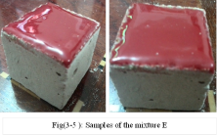
Fig(1-0 ): Samples of the mixture A₅

3.The chemical composition of the trial mixture A₅

A pre-mixed 100g Alkali glass was used in the glazing process. Table (1-2) shows it's chemical analysis .

Element | K₂O | Na₂O | BaO | CaO | B₂O₃ | Al₂O₃ | SiO₂
% | 2.2 | 11.2 | 6.3 | 14.1 | 13.7 | 7 | 45.2

Ceramics stains or pigment were also added to the mixture of alkali glass with percentage 5% and as shown in Table (1-3)
Table(1-3):Chemical composition of ceramics stains

pigment | SnO2 | CaCO3 | SiO2 | Na2O.2B2O3.10H2O | K2Cr2O7
% | 50 | 25 | 18 | 4 | 3

- Optimization of mixture A₅

Several and consequence attempts were carried out to get the best smoothness and the best match on mixture A₅. It was found that the best results can be produced by painting the thermostone sample surface with a thin layer of lead thickness of (0.2) mm, to obtain a match ( less shrinkage) between the glass layer and the sample surface, before spraying with the coated glazing (mixture A₅) with thickness of (1.4) mm .
Then, different weights of alkali glass A₅ powder and mixture A₄ with different weights of water were used to investigate the flow of curdled glass at different times of sprayed and constant thicknesses, the greater the ratios of glass to water, the less spray time as illustrated in the Table(1-4).
Table (1-4): Optimization of mixture A₅

No. | Water(W)g | Glass(G)g | Percentage  (G / W) % | Spray Time  sec | Thickness A₄  mm | Thickness A₅  mm
1 | 90 | 10 | 10/90 | 35 | 0.2 | 1.4
2 | 70 | 30 | 30/70 | 25 | 0.2 | 1.4
3 | 50 | 50 | 50/50 | 15 | 0.2 | 1.4

It was found that the ratio 30/70 with spray time of 25 seconds could give the best results in terms of flow of spraying and penetration of the glaze materials into the pores, and the best results practically and economically. An electric furnace was used for firing processes.
680

5. Mixing and spraying
After getting the curdled and homogenous mixture of glass and water (for each mixture shown in Table 1-4), the resulted glazing mixture was then put in a pot spray gun in order to be ready for spraying . An air compressor was used to spray the glaze raw materials with conditions of rated revolving speed 2800 r/min and pressure pumping 90 Kg/cm².

6. Firing process

The next step of glazing operation, after mixing and spray was the firing the glazed samples. Fire bricks were used to incubate the thermostone unglazed faces as in figure (1-1) . Several cubic holes were manually excavated though the bricks body according to the dimensions of thermostone samples after preparing the thermostones holders, the samples top faces were sprayed with the lead layer (mixture A₄) . Three stages firing process was applied an average 10 thermostone cubes gathered and rolled inside the fire bricks for each stage. Firing process of A₄ glazed samples at degree (550 C°) for (3hr) and firing process of A₅ glazed samples at degree (920 C°) for (4hr) with half an hour soaking time. After 24 hours , the samples were taken out of the furnace. By completing this step glazing cohesive has its excellent smoothness and match.

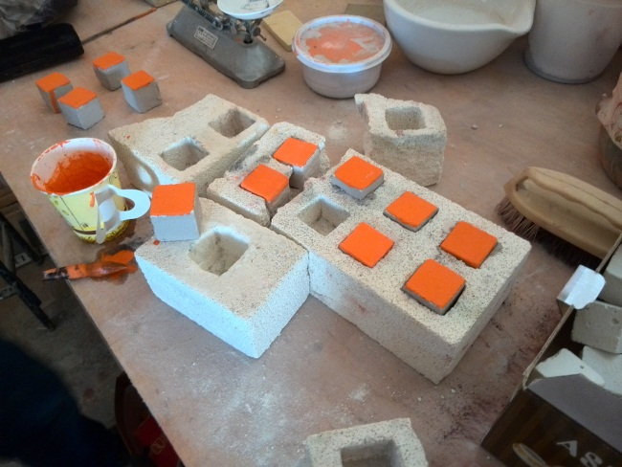
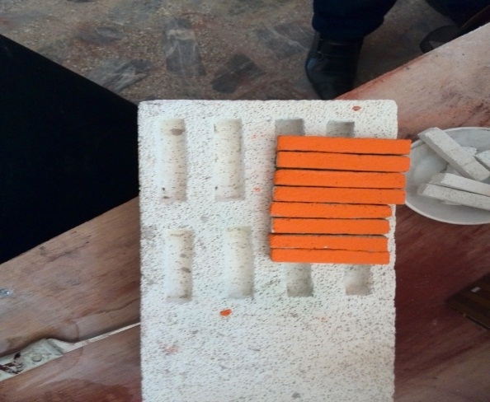
Fig(1-1): Cubic holes in the fire bricks

7.Results and discussion
Porosity and water absorption measurements:

For A₄ glazed samples (fig. 1-2), G/W ratio of 30/70 recorded the less porosity (47.2%) because of that suitable constitution which curdled glass could have at 30/70 ratio, whereby, the curdled glass penetrated and sealed the pores. In view of above, 50/50 ratio recorded the highest (51.4%) porosity ratio where the more dense constitution could disenable the curdled glass from close the pores. Such behavior proves the effecting of the constitution of the curdled glass on the porosity ration.
A₅ glazed samples (fig.1-3) recorded porosity rations (46.6%-50.1%) less than those of A₄-glazed samples. It is useful to mention that the glazing at 920 C° in the A₅-glazed the layer could give the desired properties by means of physical and mechanical due to the glaze alkaline composition and its interaction with thermostone substrate. Figures (1-4) and (1-5) show results of water absorption. The glazed samples showed the same behavior recorded for porosity ratio, where glazed samples with high porosity exhibited high water absorption. It is clear that the absorption ratios of unglazed samples are higher (94.05%) than those of A₄-glazed samples (71.1% -85.7%) and A₅-glazed samples (69.5% -79.6%). A₅-glazed samples recorded absorption ratios less than these of A₄-glazed samples depending on the effect of porosity. A₄-glazed and A₅-glazed samples using 30/70 G/W ratios recorded the less water absorption in comparing with other glazed samples.
681

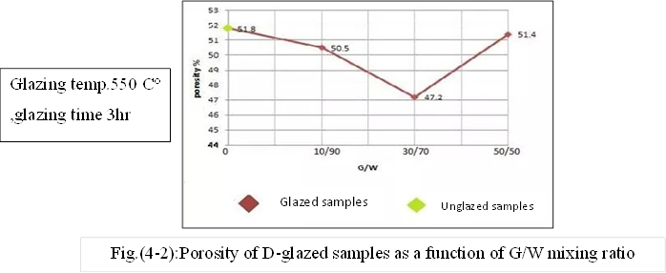
Fig.(1-2):Porosity of A₄-glazed samples as a function of G/W mixing ratio

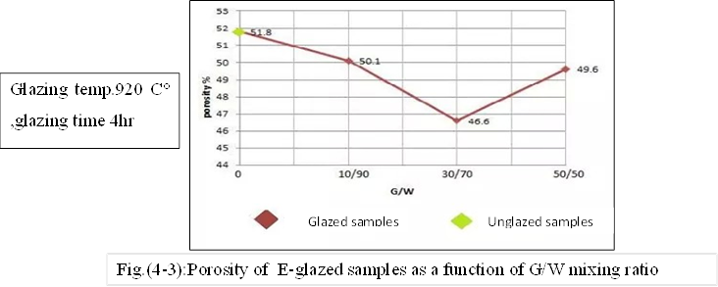
Fig.(1-3):Porosity of A₅-glazed samples as a function of G/W mixing ratio

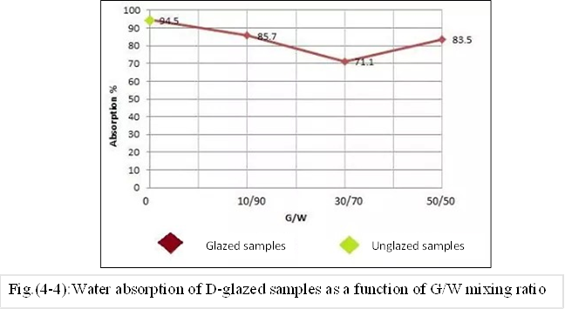
Fig.(1-4):Water absorption of A₄-glazed samples as a function of G/W mixing ratio

682
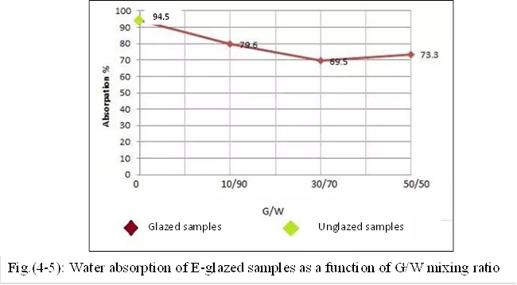
Fig.(1-5): Water absorption of A₅-glazed samples as a function of G/W mixing ratio

Bulk Density:

The bulk densities of glazed and unglazed samples are shown in fig.(1-6) and (1-7). It is clear that the bulk densities of unglazed samples are (0.54 g/cm3) less than these of A₄-glazed samples (0.58-061)g/cm3 and A₅-glazed samples (0.62-0.67)g/cm3 due to the same effects of porosity mentioned in fig.(1-2 to 1-5). A₅-glazed samples could record the best results. The highest result of densities can be observed for A₅-glazed samples at 30/70 G/W ratio in comparing with other glazed samples.

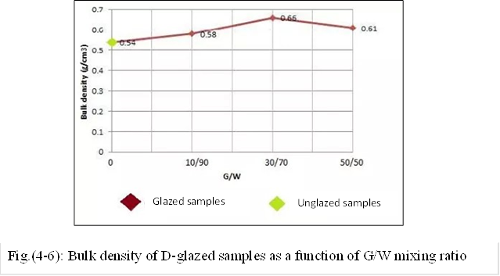
Fig.(1-6): Bulk density of A₄-glazed samples as a function of G/W mixing ratio

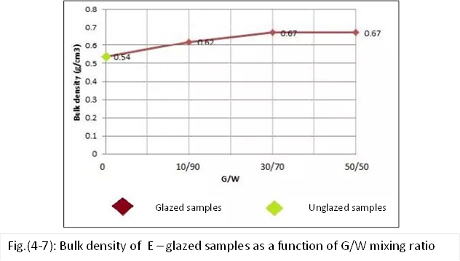
Fig.(1-7): Bulk density of A₅ – glazed samples as a function of G/W mixing ratio

683
Thickness:

The thickness of A₄-glazed layer was (0.2 mm) because of that non- uniformity of the glaze layer and it could not give the required glaze layer. For the A₅-glazed layer, the thickness was (1.4 mm). This result is more acceptable in considering the layer thicknesses in the lecture which is up to (1.5 mm)) ( علي حيدر،2002.
Roughness surface:
Figure (1-8)shows the results of surface roughness of A₅- glazed. It is obvious that increasing of roughness with G/W ratio increasing. Despite such behavior, the samples glazed at 30/70 G/W ratio could give the lowest (0.261 µm) value among all samples overall all samples recorded roughness in the range (0.261 – 0.391) µm , and less than unity (1), which means that these samples could have a smooth surface according to the standard roughness value (1.16 µm) of the device sample. A₄-glazed samples could not be tested due to their high roughness.
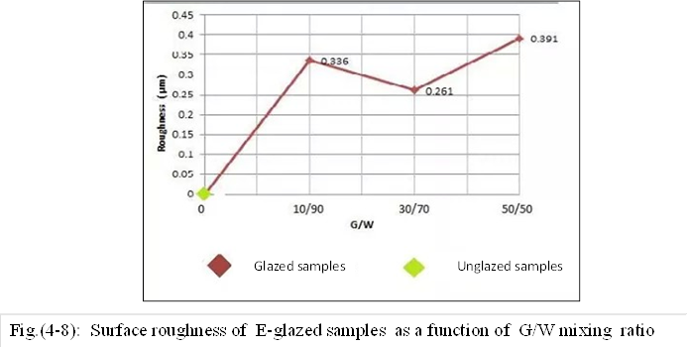
Fig.(1-8): Surface roughness of A₅-glazed samples as a function of G/W mixing ratio
Compression Strength:

It is obvious from fig.(1-9) that decreasing of compressive strength (0.396 – 1.582) MPa of glazed samples (2.39 MPa) due to present of PbO (60%) in the glass structure which decreased the mechanical strength of the glaze. Anyhow, samples glazed at 30/70 % G/W ratio recorded the best results among other glazed samples. Furthermore, A₅-glazed sample fig.(1-10) at this ratio could record the best result (2.472 MPa) among all samples due to alkaline composition in the A₅-glass which increased the mechanical strength. In addition, reduction of porosity in A₅-glazed samples hers its effect in improving the mechanical properties.

684

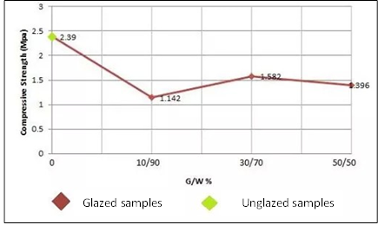
Fig.(1-9): compressive strength of A₄-glazed samples as a function of G/W mixing ratio

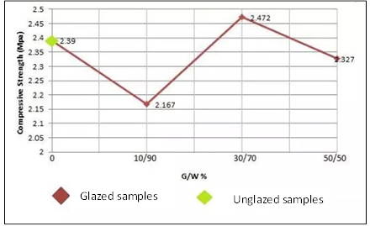
Fig.(1-10): compressive strength of A₅-glazed samples as a function of G/W mixing ratio

Micro- hardness:
Results of Vickers hardness are shown in fig.(1-11) and (1-12). The hardness of unglazed thermostone was 350.6 Hv (3.438 GPa) while after glazing it could be improved to (424.8 – 846)Hv. The A₅-glazed samples at 30/70 G/W ratio could record the best result 846.2 Hv (8.298 GPa) due to improved properties of density and porosity in such type of glass.

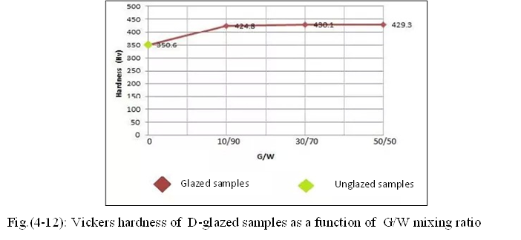
Fig.(1-11): Vickers hardness of A₄-glazed samples as a function of G/W mixing ratio

685
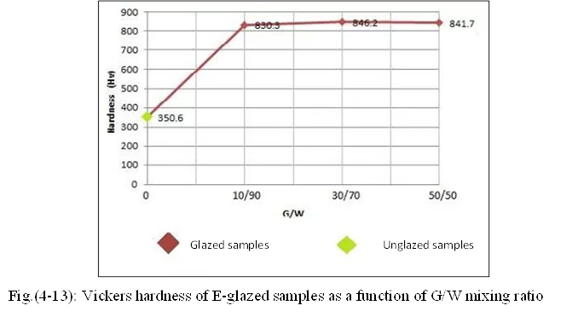
Fig.(1-12): Vickers hardness of A₅-glazed samples as a function of G/W mixing ratio

Digital Microscope (S04-600X):
Figures(1-13) and (1-14) show the microscope images and color analysis of A₄ and A₅-glazed samples. Generally, figures could prove the porosity differences between the glazed and unglazed samples due to glazing process. It can be observed that difference in color between A₄ and A₅ –glazed analysis depending on the glazing temperature and oxides components. White areas in the micrographs of glazed samples denoted for uncoated substrate during the glazing less penetration of the glass. However, A₅-glazed micrographs showed more dense and less pores layers in comparing to those of A₄-glazed micrographs. Micrographs of glazed samples at 30/70 G/W ratios showed the best results among all the glazed samples by means of pores sealing and glazing distribution. RAD spot areas in micrographs of A₄-glazed samples denoted for glazes which didn’t fully fired. Also, areas of dark –yellow color denoted for more penetration of glaze into the pores, while these of light-yellow color denoted less penetration.

Photograph  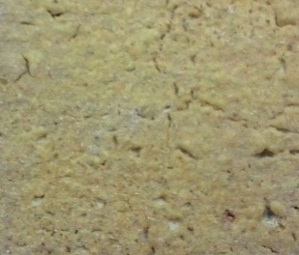 |  |  |  | DM
 |  |  |  | 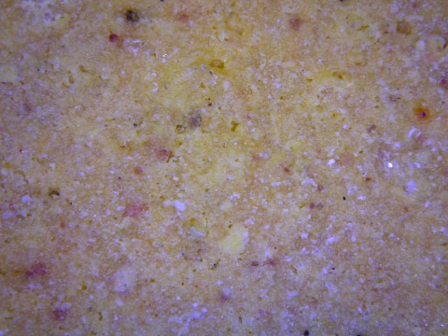
Oxides Composition |  | Mix. Type
G/W | Spray Time | A₄ |  | Roughness | Surface Tension (N/mm²) | Hardness (Hv)
30/70 | 25 sec | A₄ |  | errer | 332 | 430.1

686
Results of color analysis
b)) | a)) |  | L))
34.59 | 6.90 |  | 72.34
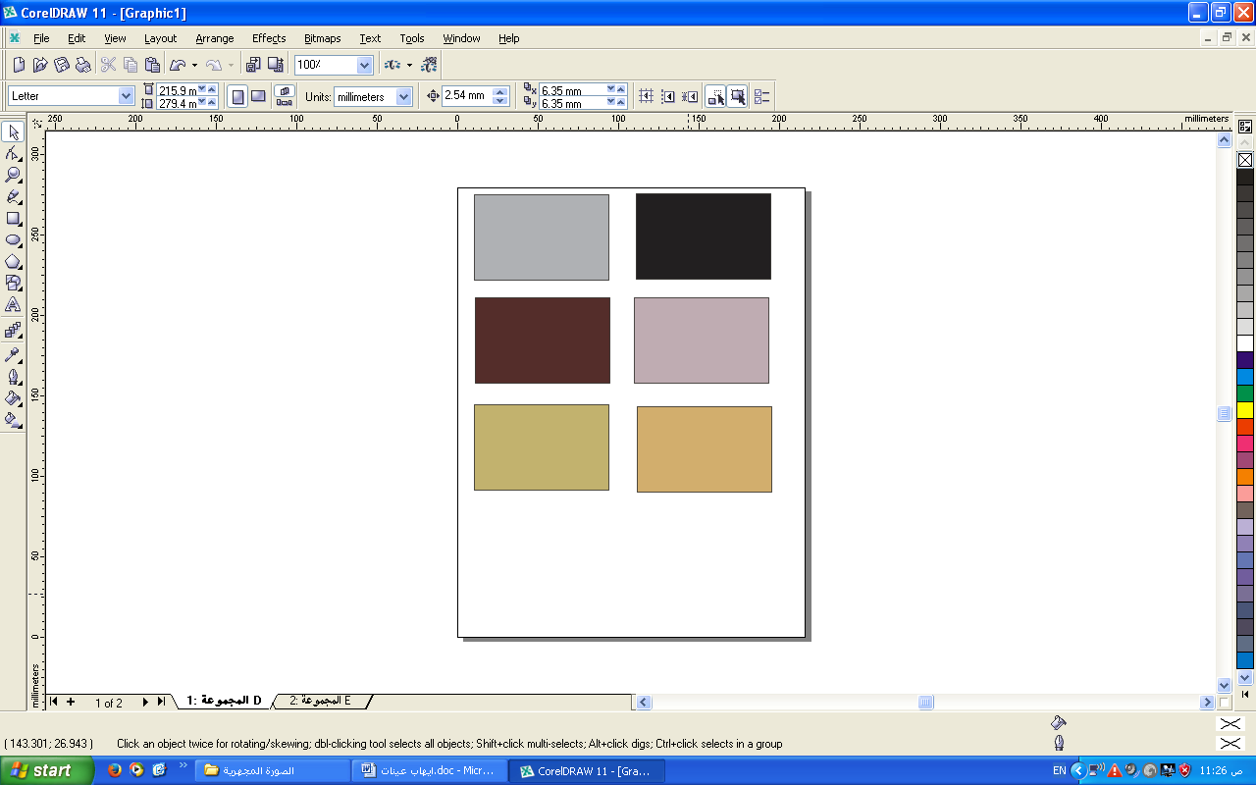 | 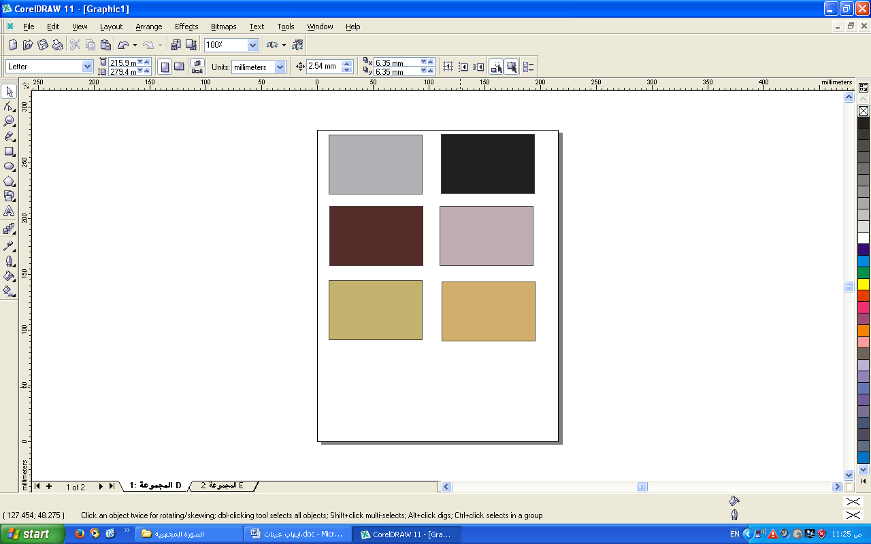 |  | 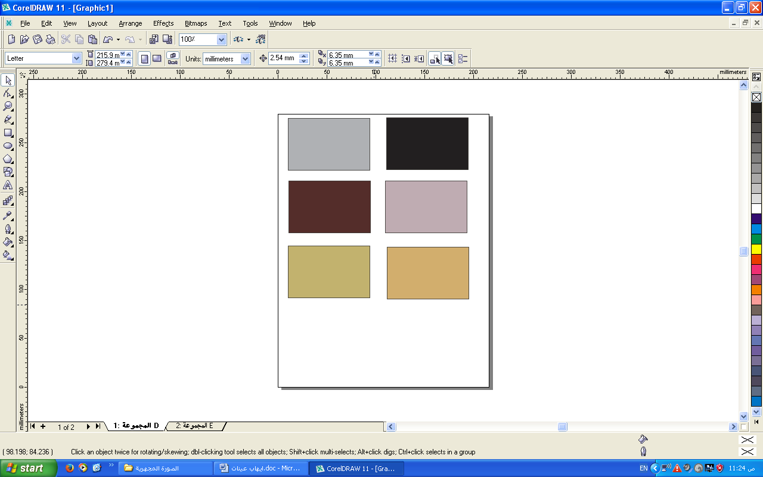
L.b)) |  | (L.a)
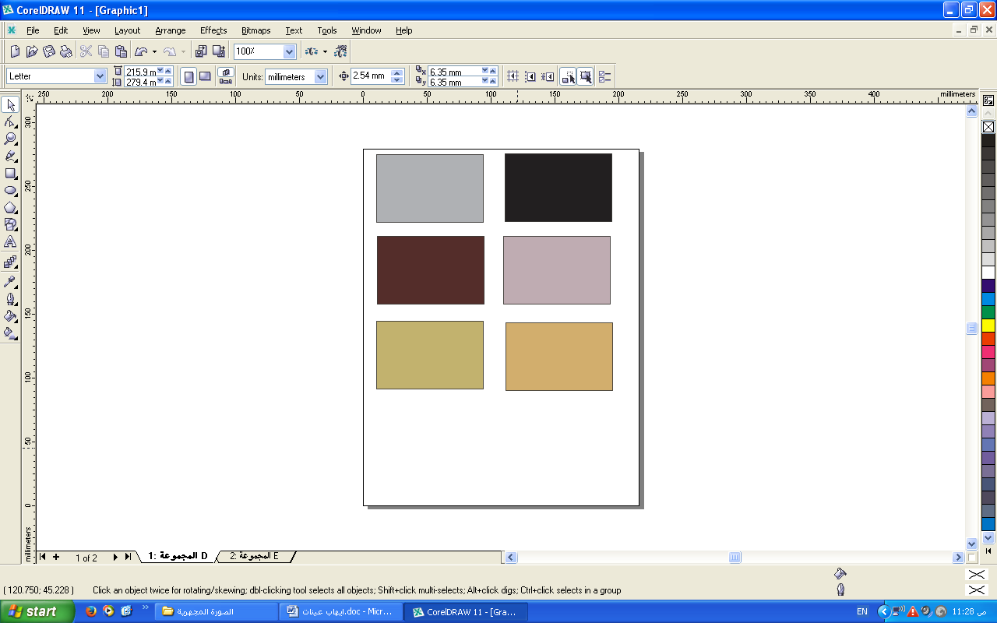 |  | 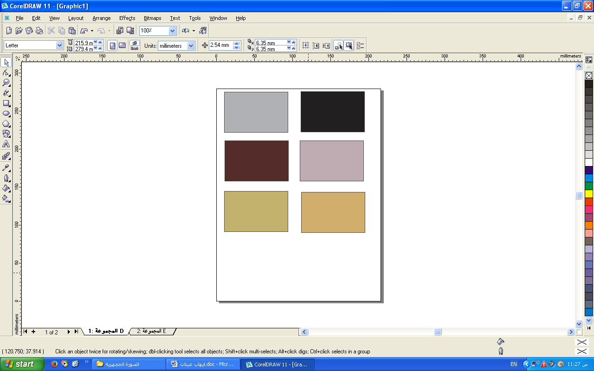
L.a.b))
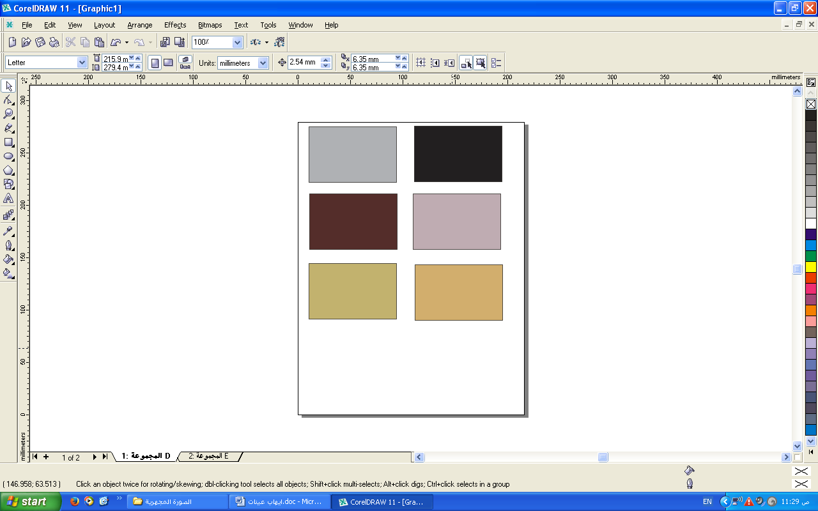

Fig. (1-13) : Represent the (DM) micrographs , Photographs and Color analysis for A4-glazed samples at 30/70 G/W ratio .

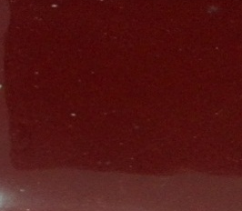  Photograph |  |  |  | DM
 |  |  |  | 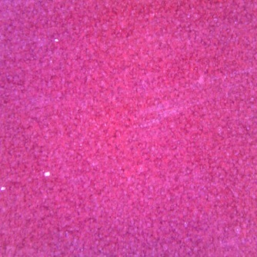
Oxides Composition |  | Mix. Type
G/W | Spray Time | A₅ |  | Roughness | Surface Tension (N/mm²) | Hardness (Hv)
30/70 | 25 sec | A₅ |  | 0.261 | 334.86 | 830.3

Results of color analysis
b)) | a)) |  | L))
7.80 | 20.96 |  | 34.53
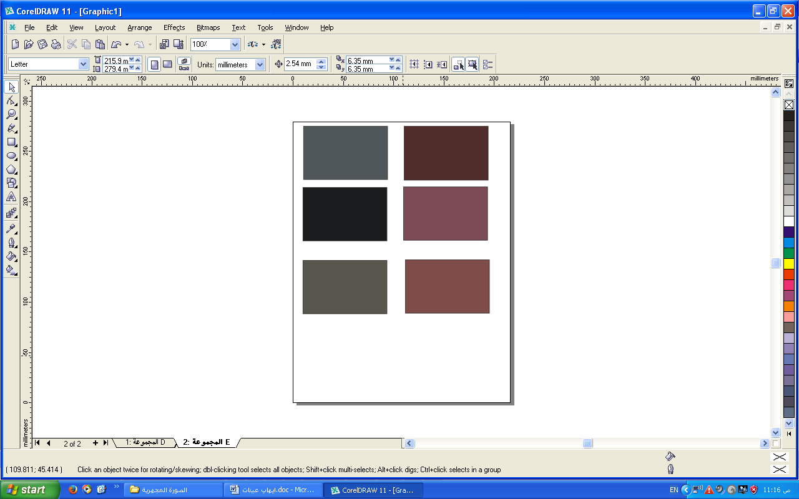 | 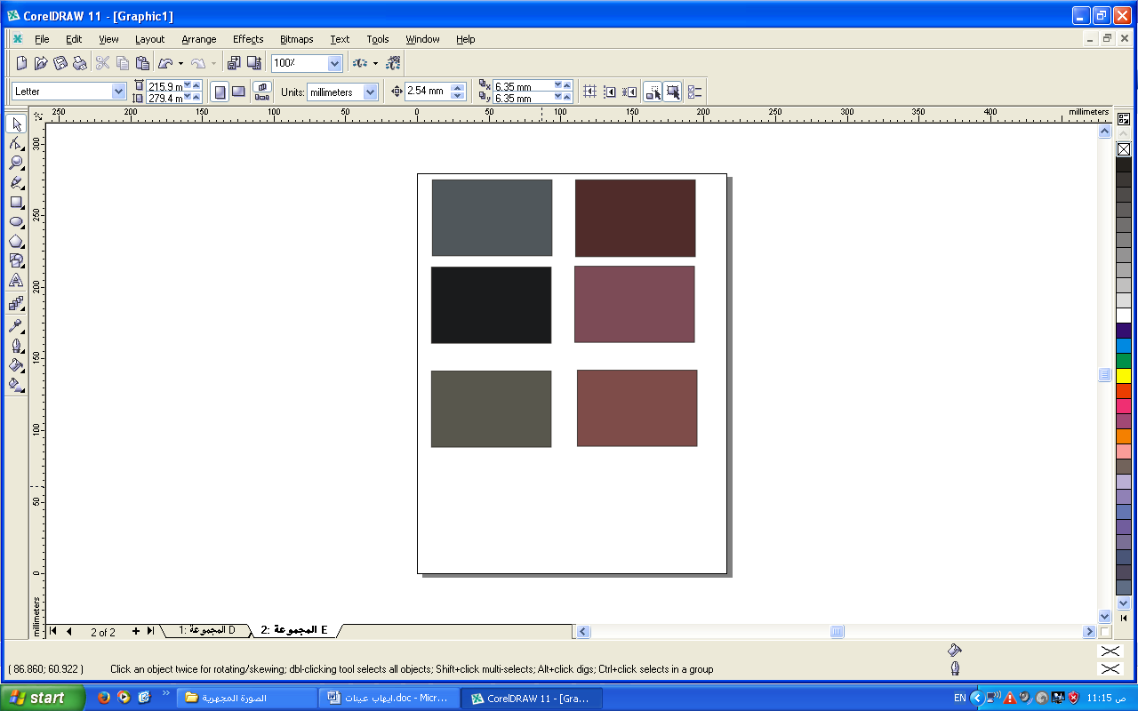 |  | 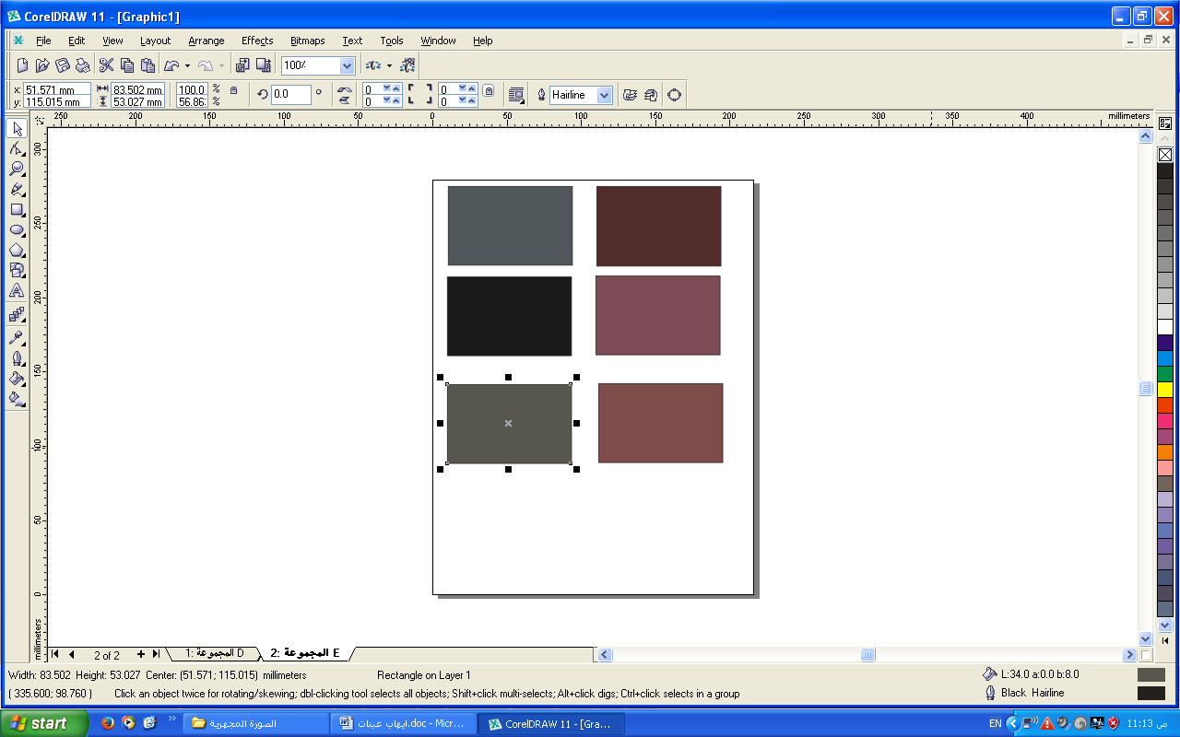
L.b)) |  | L.a))
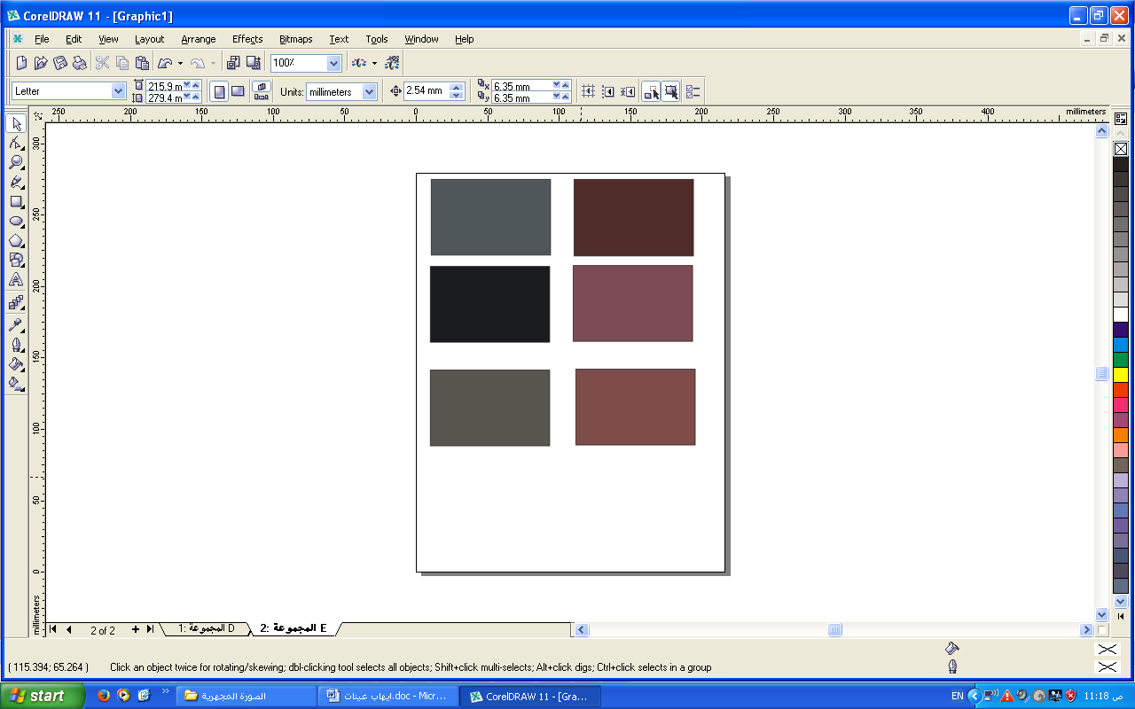 |  | 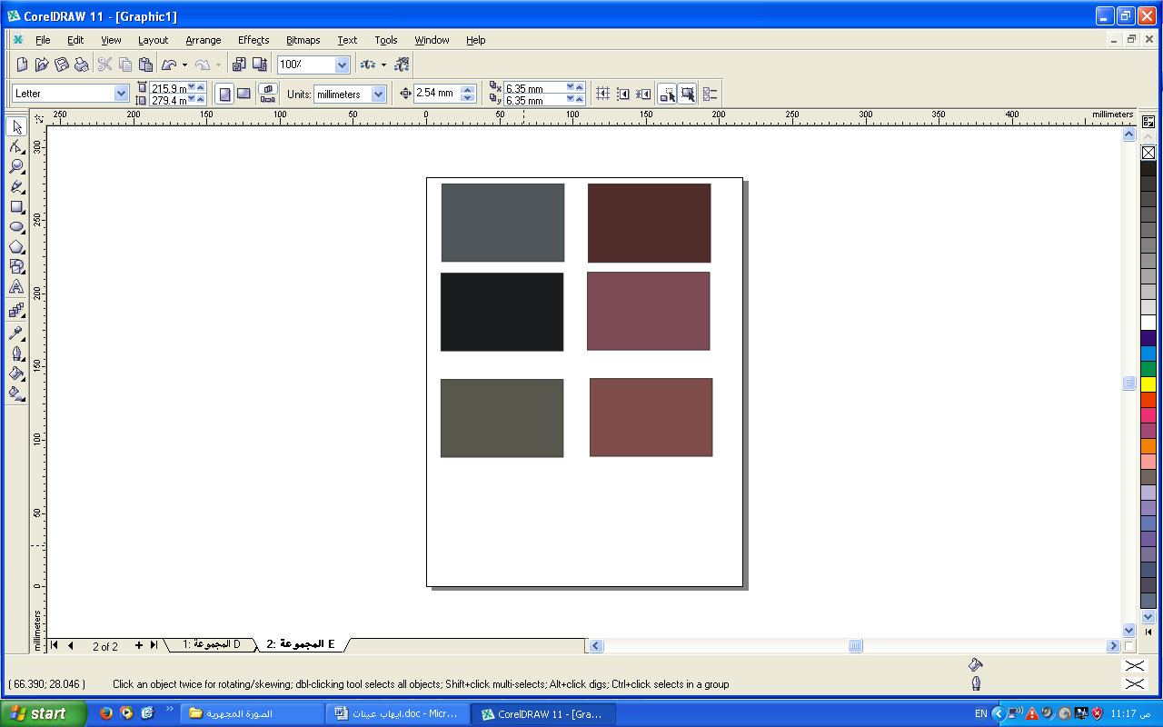
L.a.b))
687
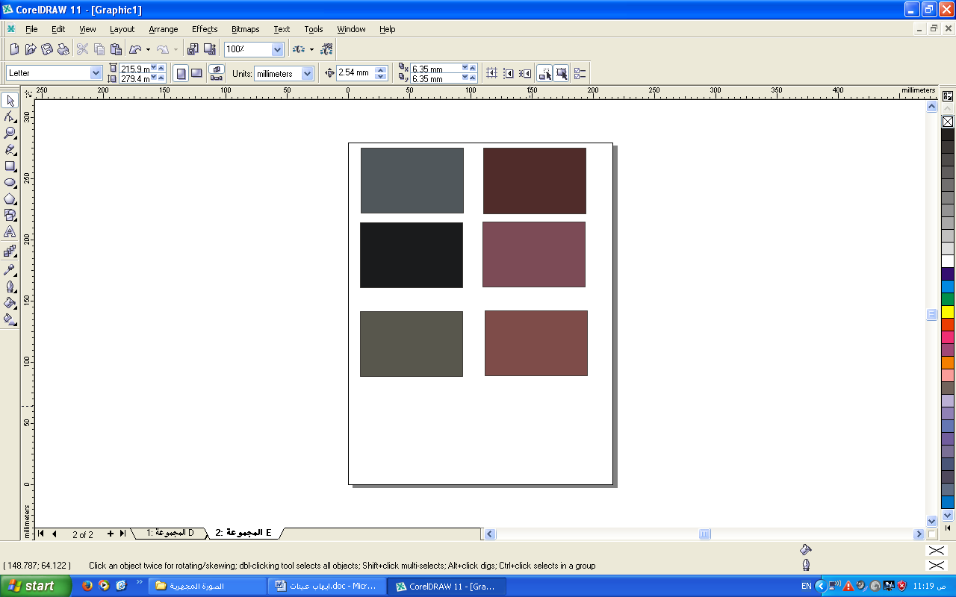

Fig. (1-14) : Represent the (DM) micrographs , Photographs and Color analysis for A5-glazed samples at 30/70 G/W ratio .

Conclusions
1. The study could introduce a glazed thermostone with improved properties using spray technique by means of compressive strength ,porosity, hardness , water absorption and bulk density aspects.
2. Duplex layer of A₅-glazed layer (Alkaline glass fired at 920 C°) coated on pre-coated layer of mixture A₄ (lead glass at 550 C°) at G/w ratios of 30/70 gave the best results among other mixtures and unglazed surfaces, whereby, a curdled glass with a suitable consistency and density, and spraying process could be achieved.
3. In terms of mechanical properties, it is interesting to know that samples without glazing had a lower compressive strength of about 2.390 MPa than that of A₅-glazed thermostone at (30/70) ratio which recorded the its maximum value of about 2.472 MPa with a microhardness value of 8.298 GPa.
4. In terms of decoration , the roughness surface of the glazing thermostone with the mixture A₅ was about (0.261µm) at (30/70) ratio which was much lower that of the standard roughness value (1.16 µm) and microscope images proved the effect of A₅-mixture glaze in producing a semi-non porous and uniform glazed surfaces specially those at 30/70 G/W ratios.
References
الجهاز المركزي للتقييس والسيطرة النوعية,المواصفات القياسية العراقية الخاصة بالكتل الخرسانية الخلوية (الثرمستون) , رقم 2000/1441.
Ali A. Hussain abdulameer,2012"Types of failure in cellular concrete Blocks (Thermostone)" , Kufa Journal of Engineering, ,Vol.3.no.2pp.101-114.
http://www.aircrete-europe.com/images/download/W.M.%20van%20Boggelen%20-%20History%20of%20Autoclaved%20Aerated%20Concrete.pdf
Sasan Somi,2011" Humidity Intrusion Effects on Properties of Autoclaved Aerated Concrete".
Simge Andolsun,2006" A Study on Material Properties of Autoclaved Aerated Concrete (aac) and its Complementary Wall Elements:their Compatibility in Contemporary and Historical Wall Sections".
Technology Brief 2010 http://www. imiweb. org/design_ tools/tech_ briefs/01. 02%20AAC%20MASONRY%20UNITS.pdf
Van, W. Boggelen, 2014" History of Autoclaved Aerated Concrete".
علي حيدر صالح البدري,2002،"كتاب التقنيات العلمية لفن الخزف التزجيج والتلوين",الطبعة الاولى- الاردن.

688

