Evaluation of Traffic Accidents Rates in Al-Diwaniya City

Jalal Taqi Shaker Al-Obaedi
Department of Roads and Transport Engineering, University of Al-Qadisiya.
JALALALOBAEDI@GMAIL.COM
Abstract
Although the enhancing of traffic safety is the main concern of the local highways agencies, traffic accidents have been increased rapidly in recent decades mainly due to sharp increase in vehicles using road networks. In order to limit such increase, the causes of accidents should be analyzed properly so as to consider proper solutions. This paper uses real data taken from the local traffic agency in Al-Diwaniya city for the period from 2004 to 2013 to indentify the frequency and causes of traffic accidents.Questionnaire technique has also used in this study to show the percentage of unrecorded accidents. The results showed that the average deaths in the city caused by traffic accidents was found to be 33 deaths per 100000 population which is much higher than the world’s average death rates of 18 deaths per 100000 population. It is found that more than 50% of traffic accidents are related to drivers’ errors while the faults which may happen for vehicles are representing about 24%. About 46% of the recorded accidents are found to be when vehicles are hitting pedestrians while about 32% of accidents are related to vehicle collisions. This suggests that some attention should be given to enhance the pedestrians’ safety. The questionnaire results showed that about 21% of accidents are not recorded within the local traffic agency and 39% of vehicles are involving traffic accidents. Some recommendations are suggested in order to reduce traffic accidents such as the use of median barriers to regulate pedestrians crossing, and the use of intersections channelizing, tunnels and bridges so as to reduce traffic collisions.
Keywords: Traffic safety, accident types, accident statistics, accidents questionnaire
الخلاصة
على الرغم من ان تحسين السلامة المرورية هي المتطلب الاساسي للدوائر المعنية بالطرق فان معدلات الحوادث المرورية في تزايد مستمر كنتيجة حتمية للزيادة الحادة في عدد المركبات المستخدمة لشبكات الطرق. لغرض تحجيم الزيادة في الحوادث المرورية يجب دراسة اسباب الحوادث لغرض عمل الاقتراحات والحلول اللازمة. في هذا البحث تم استخدام بيانات حقيقية من مديرية مرور الديوانية للحوادث المسجلة للفترة من 2004 ولغاية 2013. كذلك تم عمل استمارة استبيان لمعرفة عدد الحوادث المرورية الغير مسجلة ضمن مديرية المرور.بينت النتائج بان معدل الوفيات لسنة معينة نتيجة للحوادث المرورية هي 33 حالة وفاة لكل مئة الف مواطن وهذه النسبة هي اعلى من المعدل العالمي لسنة 2010 والبالغ 18 حالة وفاة لكل مئة الف مواطن. ووجد بان 50% من الحوادث هي نتيجة اخطاء فردية للسائق و24% من الحوادث هي نتيجة عطل مفاجئ في المركبات. ووجد ايضا بان 46% من الحوادث هي حوادث دهس و32% من الحوادث هي حوادث اصطدام وهذا يؤشر ضرورة توفير الحماية اللازمة للمشاة. نتائج استمارة الاستبيان وضحت بان 21% من الحوادث هي غير مسجلة ضمن مديرية المرور في المدينة وكذلك وجدت بان 39% من المركبات المتواجدة في المدينة سبق وان تعرضت لحادث واحد على الاقل. كما وتم التوصية ببعض المقترحات لتقليل الحوادث المرورية مثل استخدام حواجز الجزرات الوسطية لتنظيم عبور المشاة واستخدام القنوات, الجسور والانفاق في التقاطعات المرورية لتقليل حوادث التصادم.
الكلمات المفتاحية: السلامة المرورية, انواع الحوادث, احصائيات الحوادث, استطلاع للحوادث
- Introduction and Literature Review
Reducing traffic accident rates is the main goal of highways designers. However, traffic accidents have been increased rapidly in recent decades mainly due to a sharp increase in vehicles using road networks. According to the USA National Highway Transportation Safety Administration (NHTSA),the annual deaths due to traffic accidents were about 10-15 cases per 100000 population. The World Health Organisation(WHO) made a survey covering most of the World’s countries, including Iraq, and reported that the number of deaths over the world reached about 1.24 million deaths in the year of 2010 with average of 18 deaths per 100000 population. Iraq falls within the worst 10 countries in the death rates caused by traffic accidents. The average deaths in Iraq in 2010 were 31.5 deaths per 100000 population.This represents a need to focus on the accident rates causes in Iraq so as to make the necessary solutions.
Fig. 1 shows that there are economically factors which are affecting accident rates. Although, the low-income countries have only 1% from the worlds’ registered vehicles, these countries have about 12% from the words’ deaths. The high-income countries have about 47% from the worlds’ registered vehicles with only 8% from the words’ deaths. The middle-income countries, where Iraq is classified in to, have 80% from the words’ deaths with 52% from the world’ registered vehicles.
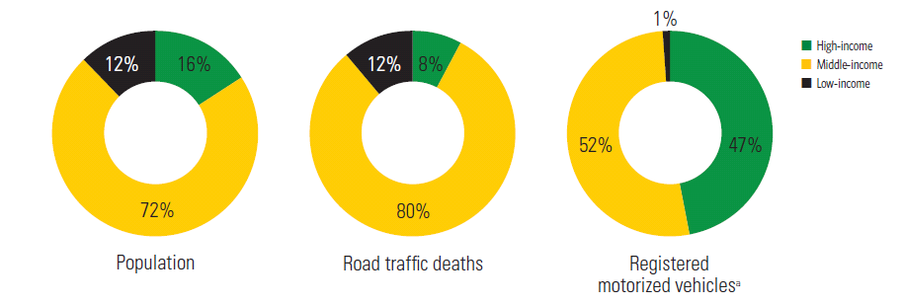
Fig. 1: Population, road traffic deaths, and registered motorized vehicles, by country income status (Source: WHO, 2013)
There are some researches works which are focus on traffic accidents in Iraq. Wisam (2011) studies the accidents pattern in Diyala city (east of Baghdad) and reported that there were 400 accidents happened in the years of 2009 and 2010 and about 130 persons were killed while about 830 were injured. Ewadh and Habieb (2007) focused on fitting the binomial distributed for traffic accident data. Al-Anbari (2011) reported that most accidents related to head injuries are caused by cycling accidents. Such head injuries will mostly caused the injured to die. Mohammed (2012) reported that more than 3000 people were entered the hospitals of Al-Najaf city (160km to the south of Baghdad) due to traffic accident injuries while 14 of them were dead after 24 hours from entering the hospitals. Zalzala and Mahmood (2013) reported that there are about 3400 accident rates were recorded in 15 provinces of Iraq during 2006. About 27.6% of these accidents were fatal while the others are related to injuries only.
This paper uses real accident data taken from local traffic agency in Al-Diwaniya city- Iraq to evaluate the traffic safety at the city. The data has been used to present the difference in the accident rates between urban and rural areas, to show the main causes of traffic accidents so as to make necessarily suggestions, and finally to find the percentage of accidents which are not recorded within the officials’ local traffic authority.
- Methodology
This paper uses real accident data taken from local traffic agency in Al-Diwaniya city- Iraq to evaluate the traffic safety at the city. The provided raw data represents the monthly accident rates, accident causes, accident types and accident hazard for the period from 2004 up to 2013. The data were based on highway types as follows:
- Major urban roads: includes collector streets which are connecting the city with other highways (i.e. rural roads) leading to the surrounding cities.
- Major rural roads: includes parts of highways leading to the surrounding cities. These parts are within the official borders of Al-Diwaniya city.
- Local streets: includes all streets coming from the city’s neighborhoods.
In addition, questionnaire technique is used to find the percentage of accidents which are not recorded within the officials’ local traffic authority.
- Analysis of Data Taken From Local Traffic Agency
This section describes the analyses of data taken from both traffic local agency and also the data collected using questionnaire. The data used is for the period from 2004 to 2013.
3.1 Accident Rates
Fig. 2 shows the accident rates for some years from 2004 to 2013 in Al-Diwaniya city based on highway types. In general, the figure suggests that there is no fixed trends the accident rate at the city. The accident rates in high speed highways “Major urban” (usually multilane highways) are much higher than those accident rates in local and urban streets (which are usually have less speed rates). More or less, there are about 1000 cases as yearly traffic accidents which are recorded with in the local traffic agency.
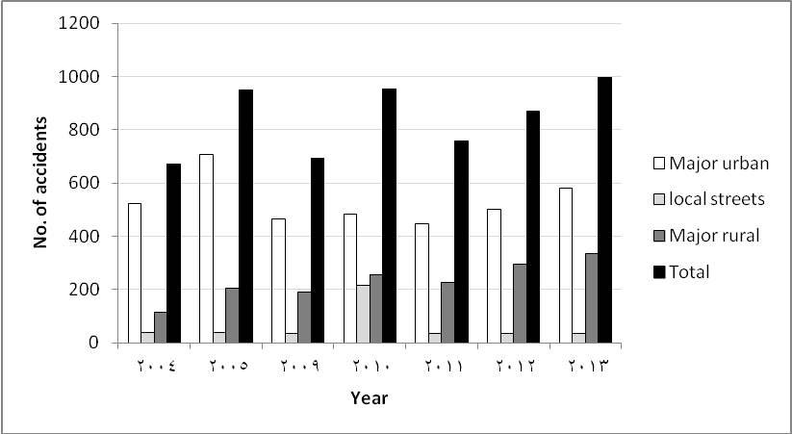
Fig. 2: Accident rates in Al-Diwaniya city
3.2 Accident types
Fig. 3 shows typical distribution of the accident types which happened during 2010. The main types which are presented here are:
- Car to car accidents “collision”: includes all accidents occurred between vehicles.
- Car to pedestrian’s accidents “hitting”: includes accidents where vehicles are hitting pedestrians.
- Single car accidents “overturn”.
- Other: includes all other accident types (e.g. a vehicle hits the highway barrier).
In general, the second type (i.e. when cars are hitting pedestrians) is the most observed type of accidents. This represents about 46% of the total recorded accidents and that suggests that some attention should be given to enhance the pedestrians’ safety. It should be noted here that about 160 accidents out of 918 accidents during the 2010 happened in only five main roads and intersection in the city.
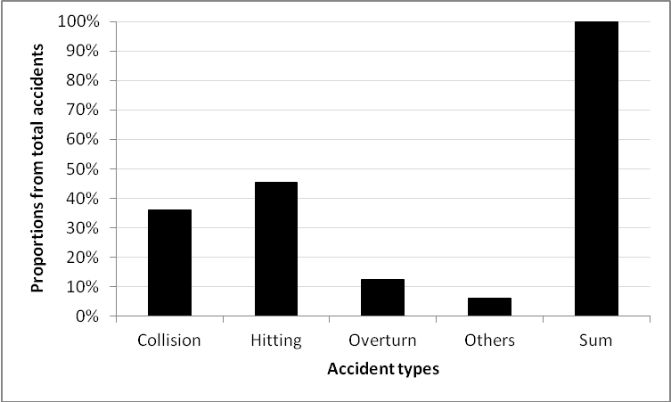

Fig. 3 :Typical distribution of the accident types during 2010

3.3 Accidents Distributions
Fig. 4 shows the accidents distribution over the months of the year of 2010. The figure shows that the highest rates were during February and November. This may be related to bad weather conditions in winter season.

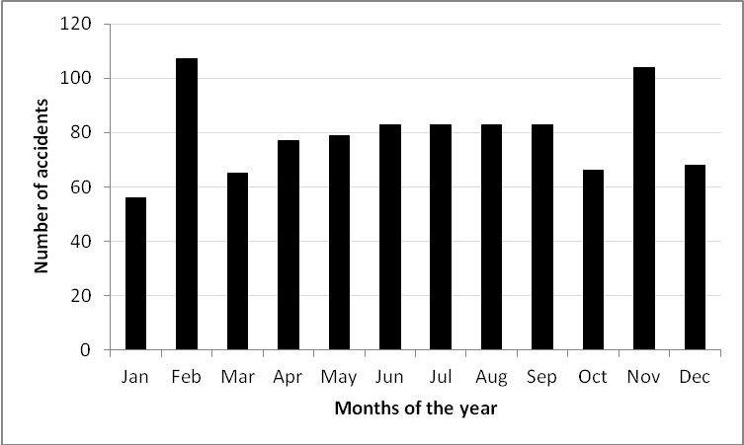

Fig. 4: Accidents distribution over the months of 2010

3.4 Accident causes
Fig. 5 shows the main causes of traffic accidents as recorded by the traffic officers for the accidents happened during the year of 2010. About 60% of accidents are related to drivers’ errors while the faults which may happen for vehicles while moving are representing about 20% of the total accidents. Pedestrians’ errors caused about 13% of the total accidents. This is mainly due to lack of crossing areas within the city. Other causes such as “Roads”(e.g. poor geometric design) and passenger errors (e.g. when passengers are talking to a driver” are representing about 2%).
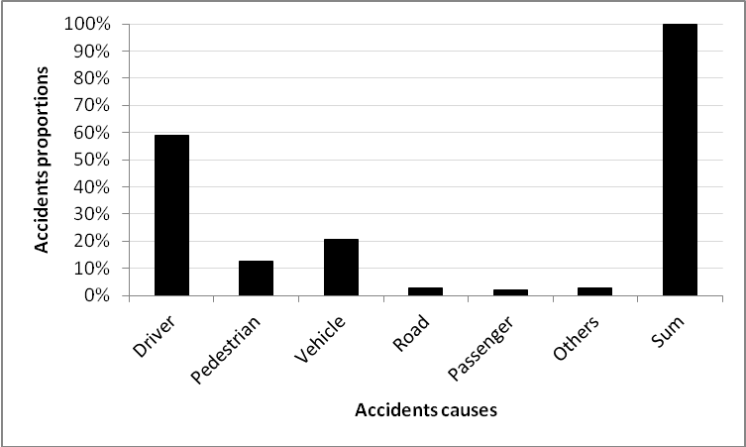
Fig. 5 :Main causes of traffic accidents
3.5 Accident hazard
Fig. 6 shows the accidents hazard for each accident type during the year of 2010. In general, the figure suggests that about 200 people were killed, 200 people were got hazard injuries and about 750 people were got light injuries. It should be noted here that these cases were only within the officials borders of Al-Diwaniya city.
The figure also shows that most of the accidents within the city are related to light injuries. This is mainly due to the fact that the speeds of vehicle are minimal in the city due to traffic congestion or due to the use of traffic calming tools which may significantly affect the speed of the majority of vehicles.
Considering the rate of fatal accidents per the 100000 population, and by using the number of populations for Al-Diwaniya city (part of Al-Qadisiya province) in 2010 of about 600,000 people, the rate of deaths could be estimated as below:
No. of deaths
Deaths rate = * 100000 Equation (1)
Total population
200
Deaths rate = * 100000=33.3 deaths/100000 population
600000
The value of 33 deaths per 100000 population is near to the Iraq average deaths rates as reported by WHO (2013) of 31.5 deaths/100000 population (see section 1 above in this paper). It should be noted here that the Central Statistical Organization in Iraq (CSO) reported that the number of deaths in Iraq in fifteen provinces in Iraq, with population of about 25 million populations was about 2508 deaths. This suggests average deaths if about 10 deaths/100000 population.The later rate is inconsistent with that rate reported by WHO (2013) and the rate found in this study. This reveals that there are some problems in the traffic accident data which are reported by the CSO.
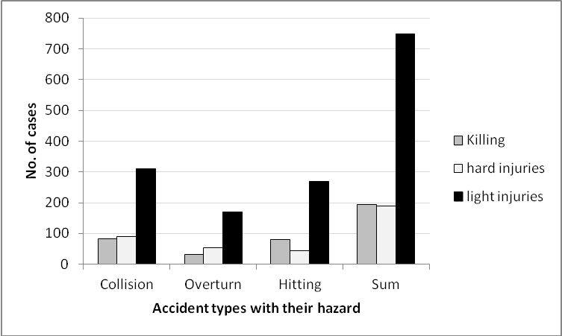
Fig. 6 :Accidents hazard during 2010

Fig.7 shows the percentages of the recorded accidents rates to the number of registered vehicles based on data from 2003 to 2010. The figure suggests that about 3-7% of vehicles are subjected to traffic accidents every year. This means that during ten years, for example, about 50% of vehicles may involve by one or more traffic accidents.
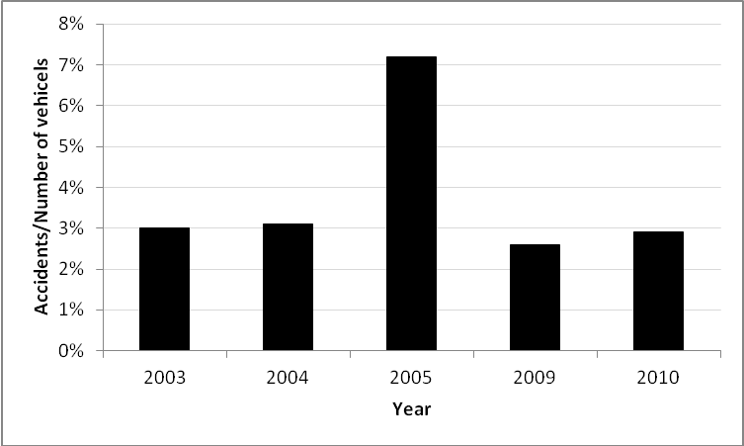
Fig.7: Percentages of the recorded accidents to the number of vehicles

- Analyses of Questionnaire’s Data
It is strongly believed that there are some traffic accidents which were not recorded within the local traffic agencies. This happened especially for accidents which are not related to kills or hard injuries cases. Therefore, questionnaire technique has been used so as to highlight the proportions of unrecorded traffic accidents. The questionnaire contained some enquiries about the number of traffic accidents happened for the driver and whether these accidents have been recorded in the traffic agencies. The questionnaire sheets were given to the students of the Engineering college-University of Al-Qadisiya and some other employers in other official offices to be filled by them or their families. In total,about 1000 sheets were given while only about 320 answers were obtained.
Fig. 8 shows that about 39% of vehicles, which are covered by the survey, had one or more accidents before the survey. This supports the findings extracted from Fig. 7 which shows the annual percent of traffic accident to number of vehicles.
Fig. 9 shows that about 21% of these accidents are not recorded. This suggests that some efforts should be given so as to consider such high proportions of such unrecorded accidents.

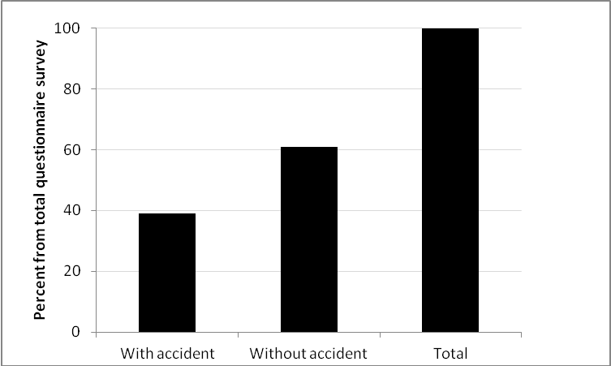
Fig. 8 :Percentages of vehicles involving accidents
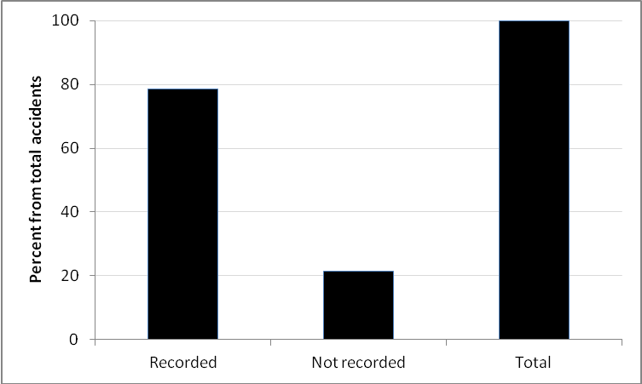
Fig. 9 : Percentages of recorded and unrecorded accidents

- Recommendations to Reduce Traffic Ccidents
In order to reduce traffic congestion, it is essential to adopt traffic safety requirements in design and constructing of highways. For example, median barriers should be used to prevent the crossing of pedestrians from unauthorized locations and therefore minimizing of pedestrians’accidents. Such median barriers are strongly recommended to be used in pedestrians bridges’ areas since it has been noticed that people are rarely used such bridges. In order to minimize traffic collisions, it is essential to manage traffic movements on intersections.This could be applied by splitting traffic movements using bridges and/or tunnels or by channelizing such intersections. Additional solutions might be useful such as applying of traffic calming technique which reduces vehicles’ speeds and consequently reduce accidents fatality.
- Conclusions
This paper uses real data taken from the local traffic agency in Al-Diwaniya city for the period from 2004 to 2013 to indentify the frequency and causes of accidents. Questionnaire technique has also used in this study to show the percentage of unrecorded accidents. The results showed that the average deaths in the city caused by traffic accidents was found to be 33 deaths per 100000 population which is much higher than the world’s average death rates of 18 deaths per 100000 population. It is found that more than 50% of accidents are related to drivers’ errors while faults which may happen for vehicles while moving are representing about 24%. About 46% of the recorded accidents are found to be when vehicles are hitting pedestrians while about 32% of accidents are related to vehicle collisions.This suggests that some attention should be given to enhance the pedestrians’ safety.The results also showed that most urban accidents are not associated with death cases.
Questionnaire’s technique has also used in this study to show the percentage of unrecorded accidents. The results showed that about 21% of accidents are not recorded and about 39% of vehicles, which were participated in the survey, were involved by one or more traffic accidents.
Some recommendations are suggested in order to reduce traffic accidents such as the use of median barriers to regulate pedestrians crossing,and the use of intersections channelizing, tunnels and bridges so as to reduce traffic collisions. In order to reduce accidents fatality, it is recommended to adopt traffic calming technique which reduces traffic speed.
- References
Al-Anbari, H.G.,2011,“Head injuries due to motorway accidents in Karbala-Iraq prospective clinical study”, Karbala J. Med. Vol.4, No.3-4. p.p. 1170-1179.
Ewadh, H.A, and Habieb,A. H.,2007,“Underlying Rates of Binomial Distributed Traffic Accident Data”, Jornal of Kerbala University, Vol. 5 No.4 Scientific, p.p. 209-216.
Fatality Analysis Reporting System’ 2014, fars.NHTSA.dot.gov.
Mohammed, S. J.,2012,“Epidemiological study on road traffic accidents in Al-Najaf city during 2011” kufa Journal for Nursing sciences, Vol. 2, No. 3, p.p.138-142.
The Central Statistical Organization in Iraq (CSO). Traffic accident report for the year of 2010.
WHO,ed.,2013,“Global Status Report on Road Safety 2013: supporting a decade of action” (official report).Geneva,Switzerland:World Health Organisation (WHO).
شذى حسن زلزلة و خولة خالد محمود،2013،" دراسة احصائية للحوادث المرورية في العراق" مجلة الادارة والاقتصاد, العدد 96.
وسام متعب محمد،2010،"الحوادث المرورية في محافظة ديالى لعامي 2009 و2010 دراسة في جغرافية النقل" مجلة ديالى,العدد 50, الصفحات 511-529.

