The Use of AL-Malih Valley Crushed Limestone as Coarse Aggregate in Concrete Production
Mohammed A. S. Elizzi
Department of Civil Engineering, University of Al-Mustansiriya
Moh1936@yahoo.com

Ali Abdulhussein Al-Tameemi
Department of Civil Engineering, University of Kufa
ali_altamimy@yahoo.com
Perikhan Fadhil
National Center of Construction Labs
purapary@yahoo.com

Abstract
The southern part of Iraq suffers from shortages of suitable natural coarse aggregate for concrete production. Most of the available natural gravel are contaminated with coating sulphates. Therefore, coarse aggregates, for the time being are brought from middle & northern parts of Iraq, to be used in the southern areas.
This research was carried out to study the suitability of crushed limestone from AL-Malih valley as coarse aggregate in concrete production.
Geological investigation, evaluation of crushed rock aggregates properties, and evaluation of concrete properties produced by using crushed limestone as coarse aggregate, have been carried out in this research on limestone of AL-Malih valley area.
The results showed that, it is possible to use this type of crushed rock aggregates in producing good quality concrete. Therefore, it is recommended to use the crushed limestone from the investigated area as coarse aggregate in producing concrete at the southern province of Iraq.
Key words: Aggregate, Concrete, Crushed, Limestone, Properties.
الخلاصة
تعاني المنطقة الجنوبية من العراق من شحة الركام الخشن الطبيعي المطابق لمتطلبات انتاج الخرسانة، حيث ان اغلب الحصى الطبيعي المتوفر ملوث بطبقة من املاح الكبريتات. لهذا السبب ينقل الركام الخشن من المناطق الوسطى والشمالية من العراق لغرض استعماله في الاعمال الخرسانية المنفذة في جنوب العراق.
يهدف هذا البحث الى بيان امكانية استعمال حجر وادي المالح الجيري المكسر كركام خشن في انتاج الخرسانة.
تضمن البحث اجراء الدراسات الجيولوجية فضلا عن تقويم خصائص الركام الناتج عن تكسير الحجر الجيري من مقالع منطقة وادي المالح وكذلك خصائص الخرسانة الناتجة.
بينت النتائج امكانية استعمال هذا النوع من الركام الناتج عن تكسير الحجر في انتاج خرسانة بنوعية جيدة بناء على ذلك يمكن استعمال الحجر المكسر من منطقة الدراسة كركام خشن في انتاج الخرسانة في المناطق الجنوبية في العراق.
الكلمات المفتاحية: ركام، خرسانة، مكسر، حجر جيري، خصائص.
1. Introduction
Natural coarse aggregate at present time, which is gravel, has been intensively used for concrete manufacture in the middle and southern parts of Iraq. Unfortunately most of the available natural gravel is contaminated with sulphates, which influences the quality of concrete. Many studies were carried out to give an alternative coarse aggregate to be used for concrete manufacture (Elizzi, 1990;AL-Baldawi, 1986), and fine aggregate (Mazin et al.,2011;Thanoon et al., 2005). This research was carried out to investigate the use of a crushed limestone from AL-Malih valley as coarse aggregate in concrete production. AL-Malih valley quarry, is situated in southern of Iraq, about 15 km to the south of Najaf city, Fig (1).

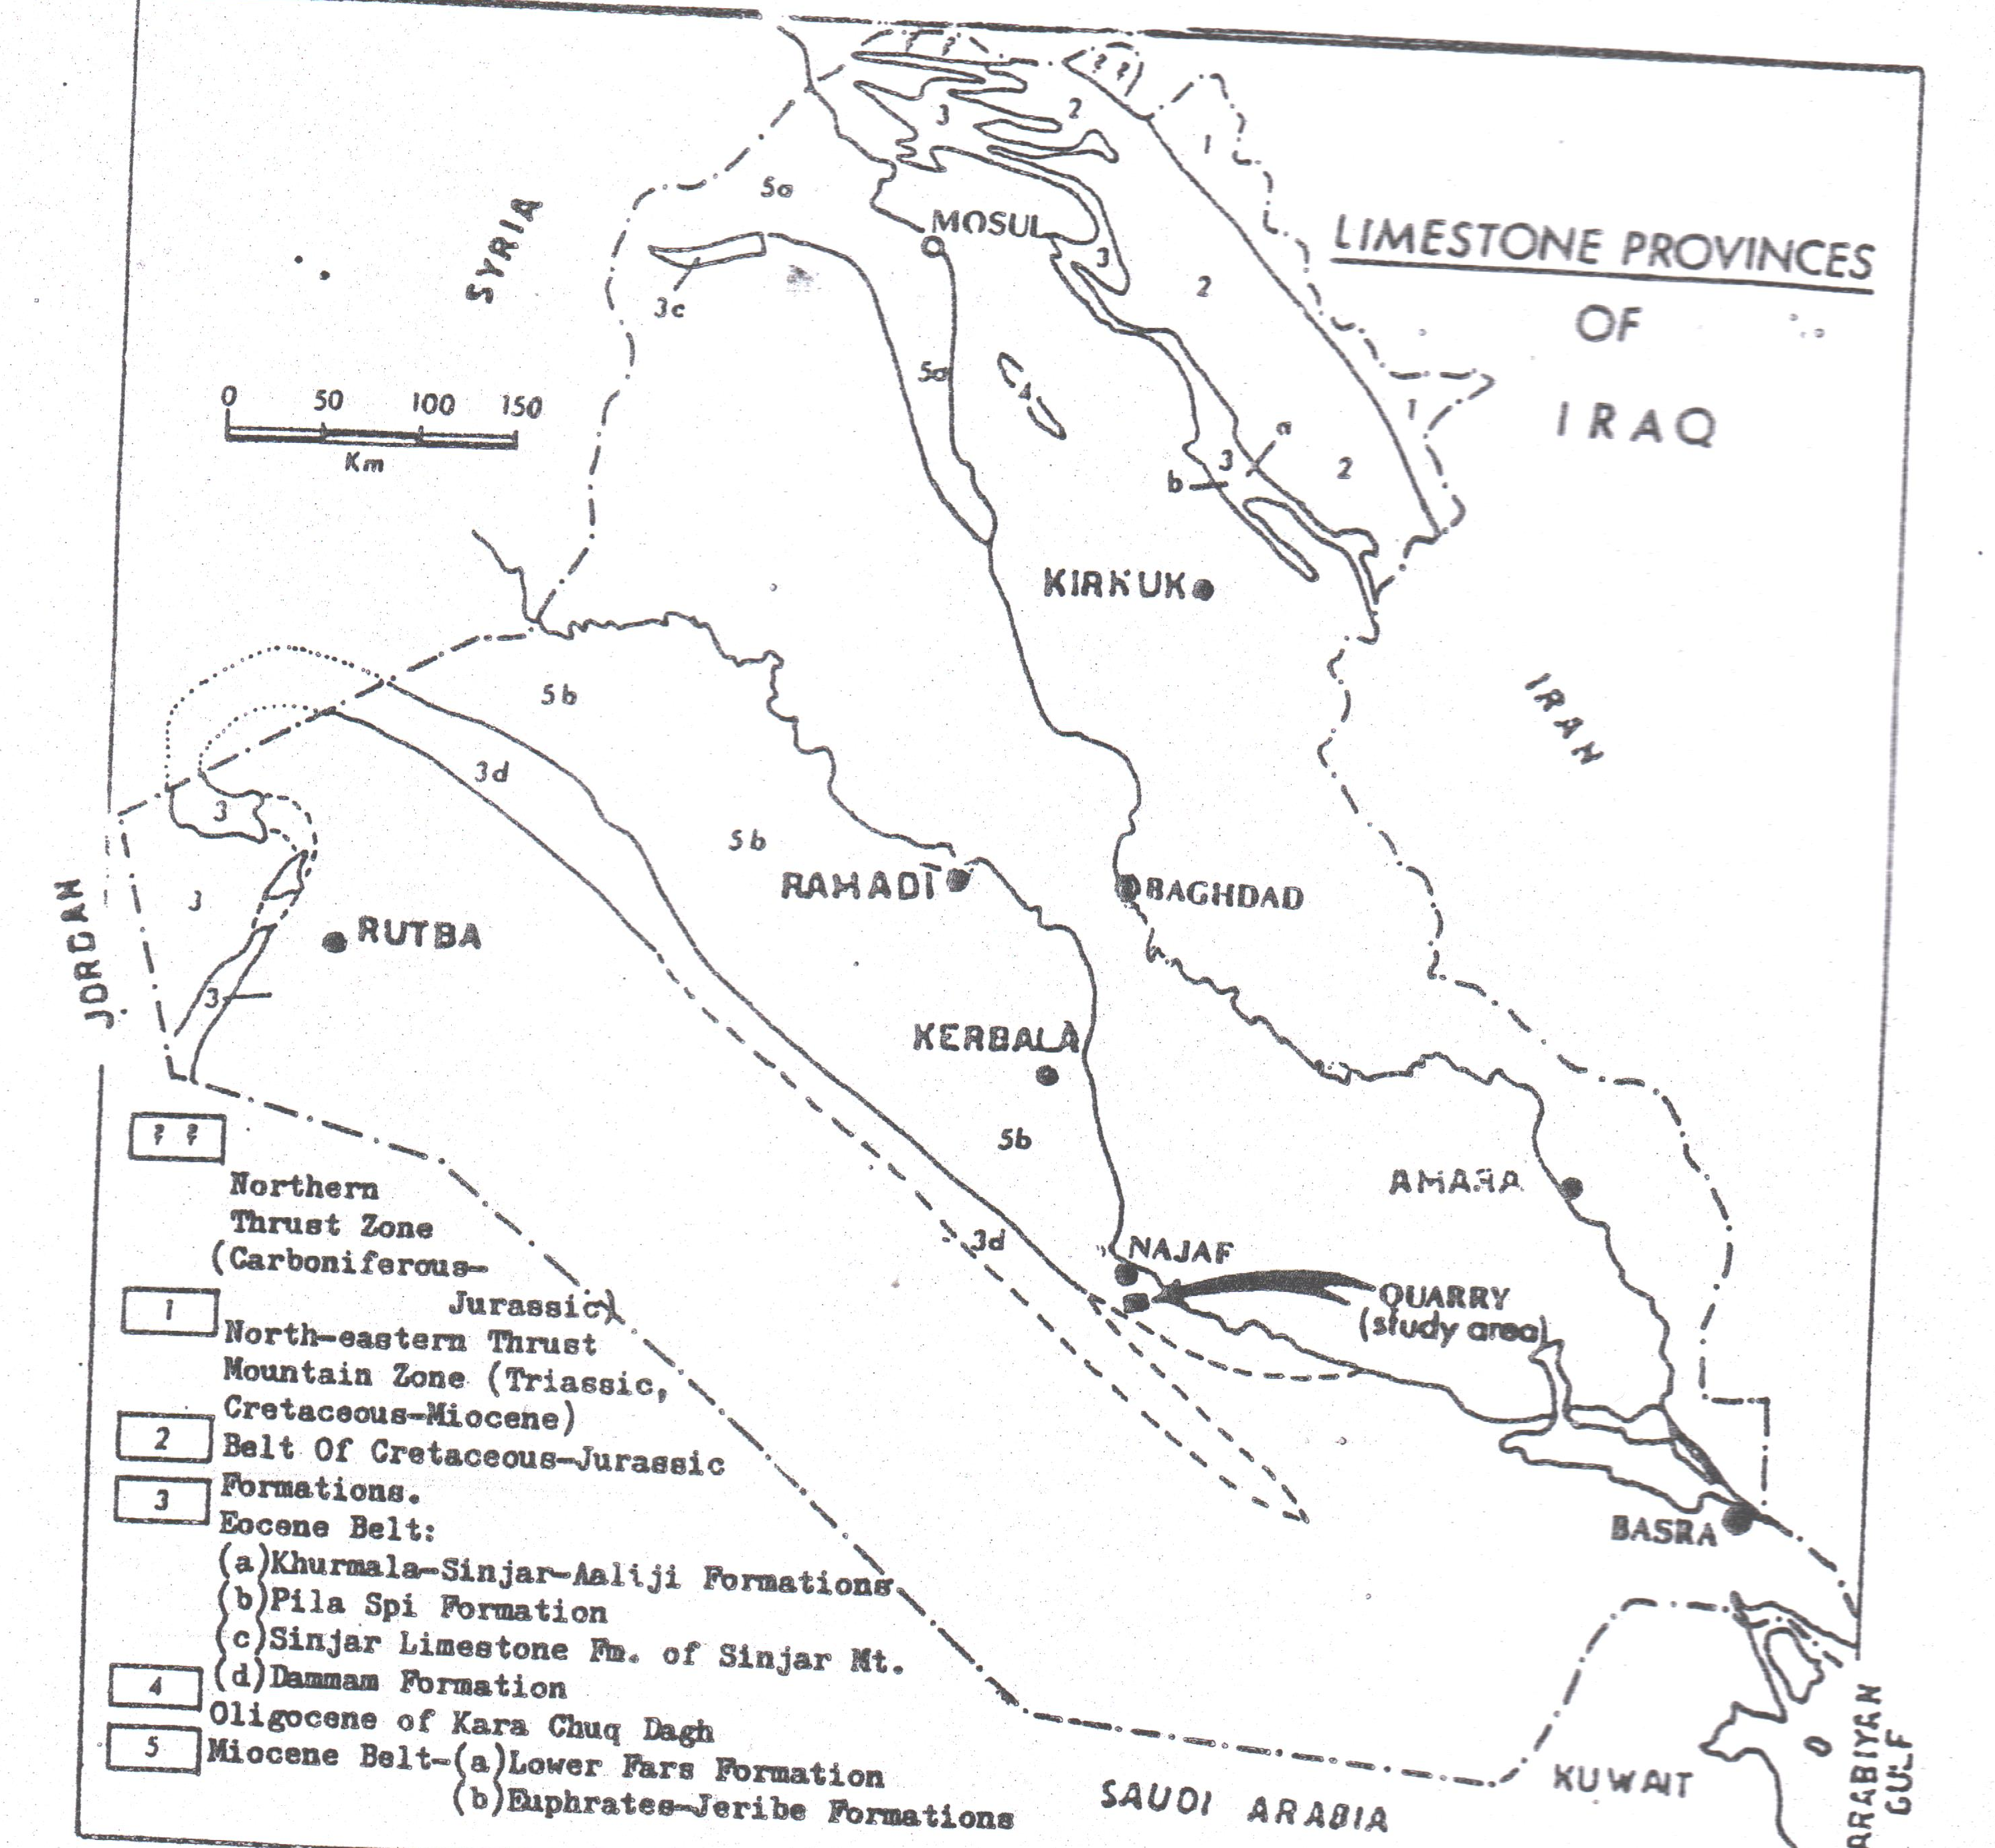

Fig (1) Limestone provinces of Iraq and location of AL-Malih valley area (AL-Baldawi & AL-Naib 1986, modified)
Dolomitic limestone from AL-Malih valley area was used in this study due to the following:
- Most of dolomitic limestone is exposed at surface(thickness of covering soil is 0-5 m)
- The ease of transportation and proximity of AL-Malih area to the main roads, will reduce the cost of raw materials.
- The distribution of a large reserve in the area with the possibility of future extension in known directions.
- The reserve of limestone rocks at AL-Malih valley area was estimated equals to 75 million cubic meter (AL-Komi,1983).
Chemical & physical analyses on crushed limestone rocks of AL-Malih area were carried out to show their suitability as coarse aggregate for concrete production. Alkali reactivity studies were also concluded on these aggregate.
Finally compressive strength tests were carried out on different concrete mixes. All tests showed acceptable results for the use of limestone rocks as coarse aggregate in concrete production.
2. Experimental work
2.1 Chemical analysis of limestone rocks
Chemical analysis was carried out on several rock specimens from different depths. Table (1) gives the results of this analysis.
Table (1) Chemical composition of Limestone from Al-Malih Valley area
Oxide | CaO | MgO | SiO₂ | Al₂O₃ | SO₃ | Fe₂O₃ | Ins.M | L.O.I | Total
Percent | 37.5 | 13.64 | 0.62 | 0.76 | 0.15 | 0.12 | 2.18 | 44.37 | 99.34
2.2 Physical properties of limestone rocks
Physical properties of limestone were determined by carrying out several tests, including: Abrasion tests, apparent specific gravity, water absorption etc. All the physical properties results are listed in Table (2)
Table (2) Physical properties of limestone aggregate
Test | Value
Abrasion  Water absorption  Apparent specific  Gravity  Total specific gravity  Impact | 24%  1.5%  2.68  2.55  11.5%
2.3 Potential alkali reactivity
Potential alkali °reactivity takes place when the alkalies present in cement paste (Na₂O, K₂O) are attacked by the silica or calcium carbonates present in aggregate. Insoluable complex compounds are formed due to this reaction, and as a result of that, cement paste is subjected to osmotic pressure and then fractures, (Neville,1995). To determine the potential "alkali reactivity of the aggregate used, the bar mortar method described in ASTM C298-03 was followed to measure the linear expansion of mortar bars over a period of six months, the average value of expansion was 0.052%.
2.4 Concrete mixes
Three different mixes namely 1:3:6, 1:2:4 and 1:1 1/2:3, which are commonly used in Iraq, were used. Crushed limestone was used as coarse aggregate, while natural silica sand was used as fine aggregate, different W/C ratios were tried to keep medium workability. Concrete specimens (150 x 150 x 150 mm), for the mentioned mixes, were made and cured in water until the time of testing. Compressive measurements were made at ages of 7, 28 and 90 days. All results are shown in Fig (2) and Table (3).

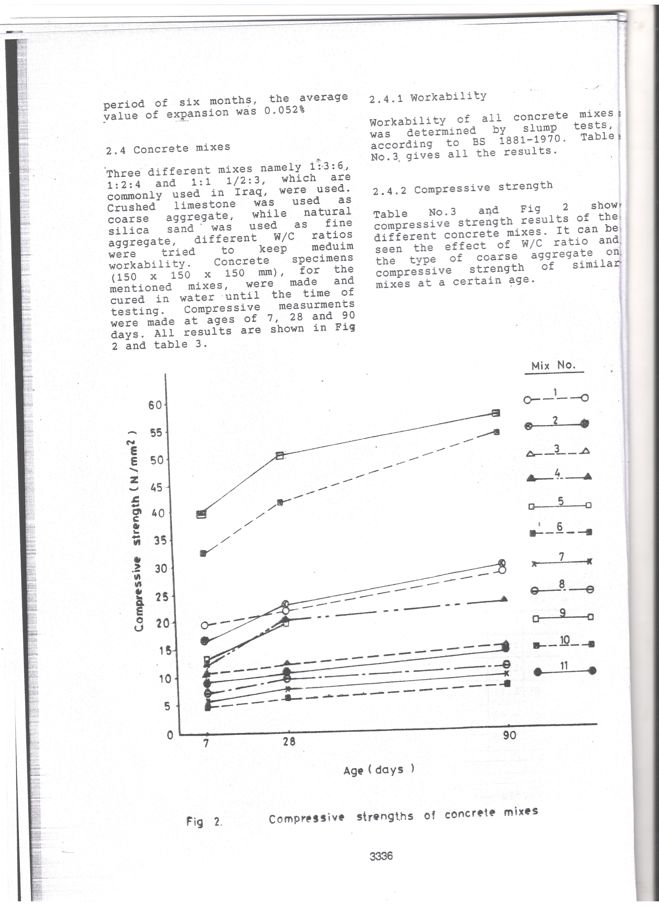

Fig (2) Compressive strengths of concrete mixes

2.4.1 Workability
Workability of all concrete mixes was determined by slump tests, according to BS 1881-1970, Table (3), gives all the results.
2.4.2 Compressive strength
Table (3) and Fig (2) show, compressive strength results of the different concrete mixes. The effect of W/C ratio and the type of coarse aggregate on compressive strength of similar mixes at a certain age, can also be seen.
Table (3) Compressive strength and workability of different concrete mixes at different ages
Mix No. | Mix ratio | W/C | Workability Slump (mm) | Compressive strength N/mm² for given age (days)
 |  |  |  | 7 | 28 | 90
1 | 1:1.5:3 | 0.7.0 | 80 | 20.0 | 22.8 | 27.3
2 | 1:1.5:3 | 0.64 | 75 | 17.5 | 23.5 | 28.8
3 | 1:2:4 | 1.10 | 95 | 10.8 | 13.5 | 15.0
4 | 1:2:4 | 0.90 | 75 | 13 | 21.2 | 23.0
5 | 1:2:4 | 0.86 | 70 | 14.2 | 20.6 | -
6 | 1:2:4 | 1,65 | 110 | 4.4 | 5.9 | 7.2
7 | 1:3:6 | 1.50 | 100 | 5.7 | 7.4 | 9.4
8 | 1:3:6 | 1.10 | 50 | 7.7 | 9.9 | 12.4
9* | 1:1.5:3 | 0.42 | 60 | 41.2 | 51.0 | 57.3
10* | 1:2:4 | 0.50 | 55 | 33.4 | 43.1 | 51.4
11* | 1:3:6 | 0.75 | 65 | 8.8 | 11.3 | 14.2
* Natural gravel was used as coarse aggregate

3. Results and discussion
3.1 Properties of crushed rock aggregate
All tests results of crushed rock aggregates properties are presented in Table (2). The results show that the properties of crushed rock aggregates used were within the required limits of the standard specifications for aggregates used in concrete. The water absorption of tested rock is 1.5%, while according to specification (Akroyd,1962), the absorption of aggregate suitable for concrete should not exceed 5%. The abrasion of the tested limestone is 24% which is less than 35% required by Iraqi Standard 45-1984. The same standard requires impact resistance for the aggregates not more than 30%, while the impact resistance for the tested limestone aggregates is 11.5%.
3.2 Concrete workability
Table (3) shows all results of workability tests of different mix proportions as well as the type of aggregate. It can be seen from this table that for the same Agg/C ratio mixes of crushed rock coarse aggregate required higher W/C ratio than mixes of natural gravel coarse aggregate to maintain the same workability. It, also, shows that the differences in W/C ratios increase as the Agg/C ratio increases. The reason for that is the higher water absorption, angularity and rougher surface texture of crushed rock aggregate. These differences can be reduced by using super plasticizer (Elizzi,1990).
3.3 Concrete strength
Fig (2) and Table (3) show compressive strength results of the different concrete mixes. It can be seen that the strength of concrete mixes No. (9, 10 & 11), where natural gravel were used as coarse aggregate is higher than other mixes where crushed limestone was used. This was due to the higher differences in W/C ratio required to maintain the same workability.
In spite of this reduction in compressive strength, the concrete produced by using crushed limestone as coarse aggregate can be used for many concrete structures, depending on the compressive strength (at age 28 days) required by Unified Arabic Code for reinforced concrete (UAC,1997) and Iraqi Building Code for reinforced concrete (Code 1,1987) as follows:
a. It is possible to use concrete mixes No. (1, 2, 4 & 5) for general reinforced concrete (minimum compressive strength required, 20 N/mm²).
b. It is possible to use all concrete mixes except mix No.6 for plain concrete work (minimum compressive strength required, 7 N/mm²).
3.4 Alkali reactivity
According to ASTM C289-03 the linear expansion of specimens age 6 months should not exceed 0.10%, while the linear expansion of specimens using crushed limestone was found equals to 0.052% as mentioned in (2.3). So this type of limestone aggregate is suitable for concrete production.
4. Conclusions
The overall results stemming from the experimental work, have led to the following conclusions:
- The properties of crushed limestone aggregate from AL-Malih valley area are within the required limits of the standard specifications for normal aggregates used in concrete.
- For the same richness, concrete mixes of crushed rocks coarse aggregate required higher W/C ratio than natural gravel aggregate concrete mixes to maintain the same workability.
- It is recommended to use this type of crushed rock aggregate in producing good quality concrete which will solve most of the problems due to the shortage of coarse aggregate at the south of Iraq, which will reduce the cost of concrete production.
References
Akorovd,T.N.W.,1962, “Concrete properties and manufacture”, Pergamon press, London
AL-Baldawi, T.A. and AL-Naib, S.B., 1986, “The use of AL -Rahba crushed dolomitic limestone as aggregate in concrete”, Jr.Bldg.Res., Vol.5, No.2,pp 1 – 28
AL-Komi, M.A., 1983, “Reserve of limestone and dolomitic limestone in Iraq”, Special report, state organization of Minerals, Baghdad.
BRC., Scientific Research Council, 1987, “Iraqi Building Code for reinforced concrete (Code 1)” Baghdad.
Elizzi, M.A. & Ikzer, B.G.,1990,“The use of crushed sedimentary rocks for concrete production in Iraq”,Proc.6th Int.IAEG Congress pp.2956-2970 Rotterdam Balkema.
Hanson, F.R.S., 1944, “Cretaceous and tertiary reef formation and associated sediments in the Middle East” Am. Assoc., Petroleum Geologist, V34, pp 215-238.
Mazin, T. H., Eman, A. Q., and Ali, H. A., 2011, “Production of Light-Weight Concrete Blocks Using Crushed Limestone as Fine Aggregate and Crushed Clayey Bricks as Coarse Aggregate” Al-Ataqani Journal for Engineering Research, Foundation of Technical Education. Vol. 24, No. 6, pp. 53-63.
Neville, A. M., 1995, “Properties of Concrete” Longman Group Ltd. Pub. England, 6th edition, 841 pp.
Technical Committee of Arabic Construction Ministers Council, 1997 “Unified Arabic Code for reinforced concrete structures”
Thanoon, A. T., Mazin, T. H., and Eman, A. Q., 2005, “Utilization of By-Products from Cutting Limestone as Fine Aggregate in Mortars” Al-Ataqani Journal for Engineering Research, Foundation of Technical Education.Vol.18, No. 2, pp. 15-21.

