Study the Effect of Evaporation on Water Quality to the Iraq Reservoirs

Ameer Hashim Hussein Ahmed

Assistant Teacher/Al_musaib Institute technique

Ameer_almashhadany@yahoo.com
Abstract:
Water budget is a basic tool that can be used to evaluate the occurrence and movement of water through natural environment.A water budget provides a foundation for evaluating its use in relationship to other important influencing conditions such as other ecological systems and features, as well as social and economic components; how much water is being used by industry, residents, etc.
The main research methodology is to find area elevation curves of the reservoirs, monthly evaporation losses from the reservoirs with different conditions of storage, the amount of increase in the salinity of the water due to evaporation and its relationship with the volume of storage, the results analyzed and discussion.
The study presents an estimation of to the amount of water loss due to evaporation from some Iraqi reservoirs and its effect on the water quality. This paper studies the effect of storage in water losses due to evaporation of reservoirs, lakes and marshes in Iraq with different conditions of storage (minimum, average and maximum). Q-Basic program uses to find the results. Results show that losses caused by evaporation reaches about (22%) from storage volume at average condition, where the Total Dissolved Salts is increase to about 17% at the same condition.
Key word: water quality, Evaporation , Resevoirs, storage
الخلاصة:
الموازنة المائية هي الأداة الأساسية التي تستخدم لتقييم حدوث وحركات المياه خلال البيئة الطبيعية وهي التي تجهز كأساس لاستخدامها في علاقات مهمة اخرى كالنظم الايكولوجية والامكانيات بالإضافة الى المكونات الاجتماعية والاقتصادية مثل كمية الماء المستخدمة في الصناعة والاستخدامات السكانية الخ.
الموضوع الرئيسي للبحث هو العثور على منحنيات المساحة مع المنسوب، التبخر شهرية من الخزانات في الظروف المختلفة للتخزين، ومقدار الزيادة في ملوحة المياه بسبب التبخر وعلاقته مع حجم الخزان وتحليل و مناقشة النتائج.
درس هذا البحث تقدير كمية فقدان المياه بسبب التبخر من خزانات العراق، وتأثيرها على جودة المياه ويهتم هذا البحث تأثير الفقدان من المياه للتخزين بسبب التبخر من الخزانات والبحيرات والمستنقعات في العراق مع الظروف المختلفة للتخزين (اقل، متوسط، اعلى). تم استخدام برنامج (Q-Basic) لايجاد النتائج. وتشير النتائج إلى أن حجم الخسائر الناتجة من التبخر حوالي (22٪) من حجم التخزين في حالة متوسطة، كما بينت النتائج أن عملية التخزين تؤثر على جودة المياه للخزان والبحيرات والمستنقعات من خلال زيادة الأملاح الذائبة (T.D.S ) إلى حوالي (17٪) من المتوسط.
الكلمات المفتاحية: نوعية المياه، التبخر، الخزانات، الخزن
Introduction:
The water scarcity is the lack of sufficient available water resources to meet the demands of water usage within a region. Scarcity in Iraq becomes a big problem, this is due to many reasons, especially due to building of many dams at the Euphrates and Tigris tributaries. Water shortage is a real problem in many parts of Iraq as a large part of the country is desert. But the existing networks also have been suffered from lack of maintenance or by being destroyed during the war, according to the Ministry of Water Resources, only 32 percent of the Iraqi population has access to clean drinking water, and only 19 percent has access to a good sewage system, and the proportion of rainfall in Kurdistan 600-1200 millimeters per year in the rest of Iraq is less than 200 millimeters per year, lack of rainfall in Kurdistan mountains which led to lack of water that feed groundwater and springs and artesian wells, Iraq consumes 90% of its water in agriculture. The number of tributaries of the Tigris, which stems from Iran, both seasonal ones and permanent are 30 tributaries; Iran has transferred tracks mostly into Iran.
Ihsan F. Hasan, 2013 was implement the (Linacre) mathematical Pilot Model used for estimating evaporation from free water surface and testing the results accuracy of the mathematical evaporation model by comparing with values of the measured pan evaporation class (A) at the Mosul Dam Reservoir. Daily measured temperature data recorded in meteorological station at the Mosul Dam Reservoir for the period (2003 -2006).
The study area:The water Resources in Iraq has made a tremendous wealth of Iraq and one of the richest countries in the world in this vital area which is sponsor of the refreshment of the country and achieves high levels of prosperity. Figure(1) shows Iraq Maps and location of Dams.
Haditha Dam:Haditha Dam is an earth-fill dam on the Euphrates north of Haditha (Iraq), creating Lake Qadisiyah (Buhayrat Al_Qadisiyah). The purpose of the dam is to generate hydroelectricity Regulate the flow of the Euphrates and provide water for irrigation .It is the second-largest hydroelectric contributor to the power system in Iraq behind the Musol Dam. Height of the Dam is 75m and 325m the width of the Dam , the width of crest is 20 m its level 154m.The operational level 147m , the area of reservoir at operational level is 500 km² and storage volume in the level is 8.25 billion m³.The top level in flood 150.2m the area of reservoir at the level 567km² and storage volume 9.8 billion m³.The area-elevation and storage curve of the Dam reservoir are as shown in Figure (2).
Derbendikhan Dam: The dam site is in the Sulaimaniyah at Diyala River and its an earth stone dam. The purpose of the dam is to protect against flooding, irrigation, electric power generation and for recreation. The dam height is 128m its width 500m, length of crest 445m and its width 17m at level 495m. Operational level is 485m and reservoir area at this level 114km2 and storage volume 3 billion m3. Top level in flood is 493.5 and reservoir area at this level 171km2 and storage volume 3.85 billion m3 .Total storage capacity 3 billion m3, dead storage capacity 0.47m3 and live storage capacity 2.53 billion m3. The area-elevation and storage curve of the dam reservoir are as shown in figure (3).
Mousel Dam:The Dam site in Ninawa on Tigris River and it is an earth dam with central earth core. Height of the dam is 100m its width 800m, length of crest 3652m including length of spillway 50m and width of crest is 10m, dam crest level 342.2m.The operational level 330m and reservoir area at this level is 380 km² and storage volume 11.11 billion m³, top level in flood 339.4m and reservoir area at this level 446.5km² and storage volume 13.3 billion m³, total storage capacity 11.11 billion m³ and dead storage capacity 2.95 m³ and live storage capacity 8.16m³, max probable discharge to the gated spillway 13000m³/sec and to the ungated 4000m³/sec. The area-elevation and storage curve of the dam reservoir are as shown in figure (4).
Dokan Dam: The dam site in Sulaymania on the small Zab River of arch dam (140m radius).The purpose is protecting against the dangers of flooding, irrigation, electric power generation, development of fisheries and for recreation. Height of the dam 116.4m, width 65m, length of crest 350m and level 516m,operational level 511m, reservoir area at this level 370km² and storage volume 6.8m³,top level in flood 515m and reservoir area at this level 446.5km². The total storage capacity 6.8billion m³,dead storage capacity 0.79m³,live storage capacity 6.01 billionm³,number of gates is 3 and maximum probable discharge 11400m³/sec in a level of 495.5m.Area-elevation curve of the reservoir is shown figure(5).
Al_Adhaim Dam:Dam is located at AL-Adhaim River in Diyala. The length of the dam is 3800m and width of the crest 12 m in a level 145.50 m above sea level, operational level is 131.5 m, volume of storage 1.5 billion m³ and the reservoir area of 120 km² the highest level in the flood 142 m and volume of storage 3.9 billion m³ and an area of 280km². Area elevation curve of the reservoir is shown in figure (6).
Tharthar Lake:The lake is Located 120 km northwest of Baghdad between Tigris and Euphrates Rivers. Its area is 2710 km² and has a higher level of storage 65m and its capacity 85.59 billion m³,its dead storage 35.18 billion m³ and lives storage 85.59 billion m³.The area elevation curve of Tharthar Lake is shown in figure (7).
Hammar Lake:The lake is a saline lake in southeastern part of Iraq within the Marshes. It has an area of 600-1,350 km², water level in the lake fluctuates, with maximum depths varying from 1.8 meters (winter) to 3.0 meters (spring).The lake is an important wetland site for birds. The native inhabitants are Marsh Arabs, some of whom occupy villages on artificial, floating islands. The area elevation curve of Hammar Lake is shown in figure (8).
Habbania Lake: Habbaniya Lake is located southeast of Ramadi, the Anbar Governorate, and west of Baghdad. It is a large water reservoir constructed in 1982 and Evans (1994) included it in the original list of Important Bird Areas. It receives excess floodwaters from the Euphrates in the summer through a small canal near Ramadi called Sin Al-Dhuban. The canal passes through Al-Saglawiya and the calcareous Al-Guss hills, which separate the canal from Habbaniya. The excess floodwaters drain out on the southern edge of the lake through the narrow Al-Majarah Canal, which drains to Bahar Al-Milih and the northern part of Razzaza Lake in Karbala Governorate. The capacity of the lake is 3.3 billion m³; area of reservoir is 426 km² and Storage level 51m, dead storage is 43 billion m³ and live storage 0.743m³. The area elevation curve of Habbania Lake is shown in figure (9).
Qurna marsh:The Central or Qurna Marshes were a large complex of wetlands in Iraq.Formerly covering an area of around 3000 square kilometers, they were almost completely drained following the 1991 uprisings in Iraq . The area elevation curve of Qurna Lake is shown in figure (10).
Hawizah marsh: Situated to the east of the River Tigris, Haur Al Hawizah (Hawaizah) and its associated marshes cover an area of approximately 2,200 km² between Amara and Basrah. Al Hawizah provides wintering habitat for some of the largest concentrations of wildfowl in the world. The area-elevation curve of AL Huwizah marsh is shown in figure (11).
Table (1) shows data available which have been taken from (Ministry of Transportation, 2013) to the evaporation for each month for Reservoirs and lakes.
Estimate the losses of the evaporation:
The area of Reservoir changing with the different elevation of level then the area-elevation curves were used to find the area for different elevation and multiply this area by the evaporation for the same month the volume of evaporation in m³ was found.The Rule curve for evaporation - storage was drawn as shown in
(from Fig.12-21).
Calculated water quality:
Increase of evaporation affects water quality then it increases the water salinity. Salt mass balance equation was used for calculating the increase in salt mass due to water evaporation from reservoirs,Table (2) show the mean monthly Total Dissolved Salts (T.D.S) for each location. The storage (max.,avg and min.)is shown in Table (3).
The Total Dissolved salts (T.D.S) calculated from the Equation:
T.D.S = (S * T.D.S)/(S – Eva.)
When:
S: Volume of Storage (Km³);
Eva. : Volume of Evaporation (Km³).
Table (4) shows the T.D.S for each of the Reservoir and Lakes for (Smax. , Savg. and Smin).
Conclusions and Discussion:
Building of dams and water storage has a lot of benefits when the process of water storage has negative effects, most important factor is evaporation losses which lead to lose large of amount of water every year, evaporation also leads to increase the salinity of water.
The paper studies the effect of evaporation from reservoirs, lakes and marshes in Iraq on salts with increasing or decreasing with different conditions of storage (Min., Avg., Max.). The results show that the volume of losses because of evaporation is reaches about (22%) from storage volume at average condition, also the results show that the process of water storage affects water quality of reservoirs, lakes and marshes through increasing the T.D.S to about (17) % from the average.

Recommendation:
- Studying variation of evaporation loss according to the reservoirs and lakes rules curve.
- Collect more data about reservoirs in Iraq and study the effect of evaporation on the reservoirs.
- Studying the effect of water loss from reservoirs on the ecological of rivers.

References:
Rowe, D.R. and I.M. Abdel-Magid. 1995. Handbook of Wastewater Reclamation and Reuse. CRC Press, Inc. 550p.

Water quality for agriculture, http://www.fao.org
Al-Ansari ,N. A. and Knutsson, S. “Toward Prudent Management of Water Resources in Iraq,” Journal of Advanced Science and Engineering Research, Vol. 1, 2011, pp. 53-67.
General Commission for Dams and Reservoirs, Official Internet Site, Iraqi Government, 2009. http://www.mowr.gov.iq/arabic/dams/small%20dams%20 under%20dicition.php.
University of Victoria, "Dams in the Tigris Euphrates River Basins ", Online Map, 2010. http://hdl.handle.net/1828/2400.
Kamona, H. A., "The Effect of Turkish Water Policy on Iraq", AlSabah Iraqi News Net , Baghdad, 2003.
Ihsan, F. Hasan, "Estimation of Reference Evapotranspirationby Predicting Temperature Values using a Stochastic Model", AL- Rafdain Engineering Journal, Mosul University, 2013.
http://www.owp.csus.edu/glossary/energy_grade_line.php.
وزارة التعليم العالي والبحث العلمي، جامعة الموصل، مركز بحوث السدود والموارد المائية، (2009-2010)، 577 المشروع البحثي رقم (9).

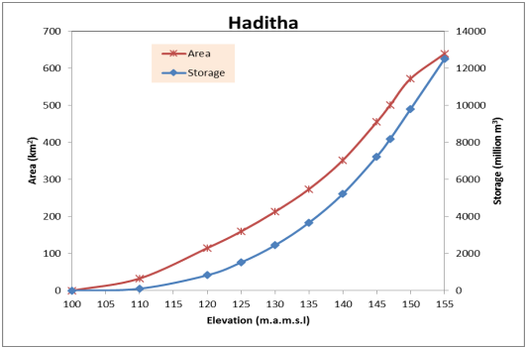
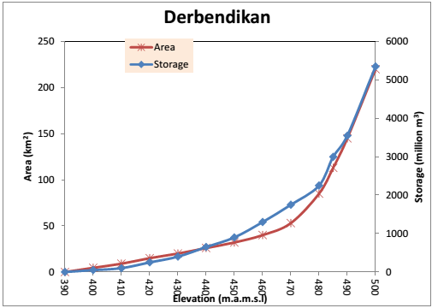

Figure (2): The area-elevation and storage curve
of Haditha Dam
Figure (3): The area-elevation and storage curve
of Debendikan Dam
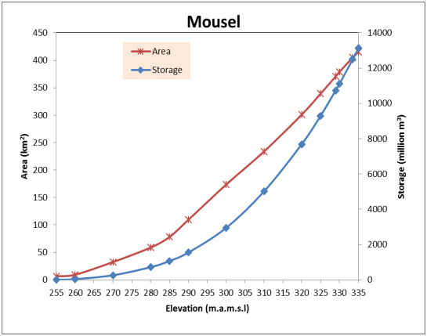
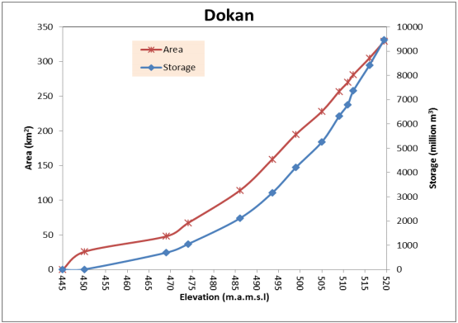

Figure (4): The area-elevation and storage curve
of Musel Dam
Figure (5): The area-elevation and storage curve
of Dokan Dam

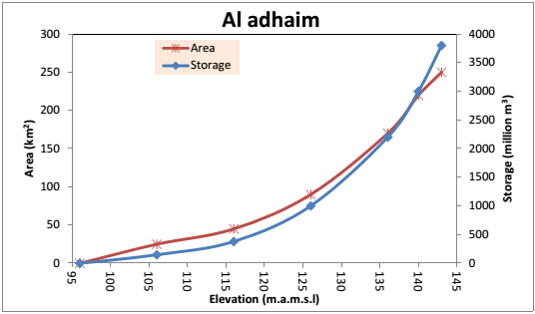
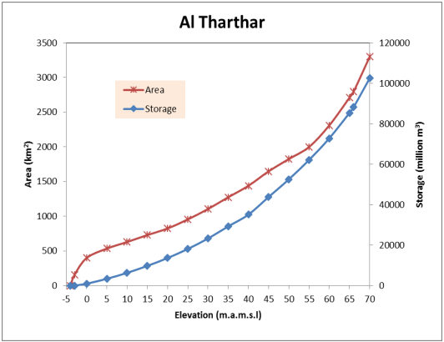

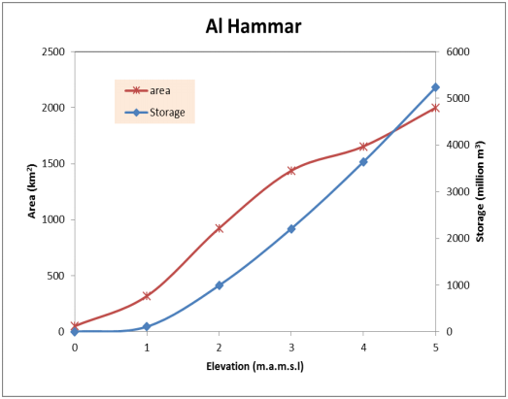
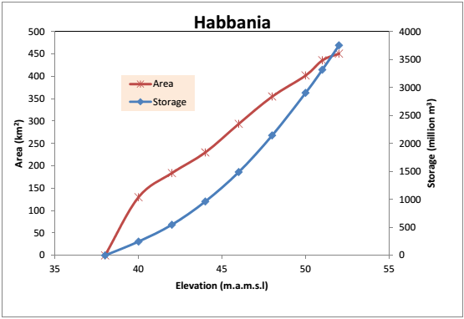
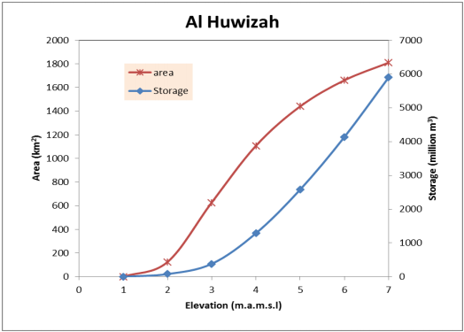
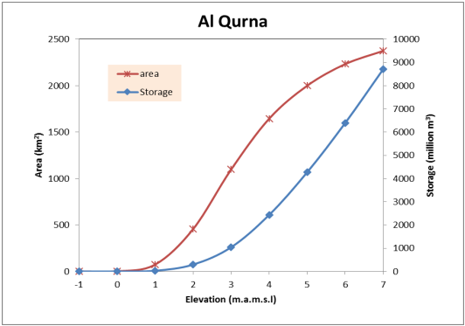

Figure (8): The area-elevation and storage curve
of Al_Hammar lake
Figure (9): The area-elevation and storage curve
of Habbania lake

Figure (10): The area-elevation and storage curve
of Al_Qurna Marsh
Figure (11): The area-elevation and storage curve
of Al_Huwizah Marsh

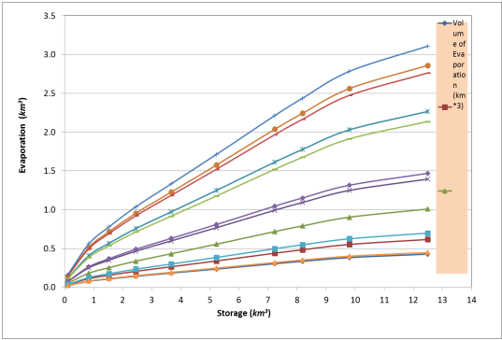
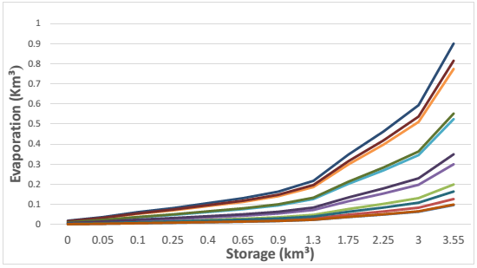

Figure (12): The Rule curve for evaporation _ storage for Haditha Dam
Figure (13): The Rule curve for evaporation _ storage for Derbendikan Dam

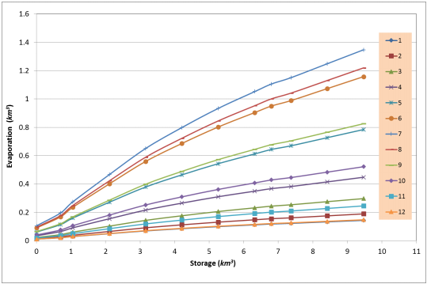
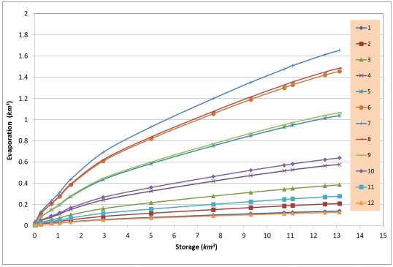

Figure (15): The Rule curve for evaporation _ storage for Dokan Dam
Figure (14): The Rule curve for evaporation _ storage for Musel Dam

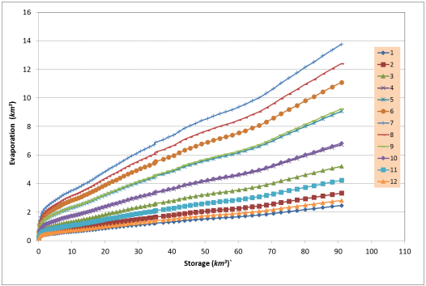
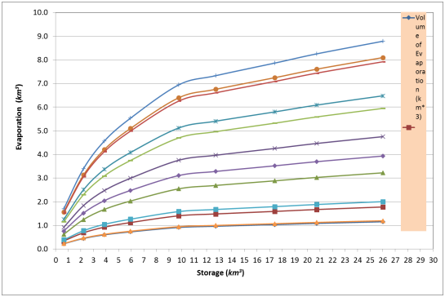

Figure (17): The Rule curve for evaporation _ storage for Tharthar lake
Figure (16): The Rule curve for evaporation _ storage for Al_Adhaim Dam

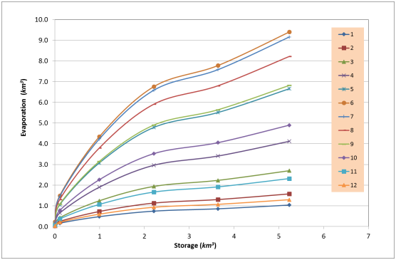
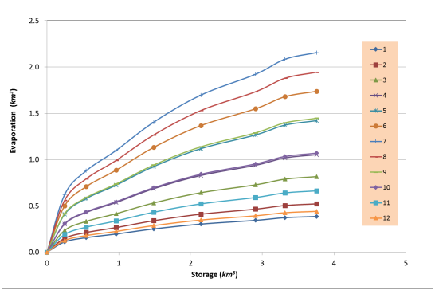

Figure (18): The Rule curve for evaporation _ storage for Al_Hammar Lake
Figure (19): The Rule curve for evaporation _ storage for Habbania Lake

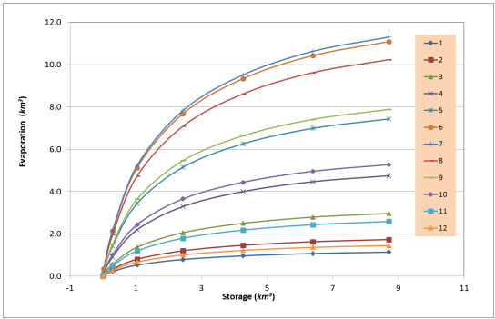
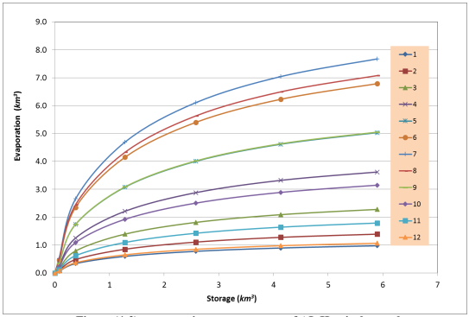

Figure (20): The Rule curve for evaporation _ storage for Qurna Marsh
Figure (21): The Rule curve for evaporation _ storage for Huwizah Marsh

Figure(1): Iraq Map shows the location of Dams

Figure (2): The area-elevation and storage curve
of Haditha Dam

Figure (3): The area-elevation and storage curve
of Debendikan Dam
Figure (4): The area-elevation and storage curve
of Musel Dam
Figure (5): The area-elevation and storage curve
of Dokan Dam

Figure (6): The area-elevation and storage curve
of Al_Adhaim Dam
Figure (7): The area-elevation and storage curve
of Tharthar lake

Figure (8): The area-elevation and storage curve
of Al_Hammar lake
Figure (9): The area-elevation and storage curve
of Habbania lake

Figure (10): The area-elevation and storage curve
of Al_Qurna Marsh
Figure (11): The area-elevation and storage curve
of Al_Huwizah Marsh

Figure (13): The Rule curve for evaporation _ storage for Derbendikan Dam
Figure (12): The Rule curve for evaporation _ storage for Haditha Dam

Figure (15): The Rule curve for evaporation _ storage for Dokan Dam
Figure (14): The Rule curve for evaporation _ storage for Musel Dam

Figure (16): The Rule curve for evaporation _ storage for Al-Adhaim Dam
Figure (17): The Rule curve for evaporation _ storage for Tharthar lake

Figure (18): The Rule curve for evaporation _ storage for Al_Hammar Lake
Figure (19): The Rule curve for evaporation _ storage for Habbania Lake

Figure (20): The Rule curve for evaporation _ storage for Qurna Marsh
Figure (21): The Rule curve for evaporation _ storage for Huwizah Marsh

Location | Evaporation(Km)
Location | Jan. | Feb. | Mar. | Apr. | May | Jun. | Jul. | Aug. | Sep. | Oct. | Nov. | Dec.
Haditha Dam | 0.00066 | 0.00095 | 0.0015 | 0.00219 | 0.00355 | 0.00438 | 0.00477 | 0.00444 | 0.00443 | 0.0032 | 0.0019 | 0.001
Derbendikhan | 0.0005 | 0.0005 | 0.001 | 0.0018 | 0.0035 | 0.0037 | 0.0047 | 0.0036 | 0.0021 | 0.002 | 0.001 | 0.0004
Mousel Dam | 0.0003 | 0.0006 | 0.0009 | 0.0015 | 0.003 | 0.0037 | 0.0041 | 0.0031 | 0.0021 | 0.001 | 0.0007 | 0.0003
Dokan Dam | 0.0004 | 0.0006 | 0.0009 | 0.0014 | 0.0024 | 0.0035 | 0.0041 | 0.0037 | 0.0025 | 0.0016 | 0.0007 | 0.0004
AlAdhaim Dam | 0.0003 | 0.0006 | 0.001 | 0.0014 | 0.0025 | 0.0038 | 0.004 | 0.0036 | 0.0025 | 0.001 | 0.0007 | 0.0003
Tharthar Lake | 0.001 | 0.0014 | 0.0017 | 0.0023 | 0.003 | 0.004 | 0.0048 | 0.0041 | 0.0031 | 0.0026 | 0.0014 | 0.001
Hammar Lake | 0.0005 | 0.0009 | 0.0016 | 0.002 | 0.0032 | 0.0048 | 0.0046 | 0.0041 | 0.0035 | 0.0026 | 0.0013 | 0.0007
Habbania Lake | 0.00085 | 0.00115 | 0.00182 | 0.00235 | 0.00319 | 0.00382 | 0.00479 | 0.00432 | 0.00326 | 0.00231 | 0.00147 | 0.00098
Qurna marsh | 0.00049 | 0.0007 | 0.0013 | 0.0023 | 0.0031 | 0.0047 | 0.0049 | 0.0043 | 0.0033 | 0.0025 | 0.0015 | 0.0006
Hawizah marsh | 0.0005 | 0.0008 | 0.0015 | 0.002 | 0.0029 | 0.0038 | 0.0044 | 0.0039 | 0.0028 | 0.0017 | 0.001 | 0.0006

Table (1): The evaporation for each month for Reservoirs and lakes taken from (Ministry of Transportation,Iraq, 2013).
Reservoir  Name | Mean monthly(p.p.m)  Jan. | Mean monthly(p.p.m)  Feb. | Mean monthly(p.p.m)  Mar. | Mean monthly(p.p.m)  Apr. | Mean monthly(p.p.m)  May | Mean monthly(p.p.m)  Jun. | Mean monthly(p.p.m)  Jul. | Mean monthly(p.p.m)  Aug. | Mean monthly(p.p.m)  Sep. | Mean monthly(p.p.m)  Oct. | Mean monthly(p.p.m)  Nov. | Mean monthly(p.p.m)  Dec.
HadithaDam | 625 | 570 | 598 | 573 | 575 | 547 | 615 | 638 | 637 | 643 | 638 | 635
Derbendikhan Dam | 264 | 264 | 255 | 235 | 200 | 179 | 202 | 222 | 224 | 259 | 230 | 236
MouselDam | 247 | 249 | 247 | 247 | 226 | 210 | 212 | 201 | 204 | 220 | 232 | 240
DokanDam | 197 | 188 | 233 | 199 | 180 | 179 | 157 | 141 | 153 | 149 | 203 | 201
AL-Adhaim  dam | 399 | 413 | 425 | 385 | 380 | 370 | 370 | 363 | 364 | 334 | 369 | 384
Thartharlake | 1440 | 1490 | 1504 | 1457 | 1378 | 1212 | 1259 | 1341 | 1255 | 1454 | 1422 | 1326
Hammarmarsh | 1871 | 1348 | 1890 | 1356 | 1310 | 1288 | 1216 | 1264 | 1327 | 1320 | 1330 | 1480
Habbanialake | 958 | 928 | 865 | 929 | 904 | 921 | 918 | 1115 | 976 | 1144 | 1112 | 1245
Qurnamarsh | 1568 | 1048 | 1651 | 1106 | 1048 | 863 | 746 | 827 | 886 | 830 | 893 | 1015
Huwizahmarsh | 625 | 601 | 437 | 508 | 535 | 850 | 1111 | 875 | 852 | 1234 | 885 | 750
Table (2) : Mean monthly totaldissolved salts (T.D.S) for each location
Table (3): Max., Avg. and Min. storage for the Dams and Marshes
Smin | Savg | Smax | Reservoir
0.85 | 5.2 | 12.5 | Haditha  Dam
0.1 | 1.65 | 5.4 | Derbendikhan Dam
0.3 | 5.9 | 13 | Mousel  dam
0.8 | 5.0 | 9.5 | Dokan  dam
0.4 | 1.8 | 3.8 | AL_Adhaim  dam
1.4 | 32.3 | 91 | Tharthar  lake
0.2 | 5.2 | 4.6 | Hammar  marsh
1 | 2.1 | 3.75 | Habbania  lake
0.41 | 5.3 | 8.3 | Qurna  marsh
0.1 | 3.3 | 5.9 | Huwizah  marsh
0.9 | 12.5 | 5.15 | Haditha  Dam

Table (4): Total Dissolved Solids (T.D.S) (continue)
Total Dissolved Salts (T.D.S) |  |  |  |  |  |  |  |  |  |  |  | Storage  Km³ | location
Dec. | Nov. | Oct. | Sep. | Aug. | Jul. | Jun. | May | Apr. | Mar. | Feb. | Jan. | Storage  Km³ | location
1368 | 1482 | 1574 | 1504 | 1553 | 1496 | 1367 | 1533 | 1579 | 1598 | 1540 | 1480 | Smax. | Tharthar  lake
1381 | 1501 | 1607 | 1554 | 1621 | 1570 | 1425 | 1577 | 1610 | 1622 | 1563 | 1490 | Savg. | Tharthar  lake
1345 | 1436 | 1530 | 1434 | 1425 | 1361 | 1270 | 1455 | 1520 | 1556 | 1525 | 1460 | Smin. | Tharthar  lake
1845 | 1334 | 1861 | 1332 | 1301 | 1223 | 1212 | 1233 | 1302 | 1301 | 1212 | 1322 | Smax. | Hammar  marsh
1871 | 1350 | 1886 | 1366 | 1322 | 1298 | 1236 | 1275 | 1325 | 1322 | 1341 | 1485 | Savg. | Hammar  marsh
1916 | 1456 | 1910 | 1398 | 1354 | 1356 | 1342 | 1298 | 1367 | 1398 | 1388 | 1501 | Smin. | Hammar  marsh
1400 | 1350 | 1610 | 1585 | 2105 | 1085 | 1700 | 1442 | 1254 | 1100 | 1059 | 1078 | Smax. | Habbania  lake
1451 | 1440 | 1820 | 1940 | 3061 | 3543 | 2263 | 1676 | 1444 | 1221 | 1118 | 1117 | Savg. | Habbania  lake
1425 | 1411 | 1731 | 1790 | 2685 | 2952 | 2050 | 1730 | 1455 | 1298 | 1333 | 1245 | Smin. | Habbania  lake
1523 | 1013 | 1632 | 1012 | 988 | 786 | 732 | 799 | 820 | 811 | 850 | 987 | Smax. | Qurna  marsh
1568 | 1048 | 1651 | 1106 | 1048 | 863 | 746 | 827 | 886 | 830 | 893 | 1015 | Savg. | Qurna  marsh
1612 | 1148 | 1711 | 1167 | 1148 | 913 | 881 | 887 | 911 | 889 | 1001 | 1087 | Smin. | Qurna  marsh
621 | 561 | 432 | 512 | 504 | 801 | 1111 | 856 | 832 | 1211 | 834 | 713 | Smax. | Huwizah  marsh
645 | 621 | 457 | 548 | 545 | 880 | 1211 | 888 | 862 | 1236 | 887 | 752 | Savg. | Huwizah  marsh
689 | 687 | 512 | 611 | 615 | 953 | 1298 | 954 | 914 | 1298 | 910 | 767 | Smin. | Huwizah  marsh

Table (4): Total Dissolved Solids (T.D.S) (continue)

Dec. | Nov. | Oct. | Sep. | Aug. | Jul. | Jun. | May | Apr. | Mar. | Feb. | Jan.
668 | 672 | 728 | 756 | 820 | 804 | 712 | 701 | 645 | 650 | 600 | 637 | Smax. | Haditha Dam
678 | 690 | 760 | 799 | 883 | 885 | 770 | 745 | 668 | 668 | 612 | 645 | Savg. | Haditha Dam
665 | 668 | 710 | 720 | 770 | 750 | 658 | 660 | 630 | 636 | 598 | 632 | Smin. | Haditha Dam
240 | 239 | 238 | 276 | 257 | 255 | 244 | 222 | 260 | 265 | 267 | 269 | Smax. | Derbendikhan Dam
239 | 246 | 273 | 247 | 248 | 241 | 219 | 221 | 258 | 263 | 271 | 268 | Savg. | Derbendikhan Dam
251 | 249 | 290 | 267 | 262 | 253 | 222 | 227 | 272 | 282 | 288 | 284 | Smin. | Derbendikhan Dam
242 | 237 | 231 | 222 | 227 | 243 | 237 | 247 | 258 | 255 | 253 | 250 | Smax. | Mousel  Dam
243 | 236 | 235 | 231 | 240 | 260 | 249 | 253 | 260 | 258 | 253 | 251 | Savg. | Mousel  Dam
249 | 252 | 272 | 295 | 360 | 424 | 364 | 361 | 321 | 277 | 264 | 257 | Smin. | Mousel  Dam
233 | 219 | 162 | 195 | 169 | 179 | 2!7 | 215 | 212 | 233 | 182 | 190 | Smax. | Dokan  dam
225 | 210 | 161 | 181 | 168 | 177 | 211 | 212 | 210 | 231 | 182 | 190 | Savg. | Dokan  dam
215 | 198 | 158 | 179 | 165 | 161 | 203 | 202 | 199 | 201 | 178 | 188 | Smin. | Dokan  dam
416 | 401 | 411 | 424 | 460 | 500 | 437 | 480 | 437 | 464 | 450 | 425 | Smax. | AL_adhaim  Dam
455 | 462 | 613 | 895 | 1780 | 3566 | 2105 | 1096 | 622 | 585 | 501 | 456 | Savg. | AL_adhaim  Dam
663 | 667 | 717 | 724 | 776 | 750 | 659 | 662 | 625 | 632 | 590 | 630 | Smin. | AL_adhaim  Dam

