Study of Some Mechanical Properties for Aluminum Reinforced by Alumina Fibers

Shaker Jahel Eddres Ali Hubi Haleem Newal Muhammad Dawood
Babylon university –Materials Engineering Collage
dralishakerj@yahoo.com alialihhhobi@yahoo.com al_kazraji@yahoo.com
Abstract
The aim of this research was to study the ability of improving the impact resistance and Vickers microhardness of composite material based on aluminum metal reinforced by 5, 10, and 15wt.% of chopped alumina fibers. Stirring casting method has been used to make composite material by using vortex technique which is used to pull the chopped alumina fibers to inside the melted aluminum and distributed them homogeneously.
Regarding the impact test, results shown that the impact resistance of the composite material are more than that in the aluminum metal and these values are increased with increasing of the amount add fibers and they reached maximum values at (10 wt. %). Then they are decreased at (15 wt. %) but these values remain at higher values than that in the aluminum metal. While the Vickers microhardness reached maximum values at (15 wt. %).
Key words: Metal matrix composite, Impact test, Vickers micro hardness test, Alumina fibers, Aluminum.
الخلاصة
يهدف البحث الحالي إلى دراسة تحسين مقاومة الصدمة و صلادة فيكرز المايكروية لمادة مركبة ذات أساس من معدن الألمنيوم مقوى بألياف الألومينا المقطعة وبنسب وزنية (5%, 10%, 15%). وتم استخدام طريقة السباكة بالمزج في تصنيع المادة المتراكبة باستخدام تقنية الدوامة والتي تعمل على سحب ألياف الألومينا ألمقطعه إلى داخل منصهر معدن الألمنيوم وتوزيعها خلاله بشكل متجانس.
أظهرت نتائج اختبار الصدم إن مقاومة الصدمة للمادة المركبة أعلى مما هي عليه لمعدن الألمنيوم وتزداد هذه القيم مع زيادة النسب الوزنية لألياف الألومينا والى حد (10%) ثم تسلك سلوكا مغايرا لكنها تبقى محافظة على قيم أعلى مما هي عليه لمعدن الألمنيوم . في حين تصل صلادة فيكرز المايكروية أعلى قيمها عند التقوية بألياف الألومينا المقطعة وبكسر وزني ((15%.
الكلمات المفتاحية:المواد المركبة ذات الأساس المعدني, اختبار الصدم, اختبار صلادة فيكرز المايكروية, ألياف الألومينا, الألمنيوم.
1.Introduction
During the last two decades, the need for new and improved materials has engendered considerable scientific and technological interest. The newer generation materials are used in a spectrum of performance critical products in the industries of aerospace, automobile, power generation and even consumer related products (Lewandowski, 2000).To meet this emerging need, innovations in materials processing enabled achieving an enhancement in stiffness, realization of high strength to weight ratio, an improvement in wear resistance, maintaining strength at elevated temperature, and enhanced resistance to corrosion when exposed to aggressive environments, while concurrently retaining other desirable properties based on end applications(Srivatsan et al.,1995).
In the early stages of materials development and emergence, the newer generation alloys offered acceptable specific stiffness (E /δ), high strength at the expense of ductility, and formability. Alternatively, pure metals and their alloys counterparts when reinforced with ceramic materials, offer notable improvement in existing properties(Christman and Suresh, 1988). The outcome of sustained research efforts resulted in the development an emergence of a family of reinforced materials referred to and marketed as composite materials. The development of reinforced materials was based on choosing metal, intermetallic, ceramic or polymers as the matrix. Among the reinforced materials, metal- matrix composites (MMCs) have generated considerable scientific and technological interest, primarily because of the intrinsic advantages they offer with respect to: (a) processing ,( b) fabrication using existing infrastructure, and (c) property development and/ or enhancement (Minghetti et al., 2002;Marchi et al.,2003).
To increase the reinforcing effect and to reduce the weight still further, it is judicious to use non metallic reinforcing elements which have a higher specific strength and stiffness than metallic components [Table 1] (Pietzka et al., 2008). One possibility of combining the light weight material aluminum with non- metallic components is provided by alumina fibers. However, on the one hand alumina fibers have a high tensile strength, but on the other hand the fibers are brittle and rough considering bending forces ( Pietzka et al., 2008).
The aim of this work is to prepare and to study the mechanical properties (impact resistance and Vickers micro hardness) of aluminum matrix composite material reinforced by (5, 10, and 15 wt. %) chopped alumina fibers using Stirring Casting method.
2.Material Used
2.1. Aluminum
A wide range of aluminum alloys in various forms has been incorporated in MMCs. Pure aluminum melts at 660 °C; this relatively low melting temperature in comparison to most other potential matrix metals facilitates processing of Al-based MMCs by solid-state routes, such as powder metallurgy, and by casting methods (Butler, 2006). Tables 2 (Callister, 2003) illustrate some mechanical properties of aluminum metal.
2.2 Alumina Fibers
A need for higher modulus of elasticity, melting point, and exceptional resistance to corrosive conditions resulted in manufacturing fibers of pure or near pure Al₂O₃. These relatively pure alumina fibers contain very little if any SiO₂ and other components within the fibers composition. As the temperature continues to increase, the alumina becomes crystalline, undergoing different phase changes until it reaches the desired stable α phase. The first Al₂O₃ phase to form is η and, as the temperature decrease, changes and continues through to γ, δ,$θ$, and finally the composition becomes α phase (Reinhart, 1989). The α phase of Al₂O₃ is desired for fibers used in composites with high temperature applications due to its higher temperatures resistance and modulus value (Cooke, 1991).
3. Theoretical View
Fracture mechanics can be defined as material breaks into two parts due to the effects of external forces. Griffith was the first person who fixed the basic principles of fracture mechanics by energy balance theory. Griffith (Boresl and Schmidt, 2002)studies the process, which occurred to the crack by reverse thermodynamics process. He proposed the existence of static equilibrium condition for crack through the effects of energies given by equations 1 and 2:
$$U=(−W_{L}+U_{o})+U_{S}\begin{matrix}\begin{matrix} & & & \end{matrix} & & & \end{matrix}(1)$$
Where W_{L:} External performed work on system.
U_{o}: Saved energy in system.
U_{S}: Required energy to create new surface (free surface energy).
U: External impact energy.
Therefore, fracture mechanics is calculated from impact energy (U) if engineering sample dimensions and crack depth (a) are measured. When crack growth occurred, malleability will increase for material according to the value of saved energy, therefore if malleability changes and crack depth (a) are known, absorbed energy is calculated by the following equation (Boresl and Schmidt, 2002 ):
$U=\frac{1}{2}P^{2}C\begin{matrix}\begin{matrix}\begin{matrix} & & & \end{matrix} & & & \end{matrix} & & & \end{matrix}(2)$
Where P: applied load in Newton
C: malleability.
If sample width is B in meter then:
$$G_{c}=\frac{1}{B}\frac{\text{dU}}{\text{da}}\begin{matrix}\begin{matrix}\begin{matrix} & & & \end{matrix} & & & \end{matrix} & & & \end{matrix}(3)$$
$$G_{c}=\frac{1}{B}\frac{\text{dU}}{dC}\frac{\text{dC}}{\text{da}}\begin{matrix}\begin{matrix}\begin{matrix} & & & \end{matrix} & & & \end{matrix} & & & \end{matrix}(4)$$
Where: G_{C} is material toughness when crack occurred. (G_{C)} is one of the material properties, and it is regarded as absorbed energy by crack unit area, also it represents released critical strain energy, which is given by the following equation (Boresl and Schmidt, 2002 ):
$$G_{c}=\frac{P^{2}}{2B}\frac{\text{dC}}{\text{da}}\begin{matrix}\begin{matrix}\begin{matrix} & & & \end{matrix} & & & \end{matrix} & & & \end{matrix}(5)$$
From equations, two and five, absorbed energy is calculated by impact test:
$$U=G_{C}B\frac{C}{{\text{dC}}/{\text{da}}}\begin{matrix}\begin{matrix}\begin{matrix} & & & \end{matrix} & & & \end{matrix} & & & \end{matrix}(6)$$
Practically, U is calculated for different crack depths.
$$G_{c}=\frac{U}{\text{BDC}}\frac{\text{dC}}{d(a/D)}\begin{matrix}\begin{matrix}\begin{matrix} & & & \end{matrix} & & & \end{matrix} & & & \end{matrix}(7)$$
Where D: Sample thickness in meter.
So, engineering configuration function Φ is given by malleability C:
$$Φ=\frac{C}{{\text{dC}}/d(a/D)}\begin{matrix}\begin{matrix} & & & \end{matrix} & & & \end{matrix}(8)$$
So equation 8 can be solved to calculate material toughness G_{C}:

$$U=G_{C}\text{BD}Φ\begin{matrix}\begin{matrix}\begin{matrix} & & & \end{matrix} & & & \end{matrix} & & & \end{matrix}(9)$$
Where : Ф = 0.135 (a /D)^{- 0.77} (10)
The relationship between absorbed energy (U) and engineering configuration function (Φ) is linear, and the slop of this line is material toughness G_{C} (Boresl and Schmidt, 2002).
4. Experimental Work
4.1.Alumina Fiber Preparation
The route of ceramic fibers involves the preparation of a concentrated solution with which to impregnate a conventional rayon or cotton thread chosen for its wicking rate. During heating two processes occur; the first, solution is rapidly crystallized when solvent molecules are flash- evaporated, and the second cotton is pyrolysed, leaving behind a skeleton of the relevant oxide. This pyrolysis has to be undertaken carefully to avoid disruption, and is responsible for the hollow tube morphology. The evaporation stage remove solution from the surface to cause a degree of back-wicking leaving a center core with no solution. The more rapidly the evaporation can be achieved, the smaller will be the cross section of the hollow tube.
The manufacturing process of alumina fiber is proprietary, although certain details have been made available which outline the general fabrication route. The innovation fabrication technique involves the use of an organic precursor fiber, rayon as an internal former. The organic fiber is impregnated with an aqueous solution of aluminum chloride. During drying, the metallic salts are deposited within the organic fiber, which can be burnt off by controlled oxidation.
These steps achieved the fabrication process:
- Preparation the solution of the aluminum oxychloride in a concentration of 1- M solution.
- Selection cotton as a substrate.
- Impregnation of the cotton from the solution three days and extraction the cotton from the drying in furnace at 100 °C.
- Heat treatment was achieved at two stages, heat-treated to a temperature 350 °C slowly, need four hrs. to reach this temperature then raised the temperature to 600 °C and leave the cotton at this temperature to 1 hr. then slowly cooled at furnace.
4.2.Composite Manufacturing
Stirring casting was used here in preparing composite samples. This method could distribute chopped alumina fibers homogenously in the aluminum microstructure by forming vortex in molten metallic. It could pull chopped alumina fibers through molten metallic and distributed them homogenously. Stirring casting improve mechanical and physical properties of the aluminum matrix.
Matrix material (aluminum, assay 99.9%, supplied from universal company of electrical industries) cut into small pieces to obtain the required weight according to reinforcement chopped alumina fibers weight fraction (5, 10, and 15 wt. %). Pre-weighted samples were putted in alumina pots, then inserted in Carbolite tube furnace setting at 700 °C to ensure melting of the sample.
To ensure the homogeneity of the added chopped alumina fibers through molten aluminum, electrical mixer was inserted into alumina pot, which is kept in the holding electrical furnace at 700°C . Molten aluminum was stirred at (900 r.p.m.) to get suitable vortex. Later chopped alumina fibers, which are enveloped in aluminum foil, were added to molten metal to modify chopped alumina fibers distribution through the molten aluminum.
Due to the vortex effect, chopped alumina fibers were pulled inside the molten metal and uniformly distributed. Molten aluminum was stirred for (1- 5 min.) until the molten aluminum becomes slurry. Later molten aluminum was poured into suitable stainless steel mould, which is preheated at 250 °C to prevent sudden cooling for molten aluminum.
This process was repeated several times according to reinforcement fibers ratio (alumina fibers). It was noted obviously increasing in slurry viscosity especially at 15 wt. % alumina fibers. This phenomenon requires long stirring time to overcome the difficulties in casting process.
4.3.Samples Preparation
4.3.1.Impact Test Samples
Impact test samples were prepared according to ISO-179 . Aluminum samples without and with reinforcement alumina fibers at (5%, 10, 15 wt. %) using (Charpy Impact Test).
4.3.2.Hardness Test Samples
All samples were tested using Vickers micro hardness test using Micro hardness Tester HV 1000, where the average indentation diameter d (mm) were recorded.Micro hardness was calculated according to the following eq. (Dieter, 1976):
HV=1.854 L/ d² _{av.} (11)
Where L: Applied load (kg / mm).
Vickers micro hardness test was repeated several times to evaluate micro hardness average value.

5.Results and Discussion
Figures 1a and b illustrate light optical microscopy images of chopped alumina fibers prepared in this work. Whereas Figures 2 and 3 shows diffractograms from the surface chopped alumina fibers and the standard diffractograms from the surface of α-Al₂O₃ respectively.
Figure 4 illustrate the effect of (5,10,15 wt.% alumina fibers) as reinforcement material on the aluminum hardness. It is noted that Vickers micro hardness values increases with the increasing alumina fiber weight fractions. This is because of the good bonding between the alumina fibers and aluminum as matrix material. The Vickers micro hardness of composite material reaches maximum value (382) at 15 wt. % alumina fibers. The interface is crucial in controlling composite properties because load is transferred from the matrix to the fiber through the interface.
In this work, composites with chopped alumina fibers, the critical factors are the length –to-diameter ratio of the fiber, the shear strength of the bond between the fiber and the matrix, and the amount of fiber. All these variables affect the strength of the composite. However, a good deal of composite is made with chopped of alumina fibers because of the ease with which is formed into complex shapes even when the length to diameter ratio is unfavorable (Kozma, 2003).
Figure 5 shows the effect of added chopped alumina fibers in different weight fractions (5, 10, 15 wt. %) to aluminum on fracture energy (joule). Reinforcement fibers act as strong obstacle against cracks propagation and this will tend to change crack shape and direction. Then this crack will transform into secondary cracks. Change in crack shape and direction leads to increase crack surface area and consumed fracture energy. All these factors tend to increase composite strength especially in case of good bonding between reinforced fibers and matrix
(Hanan, et al., 2005).
Further, Figure 5 showed impact energy (U) variation with engineering configuration function (BDΦ) by variable crack depth (a) under different chopped alumina fibers at a selected weight fraction of (5, 10, 15) % . It's clear that fracture impact energy was decreased with increasing of crack depths due to decreasing cross section area of sample under shock test.
Results indicated that impact resistance was increased by a ratio of (67.4%) with increasing chopped alumina fibers weight fraction at (10 wt. %). Then it decreased at (15 wt. %) but its value remain at higher value than that in the aluminum metal. This is probably because of the decrease in fibers wetability due to the deficit in matrix material. Therefore, the matrix material could not transfer the applied load between alumina fibers any more.
During preparation of current composite material, aluminum as a continuous phase, envelops the alumina fibers and forms a coherent bond, usually chemical in nature, at the fiber/ matrix interface. During deformation, the matrix transfers stress to the fibers, which are usually stronger and have a higher elastic modulus. The response of the composite then depends on the relative properties of the fiber and the matrix, the volume fraction of each phase, the fiber length and orientation (Kozma, 2003). It was noted that failure of individual fibers is local and takes place without destroying the integrity of the whole composite.
Table 3 shows material toughness of prepared samples. The toughness G_{C} of composite (like that of any other material) is a measure of the energy absorbed per unit crack area. Material toughness (G_{C}) was calculated for each sample from the tendency of linear relationship between fracture energy (U)and engineering configuration function BDΦ (as in Figure 4). Results shows that maximum toughness was found in case of reinforced aluminum by 10 wt. % chopped alumina fibers (948.9kJ/m²).
6.Conclusions
This research covers reinforcement of aluminum metal with chopped alumina fibers, and focalizes on studying Vickers microhardness, impact resistance, and material toughness properties by preparing the aluminum metal reinforced by random chopped alumina fibers at a selected weight fraction of (5, 10, 15) % . Further, the following results can be concluded:
- Addition of chopped alumina fibers to aluminum metal increase Vickers microhardness proportionality especially in case of reinforcement by weight fraction of (15 %), it increases 189% in comparison with unreinforced aluminum.
- The toughness G_{C} of prepared composite material reaches maximum value with increasing chopped alumina fibers weight fraction at (10 wt. %), it increased by a ratio of 320 % in comparison with unreinforced aluminum.
7. References
Boresl, A. P and Schmidt, R. J.; 2002; "Advanced Mechanics of Materials", sixth edition, John Wiley and Sons, INC, USA
Butler, J.,2006, In-situ Fiber Strength Distribution In NextelTM 610 Reinforced Aluminum Composites, MSc thesis, Faculty of the Virginia Polytechnic Institute and State University.
Callister, W. D., and J R., 2003, Material Science and Engineering, An Introduction, 6thed. John Wiely.
Christman, T., and Suressh, S., 1988, Microstructural Development in an Aluminum Alloy SiC Whisker Composite, Acta Metall., 36,pp. 1699- 1704.
Cooke, T. F., 1991, Inorganic Fibers- A Literature Review, Journal of American Ceramic Society, 74(12), 2959-78.
Dieter,E.G.,1976, Mechanical Metallurgy, Second Edition, Published by McGraw-Hill.
Hanan, J. C., Mahesh, S., Ustundag ,E., Beyerlein, I. J., Swift, G. A., Clausen, B., Brown, D. W., Bourke, M. A. M., 2010, Strain Evolution After Fiber Failure in A Single Fiber Metal Matrix Composite Under Cyclic Loading, Material Science and Engineering, article in press.
Kozma, M., 2003, Friction and Wear of Aluminum Matrix Composites, National Tribology Conference, pp. 99-106.
Lewandowski, J. J.,2000, Fracture and Fatique of Particulate Composites, Metal Matrix Composites, ed. Clyne, T. W., Elsevier Publishers, New York, Vol. 3,pp. 151-187.
Marchi, C. S., Kouzeli, M., Rao, R., Lewis, J. A., Dunan, D. C.,2003, Alumina-aluminum interpenetrating-Phase Composites With Three- Dimensional Periodic Architecture, Scripta Materialia 49, 861-866.
Minghetti, T., Steinhoff, Nastran, M., Kuzman, K., Gullo, G. C., Uggowitzer, P. J.,2002, Advanced Forming Techniques for Aluminum –Based Metal Matrix Composite,Tiziano-Minghetti@sm.admin.ch.
Pietzka, D., Schikorra, M., and Erman, A, T., 2008, Embedding of Alumina Reinforcing Elements in the Composite Extrusion Process, Advanced Materials Research, vol. 43, pp.9-16.
Reinhart, T. J., 1989, Engineering Materials Handbook, ed. C.A. Dostal. Vol. 1, Metals Park, Ohio: ASM INTERNATIONAL Handbook Committee.60.
Srivatsan, T. S., Sudarsha, T. S., and Lavernia, E. J.,1995, Processing of Discontinuously Reinforced Metal Matrix Composites by Rapid Solidification, Prog. Material Science, 39,pp. 317-409.
Table 1: Mechanical Properties of Reinforcing Elements (Pietzka et. al., 2008).
Material | R_{m} [MPa] | E [GPa] | ρ [g/ cm³] | E/ρ[GPa. cm³/ g]
Spring steel 1.4310 (d: 1mm) | >1950 | 185 | 7.8 | 23.7
Nickel-based alloy (d: 1mm) | 1300-1600 | 205 | 8.1 | 25.3
Alumina fibers | Until 3100 | Until 400 | 4.0 | Until 100

Table 2: Some mechanical properties of aluminum metal (Callister, 2003).
Density(kg/m³) | Modulus of Elasticity (GPa) | Tensile Strength (MPa) | Thermal Conductivity(W/m. °C)
2700 | 71 | 60 | 247

Table 3: Material toughness values for Aluminum samples with and without reinforcement alumina fibers at (5%, 10, 15 wt. %).
Material | Toughness (kJ /m²)
Al | 225.8
Al+5%Al2O3 | 461.3
Al+10%Al2O3 | 948.9
Al+15%Al2O3 | 622.4

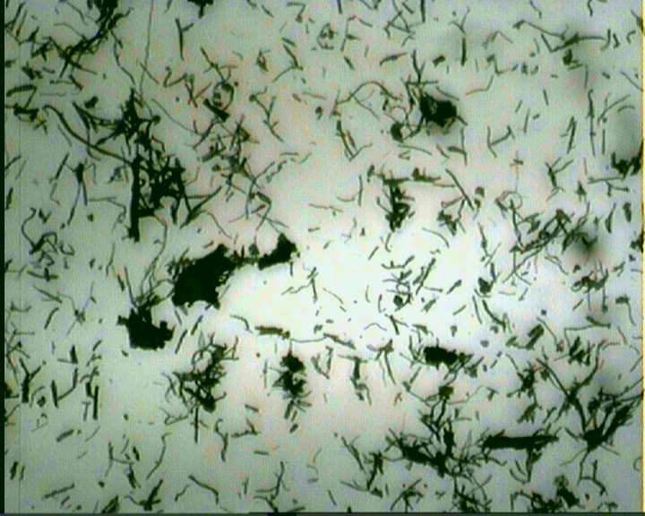
a

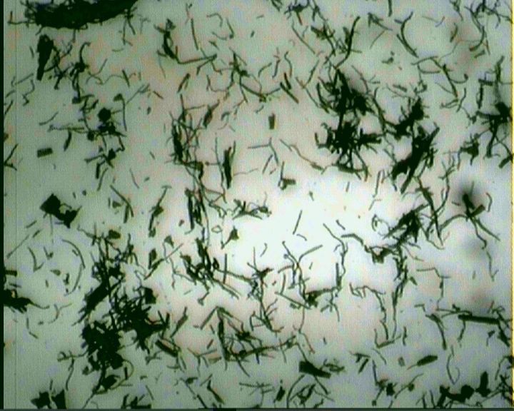
b

Figures 1a and b: Light optical microscopy images of chopped alumina fibers which prepared in this work(Magnification 400X).

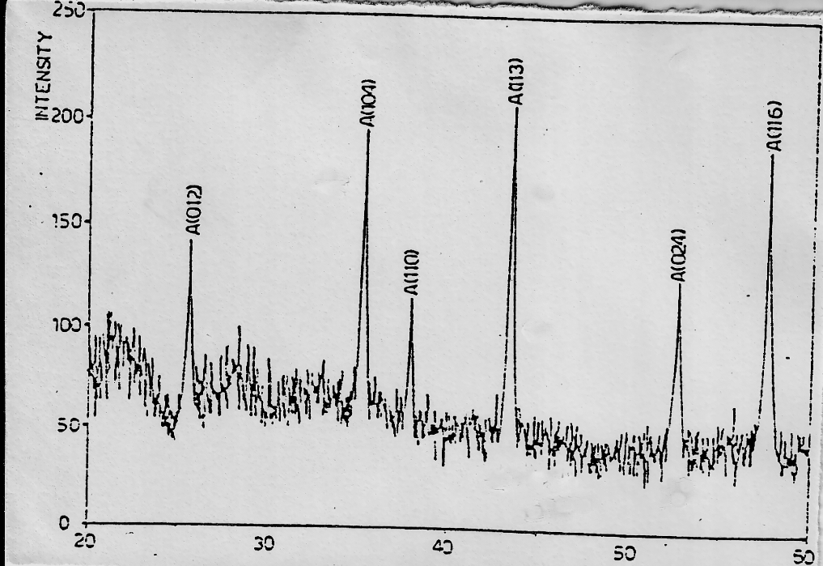
Diffraction Angle,2 Ɵ (degree)
Intensity (cps)

Fig. 2: Diffractograms from the surface of chopped alumina fibers (Al₂O₃)

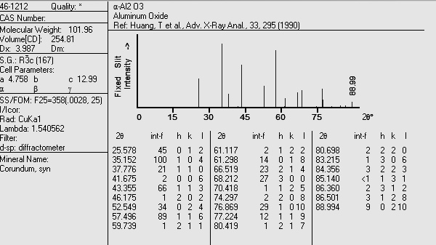

Fig. 3: Standard Diffractograms of α-Al₂O₃

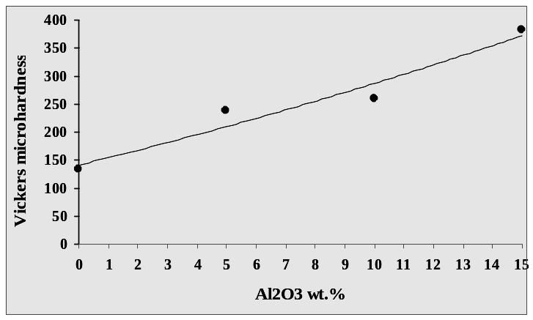

Fig. 4: Vickers micro hardness vs. chopped alumina fibers (Al₂O₃wt.%)

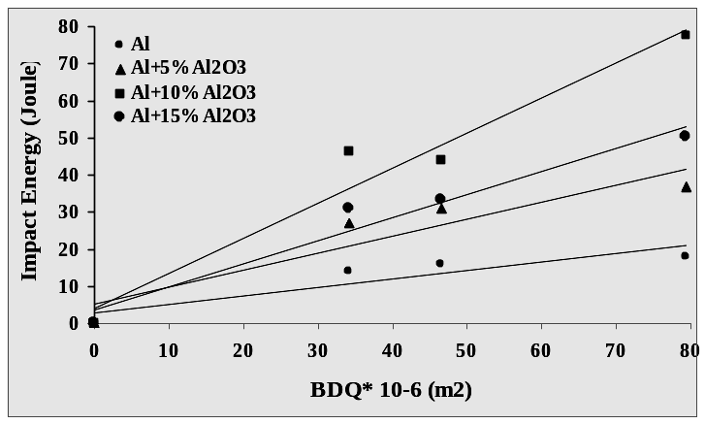

Fig. 5: Impact energy vs. BDФ

