Proposed Model for Uniaxial Compression Behavior of Reactive Powder Concrete

Hisham Mohamed Al-Hassani Wasan Ismail. Khalil
Building and Construction Engineering Department
University of Technology/ Baghdad
wasan1959@yahoo.com
Lubna Salim Danha
Building and Construction Engineering Department
University of Technology/ Baghdad
Abstract
This paper investigates experimentally the complete compressive stress-strain relationships of Reactive Powder Concrete (RPC) and general equation for expressing such relationships is obtained. The effects of three variable parameters on the compression behavior were carefully studied which are, the silica fume content SF (0%, 10%, 15%, 20%, 25%, and 30%) as a partial replacement by weight of cement, steel fibers volume fraction V_{f} (0%, 1%, 2% and 3%) and superplasticizer type (Sikament ®-163N, PC200). The experimental results of the compressive stress-strain relationship obtained for different RPC mixes, showed that increasing the silica fume content caused the ascending part of the compressive stress-strain curve to become steeper giving higher modulus of elasticity as well as an apparent increase in compressive strength, but there was no clear effect on the value of its corresponding strain. It was also found that the addition of steel fibers slightly increased the slope of the ascending portion of the stress-strain curve, but there was a clear increase in strain at peak stress and an increase in ductility. The suggested nonlinear equation for modeling the complete compressive stress-strain relationship of RPC showed a very close agreement with the experimental results and therefore this proposed equation can be used safely in design and analysis.
Keywords: Compressive stress-strain relationship, Steel fibers, Silica fumes.
الخلاصة:
يقدم هذا البحث تحري عملي للعلاقة المتكاملة بين الإجهاد والإنفعال في حالة الانضغاط لخرسانة المساحيق الفعالة, كما تم ايجاد معادلة عامة للتعبير عن هذه العلاقات. تم بعناية دراسة ومناقشة تأثير ثلاث متغيرات على سلوك الانضغاط والتي هي محتوى ابخرة السليكا المكثفة (0%, 10%, 15%, 20%, 25%, 30%) والنسبة الحجمية للالياف الفولاذية (0%, 1%, 2%, 3%) ونوع الملدن المتفوق (Sikament ®-163N, PC200). اظهرت النتائج العملية التي تم الحصول عليها من علاقة إجهاد-انفعال الانضغاط لخلطات خرسانة المساحيق الفعالة المختلفة أنه بزيادة محتوى ابخرة السليكا المكثفة فان الجزء الصاعد من منحنى الإجهاد-الانفعال يصبح أشد انحداراً معطياً معامل مرونة ستاتيكي اعلى, بالاضافة الى زيادة واضحة في مقاومة الانضغاط ولكن ليس هناك تأثير واضح على قيمة الانفعال المصاحبة لها. ولقد وجد أيضا أن إضافة الألياف الفولاذية تؤثر قليلا على ميل الجزء الصاعد من منحنى الإجهاد-الانفعال، ولكن هناك زيادة واضحة في قيمة الانفعال المصاحبة لمقاومة الانضغاط القصوى وزيادة في المطيلية. و لقد أظهرت المعادلة غير الخطية المقترحة لنمذجة العلاقة الكلية للإجهاد-انفعال تحت تأثير الانضغاط لخرسانة المساحيق الفعالة تقاربا مع النتائج العملية ولذلك فان هذه المعادلة يمكن استخدامها في التصميم والتحليل بشكل آمن.
الكلمات المفتاحية: علاقة الاجهاد- الانفعال للانضغاط, الالياف الفولاذية, ابخرة السليكا المكثفة
- Introduction
Researches over the past decade have yielded a new classification of highly resilient concrete, called Reactive Powder Concrete (RPC) now labeled and classified as Ultra High Performance Concrete (UHPC) [Al- Hassani et al., 2013; Al- Hassani and Ibraheem,2011]. Ultra high performance concrete is one of the latest advances in concrete technology and it addresses the shortcomings of many concretes today. In addition to achieving high compressive strength UHPC is also nearly impermeable. This very low permeability allows UHPC to withstand many distresses normally associated with Normal Strength Concrete (NSC) and High Performance Concrete (HPC) such as freeze – thaw deterioration, corrosion of embedded steel and chemical ingress [Theresa et al., 2008]. Since the intrinsic strength of concrete is its ability to resist compressive loads, reinforced concrete members are designed to take advantage of this intrinsic strength. Therefore the knowledge of the behavior of concrete in compression is very important. The behavior of RPC under compression is of considerable interest in the design of RPC members and prediction of their structural behavior. Very few investigations report the complete stress- strain behavior of RPC. The effect of different parameters on stress- strain characteristics are not investigated in detail [Prabha et al., 2010]. All previous researches use micro steel fibers in producing RPC. The cost of this type of fiber is very high. In this study macro hooked steel fiber (diameter 0.5mm, length 30mm) is used. It is cheaper than micro type. The complete stress- strain behavior for RPC with various dosages of macro steel fibers and silica fume under uniaxial compression is presented in this paper. Also a model of compressive stress- strain relationship for RPC based on the experimental results is proposed.
- Experimental Program
  - Materials
2.1.1 Cement
Sulfate resisting Portland cement Type V was used throughout this research. Its chemical and physical properties conforms the provision of Iraqi specifications No.5/1980.
    - Fine Aggregate
AL-Ukhaider natural sand of maximum size 600µm is used. Its gradation lies in zone (4), as shown in table (1). The gradation and sulfate content results of fine aggregate were within the requirements of the Iraqi specification No. 45/1980.
    - Admixtures
Two types of concrete admixtures are used in this work:
      - Superplasticizer
Two different types of superplasticizer are used to produce the RPC mixes. They are, naphthalene formaldehyde sulphonate polymer manufactured and supplied by SIKA® Company under the commercial name Sikament®-163N, and polycarboxylate ether polymer manufactured by PAC Technologies Company under the commercial name PC 200. These admixtures comply with the requirements of ASTM C494.
      - Silica Fume
Silica fume has been used as a mineral admixture added to the RPC mixes of this study. The percentages used were 10%, 15%, 20%, 25%, and 30% as partial replacement of cement weight. Its accelerated pozzolanic strength activity index with Portland cement at 7 days is 125.6%. The chemical composition and physical requirements show that the silica fume conforms the chemical and physical requirements of ASTM C1240 specifications.

Table (1) Fine aggregate properties
Sieve size  (mm) | Cumulative passing % | Limits of Iraqi specification  No.45/1984, zone 4
4.75 | 100 | 95-100
2.36 | 100 | 95-100
1.18 | 100 | 90-100
0.60 | 100 | 80-100
0.30 | 44 | 15-50
0.15 | 7 | 0-15
Fineness modulus = 1.5
Specific gravity =2.69
Sulfate content =0.13%
(Iraqi specification requirement ≤ 0.5%)
Absorption = 0.73%
Material finer than 75µm=1.24%
(Iraqi specification requirement ≤ 0.5%)

    - Steel Fibers
Hooked macro steel fibers are used throughout the experimental program. The steel fiber used has diameter 0.5mm, length 30mm (aspect ratio lf/ df =60), density 7800 kg/m³ and ultimate tensile strength of 1180 MPa.
  - Concrete Mixes
The key features of RPC mix design include high Portland cement content, fine sand with a particle size of between 150 and 600 µm, extremely low w/c ratio made possible by high dosages of the latest generation of superplasticizer, the presence of a high reactivity silica fume, and the incorporation of steel fibers. Sand to cement ratio (S/C) in mortar has a significant effect on compressive strength, S/C ratio equal to 1.0 was found to be very effective for the optimization of mortar mixture with superplasticizer and mineral admixture [Dauriac et al., 1997]. Within the above limits and according to pervious researches [Acker et al,.2004; Harris et al.,2005; Kang et al.,2010, Spasojevic,2008], many mix proportions are tried in this study to have maximum compressive strength and flow of (110+5%) according to ASTM C109 and ASTM C1437 respectively. Ten RPC mixes are used in the present study as listed in table (2) to investigate the performance of RPC in the hardened state.
Three variable parameters are considered in the preparation of these ten RPC mixes. They are;
- The silica fume content (as partial replacement by weight of cement). Six ratios are used (0%, 10%, 15%, 20%, 25% and 30%).
- The steel fibers volume fraction (as ratio of the mix volume). Four ratios are used (0%, 1%, 2% and 3%).
- The type of the superplasticizer used in the mix is either type N (Sikament®-163N) or type P (PC200).

Table (2) RPC mixes used in the present research
Group | Mix  symbol | cement kg/m³ | fine sand kg/m³ | silica fume*  (%) | silica fume kg/m³ | steel fibers** (%) | steel fibers content kg/m³ | w/cm ratio | HRWRA*** (%) | HRWRA type
1 | MSP-N | 935 | 1100 | 15% | 165 | 2% | 156 | 0.181 | 9.5% | Sikament®-163N
 | MSP-P | 935 | 1100 | 15% | 165 | 2% | 156 | 0.169 | 8.7% | PC200
2 | MSF0 | 1100 | 1100 | 0% | 0 | 2% | 156 | 0.161 | 8.7% | PC200
 | MSF10 | 990 | 1100 | 10% | 110 | 2% | 156 | 0.166 | 8.7% | PC200
 | MSF15† | 935 | 1100 | 15% | 165 | 2% | 156 | 0.169 | 8.7% | PC200
 | MSF20 | 880 | 1100 | 20% | 220 | 2% | 156 | 0.174 | 8.7% | PC200
 | MSF25†† | 825 | 1100 | 25% | 275 | 2% | 156 | 0.180 | 8.7% | PC200
 | MSF30 | 770 | 1100 | 30% | 330 | 2% | 156 | 0.188 | 8.7% | PC200
3 | MFR0 | 825 | 1100 | 25% | 275 | 0% | 0 | 0.171 | 8.7% | PC200
 | MFR1 | 825 | 1100 | 25% | 275 | 1% | 78 | 0.175 | 8.7% | PC200
 | MFR2 | 825 | 1100 | 25% | 275 | 2% | 156 | 0.180 | 8.7% | PC200
 | MFR3 | 825 | 1100 | 25% | 275 | 3% | 234 | 0.187 | 8.7% | PC200
† MSF15 in group 2 is the same mix designated MSP-P in group 1
†† MSF25 in group 2 is the same mix designated MFR2 in group 3
* Percent by weight of cement.
** Percent of mix volume.
*** Percent of cementitious materials (cement + silica fume) weight.
All mixes shown in Table (2) have a flow ranging between 105% and 115%.

  - Mixing of Concrete
All RPC mixes are performed in a rotary mixer of 0.1m³. For RPC concrete, the silica fume and cement are mixed in dry state for about three minutes to disperse the silica fume particles throughout the cement particles, then the sand is added and the mixture is mixed for five minutes. The superplasticizer is dissolved in water and the solution of water and superplasticizer is gradually added during the mixing process then the whole mixture is mixed for 3 minutes. The mixer is stopped and mixing is continued manually especially for the portions not reached by the blades of the mixer. The mixer then operates for five minutes to attain reasonable fluidity. Fibers are uniformly distributed into the mix in 3 minutes, and then the mixing process continued for additional 2 minutes. In total, the mixing of one batch requires approximately 15 minutes from adding water to the mix.
  - Preparation and Testing of Specimens
The compressive strength test is carried out according to:
ASTM C39/C39M-07, Cylindrical specimens (100×200 mm) are used to determine the compressive strength of RPC using a digital testing machine of 2000 kN capacity.
B.S: 1881: part 116, Cube specimens (100 mm) are used to determine the compressive strength of RPC using a digital testing machine of 2000 kN capacity.
The specimens are tested at the age of 28 days and the average of three specimens is adopted for each mix.
Static modulus of elasticity is carried out on 100×200 mm cylindrical specimens. The 40% of ultimate compressive strength of concrete specimen is applied on the concrete cylinders to perform the elastic modulus test as specified by ASTM C469-07. The specimens are tested at age 28 days and the average of three specimens is adopted.
Compressive Stress-Strain relationship is performed under uniaxial compressive load on 100×200mm cylinder specimens to obtain the compressive stress-strain curve using a digital testing machine of 2000kN capacity. At each value of the applied axial compressive load (P),the corresponding displacement is obtained using a digital dial gage of 0.01mm sensitivity to determine the compressive stress-strain curve. The test is conducted at age of 28 days.
  - Curing
All specimens are demolded after 24 hours, and then they are steam cured at about 90ºC for 48 hours in a water bath. After that they are left to be cooled at room temperature, and then placed in water for 28 days.
3. Results and Discussions
3.1 Compressive Strength
    - Effect of Steel Fibers Volume Fraction on Compressive Strength
Table (3) shows that by increasing the fibers volume fraction from 0% to 1.0%, 2.0%, and 3.0% the cube compressive strength (f_{cu}) slightly increased by 3.72%, 8.36%, and 8.89% respectively, while the cylinder compressive strength (f ′_{c}) slightly increased by 6.36%, 9.9%, and 11.54% respectively. Such increase may be associated with crack arrest theory of the fibers which accounts for the increase in compressive strength. According to Lee and Chisholm 2005, the improved compressive strength does likely reflect the contribution of steel fibers to the tensile capacity of RPC. An accepted view is obtained, that concrete under uniaxial compressive load fails because of lateral strain induced by Poisson’s ratio effects leading to lateral swelling of unconfined central section accompanied by cracking parallel to the loading axis and shear failure near the specimen ends.
    - Effect of Silica Fume Content on Compression Strength
Table (3) shows that increasing silica fume content (SF) from 0% to 10%, 15%, 20%, 25%, and 30% caused a considerable increase in both the cube compressive strength (f_{cu}) by 13.54%, 18.02%, 24.72%, 29.86%, and 34.17% respectively and the cylinder compressive strength (f ′_{c}) by 17.56%, 20.30%, 30.92%, 33.79%, and 41.04% respectively. This can be explained by the high pozzolanic reaction of silica fume particles with calcium hydroxide released from cement hydration leading to pore size and grain size refinement processes which can strengthen the microstructure and reducing the microcracking. The extreme fineness of the silica fume particles provides nucleation sites for calcium hydroxide and the additional contribution to the progress of hydration of the cement occurs. The beneficial effects of silica fume are not limited to its pozzolanic reaction. There is also a physical effect which comes from the enhanced particle packing. This leads to improving the microstructure of RPC matrix and increase its density [Neville, 2005].

Table (3): Cube and cylinder compressive strengths of RPC
Group | Mix  Symbol | Silica Fume  (SF) (%) | Steel fibers  (V_{f}) (%) | f_{cu}  (MPa) | %Increase in f_{cu} with respect to the first mix in each group | f '_{c}  (MPa) | %Increase in f '_{c} with respect to the first mix in each group | f_{cu}/ f ′_{c}
1 | MSP-N | 15% | 2% | 126.84 | 0 | 118.91 | 0 | 1.067
 | MSP-P | 15% | 2% | 139.56 | 10.03 | 134.33 | 12.97 | 1.039
2 | MSF0 | 0% | 2% | 118.26 | 0 | 111.66 | 0 | 1.059
 | MSF10 | 10% | 2% | 134.28 | 13.54 | 131.27 | 17.56 | 1.023
 | MSF15* | 15% | 2% | 139.56 | 18.02 | 134.33 | 20.30 | 1.039
 | MSF20 | 20% | 2% | 147.49 | 24.72 | 146.19 | 30.92 | 1.009
 | MSF25** | 25% | 2% | 153.57 | 29.86 | 149.39 | 33.79 | 1.028
 | MSF30 | 30% | 2% | 158.67 | 34.17 | 157.48 | 41.04 | 1.008
3 | MFR0 | 25% | 0% | 141.72 | 0 | 135.93 | 0 | 1.043
 | MFR1 | 25% | 1% | 146.99 | 3.72 | 144.57 | 6.36 | 1.017
 | MFR2 | 25% | 2% | 153.57 | 8.36 | 149.39 | 9.90 | 1.028
 | MFR3 | 25% | 3% | 154.33 | 8.89 | 151.62 | 11.54 | 1.018

*MSF15 in group 2 is the same mix designated MSP-P in group 1
**MSF25 in group 2 is the same mix designated MFR2 in group 3

3.2 Static Modulus of Elasticity
The modulus of elasticity is strongly influenced by the concrete materials and their proportions. It is a function of modulus of elasticity of each component and its content ratio in the composite. An increase in the modulus of elasticity is expected with an increase in compressive strength since the slope of the ascending branch of the stress-strain diagram becomes steeper [Mahdi, 2009]. The static modulus of elasticity results for all RPC mixes are presented in table (4). In general, the increase in steel fibers ratio show only slight increases in the static modulus of elasticity. This increase may be first due to the high static modulus of elasticity of the steel fibers (even though their volumetric ratio in the matrix is low), and secondly due to the transfer of stress from the matrix to the fibers by interfacial bond between the steel fibers and matrix. The stress is thus shared by the fibers and matrix, and a higher load could be applied before the matrix cracks
[Mahdi, 2009].
The results also show that increasing silica fume content shows increases in the static modulus of elasticity and this may be attributed to the interfacial-toughening effect and densification of the RPC matrix which comes from the enhanced particle packing as well as from the intensive chemical reaction due to pozzolanic reaction. This leads to improving the microstructure of RPC matrix and increase its density [Chan and
Chu, 2004].

Table (4): Static modulus of elasticity results of RPC mixes
Group | Mix  Symbol | Silica Fume  (SF) (%) | Steel fibers  (V_{f} )(%) | Ec  (MPa) | %Increase in Ec with respect to the first mix in each group
1 | MSP-N | 15% | 2% | 44841 | 0.00
 | MSP-P | 15% | 2% | 46398 | 3.47
2 | MSF0 | 0% | 2% | 43836 | 0.00
 | MSF10 | 10% | 2% | 45900 | 4.71
 | MSF15* | 15% | 2% | 46398 | 5.84
 | MSF20 | 20% | 2% | 47422 | 8.18
 | MSF25** | 25% | 2% | 48295 | 10.17
 | MSF30 | 30% | 2% | 49103 | 12.02
3 | MFR0 | 25% | 0% | 46262 | 0.00
 | MFR1 | 25% | 1% | 47363 | 2.38
 | MFR2 | 25% | 2% | 48295 | 4.39
 | MFR3 | 25% | 3% | 48538 | 4.92
*MSF15 in group 2 is the same mix designated MSP-P in group 1
**MSF25 in group 2 is the same mix designated MFR2 in group 3

3.3 Experimental Results for Compressive Stress-Strain Relationship
The experimental compressive stress-strain curves for all RPC mixes of the present research are plotted in figures (1) and (2) and the coordinates of their peak points are listed in table (5). The results indicate that the axial strain at peak stress (ε_{o}) lies between 0.00352-0.00497. It can be seen that UHPFRC exhibits linear elastic stress-strain behavior up to approximately 90% of the peak stress. For conventional concrete, deviation from linearity begins at 0.65-0.8 of the peak stress. This increase in the linear behavior in UHPFRC is the effect of the delay in the growth of internal microcracks resulting from the increased homogeneity of the material above that of conventional concrete [Warnock, 2005].
    - Effect of Steel Fibers Ratio on Compressive Stress-Strain Relationship
The compressive stress-strain curves of RPC specimens with fiber volume fraction of 0%, 1%, 2%, and 3% are plotted in figure (1). The figure shows that the ascending portion of the curve for the non fibrous specimen (MFR0) is steep and almost a straight line, whereas the descending curve has almost vanished. The presence of steel fibers has altered the failure mode of the RPC cylinders from a brittle to a more ductile one. The addition of steel fibers slightly influences the ascending portion of the stress-strain curve as shown in figure (1), but there is a clear increase in the strain ε_{o}(strain at peak stress) and ductility, as described by the area under the descending portion of the stress-strain curve. This behavior may be attributed to the ability of steel fibers to arrest and slow down the progress of propagation of microcracks, thus producing noticeable increase in both the strain at peak stress and the ductility and improve the integrity of the composite. Naaman and Homrich 1985 observed that the addition of fibers (especially steel fibers) to concrete, transforms it from a brittle to a more ductile material. Ashour and Wafa 1992 reported that the presence of steel fibers in a high strength concrete matrix changes the basic characteristics of its stress-strain curve. This change is generally characterized by a noticeable increase in the strain corresponding to peak stress and a significant increase in ductility as described by the descending portion of the stress-strain curve.

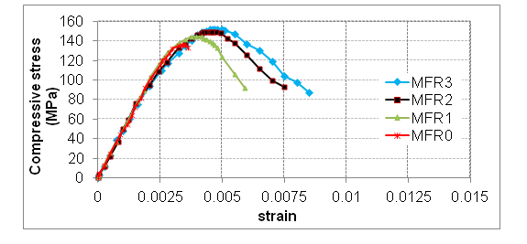
Fig.(1) :Effect of steel fibers volume fraction on the compressive stress-strain relationship of RPC

    - Effect of Silica Fume Content on Compressive Stress-Strain Relationship
The compressive stress-strain curves of RPC specimens with silica fume content (SF) of 0%, 10%, 15%, 20%, 25%, and 30% are plotted in figure (2). The figure shows that the shape of the ascending part of the stress-strain curve for RPC mixes with high silica fume content is steeper than that of RPC mix without or with less content of silica fume. This may be attributed to the ability of the mineral admixture SF to produce high strength concrete. Consequently more brittleness is expected by the addition of such admixture. Referring to figure (2) and the summary of test results in table (5), it can be noticed that as silica fume content increases the ultimate compressive strength increases significantly but there is no clear effect on the value of its corresponding strain ε_{o}. This behavior can be attributed to the fact that increasing silica fume content results in a denser composite which can have less ability to gain more strain under excessive stresses.
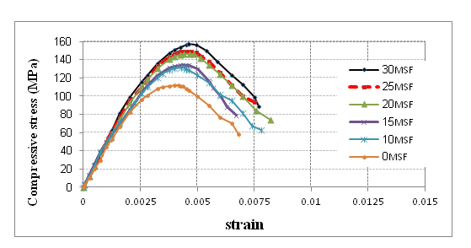
Fig. (2): Effect of silica fume content (SF) on the compressive stress-strain relationship of RPC
3.4 Proposed Model for the Complete Compressive Stress-Strain Relationship
Based on the results of the present experimental tests, a regression analysis is carried out to obtain a curve fitting model for expressing the complete compressive stress-strain relationship of RPC mixes. A nonlinear equation is suggested (Equation 1) to model the complete compressive stress-strain relationship for all RPC mixes of the present study with coefficient of multiple determination (R²) = 0.985.
where:
f_{c} :compressive stress of concrete, MPa
ε_{c} :compressive strain of concrete
a=3.805, b=0.919
c=2.831, d=3.970
and the values of f ′_{c} and ε_{o} are experimental compressive strength and its corresponding strain respectively as listed in table (5).
Equation (1) is plotted in Figures (3) to (12) to enable a close comparison between the proposed f_{c} – ε_{c} model and the experimental findings. The comparison shows a very close agreement and therefore equation (1) can be considered as a good representative equation for predicting the compressive stress-strain behavior of the RPC mixes of the present study.

Table (5): Cylinder compressive strength (f ′_{c}) and its corresponding strain (ε_{o})
Group | Mix  Symbol | Silica Fume  (SF) (%) | Steel fibers  (V_{f} ) (%) | f ′_{c} (MPa) | ε_{o}
1 | MSP-N | 15% | 2% | 118.91 | 0.00412
 | MSP-P | 15% | 2% | 134.33 | 0.00436
2 | MSF0 | 0% | 2% | 111.66 | 0.00418
 | MSF10 | 10% | 2% | 131.27 | 0.00446
 | MSF15* | 15% | 2% | 134.33 | 0.00436
 | MSF20 | 20% | 2% | 146.19 | 0.00484
 | MSF25** | 25% | 2% | 149.39 | 0.00459
 | MSF30 | 30% | 2% | 157.48 | 0.00463
3 | MFR0 | 25% | 0% | 135.93 | 0.00352
 | MFR1 | 25% | 1% | 144.57 | 0.00395
 | MFR2 | 25% | 2% | 149.39 | 0.00459
 | MFR3 | 25% | 3% | 151.62 | 0.00497
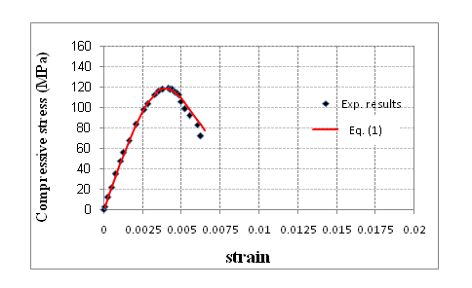
Fig.(3): Compressive stress-strain curves of RPC mix (MSP-N)
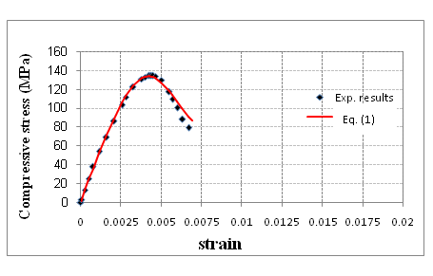
Fig.(4) Compressive stress-strain curves of RPC mix (MSP-P)
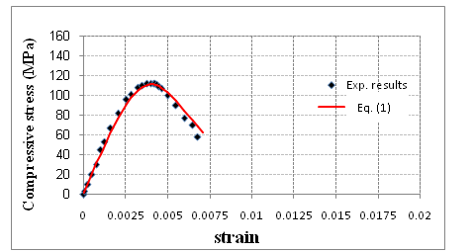
Fig.(5) Compressive stress-strain curves of RPC mix (MSF0)
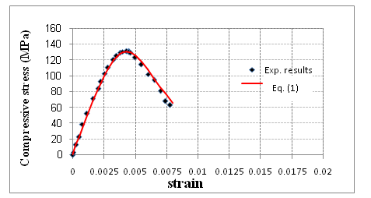
Fig.(6) Compressive stress-strain curves of RPC mix (MSF10)
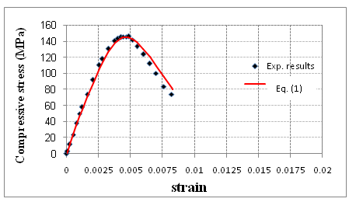
Fig.(7) Compressive stress-strain curves of RPC mix (MSF20)
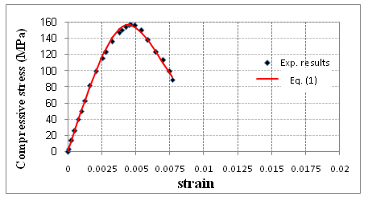
Fig.(8) Compressive stress-strain curves of RPC mix (MSF30)
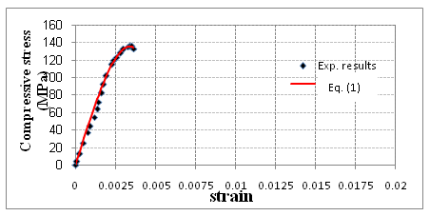
Fig.(9) Compressive stress-strain curves of RPC mix (MFR0)

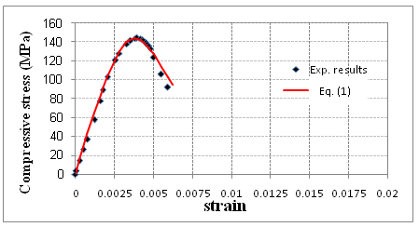
Fig.(10) Compressive stress-strain curves of RPC mix (MFR1)
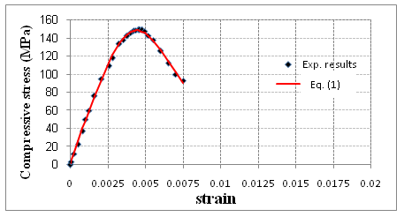
Fig.(11) Compressive stress-strain curves of RPC mix (MFR2)
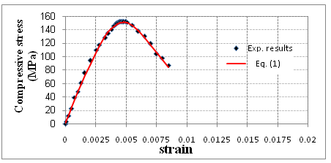
Fig.(12) Compressive stress-strain curves of RPC mix (MFR3)

3.5 Evaluation of the Proposed Compressive Stress–Strain Response Equation
The accuracy of equation (1) can be examined through comparison with the experimental compressive stress–strain curves obtained by other investigators like Saeed 2010 and Prabha et al. 2010. Figures (13) and (14) show plots of the test results and the proposed model (Eq.1) for the prediction of the compressive stress-strain relationship of RPC mixes (the results are shifted by 0.001 strain for clarity). The comparison clearly shows a very close agreement between the proposed equation and the test results, and therefore equation (1) is a good representative equation for predicting the compressive behavior of RPC mixes.
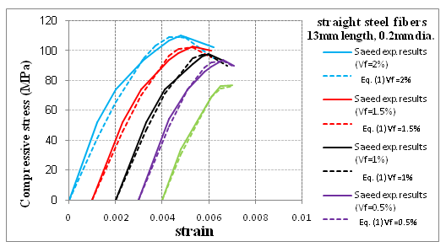
Fig.(13):A Comparison between Saeed 2010 experimental compressive stress-strain curves and the proposed model (Equation 1)
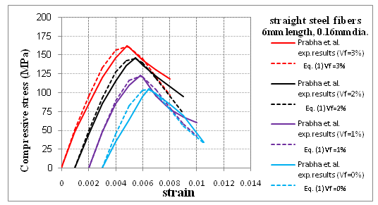
Fig.(14):A Comparison between Prabha et al. 2010 experimental compressive stress-strain curves and the proposed model (Equation 1)
4. Conclusions
Based on the experimental and theoretical investigation of this research the following remarks can be concluded:
- Results indicate that by increasing the volume fraction of fibers from 0% to 1.0%, 2.0%, and 3.0% the cube compressive strength is increased by 3.72%, 8.36%, and 8.89% respectively, while the cylinder compressive strength is increased by 6.36%, 9.9%, and 11.54% respectively.
- Increasing silica fume content from 0% to 10%, 15%, 20%, 25%, and 30% cause a considerable increase in the cube compressive strength by 13.54%, 18.02%, 24.72%, 29.86%, and 34.17% respectively, as well as a comparative increase in the cylinder compressive strength by 17.56%, 20.30%, 30.92%, 33.79%, and 41.04% respectively.
- The compressive stress-strain relationship for different RPC mixes indicates that the addition of steel fibers has no significant effect on the shape of the ascending part of the stress-strain curve, but there is a clear increase in the value of the strain ε_{o} corresponding to peak stress. An increase in the ductility is also noticed and represented by the increase in the area under the descending portion of the stress-strain curve.
- Increasing the silica fume content gives a steeper ascending part of the compressive stress-strain curve and consequently a higher modulus of elasticity as well as apparent increase in the value of the compressive strength with no clear effect on its relevant strain ε_{o}.
- The suggested nonlinear equation for modeling the complete compressive stress-strain relationship of RPC shows a very close agreement with the experimental results of this study and previous studies; therefore this proposed equation can be used safely in design and analysis.
- References
Acker, P., and Behloul, M., 2004, "Ductal® Technology: a Large Spectrum of Properties, a Wide Range of Applications", Proceedings of International Symposium on Ultra High Performance Concrete, University of Kassel, Kassel, Germany, September 13-15, pp.11-23.
Al- Hassani, H.M., Khalil, W.I., and Danha, L.S., 2013 "Mechanical Properties of Reactive Powder Concrete with Various Steel Fiber and Silica Fume Contents", Engineering and Technology Journal, Vol.31, Part (A), No.16, pp.61-77.
Al-Hassani, H., M. and Ibraheem, S., K., 2011, "A Proposed Equation for the Evaluation of the Nominal Ultimate Bending Moment Capacity of Rectangular Singly Reinforced RPC Sections", Engineering and Technology Journal, Vol. 29, No. 5, pp.925-934.
Ashour, S.A., and Wafa, F.F., 1992, "Use of Steel Fibers as Shear Reinforcement in High Strength Concrete Beams", RILEM International Symposium on Fiber Reinforced Concrete, Sheffield, pp. 517-529.
Chan, Y., and Chu, S., 2004, "Effect of Silica Fume on Steel Fiber Bond Characteristics in Reactive Powder Concrete", Cement and Concrete Research, Vol. 34, No. 7, pp. 1167–1172.
Dauriac, C.,1997,"Special Concrete May Give Steel Stiff Competition",The Seattle Daily Journal of Commerce, May 9, 5pp.
Harris, D.K., and Roberts- Wollmann, C. L.,2005,"Characterization of the Punching Shear Capacity of Thin Ultra-High Performance Concrete Slabs"Virginia Transportation Research Council, Final Contract Report, 64 pp.
Kang, S. T., Park, J. J., Ryu, G. S., Koh, G. T., and Kim, S. W., 2010, "Comparison of Tensile Strengths with Different Test Methods in Ultra High Strength Steel-Fiber Reinforced Concrete (UHS-SFRC)", Key Engineering Materials, Vols. 417-418, pp. 649-652.
Lee, N.P., and Chisholm, D.H., 2005, "Reactive Powder Concrete", Study Report No. 146, Building Research Levy, New Zealand, pp. 1-29.
Mahdi, B.S., 2009, "Properties of Self Compacted Reactive Powder Concrete Exposed to Saline Solution", Ph.D. Thesis, Building and Construction Engineering Department, University of Technology, Baghdad, 223 pp.
Naaman, A. E., and Homrich, J. R., 1985, "Properties of High-Strength Fiber Reinforced Concrete", ACI Special Publication, Vol. 87, No. 13, pp. 233-250.
Neville, A.M., 2005, "Properties of Concrete", Pearson Education Limited, Fourth and Final Edition, 844 pp.
Prabha, S. L., Dattatreya, J. K., Neelamegam, M., and Seshagiri , M.V., 2010, "Study on Stress-Strain Properties of Reactive Powder Concrete under Uniaxial Compression", International Journal of Engineering Science and Technology (IJEST), Vol. 2, No. 11, pp. 6408-6416.
RPC Applications, http://www.ductal-lafarge.com/wps/portal/ductal/2-Structural.
Saeed, M. M., 2010, "Shear Behavior of Reactive Powder Concrete Beams ", Ph.D. Thesis, University of Technology, Baghdad, 205 pp.
Spasojevic, A., 2008,“Structural Implications of Ultra-High Performance Fiber-Reinforced Concrete in Bridges Design", Ph.D. Thesis, Ecole Polytechnique Federal de Lausanne (EPFL), Switzerland, 285pp.
Theresa, M. A., Erron J. P., and Donald L. M., 2008, "Ultra High-Performance Concrete for Michigan Bridges Material Performance Phase-I", Center for Structural Durability, Michigan Technological Transpiration Institute, Final Report – November, 152 pp.
Warnock, R., 2005, "Short-Term and Time-Dependent Flexural Behaviour of Steel-Fibre Reinforced Reactive Powder Concrete Beams", Ph.D. Thesis, University of New South Wales, School of Civil and Environmental Engineering.

