Contribution to the Weaving Area Management Using Microscopic Simulation Model

**Hamid Athab Eedan Al-Jameel**

*Civil Dep./ College of Engineering/ Kufa University*

hamidathab@yahoo.com

# Abstract

Weaving sections have been proved to be the bottleneck of motorway because of high lane changes in this section rather than other sections in the motorway. In this study, a simulation model has been developed to cover the shortcomings inherit in the existing simulation package such as Paramics, VISSIM and AIMSUN. The model has been developed using Visual Compact Fortran as bed set because of its efficiency in representing different scenarios and high quality of animation representation. On other hand, Field data has been collected throughout the Greater Manchester City to be used in the calibration and validation of the developed model. Then, a new management has been suggested by this study to change the type of weaving section from Type A (ramp weave) to Type B. This management has been done by using the pavement marking only. A case study has been taken from Northenden section which suffers from high congestion and long queuing. By applying this management using simulation model, the encouraging results show vanishing the congestion and disappearing the queuing completely. The merit of this study is that most weaving sections in the UK have the geometric design which enables to make this management applicable. Finally, this management could be more economical than using traffic signal and adding new lane because the capacity of new section will be higher than original section as indicated in the Highway Capacity Manual (HCM).

**Keywords:** weaving capacity, ramp weave, weaving management, simulation model

الخلاصة

**اثبتت الدراسات ان المقاطع ذات الحركات المتعابره او المتماوجه (Weaving Sections) تمثل مناطق اختناق للطريق الحر(الطريق السريع) لانها تمتاز بكثرة حدوث تغير الممرات(Lane Changes ) فيها اكثر من المقاطع الاخرى الموجوده في الطريق الحر. تم في هذه الدراسة تطوير نموذج محاكاة لغرض التغلب على النواقص الموجوده في نماذج المحاكاة الجاهزه كنموذج Paramics وVISSIM وAIMSUN . النموذج الحالي طور باستخدام نوع متطور من لغة فورتران تسمى (Visual Compact Fortran) وذلك لكفائتها في تمثيل بدائل مختلفة وكذلك لنوعيتها الجيده في تمثيل الحركة المرئية. من ناحية اخرى تم جمع البيانات الحقلية من مدينة مانشستر كي تستخدم في عملية معايرة وتقييم النموذج المطور. بعد ذلك تم استخدام النموذج المطور في اقتراح نوع جديد من مقطع ال Weaving Section حيث تم تغير نوع Type A الى نوع Type B . هذا التغير تم باستخدام العلامات المرورية الارضية ( Pavement Marking) فقط. مقطع ال Weaving Section الموجود في مدينة Northenden البريطانية تم اعتمادها كحالة خاصة لهذا التغير حيث انها من نوع Type A وتعاني من ازدحام مروري وطابور طويل من المركبات . بتطبيق هذه الالية اي تحويل المقطع من نوعType A الى نوع Type B باستخدام النموذج المطور تم الحصول على نتائج مشجعه وذلك بالتخلص من الازدحام وغياب الطوابير من المركبات بصورة كاملة. ومن الايجابيات التي تساعد في اعتماد هذا التغير في مقطع ال Weaving Section هو امكانية تطبيقها على اغلب المقاطع الموجوده في المملكة المتحده. واخيرا فان هذه الالية اكثر اقتصادية من استخدام الاشارات الضوئية كما معمول به فــي بريطانيا وكذلك فهي اكثر اقتصادية من اضافة ممر اخر كون تغير الممر يعطي سعة اكبـر كون Type B هو اكثر سعة من نوع Type A كما يمكن ملاحظة ذلك في المواصفات الامريكية للطرق (Higway Capacity Manual-HCM)**

الكلمات المفتاحية: **سعة المقطع المتموج, ادارة مقاطع المتماوجه, نموذج المحاكاة.**

**1. Introduction**

More attentions have been directed towards microscopic simulation in the last two decades because of several merits of using this approach. These are ability of simulation to provide visual environment and managing many problems, such as congestion and signal control optimisation, public priority, etc., which cannot be solved by traditional tools because of the complexity of the urban road transport system.In addition, these microscopic models help more in applying different scenarios without disrupting the traffic and using expensive sources (Hidas,2005). Paramics, AIMSUN and VISSIM are examples of well-known micro-simulation models. However, the difficulty of integration with advanced traffic management and the accuracy of models in representing the traffic flow are from limitations in the existing simulation models (Skabardonis and May, 1998).

The existing models suffer from several limitations especially in weaving areas. Prevedouros and Wang (1999)reported that INTEGRATION model has several limitations such as waiting at the divergence point and making long queue which not occur in reality. Questionable capacity and gap acceptance have been reported in the CORSIM simulation model for weaving sections (Zhang and Rakha, 2005).

To overcome these limitations which affect on the accuracy of estimation the weaving capacity using these simulation models, there is a need for developing new simulation model. Therefore, this study engaged in developing simulation model to evaluate the capacity of weaving section and apply different scenarios to improve the weaving section performance.

**2. Weaving section**

A weaving can be defined as the crossing of two or more traffic streams while travelling in the same general direction along a specific section of highway without the aid of traffic control devices such as traffic signals and traffic signs (HCM, 2000). The HCM classifies weaving into three types: Type A, B and C. This classification based on the minimum number of lane changes that expected by weaving vehicle.

A few studies were found in the literatures that related to this study. For example, Zarean and Nemeth (1988) adopted the WEAVSIM microscopic simulation model to investigate the effect of the different arrival speeds on the operation of weaving sections. Subsequently, the researchers suggested a regression model for the modelling of weaving sections based on the simulation results. However, this model does not include the cooperative behaviour in its algorithm.

Cassidy and May (1991) compared the speed of weaving and non-weaving vehicles results from six procedures; 1985 HCM, Leisch, JHK, Fazio and Polytechnic Institute of New York (PINY), with field data. The results show that no one of these procedures was adequate because speed insensitive to flow. In addition, HCM 2000 has been proved to be inaccurate because it estimates weaving capacity based on the assumption that density at capacity is 27pcphpl without specific reason why this value was selected. This was reflected in developing different simulation models which have been proved to the best than other procedures in dealing with weaving section (Skabardonis *et al.*, 1989, Zhang, 2005, Lee and Cassidy, 2009).

These simulation models mainly depend on the field data to represent the behaviour of drivers through the calibration and validation processes. Moreover, most weaving data suffer from either limited samples or incomprehensive data (Lee and Cassidy, 2009).

Here in the UK, there is an obvious lack of field data for weaving section. Developing a simulation model for a specific case depending on data from other environmental conditions or different rules and system of driving may lead to inaccurate behaviour. Therefore, in this study in order to overcome this problem, data from seven weaving sections have been collected.

**3. Developed model**

The developed model consists of sub-models such as car-following, gap acceptance, lane changing and weaving process. The algorithms of these processes have been programmed using Visual Compact Fortran as bed test.

**3.1 Car –following rules**

The developed car following model governs the longitudinal movement by selecting the suitable acceleration/deceleration based on the situation conditions. If a driver has no obstruction, s/he will driver to reach the desired speed or a driver will choose the maximum deceleration in the case of emergency and suddenly stopping of its leader. In addition, a driver will use his/her normal acceleration/deceleration when s/he exceeds the desired speed or speed limit. These different accelerations have been included in this model. For more details about the building, calibration and validation of the developed model have been discussed comprehensively in Al-Jameel (2010).

**3.2 lane changing rules**

Lane changing represents transferring vehicle from subject lane to adjacent lane under different conditions. Two types of lane changing have been adopted in this study: discretionary and mandatory. Discretionary lane changes are implemented when a driver has a desire to increase his/her speed or to avoid blocking behind slower vehicles (Sultan and McDonald, 2001). Whereas, mandatory lane change achieves to reach the destination, i.e. a driver has to change lane to be in the right direction such as weaving process. The details of lane changing process have been discussed in more details in Al-Jameel* (2011).

**4 Weaving rules**

The main processes of weaving section can be summarised by the interaction between traffic stream coming from on-ramp and traffic stream coming from a motorway. For motorway vehicles, the interaction is the cooperative behaviour, shifting to the adjacent lane or stay in the same lane. Whereas, for the on-ramp traffic, the same behaviour for motorway vehicles but without shifting in the case of one auxiliary lane. This behaviour is before and during the weaving process and close following and relaxation behaviour after this process (Al-Jameel*, 2011). Figure 1 indicates the output screen of the developed model.

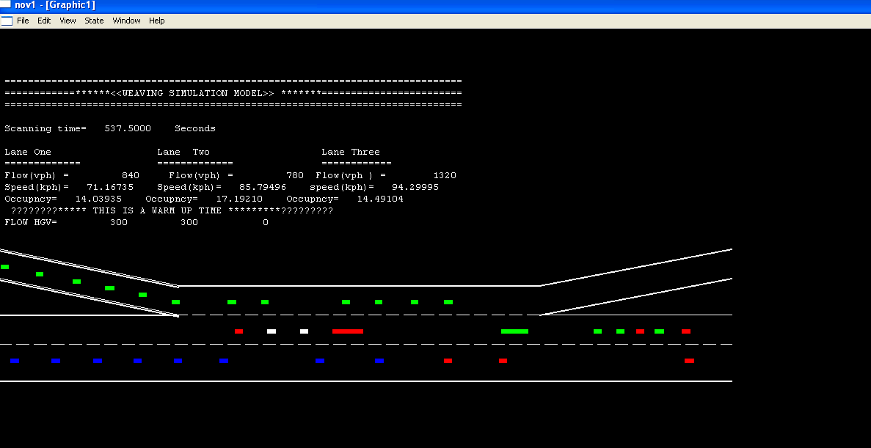

**Figure 1 Output screen of the developed model for three-lane weaving section.**

**4.1 Upstream behaviour**

The segregation can be defined as the manner in which weaving vehicles segregate from through traffic and relocate to the lanes closer to the auxiliary lane before entering a weaving section (Cassidy, 1990).

Field data from Mancunian Site 1 and Northenden Site 2 throughout the Greater Manchester City have demonstrated that the 250m, which extends from the entrance point to the upstream of main road, represents intensive frequency of lane changes due to segregation behaviour (AL-Jameel, 2011). The results show that more than 70% of weaving vehicle segregate within the 250m upstream section (Al-Jameel, 2011). Therefore, at this upstream section the behaviour of driver affects by weaving section.

**4.2 Weaving behaviour**

Weaving process consists of complicated processes to reach the destination such as reducing and increasing the speed of vehicles involving in the weaving process. Based on real data from weaving sections, M60 J2,Mancunian Way Site 1 and 2 investigated by this study, it was found that the percentage of cooperative is more than 95% which is similar than values reported for isolated merging sections (Zheng,2003 and Wang, 2006). However, weaving section has more cooperative percentage than merging section because it was found from observed data that most weaving vehicles located in the adjacent lane. Consequently, it was observed from the above sites that more than 98% of weaving vehicles from motorway cooperate to weaving vehicles from on-ramp.

Effective length, which is the length at which more than 98% from weaving vehicles completed their manoeuvres, reflects the behaviour of weaving vehicles. This length influences by the geometric design such as weaving type and weaving length. It was found within 200m for ramp weaving length is more than 300m and whole weaving length for section with length less than 150m for the same type. Whereas, it extended to more than 300m for weaving length equal or higher 300m for Type B weaving section.

In this study,a sample of 300 cases from Mancunian Way Site 1,it was found that more than 92% from merging vehicle select the first gap, the gap facing subject vehicle when entering the weaving section. For diverging vehicles, weaving vehicles coming from motorway towards off-ramp, it was found more than 90% select the first gap.

**4.3 Testing the developed model with field data**

The developed model has been tested with field data collected by video recording and Motorway Incident Detection and Automatic Signalling (MIDAS) data. Figure 2 indicated the location of loop detectors at the weaving section in the M60 J2. Upstream loop detector has been used as input for the simulation model and other loops have been used for comparison with field data.

**Upstream loop**

**After merging loop**

**After diverging loop**

**M60 9034B**

**M60 9030B**

**M60 9026B**

**Figure 2 Data collected from different loops with weaving section (M60 J2).**

The type of this weaving section is Type A (ramp weave) with four lanes. In another word, the motorway consists of three lanes and one lane for the on-ramp section. The length of the section is 400m.Moreover, this set represents 130.0 minutes for both speed and flow.

In this weaving section M60 Junction 2, there are three loop detectors. Firstly, the upstream loop detector (M609034B) is 200m from the entrance point. Secondly, the merging loop detector (M609030B) is 200m after the entrance point. Thirdly, the diverging loop detector (M609026B) is 90m after exit point.

Table 1 demonstrates the statistical tests for comparison with field data. These tests are coefficient of determination (r), root mean square percent (RMSP), Theil`s Inequality coefficient (U),Theil`s mean difference (Um) and Theil`s standard deviation (Us).These tests have been used in different traffic simulation models (Hourdakis *et al.*, 2003 and Wang, 2006).The results of comparison show these values are within acceptable limits. Therefore, the developed model reasonable represents the reality as shown in Table 1.

Another set of field data from M60- J2 has been used to test the developed model as indicated in Table 2. The results also show good agreement with field data because statistical tests are within acceptable limits as shown in the table below.

**Table 1 Comparison simulated and observed data-M60-J2 -29-10-2010.**

|  |  |  |  |  |
| --- | --- | --- | --- | --- |
| **Loop location** | **After merging section** | | **After diverging section** | |
| **Parameters** | **Flow** | **speed** | **Flow** | **Speed** |
| **RMSP** | **0.035** | **0.0151** | **0.036** | **0.07** |
| **r** | **0.88** | **0.91** | **0.88** | **0.83** |
| **U** | **0.017** | **0.034** | **0.0169** | **0.034** |
| **Um** | **0.276** | **0.039** | **0.299** | **0.409** |
| **Us** | **0.029** | **0.0081** | **0.0463** | **0.09** |

**Table 2 Comparison of simulated data with field data - M60 –J2 8-10-2010.**

|  |  |  |  |  |
| --- | --- | --- | --- | --- |
| **Location** | **After merging section** | | **After diverging section** | |
| **Parameters** | **Flow** | **speed** | **Flow** | **Speed** |
| **RMSP** | **0.049** | **0.0011** | **0.026** | **0.017** |
| **r** | **0.93** | **0.89** | **0.975** | **0.90** |
| **U** | **0.029** | **0.046** | **0.048** | **0.038** |
| **Um** | **0.086** | **0.007** | **0.826** | **0.009** |
| **Us** | **0.0116** | **0.0045** | **0.006** | **0.193** |

**5. The applications of the developed model**

After showing reasonable representations of weaving behaviour, the developed model has been used to investigate different impacts of some characteristics such as the percentage of heavy goods vehicles (HGVs) as discussed below.

The effect of HGVs has been investigated using the developed model. In order to test the effect of varying the percentages of HGVs,other parameters were fixed in the model. These parameters include the length of weaving section (300m), the VR (0.25), R (0.4).They are assumed to be constant except the HGVs percentage. Three types of weaving sections have been used in this test: two-lane, three-lane and four- lane sections.

Figure 3-a shows the effect of different percentages of HGVs on the flow rate with two-lane weaving section. As the percentage of the HGVs increases, the level of flow decreases from approximately 2500 veh/hr to less than 1750 veh/hr. This indicates how largely influencing the capacity of the two-lane weaving section.

For a three-lane weaving section, the effect of the percentage of the HGVs has also been investigated as shown in Figure 3-b.The percentage of the HGVs sharply decreases with flow. This reduction in the flow is higher than that for the two-lane weaving section. Although of this difference, the influence of the HGVs is still ineffective.

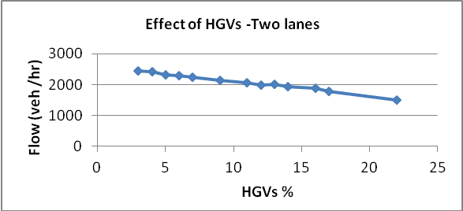

1. **Two-lane section**.
2. **Three-lane section. c. Four-lane section**.

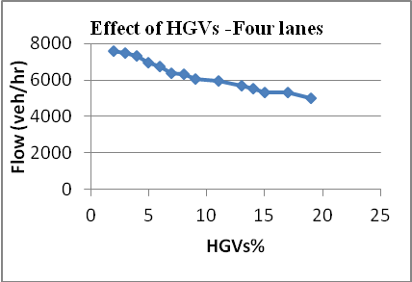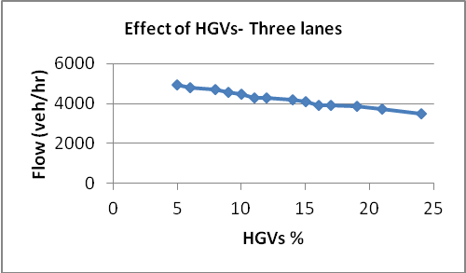

**Figure 3 Impact of HGVs on the capacity of weaving section.**

On other hand, the effect of the HGVs for the weaving section with four lanes has also been investigated as shown in Figure 3-c. The reduction in the flow reaches up to 2600 veh/hr as the HGVs percentage increases from 2% to 19%. The main difference from the other sections with two and three lanes is that the percentage below 5% affects on the flow rate. However, this difference is not significantly.

Finally, for all configurations, the percentage of HGVs which less than 5% is ineffective.

**6. New management of weaving section**

Different management strategies have been suggested to reduce or mitigate traffic congestion in weaving section. In this study, from important strategy that has been used is to change the type of weaving section from original type to new one just by using pavement marking under specific conditions. These conditions are the low value of weaving vehicle from ramp to motorway (main road) (R-M) and high value of weaving vehicle from motorway to ramp (M-R).

Other important characteristics that encouraging implementing this management, by changing weaving type from ramp weave (Type A) to Type B, are geometric characteristics. In most weaving sections in the UK, the off-ramp consists of two lanes and extended before the exit point towards the weaving section for more than 50m.

The above traffic and geometric characteristics help more in making changing the type of weaving section using pavement marking is more effective as shown in Figure 4.



1. **Original case.**

**1**

**2**

**3**

**4**

1. **Improved case.**

**Figure 4 Changing weaving type from Type A to Type B.**

This new management has been applied to the Northenden weaving section because this section suffers from congestion and long queuing extending from entrance point towards upstream. However, the R-M is very low as shown in Figure 5 and maximum traffic flow up to 5000 veh/hr.

According to the above conditions, the bottleneck problem is due to high interaction in the merging section. Northenden Site 1 has the similar conditions and the queue extended for more than 50m even the flow rate under the capacity of the section.However,stopping vehicles have been seen at that site despite that the merging vehicle (R-M) is very low comparing with the diverging vehicles (M-R) as shown in Figure 5.

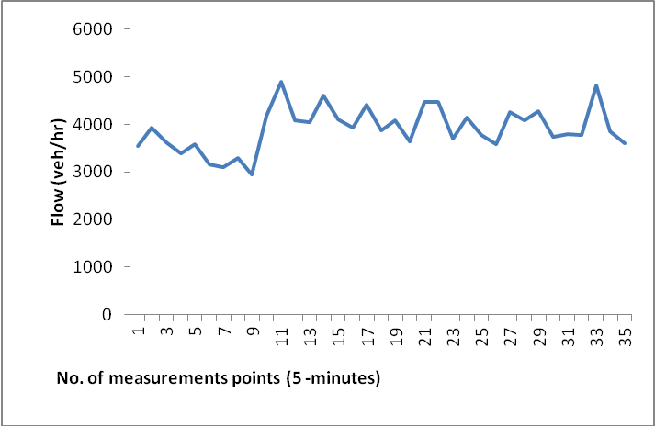

**A. Flow rate of observed traffic.**

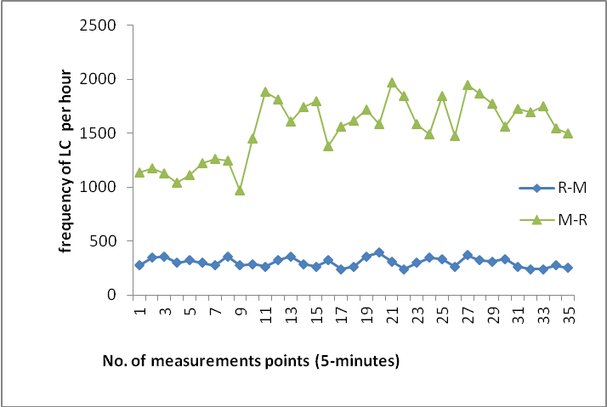

**B. Diverging and merging flow.**

**Figure 6 Northenden Site characteristics.**

By to The off-ramp consists of two lanes extending to more than 80m. In addition, the M-R is higher than R-M as shown in Figure 5. Therefore, the new management has been applied as shown in Figure 6. The geometric design for the Northenden weaving section as shown in Figure 7 with length equals to 300m.

According to the field observations for this section, it was noticed that the off-ramp of this section characterises with high speed and high flow because it connects the M60 with two lanes.

sting the original case using the developed model, the results reveal the same level of congestion already exists in this section such as long queue formation starting from the entrance area and propagate towards upstream.

The improving process can be summarised by adding solid lane beside the old broken one to prevent diverging vehicle from changing lane along the first 150m and at the same time to allow the merging vehicle from changing lane. As observed in the field the main problem is that the diverging vehicles change lane earlier and very close to the entrance point due to very low flow in the on-ramp lane. These observations have been supported by Lee and Cassidy (2009) as discussed.



1. **Original geometric design.**

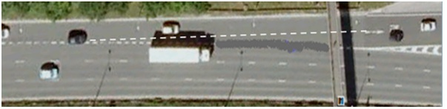

1. **Improved geometric design.**

**Figure 7 Northenden geometric design.**

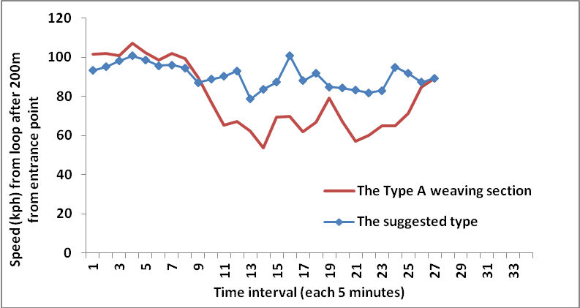

**Figure 8 Operational speeds for both new and old configurations.**

In addition, the broken line close to the exit point has been deleted for 90m before the exit point. By doing so, the type of weaving section has been changed from ramp weave (Type A) to Type B.After that the developed model has been used to apply this scenario. The same field data that cause the bottleneck have been used. The results show increasing the level of speed at simulated loop detector located at 200m from the entrance point for the new configuration than the old one as shown in Figure 8. Moreover, there is no queue at or close entrance point.

It is worthy to mention here that the capacity of type B weaving section for a certain number of lanes and traffic characteristics is higher than the capacity of type A for the same characteristics (see Exhibit 24-8-HCM 2000).Moreover,Stewart *et al*. (1996) used INTEGRATION to evaluate the capacity of weaving section. The results show that the capacity of type B weaving section is higher than both types A and C for the same characteristics. This is because the type B less affects by the VR because of minimum number of lane need to be changed in this type than the others.

**7. Conclusions**

The main points of this study can be summarised by the following points:

1. The developed model has been proved to be better than other simulation models such as Paramics, AIMSUN and VISSIM in terms of car-following behaviour. In addition, its lane changing behaviour shows reasonable representation for the observed data.
2. The developed model shows acceptable behaviour of weaving section when simulated data compared with field data.
3. The effect of HGVs has been investigated using the developed model.
4. New management has been applied by changing the type of weaving section from Type A (ramp weave)to Type B just by using pavement marking. This management has been applied by the developed model and the results show encouraging outputs in terms of increasing the level of speed and dissipating the long queuing existing in the original case. It is believed that this management is more efficient and economical than other methods such as using traffic signal or adding new lane. Moreover, Type B has been reported by the HCM 2000 to be higher than Type A with same geometric design as shown in exhibit 24-8 in the same manual.

**8. References**

Al-Jameel*,H.,2011. Developing a Simulation Model to Evaluate the Capacity of Weaving Sections. PhD Thesis, University of Salford, UK.

Al-Jameel, H.,2010. Evaluation of Car-following Models Using Field Data. In: Salford Postgraduate Annual Research Conference (SPARC),10-11 June 2010, University of Salford, UK.

Al-Jameel, H.,2011. Empirical Study of Drivers’Behaviour at Weaving Sections. UTSG 43, Open University.

Cassidy, M.,1990. A Proposed Analytical Technique for the Design and Analysis of Major Freeway Weaving Sections**.** PhD Dissertation, University of California, Berkeley.

Cassidy, M., and May, A.,1991. Proposed Analytical Technique for Estimating Capacity and Level of Service of Major Freeway Weaving Sections. Transportation Research Record 1320, pp. 99-109.

HCM ,1985.Highway Capacity Manual. Transportation Research Board, TRB Special Report 204.

HCM,2000. Highway Capacity Manual. Transportation Research Board, TRB Special Report 209.

Hidas, P.,2005. Modelling Vehicle Interactions in Microscopic Simulation of Merging and Weaving. Transportation Research Part C, 13, pp. 37 - 62.

Hourdakis, J., Michalopoulos, P., and Kottommannil, J.,2003. Practical Procedure for Calibrating Microscopic Traffic Simulation Models. Transportation Research Record, No. 1852, pp. 130-139.

Lee, J., and Cassidy, M.,2009.An Empirical and Theoretical Study of Freeway Weave Bottlenecks. California PATH Research Report, UCB-ITS, PRR-13.

Panwai, S. and Dia, H.,2005. Comparative Evaluation of Microscopic Car-Following Behaviour. IEEE Transactions on Intelligent Transportation Systems,6 (3), pp. 314 - 325.

Prevedouros, P., and Wang,Y.,1999. Simulation of Large Free-way and Arterial Network with CORSIM, INTEGRATION, and WATSim. Journal of the Transportation Research Board, Na-tional Research Council, Washington, DC.

Skabardonis, A. and May, A.,1998. Simulation Models for Freeway Corridors: State-of-The Art and Research Needs. Transportation Research Board, 77th Annual Meeting, Washington D.C.

Skabardonis, A., Cassidy, M., May, A., and Cohen, S.,1989.Application of Simulation to Evaluate the Operation of Major Freeway Weaving Sections. Transportation Research Record, 1225, pp.91-98.

Sparmann,I.,1979.The Importance of Lane-changing on Motorway. Traffic Engineering and Control, vol.20, pp.320-323.

Stewart, J., Baker, M., and Van Aerde, M.,1996. Evaluating Weaving Section Designs Using INTEGRATION. Transportation Research Record, (1555), pp.33-41.

Sultan B., and McDonald, M.,2001. The lane changing process: Data analysis and modelling behaviour. Traffic Engineering + Control, 43(5), pp.202- 207.

Wang, J.,2006. A Merging Model for Motorway. PhD Thesis, University of Leeds, UK.

Yousif, S.,1993. Effect of Lane Changing on Traffic Operation for Dual Carriageway Roads with Roadworks, PhD Thesis, University of Wales, Cardiff.

Zarean, M. and Nemeth, Z.,1988. WEAVSIM: A Microscopic Simulation Model of Freeway Weaving Sections. Transportation Research Record 1194, pp. 48-54.

Zhang, Y.,2005. Capacity Modelling of Freeway Sections. PhD Dissertation, Virginia Polytechnic Institute and State University, USA.

Zhang, Y., and Rakha, H.,2005.Systematic Analysis of Capacity of Weaving Sections. Transportation Research Board annual meeting, USA.

Zheng, P.,2003. A Microscopic Simulation Model of Merging Operation at Motorway On-ramps. PhD Thesis, University of Southampton, UK.

[***www.google.com/earth/download-earth.html***](http://www.google.com/earth/download-earth.html) (Showing a map of the sites used for the survey- Accessed 01/08/2010).