مجلة جامعة بابل
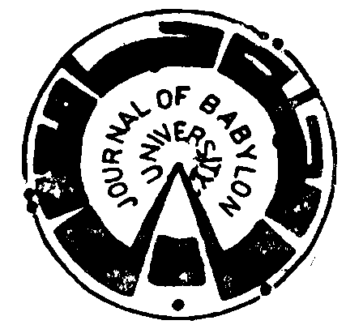

Series of Engineering Sciences

Vol.23, No. 3, 2015

ISSN: 1992-0652
E.ISSN: 2312-8135

Research Title | Page No.
*The Use of AL- Malih Valley Crushed Limestone as Coarse Aggregate in Concrete Production  - Mohammed A. S. Elizzi & Ali Abdulhussein Al- Tameemi & Perikhan Fadhil | 552-557
* Study the Effects of Squeeze Casting Parameters on the Corrosion Behavior of Al- Si-4Cu Alloy  - Rabiha S. Yaseen & Hussein A. Hussein & Amjad H. Jassim | 558-570
* Evaluation of Traffic Accidents Rates in Al- Diwaniya City  - Jalal Taqi Shaker Al- Obaedi | 571-578
*Performance Evaluation of A Jet Impingement Cooling for A Compact Shell and Tube Evaporator  - Hasan Shakir Majdi | 579-590
*Proposed Model for Uniaxial Compression Behavior of Reactive Powder Concrete  - Hisham Mohamed Al- Hassani & Wasan Ismail Khalil | 591-606
*Study of Some Mechanical Properties for Alumium Reinforced by Alumina Fibers  - Shaker Jahel Eddres & Ali Hubi Haleem & Newal Muhammad Dawood | 607-615
*Improve the Performance of Transferring WiMAX OFDM Signals Over Laser Communication Links Based on Optimum Gain of Laser Transmitter  - Awwab Qasim Jumaah Althahab | 616-626
*Methyl Red Dye Removal From Aqueous Solution by Adsorption on Rice Hulls  - Afrah Abood Hassan & Hadeel Ali Abdulhussein | 627-637
*Study the Effect of Evaporation on Water Quality to the Iraq Reservoirs  - Ameer Hashim Hussein Ahmed | 638-653
* Performance Evaluation of Modified Asphalt Concrete Mixes Containing Natural Sand  - Nahla Yassub Ahmed & Ammar Jawad Kandouh | 654-666
*Contribution to the Weaving Area Management Using Microscopic Simulation Model  - Hamid Athab Eedan Al- Jameel | 667-677
*Glazing and Coloring of Cellular Concrete Blocks  - Samir H. Awad & Elham Abd Al- Majeed & Mohammed Al- Issawi | 678-688
*Estimation of Sediment Quantity Upstream of Al- Yaa'o Regulator  - Hana'a Mahmood Amer Al-kassar | 689-697
*Numerical Investigation in a Circular Tube To Enhance Turbulent Heat Transfer Using Opened Rings- Triangular Cross Section  - Arkan Altaie & Moayed R. Hasan & Farhan Lafta Rashid | 698-707

