Design and Implementation of High Frequency Inductor for Simultaneous Hardening

Mohammed. Ridha. Saeed. Al- Hendaw
Al- Hussain Engineering University Collage. Iraq
alhussainunv@gmail.com

Abstract:

This paper aimed at an investigating the design principles of coil and attempt manufacturing – high frequency induction heating coils which are important elements in heat treatment process and the cost of importing such coils are not readily available upon request. A number of factors taken into consideration such as, dimension configuration of work- pieces, number of parts to be heated, temperature required, pattern of heat desired, applied frequency and level of power. In this work a design of two coils of ( Ø 40 mm) and (Ø 60 mm) inner diameter. The two coils are febracted from red copper. This design improved that the greatest number of flux lines in a solenoid coil is toward the center of the coil, also prevent the cancellation of the field of magnetic coils. The results show that the designed coils are of higher resistance (50 M Ω for Ø = 40 mm and 500 M Ω for Ø = 60 mm); also the coils resistances are (0.20Ω for Ø = 40 mm and 0.22 Ω for Ø = 60 mm)
Keyword: Induction coil, Heat – treatment, surface hardening, casus depth , frequency.
الخلاصة:
هذه المقالة تتناول التحري عن اختيار القواعد الأساسية لتصنيع ملف حث للترددات العالية والذي هو يعتبر العنصر الأساس في إجراء عمليات المعالجة الحرارية ومقارنة ذلك مع كلفة استيراد الملف المماثل. تم اعتماد عدد من العوامل المهمة مثل أبعاد وشكل القطع المعالجة حرارياً وعددها، درجة الحرارة المطلوبة، نظام المعالجة الحرارية، الترددات المستخدمة ومستوى القدرة. حيث تم في هذا البحث تصميم ملفين بقطر 40 ملم و 60 ملم واستخدمت أنابيب النحاس الأحمر. في هذا التصميم تم استنتاج إن اكبر عدد من خطوط الفيض الكهربائي في الملف هي باتجاه محور المركز وهي تحقق منع الفيض المغناطيسي في الملف كما أشارت نتائج التصميم إلى إن الملفات ذات مقاومات عالية وكما يلي
50 MΩ for 40 mm و 500MΩ for 60mm وذلك في حالة عملها.
الكلمات المفتاحية: المصطلحات الواردة: تردد عمق المؤثر، تصليد سطحي، معالجة حرارية، ملف الحث.

Introduction:
Introduction heating is a process used to bond, harden or soften metals or other conductive materials. For many modern manufacturing processes, induction heating offers an attractive combination of speed, consistency and control. All induction heating applied systems are developed using electromagnetic induction which was first discovered by Michael Faraday in 1831. Electromagnetic induction refers to the phenomenon by which electric current is generated in a closed circuit by the fluctuation of current in another circuit placed in the next circuit. The basic principle of induction heating has been understood and applied to manufacturing since 1920.
During world war LI, the technology developed rapidly to meet urgent war time requirements for a fast, reliable process to harden engine parts. More recently, the focus on lean manufacturing techniques and emphasis on improved quality control have led to a rediscovery of induction technology, along with the development of precisely controlled, all solid state induction power supplies, [Rudnev, 2003].
The development of high – frequency induction power supplies provided means of using induction heating for surface hardening. The early use of induction involved trial and error with built – up personal knowledge of specific application, but a lack of understanding of the basic principles, [Rudnev, 2005].Throughout the years the understanding of the basic principles has been expanded extending currently into computer modeling of heating application and processes, [Rudnev, 2005].
Knowledge of these basic theories of induction heating helps to understand the application of induction heating as applied to induction heat treating. Induction heating occurs due to electromagnetic force fields producing an electrical current in a part.
The parts heat due to the resistance to the flow of this electric current. The induction heating method is a unique due to the fact that in the most common heating methods, a torch or open flam is directly applied to the metal part. But with induction heating, heat is actually "induced" within the part itself by circulating electrical currents, [Heat Treating, 1991].
Induction heating relies on the unique characteristic of radio frequency (RF) energy that portion of the electromagnetic spectrum below infrared and microwave energy. Since heat is transferred to the product via electromagnetic waves, the part never comes into direct contact with any flame, the inductor itself does not get hot (watch video at upper right), and there is no product contamination. When properly set up, the process becomes very repeatable and controllable. Heat loss, which occurs during the induction heating process, was major headache undermining the overall functionality of a system, [Induction Heating system Topology Review Rev, 2000].
The induction heating work according to the basic understanding of the principles of electricity. When an alternating electrical current is applied to the primary of transformer, an alternating magnetic field is created. According to Faraday's Law, if the secondary current of the transformer is located within the magnetic field, an electric current will be induced.
The basic of induction heating is comprised of the three factors: electromagnetic induction, the skin effect, and heat transfer. The basic induction heating setup is shown in Fig.(1).A solid state (RF) power supply sends an AC current through an inductor (often a copper coil), and the part to be heated ( the work piece) is places inside the inductor. The inductor serves as the transformer primary and the part to be heated becomes a short circuit secondary. When a metal part is placed within the inductor and enters the magnetic field, circulating eddy currents are induced within the parts. As shown in Fig.(2), the eddy currents flow against the electrical resistivity of the metal, generating precise and localized heat without any direct contact between the part and the inductor. This heating occurs with both magnetic and non – magnetic parts, [lozinskii, 1969].
The main parameters affected the inducting heating are types of material, [Heat treating device and treating method Us 7648600, Jan 29, 2009, Neturen Co. Ltd], magnetic and non– magnetic, thickness and resistivity, [Inductive heating converter comprising a resonant circuit with simultinance multi-frequency current, 01/2/2010].

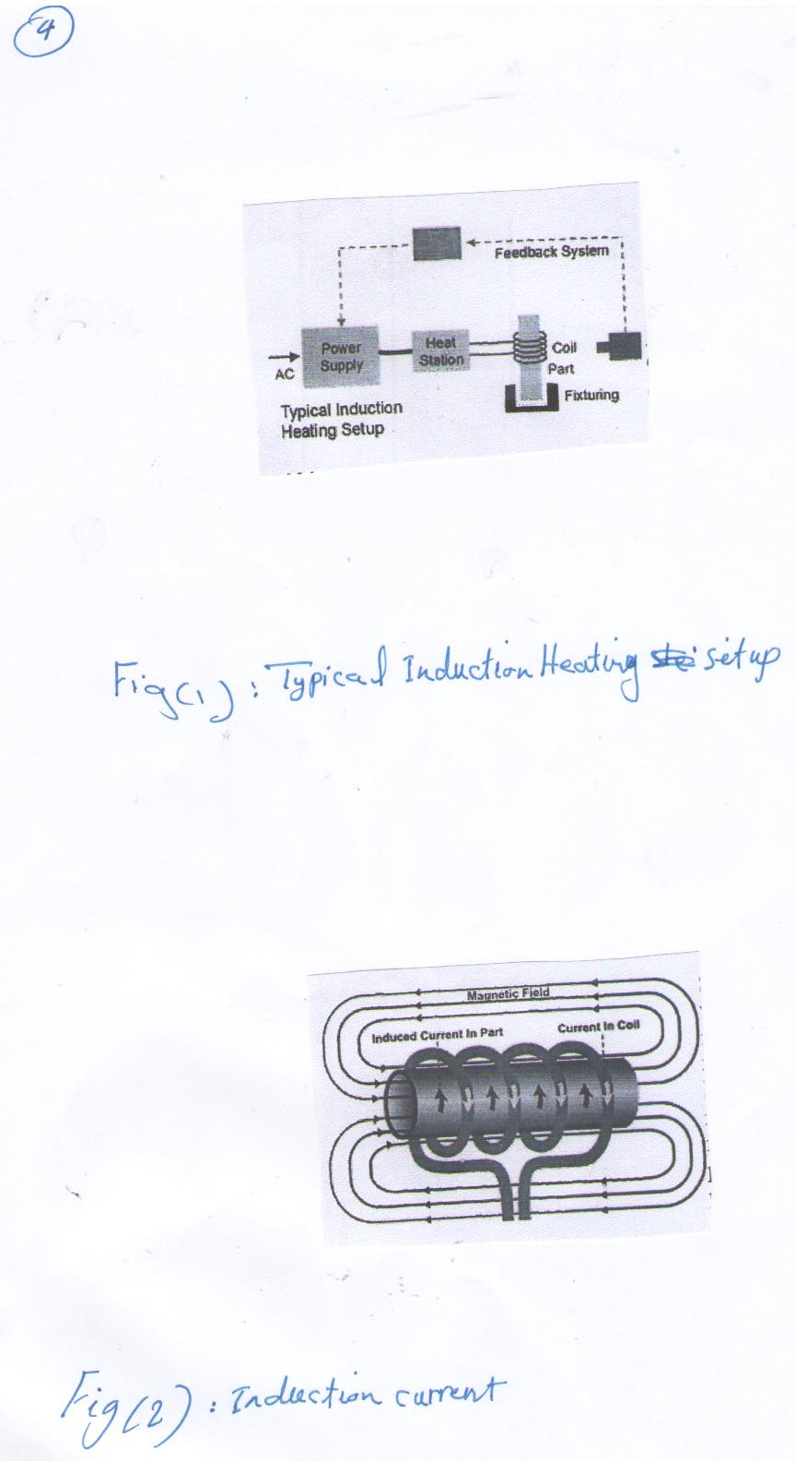

Fig. (1): typical Induction Heating set up

Fig. (2): Induction current
Experimental work:
The experimental work included design and development of two induction unites. The design depend on a number of parameter such as resistance, electromagnetic, induction, shin effect and power system. All metals conduct electricity, while offering resistance to the flow of this electricity. The resistance of this flow of current causes losses in power in the form of heat. This due to the law of conservation of energy, which is transformed from one to another and not lost. As shown in Fig.(2).The losses produced by resistance are based upon the basic electrical formula [P = i²R],where (i) is the amount of current, and (R) is the resistance. Because the amount of loss is proportional to the square of the current, doubling the current significantly increases the loss (or heat) produced. Some metals, such as silver and copper, have very low resistance and, consequently, are very good conductors. Other metals, such as steel, have high steel resistance to an electric current, so that when an electric current is passed through them, substantial heat is produced. The steel heating coil on top of an electric stove is an example of heating due to the resistance to the flow of the household, 50 Hz electric current.
The higher the frequency of the current administered to the coil, the more intensive is the induced current flowing around the surface of the load. The density of the induced current diminishes when flowing closer to the center as shown in formula (1) and (2).
^{i}x = i₀ e^{-x/d0}……….(1)
Where: ^{i}x = distance from the skin (surface) of the object, current density at (x)
i₀ = current density on skin depth (x = 0)
d₀ = a constant determined by the frequency(current penetration depth)

d₀ = ……… (2)
where p = resistivity
µ = permeability of the object
$ω$= frequency of the current flowing through the object.
In our coils design the distribution of current density with relation to the surface thickness is shown in Fig (3).
Inductor design is one of the most important aspects of the overall system. A well– designed inductor provides the proper heating pattern for a part and maximizes the efficiency of the induction heating power supply, while still allowing easy insertion and removed of the part.
Any surface induction heat – treatment required a carefully selection of equipment and understand the metallurgical variables that control the process. The most important equipment are inductor design, generator frequency, and applied power density. Solenoid coils designed according to the following factor:
* Dimensions and configuration of work – piece to be heat – treated.
* Number of work – pieces.
* Temperature required.
*Heat – treated depth.
* Applied frequency and power level.
The coil must be designed to prevent cancellation of the magnetic field induction by opposite sides of the inductor. The two coils are made of pure copper material with inner diameter of Ø40 mm and Ø60 mm, and the thickness of heating ring is 1.6 mm and for cooling ring 2.1 mm as shown in Schematic diagram in Fig. (4) and Fig. (5-A-B).
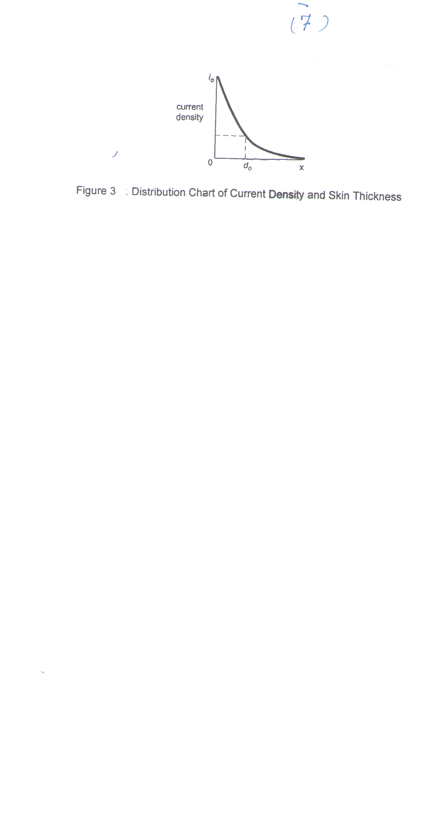

Fig. (3) distribution Cart of current density and skin Thickness
x= mm
i₀= Amp/mm²

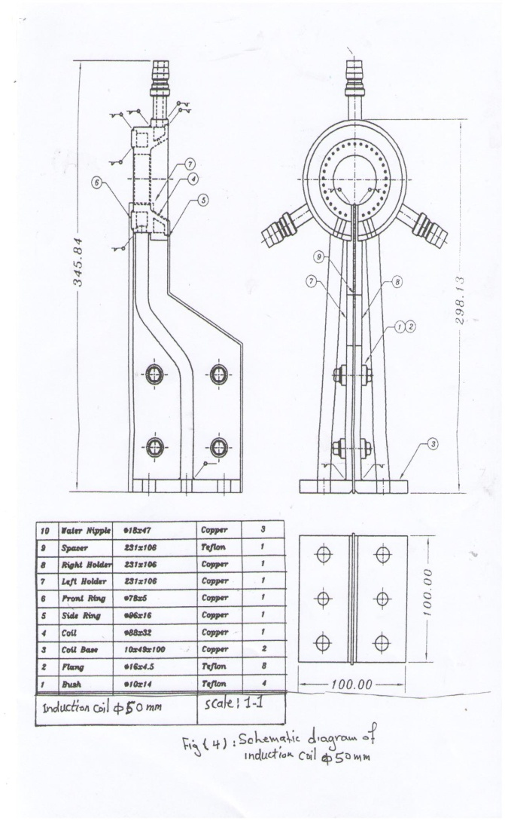
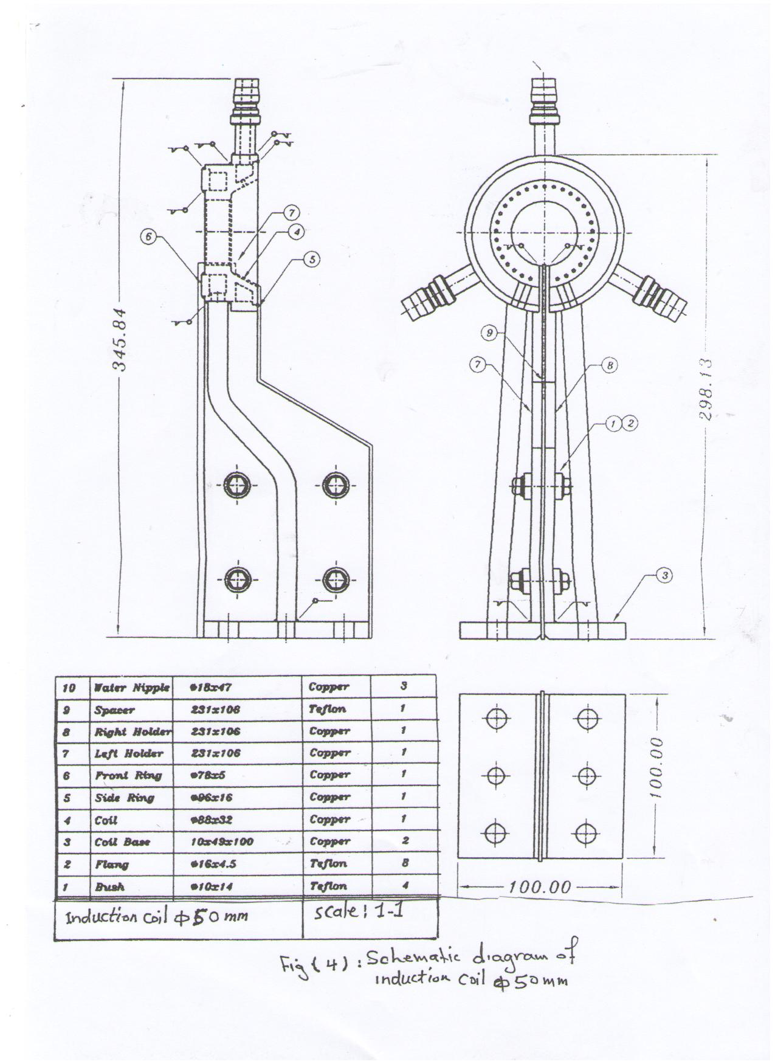

Fig. (4): Schematic diagram of induction coil Ø50 mm

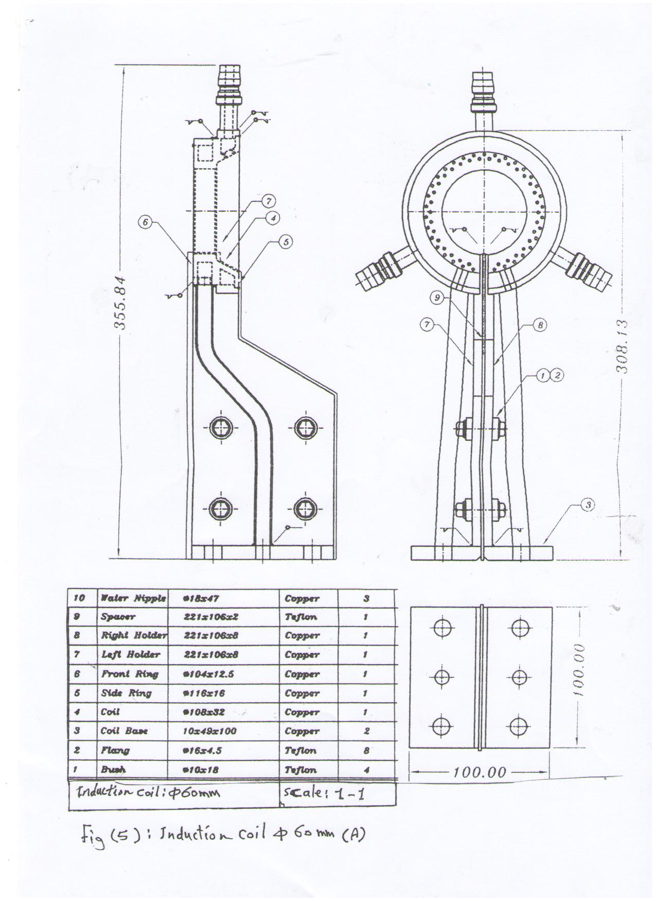
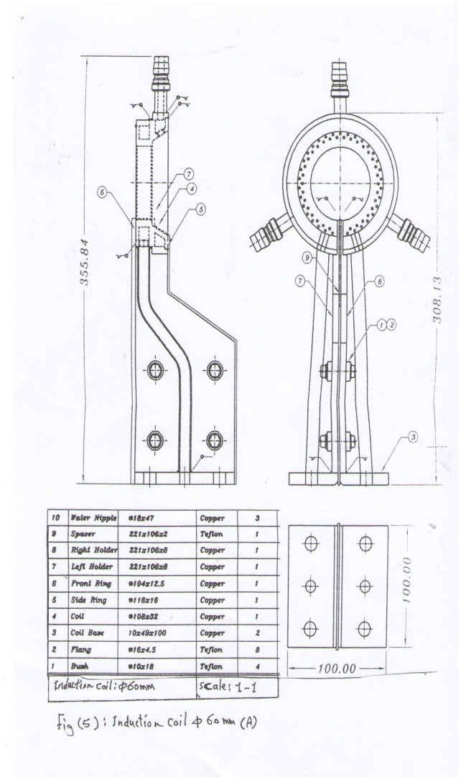

Fig. (5-A): Induction coil Ø 60 mm

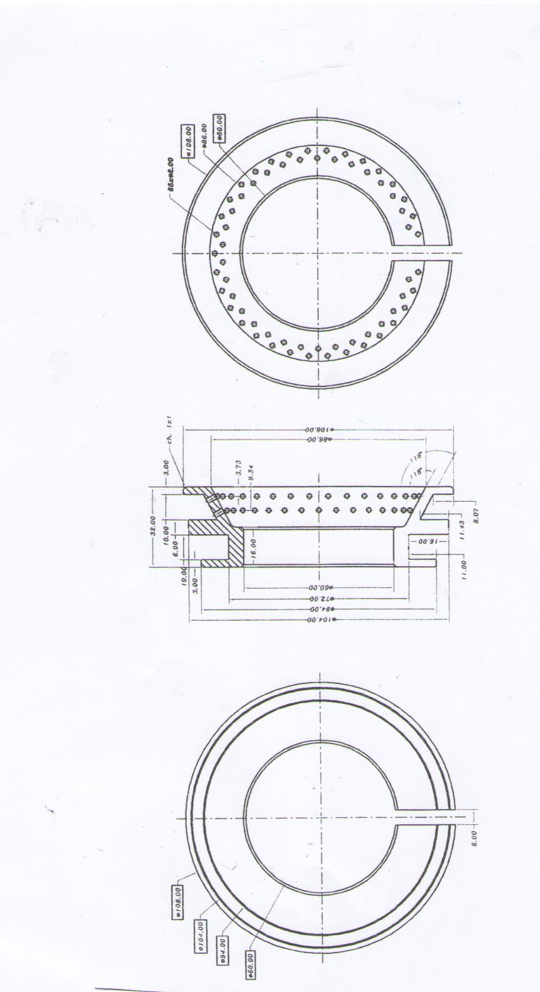

Fig. (5-B): Induction coil Ø60 mm

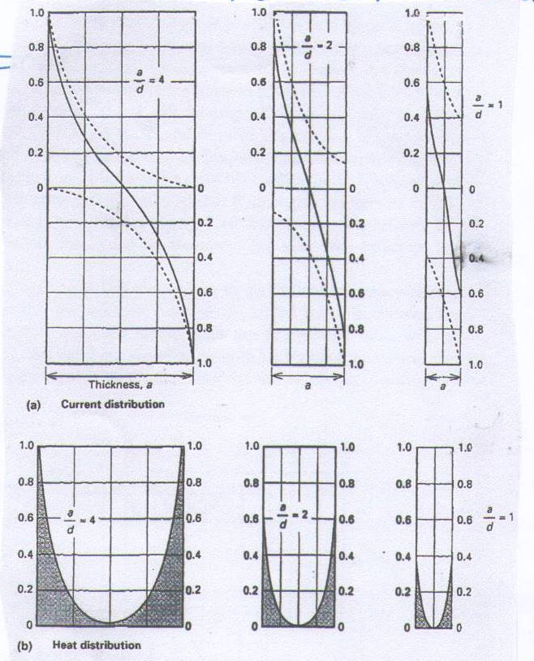

Fig (6): (A): Ratios of object thickness, a. (B): reference depth ,b.

Generator frequency is determined by the material, part size and the need for through or surface heating. Low frequencies, which provided large penetration depths of the induced eddy currents, are used for through heating treating. High frequencies are used for surface heat – treating. Heating efficiency is the percentage of the energy put through the coil that is transferred to the work piece by induction.
As shown in Fig (6), if the ratio of work piece diameter to reference depth for a round bar drops below about (4 to1), the heating efficiency drops. This ratio becomes as defined for round bars to be heat – treated, as the critical frequency for heating. Fig (7) shows the critical frequency as a function of diameter for round bars.

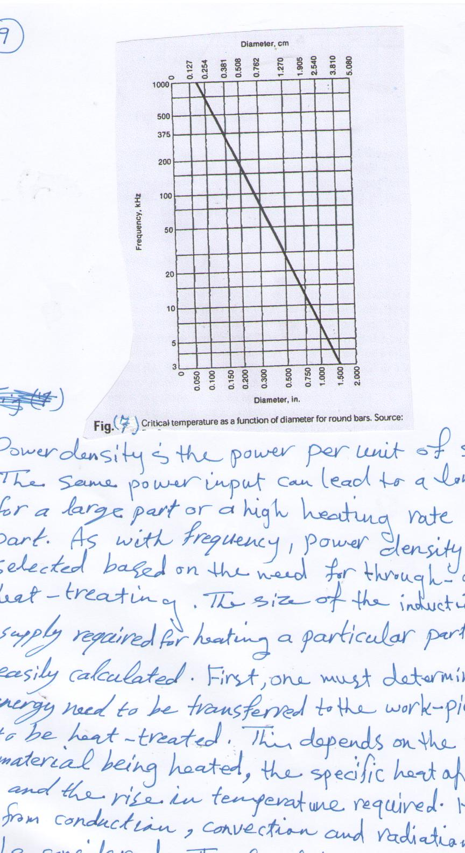

Fig (7) Critical temperature as a function of diameter for round bars.

Power density is the power per unit of surface area. The same power input can lead to a low heating rate for a large part or a high heating rate for a small part. As with frequency, power density levels is selected based on the need for through – or surface heat – treating. The size of the induction power supply required for heating a particular part can be calculated. First, it's important to determine how much energy need to be transferred to the work piece (part) to be heat – treated. This depends on the mass of the material being heated, the specific heat of the material, and the rise in temperature required. Heat losses from conduction, convection and radiation should also be considered. The final design of the coil and power system is shown in Fig. (8).
Result and discussion:
The efficiency of the two manufactured coils compared with that of imported coil, when the subjected to the following inspections before installation on the machine, these test, are carried out in Quality control laboratory. In this test many trials are carried out using both imported coil of Ø60 mm and the manufactured coil of Ø60 mm. Medium carbon steel samples (A151–1045) are used for heat – treatment and the result are shown in tables (1) and (2).
Table (1) Trails of imported coil Ø60 mm
Hardness  H_{v} | Case Depth  (mm) | Current  (A) | Transformer secondary voltage  (v²) - v | Samples diameter  Ø mm
792 | 1.3 | 180 | 450 | 90
763 | 1.7 | 180 | 321 | 85
763 | 1.2 | 180 | 281 | 80
565 | 0.9 | 160 | 280 | 75
454 | 0.7 | 150 | 280 | 70
Table (2): trials of manufactured coil Ø60 mm
Hardness  Hv | Case Depth  (mm) | Current  (A) | Transformer secondary voltage  (v²) - v | Samples diameter  Ø mm
690 | 1.4 | 180 | 450 | 90
700 | 1.8 | 180 | 320 | 85
710 | 1.6 | 170 | 280 | 80
570 | 1.0 | 160 | 280 | 75
460 | 0.8 | 160 | 280 | 70

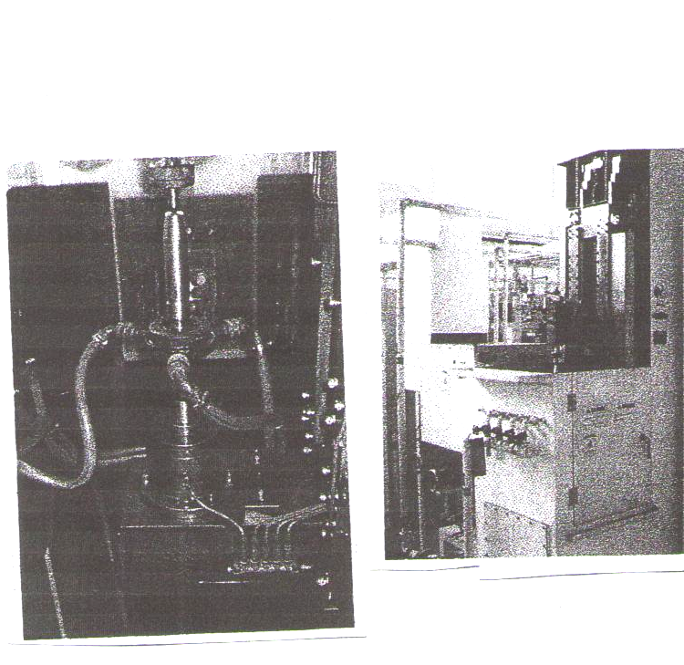

Fig (8): Power system and induction coil with heat – treated sample.
The manufacturing coils are designed according to a number of conditions such as,the coil should be coupled to the part as closely as feasible for maximum energy transfer, and the greatest number of flux lines in a solenoid coils toward the center of the coil, also the sample or part should be placed in the center of the induction coil.
The manufactured coils are inspected and the result is compared with the imported coil.
Insulation resistance:
250 M Ω for manufactured coil Ø = 40 mm 500 M Ω for manufacture coil Ø = 60 mm. 100 M Ω for imported coil of Ø = 60 mm.
Coil resistance
0.20 Ω for manufactured coil of Ø = 40 mm. 0.22 Ω for manufactured coil of Ø = 60 mm. 0.25 Ω for imported coil of Ø = 40 mm.
Also the test results of the manufactured coil with that of imported coil are shown in Fig. (9) and Fig. (10).
More similarities can be seen in behavior of the relation between case depth, current and between case depth and hardness.

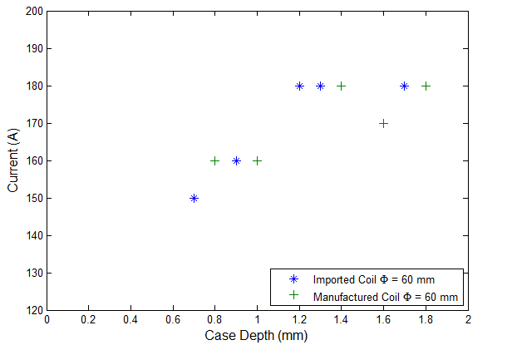

Fig. (9) Comparison between Imported and Manufactured Coils
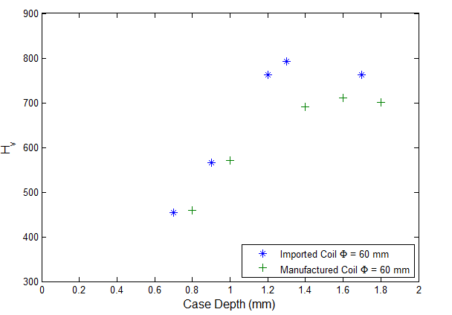

Fig. (10) Comparison between Imported and Manufactured Coils
Conclusions:
1. Induction heating is a process which is used to bond harden or soften metals.
2. High frequency induction depends mainly on Ohm's Law.
3.Hardening depth is dependent on penetration depth (p), which is calculated through frequency (f), and as frequency increased hardening depth increases.

D = 3.5p p =
4. The inductor coil is device that shapes the electromagnetic field a round and into the part or material being heated.
5. The performance of the manufactured coils is the same as that of the imported coil.
6. The court of manufactured coils is very low as compared with that imported coils.
References:
Heat Treating, vol.4, ASM Handbook, ASM international, 1991.
Heat treating device and treating method Us 7648600, Jan 29, 2009, Neturen Co. Ltd.
Induction Heating system Topology Review Rev, D, July, 2000.
Inductive Heating converter comprising a resonant circuit with simultinance multi-frequency current,01/2/2010.
M.G.lozinskii,1969 , Industrial Applications of induction Heating, pĕrgamon press.
Rudnev,V., Loveless,D., cook R.,and Black, M.,2003, Marcel Dekker ,Hand book of induction heating, New York.
Rudnev,V., 2005,proceedings of A514 Heat Treating Society conference Pittsburgh, Failure Analysis of induction coils , Pa, Sept.
Rudnev,V.,2005, Heat Treating progress, Electromagnetic Forcesin induction Heating vol5, No. 4, July.

