Comparative Study on the Required Tension Reinforcement for Singly Reinforced Concrete Rectangular Beams According to Different Codes

Talib Abdul Jabbar AL-Eyssawi
Foundation of Technical Education/ Technical Institute / Babylon
ambar606@yahoo.com
Abstract
This paper aims to compare the required, maximum and minimum tension reinforcement of singly reinforced concrete (RC) rectangular beams according to three common Codes. These adopted Codes are the ACI 318M-11, BS 8110-1:1997 and IRAQI Code 1/1987.
The results of analysis and design of (36) various beams cases indicate that the BS Code and the IRAQI Code have given an increase in the required area of tension reinforcement to about (15%) and (30%) respectively with respect to the ACI Code.
It is clearly shown that adopted ACI Code gives the minimum required area of tension reinforcement in the same beam, which leads to good economy and satisfy the ductility provisions in order to prevent sudden and brittle collapse of members subject to flexural.
Finally it is recommended to adopt the provisions of ACI Code to obtain the required area of tension reinforcement in members subjected to flexure in the next edition of IRAQI Code.
الخلاصة
يهدف هذا البحث مقارنـة تسليح الشد المطلـوب، الحد الاقصى والحد الادنى في العتبات الخرسانية المسلحة ذو التسليح المنفرد والمقطع المستطيل وفق ثلاثة مدونات مشهورة ومعتمدة عالميا. المدونات هي المواصفة الامريكية ACI 318M-11، المواصفة القياسية البريطانية BS 8110-1:1997 والمواصفة العراقية 1/1987.
أظهرت نتائج تحليل وتصميم (36) حالة مختلفة للعتبات أن المواصفة البريطانية والمواصفة العراقية تعطي زيادة في كمية تسليح الشد المطلـوب تصل الى (15%) و (%30) مقارنة مع المواصفة الامريكية على الترتيب.
لقد لوحظ ان اعتماد المواصفة الامريكية يعطي الكمية المثلى لتسليح الشد المطلوب للعتبة ذاتها، وهذا يؤدي الى اقتصاد جيد بالتكاليف وتلبية متطلبات المستمطلية لمنع حدوث انهيار مفاجئ وهش في الاعضاء المعرضة للانثناء.
اخيرا يوصى باعتماد فرضيات المواصفة الامريكية للحصول على كمية تسليح الشد في الاعضاء المعرضة للانثناء في الاصدار القادم للمواصفة العراقية.
1. Introduction
1.1. Previous Studies
The structure should satisfy four major criteria which are the appropriateness, economy, structural adequacy and maintainability [Wight et al., 2012].
Economy is one major criteria of the structure, and efficient structural designs can reduce the total quantity of concrete and reinforcing steel required for different building components [Wight et al, 2012]. Steel is much more expensive than concrete [Arya, 2009], and reduce the amount of reinforcement will lead to save the cost and good economy.
Another major criteria of the structure is adequacy which involves the analysis and design. Design deals with amount of required tension reinforcement to satisfy the basic requirements.
The amount of tension reinforcement deals with type of the beam failure. The failure of an under-reinforced beam is termed as tension failure or ductile failure, while the failure of over-reinforced beam is termed as compression failure or brittle failure. The ductile failure is gradual, giving ample prior warning of the impending collapse by way of increased curvatures, deflections and cracking, while brittle failure occurs explosively without warning [(Nawy, 2009) and (Menon et al., 2009)].
Different researches emphasize that the ductility of singly (RC) beams decreases when the percentage of reinforcement increases [(Hasan et al., 2011), (Kheyroddin et al., 2007) and (Siddique et al., 200)].
Another reason for using smaller percentages of steel is given in ACI where a plastic redistribution of moments is permitted in continuous members whose net tensile strain of steel reinforcement are (0.0075) or greater [McCormac et al., 2006].
Previous comparative study on strength design requirements of ACI-318-02 Code, BS8110 and EuroCode2 was found that the ACI Code gives higher moment capacity for lower steel ratios. The results was based on the analysis of rectangular beam with ( and ([ Jawad, 2006].
1.2. Objective of the Research
This paper is devoted to compare the required, maximum and minimum tension reinforcement of singly (RC)rectangular beams according to different Codes, and then adopt the Code which gives the minimum required area of tension reinforcement to save the cost. Three common Codes are selected in this study. These Codes are the ACI 318M-11, BS 8110-1:1997 and IRAQI Code 1/1987. The ACI Code adopts the compressive strength of concrete () of the standard cylinder while the BS Code and IRAQI Code adopt the characteristic compressive strength of concrete () of the standard cube.
The ACI Code adopts the elastic analysis and strength design method, while the BS Code and IRAQI Code adopt the elastic analysis and the ultimate limit state design method [(ACI Committee 318, 2011), (British Standard Committees, 1997) and (IRAQI Code Committee, 1987)].
2. Theortical Background
2.1. ACI CODE (ACI 318M, 2011)
The strength design method is adopted in this Code. Two factors of safety, one is called the load factors and equal to (1.2 and 1.6) for unfactored dead and unfactored live load respectively and the other is called the strength reduction factor (ϕ) which is equal to ( 0.9 ).
Referring to Fig. (1) and applying the conditions of equilibrium and compatibility of strains with maximum concrete compressive strain at crushing of the concrete equal to (0.003) and other hypotheticals sanctioned by this Code,
= 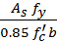 ( 1 )
M_{u} = 0.9 ( d − ) ( 2.a )
Substituting Eq. (1) in Eq. (2.a) gives:
M_{u} = 0.9 ( d − 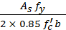 ) ( 2.b )
To ensure under-reinforced behavior, ACI Code encourages the use of lower reinforcement ratios. The Code defines a tension – controlled member as one with a net tensile strain greater than or equal to (0.005) [(Nawy, 2009), (Nilson et al., 2010) and (Subramanian, 2010)]. Such a tension-controlled section will give ample warning of failure with excessive deflection and cracking ) [Subramanian, 2010]. Based on that limitation, the maximum reinforcement ratio is given by:
ρ_{max} ($∈$_{s}=0.005) = 0.85β1 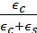 ( 3.a )

where (β1 ) is equal to (0.85) for () up to and including (28 MPa ) and (0.05) less for each (7 MPa) of strength in excess of (28 MPa ), but (β1 ) shall not be taken less than (0.65).
Substituting (Eq. (3.a) can be expressed as:
ρ_{max} ($∈$_{s}=0.005) = 0.31875β1 ( 3.b )
The minimum reinforcement ratio of a flexural member where tensile reinforcement is required by analysis should not be less than that given by:
ρ_{min} = 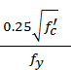 ≥ ( 4 )
2.2. Bs code (BS 8110-1, 1997)
The ultimate limit state design method is adopted in this Code for bending through the using of two partial safety factors, one is related with loads and equal to (1.4 and 1.6) for characteristic dead and characteristic live loads respectively and other for materials ( γ_{m} ). The partial safety factors for reinforcement and concrete are (1.05) and (1.5) respectively.
Referring to Fig. (1) and applying the conditions of equilibrium and compatibility of strains with maximum strain in concrete at failure equal to (0.0035) and other hypotheticals sanctioned by this Code,
= 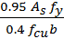 ( 5 )
M_{u} = 0.95 ( d − ) ( 6.a )
Substituting Eq. (5) in Eq. (6.a) gives [Bayagoob et al, 2013]:

M_{u} = 0.95 ( d − 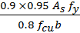 ) ( 6.b )
To ensure under-reinforced behavior, BS Code encourages the use of lower reinforcement ratios also. If the section is under-reinforced, the steel yields and failure will again occur due to crushing of the concrete. However, the beam will show considerable deflection which will be accompanied by severe cracking and spalling from the tension face thus providing ample warning signs of failure [(Arya, 2009) and (Bhatt et al., 2006)]. In order to ensure that the section is under-reinforced, BS 8110 limits the ultimate moment of resistance by [Arya, 2009]:
M_{u} = 0.156 ( 7 )
Based on the above limitation, the maximum reinforcement ratio can be calculated.
The minimum areas of reinforcement in a beam section to control cracking as well as to resist tension or compression due to bending in different types of beam section are given in BS 8110: Part 1 [Bhatt et al., 2006].
For rectangular beams with overall dimensions b and h, the area of tension reinforcement, As, should lie within the following limits [Arya, 2009], the minimum tension reinforcement ratio for mild steel and high yield steel are:
A_{s,min} = , when =250 MPa ( 8.a )
A_{s,min} = , when =460 MPa ( 8.b )
2.3. Iraqi Code (Iraqi Code 1, 1987)
The ultimate limit state design method is adopted in this Code for bending through the using of two partial safety factors, one is related with loads and equal to (1.4 and 1.7) for unfactored dead and unfactored live loads respectively and other for materials ( γ_{m} ). The partial safety factors for reinforcement and concrete are (1.15) and (1.5) respectively.
Referring to Fig. (1) and applying the conditions of equilibrium and compatibility of strains with maximum strain in concrete at failure equal to (0.0035) and other hypotheticals sanctioned by this Code,
= 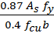 ( 9 )
M_{u} = 0.87 ( d − ) ( 10.a )
Substituting Eq. (9) in Eq. (10.a) gives:
M_{u} = 0.87 ( d − 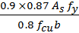 ) ( 10.b )
The IRAQI Code is similar to BS Code, which limits the ultimate moment of resistance by above Eq. (7). Also, based on that limitation, the maximum reinforcement ratio can be calculated.
The minimum reinforcement ratio of flexural members is given by:
ρ_{min} = ( 11 )
3. Theretical Approach and Discusion
3.1. Comarision Between Different Codes
For ordinary applications of RC, the strength of concrete of 21 and 28 MPa concretes are used [McCormac et al, 2006]. Using the following relation between ) which is used in the ACI Code and ( which is used in other Codes [(IRAQI Code Committee, 1987), (Subramanian, 2010) and (McCormac et al, 2006)].
= 1.25 ( 12 )
the three ( values of [ 21(26.25), 24(30) and 28(35) ] MPa are used.
The strength of steel reinforcement is selected based on () value of 280 and 420 MPa for ordinary grade and high-strength grade respectively [Hassoun et al, 2008].
Before selecting miscellaneous cases of beams, the values of factored flexural resistance (R_{u} ) is investigated, where (R_{u} ) is given by [Hassoun et al, 2008]:
R_{u} = ( 13 )
so that the required area of tension reinforcement satisfies the limitations of minimum and maximum ratios for all Codes.
The area of tension reinforcement in a reinforced-concrete flexural member can be expressed as the ratio [Merritt, 2001]:
ρ = 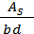 ( 14 )

For ACI Code, rearranging Eq. (2.b) by using Eqs. (13) and (14), the factored flexural resistance (R_{u} ) of this Code can be written as [Hassoun et al, 2008].
R_{u} = 0.9 ( 1 − 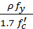 ) ( 15 )
The value of (ρ) can be determined by solving the quadratic Eq. (15) [Wang et al., 2006]. Letting the ratio (m₁) for strength of concrete and reinforcement for ACI Code,

m₁ = 0.85 ( 16 )
and the ratio (m₂) for strength of concrete for ACI Code,
m₂ =
m₂ =2.6144 ( 17 )
then (ρ) for ACI Code can be determined by the following:
ρ = m₁ ( 1− ) ( 18 )
For BS Code, rearranging Eq. (6.b) by using Eqs. (13) and (14), the factored flexural resistance (R_{u} ) for this Code can be written as:
R_{u} = 0.95 ( 1 − 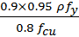 ) ( 19 )
Also, the value of (ρ) can be determined by solving the quadratic Eq. (19). Letting the ratio (m₁) for strength of concrete and reinforcement for BS Code,
m₁ = 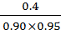
m₁ = 0.4678 ( 20 )
and the ratio (m₂) for strength of concrete for BS Code,
m₂ = 4.5 ( 21 )
then, also (ρ) for BS Code can be determined by the same above Eq. (18), but with ratios (m₁) and (m₂) for BS Code.
Also,for BS Code, rearranging Eq.(7) by using Eqs. (13), the ultimate factored flexural resistance (R_{u} ) for this Code which is related with the maximum reinforcement ratio can be written as:
R_{u} = 0.156 ( 22 )
Substituting Eqs. (20), (21) and (22) in Eq. (18), the maximum reinforcement ratio for BS Code can be written as:
ρ_{max} = 0.2124 ( 23 )
For BS Code and based on ( d/h = 0.9) [Concrete Centre, 2009], the minimum reinforcement ratio in Eqs. (8.a) and (8.b) can be calculated by interpolation as:
ρ_{min} = 0.0025 , when =280 MPa ( 24.a )
ρ_{min} = 0.0016 , when =420 MPa ( 24.b )
For IRAQ Code, rearranging Eq. (10.b) by using Eqs. (13) and (14), the factored flexural resistance (R_{u} ) for this Code can be written as:
R_{u} = 0.87 ( 1 − 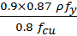 ) ( 25 )
Also, the value of (ρ) can be determined by solving the quadratic Eq. (25). Letting the ratio (m₁) for strength of concrete and reinforcement for IRAQ Code,
m₁ = 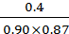

m₁ = 0.5109 ( 26 )
and the ratio (m₂) for strength of concrete for IRAQ Code is equal to the same ratio (m₂) for strength of concrete for BS Code in Eq. (21).
then, also (ρ) for IRAQI Code can be determined by the same above Eq. (18), but with ratios (m₁) and (m₂) for IRAQI Code.
Also, for IRAQI Code, rearranging Eq. (7) by using Eqs. (13), the ultimate factored flexural resistance (R_{u} ) for this Code which is related with the maximum reinforcement ratio can be written in a similar way of Eq. (22) for BS Code.
Substituting Eqs. (21), (22) and (26) in Eq. (18), the maximum reinforcement ratio for IRAQI Code can be written as:
ρ_{max} = 0.2320 ( 27 )
For all Codes, the limitations of reinforcement ratios are shown in Table (1), based on Eqs. (3.b and 4), (23 , 24.a and 24.b) and (11 and 27) for ACI, BS Code and IRAQI Code respectively.
For all Codes and depending on the limitations of reinforcement ratios of Table (1), the limitations of (R_{u} ) are listed in Table (2), based on Eqs. (15), (19) and (25) for ACI Code, BS Code and IRAQI Code respectively.
It is obvious from Table (2) that the limitations of greatest lower bound and least upper bound of (R_{u} ) are ( 1.21 and 4.10 MPa ), (1.22 and 4.68 MPa) and (1.22 and 5.46 MPa) for the ( of [ 21(26.25), 24(30) and 28(35) ] MPa respectively for all Codes. The lower and upper bounds designate the range of permissible values for [Guerra,2006] the limitations of (R_{u}) which are (1.22 and 4.10 MPa ) of greatest lower and least upper bound for all Codes. Six miscellaneous realistic beams which have values of (R_{u}) ranging between (1.30 and 3.98 MPa ) are chosen to investigate the reinforcement. The details of all beams are shown in Table(3).Hence (36) various beams which have different strength of concrete, yield strength of reinforcement and factored flexural resistance (R_{u} ) are studied in this comparison between the ACI Code, BS Code and IRAQI Code.
3.2. Optimum (Minimum) Required Tension Reinforcement
The optimized Code is the Code which gives minimum required area of tension reinforcement in the same beam, satisfy the basic requirements and most economical. The same beam is the beam with the same dimensions, unfactored or characteristic loads, strength of concrete, strength of reinforcement and same support conditions. The loads having same values, positions and concentrations.
Reducing the quantity of reinforcement, will reduce the complex or congested reinforcement and will lead to economic design [Wight et al., 2012], and also satisfy the ductility provisions for cracks and deflections in order to ensure happening the ductile failure and avoiding the brittle failure.
The required area of tension reinforcement in all selected beams is calculated based on Eq. (18) and Eq. (14), using the values of ratios (m₁) and (m₂) in Table (4). These values are computed by using Eqs. ( 16 and 17 ), ( 20 and 21 ) and ( 26 and 21) for ACI Code, BS Code and IRAQI Code respectively.
Table (5) and Table (6) signify that the required area of reinforcement for ACI Code is less than that for BS Code and IRAQI Code. Table (5) and Table (6) also illustrate the percentage increase in the required area of reinforcement for BS Code and IRAQI Code with respect to ACI Code. It is clearly appeared that percentage increase in the required area of reinforcement is not affected with the strength of reinforcement (). Hence, Table (7) is established depending on values of related (R_{u} ) and the percentage increase in the required area of reinforcement of Table (5) and Table (6).
Figs. (2, 3 and 4) are drawn with regression analysis to illustrate the relation between (R_{u}) and the percentage increase in the required area of reinforcement of Table (7). These figures clearly show that there is an increase in required area of reinforcement for BS Code and IRAQI Code with respect to ACI Code. To avoid exaggeration and to attain rational equations for the best fitted curves, polynomial equations of second degree with correlation coefficient are calculated and shown in these figures. Based on the equations of these best fitted curves, the percentage increase in the required area of reinforcement for least upper bound of (R_{u} ) of table (2), are calculated and presented in Table (8). It is clearly appear from Table (8) that the percentage increase in the required area of reinforcement may reach to about (15%) and (30%) for BS Code and IRAQI Code respectively.
For the above several reasons mentioned, it is obvious that the ACI Code gives the minimum required area of tension reinforcement compared with BS Code and IRAQI Code.
4. Conclusions and Recommendation
The main results of this study can be indicated as following:
- ACI Code gives the minimum required area of tension reinforcement in the same beam compared with BS Code and IRAQI Code, which leads to good economy and satisfy the basic requirements.
- The results indicate that the BS Code have given an increase in the required area of tension reinforcement up to (15 % ) with respect to ACI Code.
- The results indicate that the IRAQI Code have given an increase in the required area of tension reinforcement up to (30 %) with respect to ACI Code.
- The paper provides swift, simple and accurate computations to find the percentage of required tension reinforcement for the ACI Code, through using the ratios (m₁) and (m₂) in Table (4) and the formula of Eq. (18).
It is recommended to adopt the provisions of ACI code to obtain the required area of tension reinforcement in members subjected to flexure in the next edition of IRAQI code.
References
ACI Committee 318,2011,“Building Code Requirements for Structural Concrete”, (ACI 318M-11) and Commentary, American Concrete Institute, Farmington Hills, MI.
Arya,C., 2009,“Design of Structural Elements”, 3rd Ed., Taylor & Francis, pp. 18-50.
Bayagoob, K., H., Yardim, Y. and Ramoda, S.,A., 2013, “Design Chart for Reinforced Concrete Rectangular Section”,2nd International Balkans Conference on Challenges of Civil Engineering, Epoka University, Tirana, pp. 1-11.
Bhatt, P.,MacGinley, T., J. and Choo, B.,S., 2006,“Reinforced Concrete”,3rd Ed., Taylor & Francis.
British Standard Committees,1997,“Structural Use of Concrete, Part 1”,(BS8110-1:1997), British Standards Institution, 2nd Ed., London.
Concrete Centre, 2009, “Concrete Buildings Scheme Design Manual”, 2nd Ed., MPA, London.
Guerra, A. and Kiousis, P., D.,2006,“Design Optimization of Reinforced Concrete Structures”, Journal of Computers and Concrete, Vol. 3, No. 5, pp. 313-334.
Hasan,W., M.,El-Khatieb, M. and Al-Ani, H., 2011, “Steel Reinforcement Ratio Dependency of Plastic Rotational Capacity of Reinforced Concrete Beams”, Jordan Journal of Civil Engineering, Volume 5, No. 4, pp. 480-491.
Hassoun, M.,N. and Al-Manaseer, A.,2008, “Structural Concrete”, 4th Ed., John Wiley and Sons, Inc..
IRAQI Code Committee, 1987, “IRAQI Building Code Requirements for Reinforced Concrete”, (Code 1/1987), Building Research Center – Scientific Research Council, 1st Ed., Baghdad.
Jawad, A., H., 2006, “Strength Design Requirements of ACI-318M-02 Code, BS8110, and EuroCode2 for Structural Concrete: A Comparative Study”, Journal of Engineering and Development, Vol. 10, No. 4, pp. 136-150.
Kheyroddin, A. and Naderpour, H., 2007,“Plastic Hinge Rotation Capacity of Reinforced Concrete Beams”, International Journal of Civil Engineerng, Vol. 5, No. 1, pp. 30-47.
McCormac, J., C. and Nelson, J., K., 2006, “Design of Reinforced Concrete”, 7th Ed., John Wiley and Sons, Inc.
Menon, D. and Pillai, S., 2009, “Reinforced Concrete Design”,3rd Ed., Tata McGraw-Hill Education Pvt. Ltd., New Delhi.
Merritt,F.,S. and Ricketts, J.,T., 2001, “Building Design and Construction Handbook”, 6th Ed., McGraw-Hill.
Nawy, E.,G.,2009,“Reinforced Concrete”,6th Ed.,Pearson Education,Inc., New Jersey.
Nilson, A., H., Darwin, D. and Dolan, C., W., 2010, “ Design of Concrete Structures”, 14th Ed., McGraw-Hill.
Siddique, M., A. and Rouf, M., A., 2006, “Effect of Material Properties on Ductility Factor of Singly RC Beam Sections”, 6th Asia-Pacific Structural Engineering and Construction Conference, Kuala Lumpur, pp. A83-A90.
Subramanian, N., 2010, “Limiting reinforcement ratios for RC flexural members”, The Indian Concrete Journal, pp. 71-80.
Wang, C., K., Salmon, C., G. and Pincheira, J., A., 2006, “Reinforced Concrete Design”, 7th Ed., John Wiley and Sons, Inc.
Wight, J., K. and MacGregor, J., G., 2012, “Reinforced Concrete Mechanics and Design”, 6th Ed., Pearson, Inc., New Jersey, pp. 12-39.

Notation
 | = area of tension reinforcement
 | = depth of equivalent rectangular stress block for ACI Code
 | = width of beam
 | =concrete compression force
 | =distance from extreme compression fiber to neutral axis for ACI Code
d | = distance from extreme compression fiber to centroid of tension reinforcement
 | =cylinder compressive strength of concrete for ACI Code
 | =cube characteristic strength of concrete for BS Code and IRAQI Code
 | =specified yield strength of reinforcement
h | = overall depth of beam
 | = span length of beam
M_{D} | = dead load bending moment at section
M_{L} | = live load bending moment at section
M_{u} | = factored bending moment at section
m₁ | = ratio for strength of concrete and reinforcement ( see equations 16, 20 and 26 for ACI Code, BS Code and IRAQI Code respectively or Table 4)
m₂ | = ratio for strength of concrete ( see equations 17 for ACI Code, 21 for BS Code and IRAQI Code or Table 4)
RC | = Reinforced Concrete
R_{u} | = factored flexural resistance
 | =steel reinforcement tension force
 | =distance from extreme compression fiber to neutral axis for BS Code and IRAQI Code
W_{D} | =uniformly distributed dead load over the span length of beam
W_{L} | =uniformly distributed live load over the span length of beam
β1 | = factor relating depth of equivalent rectangular compressive stress block to neutral axis depth for ACI Code
ϕ | = strength reduction factor for ACI Code
ρ | = ratio of A_{s} to bd
 | =maximum usable strain at extreme concrete compression fiber
 | =tension steel strain
γ_{m} | = BS Code and IRAQI Code partial safety factors for materials

Table (1) - The limitations of reinforcement ratios
f_{y} , MPa | Code | fć(f_{cu}) , MPa
f_{y} , MPa | Code | 21(26.25) |  | 24(30) |  | 28(35)
f_{y} , MPa | Code | Min. | max. | min. | max. | min. | max.
280 | ACI | 0.0050 | 0.0203 | 0.0050 | 0.0232 | 0.0050 | 0.0271
280 | BS | 0.0025 | 0.0199 | 0.0025 | 0.0228 | 0.0025 | 0.0266
280 | IRAQI | 0.0050 | 0.0218 | 0.0050 | 0.0249 | 0.0050 | 0.0290
420 | ACI | 0.0033 | 0.0135 | 0.0033 | 0.0155 | 0.0033 | 0.0181
420 | BS | 0.0016 | 0.0133 | 0.0016 | 0.0152 | 0.0016 | 0.0177
420 | IRAQI | 0.0033 | 0.0145 | 0.0033 | 0.0166 | 0.0033 | 0.0193

Table (2) - The limitations of factored flexural resistance (R_{u} )
f_{y} , MPa | Code | R_{u,} (MPa) for different fć(f_{cu}) , MPa
f_{y} , MPa | Code | 21(26.25) |  |  | 24(30) |  |  | 28(35)
f_{y} , MPa | Code | Min. | Max. | Diff. | Min. | Max. | Diff. | Min. | Max. | Diff.
280 | ACI | 1.21 | 4.30 | 3.09 | 1.22 | 4.92 | 3.70 | 1.22 | 5.74 | 4.52
280 | BS | 0.65 | 4.10 | 3.45 | 0.65 | 4.68 | 4.03 | 0.65 | 5.46 | 4.81
280 | IRAQI | 1.15 | 4.10 | 2.95 | 1.16 | 4.68 | 3.52 | 1.17 | 5.46 | 4.29
420 | ACI | 1.20 | 4.29 | 3.09 | 1.21 | 4.92 | 3.71 | 1.21 | 5.75 | 4.54
420 | BS | 0.62 | 4.10 | 3.48 | 0.62 | 4.68 | 4.06 | 0.62 | 5.46 | 4.84
420 | IRAQI | 1.14 | 4.10 | 2.96 | 1.15 | 4.68 | 3.53 | 1.16 | 5.46 | 4.30

Table (3) - Beams details
Beam Information | Case 1 | Case 2 | Case 3 | Case 4 | Case 5 | Case 6 | Notes
b , mm | 250 | 300 | 350 | 400 | 450 | 500
d , mm | 340 | 390 | 490 | 540 | 740 | 840 | Assuming effective cover=60 mm [McCormac et al, 2006]
h , mm | 400 | 450 | 550 | 600 | 800 | 900 | Satisfy deflection for all Codes
h / b ratio | 1.60 | 1.50 | 1.57 | 1.50 | 1.78 | 1.80 | Ratio between 1.5 to 2 [(McCormac et al, 2006) and (Wang et al, 2006)]
d / h ratio | 0.85 | 0.87 | 0.89 | 0.90 | 0.93 | 0.93
L , mm | 3500 | 4000 | 6000 | 6500 | 7000 | 8000 | All beams are simply supported
L / d ratio | 10.29 | 10.26 | 12.24 | 12.04 | 9.46 | 9.52
w_{L ,} kN/m | 6 | 10 | 10 | 15 | 35 | 45 | Unfactored load
w_{D} , kN/m | 10 | 16 | 16 | 25 | 50 | 60 | Unfactored load
Beam dead weight , kN/m | 2.4 | 3.24 | 4.62 | 5.76 | 8.64 | 10.8 | Unfactored load, concrete density=24 kN/m³ [(Arya, 2009) and (McCormac et al, 2006)]
M_{L} , kN.m | 9.19 | 20.00 | 45.00 | 79.22 | 214.38 | 360.00 | Unfactored moment at center [(Arya, 2009) and (McCormac et al, 2006)]
M_{D} , kN.m | 18.99 | 38.48 | 92.79 | 162.45 | 359.17 | 566.40
M_{u} , kN.m | 37.49 | 78.18 | 183.35 | 321.69 | 774.00 | 1255.68 | Load factors - ACI Code =1.2, 1.6
M_{u} , kN.m | 41.28 | 85.87 | 201.91 | 354.18 | 845.84 | 1368.96 | Load factors - BS Code=1.4, 1.6
M_{u} , kN.m | 42.20 | 87.87 | 206.41 | 362.10 | 867.28 | 1404.96 | Load factors - IRAQI Code=1.4, 1.7
R_{u} , MPa | 1.30 | 1.71 | 2.18 | 2.76 | 3.14 | 3.56 | ACI Code
R_{u} , MPa | 1.43 | 1.88 | 2.40 | 3.04 | 3.43 | 3.88 | BS Code
R_{u} , MPa | 1.46 | 1.93 | 2.46 | 3.10 | 3.52 | 3.98 | IRAQI Code

Table (4) - Values of (m₁) and (m₂) ratios
f_{y} , MPa | Code | fc′(f_{cu}) , (MPa)
f_{y} , MPa | Code | 21(26.25) |  | 24(30) |  | 28(35)
f_{y} , MPa | Code | m₁ | m₂ , 1/MPa | m₁ | m₂ , 1/MPa | m₁ | m₂ , 1/MPa
280 | ACI | 0.0638 | 0.1245 | 0.0729 | 0.1089 | 0.0850 | 0.0934
280 | BS | 0.0439 | 0.1714 | 0.0501 | 0.1500 | 0.0585 | 0.1286
280 | IRAQI | 0.0479 | 0.1714 | 0.0547 | 0.1500 | 0.0639 | 0.1286

Table (4) - Values of (m₁) and (m₂) ratios ( Continued)
f_{y} , MPa | Code | fc′(f_{cu}) , (MPa)
f_{y} , MPa | Code | 21(26.25) |  | 24(30) |  | 28(35)
f_{y} , MPa | Code | m₁ | m₂ , 1/MPa | m₁ | m₂ , 1/MPa | m₁ | m₂ , 1/MPa
420 | ACI | 0.0425 | 0.1245 | 0.0486 | 0.1089 | 0.0567 | 0.0934
420 | BS | 0.0292 | 0.1714 | 0.0334 | 0.1500 | 0.0390 | 0.1286
420 | IRAQI | 0.0319 | 0.1714 | 0.0365 | 0.1500 | 0.0426 | 0.1286

Table (5) - The required area of reinforcement; =280 MPa
Beam Case | Code | fć(f_{cu}) , MPa
Beam Case | Code | 21(26.25) |  | 24(30) |  | 28(35)
Beam Case | Code | A_{s} , mm² | % Increase | A_{s} , mm² | % Increase | A_{s} , mm² | % Increase
1 | ACI | 457 | 0.0 | 454 | 0.0 | 452 | 0.0
1 | BS | 488 | 6.9 | 484 | 6.6 | 480 | 6.2
1 | IRAQI | 546 | 19.6 | 541 | 19.1 | 536 | 18.7
2 | ACI | 843 | 0.0 | 836 | 0.0 | 830 | 0.0
2 | BS | 908 | 7.7 | 896 | 7.1 | 885 | 6.6
2 | IRAQI | 1017 | 20.7 | 1004 | 20.0 | 991 | 19.3
3 | ACI | 1602 | 0.0 | 1585 | 0.0 | 1569 | 0.0
3 | BS | 1753 | 9.4 | 1721 | 8.6 | 1692 | 7.8
3 | IRAQI | 1964 | 22.6 | 1927 | 21.6 | 1893 | 20.6
4 | ACI | 2612 | 0.0 | 2575 | 0.0 | 2540 | 0.0
4 | BS | 2914 | 11.6 | 2837 | 10.2 | 2769 | 9.0
4 | IRAQI | 3270 | 25.2 | 3181 | 23.5 | 3102 | 22.1
5 | ACI | 4663 | 0.0 | 4584 | 0.0 | 4510 | 0.0
5 | BS | 5235 | 12.3 | 5065 | 10.5 | 4918 | 9.0
5 | IRAQI | 5904 | 26.6 | 5704 | 24.4 | 5531 | 22.6
6 | ACI | 6794 | 0.0 | 6656 | 0.0 | 6529 | 0.0
6 | BS | 7762 | 14.2 | 7442 | 11.8 | 7174 | 9.9
6 | IRAQI | 8785 | 29.3 | 8402 | 26.2 | 8085 | 23.8

Table (6) - The required area of reinforcement; =420 MPa
Beam Case | Code | fć(f_{cu}) , MPa
Beam Case | Code | 21(26.25) |  | 24(30) |  | 28(35)
Beam Case | Code | A_{s} , mm² | % Increase | A_{s} , mm² | % Increase | A_{s} , mm² | % Increase
1 | ACI | 304 | 0.0 | 303 | 0.0 | 301 | 0.0
1 | BS | 326 | 6.9 | 323 | 6.6 | 320 | 6.2
1 | IRAQI | 364 | 19.6 | 361 | 19.1 | 357 | 18.7
2 | ACI | 562 | 0.0 | 558 | 0.0 | 553 | 0.0
2 | BS | 605 | 7.7 | 597 | 7.1 | 590 | 6.6
2 | IRAQI | 678 | 20.7 | 669 | 20.0 | 660 | 19.3
3 | ACI | 1068 | 0.0 | 1057 | 0.0 | 1046 | 0.0
3 | BS | 1169 | 9.4 | 1148 | 8.6 | 1128 | 7.8
3 | IRAQI | 1309 | 22.6 | 1285 | 21.6 | 1262 | 20.6
Table (6) - The required area of reinforcement; =420 MPa ( Continued)
Beam Case | Code | fć(f_{cu}) , MPa
Beam Case | Code | 21(26.25) |  | 24(30) |  | 28(35)
Beam Case | Code | A_{s} , mm² | % Increase | A_{s} , mm² | % Increase | A_{s} , mm² | % Increase
4 | ACI | 1741 | 0.0 | 1716 | 0.0 | 1693 | 0.0
4 | BS | 1942 | 11.6 | 1892 | 10.2 | 1846 | 9.0
4 | IRAQI | 2180 | 25.2 | 2121 | 23.5 | 2068 | 22.1
5 | ACI | 3108 | 0.0 | 3056 | 0.0 | 3007 | 0.0
5 | BS | 3490 | 12.3 | 3377 | 10.5 | 3278 | 9.0
5 | IRAQI | 3936 | 26.6 | 3803 | 24.4 | 3687 | 22.6
6 | ACI | 4529 | 0.0 | 4437 | 0.0 | 4353 | 0.0
6 | BS | 5174 | 14.2 | 4961 | 11.8 | 4783 | 9.9
6 | IRAQI | 5857 | 29.3 | 5601 | 26.2 | 5390 | 23.8

Table (7) - The relation between factored flexural resistance (R_{u} ) and the percentage increase in the required area of reinforcement with respect to ACI Code provisions
Beam Case | Code | fć(f_{cu}) , MPa
Beam Case | Code | 21(26.25) |  | 24(30) |  | 28(35)
Beam Case | Code | R_{u} , MPa | % Increase | R_{u} , MPa | % Increase | R_{u} , MPa | % Increase
1 | ACI | 1.30 | 0.0 | 1.30 | 0.0 | 1.30 | 0.0
1 | BS | 1.43 | 6.9 | 1.43 | 6.6 | 1.43 | 6.2
1 | IRAQI | 1.46 | 19.6 | 1.46 | 19.1 | 1.46 | 18.7
2 | ACI | 1.71 | 0.0 | 1.71 | 0.0 | 1.71 | 0.0
2 | BS | 1.88 | 7.7 | 1.88 | 7.1 | 1.88 | 6.6
2 | IRAQI | 1.93 | 20.7 | 1.93 | 20.0 | 1.93 | 19.3
3 | ACI | 2.18 | 0.0 | 2.18 | 0.0 | 2.18 | 0.0
3 | BS | 2.40 | 9.4 | 2.40 | 8.6 | 2.40 | 7.8
3 | IRAQI | 2.46 | 22.6 | 2.46 | 21.6 | 2.46 | 20.6
4 | ACI | 2.76 | 0.0 | 2.76 | 0.0 | 2.76 | 0.0
4 | BS | 3.04 | 11.6 | 3.04 | 10.2 | 3.04 | 9.0
4 | IRAQI | 3.10 | 25.2 | 3.10 | 23.5 | 3.10 | 22.1
5 | ACI | 3.14 | 0.0 | 3.14 | 0.0 | 3.14 | 0.0
5 | BS | 3.43 | 12.3 | 3.43 | 10.5 | 3.43 | 9.0
5 | IRAQI | 3.52 | 26.6 | 3.52 | 24.4 | 3.52 | 22.6
6 | ACI | 3.56 | 0.0 | 3.56 | 0.0 | 3.56 | 0.0
6 | BS | 3.88 | 14.2 | 3.88 | 11.8 | 3.88 | 9.9
6 | IRAQI | 3.98 | 29.3 | 3.98 | 26.2 | 3.98 | 23.8

Table (8) - The relation between least upper bound of factored flexural resistance (R_{u} ) and the percentage increase in the required area of reinforcement with respect to ACI Code provisions
Code | fć(f_{cu}) , MPa
Code | 21(26.25) |  | 24(30) |  | 28(35)
Code | R_{u} , MPa | % Increase | R_{u} , MPa | % Increase | R_{u} , MPa | % Increase
BS | 4.10 | 14.98 | 4.68 | 13.53 | 5.46 | 11.40
IRAQI | 4.10 | 29.83 | 4.68 | 28.69 | 5.46 | 27.11

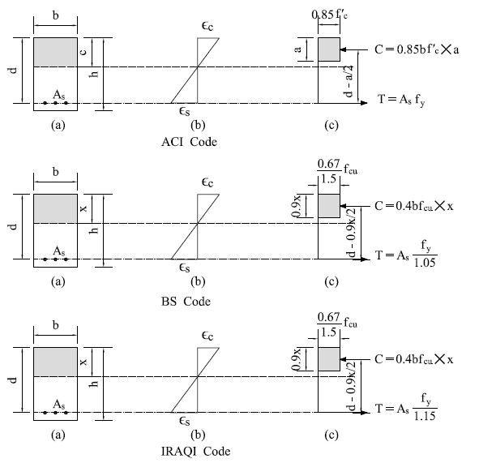

Fig. 1 - Strain distribution and stress block

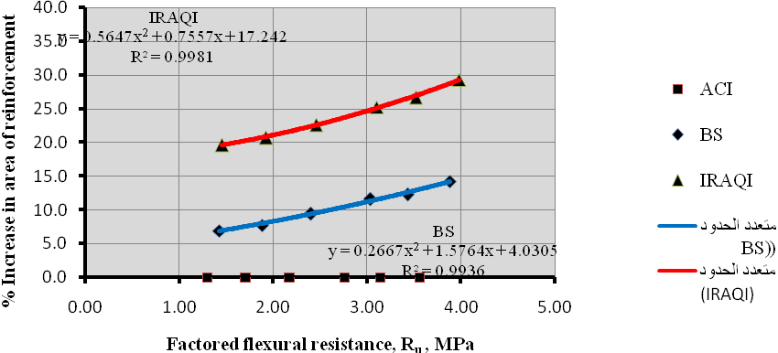
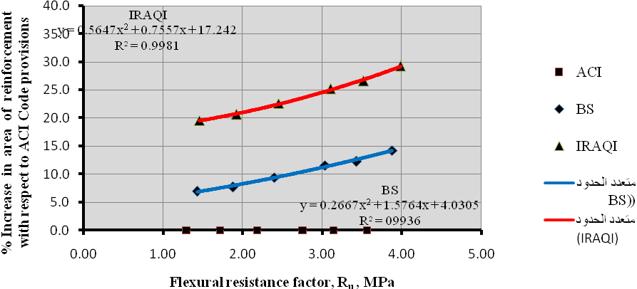

Fig. 2 - Comparison of tension reinforcement, (f_{cu}) = 21(26.25) MPa

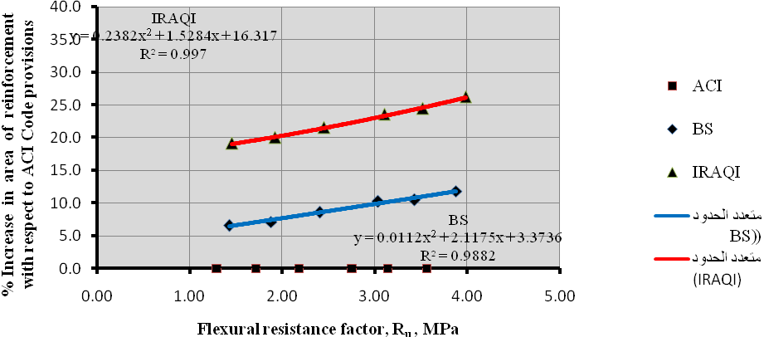

Fig. 3 - Comparison of tension reinforcement, (f_{cu}) = 24(30) MPa

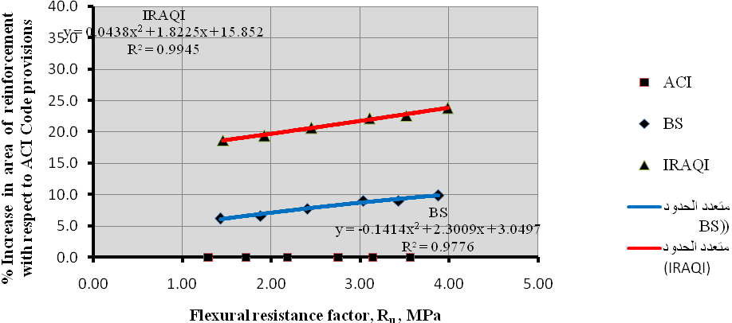

Fig. 4 - Comparison of tension reinforcement, (f_{cu}) = 28(35) MPa

