Behavior of Steel Fiber Normal Strength Concrete Square Columns Under Cyclic Loading

Jabor AL-Jeabory

Department of Civil Engineering- University of Babylon, Babylon, Iraq
dr.jabor@yahoo.co.uk
Abstract:
Experimental investigations were made to determine the ultimate capacity of tied reinforced normal strength concrete columns subjected to both axial and transverse loads. Of the twelve specimens of 1200mm long and 200x200mm cross section tested, six were without steel fiber inclusions. All the specimens were tested under cyclic load until failure with the presence of constant axial load. Specimens differed in the amount of lateral reinforcement. The effects of 1% fiber inclusion by volume and amount of lateral reinforcement were investigated. The test results showed a direct relationship between absorbed energy and the spacing of lateral reinforcement. The ductility of the member increased due to 1% fiber inclusion by about 20-35 %.
Keywords: normal strength Concrete; Ductility; Deformability; Steel fiber; Column; cyclic loading
الخلاصة
لقد أجريت تجارب على أثنى عشر عمودا لتحديد التحمل الأقصى للأعمدة الخرسانية المعمولة من الخرسانة العادية والمضاف أليها الألياف الحديدية. لقد خضعت تلك النماذج الى حمل محوري أضافة الى الحمل التعاقبي المسلط على منتصف طول العمود حتى أنهيارة. تقد تم أضافة الألياف الحديدية الى نصف عدد تلك الأعمدة في حين كانت لجميعها كميات مختلفة من الحديد العرضي. أن تأثير الألياف أضافة الى المسافات بين حديد التسليح العرضي قد تمت دراستها . ان مطاوعة العمود قد زادت بحدود 20- 35% نتيجة أضافة الألياف الحديدية بمقدار 1% حجما.
الكلمات المفتاحية : الخرسانة قوة طبيعية. ليونة. التشوه. الألياف الفولاذية. العمود. تحميل دوري
Introduction:
Concrete can be modified to perform in a more ductile manner, by the addition of randomly distributed discrete fibers in concrete matrix[Hsu and Hsu,1994; Peled and Mobasher,2005] . Adding steel fibers to concrete mixture improves many engineering properties by different deformation and failure mechanism [Haider ,2002; Jun, et al.,1971 Surendra, and James , 1974; Swamy and Mangat , 1974]. When fibers were added to concrete mix, volume fraction V_{f} and the aspect ratio L_{f}/d_{f} were taken in consideration due to their effect on workability. To overcome this problem a modification of concrete mix design is recommended. Such modifications include the use of additives [Sana and John, 2009]. The behavior of fiber reinforced concrete columns and beam-column connections under monotonic and cyclic axial load were tested until failure by several researchers [Ganesan and Ramana, V.1990; Ziad and Michael, 2002; Hadi, 2009; Efe and Musbau, 2011; Gebman,2001; and Asad and Van, 2004].
The investigations presented in this paper are aimed at examining the feasibility of combining conventional reinforcing steel with fibers in normal strength concrete columns under cyclic load because of little detailed study deals with such concrete. An effort is made in this study to observe the effect of the additives like gilenium 51. This has advantages of enhancing the workability and improving the shrinkage characteristics of concrete.Based on previous studies steel fibers were added with volume fraction of 1% and aspect ratio L_{f}/d_{f} equal 100 to obtain the superior benefits of steel fibers without workability problems, (Spadea and Bencardino,1997, AL-Jeabory, 1993, Parasadh and Kumar, 2005).The method of test can permit to interpret cases which are actually used in practice like:- a member fixed from one end and hinged in the second end(considering half of the element tested).

Research Significance:

The research results reported in this paper are intended to clarify the effect of steel fiber inclusion on the behavior of reinforced normal strength concrete tied columns under load reversals. The research attempts to clarify the elastic-plastic characteristics of these members, and to establish the ultimate capacity and cyclic behavior of these columns subjected to bending in the presence of axial load.
Confinement Effectiveness:
The degree of confinement presently used in practice is determined from practical design requirements established by ACI Code. A minimum amount of confinement is suggested to provide a threshold level of ductility. From section 11.5.7.2 of ACI318-05, the shear strength provided by the transverse reinforcement based on a truss model with 45º struts as:

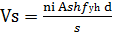 (1)

where n_{i} is the number of hoop legs, and A_{sh} is the cross-sectional area of transverse bar. The volumetric reinforcement ratio can be expressed in terms of the area of the bars A_{sh}, the width and height of the column core (b_{w} and d), and the spacing of the transverse reinforcement, s. substituting the relationship between reinforcement ratio and area of transverse bar into Eq.(1), the shear strength can be expressed in term of the volumetric reinforcement ratio(ρ_{vol}) as:

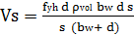 (2)

The minimum amount of confinement necessary to develop yielding of the column was determined based on the difference between the total shear demand and the shear strength provided by the concrete(V_{c}):

ρ_{vol} 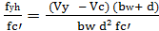 (3)

The shear strength V_{c,} for concrete shall be computed by ACI Code 11.3.1 to determine amount of confinement needed to develop yielding of the columns:

b_{w} d (4)

and
b_{w} d (5)

The nominal shear strength computed by:

V_{n} = V_{c} + V_{s} (6)

Experimental Program:
All the columns were 1200mm long and 200x200 mm cross-section. The longitudinal reinforcement ratio was 0.0135 with four bars at the corners of the cross-section. The transverse
steel ratio and other parameters for the twelve columns are given in Table 1. The columns were tested in the apparatus shown in Fig. 1.

Table 1- Specimens designations, axial loads, longitudinal and transverse steel
Columns  Designations | Lateral reinforcement | ρs% | fy  MPa | Longitudinal reinforcement |  | ρl% | fy  MPa | Fiber volume  Vf% | N/Agfc´
C1 | Ø6mm@60mm | 0.450 |  | 4 Ø 12mm |  | 1.35 |  | 0% | 0.1
C2 | Ø6mm@60mm |  |  | 4 Ø 12mm |  | 1.35 |  | 1% | 0.1
C3 | Ø6mm@100mm | 0.282 |  | 4 Ø 12mm |  | 1.35 |  | 0% | 0.1
C4 | Ø6mm@100mm |  | 350 | 4 Ø 12mm |  | 1.35 | 420 | 1% | 0.1
C5 | Ø6mm@140mm | 0.202 | 350 | 4 Ø 12mm |  | 1.35 |  | 0% | 0.1
C6 | Ø6mm@140mm |  |  | 4 Ø 12mm |  | 1.35 |  | 1% | 0.1
C7 | Ø6mm@160mm | 0.177 |  | 4 Ø 12mm |  | 1.35 |  | 0% | 0.1
C8 | Ø6mm@160mm |  |  | 4 Ø 12mm |  | 1.35 |  | 1% | 0.1
C9 | Ø6mm@180mm | 0.157 |  | 4 Ø 12mm |  | 1.35 |  | 0% | 0.1
C10 | Ø6mm@180mm |  |  | 4 Ø 12mm |  | 1.35 |  | 1% | 0.1
C11 | Ø6mm@200mm | 0.141 |  | 4 Ø 12mm |  | 1.35 |  | 0% | 0.1
C12 | Ø6mm@200mm |  |  |  | 4 Ø 12mm | 1.35 |  | 1% | 0.1

N= axial load, Ag= gross area, fc′= concrete compressive strength, deformed bars
The transverse load (lateral load) was applied at a point in the middle height of the column according to load ratio controlled schedule shown in Fig. 3. The lateral load was applied gradually, realizing as much as possible cyclic loads. The elastic and inelastic cycles were conducted for increasing lateral load level in relation to the maximum load P, with three repeated cycles at each load level. The center to center distance between supports was 1000mm. The axial load(N) was applied through steel plates fitted at the ends of the column by a hydraulic jack as shown in Fig. 1. Curvatures were measured by five demec gauges on each side of the column (left and right sides), perpendicular to the direction of load application through the length of the column. The measurements were taken in both the pure moment region and the shear span. During each test, the column axial load which was about 50-72 percent of the maximum axial load (≤ 0.1 Ag fc') remained constant. The lateral load (P) was calculated from nominal flexural strength of the section. The tie spacing, S, and the total area of transverse bars A_{sh} were calculated according to ACI code 318-08(21.4.4.1b) and then modified as (S±30%) as shown in Table 1 for research need.
Hydraulic jack
Dial gauges
Steel pin reaction

Steel plate

Fig. 1- Testing Apparatus
Construction of test Specimens:
- Experimental Elements
Twelve reinforced concrete columns were constructed and tested. The configuration of these specimens is shown in Fig.2, the dimensions and reinforcement details are presented in Table 1. The tie spacing were done according to ACI Code(318-08) and verified with Nige1994, and Graig 1979. All the ties were bent with an angle of 135 degrees and anchored in concrete core to approximately 60 mm long. The ends of the columns were provided by steel plates of 4mm thickness and fixed by two anchorage bars of 80 mm length and 90 degrees hooked end, which extend in column core to 40 mm length to prevent undesired failure due to axial compressive stresses. The specimens were cast upright to simulate construction procedure in the field.

Ø10mm 4Ø12

200 200 200

200 1200 80

Fig. 2 -Details of specimen Configurations

Six cubes of 150x150x150 mm were cast for each column. Three cubes used to determine the compressive strength after 28 days and the other three used to fix the compressive strength on the day of test. Also, six cylinders were cast three of dimensions (100x200)mm to determine the tensile strength and the other three of (150x300)mm to determine the modulus of elasticity.

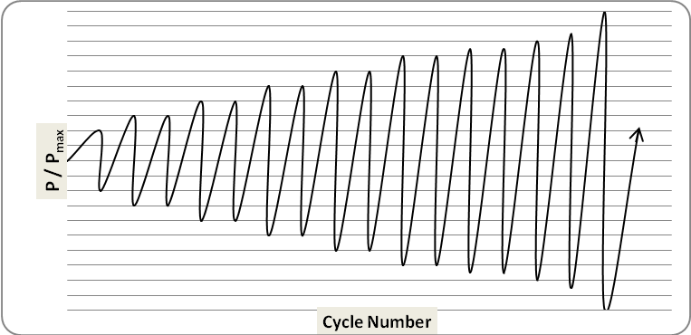

Fig.3- loading history

Materials Used:
Standard tests according to the specifications of ASTM, and Iraqi specifications IQS-No.45/1984, were conducted to determine the properties of materials used in this work. The cement used was ordinary Portland cement. The fine aggregate has a fineness modulus of 2.74 was obtained by sieving and washing by clean water several times. The coarse aggregate was rounded gravel with relative density of 2.65. The grading of these aggregates was according to IQS- No.45and 5/1984 as shown in Tables 2-4.
The concrete used in this work was normal strength concrete with and without steel fibers. Concrete was designed to give a compressive strength of 21 MPa at 28 days without fibers inclusion and 25 MPa for fiber reinforced concrete with 1% fiber content by volume. The normal strength concrete mix proportion by weight which was used throughout this study is 1:1.5:2.55.(cement: fine aggregate: coarse aggregate). Gilenuim 51 was used as superplasticizer(SP) in mixes with steel fiber to maintain a workable mix.
Table 2 Grading of Fine Aggregate
Iraqi specification No. 45/1984 for Zone(3) | Passing % | Sieve Size
90-100 | 99.15 | 4.75 mm
85-100 | 92.30 | 2.36 mm
75-100 | 81.20 | 1.18 mm
60-70 | 64.96 | 600 μm
12-40 | 26.50 | 300 μm
0-10 | 5.12 | 150 μm
 | 0 | Pan
≤ 0.5 | 0.26 | Sulfate content SO3%
- | 0.26 | Specific gravity
- | 1.6 | Absorption
Table 3 Grading of Coarse Aggregate
Iraqi specification No. 45/1984 | % Passing | Sieve Size
90-100 | 100 | 14 mm
50-85 | 81.57 | 9.5mm
0-10 | 9.65 | 5mm
- | 0 | Pan

Properties | Test results | Iraqi specification No. 45/1984
Sulphate content,  SO₃ (%) | 0.08 | ≤ 0.5
Specific gravity | 2.64 | -
Absorption (%) | 0.8 | -

Table (4): Physical properties of the cement
Physical Properties | Test Results | Iraqi specification No. 5/1984
Fineness ( Blain )(m²/kg) | 345 | ≥ 250
Soundness using autoclave method | 0.15% | ≤ 0.8%
Setting time using Vicat’s instruments  Initial(min.)  Final(hr) | 115  4.5 | ≥ 45 min  ≤ 10 hr
Compressive strength for cement Paste at:  3days(MPa)  7days(MPa) | 21  29.8 | ≥ 15  ≥ 23

The average compressive strength obtained with 0% fiber content is 27.0 MPa and equal to 37.0 MPa with 1% by volume fiber content at 28 days( day of test).
Test Results and discussion:
The recorded ultimate loads, first crack loads, and modes of failure of these columns are presented in Table 5. In specimens C11, C12, and C9, inclined cracks observed. These cracks extend through both sides of the load point starting with second cycle of loading for columns C11 and C9 while, they start at third cycle for column C12, due to the presence of steel fibers. Specimens C11 and C9 have explosive failure(see Appendix B), while C12 (1% V_{f}) has lenient failure. The shear capacity of column C12 was increased by 14% than column C11 due to fiber inclusion.
Table 5- Loads, dissipated energy and failure modes of columns tested.

Column  No. | fcʹ  MPa | First visible crack |  | yielding load  kN | Dissipated  Energy  kN.m  (DE) | Mode of failure | N/Agfcˊ on the day of test
Column  No. | fcʹ  MPa | Load  kN | Crack  Width mm
C1 | 29.5 | 62 | 0.1 | 73.5 | 87.2 | Flexure failure | 0.118
C2 | 37.2 | 70 | 0.03 | 80.5 | 133.9 | Flexure failure | 0.097
C3 | 28.9 | 50 | 0.05 | 62.5 | 74.0 | Flexure failure | 0.124
C4 | 32.0 | 60 | 0.03 | 70 | 106.8 | Flexure failure | 0.113
C5 | 26.0 | 40 | 0.10 | 65 | 45.8 | Shear-Flexure failure | 0.138
C6 | 37.0 | 55 | 0.08 | 68.5 | 62.3 | Flexure failure | 0.097
C7 | 27.0 | 35 | 0.03 | 59 | 44.1 | Shear failure | 0.133
C8 | 33.4 | 45 | 0.05 | 67 | 49.1 | Flexure failure | 0.108
C9 | 27.4 | 10 | 0,02 | 57 | 21.0 | Shear failure | 0.131
C10 | 33.2 | 20 | 0.05 | 62.5 | 32.1 | Flexure failure | 0.108
C11 | 27.4 | 12 | 0.12 | 50 | 15..1 | Shear failure | 0.131
C12 | 35.1 | 15 | 0.05 | 65 | 25.0 | Shear failure | 0.103

In all specimens C10 and (C8 to C1) a flexural cracks observed first. The cracks propagate towards the loading point and one main flexural crack caused the collapse of the specimens, although some shear cracks appeared during the test( see Appendix B). In specimens C5 and C7 the flexural cracks became inert or extend slowly as the intensity of the transverse load increased, whereas the shear cracks became more large and the specimens collapse(see Table 5).
Fig.4a and b shows the monotonic envelope for some of the specimens subjected to cyclic loading. The envelopes were formed by connecting the turning points that occurred during the first cycle of each load level. These envelops have three break points: (1) first crack point ,(2) yield point, and (3) failure point. The yield displacement was determined by observing a flattening of the plot of the applied load versus load point displacement. These envelopes resemble the curves of the tested specimens.
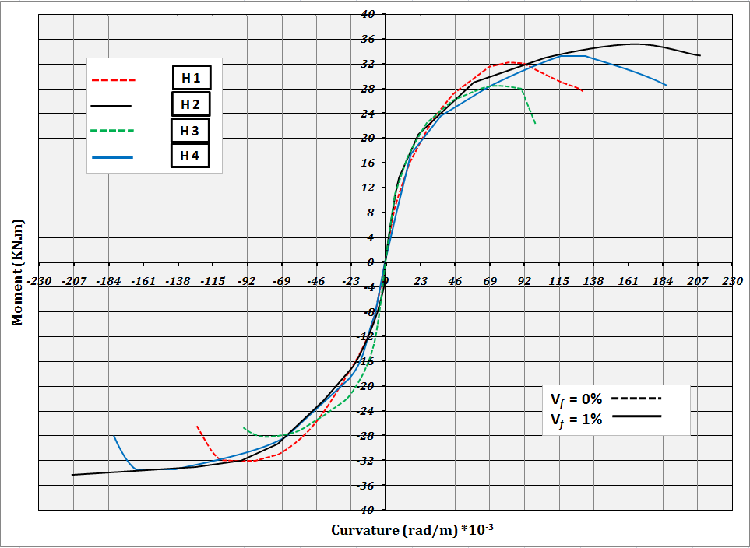
C1
C2
C3
C4

a-
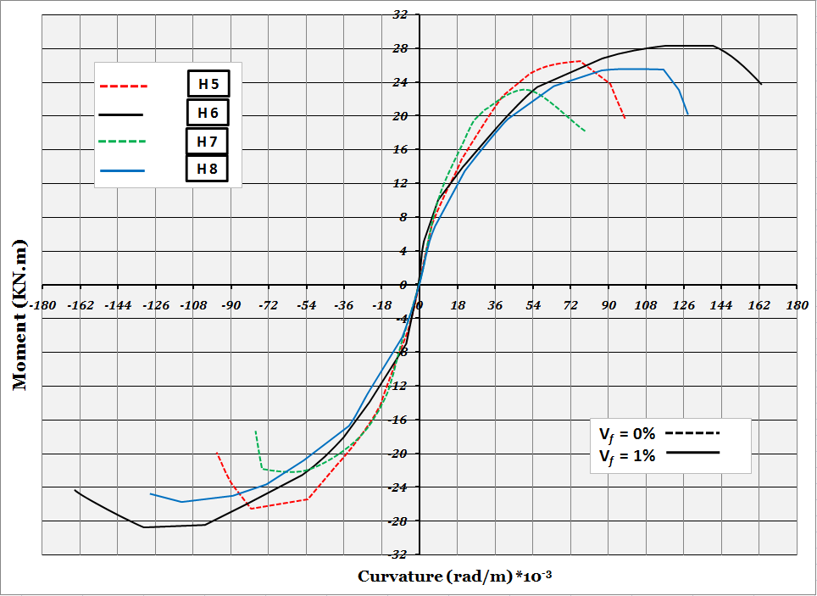
C5
C6
C7
C8

b-
Fig. 4 Moment-curvature envelopes for some of specimens in the pure moment region
Lateral Reinforcement:
The transverse reinforcement in the column is needed to resist the shear forces and provide confinement for concrete core of the column. The presence of steel fibers also enhances the confinement.
The major benefit of steel fibers is to increase the shear resistance and ductility of the members. They eliminate the sudden and brittle failure mode and transformed it to a ductile mode of failure associated with significant warning near the maximum applied load and more absorbed energy. The steel fibers not only delay the spalling of the cover concrete but also control the growth and widening of the cracks.
Reducing the tie spacing from 200mm in column C11 to 60 mm in column C1 the shear resistance increased about 51 percent and by adding steel fibers (1% V_{f}) to column C2 the shear strength increased about 53% with respect to column C12. Specimen C4 failed by the development of flexural cracks and spalling of concrete cover due to yielding of longitudinal reinforcement at 132 kN. Although, the cracks width was smaller as compared with C3 but it is difficult to quantify effect of steel fibers on reducing of concrete spalling during the test.
The addition of steel fibers (V_{f}=1%) to columns shown in Table 5 increases the shear resistance between 5 to 20 kN depending upon the amount of lateral reinforcement.
From the test specimens the effect of steel fibers appears to be significant at low and moderate load intensities whereas this effect reduced at high loading rate. This probably that, most of fibers will be pulled out at this stage. However, the effect of steel fibers also reduced with very closed hoop spacing due to confining effect which delay the crack propagation and dilation of concrete core. A considerable increment in the strength capacity obtained through the addition of steel fibers and reducing the tie spacing.
From Table 6, columns with high amount of lateral reinforcement ratio(C1, C3,and C5) exhibited a large displacement ductility 6.05, 4.70, and 4.04 respectively whereas, columns C2, C4, and C6 which have the same lateral reinforcement ratio as in previous columns with 1% fiber inclusion by volume perform a ductility of 8.17, 5.89, and 4.75 respectively. The enhancement in ductility was 35%, 25% and 20% . However, columns with steel fibers inclusion exhibited a ductile performance even with small ratio of lateral reinforcement, while columns with insufficient lateral confinement and without steel fibers showed a brittle behavior due to quick development of cracks. The ductility can be calculated by the following equation
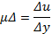 (7)

Increasing the amount of the lateral ties with the addition of steel fibers were very effective in reducing the strength degradation caused by axial load , due to the increase of confinement produced by the ties on the longitudinal bars which delayed its yielding and reduced its deformation. Also the enhancement of confinement provided to the concrete core of the column by the increased number of ties or increased number of hoops with steel fibers inclusion leads to increase the concrete compressive strength.
The cracks were measured by using crack meter of accuracy 0.01 mm. Appendix C shows that the development of cracks and scaling of cover concrete of specimens without fibers was more than in specimens with steel fibers due to the confinement effect applied by both steel fibers and ties. Moreover, reducing the distance between ties increases the confinement of concrete core and caused an enhancement in the displacement(significantly after the first cracks). However, it is evident from the test observations that, the inclusion of steel fibers plays an important role in resisting the crack propagation, increasing the spalling resistance of the cover concrete , and also increasing the absorbed energy of the member.
Table 6 Summery of experimental results
Col. Disg. | S  mm | V_{f}  % | FCL  kN | FCW  mm | P Max (kN) |  | P_{Exp}  P_{theo} |  | Δ_{u}  mm | A_{y}  mm | µ_{Δ} | DE  kN.m |  | Increasing  %
 |  |  |  |  | Exp. | Theo |  | % | Δ_{u}  mm | A_{y}  mm | µ_{Δ} |  | µ_{Δ}(V_{f}=1%) | µ_{Δ}(V_{f}=0%) | DE
C1 | 60 | 0 | 10 | 0.12 | 172 | 169 |  | 1.04 | 121 | 2.0 | 6.05 | 87.2 | ------ | 29 | ----
C2 | 60 | 1 | 15 | 0.05 | 188 | 177 |  | 1.06 | 14.7 | 1.8 | 8.17 | 133.4 | 35 |  | 53
C3 | 100 | 0 | 10 | 0.05 | 130 | 127 |  | 1.02 | 12.7 | 2.70 | 4.70 | 74.0 | ----- | 16 | -----
C4 | 100 | 1 | 20 | 0.03 | 140 | 135 |  | 1.04 | 11.2 | 1.9 | 5.89 | 106.8 | 25 |  | 44
C5 | 140 | 0 | 35 | 0.03 | 98 | 106 |  | 0.92 | 8.0 | 1.8 | 4.04 | 45.8 | ----- | 15 | -----
C6 | 140 | 1 | 45 | 0.05 | 115 | 114 |  | 1.01 | 9.0 | 1.9 | 4.85 | 62.3 | 20 |  | 36
C7 | 160 | 0 | 40 | 0.10 | 90 | 103 |  | 0.87 | 5.6 | 1.60 | 3.50 | 44.1 | ----- | 28 | -----
C8 | 160 | 1 | 55 | 0.08 | 100 | 111 |  | 0.90 | 6.7 | 1.75 | 3.93 | 49.1 | 12 |  | 11
C9 | 180 | 0 | 55 | 0.02 | 96 | 99 |  | 0.97 | 4.8 | 1.78 | 2.73 | 21.0 | ----- | 28 | -----
C10 | 180 | 1 | 45 | 0.05 | 105 | 107 |  | 0.98 | 5.3 | 1.50 | 3.53 | 32.1 | 29 |  | 41
C11 | 200 | 0 | 50 | 0.03 | 88 | 96 |  | 0.91 | 4.25 | 2.00 | 2.13 | 15.1 | ----- |  | -----
C12 | 200 | 1 | 60 | 0.05 | 100 | 103 |  | 0.97 | 5.1 | 1.89 | 2.70 | 25.0 | 26 |  | 66

Conclusions
- Addition of steel fibers with V_{f} = 1% increased ductility of the specimens by (12%-35%), therefore, steel fibers was able to change the mode of failure from brittle failure to a ductile failure. However, the effect of steel fiber decreased as the amount of confinement and compressive strength of concrete increased.
- It is noted that strengthening of normal strength concrete columns by steel fibers resists the crack propagation, decreases the crack width, and changed the formation of cracks.
- The use of steel fibers has significant effect on shear resistance more than flexural; it's noticed that addition of SF increased shear resistance by about 9- 17%, while, the absorbed energy by about 11- 66% greater than needed to deform a similar columns made from ordinary reinforced concrete to the same load level.
- First crack strength was higher for columns containing fibers compared with columns strengthed by stirrups only. This can lead to the advantage of using steel fibers for repair of deffected members.The spalling of concrete cover for columns containing fibers was small enough to be egnored, and the amount of cracking was reduced considerably compared with coventionally reinforced columns.
- From columns tested, it can be concluded that some amount of confining reinforcement (ties) can be replaced by the addition of short, randomly oriented steel fibers. It’s noticed that steel fibers could replace about (10-20) % of lateral steel reinforcement (ties).
- The moment- curvature relationship of the tested columns has three distinct break points: at the first tension crack, at yied and at failure.
References:
ASTM C78-84 : C496-86: C469-87a, Annul Book of ASTM Standard.
AL-Jeabory,J,1993,." Fracture and Acoustic Emission Studies on Steel Fiber Reinforced Concrete." PhD Thesis, University of Wales, Cardiff, UK.

Corinaldesi, V. and G. Moriconi,2003, "Durable Fiber Reinforced Self- Compacting Concrete"Department of Materials and Environmental Engineering and Physics, Marche Polytechnic University, Ancona, Italy
Efe, E. I. and Musbau A. S. ,2011, "Effect of Short Steel Fibre Reinforcement on Laterized Concrete Columns" Faculty of Engineering, University of Lagos Akoka, Yaba, Lagos, Nigeria, ACI Structural Journal, Vol. 4, No. 1, February

ERMCO –,2005, The European Ready Mix concrete Organization "Improving the durability of concrete structure, pp1-4

Graig, 1979, " Fibrous concrete Columns" Journal of Structural Engineering, PP 72- 76.

Ganesan N. and Ramana J. V.,1990, "Strength and Behavior of Confined Steel Fiber Reinforced Concrete Columns" ACI Materials Journal, V. 87, No.3, May

Gebman, M., 2001,“Application of Steel Fiber Reinforced Concrete in Seismic Beam- column Joints”, M.Sc. Thesis, San Diego State University, USA

Gencoglu, M. and Eren, I. ,2002, "An Experimental Study On The Effect Of Steel Fiber Reinforced Concrete On The Behavior of The Exterior Beam-Column Joints Subjected to Reversal Cyclic Loading", Istanbul Technical University, Civil Engineering Faculty, Division of Structure, February .

Hadi, M.N.S.,2009,"Reinforcing Concrete Columns with Steel Fibers" School of Civil and Environmrntal Engineering, University of Wollongong, Asian Journal of Civil Engineering (building and housing) V. 10, NO. 1 pp 79-95

Haider, AL-taii,2002,"Behavior of Fiber Reinforced Concrete Frame under Cyclic Loads". M.sc. Thesis University of Mosul, Iraq.
Hsu, L.S, and Hsu C.T, 1994,"Stress-strain behavior of steel fiber high strength concrete under compression", ACI Structural Journal, Vol. 91, No. 4, PP. 48-57

Iraqi Specifications No.5, 1984,"Portland Cement," and No. 45 "Natural sources for Gravel that is used in concrete and constraction" Baghdad, Iraq.
Jun, Z., Henrik S., and Victor C.,1971,"Fatigue Life Prediction of Fiber Reinforced Concrete Under Flexural Load" University of Denmark Lyngby, Denmark, University of Michigan, USA

Nan, S., Kung-Chung H., and His-Wen C.,2001,"A simple Mix Design Method for Self-Compacting Concrete" Department of Construction Engineering, National Yunlin University of Science and Technology, Taiwan
Nigel, M.J., Ravendra, V.,and Van Xiao,1994, "Seismic Shear Strength of Reinforced Concrete Columns" journal of Structural Engineering, Vol. 120, No.8, August
Parsadh, A. D. and Kumar, N. ,2005,"Experimental Study on the Behavior of Steel Fiber Reinforced Concrete", project report, Hindustan College of Engineering, ANNA University, Chennai, April
Peled, A, and Mobasher,B.,2005, "Pultruded Fabric-Cement composites", ACI Materials Journal, Vol.102, No.1, Jan-Feb. PP.15-23
Spadea, G. and Bencardino, F. ,1997 "Behavior of Fiber-Reinforced Concrete Beams Under cyclic loading",ASCE, Journal of Structural Engineering, Vol. 123, No.5, , PP 660-668.

Surendra, P.S.and JamesI. D.,1974,"Design Considerations for Steel Fiber Reinforced Concrete". Reported by ACI Committee 544
Swamy, R. M., Mangat P. S., and Rao C.V.,1974,“The Mechanics of Fiber Reinforcement of Cement Materials”, Fiber Reinforced Concrete, ACI SP-44 Detroit, Michigan, pp. 1-28,

Ziad, B. and Michael G.,2002,"Reduction of Lateral Reinforcement in Seismic Beam-Column Connection via Application of Steel Fibers" ACI Structural Journal, V. 99, No. 6, December .
Appendix A Notation
A = energy absorbed
FCL = first crack load
FCW = first crack width
N = axial load
P = lateral cyclic load
S = tie spacing
V_{f} =fiber volume fraction
Δ = displacement in mm
µΔ = ductility of the column
V_{y} = shear strength to develop yielding of the column
V_{c} = shear strength provided by cooncrete
b_{w} = width of column specimen
d = effective depth is approximetly equal to height of concrete core.
fc′ = concrete compressive strength
Vn = the nominal shear strength

Appendix B

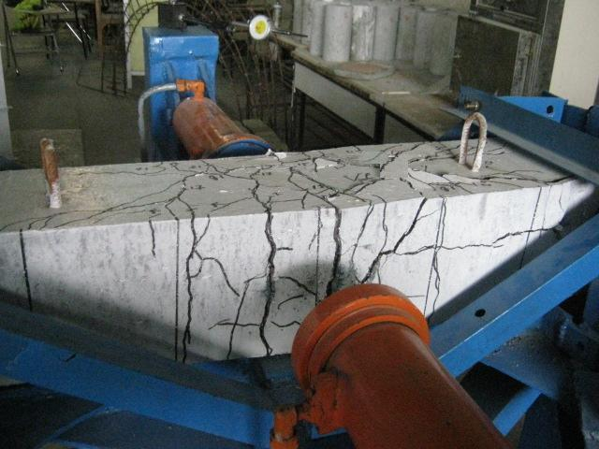

Failure of columnC8
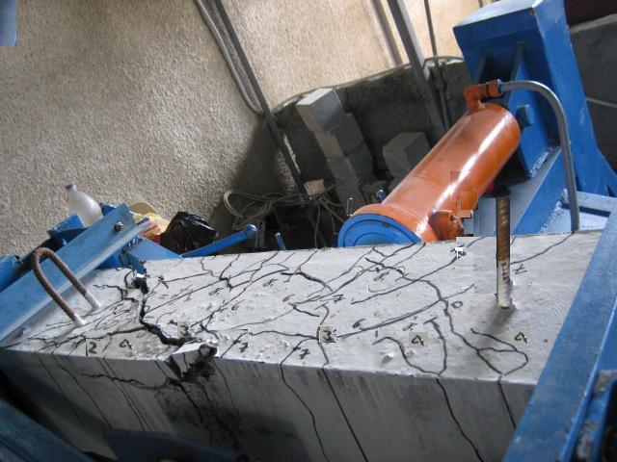
Failure of columnC7
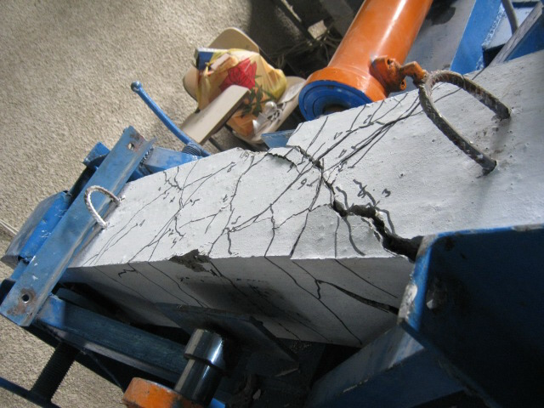
Failure of specimen C9
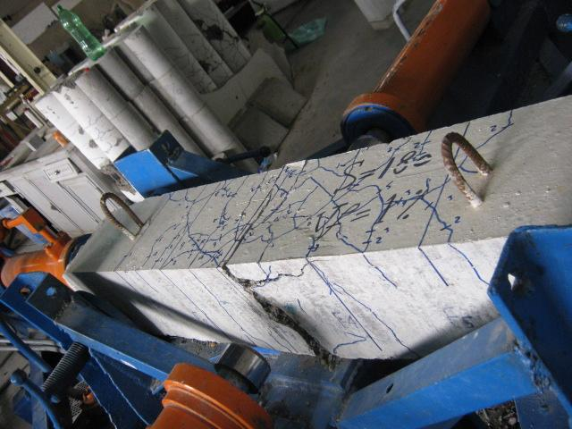
Failure of specimen C10

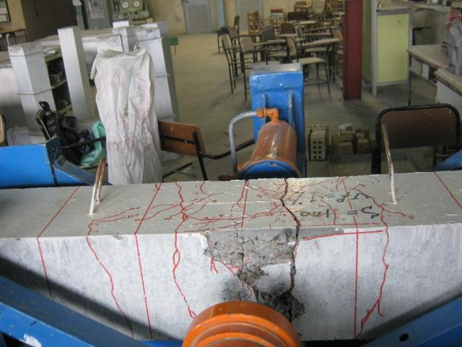
Failure of specimen C4

