Behavior of Customary Jack-Arch Slabs in
South of Iraq

Sa'ad Fahad Resan Abbass Oda Dawod
Civil Engineering Department - Engineering College
University of Misan, Amarah
sadresan@uomisan.edu.iq. abbasoda03@yahoo.com
Absract:
Jack arch slabs are brickwork arches supported by steel beams. Jack arch slabs have long been used extensively to floor and roof houses in Iraq especially in the middle and south. Due to their easy construction together with low cost, the jack-arch slab is still widely used in Iraq and many countries. Static tests were conducted to determine the effect of span width and camber configuration on mechanical properties of brickwork arch specimens. The relative weakness of this type of ﬂooring highlighted the need for developing appropriate retroﬁtting schemes. Strengthening jack arch by ferrocement layer has been introduced. The strength, load –displacement relationship and failure modes of jack arch specimens were presented. The test results indicated that the composite action between jack arch slab and ferrocement layer highly improved flexural strength, stiffness and ductility without considerably increases the weight of the slab.
Key Words: Jack arch, camber, Ferrocement, Brickwork, Clay bricks and Gypsum mortar.
الخلاصة
تعرف سقوف الاقواس المرفوعة بانها تشكيل من اقواس البناء بالطابوق المستندة بواسطة جسور من الحديد (تعرف هذه السقوف محليا بالعقادة). يستخدم هذا النوع من السقوف بصورة واسعة لانشاء سقوف المنازل خصوصا في وسط و جنوب العراق. وبسبب سهولة انشائها بالإضافة لكلفتها الواطئة, يعتبر هذا النوع من اكثر الأنواع شيوعا و انتشارا في العراق وفي الكثير من البلدان الأخرى. ورغم الشيوع والأهمية النسبية لهذا النوع من الانشاء لعموم المجتمع العراقي لارتباطة بالكلفة الواطئة, لا توجد دراسة واضحة متعلقة بالتحليل الانشائي لهذا النوع من السقوف.تم اجراء فحوص مختبرية لبيان تاثير عرض الفضاء وكذلك تاثير التقوس على الخصائص الميكانيكية لنماذج من سقوف الطابوق المرفوعة. وتم تحليل نماذج مقواة بواسطة الفيروسمنت لبيان إمكانية تطوير التحمل الانشائي لهذا النوع من السقوف المعروف بالضعف نسبة لسقوف الخرسانة المسلحة. و تم استعراض و تحليل النتائج المختبرية المتمثلة بقيم التحمل و علاقات الاحمال مع الازاحات بالإضافة لانماط الفشل. وبينت النتائج المختبرية ان فعالية التركيب مع الفيروسمنت قد حسن مقاومة الانثناء, الجساءه, و المطيلية بصوة فائقة بدون زيادة معتبرة في الوزن.
الكلمات المفتاحية: قوس مرفوع, تقوس, فيروسمنت, انشاء بالطابوق, الطابوق الطيني, و مونة الجص.
1. Introduction
The traditional steel I-beam, jack arch flooring system was developed in Britain towards the end of nineteenth century and was used extensively to cover large floor areas in factories and other industrial buildings. The technique spread eastwards and, by the middle of the twentieth century, it became a popular flooring system in parts of East Europe, the Middle East and the Indian subcontinent. Due to its technical simplicity, speed in construction and low cost, traditional jack arch slabs are still very popular in the Middle East, where, not only industrial buildings and ordinary dwellings but also many high-rise steel and concrete framed buildings are floored by this method
(Maheri, et al., 2003). Plates (1) and (2) show historical mode and trendy style of brickwork arches construction.
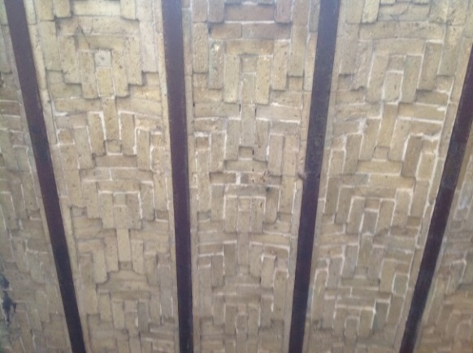
A-Jack arch slab of a heritage house, about 1830 B- Al Amarah city historical market, about 1871
Plate (1) Historical and traditional brickwork arching in Amara city, belong to nineteenth century
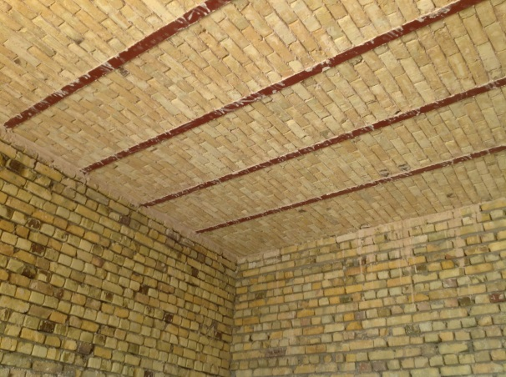
A-Before applying finishing layers B-After applying finishing layers
Plate (2) Customary jack arch brickwork slab in south of Iraq

The primary function of floor and roof systems is to support gravity loads and to transfer these loads to other structural members such as columns and walls ) Naeim
et al., 2001(.The floor slabs constructed using the steel I-beam jack arch system are stable under normal static conditions as the brick arches transfer the gravity loads, mainly in compression, along the arch to the supporting beams. The load is then transferred along the parallel steel beams to the supporting walls or beams. The geometric form of the steel I-beam jack arch system and the load path through the steel beams, make the slab act as a one-way system (Maheri et al., 2003). In 2012, Maheri conducted out-of-plane pushover tests on a number of full-scale ordinary and retroﬁtted jack arch slabs. Results of the tests are then used to compare the strength capacity and other seismic performance parameters of the slabs including; ductility and the behavior factor (Maheri et al., 2012). Many researches had been investigated the use of ferocement layer as strengthening technique for various structural elements. In 1998, Paramasivam reviewed methods of repair and strengthening of reinforcement concrete beams using ferocement laminated attached on the surface of the beams, the results showed that ferrocement is a viable alternative strengthening components for rehabilitation of reinforced concrete structures (Paramasivam et al., 1998).
2. Study scope
The study aims are to generate data and provide information about the structural behavior of the customary jack arch slabs used in south of Iraq by investigation the following tips;
1- No significant studies were related to the behavior of jack arching with solid clay brick units and gypsum mortar which represent the common materials used to manufacture it in south of Iraq.
2- For architectural requirements, the trendy configuration of jack arching tends to cancel the camber (brickwork flat slab instead of brickwork arch slab).
3-As the jack arch brittle construction due to their components brittleness (clay bricks and gypsum mortar), an improvement technique is introduced to upgrade its flexural strength, stiffness, and ductility by reinforcing cement matrix layer (traditional provided finishing layer) by steel wire mesh to be thin ferrocement layer (Naaman, 2000).
3. Experimental Investigation
3.1 Material Properties
3.1.1 Solid Clay Bricks and Gypsum Mortar
The brick arches in south of Iraq consists of local clay bricks joined together by a gypsum mortar. Gypsum is a very soft sulfate mineral composed of calcium sulfate dihydrate (CaSO_{4·}2H₂O).The gypsum mortar composed of gypsum mixed with water. It is one of the oldest known types of mortar in Iraq due to availability of its raw materials. It is the only mortar used for jack arch construction in Iraq because it sets hard and quickly. Clay bricks are the most commonly types of bricks in Iraq because of availability of raw materials, low cost of production, appropriate to bear the weight, heat isolation, resistance to fire and atmospheric changes, their standard dimensions are (240 mm x 115mm x 75mm) according to Iraqi specifications (Iraqi standard 25-2000)..
No data on the properties of this type of masonry were available. For this reason, Iraqi standard static tests were carried out on brick units and gypsum mortar Iraqi standard 25, 28-2000).. The tests of bricks and mortar are included mechanical and physical properties. For masonry unit (both bricks and mortar) the flexural bond strength between brick and mortar is investigated (Fouad 2005). Details of the tests are presented in Table (1) and shown in plate (3).The stress–strain relations for a number of brick and gypsum mortar samples are shown in Figure (1).
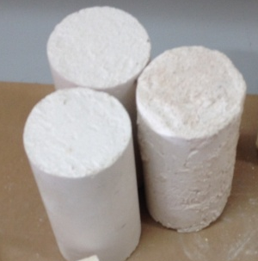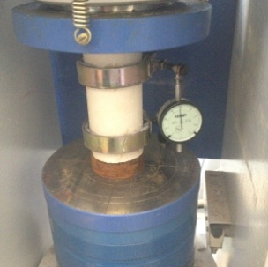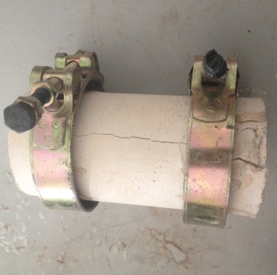
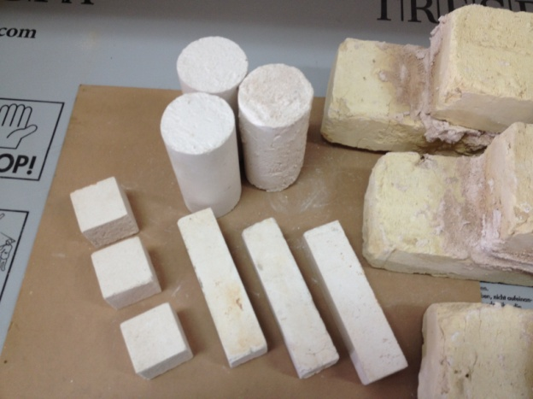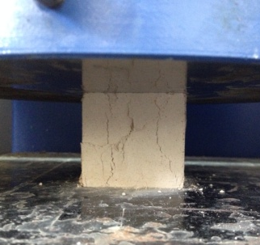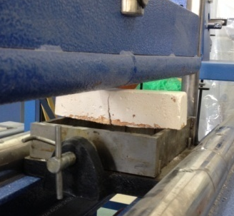
- Gypsum mortar tests
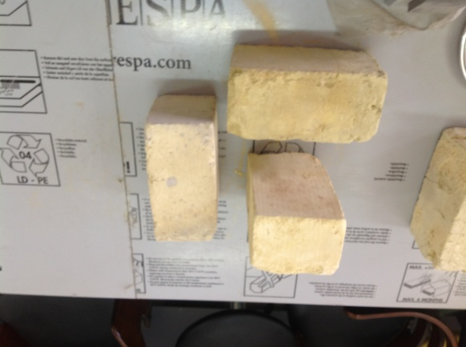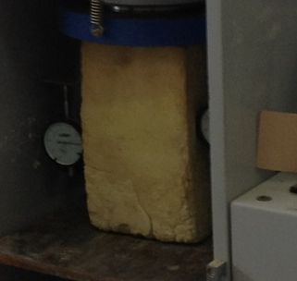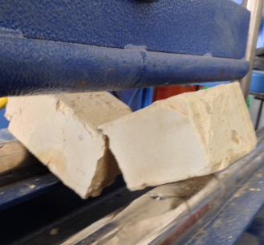
- Clay bricks tests
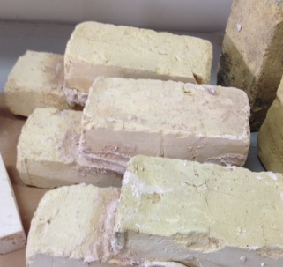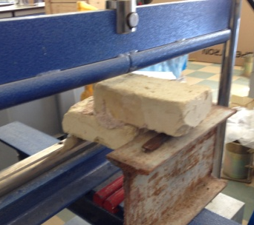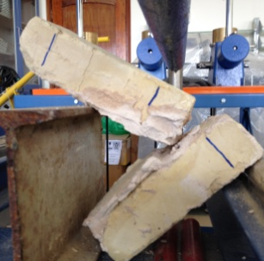
- Clay bricks - gypsum mortar bonding strength test
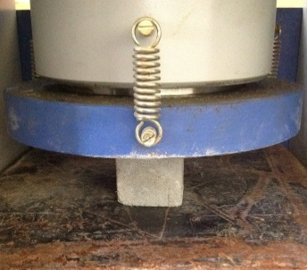 `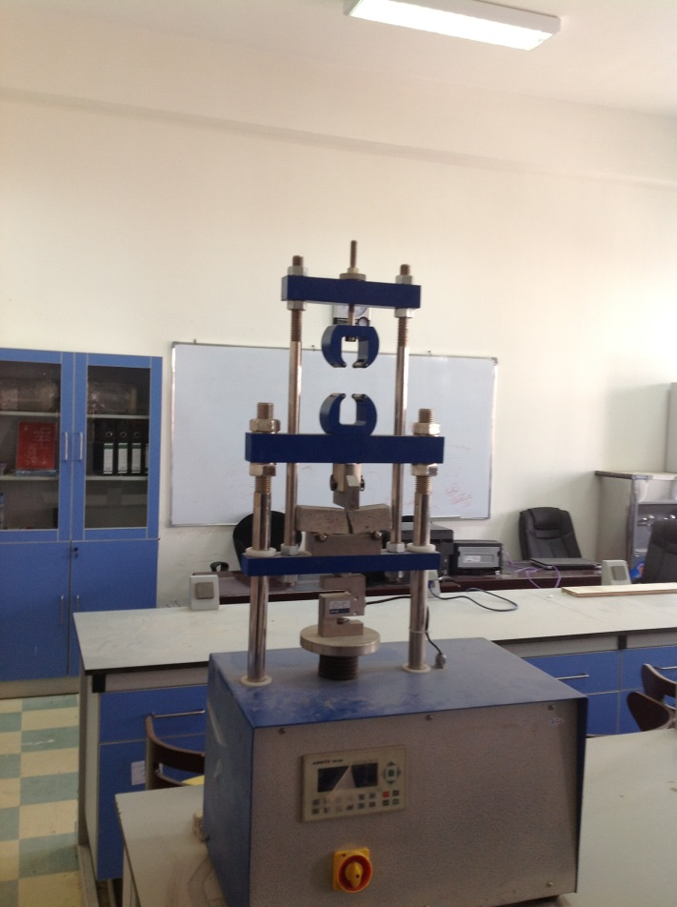 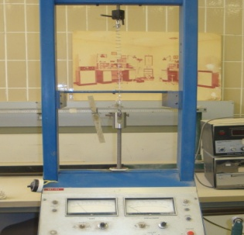
d- Ferrocement components tests (cement mortar an fabricated wire mesh)
Plate (3) Material properties tests
Table (1) Clay bricks and gypsum mortar properties
I- Solid clay bricks (Iraqi standard 25-2000)
Mechanical properties | Compressive strength (MPa) | Rupture modulus (MPa) | Young's modulus (MPa)
Mechanical properties | 7 | 2.04 | 700
Physical properties | Density (Kg/m3) | Water absorption (%) | Efflorescence
Physical properties | 1665 | 20 | light
II- Normal gypsum mortar (Iraqi standard 28-2000)
Mechanical properties | Compressive strength (MPa) | Rupture modulus (MPa) | Young's modulus (MPa)
Mechanical properties | 3 | 0.466 | 1000
Physical properties | Fineness* (%) | Setting time (minute) | Water ratio (%)
Physical properties | 6 | 15 | 38%
III- Tensile bonding strength** between clay bricks and gypsum mortar (Fouad 2005): 0.332 MPa
*Percentage of gypsum remains in sieve No. 16.
** Tensile bonding strength between clay bricks and gypsum mortar calculated by using new procedure introduced by Fouad and depending on experimental data of locally available bricks and gypsum.

3.1.2 Hydraulic Binder and Aggregate
The Portland Cement (PC) binder was used as the only hydraulic paste in ferrocement layer. The mixing procedure was according to mixing mortars specification (ASTM, C305-2003), the mixing ratio was 1:2 - 0.5, (cement: sand – water/cement ratio). Mortar compressive strength is 34.5 MPa and flexural strength is 4.5 MPa, they predicated by testing standard cubes (ASTM, C109-2003) and prism (BS, 1881-1983). Locally available natural silica sand was used as fine aggregate. Its grading conformed to Iraqi standard (Iraqi standard 45/2000).
3.1.3 Fabricated Wire Mesh FWM
Fabricated steel wire mesh of 12.5 mm square opening with average wire diameter of (1 mm) has been used in this investigation. Several tensile wire tested under direct tension by 5 kN capacity Bench-Top testing machine model BT-1000. The tensile coupons were prepared and tested (ACI Committee 549, 1R-1993).The yield strength and ultimate strength were 405 MPa and 600 MPa, respectively.
A- Solid clay brick B- Gypsum Mortar
C- Cement – sand mortar D- Fabricated wire mesh (FWM)
Figure (1) Stress –strain relationships of used materials in brickwork arches Fabrication

4. Test Specimens
The Experimental work consisted of two programs, the minor program which is described previously is concerned with physical and mechanical properties of used materials to supply sufficient information about local materials which are used to manufactured Jack arch slab in Iraq. The major program relates to testing one way brickwork arch specimens, six specimens are fabricated and experimentally investigated to highlight the effectiveness of panel width, camber and benefit of reinforcing finishing layer with fabricated wire mesh (providing ferrocement layer). A workable Gypsum mixture is used to bind units together and fill the gaps between them. Figures (2) and (3) show Jack arch slab configuration and anatomy laminated view of a brickwork specimen, respectively. The specimens are shown in Plate (4) while their details are summarized in Table (2).
Table (2) Specimens details*
No. | Specimen Designation | Target Parameter | Length (cm) | Camber (cm) | Fraction volume (%) | Width (cm)
1 | J 7-0-0 | Control specimen | 70 | 0 | 0 | 32
2 | J 9-0-0 | One way length effect | 90 | 0 | 0 | 32
3 | J 7-0-1 | Fraction volume effect |  |  | 1
4 | J 7-0-2 | Fraction volume effect | 70 | 0 | 2 | 32
5 | J 7-2-0 | Camber effect | 70 | 2 | 0 | 32
6 | J 7-5-0 | Camber effect | 70 | 5 | 0 | 32
* Designation; J i-j-k, where:
J Jack arch element
i length: 7 and 9 refer to 70 and 90 cm, respectively.
j camber: 2 and 4 refer to 2 and 5 cm, respectively.
k volume fraction of fabricated wire mesh (v_{r}): 0, 1 and 2 refer to 0 (no wire mesh layer), 0.124 (one layer), and 0.248 (two layers), respectively.
The volume fraction of fabricated wire mesh is the ratio of volume of reinforcement to the volume of composite. When the same square wire mesh is used throughout the depth of ferrocement element, the volume fraction of ferrocement can be calculated by the following formula (Naaman 2000); v_{r} = .
Where; N = number of layers of mesh
d_{w} = diameter of mesh wire
D ₌ distance center to center between wires
h = thickness of ferrocement element

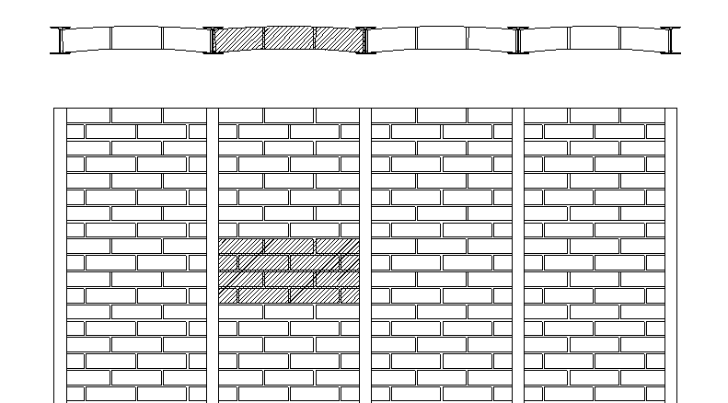
I steel section

Brickwork

In front view

Tested specimen

Top view

Figure (2) Jack arch slab configuration

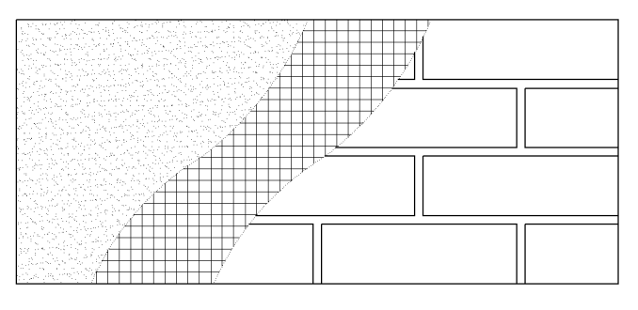
Ferrocement layer:
- Fabricated steel wire mesh embedded in;
- cement sand mortar
Brickwork
- clay bricks jointed by;
-gypsum mortar

Figure (3) Anatomy laminated view of a specimen

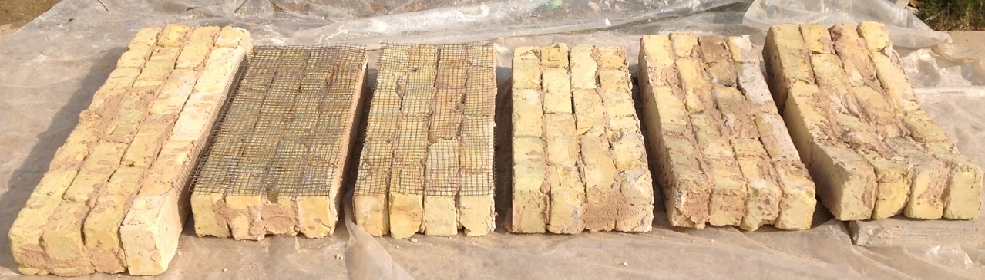
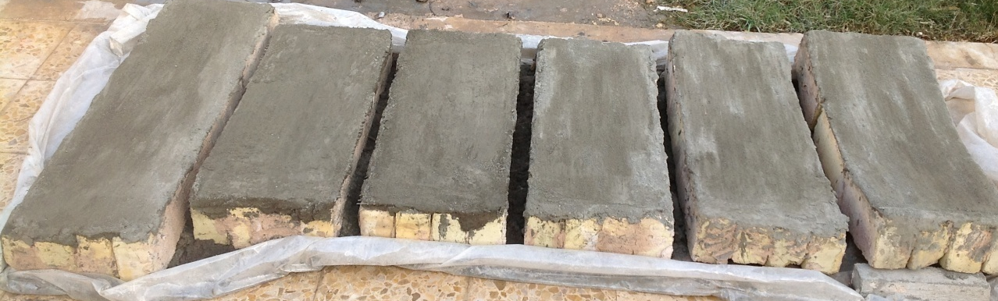
J 9-0-0 J 7-0-2 J 7-0-1 J 7-0-0 J 7-2-0 J 9-5-0

Plate (4) Specimens details

5. Testing Procedure
All one way brickwork arch elements were tested under three-point bending. Load was applied in equal increments and maintained constant at each load level (rate of loading = 10 kg/sec) at the mid-span of the slab using a hydraulic jack having a capacity of 10 Ton. The slab was supported on two steel rods. Dial gauge was placed on the mid-points of mid span of the slab to measure the deﬂection while a calibrated load cell was used to record the load. Plate (5) shows a photograph of the test arrangement.

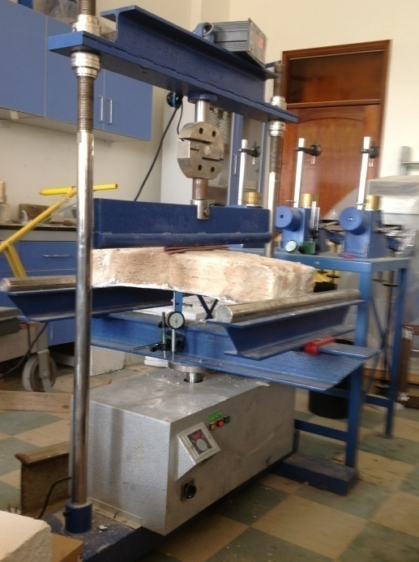
Plate (5) Test setup
6. Test results
The effectiveness of panel width (specimen length), camber and ferrocement strengthening technique upon specimen's strength, deflection and flexural ductility are illustrated in this section and summarized in Table (3).
Figure (4) illustrates load versus midspan deflection curves for specimens with 0.7 m and 0.9 m length and without camber or ferrocement strengthening. These curves reveal that the strength and stiffness are highly improved. As the panel width decreased by 22%, the strength is doubled. Slightly effect indicated on ductility. The midspan deflection changes from 1.184 mm to 1.3 mm for the same specimen length decrease ratio.
Table (3) Test result
No. | Specimen Designation | Ultimate load, P (kN) | P/P_{J7-0-0} | Midspan deflection at ultimate load, D (mm) | D/D _{J} ₇₋₀₋₀ | Service load* (kN) | Mid-span deflection at service load (mm) | Flexural ductility**
1 | J 7-0-0 | 3.358 | 1 | 1.184 | 1 | 2.238 | 0.85 | 1.086
Panal width effect
2 | J 9-0-0 | 1.637 | 0.487 | 1.3 | 1.098 | 1.091 | 0.8 | 1.057
Ferrocement strengthening effect
3 | J 7-0-1 | 9.443 | 2.812 | 4.202 | 3.549 | 6.295 | 1.125 | 4.457
4 | J 7-0-2 | 9.8 | 2.918 | 3.6 | 3.041 | 6.53 | 1.1 | 3
Camber effect
5 | J 7-2-0 | 3.554 | 1.058 | 0.82 | 0.693 | 2.37 | 0.47 | 1.5
6 | J 7-5-0 | 3.981 | 1.186 | 0.64 | 0.541 | 2.654 | 0.32 | 2.14
* Service load = (2/3) Ultimate load
** Flexural ductility is the ratio of deflection at ultimate load to deflection at the end of linear region.
Figure (4) Panel width effect upon strength and variation of mid-span deflection with applied load for jack arch specimens without camber or ferrocement layer

Figure (5) illustrates load versus midspan deflection curves for specimens with different camber crown 0, 2 cm and 5 cm, respectively. These curves reveal that the stiffness is highly affected by camber while humble effect indicted up on strength and ductility. The stiffness increase ratio ranged between 2.01 and 2.87, while the strength increase ratio ranged between 1.058 and 1.186 when camber changed from 0 to 2 cm and 5 cm, respectively. Mid span deflection reduction is observed, its ratios were 0.69 and 0.541 for the same changing of camber. An improvement is indicated for flexural ductility. They ranged between 1.5 to 2.14 for camber specimens with 2 cm and 5 cm, respectively, against 1.086 for no camber specimen.

Figure (5) Camber effect upon strength and variation of mid-span deflection with applied load for jack arch specimens

Figure (6) illustrates load versus midspan deflection curves for specimens with different fraction volume in ferrocement layer and without camber. These curves reveal that the strength, stiffness and ductility are highly improved for specimens strengthening by ferrocement. The strength increase ratio is 2.812 for specimen has 0.124 volume fraction, when fraction volume doubled, the upgrading of strength slightly affected as the ratio changed from 2.812 to 2.918. The overall load - deflection behavior changed, very good improvement is indicated for flexural ductility. They ranged between 3 to 3.25 for strengthened specimens with 0.124 and 0.248 volume fractions , respectively, against 1.086 for non-strengthened specimen. The ferrocement layer which is with full connection to slab provided sufficient constrain and eliminate brittleness problem which is a characteristic problem for brickwork. After the initiation of flexural cracks, the slab stiffness reduces and the linear load – deflection behavior vanishes when the internal steel wire mesh begins to yield.

Figure (6) Reinforced finishing layer (Ferrocement) effect upon strength and variation of mid-span deflection with applied load
7. Failure modes
There are two signification modes of failure. In specimens without strengthening (with or without camber), failure is characterized by brittleness and suddenly collapse of brickwork arch. For specimens strengthened by ferrocement layer, failure is characterized by the formation of cracks in the tension zone of the region under the applied load and yielding of wire mesh reinforcement accompanied by the propagation of cracks towards the compression zone. Under serviceability limit state conditions, no cracking is detected during the loading period. After the initiation of flexural cracks, the slab stiffness reduces. For strengthened specimens by ferrocement, the linear load – deflection behavior vanishes when the internal steel wire mesh begins to yield. Plate (6) clearly summarized assigned failure modes.
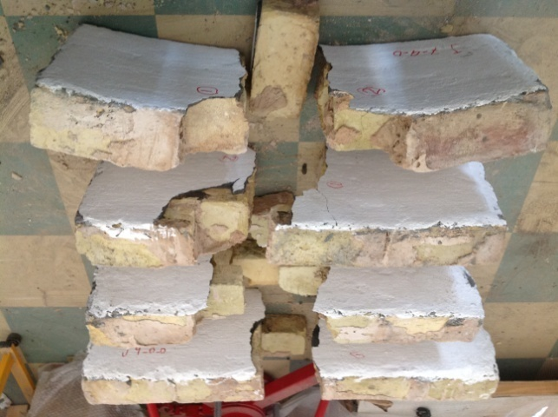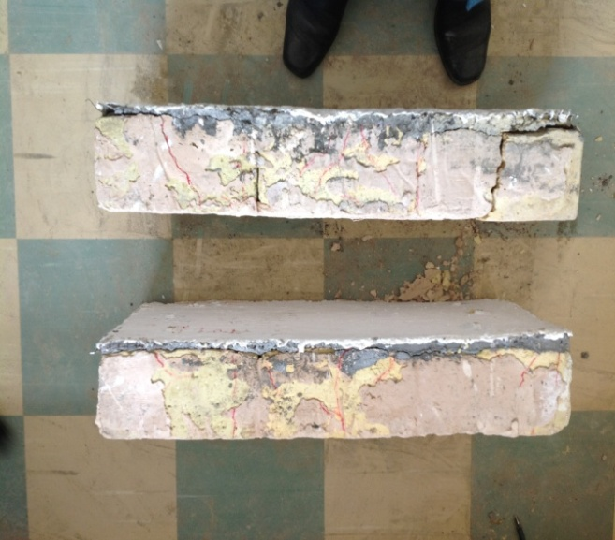
J 9-0-0 J 7-0-0 J 7-2-0 J 7-5-0 J 7-0-1 J 7-0-2
Plate (6) Failure modes

8. Conclusions
The most important conclusions that can be drawn from the present study are the followings:
1- The study reveals that slightly effect indicted up on strength and ductility in present of camber while the stiffness are highly affected. The stiffness increase ratio ranged between 2.01 and 2.87 , while the strength increase ratio ranged between 1.058 and 1.186 when camber changed from 0 to 2 cm and 5 cm, respectively.
2- Strengthening brickwork arches exhibited high increase of section capacity as compared with unstrengthened specimens. Although, the used ferrocement layer is thin (20 mm), and it adds about (44 kg/m2) for slab weight, the overall ductility, stiffness, and strength of the slab are increased with high ratio. The strength increase ratio is 2.812 for specimen has 0.124 volume fraction (one layer of wire mesh).
3- The ferrocement layer with full connection to slab provided sufficient constrain and eliminate brittleness and suddenly collapse problem which is a characteristic problem for brickwork arches.
4- Geometry of the slab is governed by the steel I- section beams spacing which are dominated the effective span length or panel width of jack arch slabs. The strength and stiffness are highly improved as the panel width decreased while slightly effect indicated on ductility. As the panel width decreased by 22%, the strength is doubled. Slightly effect indicated on ductility.
Acknowledgement:
The corresponding author would like to show his greatest appreciation, gratitude and highly indebted to his lovely young brother, murdered Muamal Fahad Resan who taught him how to give and inform him that the brotherhood is the life.
References:
ACI Committee 549, 1993 "Guide for the Design, Construction, and Repair of Ferrocement", ACI 549.1R-.
ASTM, American Society of Testing and Material, 2003 "Standard Test Method for Compressive Strength of Hydraulic Cement Mortars", C-109, West Conshohocken, PA.
ASTM, American Society of Testing and Material,2003"Standard Practice for Mechanical Mixing of Hydraulic Cement Pastes and Mortars of Plastic Consistency ", C-305, West Conshohocken, PA.
British Standard Institute, 1983 "Method of Testing Concrete", Part 118, BS - 1881.
Fouad, M., 2005 "New Test for Determination of Masonry Tensile Bond Strength", Journal of Materials in Civil Engineering, Vol. 17, No. 6, pp. 725–732.
Iraqi standard (25/2000).
Iraqi standard (28/2000)
Iraqi standard 45/2000.
Maheri, R. and Rahmani , H., 2003 "Static and seismic design of one-way and two-way jack arch masonry slabs", Engineering Structures No. 25, p.p 1639–1654.
Maheri, R., Pourfallah, S., Azarm, R., 2012"Seismic retroﬁtting methods for the jack arch masonry slabs", Engineering Structures No.36, pp. 49-60.
Naaman, A., 2000 "Ferrocement and laminated cementitious composites", University of Michigan, Michigan.
Naeim, F. and Boppana, R., 2001 "Seismic Design of Floor Diaphragms", Los Angeles, California.
Paramasivam, P.,1998 "Strengthening of RC beams with ferrocement laminated", Cement and concrete composites, No. 20, pp. 53-65.

