Appraisals of Environmental Sustainability Indicators of Diwaniya Wastewater Treatment Plant

Sahar Abdulkaream Altaee Mohammad .A. Alanbari
Babylon University, College of Engineering
profdr_alanbari@yahoo.com
Abstract
Sustainability has strong implications on the practice of engineering. Life cycle assessment (LCA) is an appropriate methodology for assessing the sustainability of a wastewater treatment plants. The present study used Simapro7 that structured on the principles of LCA, it used to analyze the impacts and damages of Diwaniya WWTP. The results of LCA show that Diwaniya WWTP was impact and damage on the environment 41.1 point per 1 cubic meter of wastewater, The most environmental impacts potential were global warming, respiratory inorganics and non-renewable energy. The study also showed that most of the effects were the result of the phase of construction more than operational phase.
Key Words: Sustainability, Wastewater Treatment, Environmental Indicators, Environmental Impact, Life Cycle Assessment (LCA).
الخلاصة
الاستدامة لها نتائجها القوية إذا طبقت في أي مجال هندسي. تقييم دورة الحياة يعتبر إطار منهجي ملائم لتقييم استدامة أنظمة معالجة مياه الصرف الصحي. الدراسة الحالية استخدمت برنامج سيما الإصدار السابع والذي منشأ ومرتب حسب مبادئ تقييم دورة الحياة, استخدم هذا البرنامج لغرض تحليل الآثار والأضرار الناجمة عن أنظمة معالجة مياه الصرف الصحي. نتائج هذه الدراسة أوضحت بأنه محطة معالجة مياه الصرف الصحي في مدينة الديوانية تؤثر على البيئة بمقدار 41.1 نقطة لكل متر مكعب من مياه الصرف الصحي, أكثر الآثار البيئية الناتجة من المحطة كانت الاحتباس الحراري, التأثيرات التنفسية الناتجة من المواد غي العضوية و الطاقة الغير قابلة للتجديد, الدراسة أظهرت أيضا بان أكثر تأثيرات المحطة على البيئة كانت نتيجة طور الإنشاء أكثر من الطور التشغيلي.
الكلمات المفتاحية: استدامة, معالجة مياه الصرف صحي, مؤشرات بيئية, اثر بيئي, تقييم دورة الحياة.
Introduction
Municipal wastewater utility managers have faced various difficult and complex challenges for many years. Some of the more recent and significant issues utilities are dealing with include:
1- Making difficult decisions on capital improvement projects and staffing in tough economic times.
2- Dealing with the wide variety of bio-solids treatment technology and disposal options within the context of increasing public health concerns, reduced availability of land application sites, and rising disposal costs.
3- Increasingly stringent permit limits.
4- Water resource scarcity concerns and decisions to implement costly water reuse technologies and programs.
5- Rising energy costs and decisions to implement costly energy-related capital projects with long payback periods.
6- Risk and uncertainty related to budget constraints, costs, technology limitations, regulations, policy issues, and stakeholder concerns.
As wastewater utilities grapple with these issues that have a direct impact on the organization, there has been increasing awareness, understanding, and acceptance by many utilities that their decisions and actions can have significant and lasting impacts beyond the boundaries of their respective service areas. This change in mindset has been largely due to the “sustainability movement” that has surged within the wastewater industry only within the past 5 years, {Steve,2009}.Life Cycle Assessment (LCA) was one of the sustainability tools , it was applied to analyze and assess the environmental impacts over the entire life cycle of wastewater treatment processes. Life-cycle assessment (LCA) has been found to be(i)a useful and promising technique which provides a holistic look at the environmental impacts of a product, process or activity, and (ii) an appropriate framework for environmental assessment.LCA studies have identified opportunities to improve environmental performance, by quantifying (a) the materials used, (b) the energy consumed, and (c) releases to the environment, {Zhang et al.,2000}. LCA is described in the ISO 14040:1997 series, namely by ISO 14041:1997 standard–Definition of objective, scope and inventory analysis, ISO14042:1997 standard–Environmental impact assessment and ISO 14043:1997 standard – Interpretation. SimaPro 7 software was used for the inventory and database on resources consumption and environmental emissions in the present LCA, {PRé Consultants, 2010}. In SimaPro, the impacts of wastewater treatment plants are divided into four categories: ecosystem quality, human health, climate change and natural resources. SimaPro offers a vast database of environmental impacts associated with thousands of industrial processes and products, {Leah, 2003}.
The aim of the study is to appraise (include, in addition to evaluate, improve, develop toward the quality of the activity) the sustainability of conventional and domestic wastewater treatment system by using environmental sustainability indicators.
Methodology
Wastewater treatment plant
The case study of this study was Diwaniya WWTP (extended aeration/activated sludge), it designed to service 52,000 person, The layout of the Diwanyia wastewater treatment plant can be summarized by the following stages.
1-Screening
2-Lift pumping station
3-Grit removal
4-Storing tank
5-Parshal flume
6-Flow distribution chamber
7-Aerated aeration system
8-Flow distribution chamber
9-Secondary settling tanks
10-Collection chamber
11-Parshal flume
12-Disinfection before discharging into Diwanyia river.
13-Discharging into Diwanyia river
14-Sludge pumping station
15-Sludge holding tanks
16-Drying bed dewatering. As shown in fig.1.

Fig.1 Flowchart of Diwaniya WWTP.
LCA methodology
LCA method used for assessment the environmental indicators. The raw material,energy uses, emission to air and emission to water were analyzed. All raw material,emission to water ,emission to air and energy inputs and outputs were calculated in terms of per cubic meter wastewater treatment. LCA methods were conducted according to the following steps:
1- Setting goal and scope definition of the LCA study
- Goal definition: the goals of this LCA study are to analyze and to evaluate the environmental impacts of Diwaniya WWTP.
- Scope definition: the scope definition of the LCA – study were defined as follows:

- Objective
The objective of this study is to assess 1 cubic meter of wastewater of Diwaniya WWTP in Iraq.
The functional unit of this study is 1 cubic meter of wastewater.
- Assessment criteria
Table 1 Shows the assessment criteria in terms of environmental impact and resources used.
Table 1 Assessment criteria in the study
level | Environment | Resources
Global | Global warming | Fuel e.g. oil, coal and natural gas
regional | Acidification  Nutrient enrichment
local | Human toxicity | Biomass e.g. sludge

- System boundaries in the study
System boundaries are conditions refer to which processes are included and excluded in the study. The unit processes in this study were considered only wastewater treatment and sludge treatment processes and other processes related to wastewater treatment e.g. construction and materials transportation (Fig.2).
Fig.2: System boundaries for wastewater treatment system (Modified from { Thitirut ,2005}).

2- Inventory Analysis
The IMPACT2002+ method was used to determine the environmental impacts of the treatment plant. Fig.3 shows the overall scheme of the IMPACT 2002+ framework, linking all types of LCI results via the 14 midpoint categories (human toxicity ,respiratory effects, ionizing radiation, ozone layer depletion, photochemical oxidation, aquatic ecotoxicity, terrestrial ecotoxicity, terrestrial acidification/ nitrification, aquatic acidification, aquatic eutrophication, land occupation, global warming, non-renewable energy and mineral extraction) to the damage categories (human health, ecosystem quality, climate change and resources), {Rolf.F,2007}.

Fig.3 Overall scheme of the IMPACT 2002+ framework, linking LCI results via the midpoint categories to damage categories, {Rolf.F, 2007}.

The inventory analysis involves parameters describing resources uses, material uses and emission to air and water. The assessment covers throughout the entire life cycle of the products or activities; construction; treating; sludge disposal; and all transportation involved.
- The unit process
An important goal of data collection is to establish a database which can be used on an ongoing basis for LCA. The data for a process must be collected in form, so called normalizing the process. (Fig.4)
Fig.4 Inventory analysis of Diwaniya wastewater treatment plant.
After that, all above data must be entered to simapro7 to analyze it.

3- Impact assessments
The impact assessment phase of LCA is aimed at evaluating the significance of potential environmental impacts using the results of the inventory analysis general, this process involves associating inventory data with specific environmental impacts attempting to understand those impacts.The impact assessment were calculated according to the Environmental Design of Industrial Products, interpretation of the inventory were done by assessing the magnitude of the contribution{Thitirut ,2005}.
In SimaPro the impact methods are structured as four steps: characterization, damage assessment, normalization, and weighting.

- Characterization
The substances that contribute to an impact category are multiplied with a characterization factor that expresses the relative contribution of the substance. For example, the characterization factor for CO₂ in the impact category Climate change can be equal to 1, while the characterization factor of methane can be 21. This means the release of 1 kg methane causes the same amount of climate change as 21 kg CO₂. The total result is expressed as impact category indicators, { Leah,2003 }.
EP(j)_{i} = Q_{i} × EF(j)_{i}………..(1)
EP : Environmental impacts potentials
Q : Quantity of substance
EF : Substance’s equivalency factor
(j) : Environmental impact category
(i) : Emission of the substance
- Normalization
This step is to provide and impression of the relative magnitude of the potentials environmental impact and to present the result in a suitable form for the final weighting and decision-making .
NEP(j) = EP(j) 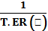……………….(2)
NEP : the normalized environmental impact potentials.
EP : the environmental impact potentials.
ER : the normalization reference for impact category for specific area.
T : time of functional unit.
The equivalency factor of each impact will be calculated with the quantities of substances . Equivalency factor is factor that shows how many times of effects with environmental compare with reference substance in each environmental impact. Normalization is a relative scaling of the product’s impact potentials and resource consumptions though each of them with a reference.
- Weighting
This step is to determine which of the environmental impacts and resources use are the most important.
WEP(j) = WF(j) × NEP(j)………(3)
WEP(j) =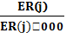×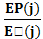×……(4)
WEP(j) = 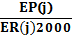 × …………(5)
WEP: The weighted environmental impact potential
ER : The environmental impact potential of the target in the year 2000.
- Single score
In the single score step, the weighted values are added together and presented as a single number.
4- Interpretation
A complete table of all used data and results were generated as well as different graphical representations of the result.
Results and Discussion
The results of LCA were mostly not straightforward in favour of material design over the alternative one. Results of LCA had to be interpreted or weighted. The IMPACT2002+ methodology was and LCA weighting method specially developed for product design. This method had proved to be a powerful tool for designers to aggregate LCA results into easily understandable and user-friendly numbers or units, the so called IMPACT 2002-IMPact Assessment of Chemical Toxics.
Fig.5 shows the global eco-score damage in terms of impact categories, It noted that the most environmental impacts potential were global warming, respiratory inorganics, non-renewable energy, contributing to WWTP. Diwaniya contributed 16.9 pt global warming, 10.5 pt respiratory inorganics and 8.43 pt non-renewable of total impact 41.1 pt.
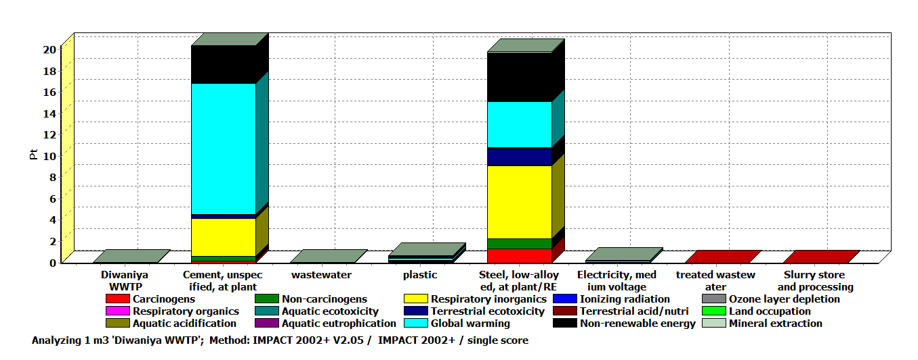
Fig.5 The global eco-score damage in terms of impact categories.
The damage categories were also analyzed by IMPACT 2002+. Four categories of damage were pointed out: Human Health, Ecosystem Quality, Climate Change and Resources.(Fig.6)
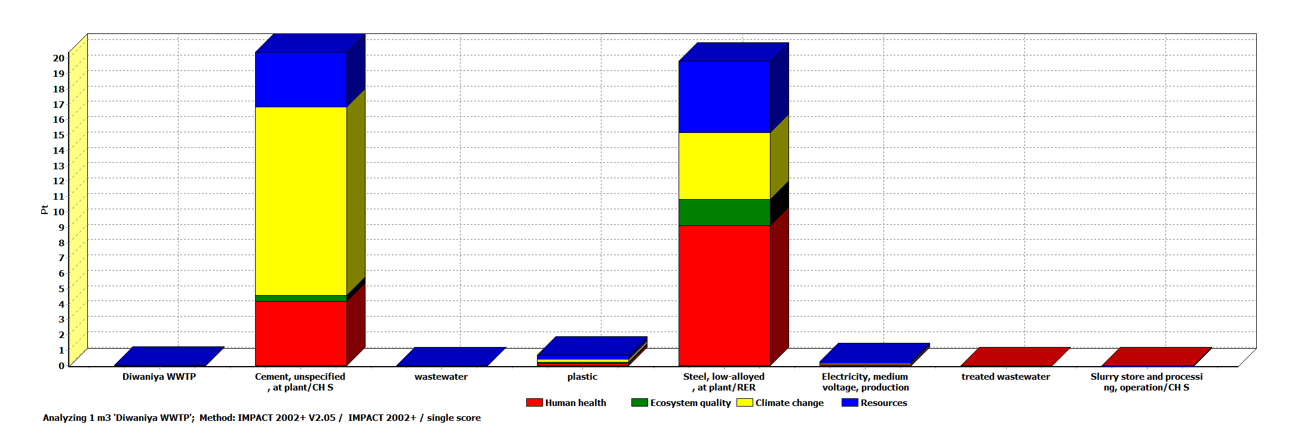
Fig.6 Global eco-score of damage categories.
From fig.6,It can be identified that Diwaniya WWTP contributed 13.5,2.14, 16.9 and 8.57 point to Human Health, Ecosystem Quality, climate change and Resources respectively.
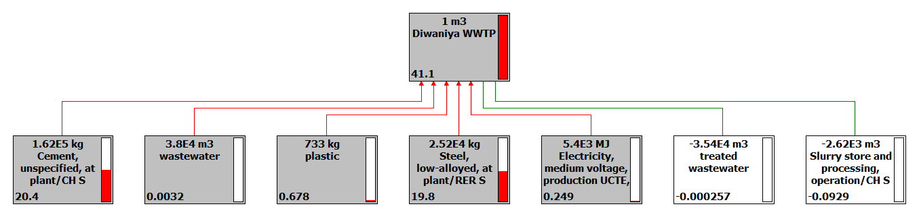
Fig.7 processes contributions of Diwaniya WWTP.
From fig.7 , It noted that cement is one of the most processes that contribute to the environment of several negative effects, followed by steel and then plastic, while the treated wastewater and sludge have positive effects.

Conclusions
The IMPACT2002+ methods was applied to evaluate environmental indicators for Diwaniya WWTP in Iraq country. It concluded the following from applying IMPACT 2002+ on that WWTP: The global eco-score on Diwaniya WWTP was 41.1 Pt, The most environmental impact potential were global warming, respiratory inorganics and non-renewable energy, as a result of cement and steel (construction phase), plastic using during chemical storing and pipes, electricity using for plant operation and emission of plant (Diwaniya WWTP). Environmental damage affected on human health, climate change and resources were 13.5, 16.9 and 8.57 respectively.
References
Leah Flowers, Katya Bilyk, P.E., Joyeeta Banerjee, P.E.,Tony Greiner, P.E., Sandeep Mehrotra,P.E., and Paul Pitt,P.E.,2003," 21st Century Sustainability Metrics: An Introduction to Life Cycle Analysis"
http://www.ncsafewater.org/Pics/Training/AnnualConference/AC10TechnicalPapers/AC10_SpecialTopics/ST-M.PM_03.45_Bilyk.pdf
PRé Consultants, 2010,"Introduction to LCA with SimaPro 7".
Rolf.F & Niels.J,2007,"Implementation of Life Cycle Assessment Methods", Swiss Centre for Life Cycle Inventories.
http://modeleau.fsg.ulaval.ca/fileadmin/modeleau/documents/Publications/pvr967.pdf.
Steve Tarallo, Marco Menendez,2009,"Achieving Sustainable Wastewater Treatment Through The Application of Life Cycle Management".
http://www.ncsafewater.org/Pics/Training/AnnualConference/AC09TechnicalPapers/AC09_Wastewater/WW_T.AM.08.30_Menendez.pdf
Thitirut C.,2005,“Appraisals of Environmental Sustainability Indicators on The Conventional Sewerage and Domestic Wastewater Treatment Systems in Thailand. Case Study in Bangkok City”,Thesis, Asian Institute of Technology School of Environment, Resources and Development Thailand.
Zhang, Z. and Wilson, F. PhD, 2000," Life-Cycle Assessment of a Sewage-Treatment Plant in South-East Asia"Research Student and Assistant Professor, respectively, School of Civil and Structural Engineering, Nanyang University, Singapore.

