Effect of Using Recycled Lightweight Aggregate on the Properties of Concrete

Tumadhir Merawi Borhan

Department of Civil Engineering, Al-Qadisiyah University Tumadhir_borhan@qadissuni.edu.iq
Abstract
In this research, a study was carried out to produce a lightweight concrete from a recycled lightweight concrete. Crushed cellular concrete (locally known as Thermostone) was used as partial replacement for both the coarse and fine aggregates in different percentages. The specimens were tested for compressive strength using two different methods: the first involved testing the specimens at room temperature in saturated surface dry conditions, whereas the second method consisted of testing the specimens immediately after heating them to 55ºC. The results showed that the compressive strength reduced with increasing the recycled lightweight concrete aggregate content. The results also showed that the compressive strength of the heated specimens was lower than that for the specimens tested in saturated dry surface conditions for all of the mixtures. However, the difference decreased with increasing the recycled aggregate content. It was also noted that the density of the specimens and the coefficient of thermal conductivity decreased with increasing the replacement ratio, which makes this type of concrete useful in places where better thermal insulation is required.
Keywords: cellular concrete; recycled aggregate; Thermostone; compressive strength; thermal conductivity
الخلاصة
في هذا البحث تم عمل دراسة لانتاج خرسانة خفيفة الوزن من اعادة تدوير خرسانة خفيفة الوزن. تم استخدام مخلفات الكتل الخلوية (المعروفة في العراق باسم الثرمستون) بدلا من الركام الخشن والركام الناعم وبنسب استبدال مختلفة. تم فحص مقاومة انضغاط للنماذج وبطرقتين : الاولى كانت بفحص النماذج بالطريقة الاعتيادية مباشرة بعد رفعها من حوض الماء وبحالتها المشبعة وجافة السطح, اما الطريقة الثانية فقد تم تسخين النماذج بدرجة حرارة 55ºC وفحصها مباشرة بعد اخراجها من الفرن. اظهرت النتائج نقصان في مقاومة الانضغاط بزيادة محتوى الثرمستون. كما بينت النتائج ان النماذج المفحوصة بعد تسخينها تكون مقاومتها اقل من النماذج المفحوصة بالطريقة الاعتيادية الا ان الفرق بينهما يتناقص بزيادة محتوى ركام الثيرمستون في الخلطة. واظهرت النتائج ايضا نقصان في الكتافة ومعامل التوصيلية الحرارية بزيادة نسبة الاستبدال مما يجعل هذا النوع من الخرسانة مفيد في المحلات التي يتطلب فيها عزل افضل للحرارة.
الكلمات المفتاحية: الخرسانة الخلوية. مجموع المعاد تدويره. مواد الاسمنتية العازلة. قوة الضغط. التوصيل الحراري
1. Introduction
Sustainable development is increasingly important on a global scale for several reasons, among which is the fact that many of the Earth's resources are non-renewable. Many countries in the world are suffering from the negative impact of the accumulation of industrial waste and the demolition of buildings, causing environmental and health problems.This requires the development of practical solutions to minimise these excess materials by recycling them as an alternative to some of the more common construction materials (e.g., cement, sand, gravel) within concrete mixtures or asphalt.
Iraq is one of the Arab gulf countries with a hot climate, mostly consisting of dry summers and cold, wet winters, with average summer temperatures of more than 50°C (outside temperature) and a relative humidity of less than 10%. Lightweight concrete is rarely used for construction in Iraq; moreover, the small amount that has been used has in most cases been imported from abroad. This has led researchers to conduct several studies on the possibility of producing lightweight aggregate from local, natural materials or by recycling construction waste materials and using them as a partial or total replacement for coarse or fine aggregate in concrete . These studies aimed to provide alternatives to the imported lightweight aggregates as well as to adhere to sustainable development requirements. One such material is crushed bricks or concrete blocks (a common by-product of factories or the demolition of buildings), of which the possibility of recycling and re-using them as an aggregate in concrete has been studied by many researchers .
One kind of blocks, made from cellular concrete (also known as autoclaved aerated concrete),is known as Thermostone. These blocks are increasingly used as an alternative to bricks in multi-storey buildings in order to reduce the total load of the building as well as to ensure thermal comfort inside it. Thermostone consists of a mix of hydrated lime, sand, cement, water and aluminum powder. The aluminum powder is added to the mix during the mixing process to create a gas-bubble structure within the concrete. This occurs due to the chemical reaction between the aluminum powder, silica and hydrated lime. After the initial setting, the concrete block is then cured under high-pressure steam for a specific amount of time . It is also possible to recycle the waste produced by this type of concrete blocks to form a lightweight aggregate. However, limited research has been carried out in this area and has been confined to limited ranges of particle size of the aggregate, which resulted in concrete with weak compressive strength (2.5-1.51 N/ mm²)
.
This study was thus conducted to investigate the effect of using recycled lightweight aggregate from lightweight concrete blocks (gathered from the waste products of construction or Thermostone factories) as a coarse (in different percentages) and fine aggregate on the thermal and mechanical properties of concrete. The study also took into consideration the hot climate of Iraq and the Arab gulf countries.

.Experimental work

Materials
ASTM C150-07 Type I Ordinary Portland Cement was used in this study. The chemical composition and other physical properties of this cement are given in Table 1. Natural sand and crushed gravel (with a maximum size of 20 mm) were used as aggregate. The grading and other characteristics were confirmed to the IQS (5-1984). The aggregate used in the concrete was in saturated surface dry condition. Its characteristics are given in Table 2.

Recycled lightweight aggregate
The recycled aggregate was obtained by crushing lightweight concrete waste, brought from Al-Najaf Thermostone factory, into a similar grading to that of the natural aggregate, and was used in saturated surface dry condition. This was then used to replace the coarse aggregate only, in the following amounts: 0, 20, 40, 60, and 100%. The total replacement of coarse and fine aggregate by crushed lightweight concrete was also investigated. The grading of the fine and coarse recycled lightweight concrete is shown in Table 2.

Mix proportions
A volumetric mixing ratio of (1:2:4) (cement: sand: gravel) was adopted for the reference mix with a 0.45 water-to-cement ratio; this ratio was maintained for all mixes. The concrete components were mixed manually on a solid, clean and non-porous surface. The components were mixed first, until the mixture took on a homogenous colour. At this stage, water was added directly to the mix and mixing continued until a homogeneous consistency was achieved. The mixture was then poured into moulds for each test. The specimens were demoulded after being cast for 24 hours, and were then cured in a water tank for a period of 28 days, after which time the test was conducted.

Compressive strength and density tests
The compressive strength test was conducted according to the standard specifications (ASTM C39-12).A total of 36 concrete cubes, each measuring 150*150*150 mm, were used for the compressive strength test and for measuring the density of the concrete (at age of 28 days). Six cubes were cast for each mix; three of them were tested immediately after removal from the water tank in saturated surface dry conditions. The remaining three were heated in an oven at 55ºC for three hours (which is the period for which peak temperature is sustained in summer in Iraq). The recorded results are the average of the three cubes for each mixture and method of examination.

Splitting tensile strength test
The same compression machine mentioned in Section 2.4 was used to conduct the splitting tensile strength test according to ASTM C496-04. A total of 18 cylinders measuring 200 mm in height and 100 mm in diameter were used for this test. The cylinders were tested, after 28 days of curing, in saturated surface dry conditions and the average of three specimens was recorded as a result for each mixture.

Modulus of elasticity test
The static modulus of elasticity test was conducted according to ASTM C469-02. 15 cylinders were cast for this purpose. The cylinders' diameter measured 100 mm and their height was 200 mm. The modulus of elasticity of each mix was taken as the average of the results of three specimens from the same mix after 28 days of curing.

Thermal conductivity test
The steady-state guarded hot plate method (ASTM C 177-04) was used to examine the thermal conductivity coefficient.10 discs were used for the thermal conductivity test in this study, two for each mix. The disc diameter measured 100 mm and the height was 50 mm. The equipment used to measure thermal conductivity consisted of an oven to provide a constant temperature (a peak period temperature of 55ºC) and the thermal conductivity system, which was placed inside it. The thermal conductivity system consisted of a heater with a diameter of 10cm connected to a power supply and temperature sensor. The heater was sandwiched between two concrete specimens (discs), as shown in Figure 1. Two copper pressure plates were placed on opposite sides of each specimen and were connected to the sensor. The amount of heat (Q) conducted through the samples was determined by multiplying the current (I) by the voltage (V) passing through the heater from the power supply equipment. The thermal conductivity was calculated using the following equation (Al-Asady 2013):
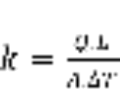 ………..(1)
where:
k: is the thermal conductivity (W/m. ºC)
Q: power supplied to specimen (watt)
L: specimen thickness (m)
A: cross-section area (m)
∆T: difference in temperature on both sides of the sample

Results and discussion

Compressive and splitting tensile strength
The use of recycled aggregate, in many cases, leads to decrease the compressive strength of concrete. The amount of this reduction depends on the amount of the aggregate used and its properties. The main properties of the aggregate that affect the compressive strength of concrete are; density, porosity, shape and gradation, the water absorption and the resistance of crushing and abrasion (McNell and Kang ,2013). In this study, the reduction in compressive strength was 32% for the mix with 20% lightweight aggregate content. This increased by up to 72% for the 100% coarse aggregate replacement in comparison with the reference mix (see Figure 2 and Table 3). Using recycled lightweight concrete as a coarse and fine aggregate in the total replacement of natural aggregate results in a concrete mix with a compressive strength 74% lower than that observed in standard concrete.
The splitting tensile strength results followed the same trend of the results for compressive strength, in that they decrease with increasing the replacement ratio for all mixes (see Figure 4 and Table 3). A reduction of between 28 and 73% was made in comparison with the reference mix.
This behavior is attributed to the fact that the lightweight concrete has many voids in its structure. These voids were produced due to the interaction of the aluminum powder with Ca(OH)₂ from lime or from the hydration of the cement. These voids made the crushing resistance of the lightweight concrete blocks is about 50 kg/cm² while the crushing resistance for the conventional aggregate is about 700-2000 kg/cm².
The effect of the bond between the recycled aggregate and the cement paste is also considered as a possible cause of these results. According to Poon et al. (2004), SEM observations revealed that the normal strength concrete aggregate–cement interfacial zone consisted mainly of loose and porous hydrates.
In their study, Raof et al. (2010) used recycled lightweight aggregate to replace 100% of the fine and coarse aggregate. The compressive strength value ranged from 2.5-1.51 N/mm², which is less than the value obtained in the present research. This difference can be attributed to the poor gradation of the particle size of the aggregate used in their study.
One of the main problems of using recycled aggregate in concrete is packing. The maximum packing density (which is the ratio of solid volume by the total volume of container) has to be taken into consideration to get an optimum mix design. This ensures good workability in the fresh state, sufficient mechanical properties at the hardened state and a satisfactory durability in certain environment (de Larrard (2009)). In case of using recycled aggregate, it is difficult to get high packing density due to the difficulties of controlling the particle shape and gradation of this type of aggregate. Thus the conventional mix design methods for concrete that have been used in several decades should be improved to get the maximum packing density for recycled aggregate concrete.
The results of the heated specimens showed that the compressive strength was unequivocally lower than that of the specimens tested in saturated surface dry condition at room temperature. The difference became smaller when the percentage of recycled aggregate was increased, as shown in Figure 3 and Table 3. The difference in the reference mixture ratio was 29%; however, this rate dropped to 9.4% when 100% of the natural aggregate was replaced by lightweight aggregate. This is due to the superior thermal properties of the lightweight aggregate in comparison with the natural aggregate, which reduces the effect of heat on the compressive strength.

Modulus of elasticity
The results of the static modulus of elasticity for different recycled lightweight aggregate contents are given in Table 3 and Figure 5. Similarly to the process observed for compressive strength and splitting tensile strength, it was apparent that the elastic modulus decreased gradually as the recycled lightweight aggregate content increased. The reduction of the modulus of elasticity started at 21% when the 20% replacement mix was used; this figure then dropped to 80.8% when the natural aggregate was completely replaced by recycled lightweight aggregate. This result is in agreement with those obtained by many researchers using different types of recycled aggregate . The modulus of elasticity of concrete is controlled by the properties of the aggregate rather than the properties of the concrete as a whole (McNell and Kang (2013)). The modulus of elasticity of the recycled aggregate is lower than that of the natural aggregate (Schoppe, 2011). This leads to the fact that the recycled aggregate yields in lower stress than conventional aggregate.

Density of concrete
The main purpose of this research is to produce a lightweight concrete with good insulation properties for non-structural building members, so the density of the concrete produced should also be examined. The dry density of the concrete containing recycled lightweight aggregate decreased gradually, eventually reaching 1500 kg/m³ with 100% replacement of the natural aggregate (Table 3). The reason for this is that the lightweight aggregate is less dense than the natural aggregates due to the manufacturing method of aerated concrete, which leads to the presence of air bubbles in its structure. The density of the lightweight concrete blocks (Thermostone) is about 600 – 800 kg/m³ ( Al-Jelawi, 1997). This finding reflects the results obtained by Raof et al. (2010). According to EuroLightCon (1998), the concrete which has the dry density less than 2000 Kg/m3 ( for non structural members) can be classified as a lightweight concrete, thus, concrete for mixes TH100 and THT can be considered as a lightweight concrete.

Thermal conductivity
It has been long observed that with decreasing the density, the thermal conductivity of the concrete decreases. Table 3 and Figure 6 showed that the coefficient of thermal conductivity for the reference mix was 2.07 w/m.k and decreased gradually with increasing the recycled lightweight aggregate content, until it reached 1.18 w/m.k for 100% replacement of the natural aggregate. This outcome was expected, as the recycled lightweight aggregate has a lower thermal conductivity value than conventional aggregate. The coefficient of the thermal conductivity of the lightweight concrete blocks (from which the lightweight aggregate were taken) is ranging from 0.13 – 0.32 w/m.k (Al-Jelawi 1997). This is due to the presence of the voids produced from the interaction of the aluminum powder with Ca(OH)₂ from lime or from the hydration of the cement as stated in Section 3.1.

Conclusions and recommendation
The results of the present experimental work showed the following:
- The compressive strength of the concrete decreased with increasing the content of the recycled lightweight aggregate and the compressive strength of the heated specimens was lower than that tested in saturated dry surface conditions for all mixes. However, the difference decreases when the quantity of recycled aggregate is increased.
- The splitting tensile strength and the modulus of elasticity results follow the same trend as the compressive strength results.
- Concrete containing recycled lightweight aggregate totally replaced the natural aggregate is lighter than conventional concrete. This type of concrete can therefore be classified as a lightweight concrete.
- Compared to standard concrete, concrete with recycled lightweight aggregate as an aggregate has improved thermal properties, a lower density and lower thermal conductivity, thus, it can be used in the production of new building blocks.
- the conventional mix design methods should be improved to much the requierments of the recycled aggregate concrete.
- Further research is needed to investigate the effect of curing time on the strength of such concrete.
References
الجيلاوي، ندى مهدي، (١٩٩٧) خواص الخرسانة خفيفة الوزن بالاشارة الى العزل الحراري والمعاوقة الصوتية، رسالة ماجستير، كلية الهندسة، جامعة بغداد.
رؤوف، زين العابدين، فوزي، ندى مهدي، حسين، محمد حمزة، (٢٠١٠)، تطوير خرسانة خفيفة الوزن عازلة للحرارة،
مجلة الهندسة والتكنلوجيا، المجلد ٢٨، العدد ١٣، ص ٦٧٨ـ٦٩١
Abed, M. F., 2009, Preparing Lightweight Aggregate for Production of Lightweight Insulating Concrete, Tikrit Journal of Pure Science, 14(3):194-200.
Al-Asady, A. M.,2013, Evaluation of flextural and thermal properties of self compacted concrete in highway pavement, civil engineerinf, University of Babylon.
ASTM C150-07,2007, Standard Specification for Portland Cement, American Society for Testing and Materials, ASTM International, West Conshohocken, PA.
ASTM C177-04, 2004,Standard test method for steady state heat flux measurements and thermal transmission properties by means of the Guarded-Hot-Plate apparatus, 2004. American Society for Testing and Materials Philadelphia, PA.
ASTMC469-02, 2002, Standard test method for static modulus of elasticity and Poisson’s ratio of concrete in compression. ASTM International, West Conshohocken, PA. doi: 10.1520/C0469-02E01.
ASTM C496, 2004, Standard test method for splitting tensile strength of cylindrical concrete specimen. American Society of Testing Materials, West Conshohocken.
ASTM C39/C39M.,2012, Standard test method for compressive strength of cylindrical concrete specimens, , West Conshohocken, PA:7.
Debieb, F., and Said K., 2008, The use of coarse and fine crushed bricks as aggregate in concrete. Construction and Building Materials 22(5):886-893.
De Larrard, F., 2009, Concrete optimisation with regard to packing density and rheology, 3rd RILEM international symposium on rheology of cement suspensions such as fresh concrete, France.
Demir, I., and Orhan, M., 2003, Reuse of waste bricks in the production line. Building and Environment 38(12):1451-1455.
EuroLightCon, 1998, LWAC Material Properties State-ofthe-Art, Document BE96-3942/R2.
González-Fonteboa, B., and Martínez-Abella, F., 2008, Concretes with aggregates from demolition waste and silica fume. Materials and mechanical properties. Building and Environment 43(4):429-437.
Iraqi Specification, No.45. 1984, Aggregate from natural sources for concrete and construction.
Iraqi Specification, No.5. 1984, Portland cement.
Khatib, J.M., (2005), Properties of concrete incorporating fine recycled aggregate. Cement and Concrete Research 35(4):763-769.
Martínez-Lage, I. Martínez-Abella, F., Vázquez-Herrero, C., Pérez-Ordóñez, J.L., 2012, Properties of plain concrete made with mixed recycled coarse aggregate. Construction and Building Materials 37:171-176.
McNeil, M., and Kang, T.H.K., 2013, Recycled concrete aggregate: A review, International journal of concrete structures and materials, 7(1): 61-69.
Narayanan, N., and Ramamurthy, K.,2000, Structure and properties of aerated concrete: a review. Cement and Concrete Composites 22(5):321-329.

Poon, C. S., Shui, Z. H., and Lam, L.,2004, Effect of microstructure of ITZ on compressive strength of concrete prepared with recycled aggregates. Construction and Building Materials 18(6):461-468.
Rao, A., Jha,K.N., and Misra, S., 2007, Use of aggregates from recycled construction and demolition waste in concrete. Resources, conservation and Recycling 50(1):71-81.
Schoppe, B.M. 2011, shrinkage & modulus of elasticity in concrete with recycled aggregate, MSc. Thesis, the Faculty of California Polytechnic State University, San Luis Obispo.

Table 1 The chemical composition and physical properties of Ordinary Portland Cement
Oxide composition | Oxide content % |  |  | Limits of IQS (5-1984)
SiO₂ | 19.54 |  |  | ____
Al₂O₃ | 7.42 |  |  | ____
Fe₂O₃ | 4.36 |  |  | ____
CaO | 60.2 |  |  | ____
MgO | 2.03 |  |  | ≤ 5.0
SO₃ | 1.53 |  |  | ≤ 2.8
Free CaO | 1.04 |  |  | ____
L.O.I | 0.96 |  |  | ≤ 4.0
I.R | 0.95 |  |  | ≤ 1.5
L.S.F | 0.79 |  |  | 0.66-1.02
The main components (using Bogue’s formulas)
C₃S | 36.34 |  |  | ____
C₂S | 26.18 |  |  | ____
C₃A | 11.89 |  |  | ____
C₄AF | 13.27 |  |  | ____
The physical properties
Fineness (Blaine) m²/kg |  | 300 | ≥ 230
Initial setting time (Vicat) (min) |  | 92 | ≥ 45
Final setting time(Vicat)(Hrs:min) |  | 3:30 | ≤ 10
Soundness (Autoclave method) % |  | 0.1 | ≤ 0.8
Compressive Strength (MPa)  3 days  7 days |  | 15.60  25.41 | ≥15  ≥23

Table 2 Grading of fine and coarse aggregates
Fine aggregate |  |  |  | Coarse aggregate
Sieve opening size (mm) | Percentage passing % |  |  | Sieve opening size (mm) | Percentage passing %
Sieve opening size (mm) | Natural | Recycled | Limits of IQS (5-1984)zone(1) | Sieve opening size (mm) | Natural | Recycled | Limits of IQS (45-1984)
10 | 100 | 100 | 100 | 37.5 | 100 | 100 | 100
4.75 | 99 | 95.3 | 90 - 100 | 20 | 97.3 | 98.1 | 95 – 100
2.36 | 85.6 | 72.5 | 60 - 95 | 10 | 58.4 | 46.8 | 30 – 60
1.18 | 40.1 | 33.1 | 30 - 70 | 5 | 6 | 7.2 | 0 – 10
0.60 | 17 | 24 | 15 - 34
0.30 | 5 | 5 | 5 - 20
0.15 | 0.3 | 0 | 0 – 10

Table 3 Summary of the test results
Mix Mark | Recycled % coarse | Recycled % fine | Density (kg/m³) | CS at lab. (MPa) | CS at 55ºC (MPa) | CS Reduction % | SS (MPa) | ME (GPa) | TC (W/m.k)
TH0 | 0 | 0 | 2441 | 33.20 | 23.45 | 29.37 | 1.89 | 29.56 | 2.07
TH20 | 20 | 0 | 2308 | 22.40 | 15.86 | 29.17 | 1.35 | 23.3 | 1.96
TH40 | 40 | 0 | 2243 | 12.33 | 11.07 | 10.20 | 0.76 | 19 | 1.74
TH60 | 60 | 0 | 2030 | 13.47 | 10.82 | 19.63 | 1.08 | 16 | 1.63
TH100 | 100 | 0 | 1570 | 9.05 | 7.87 | 12.99 | 0.49 | 12.5 | 1.32
THT | 100 | 100 | 1517 | 8.40 | 7.62 | 9.28 | 0.52 | 5.67 | 1.18
CS: Compressive strength
SS: Splitting tensile Strength
ME: Modulus of Elasticity
TC: Thermal Conductivity

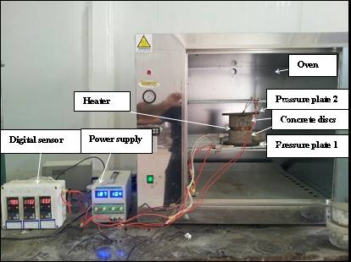

Figure 1 Thermal conductivity system

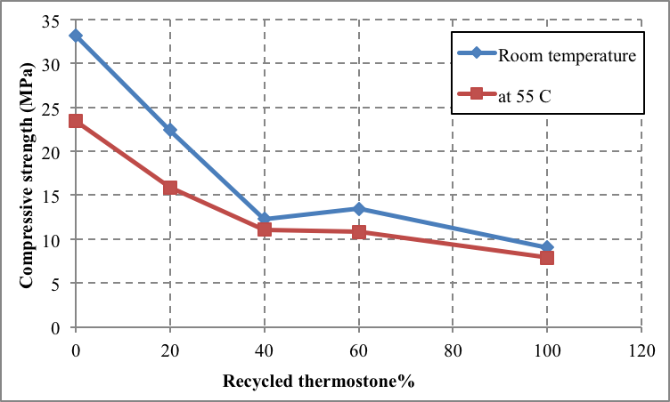

Figure 2 Compressive strength verses. Thermostone content as a coarse aggregate

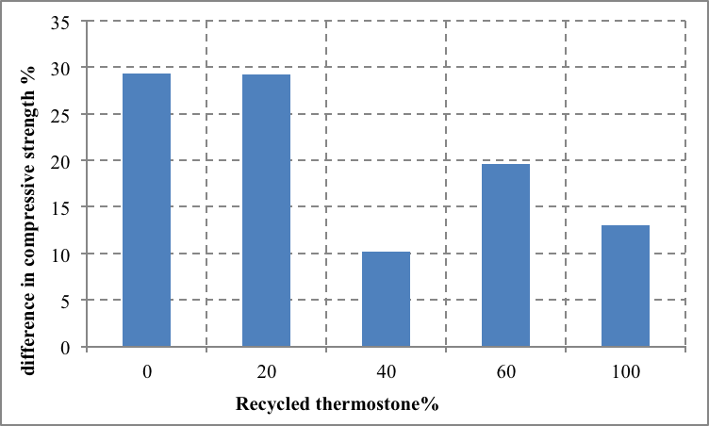

Figure 3 Differences in compressive strength between the two methods of testing

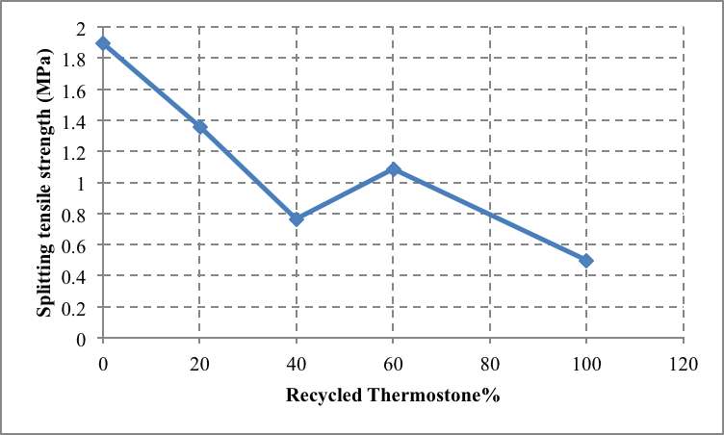

Figure 4 Splitting tensile strength verses. Thermostone content as a coarse aggregate

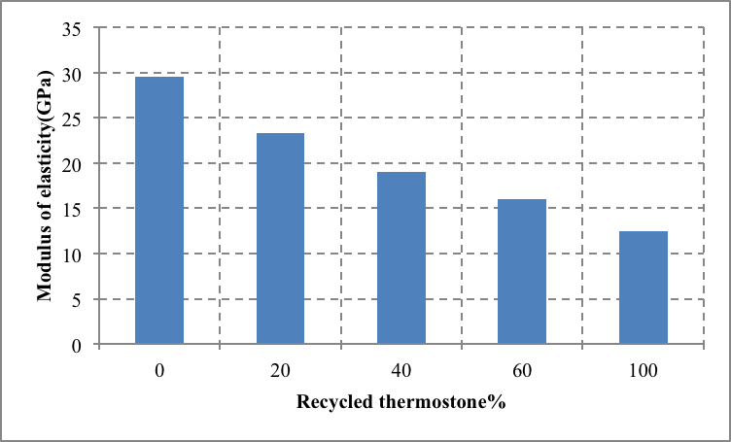

Figure 5 Modulus of elasticity verses Thermostone content as a coarse aggregate

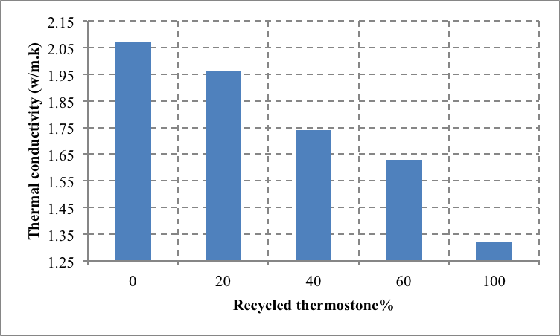

Figure 6 Thermal conductivity verses Thermostone content as a coarse aggregate

