Effect of Pavement Layers Properties on Optimum Performance by Mechanistic–Empirical Method

Ahmed Abbas Jasim
University of Babylon/ College of Engineering
ahmedpave@yahoo.com
Abstract
Premature failure of flexible pavements has been a long problem in many Iraqi roads in middle and south areas with the drastic increase in truck axle loads specially after year 2003. To fully utilize each pavement material in an economic design, a pavement should generally have reasonably balanced design between the rutting and fatigue modes of distress. The purpose of this paper is to develop a methodology for achieving a reasonable balance between fatigue and rutting lives of flexible pavements.
The methodology is based on the damage analysis concept which is performed for both fatigue cracking and rutting on different pavement sections using KENLAYER program. The investigated pavement components are; thickness and elasticity modulus for pavement layers.
The results of pavement analysis showed that thickness of base layer and elasticity modulus of subbase layer are the key elements which control the equilibrium between fatigue and rutting lives respectively. That is because, increasing thickness of base layer and elasticity modulus of subbase layer sharply increases rutting lives, and don't affect in fatigue lives. The study also concluded that, increasing thickness of surface layer significantly increases pavement lives, while increasing elasticity modulus of surface and base Layers mildly increases pavement lives.
Keywords: Pavement life, Tensile strain, and Compressive strain.
الخلاصـة
ما يزال الفشل المبكر للطرق الاسفلتية اهم مشاكل الطرق في العراق تحت الزيادة المفرطة في اوزان المركبات. ولتفادي حدوث الفشل المبكر والاستفادة المثلى وفق تصميم اقتصادي امثل للطرق، يجب ان يتم الموازنة بين انواع فشل الطرق الاسفلتية والمتمثلة في التخدد والكلل. ويهدف البحث الى توضيح منهجية لتحقيق ذلك التوازن المطلوب للوصول لمرحلة فشل التخدد و فشل الكلل. وتعتمد تلك المنهجية على مفهوم تحليل الضرر للطرق الاسفلتية والذي تم اجراءه باستخدام برنامج كينليير لتحليل عدة حالات من طبقات الطرق الاسفلتية بالنسبة لكل من التخدد والكلل. وكانت عناصر التبليط في البحث هي سمك الطبقة الاسفلتية وسمك طبقة الاساس ومعيير المرونةلكلا الطبقتين بالاضافة لطبقة التاسيس.
بينت نتائج البحث ان سمك طبقة الاساس ومعاير المرونة لطبقة التاسيس هي العناصر الرئيسية التي تساهم في التوازن المطلوب للوصول لمرحلة فشل التخدد وفشل الكلل، وذلك لان زيادة اي من العنصرين تؤدي الى زيادة كبيرة في مدة بلوغ مرحلة فشل التخدد بينما لاتتاثر مرحلة فشل الكلل بكلا العنصرين. واستنتج البحث ان زمن الوصول لمرحلة فشل التخدد وفشل الكلل يزداد بزيادة سمك طبقة التبليط الاسفلتي ويزداد باعتدال بزيادة كل من معاير المرونة لطبقة التبليط الاسفلتية والأساس.
الكلمات المفتاحية: عمر التبليط، فشل التخدد، فشل الكلل.
1. Introduction
A most field observation in Iraq for evaluation of pavement surface conditions of Iraqi roads network, showed that rutting and fatigue cracking are considered the most important distresses surveyed due to high severity and density levels, and consequently their high effects on the pavement condition.
Flexible pavements should be designed to provide a durable, skid resistance surface under in-service conditions. Also, it is essential to minimize cracking and rutting in flexible pavement layers. To fully utilize each pavement material in an economic design, a pavement should generally have reasonably balanced design between the rutting and fatigue modes of distress (Barksdal,1978).
The increased rutting or decreased fatigue life of the flexible pavements may be attributed to the shortcomings of the application of flexible pavement analysis and the absence of attention to identify the pavement components that achieve a balanced section which gives equal pavement lives with respect to rutting and fatigue (Barksdal, 1978).
2. Mechanistic–Empirical Methods
Methods of flexible pavement design can be classified into five categories: empirical method with or without a soil strength test, limiting shear failure method, limiting deflection method, regression method based on pavement performance or road test, and mechanistic–empirical method .The mechanistic–empirical method of design is based on the mechanics of materials that relates an input, such as a wheel load, to an output or pavement response, such as stress or strain. The response values are used to predict distress from laboratory-test and field-performance data. Dependence on observed performance is necessary because theory alone has not proven sufficient to design pavements realistically (Huang, 2004).
Kerkhoven and Dormon (1953) first suggested the use of vertical compressive strain on the surface of subgrade as a failure criterion to reduce permanent deformation. Saal and Pell (1960) recommended the use of horizontal tensile strain at the bottom of asphalt layer to minimize fatigue cracking. The use of the above concepts for pavement design was first presented in the United States by Dormon and Metcalf (1965).
The advantages of mechanistic methods are the improvement in the reliability of a design, the ability to predict the types of distress, and the feasibility to extrapolate from limited field and laboratory data (Huang, 2004).
3. Layered Systems
Flexible pavements are layered systems with better materials on top and cannot be represented by a homogeneous mass, so the use of Burmister's layered theory is more appropriate. Burmister (1943) first developed solutions for a two-layer system and then extended them to a three-layer system (Burmister, 1945) .With the advent of computers, the theory can be applied to a multilayer system with any number of layers (Huang, 1967, 1968).
Burmister (1943) developed the layered pavement system theory, Flexible pavements are layered systems with better materials, such as hot mixed asphalt (HMA), on the top and can not be represented by a homogenous mass (Huang,1993). The following assumptions are made while using the layered system:
1. All layers in a pavement system are homogenous isotropic, linearly elastic with modulus of elasticity and Poison ratio.
2. The materials are weightless and infinite.
3. All layers have finite thickness with a infinite thickness of the bottom layer.
4. Uniform pressure is applied on the surface of the layered system over a circular area with a radius.
5. Lastly, continuity conditions are satisfied at the layer interfaces.
This is indicated by the same vertical stresses, shear stresses, vertical displacement, and radial displacement, and for frictionless interface, the continuity of shear stresses and radial displacement is replaced by zero shear stress at each side of the interface (Huang, 1993).
Behavior of a flexible pavement under a circular wheel load is characterized by considering it as a homogenous half-space (Huang,1993). A half-space is an infinitely large area and with an infinite depth where the loads are applied on the top plane. Thus, the theory on concentrated loads being applied on an elastic half-space is called Boussinesq’s theory developed in (1885).
4. Strains in Layered Systems
Two main stresses in layered systems of flexible pavements as following below:58.

4.1. Compressive Strain
The vertical (compressive) stress on the top of subgrade is an important factor in pavement design. The function of a pavement is to reduce the vertical stress on the subgrade so that detrimental pavement deformations will not occur . The allowable vertical stress on a given subgrade depends on the strength or modulus of the subgrade. To combine the effect of stress and strength, the vertical compressive strain has been used most frequently as a design criterion . This simplification is valid for highway and airport pavements because the vertical strain is caused primarily by the vertical stress and the effect of horizontal stress is relatively small (Huang, 2004).
4.2. Tensile Strain
The tensile strains at the bottom of asphalt layer have been used as a design criterion to prevent fatigue cracking.Two types of principal strains could be considered. One is the overall principal strain based on all six components of normal and shear stresses . The other, which is more popular and was used in KEN-LAYER, is the horizontal principal strain based on the horizontal normal and shear stresses only. The overall principal strain is slightly greater than the horizontal principal strain, so the use of overall principal strain is on the safe side (Huang, 2004).
5. Damage Analysis
Damage analysis is performed for both fatigue cracking and permanent deformation as follows:
5.1. Fatigue Criteria
The relationship between fatigue failure of asphalt concrete and tensile strain (εt), at the bottom of asphalt layer is represented by the number of repetitions as suggested by Asphalt Institute (1982) in the following form:
Where:
Nf: The allowable number of load repetitions to prevent fatigue cracking.
εt: The tensile strain at the bottom of asphalt layer.
El: The elastic modulus of asphalt layer.
5.2. Rutting Criteria
The relationship between rutting failure and compressive strain; εc at the top of subgrade is represented by the number of load applications as suggested by Asphalt
Institute (1982) in the following form:
Where:
Nr: The allowable number of load repetitions to limit permanent deformation.
: The compressive strain on the top of subgrade.
6. Kenlayer Computer Program
The KENLAYER computer program applies only to flexible pavements with no joints or rigid layers. The backbone of KENLAYER is the solution for an elastic multilayer system under a circular loaded area. The solutions are superimposed for multiple wheels, applied iteratively for nonlinear layers, and collocated at various times for viscoelastic layers. As a result, KENLAYER can be applied to layered systems under single, dual, dual-tandem, or dual-tridem wheels with each layer behaving differently, either linear elastic, nonlinear elastic, or viscoelastic
(Huang, 2004).

7. Study Objective
The main objective of this study is to investigate the effects of pavement layers properties (thickness and elasticity modulus) on pavement life with respect to fatigue and rutting. That is, to recognize the key components of the pavement which achieve balanced sections having equal design lives between fatigue and rutting (Nf=Nr).
8. Pavement Analysis
Pavement materials characterized by a modulus of elasticity (E) and a Poisson’s ratio (μ). Poisson’s ratio; μ is considered as (0.35, 0.40 and 0.45) for asphalt layer, base course and subgrade, respectively. According to specifications of State Corporation of Roads and Bridges in Iraq (SCRB, 2003), minimum of Marshall stability required for pavement layers are (8 KN, 7 KN and 5 KN) for surface layer, binder layer, base layer, respectively. While minimum of CBR required are (40% and 5%) for subbase layer and subgrade, respectively.
A typical cross section in Iraq consists of asphalt layer thickness (t1= 6 cm) with elasticity modulus (E1 = 5241 Mpa (760 psi)), base layer thickness (t2 = 16 cm) with elasticity modulus (E2 = 3172 Mpa (460 psi)),and subbase layer thickness (t3 = 30 cm) with elasticity modulus (E3 = 268 Mpa (39 psi)) resting on subgrade with elasticity modulus (E4 = 97 Mpa (14 psi) is considered a section with reference components. Different probable cross sections that may be used in Iraq roads are considered for analysis through varying the reference components by ± 25% and ± 50%. Four values of each component are considered plus the reference one. That is, t1 is varied from (1.18) to (3.54) in, while t2 is varied from (3.15) to (9.45) in, and t3 is varied from (5.91) to (17.72) in. E1 is varied from (340) to (1140) psi, while E2 is varied from (230) to (690) psi and E3 is varied from (15) to (45) psi. Varying these components with each other gives various cross sections for analysis.
Traffic is expressed in terms of repetitions of single axle load (18) kip applied to the pavement on two sets of dual tires. The investigated contact pressure is (100) psi. The dual tire is approximated by two circular plates with radius (3.78) in. and spaced at (13.6) in. center to center. The detrimental effects of axle load and tire pressure on various pavement sections are investigated by computing the tensile strain (εt) at the bottom of the asphalt layer and the compressive strain (εc) at the top of the subgrade by using computer program KENLAYER. Then, damage analysis is performed using the two critical strains to compute pavement life for fatigue cracking and permanent deformation (rutting).
9. Analysis of Results
Figure (1) shows the effect of surface thickness (t1) on pavement life with respect to fatigue (Nf) and rutting (Nr). As can be seen in the figure, both Nf and Nr increase as t1 increases at all values of t2. The fact which cannot be ignored that, t2 = 9.45 in. achieves balanced sections at all values of t1, i.e. has equal lives with respect to fatigue and rutting (Nf = Nr).
Figure (2) shows the effect of base thickness (t2) on pavement life with respect to fatigue (Nf) and rutting (Nr). It can be noticed that, Nf has no sensitivity with the variation of t2, compared with Nr which is high sensitive to the variation of t2.
As shown in Figure (3), both Nf and Nr mildly increase as E1 increases at all values t2. Also, it can be noticed also, that t2 = 9.45 in. achieves balanced sections at all values of E1, i.e. has equal lives with respect to fatigue and rutting (Nf = Nr).
As shown in Figure (4), both Nf and Nr mildly increase as E2 increases at all values t2. Also, it can be noticed also, that t2 = 9.45 in. achieves balanced sections at all values of E2, i.e. has equal lives with respect to fatigue and rutting (Nf = Nr).
Figure (5) shows the effect of E3 on Nf and Nr. It can be seen in the figure that the smaller the E3, the bigger the t2 to achieve balanced sections between Nf and Nr. It also can be noticed that, Nf has no sensitivity with the variation of t2, compared with Nr which is high sensitive to the variation of t2.
Examining all figures together, it can be concluded that t2 and E3 are the key elements which control the equilibrium between Nf and Nr. That is because, increasing t2 and E3 sharply increase Nr, and don't affect in Nf. Also, increasing t1 sharply increases both Nf and Nr, while increasing E2 and E1 mildly increases Nf and Nr. That is, for obtaining balanced pavement sections with respect to fatigue and rutting.
10. Conclusions
Based on the methodology and analysis of results of this study, the following conclusions are drawn:
1. Nf and Nr increase as t1 increases.
2. E3 and t2 are the key elements which control the balance between Nf and Nr.
3. Nr has high sensitivity to the variation in t2 and E3, while Nf has no sensitivity to t2 and E3.
4. E2 and E1 have mildly effect on both Nf and Nr.
5. The value of t2 = 9.5 in. and E3 = 16 psi are the optimum values which achieve balanced sections at all values of t1, E1 and E2.
6. It is recommended to use a pavement section with t2 =9.5 in, and E3 = 16 psi at all values of t1, E1 and E2, for optimum utilization of pavement components with respect to fatigue and rutting.
11. References
Asphalt Institute, 1982, "Research and Development of the Asphalt Institute’s Thickness Design Manual", 9th Edition, Research Report 82-2, the Asphalt Institute, (MS-1).
Barksdal, R. D., 1978, “Practical Application of Fatigue and Rutting Tests on Bituminous Base Mixes”, Proceedings, AAPT, Vol. 47.
Boussinesq, J., 1885, "Application des Potentiels a l'etude de l'equilibre et du Mouvement de s Solids Elastiques" ; Gauthier-Villars, Paris.
Burmister, D. M., 1945, "The General Theory of Stresses and Displacements in Layered Soil Systems", Journal of Applied Physics, Vol.16.
Burmister, D. M., 1943, "The Theory of Stresses and Displacements in Layered Systems and Applications to the Design of Airport Runways", Proceedings, Highway Research Board, Vol.23.
Dormon, G. M., and C. T. Metcalf, 1965, "Design Curves for Flexible Pavements Based on Layered System Theory", Highway Research Record 71, pp . 69–84; Highway Research Board.
Huang, Y. H., 1968, "Stresses and Displacements in Nonlinear Soil Media", Journal of the Soil Mechanics and Foundation Division, ASCE, Vol. 94, No. SM1.
Huang, Y. H., 1967, "Stresses and Displacements in Viscoelastic Layered Systems Under Circular Loaded Areas", Proceedings, 2nd International Conference on the Structural Design of Asphalt Pavements.
Huang, Y. H., 1993, "Pavement Analysis and Design", New Jersey.
Huang, Y. H., 2004, "Pavement Analysis and Design", New Jersey.
Kerkhoven, R . E ., and G. M . Dormon, 1953, “Some Considerations on the California Bearing Ratio Method for the Design of Flexible Pavement”, Shell Bitumen Monograph No.1.
Saal, R. N. J., and P. S . Pell, 1960, “Kolloid-Zeitschrift MI”, Heft 1, pp . 61-71.
SCRB/R9 (2003) General Specification for Roads and Bridges, Section R/9, "Hot-Mix Asphalt Concrete Pavement", Revised Edition. State Corporation of Roads and Bridges, Ministry of Housing and Construction, Republic of Iraq.

Figure (1): Effect of Thickness of Surface Layer on Fatigue and Rutting Damage

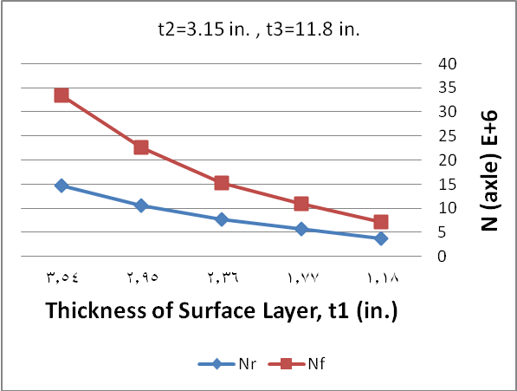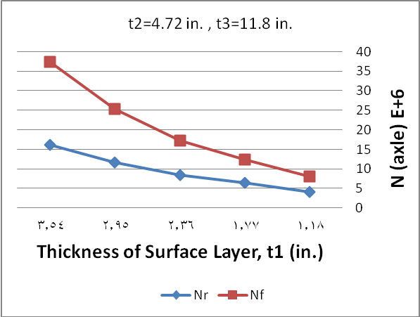
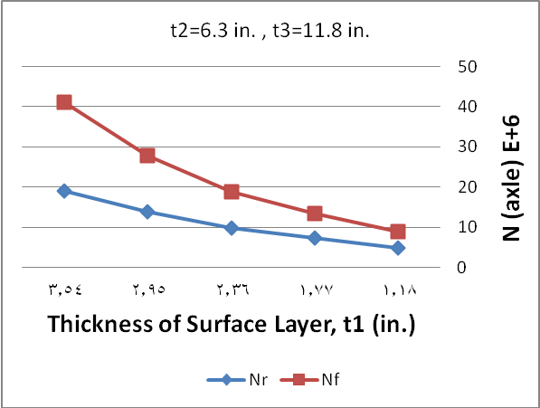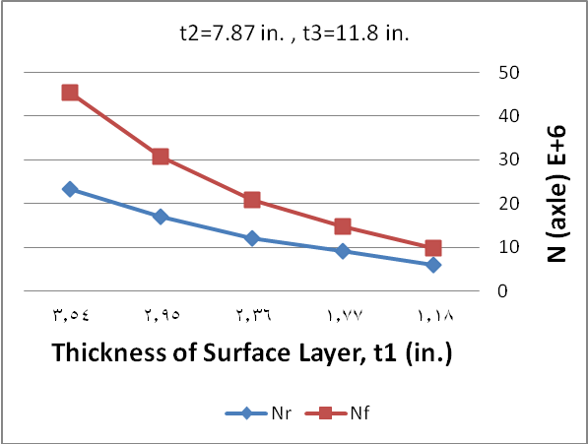
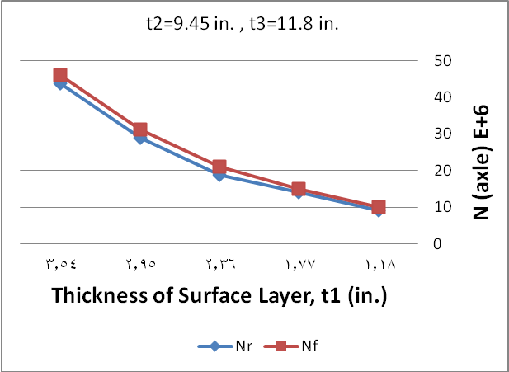

Figure (2): Effect of Thickness of Base Layer on Fatigue and Rutting Damage
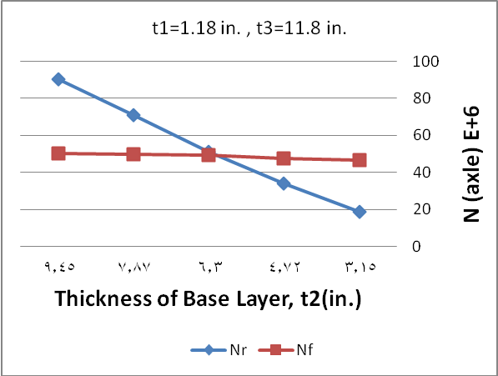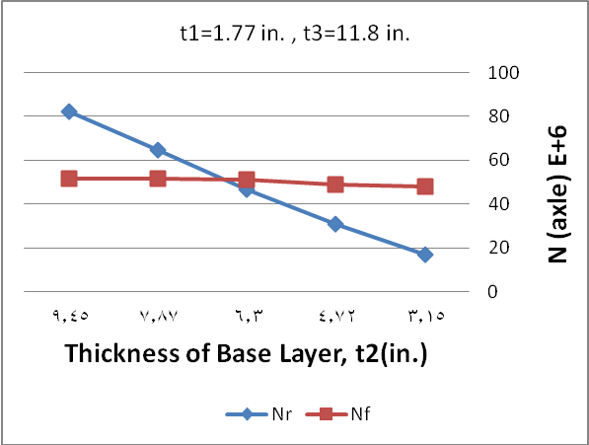
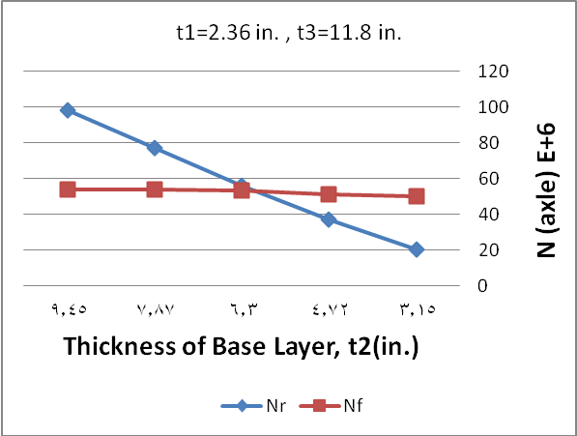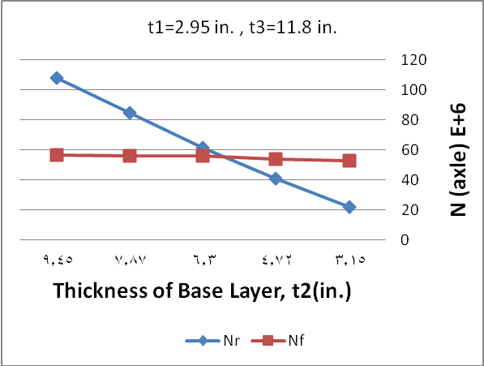
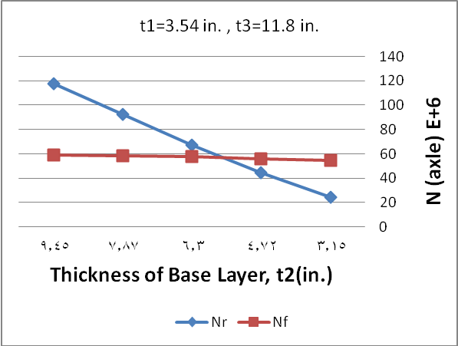
Figure (3): Effect of Elasticity Modulus of Surface Layer on Fatigue and Rutting Damage
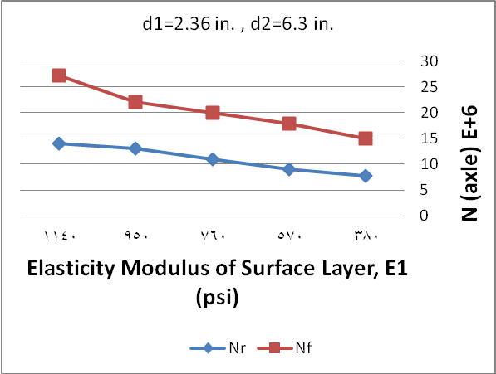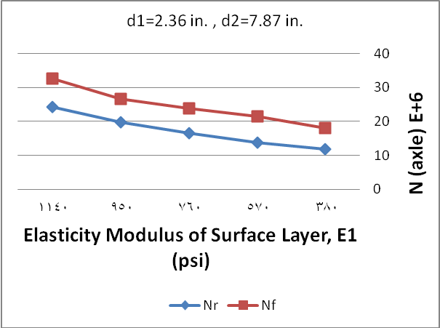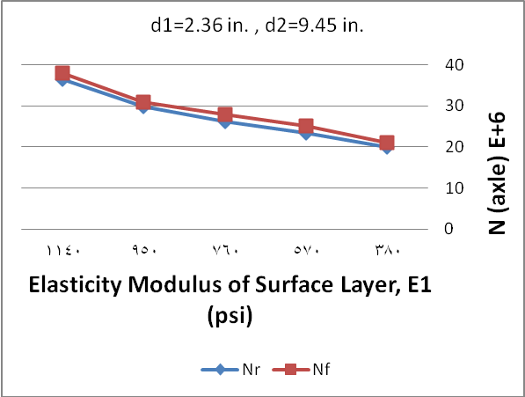
Figure (4): Effect of Elasticity Modulus of Base Layer on Fatigue and Rutting Damage
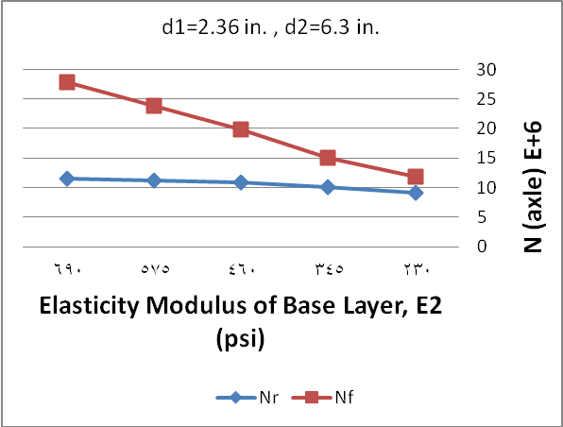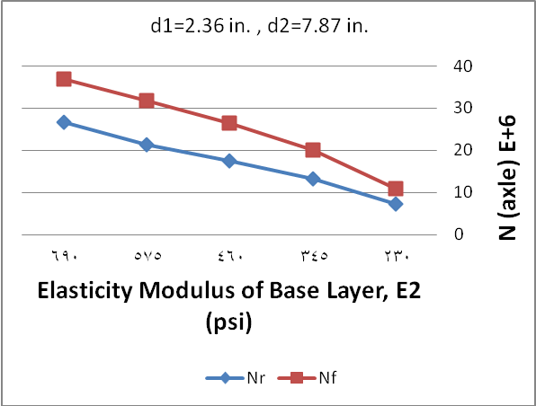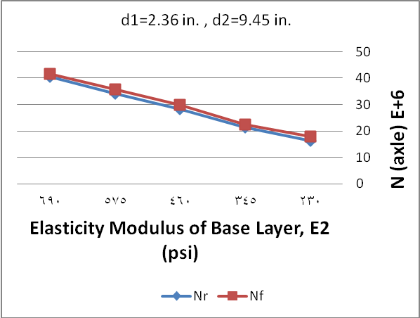
Figure (5): Effect of Elasticity Modulus of Subbase Layer on Fatigue and Rutting Damage
