Effect of Cooling Rate on the Phase Transformations Behavior and Hardness of NiTi Shape Memory Alloys

Nawal Mohammed Dawood Moqdad Juber
Babylon University, Collage of Materials Engineering
al_kazraji@yahoo.com M.J.AL.Mossawi@yahoo.com,
Abeer Sami, Hiba Adil
Babylon University, Collage of Materials Engineering
abeerssami@yahoo.com Hibaadil@yahoo.com
Abstract
NiTi alloy is well- known shape memory alloys and has been widely used for bio-medical, mechanical and electrical applications. In this study, a Ni - rich porous NiTi alloys are produced by powder metallurgy technique. Three samples of these alloys were cooled in three media: furnace, water, and ice bath. X-ray diffraction (XRD) was used in the study as characterization techniques, hardness measurement and shape memory effect (SME) properties were carried out to investigate the effect of cooling rate on phases and mechanical properties. XRD test shows that the sintered samples consist of three phases at room temperature (NiTi monoclinic phase, NiTi cubic phase and Ni₃Ti hexagonal phase) .The results show the correlation between cooling rate and properties of the alloy.
Key words: SMA, NiTi, Nitinol, Bio-medical applications, Ni₃Ti
الخلاصة
تعرف سبيكة NiTi بانها من السبائك ذاكرة الشكل وتستخدم بشكل واسع في التطبيقات الاحيائية الطبية والميكانيكية والكهربائية. في هده الدراسة حضرت سبيكة NiTi المسامية الغنية بالنيكل بتقنية ميتالورجيا المساحيق. بردت ثلاثة عينات من هده السبائك في ثلاثة أوساط: الفرن، الماء، الثلج. استخدمت تقنية حيود الاشعة السينية (XRD) لوصف الاطوار المتكونة. كما أجري اختبار فيكرز للصلادة وتأثير استعادة الشكل (SME) لمعرفة تأثير معدل التبريد على الاطوار والخواص الميكانيكية. أظهرت اختبارات XRD تكون العينات الملبدة من ثلاثة اطوار في درجة حرارة الغرفة (احادي الميل NiTi، الطور المكعب، NiTiالطور السداسي Ni₃Ti. أظهرت النتائج وجود علاقة بين معدل التبريد وخواص السبيكة.
الكلمات المفتاحية : سبائك ذاكرة الشكل، NiTi، نتنول، التطبيقات الطبية الاحيائية، Ni₃Ti.
1. Introduction
The nickel–titanium alloy was first developed in the 1960s. This alloy was named Nitinol, an acronym for the elements from which the material was composed (Ni for nickel and Ti for titanium) and the location for these investigations (nol from the Naval Ordnance Laboratory). Based on the equiatomic, intermetallic compound NiTi, the alloy composition used for the manufacture of NiTi instruments is about 55% Nickel and 45% Titanium (wt.%) [Liu,2009].Among the shape memory alloys (SMA),the NiTi compound exhibits the best thermo-mechanical characteristics. Because of the capability to recover apparently permanent deformations of about 8–10% by heating (shape memory effect), and its excellent super elasticity, with pseudo elastic field of 10–12% in strain,the Ni–Ti alloy is successfully applied in manufacturing of special devices for several industrial applications, and appears especially attractive in the biomedical field, since the possibility to make self-locking, self-expanding and self-compressing implants offers great opportunities for a vast number of applications, from vascular stents to orthodontic and surgical implants. In ordinary conditions,NiTi shows good biocompatibility due to the formation on its surface of a resistant titanium oxide layer, limiting the release of Ni ions, but the toxicity hazard remains a matter of concern [Barison et. al., 2004].NiTi alloy has been extensively studied and applied in the medical field since the initial discovery of its shape memory behavior and super elasticity. Porous NiTi shape memory intermetallic has recently become a central item of attention. It is usually used as hard tissue implants (such as artificial bone) because of its porous structure, good mechanical properties, high biocompatibility, shape memory effect (SME) and excellent super elasticity [Sadrnezhaad and Hosseini, 2009].The porous structure and related compressibility allow the transport of body fluids, and they are beneficial for the ingrowth of newborn bone tissue, making the fixation of implant more natural and reliable. Moreover, it is found that the mechanical deformation behavior of biological materials, which each has a high recovery of strain (≥ 2%) after deformation, is very different from that of common metallic materials [Yun et. al.,2000].In this sense, only the super elasticity of shape memory alloys, especially that of NiTi alloys, can satisfy this medical-mechanical requirement. Recently, intensive effort has been put to adopt the non-conventional production techniques such as powder metallurgy (PM), melt-spinning (MS)or twin roll casting (TRC)for manufacturing the NiTi-based alloys. The main advantage of the powder metallurgy is avoiding typical thermo mechanical treatment needed after conventional casting. However, powder metallurgy produces pore, which diminishes mechanical properties [Dawood, 2014].This research aims at investigating the effect of cooling rate on phases and mechanical properties of Ni-Ti shape memory alloys prepared by powder metallurgy.
2. Experimental procedures:
This include two steps:
- First step include the preparation of NiTi (55 wt. % Ni + 45 wt. % Ti) samples, sample preparation includes
a- preparation and mixing of powders
b- Compacting of powder
c- Sintering process in calibrated Electric tube furnace up to 1200 °C with quartz tube (0.025 m in diameter with 0.5 m length).
- Second step is the inspection and characterization of samples, including:
a- X – ray diffraction (XRD) test
b- Microstructure test by optical microscope test.
c- Vickers micro hardness test.
e- Shape memory effect properties test.
d- Porosity measurement.
2.1 Materials
The materials used to prepare NiTi alloy in this research are shown in Table1.
Table 1: purity and particle size of the powders.
Company | Average of particle size (µm) | Purity % | Metal powder
Bucks fluka  Aco. company | 141-216 | 99.9 | Ni
Fluke .Swiss  Made | 127.188 | 99.5 | Ti

2.2 Samples preparation:
The materials powder with (55wt. % Ni and 45 wt. % Ti) was weighted by using (Calibrated sensitive balance type (L220 S–D) with (0.0001%accuracy) German made.The powders were mixed in electric mixer,Alumina balls with different diameter have been used to mix and refine metal powder for six hours.
2.2.1 Compacting
This process involves compaction of the powders for each samples by using a die made of high alloy steel with die diameter of 14 mm. by using hydraulic press machine type (semetro Bco-113/1)which is located in the traditional ceramic laboratory in the ceramic department –engineering college in Babylon University. The powder was pressed under pressure of 450 MPa. Then samples with diameter 14 mm and 4 mm height were produced.
2.2.2 Sintering process
The sintering systems consist of a tube furnace,quartz tube and argon bottle as shown in Fig.1 that located at the University of Babylon–college of materials engineering. Samples were placed in quartz tube inside a tube furnace with the continued stream of inert gas (Argon) from the initial to final stage of sintering. The heating rate used was 25 °C/ min .The sintering process of all samples used in this research includs the followed heating cycles:
  - Heating green compacts from room temperature to 850°C.
  - Soaking time 9 hours at 850°C.
  - Slow cooling in the furnace with a continuous flow of argon to room temperature, Fig. 2 shows the sintered samples.
2.2.3 Heat treatment
After sintering, group one of samples heated up to (850°C) for (60 min) followed by quenching in water.Group two of samples are heated up to (850°C) for (60 min) followed by quenching in ice bath.
2.3 Preparation of samples for testing
All surfaces of the samples including the edges were wet ground using 120, 220, 320, 600, 1000, 1200 and 2000, grit silicon carbide papers. Then these samples were rinsed in distilled water, then polished with diamond past of 6 µm to get a bright mirror finish for the final step.Then these samples degreased with acetone. After drying, these samples were stored in Zip -lock bags. The dimensions of samples were measured and recorded.
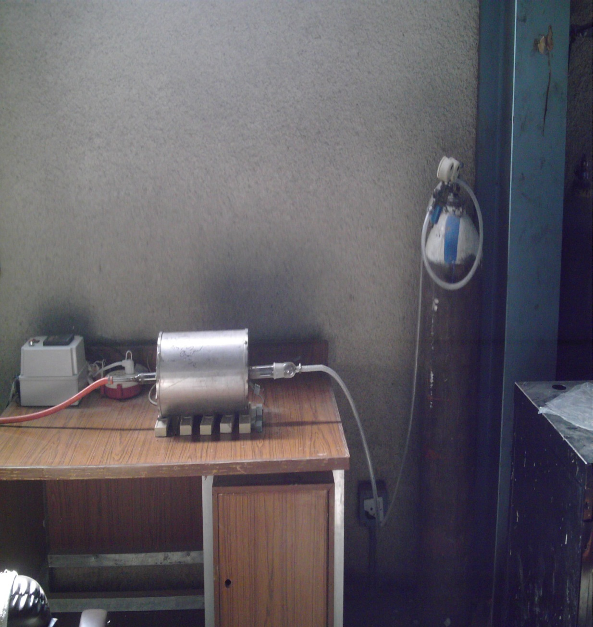
Digital controller
Tube furnace
Quartz tube
Argon cylinder

Fig. 1: The tube furnace used in this study.
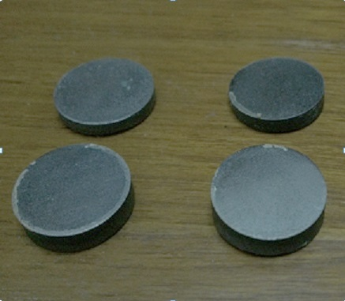

Fig. 2: Sintered samples.

2.4 Tests
2.4.1 Particle size analysis
Particle size and its distribution of elemental powders are determined for Nickel and Titanium in the ministry of sciences and technology by using Diffraction particle size analyzer by lasers named (shimadzu – sald -2101).
    - X-Ray Diffraction analysis
Phase's analysis of prepared sample is based upon X-Ray diffraction technique and microstructure examination using scanning electron microscope with different magnification. X-Ray diffraction method is used to define the phases of all samples (without and with heat treatment). A Riga Ku X-ray generator with Cu K α radiation at 40 KV and 20 mA was used. The X-ray is generated by general electrical diffracttometer, type (Minifcex II, Rgaku -200g- Japan made) operating at a scanning speed of 6° (2ɵ) per minute. The detector was moved through an angle of 2ɵ= 0 to 100 degrees. The XRD analysis was carried out in State Company for Inspection and Engineering Rehabilitation.
2.4.3 Hardness Measurements
Vickers hardness method was used to measure the hardness of the sintered samples at loading 2.0 N held for 10 seconds, and the value of hardness has been taken for three times in different places along the surface of each sample and the average of three readings has been taken to get the hardness value. This test is achieved by using Vickers hardness testing machine type (Fv 800 FUTURE-TECH Tester made in Japan).
2.4.4 Microstructure Examination
The microstructure for the samples was observed by using optical microscopy type (MMM-800RF) which is located in metallurgical laboratory in materials engineering college.
2.4.5 Porosity Measurements
It is measured by using Archimedes method (depending on weighing of sintered samples) and as follows [Hussein, 2011]:
- The weight of dry sample is measured.
- The sample is placed in a beaker of distilled water for 24 hours. The weight of wet sample is measured.
- After impregnation of the tested sample, suspended mass is measured when the sample is suspended in water.
- The sample is cleaned with cotton cloth to remove all excess water from its surface. Immediately the sample is weighted to determine the saturated mass.
- Porosity was measured by the following equation:
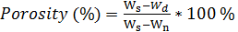……………………………... (1)
Where:
W_{s} = weight of sample after immersing it in the distilled water for 24 hours.
W_{d} = weight of the dry sample after sintering.
W_{n} = weight of immersed sample in the distilled water and suspended in air.
2.4.6 Shape memory effect
Shape memory effect is determined from Vickers impression. At first the average diameter before heating was measured then after the temperature raised to 80 ºC, then the average diameter after heating has been measured [Sadeq, 2013].
……………………. (2)
Where:
= average impression diameter in (μm) before heating.
= average impression d
3. Results and Discussions
3.1 Particle size measurements
Figs.3 and 4 show the particle size distribution of Ti,Ni powders respectively. It is evident that the average size of the powder was around 127.188 µm for Ti,141.0-216.0µm for Ni respectively. Different particle size ranges are preferred for good compacts and for good properties of the final sintered products [Anna and Janus, 2011].
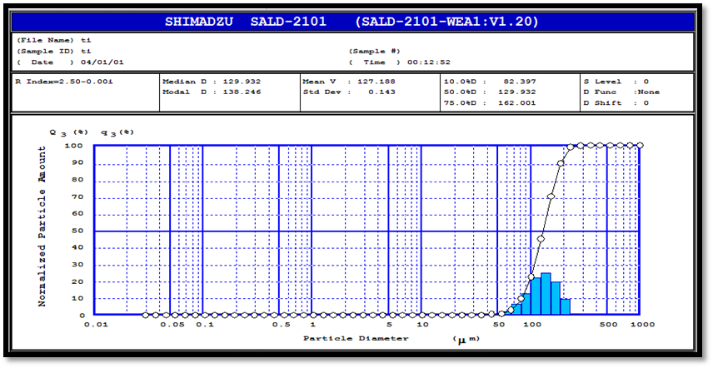

Fig. 3: Particle size distribution of Ti powder used in this Study.
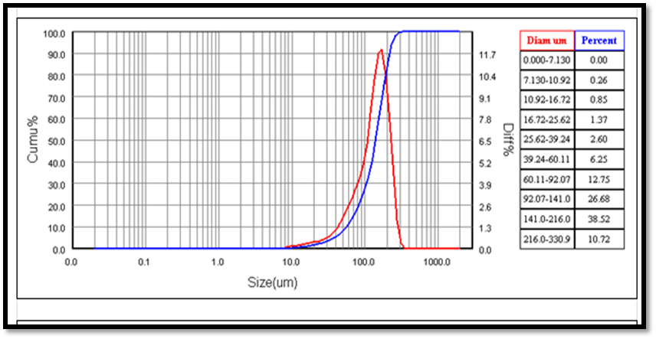

Fig. 4: Particle size distribution of Ni powder used in this study.
3.2 XRD Patterns
After preparing the samples, X-ray diffraction test was done for all samples Figs. 5,6 and 7 are the diffraction patterns obtained for the tested samples from which the phases could be detected.
The phases produced because of the sintering process and heat treatment was investigated using XRD technique. It is seen from figures 5,6 and7,that there are probably no pure metals present which proves that the sintering time and temperature used in this work result in complete sintering reaction. The above-mentioned Fig.5 shows that the samples compacted at 450 MPa consist mainly of two phases;the martensitic phase (monoclinic) and the austenitic phase (cubic), in addition to Ni₃Ti. The formation of Ni₃Ti might be attributed to the slow cooling of samples within the furnace.The suggested reactions during the process are as follows [Yun et. al., 2000] [Al - hasani, 2007].
Ni + Ti → NiTi ∆G: - 67 KJ / mol …….… (3)
Ni + Ti → Ni₃Ti ∆G: - 140 KJ / mol ……... (4)

According to the binary phase diagram of NiTi system. NiTi and Ni₃Ti are stable compounds and reaction (4) is more thermodynamically favored than reaction (3). It is also found from Fig.5,the absence of any oxides that is attributed to the controlled argon atmosphere used during the sintering process. Figs.6 and 7 show the XRD pattern for the samples after the heat treatment. It is clear from this figure that the three phases NiTi monoclinic phase,NiTi cubic phase and Ni₃Ti hexagonal are still visible but,with a significant decrease in Ni₃Ti hexagonal phase and strongly increased in NiTi monoclinic phase. This leads to enhance the shape memory properties for the alloy. The results are similar to results in [Sadeq, 2013].

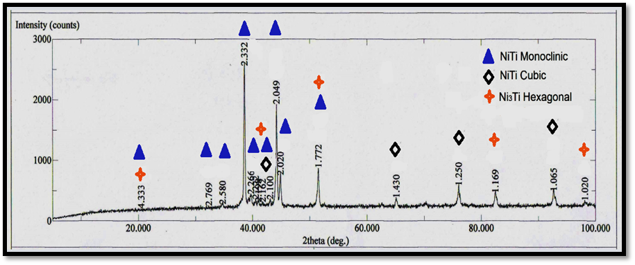

Fig. 5: XRD pattern of sample after sintering at 850 °C for 9hours cooling in furnace.
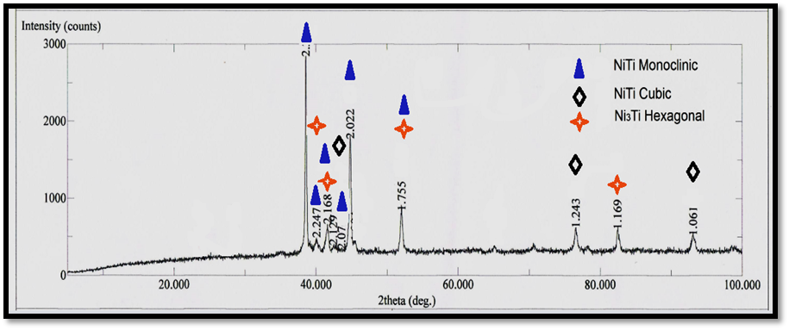

Fig. 6: XRD pattern of sample after sintering at 850 °C for 9hours followed by quenching in water.
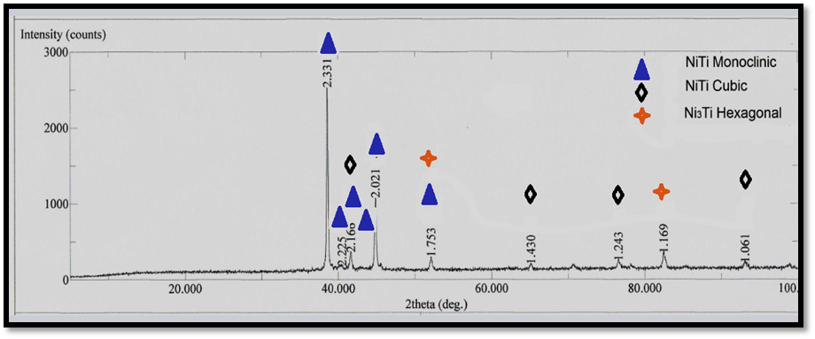

Fig. 7: XRD pattern of sample after sintering at 850 °C for 9hours followed by quenching in ice bath.

3.1.3 Porosity Percentage
The porosity percentages of the prepared samples are extracted by Archimedes method. The obtained results are presented graphically in Fig.8 which shows that the porosity percentage for the samples quenched in water or ice bath is lower than that cooled in the furnace because of the rapid cooling rate [Motemani, 2009].
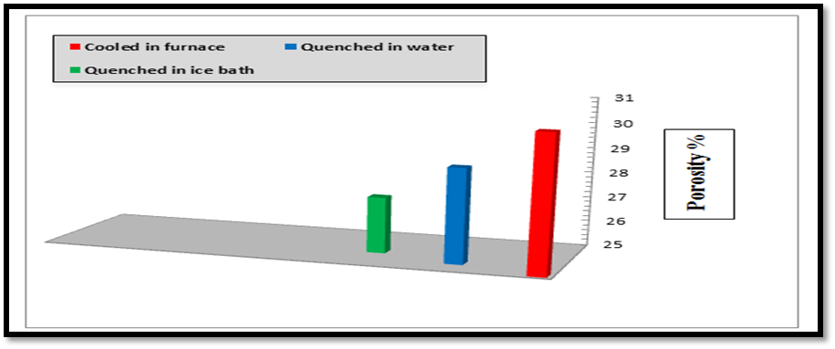

Fig. 8: Porosity percentages for the samples used in this study.
3.1.4 Vickers Hardness
The evolution of hardness as a function of cooling rate is presented in Fig.9.The results indicate that the hardness of the furnace –cooled sample is lower than that of others. This phenomenon can be attributed to the lower cooling rate of furnace-cooled sample [Motemani, 2009;Hussein, 2011].
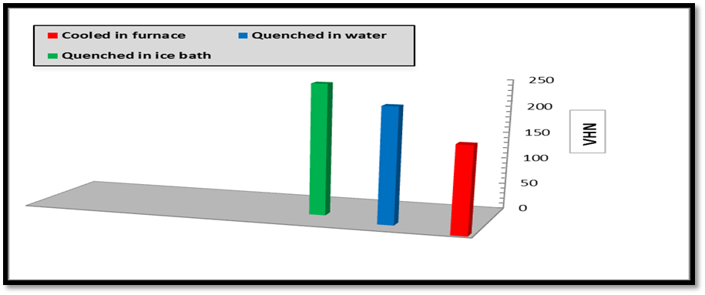

Fig. 9: Vickers micro hardness for all samples.
3.1.5 Shape memory effect properties
Shape memory effect properties of the samples are presented graphically in Fig. 10.It is clear from this figure that the SME for samples increased by increasing cooling rate because of elimination of porosity.

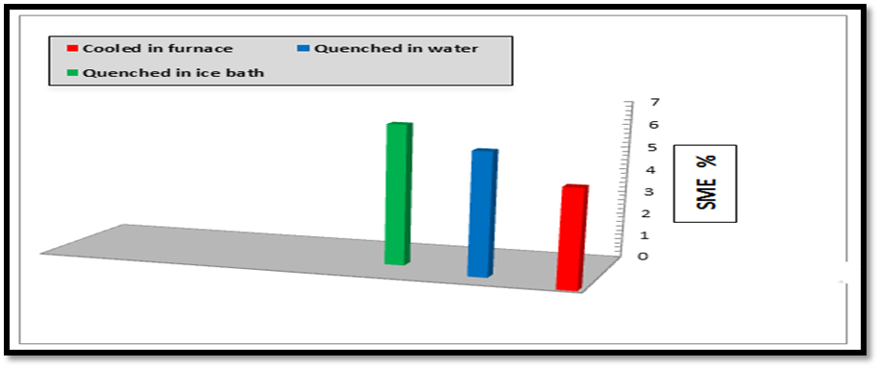

Fig. 10: SME properties for all samples
3.1.6 Microstructure observation
One of the examinations that have been done is the microstructure image by light optical microscope. Pores of different size are irregular but have been rounded. From Figs .11 b and 11 c that the pore size is small for samples after heat treatment.
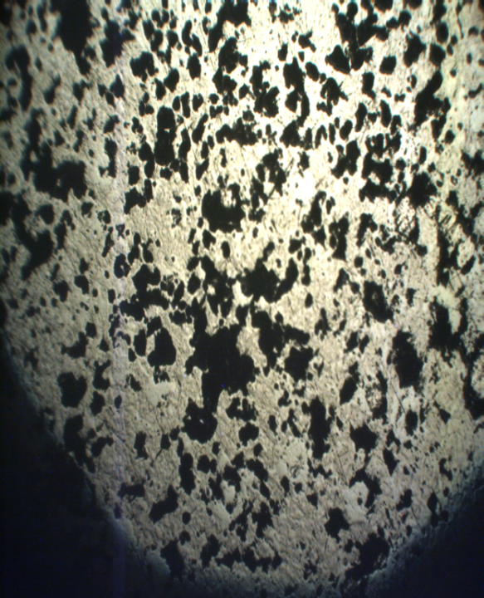
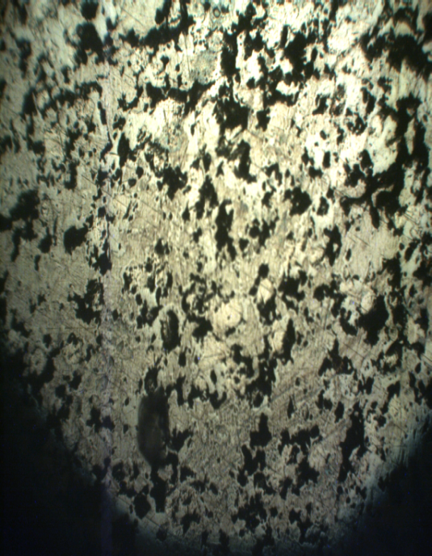
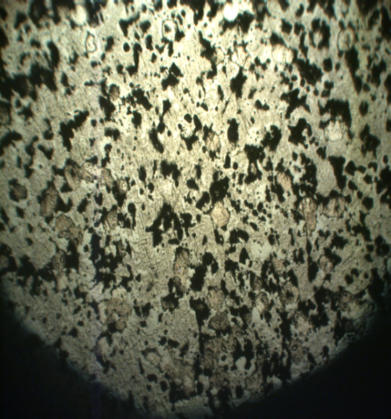
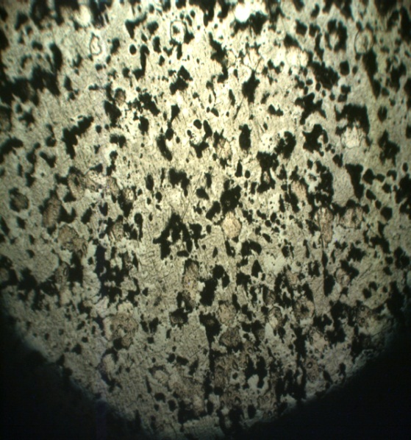
a
c
b
a
c
b

Fig. 11: Optical microscope images for all samples: (a) Cooling in furnace
(b) Quenched in water (c) Quenched in ice bath

4. Conclusions
Based on the obtained results, the following conclusions are made:
- The sintering at 850°C for 9 hours of samples (without and with heat treatment) is efficient to satisfy sintering completely and transformed Ni,Ti into alloy structure.
- The sample (cooling in furnace) compacted at 450 MPa and sintering at 850°C for 9 hours resulted in a three-phase structure (NiTi monoclinic phase,NiTi cubic phase and hexagonal Ni₃Ti phase) at room temperature while, the samples after heat treatment also resulted in the same three phases .
- The increase in cooling rate (quenched in water and ice bath) resulted in decreasing the porosity compared to the alloy cooled in furnace.
- There is distinguished increase in SME properties obtained from hardness test for the prepared NiTi alloy with the increase in cooling rate (quenched in water and ice bath) compared to the alloy cooled in furnace.
- The increase in cooling rate (quenched in water and ice bath) resulted in increasing the hardness compared to the alloy cooled in furnace.

5. References
Al - hasani, E.S.,2007,"Preparation and corrosion behavior of NiTi shape memory alloys", Ph. D. Thesis, University of technology.
Anna,M. and Janus,S.O.,2011,"Biomedical-Engineering,trends,Research and technologies ", in tech, Croatia.
Barison,S.Cattarin,S. and Daolio,S,2004,"Characterization of surface oxidation of nickel–titanium alloy”, Electrochemical Acta, VoL. 50, pp. 11–18.
Dawood, N. M.,2014,"Preparation & Characterization of Coated & Cu alloyed Bio Nitinol ",Ph. D. Thesis, University of technology.Fabricated from Special Thermo mechanically Processed NiTi Wire,Ph. D.Thesis, Ohio State University.
Hussein, R.A.,2011,"The role of Ta and Nb Additions on the transformation temperature of NiTi shape memory alloy", MSC. Thesis, University of technology.
Liu, J, 2009, Characterization of New Rotary Endodontic Instruments
Motemani, Y., Ahmad M. A. and Tan M.,2009," Effect of cooling rate on the phase transformation behavior and mechanical properties of Ni-rich NiTi shape memory alloy ", Journal of alloys and compounds, Vol. 469, pp. 164 - 168.
Sadeq, M. A., 2013,"Corrosion behavior of biocompatible coatings of porous NiTi shape memory alloy, Ph. D. Thesis, Production engineering and metallurgy department, university of technology.
Sadrnezhaad,S.K. and Hosseini S.A.,2009,"Fabrication of porous NiTi-shape memory alloy objects by partially hydride titanium powder for biomedical applications”, Materials and Design, VoL. 30, pp. 4483–4487.
Yun,B.,Jian L.and Yili,Y.,2000," Stress-strain behavior of porous Ni-Ti shape memory inter metallic synthesized from powder sintering ", inter metallic Vol. 8, pp. 643 - 646.

