Effect of Addition of (Cement- Silica Dust) Mixture on Compaction and Unconfined Compressive Strength of Soil
Basim Thabit Al-Khafaji
University of Babylon/College of Engineering
Department Of Civil Engineering
ba.th88@yahoo.com
Abstract
That to deal with soils that have problems such as (swelling, sponge behavior ( Fatigue ), hydraulic consolidation and cracks) in a way reinforced concrete is very expensive, but the treatment of these soils in a way added stabilizers local is acceptable, available, inexpensive, give acceptable strength, improve soil properties such as durability and exposure to environmental conditions and used in most countries of the world. This investigation is conducted to study the effects of the mixture (cement- silica dust) on the bearing and stabilizing soils, study the effect of different times of maturation of the specimens (7, 14, 28) days at constant temperature (26 - 30) oC and study the effect of the conditions of inundation specimens with water on Unconfined compressive strength. (cement- silica dust) Were used by a mixture of them (1:1), Foure levels of addition were used (4%, 8%, 12%,16%) of the weight of dry soil. All specimens were exposed to same curing condition ( curing temperature 26- 30 ºC). Different curing times were (7,14,28) days and some of specimens were exposed to inundation conditions. The experimental results illustrate that the maximum dry density (M.D.D) and plastic index (P.I) decrease with the addition of mixture, but the optimum moisture content (O.M.C) is increases with increasing of the mixture content. Unconfined compressive strength increases with increase of curing time but it decreased with and without of the mixture (C-SL) when the specimens exposed to inundation condition for all curing time.
Keyword: ceramic powder; compressive strength; cement mortar; Drying Shrinkage Cracks; density

الخلاصة
إن معالجة الترب التي تحتوي على مشاكل مثل ( التخسفات، الروطان، (التصرف الاسفنجني) (Fatigue)، الانتفاخ (Swelling) والانضمام المائي (Hydraulic consolidation) ) بطريقة الكونكريت المسلح ( reinforcement concrete) مكلفة جداً ، لكن معالجة هذه الترب بطريقة إضافة المثبتات المحلية والمتوفرة مقبولة وغير مكلفة وتعطي مقاومة مقبولة وتحسن من خواص التربة مثل الديمومة والتعرض للظروف البيئية وهي مستعملة في أغلب دول العالم. هذا البحث يهدف إلى دراسة تأثير الخليط ((الاسمنت- غبار السليكا) على تحمل واستقرارية الترب. حيث تم استخدام خليط منهم بنسبة ( 1:1) ، أما نسب الإضافة لهذا الخليط ( % 16 , % 12 , % 8 , % 4) من وزن التربة الجافة، و تأثير اختلاف زمن الإنضاج للنماذج ( 28, 14,7) يوم عند درجة حرارة ثابتة (26 – 30 ) ºC وأيضا دراسة تأثير ظروف غمر النماذج بالماء على مقاومة الانضغاط اللامحصور.أظهرت النتائج إن الكثافة الجافة العظمى(M.D.D) ومؤشر اللدونة (P.I) يقل تقل عند اضافة المادة الخليط (السمنت وغبار السليكا)(cement- silica dust) . محتوى الرطوبة الأمثل) (O.M.C) يزداد بزيادة محتوى الخليط (السمنت مع غبار السليكا ). بينما زيادة فترة الإنضاج ( (curing time) تزيد من مقاومة الانضغاط اللا محصور للنماذج مع أو بدون إضافة الخليط لكنها تقل عند تعرض النماذج لظروف الغمر بالماء ولكل فترات الإنضاج المختلفة.
كلمات المفتاحية: مسحوق السيراميك؛ مقاومة الانضغاط؛ ملاط السمنت؛ تشققات انكماش الجفاف؛ الكثافة.
Introduction
Many of the problems of soil and their effects are the main factor in the concern for scientists and researchers for the deposit of successful solutions to these problems as (Cracks, swelling, and the soil is stable), for treatment through technical means and simple, and does not have a high cost and impact is very clear and to improve the impact of satiability from the soil.
Was the first use of this stability in the state of California, 1935, wherever it is used in the cement industry as the active substance and stability where its main impact of low permeability, swelling and shrinkage and increase the strength and durability of the shear of the soil, so there was the use of chemical methods and physical, to the stability of the soil such as polymers used, lime and bitumen in achieving stability, such as other methods to achieve mechanical stability, and fillers, soil reinforcement.
( Eskioglon and Efthmions , 2000) state that the adding of composite materials (Nacl – lime– soil), (cement –lime) and (fly ash, lime, soil ) to different Soil in North of Japan gives good stabilization up to(% 6- % 8) by weight of dry soil, improve plastic density, strength, moisture content, and results state the adding (cement – lime) for plastic soil increase the strength up to (17 kg/cm2) but not improve the another properties .(Andromalose et al.,2002) study of the stability of the soil is weak as well (cement - soil columns) state that it gives results up to a successful outcome (23%) in the state of Florida, where the mixture is used (cement-soil). Improve worker safety and strengthen the basis static load.
(Wang et al.,2003) study of the effect of the adding the mixture (cement-lime), (Granulated Blast furnace slay) and (Class C Fly ash) for sulphat soil in north Are zana in (USA).
(Al-Tai,2005) study the effect of adding of ratengic material(Resorcinol Network, resol, Resol resins). The results state that it caused increasing in unconfined compressing strength, density, plastic and shear strength and its cost was lower than the another additives.
Experimental Work
Soil:
Siltyclay Soil class (CL) according to unified soil classification system and (AASHTO) (A-6) was used in this study . It brought from a site in Hilla weast south. The physical and chemical properties are listed in table (1).
Table (1) Chemical And Physical Properties Of Soil Used.
No. | Soil Properties % |  | Value
 | Moisture content % |  | 33
 | Specific Gravity |  | 2.70
 | Atterberg  Limits | L.L % | 38
 | Atterberg  Limits | P.L % | 23
 | Atterberg  Limits | P.I % | 15
 | Gran size of Soils | Sand % | 11
 | Gran size of Soils | Silt % | 38
 | Gran size of Soils | Clay % | 51
 | AASHTO |  | A-6
 | Sulphate % |  | 0.153
 | Carbonate % |  | 36
 | Gypsum % |  | 0.31
 | Chloride % |  | 0.017
 | PH |  | 7.6
 | Organic Matter % |  | 1.16
Silica:
The silica dust used throughout the research brought from general company of Gelogical Mining and survey in Baghdad. Which is delivered the local material form Al-sufra in western desert. It added to the soil as a dry powder. The physical and chemical analysis for it are given in Tables (2) and (3).

Table (2 ) Chemical Properties Of Silica Dust Used
Chemical ompound | Percent of total weight
SiO₂ | 98.5
Al₂O₃ | 0.67
Fe₂O₃ | 0.093
CaO | 0.54
MgO | 0.04
SO₃ | -
Ma₂O | 0.039
K₂O | 0.028
Table (3 ) Hydrometer Analysis of silica dust used
Diameter of articles ( µ) | Percent of finer particles
68 | 100
48 | 98.17
35 | 97.74
24 | 97.73
15 | 97.73
9.0 | 95.93
6.5 | 90.5
5.0 | 77.83
3.0 | 41.63
1.0 | 21.73
Cement:
Ordinary Portland cement from AL–Kuffa cement factory used. Its physical and chemical properties are give in Tables (4) and (5).
Table (4 ) Physical Properties Of OPC Used
Physical properties | Test Result | I.O.S.5: 1984 limits ASTM e143-89
Finercss, blain m2 /kg | 332.81 | 230
Sitting time  Initial hrs:min  Final hrs: min | 1: 30  2: 45 | 00:45  10: 00
Compression strength of 700 mm Cube MPa  3day  7day | 16.8  27 | 15  23
Soundness %  (Auto clave ) method | 0.5 | 0.8
Table (5 ) Chemical Properties Of OPC Used
Oxide | (%) | I.O.S.5: 1984 limits ASTM e143-89
 | 60.9 | -
CiO2 | 20.88 | -
 | 5.56 | -
 | 3.36 | -
 | 3.75 | 5%
 | 2.63 | 2.8%
Free lime | 0.65 | 4.0%
L.O.I | 1.86 | 4%
Compound Composition | (%) | I.O.S.5: 1984 limits ASTM e143-89
 | 37.72 | -
 | 31.7 | -
 | 9.04 | -
 | 10.22 | -
L.S.F | 0.07 | 0.66 – 1.02
Preparing Sample :
The soil mixed with limited levels for mixture (silica dust–cement) with homogeneity method after dried and crushed, Then the water added which was limited from known optimum moisture content (O.M.C) for standard Proctor tests the specimens prepared to test unconfined compressive strength by special mold, then were put in water box with constant temperature for purpose to curing (7, 14,28) days. The submerge specimens were put in water for (24 hours) after finishing the curing time, then all specimens were tested for unconfined compressive strength Atterberg limits, compaction and classification according to (ASTMD 2487-85), three results average were taken for all tests.
Results and Discussion
Soil Description:
The soil was (Silty clay Soil), low plasticity having impurities materials, colour ( bright brown ), class (CL), density (1:68 gm/cm³) and (O.M.C) (19.7 %) .
Atterberg Limits Tests:
The Atterberg limits test results of Soil specimens made with and without admixture are given in table (6) and Fig.(1)
Table (6) Atterberg Limits Test Results For Soil Specimens Made With And Without Admixture .
Admixture content % | L.L % | P.L % | P.I
0 | 38 | 23 | 15
4 | 37 | 24 | 13
8 | 37 | 26 | 11
12 | 36 | 27 | 9
16 | 35 | 28 | 7

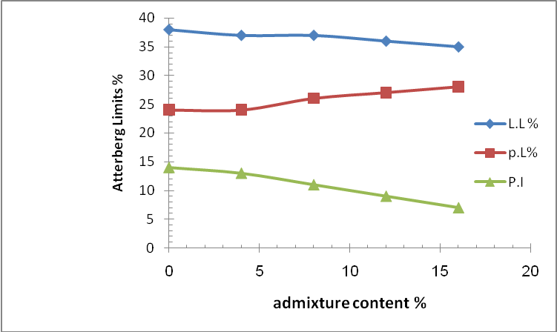

Fig. (1): Atterberg Limits Test Results For Soil Specimens Made With And Without Admixture .
The results showed that plasticity index is decreasing with adding the admixture. All happened changes in (P.I) were due to minerals soil containing which has a property for high plasticity .
Compaction Tests:
The compaction tests results for all specimens are given in table (7) and figures (2,3) The results were showed decreasing in (maximum dry density) for soil with the addition of the mixture.at (16%) the optimum moisture content(O.M.C) tincreasesclearly for the with increasing the admixture contents, This behavior is due to the strong connection between the molecules of cement, clay, water by chemical action.
Table (7) Moisture content and Maximum Dry density Results Test For Soil Specimens Made With And Without of Admixture .
Admixture content % | Maximum Dry density( M.D.D)  kg /cm² | Moisture content %
0 | 1.602 | 17.82
4 | 1.580 | 17.99
8 | 1.565 | 18.11
12 | 1.570 | 19.23
16 | 1.577 | 19.17

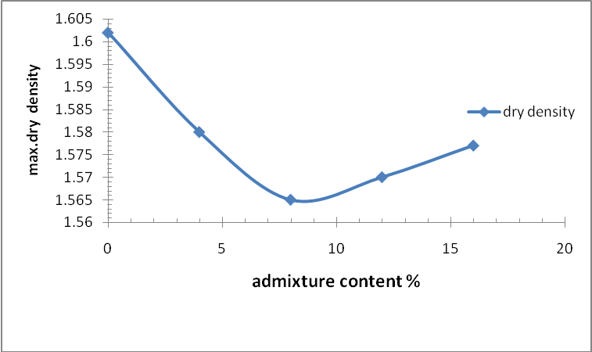
Fig. (2) :Effect of the admixture on maximum dry density (M.D.D) for soil specimens .

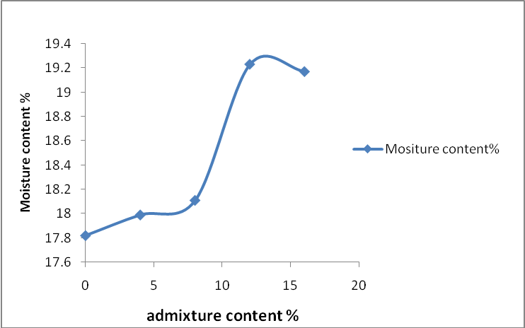

Fig. (3) :Effect of the admixture on optimum moisture contents (O.M.C) for soil specimens .

And there was a difficult sliding for the molecules during a compaction but the physics action more active where cement content increases.
The increasing of optimum Moisture content (O.M.C) is due to for cement demand to connection with mix water.
(AL-Qaisee, 2004 , Saca and et al, 2004) reached to these results.
Unconfined Compressive Strength With Different Curing Time ( 7, 14, 28) Day:
The specimens preparing at maximum dry density and (O.M.C) by standard compaction test.
The test results for unconfined compressive strength are given in Table(.8) and Fig.(4).
Table ( 8) Unconfined Compressive Strength Test Result With Different Curing Time For Soil Specimens Made With And Without of Admixture .
Admixture content  % | Unconfined compressive strength  Kg/ cm²
Admixture content  % | Curing time ( days)
Admixture content  % | 7 | 14 | 28
0 | 1.25 | 1.49 | 1.52
4 | 7.3 | 10 | 17
8 | 13 | 24 | 29
12 | 18 | 31 | 38
16 | 21.5 | 35 | 47

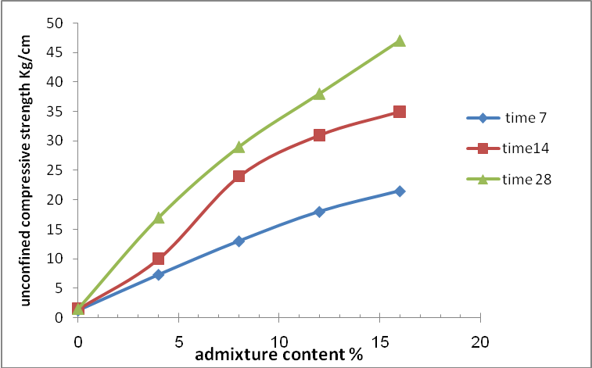

Fig. (4): Effect Of The Curing Time On Unconfined Compressive Strength For Soil Specimens Made With And Without Of The admixture
From these results it can be noticed that the unconfined compressive strength increasing with increased the admixture content and curing time, this increasing ratio is listed in Table (9).

Table ( 9) : Percentage Change In The Unconfined Compressive Strength Tests Results Due to The Adding of Admixture And Increasing of Curing Time.
Admixture content  % | Change in unconfined compressive strength for all specimens with admixture compared with control specimens  % | Change in unconfined com. St. for specimens with curing time ( 28) with compared with specimens at curing time (7) days  %
0 | 0 | 21.6
4 | 484 | 132.8
8 | 940 | 123
12 | 1340 | 111
16 | 1620 | 118.6
Unconfined compressive strength test results for submerged specimens with curing time (28) days From table (10) and Figure (5) It can be seen that the influence of the submerge decreases the unconfined compressive strength for all ratio admixture with curing time (28) days.
Table (10): Effect Of The Submerge On Test Results Of Unconfined Compressive Strength For Specimens Made With And Without Of Admixtures .
Admixture content  % | Unconfined compressive strength kg/cm²
Admixture content  % | Curing time ( 28 ) day
Admixture content  % | Without submerge | Submerge
0 | 1.52 | 0
4 | 17 | 15.8
8 | 29 | 25
12 | 38 | 32
16 | 47 | 44

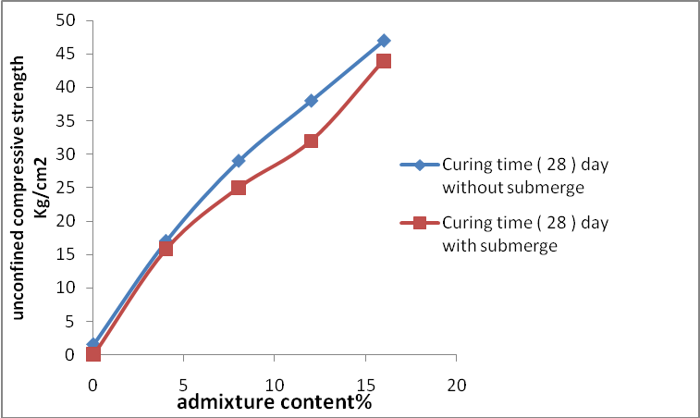
Fig. (5): Effect of the submerge on unconfined compressive strength for soil specimens made with and without of the mixture
Conclusion
- Maximum dry density (M.D.D) decreases with increasing of the content of admixture while the Optimum Moisture content (O.M.C) increases.
- Plasticity index for soil specimens decreases with increasing of the content for the admixture.
- Unconfined compressive strength increases with increasing of the curing time and the admixture content.
- Unconfined compressive strength decreases when the specimens with and without of admixture submerges in water with curing time (28) days.
References
AL- Qaissee, A.E.,2004," The effect of (sand–Cement) mixture on the swelling characteristics of compacted clayey soil "M.Sc. thesis, civil engineering department, college of engineering Al- Mustansiria university. P.76.
Al- Tai , M.A. J. , 2005, " Improvement of Barsah Soil using polymer Rosins " ph. D. Thesis in Engineering Geology, Science college, Basrah university, Iraq. P. 181.
Andromalos, K.B., Hegazy, Y. A. and Jasperse, B.H., 2002,"stabilization of soft soils by soil mixing".PP.1-8. ttp// : www brayman environmental. com/ pdf / stabilization "
ASTM D2166-82,1986, " standard Test Method for , unconfined compressive strength of cohesive soil " Annual Book of ASTM standards Vol, 04,08.
ASTM D2487- 1993 " standard Test method for classification of soil Engineering Purpose " Annual Book of ASTM standards Vol, 04, 08.
ASTM D4318- 84,1986," standard test Method for liquid limit, plastic limit, and plasticity Index of soils" Annual Book of ASTM standards Vol, 04. 08.
Eskioglou , P., and Elthymion, P.N., 2000," Alternative stabilization Methods of Forest Roads for An EAicient and Genlte ". Aristotle university of Thessaloniki , Greece. pp. 1-6.
"Iraqi" Organization of standards, IOS", 5:1984, Specification of Portland Cement.
Saco, Z.M, 1965," Soil– cement stabilization in Iraq" M.Sc. Thesis, civil Engineering Department Baghdad University, Iraq. P.92.
Wang,I.,Roy,A.,Seals, R,K.,and Metcalf,J.B.,2003,"stabilization at sulfate– containing soil, By cementations Mixtures"Paper revised form original submitted TRB Annual Meeting CD- Rom.PP.5–24. http:// www.Itrc.Isu.edu/TRB-82/ TRB-2003- 001724.

