Design, Simulation and Analysis of New Optical Beamforming Matrix

Saad Saffah Hassoon Hreshee Qais Kareem Omran Al-Gayem
Electrical Engineering Dept., Collage of Engineering, University of Babylon
saadalkhazali@yahoo.com qaiskareem@yahoo.com
Abstract:
Beamforming (beam-steering) is an advanced technique of the Space Division Multiple Access (SDMA). In the beam-steering network, an array of antennas elements are spatially filters incoming signals based on their arrive time at each element.
This paper presents a new design of true time delay beamforming technique based on using Fibre Bragg Grating (FBG) and controlled photonic circulator in a new scheme. The simulation applies a True Time-delay beamformer to an 8-elements linear phased array antenna to obtain 16 deferent beams.
A single-beam optical beamforming system was proposed and analysed. Optical beamforming network has been considered for 16GHz (Ku band). The system was studied and their results were presented at two different levels: the first is the system architecture and the second is the optical control devices for controlling the beamforming networks.
The mathematical simulation used to clarify the operation of the proposed systems. A MATLAB programs on the proposed signal model based on the proposed scheme are applied to get the results. Some results are presented to validate the performance of the proposed schemes. The results show efficient utilization of the new beamformer for real-time operation.
Keywords:- Optical, Beamforming, Antenna, Phased Array, Bragg Grating, FBG
الخلاصة
تشكيل الموجات هي تقنية متقدمة من تقنيات التقسيم الفراغي المتعدد الوصول (SDMA) حيث ان مصفوفة من الهوائيات تعمل كمرشح موجات فراغي بالاعتماد على ضبط الوقت لكل عنصر من المصفوفة. وبدونها فأن الإشارة تصل الى المصفوفة بشكل عمودي، علما ان تحديد التوقيتات يختلف اعتمادا على جهة وصول الإشارة.
هذا البحث يعرض تصميم جديد لمنظومة توجيه وتأخير في الوقت الحقيقي تعتمد على استخدام ألياف براغ المقضبة (FBG) والخاضعة لسيطرة من خلال مدور ضوئي في شكل جديد. تم اجراء محاكاة لمنظومة التوجيه للتأخير في الوقت الحقيقي لمصفوفة هوائيات خطية ذات 8-عناصر للحصول على 16 حزمة من الارسال.
تم اقتراح وتحليل منظومة ذات حزمة واحدة. اذ تعمل المنظومة المقترحة بالضوء كحامل للإشارة ذات التردد (16GHz) في منظومة تشكيل الموجات. كما أجريت دراسة نظرية للمنظومة وعرضت نتائجها على مستويين مختلفين: الأول هو بنية النظام، والثانية هي أجهزة المراقبة البصرية للتحكم في الشبكات.
استخدمت المحاكاة الرياضية لتوضيح عمل المنظومة المقترحة. اذ تمت المحاكات باستخدام لغة البرمجة (MATLAB) من خلال برامج للموديل الرياضي للإشارة المقترح للمنظومة المقترحة. النتائج التي وردت تعطي تقييم أداء للمنظومة المقترحة. وأظهرت النتائج كفاءة استخدام الموجه الجديدة للتشغيل في الوقت الحقيقي.
الكلمات المفتاحية: ضوئي، تشكيل موجة، هوائي، مصفوفة طورية، حزوز براغ.
- Introduction
Photonic True Time Delay (PTTD) beamformer was considered as a favourable technique for wideband Phased Array Antenna (PAA) systems (Saad, 2007; Parker and Zimmermann, 2002) and there are many studies in this field (Saad, 2013; and Eldek, 2006).
Modern wireless communication systems often require wideband performance for multi-function and multi-channel operations. One of the most important components of these systems is phased array antenna because of its ability to steer the beam very fast by an appropriate inter-element phase control (Liu and Weiss, 2010). Using fibre grating delay lines is an effective way to reach PTTD beamformer (Saad, 2007;Chen and Lu, 2008 and Saad, 2013).

Ideally, phased array antenna system needs to be wideband with large scanning angle. Such system has to be composed of wideband radiation elements with stable radiation patterns of acceptable gain, low cross polarization, and high front-to-back ratio (Eldek, 2006). The maximum steering angle is within (-3dB) beamwidth of the antenna co-polarized pattern, therefore wide (3dB) beamwidth is important characteristic of the array element. Researchers have carried out a lot of effort to design wideband elements with stable patterns and wide (3 dB) beamwidth for phased arrays [Saad, 2007; Saad, 2013; Eldek ,2006 and Petermann ,2007).
Array beamforming (beam steering) techniques are used to produce multiple, simultaneously main beams. The main beams can be realized to have controlled-beam width (low side lobes and high gain). In beam steering, a single beam of the array is directed and the direction can be varied either in small discrete steps or continuously (Eldek, 2006).
Fiber optics is the only technique known today to have the power to meet the strong demands for flexibility and high bandwidth posed by the rapidly growing communication networks. One of the key elements in many components for optical communication -active as well as passive- is the Fibre Bragg Grating (FBG). These gratings interact with the light in the fibre by means of mode coupling, and by tailoring grating parameters such as modulation depth and period, advanced functionalities can be achieved (Saad 2007; Saad ,2013 and Eldek, 2008).
Analogue Beam-steering has advanced to a digital format. Performing beam-steering in a digital domain rather than analogue at RF or Intermediate Frequency (IF) leads to many benefits.(1)The control of the radiation pattern correctly at high frequencies.(2) The direction and the shape of the beam can be changed fast. (3) Rapid re-configurability allows the employment of adaptive algorithms, beam scanning and self-adjustment.(4) Multiple beams can be generated simultaneously. Multiple beams generation can be used, as an example, multipath discrimination. In analogue beam-steering, the propagation time differences between array elements are compensated with time delays whereas in DBF it can be accomplished by controlling the amplitudes and phases (Saad ,2007; Liu and Weiss, 2010 and Godara, 1997).
- Signal model
Figure (1) display a Uniform Linear Array (ULA) beam-steering network. Beam-steering network or beamformer consists of N omnidirectional antenna elements with distance d between elements.

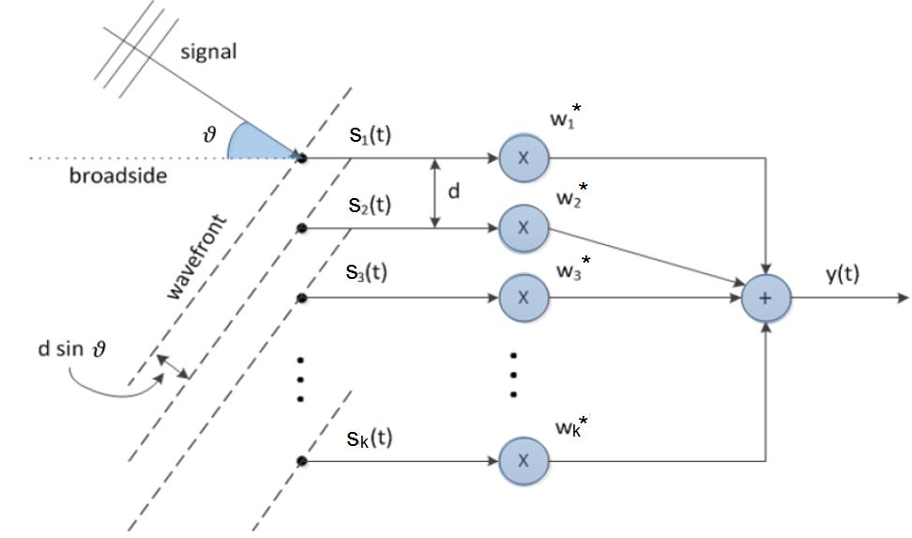
Fig 1. Uniform linear array with a beam-steering network (Liu and Weiss 2010)
The delay time for an incident signal from the first antenna to the k^{th} element, with direction of arrival (), is:
(1)
where c is the light speed and is the impinging angle, (Liu and Weiss, 2010).
The incident wave is supposed to be a complex plane wave as below:
(2)
where x_{n}(t) is the nth signal
The incident wave arrives at the kth element after seconds after the first element.
Hence, the induced signal on each array element due to the nth source is:
(3)
The overall signal, s_{k}(t), induced due to the noise on the k^{th} element and signal of N sources and, is given by
(4)
where n_{k}(t) is the k^{th} element noise.
The white Gaussian noise is the supposed noise. At different antenna elements, the noise is independent (Godara, 1997).
The beam-steering network output specified in (1) above in vector format as:
(5)
where w is the vector of weights, [·]^{H} represents the complex conjugate (Hermitian) transpose. With K complex factors vector of weights is given as:
(6)
where [·]^{T} represents the transpose and s is the vector of the induced signals on all the elements as:
(7)
The mean output power of the beam-steering network is
(8)
where E{·} represents the expectation operator and R is the correlation matrix, which is stated as:
(9)
Through manipulation algebra of (4), (7) and (9), the array matrix, R, can be written as:
(10)
where p_{i} represents the i^{th} source power measured at the array elements, represents the i^{th} source steering vector, is the noise variance of the k^{th} element and I represents an identity matrix. The correlated matrix can be stated as:
(11)
where matrix G involves of steering vectors as:
(12)
and S is the correlated matrix of the sources (Godara 1997).
The beamforming vector g_{i}(ω) is given by:
(13)

- Phased-Array Antenna Calculations
The typical PAA architecture is shown in fig.(2).The proposed PAA (see fig.(3)) consists of an 8-element array of 8-microstrip antennas that operates at . The spacing between elements are half the wavelength of the operating frequency (). The total scan range is 180°, which is divided into 16 different beam directions that can be addressed by the system (see fig.(4-b)). The beam width of the PAA is 11.25° (180°/16 =11.25°). The progressive time delay between the signals of the antenna elements can be calculated by dividing the scanning area into 16 deferent zones.
- Proposed Scheme
In this paper, the beamformer used with six different fibre Bragg gratings (see fig.(4)) to get 16 deferent paths (fig.(5)). Each path provides deferent length and so that deferent delay line. Each delay line provides single radiated beam.
The numbers inside the circulators represent the factor of the delay time (1t, 2t, 4t, 6t, 9t and 11t). In this configuration, all the delay lines will obtained. For example in the first beam the signal with 8 wavelengths must pass through zero time delay line that means all the circulators (A, B, C, and D) stay in forward moving (state 00) to get (t = 0 s).
Let’s take beam no. 6 as another example, the signal must pass through a delay line of time delay (see table (3)) which is obtained by setting the circulators (A-up (01), B-forward (00), C-up (01), D-forward (00)). Table (1) will illustrates the final representation of all cases while table 2 illustrates the mathematical representation of 16 cases.
Each delayed signal has the mathematical representation below:
(14)
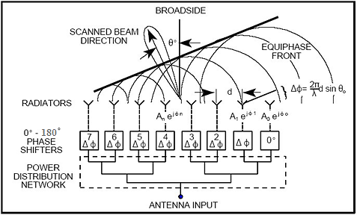
Fig. 2. Typical phased-array antenna architecture (Vidal et. al. 2012).
Digital States Generator
Optical Source Generator

Splitter (Demux) 1×8

FBG1
FBG2
FBG3
FBG4

FBG5

FBG6

Multi-wavelength Laser Source
MZM
RF signal
Beamforming network

Fig. 3. Proposed phased array antenna system

Table 1. Final representation the circulators state each beam of the 16 beams
Beam no. | STATUS  (Forward=00, Up=01, Down=10)  (digital format)
Beam no. | A | B | C | D
1 | 00 | 00 | 00 | 00
2 | 01 | 00 | 00 | 00
3 | 00 | 01 | 00 | 00
4 | 01 | 01 | 00 | 00
5 | 00 | 00 | 01 | 00
6 | 01 | 00 | 01 | 00
7 | 10 | 00 | 00 | 00
8 | 01 | 01 | 01 | 00
9 | 10 | 01 | 00 | 00
10 | 00 | 10 | 00 | 00
11 | 01 | 10 | 00 | 00
12 | 00 | 00 | 10 | 00
13 | 01 | 00 | 10 | 00
14 | 00 | 01 | 10 | 00
15 | 01 | 01 | 10 | 00
16 | 10 | 10 | 00 | 00

Table 2. Mathematical representation of all 16 cases
Beam No. |  | Beam No. |  | Beam No. |  | Beam No.
1 | 1 | 5 |  | 9 |  | 13
2 |  | 6 |  | 10 |  | 14
3 |  | 7 |  | 11 |  | 15
4 |  | 8 |  | 12 |  | 16
1
2
3
4
180 /16=11.25º
θ
Spacing=λ_{o}/2
=9.375mm
D=λ_{o}/2
=9.375mm
5
6
7
8
1
2
3
4
5
6
7
8
9
10
11
12
13
14
15
16
FBG1
1
FBG2
2
FBG3
4
0
0
0
FBG4

6
FBG5

9
FBG6

11
A
B
C
D

(a)
(b)

Fig. 4. (a) The proposed delay lines based on Fiber Bragg Gratings (FBG), (b) Schematic radiation pattern representation of the proposed phased-array antenna.

- Calculation of Time Delays and Simulation Results
The wavelengths are connected to antenna element 1, 2, 3, to 8, respectively. Table (3) shows the calculated absolute time delays required when the PAA is radiating in the upper-most direction (beam 1 in fig.(4-b), ), and in the lower-most direction (beam 16 in fig.(4-b), ).
From the above limitations (beam 1 in , and beam 16 in ), the absolute compensation delay is 31.1ps (0º-90º) (see table 3) and the path-length differences can be calculated considering the group velocity of the waveguide structure.
Table 3. Calculated time delay between the signals of the antenna elements of the proposed 16 different beam directions.
Beam no. | 1 | 2 | 3 | 4 | 5 | 6 | 7 | 8
[ps] | 3.06 | 9.07 | 14.72 | 19.82 | 24.15 | 27.55 | 29.90 | 31.10
Beam no. | 9 | 10 | 11 | 12 | 13 | 14 | 15 | 16
[ps] | 31.10 | 29.91 | 27.58 | 24.18 | 19.85 | 14.77 | 9.11 | 3.11

The variable time delays have been found by calculating the difference in time delay between beam 1 and beam 16 for each wavelength (which is 62.2 ps), and then splitting this difference in the ratio 1:2:4:6:9:11, which will be the ratio in 6 different delay lines for each wavelength.
The compensation delay is determined when the variable delay of each wavelength is zero, i.e. when all the switches are set to bypass (00 case). At this setting, it has been chosen that the PAA should radiate beam 1 (θ is 5.625º in figure 5), which means that the relative delays between the different wavelengths should be 3.06ps. From this value, the absolute compensation delays (see table 4) and the path-length differences can be calculated considering the group velocity of the waveguide structure.
Table 4. Variable absolute delays in [ps] for the different wavelengths.
 | λ₁ | λ₂ | λ₃ | λ₄ | λ₅ | λ₆ | λ₇ | λ₈
1st time delay | 3.06 | 9.07 | 14.72 | 19.82 | 24.15 | 27.55 | 29.90 | 31.10
2nd time delay | 6.12 | 18.13 | 29.45 | 39.63 | 48.30 | 55.10 | 59.80 | 62.19
3rd time delay | 12.25 | 36.27 | 58.90 | 79.27 | 96.59 | 110.21 | 119.59 | 124.39
4th time delay | 18.37 | 54.40 | 88.35 | 118.90 | 144.89 | 165.31 | 179.39 | 186.58
5th time delay | 27.55 | 81.60 | 132.52 | 178.35 | 217.33 | 247.97 | 269.09 | 279.88
6th time delay | 33.68 | 99.74 | 161.97 | 217.98 | 265.62 | 303.07 | 328.88 | 342.07
The total delay for each wavelength will be the sum of the compensation delay plus the variable delay (see table 5).
Table 5. The total delay for each wavelength [ps]
Beam no. | λ₁ | λ₂ | λ₃ | λ₄ | λ₅ | λ₆ | λ₇ | λ₈
1 | 0 | 31.1 | 62.2 | 93.3 | 124.4 | 155.5 | 186.6 | 217.7
2 | 3.06 | 40.17 | 76.92 | 113.12 | 148.55 | 183.05 | 216.50 | 248.80
3 | 6.12 | 49.23 | 91.65 | 132.93 | 172.70 | 210.60 | 246.40 | 279.89
4 | 9.18 | 58.30 | 106.37 | 152.75 | 196.84 | 238.16 | 276.30 | 310.99
5 | 12.25 | 67.37 | 121.10 | 172.57 | 220.99 | 265.71 | 306.19 | 342.09
6 | 15.31 | 76.43 | 135.82 | 192.38 | 245.14 | 293.26 | 336.09 | 373.19
7 | 18.37 | 85.50 | 150.55 | 212.20 | 269.29 | 320.81 | 365.99 | 404.28
8 | 21.43 | 94.57 | 165.27 | 232.01 | 293.43 | 348.36 | 395.89 | 435.38
9 | 24.49 | 103.64 | 179.99 | 251.83 | 317.58 | 375.92 | 425.79 | 466.48
10 | 27.55 | 112.70 | 194.72 | 271.65 | 341.73 | 403.47 | 455.69 | 497.58
11 | 30.61 | 121.77 | 209.44 | 291.46 | 365.88 | 431.02 | 485.59 | 528.67
12 | 33.68 | 130.84 | 224.17 | 311.28 | 390.02 | 458.57 | 515.48 | 559.77
13 | 36.74 | 139.90 | 238.89 | 331.10 | 414.17 | 486.12 | 545.38 | 590.87
14 | 39.80 | 148.97 | 253.62 | 350.91 | 438.32 | 513.68 | 575.28 | 621.96
15 | 42.86 | 158.04 | 268.34 | 370.73 | 462.47 | 541.23 | 605.18 | 653.06
16 | 45.92 | 167.10 | 283.06 | 390.55 | 486.62 | 568.78 | 635.08 | 684.16

- Calculation of Delay Line Lengths
The delay line lengths that calculated by using the following equation are shown in table 6 below:
(15)
where t_{delay} represents the delay time, c is the velocity of light, and N_{group} is the group effective index of the InP waveguide. The group effective index is around 3.6, and this is the value that was used to compute the delay line lengths. Table 6 below shows the calculated delay line lengths.
Table 6 Calculated delay line lengths (m).
Beam no. | λ1 | λ2 | λ3 | λ4 | λ5 | λ6 | λ7 | λ8
1 | 0.00 | 2.59 | 5.18 | 7.78 | 10.37 | 12.96 | 15.55 | 18.14
2 | 0.26 | 3.35 | 6.41 | 9.43 | 12.38 | 15.25 | 18.04 | 20.73
3 | 0.51 | 4.10 | 7.64 | 11.08 | 14.39 | 17.55 | 20.53 | 23.32
4 | 0.77 | 4.86 | 8.86 | 12.73 | 16.40 | 19.85 | 23.02 | 25.92
5 | 1.02 | 5.61 | 10.09 | 14.38 | 18.42 | 22.14 | 25.52 | 28.51
6 | 1.28 | 6.37 | 11.32 | 16.03 | 20.43 | 24.44 | 28.01 | 31.10
7 | 1.53 | 7.13 | 12.55 | 17.68 | 22.44 | 26.73 | 30.50 | 33.69
8 | 1.79 | 7.88 | 13.77 | 19.33 | 24.45 | 29.03 | 32.99 | 36.28
9 | 2.04 | 8.64 | 15.00 | 20.99 | 26.47 | 31.33 | 35.48 | 38.87
10 | 2.30 | 9.39 | 16.23 | 22.64 | 28.48 | 33.62 | 37.97 | 41.46
11 | 2.55 | 10.15 | 17.45 | 24.29 | 30.49 | 35.92 | 40.47 | 44.06
12 | 2.81 | 10.90 | 18.68 | 25.94 | 32.50 | 38.21 | 42.96 | 46.65
13 | 3.06 | 11.66 | 19.91 | 27.59 | 34.51 | 40.51 | 45.45 | 49.24
14 | 3.32 | 12.41 | 21.13 | 29.24 | 36.53 | 42.81 | 47.94 | 51.83
15 | 3.57 | 13.17 | 22.36 | 30.89 | 38.54 | 45.10 | 50.43 | 54.42
16 | 3.83 | 13.93 | 23.59 | 32.55 | 40.55 | 47.40 | 52.92 | 57.01

Figures (5-a to 5-d)) show four examples of the obtained radiation patterns of the simulated beams of an eight-elements (N=8) PAA with a physical separation of half-wavelength (9.375mm) elements of spacing d=λ/2=9.375mm between elements and various phase shift.
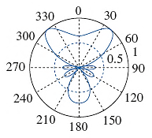 | 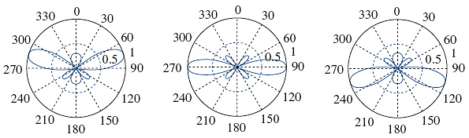
(a) | (b)
 | 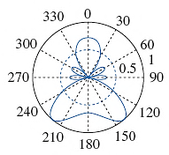
(c) | (d)
Fig. 5. Four examples of the obtained radiation pattern of 8-elements PAA. (a) Beam no. 4 with (), (b) Beam no. 7 with (), (c) Beam no. 10 with (), (d) Beam no. 13 with ().
- Conclusions
The purpose of the paper was to improve a restructuring antenna array to steering the output beam of the transmitter or receiver. By employing directional antenna, many performance developments are conceivable in the radio networks.
Phased array antenna systems has the ability to steer the beams instead of switching between fixed beams. Another factor studded in this paper, which is the model of the signal. This model show that the improved array could be realized in several shapes of which the ULA was selected. The whole radiation pattern of the array was effected by the radiation pattern of each element, this process known as pattern multiplication. The results show that the array performance is depend on the element spacing, number of elements, amplitude illumination, and scan angle.
In this paper, a new beamforming architecture has been proposed and studied due to their potential to fulfil the requirements when a single highly directive beam switched antenna is employed.
The use of optical beamforming networks based on the optical Fiber Bragg Gratings (FBGs) has been considered for the 16 GHz frequency band (Ku band). Single-beam option has been considered and detailed architectures have been proposed for an 8 element array. The proposed beamformer are valid for transmitting and receiving modes.
The results show that the 16 beams could be determined by changing the path length of the signal by using photonic circulators and FBGs.
- References
Chen,Q. and Lu,P.,2008,“Fiber Bragg Gratings and Their Applications as Temperature and Humidity Sensors”, Atomic, Molecular and Optical Physics, Chapter 6, Nova Science Publishers, Inc., pp. 235-260.
Eldek, A. A., 2006,“Pattern stability optimization for wideband microstrip antennas for phased arrays and power combiners”, Microwave Opt. Tech. Lett., Vol. 48, No. 8, 1492-1494.
Eldek, A. A., 2008,“A double rhombus antenna fed by 180 degree phase shifter for ultra wideband phased array applications” , IEEE Trans. Antennas Propagat., Vol. 56, No. 6, 1566-1572.
Godara, L.C., 1997,“Application of antenna arrays to mobile communications, part II: beam-forming and direction-of-arrival considerations”, Proceedings of the IEEE 85, pp. 1195–1245.
Liu, W. & Weiss S.,2010, “Wideband beamforming concepts and techniques”. John Wiley and Sons, Hoboken, NJ, first Ed.
Parker, D. and Zimmermann D.C.,(2002),“Phased arrays-Part I:Theory and architectures”, IEEE Trans. Antennas Propagat., Vol. 50, No. 3, 678-687.
Petermann,I.,2007,“Fiber Bragg Gratings: Realization, Characterization and Simulation”, Doctoral Thesis in Physics, Royal Institute of Technology, Department of Microelectronics and Applied Physics, Stockholm.
Saad,S.H.,2007,“Design and Simulation of Optically Controlled Phased Array Antenna and Antenna Steering”, Ph.D. Thesis, Basra University.
Sajuyigbe,S., Ross,M., Geren,P., Cummer,S. A., Tanielian M.H., and Smith D. R.,2010,“Wide angle impedance matching metamaterials for waveguide-fed phased-array antennas”,IET Microw. Antennas Propag., Vol. 4, Iss. 8, pp. 1063–1072,
Saad, S. H.,2013,“LMS Algorithm for Optimizing the Phased Array Antenna Radiation Pattern”, Journal of Telecommunications, Volume 22, Issue 1.
Saad, S.H.,2013,“Neural Network for Evolving and Optimizing Phased Array Antenna”, Proc. Of Conf. on Control, Communication and Power Engineering, Elsevier, pp. 514-519
Vidal, B., Mengual, T., and Mart, J., 2012, “Fast Optical Beamforming Architectures for Satellite-Based Applications”, Hindawi Publishing Corporation, Advances in Optical Technologies, Volume 2012, pp. 1-5 Article ID 385409.

