A GIS Assesment of Water Quality in Euphrates River/Iraq
Hussain M.Salman Mahdi N.Jasim
College of Material Engineering/University of Babylon College of IT/University of Babylon
hus12m@yahoo.com mnjisd@yahoo.com
JasimM.Salman
College of Science, University of Babylon.
jasimsalman67@yahoo.com
Abstract:
The research deals with assessment of water quality of Euphrates River which passes through the middle of Iraq, samples were taken from three sites on river. The distance covered by these sites is about (30)km (between Al Mussayeb and Al Hindiya cities). In these sites, the river suffers from different sources of pollution. The paper included a study of some physical, chemical, and biological properties (Water Visibility, salinity, electrical connectivity, pH, DO, BOD₅, and Chlorophyll). The results are analyzed by using the GIS which requires building a network database which is linked to GIS to make benefit from its analysis power and geographical distribution of data across the study area. The clear data display enables the environment interests of understanding and interpreting the actual results and responding by taking actions the preserve the natural features of the river and its dependences accordingly. The database used to keep tracking the physical, chemical, and biological pollutants and archiving their behavior through the time.
Keywords: Environmental assessment, Water pollutants, Euphrates River, GIS.
الخلاصة:
يتناول البحث تقييم نوعية المياه في نهر الفرات وسط العراق، حيث تم أخذ عينات من ثلاثة مواقع على النهر.المسافة التي تم دراستها خلال هذه المواقع حوالي (30) كم (تقع بين قضاء المسيب وقضاء الهندية). في هذه المواقع، هنالك مصادر مختلفة من التلوث. تضمن البحث دراسة بعض الخصائص الفيزيائية والكيميائية والحياتية (شفافية المياه، والملوحة، والتوصيل الكهربائي، ... الخ) والكيميائية. تم تحليل النتائج باستخدام نظم المعلومات الجغرافية (GIS) الأمر الذي يتطلب بناء شبكة قاعدة بيانات ترتبط بنظام المعلومات الجغرافية للاستفادة منها في التوزيع الجغرافي للبيانات خلال منطقة الدراسة. خلال هذه الدراسة يتم عرض واضح للبيانات حيث تمكن المهتمين بالبيئة من فهم وتفسير النتائج الفعلية والاستجابة لها من خلال اتخاذ إجراءات في الحفاظ على المعالم الطبيعية من النهر والاعتماد على هذه النتائج. استخدام قاعدة البيانات الـ GIS توفر امكانية متابعة مصادر التلوث الكيميائية والحياتية الفيزيائية ورصدها وتحجيمها خلال فترة زمنية وجيزة.
الكلمات المفتاحية: تقييم بيئي ، تلوث مياه ، نهر الفرات ، نظم المعلومات الجغرافية .
Introduction:
The water is one of the most important resources in our life and without it, life becomes impossible and many aquatic organisms show sensitivity to physical and chemical changes in aquatic environment which they live (Wetzel,2001). So water should be preserved from different types of polluters. In Iraq, there are some newly projects and procedures established to conserve water resources and this monitoring project is one of them. The river loses about (30%) of its rates because of the dams in Turkey and Syria, the countries which the river passes through before Iraq, and the heavy use of its water (Salman,2006). The water quality should be kept in acceptable standards to suit agricultural, human using, and industrial purposes. This requires a set of procedures that based on scientific rules (Cooper,2011). The chemical processes used to treat water can affect water quality in a water distribution system (WDS). However, these processes occur over time, making the hydraulic residence time or water age in WDSs a potentially critical factor influencing water quality. Researchers are discovering that treatment and distribution are equally important in maintaining fresh water for consumers. Water age analysis using hydraulic models has become a reliable surrogate for water quality evaluation (Wang et al.,2008). So the new GIS(Geographic Information System) technologies are used to facilitate collecting, archiving, and analysis(Donia,2011). Geographic databases, satellite and scanned images, and digital elevation model (DEM) data are being used to refine the databases for water quality modeling (Lee and White,1992).GIS may be provide a biological model using data from a series of experimental campaigns that measured the concentrations of pollutants in biological elements and water column(Al-Malikey,2009). The GIS also enables the team to display the data on different scales and views to be understandable by the environment and water responsible figures to support the project continuity, especially the use of GIS that is new technology in Iraq.
Research Objectives:
The research aims to monitor the water Quality of Euphrates River and preserve its parameters in acceptable rates by keeping the polluting factors in the minimal values using the latest available technologies. This aim requires periodical data collection, analysis, and sending the results to the top managements of water resources, and environment monitoring authorities to issues legislative facilities and lows that keep the water from the sewage, industrial waste, Agricultural waste and other pollutants.
System structure:
- The system architecture consists of three modules; the first is the data collection stations that positioned on the river.
- The second unit is GIS unit, which is the core unit; it consists from the spatial database unit, Geographical data processing unit, and map projection.
- The third is the decision-making unit, which used to issue the required procedures that grant keeping water quality and preserving the biological life of the river. Figure (2) shows the main system units.
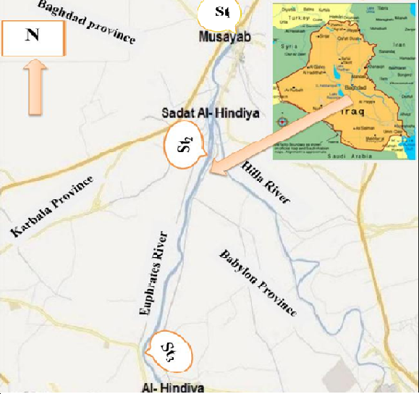
Figure 1. Map of Euphrates River
As shown in figure (2). The system consists of three data reading stations laid on the Euphrates River. The data is offline transferred to the spatial database designed to hold the data for archiving and analysis purposes. The database designed using SQL-Server to suite the installation in website built for that purpose.
The GIS unit consists of ARC GIS 10 (Desktop) used to analyses the data using its facilities in drawing and making charts to be more understandable by high management analysts and presenting geographical distribution along the river.
The map analysis unit consists of a set of river maps related to the study area and the distribution of the physical, chemical, and biological factors of river water. This unit also used to transform the analysis results to multiple data formats to distribute them among the interested agencies like ministries of agriculture, water resources, and environment to share ideas and procedures to improve water quality and preserve environment. It worthy noted that the quality of vector maps used in the system was poor which make the analysis results more difficult, but it is the first often these maps used for this purpose, so it needs more revisions.
Study Area Description
As indicated in the map of figure 1, the study area is a middle section of Euphrates River in Iraq, through the provinces of Babylon and Kerbalaa, the coordinates of each station depicted in figure 2.
Map Analysis
Unit
Station 2

Station 1
Station 3

Spatial DB
GIS Unit
Decision Making Unit

Figure 2. The System Architecture
Results & Discussions:
Analysis of Collected Data
The collected data displayed on the river map to help the analysts to determine the causes and sources of water pollution and trying prevent them and enhance water quality for human, animal agriculture, and industry consumption. In the following section, the chemical, biological and physiological data analysis are presented.
The data collected from the period from October 2011 to August 2012 in the middle section of the River of Iraq (the deepest part).
1-Biological Oxygen Demand (BOD₅)
The parameter BOD₅ is the amount of dissolved oxygen needed by aerobic biological organisms in a body of water to break down organic material present in a given water sample at certain temperature over a specific time period. This is not a precise quantitative test, although it is widely used as an indication of the organic quality of water(Salman et al.,2013). The BOD value is most commonly expressed in milligrams of oxygen consumed per liter of sample during 5 days of incubation at 20 °C and is often used as a robust surrogate of the degree of organic pollutants of water(APHA,2003). Figure (4) shows the behavior of BOD in the Euphrates River for the three stations.
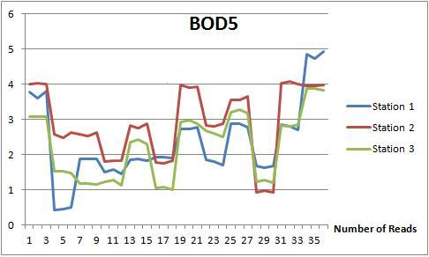

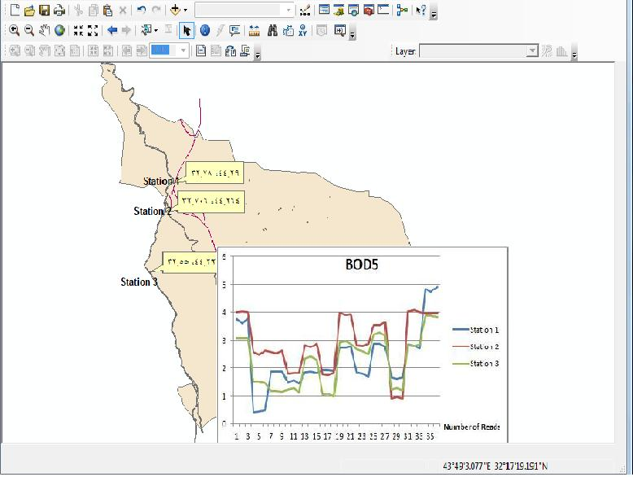
Figure 3. The behavior of BOD between the three stations on the Euphrates River.

It's clear that station 2 recorded the highest values of BOD, because of station2 location lies behind Al- Hindiya dam that leads in decrease of water flow of the River that leads to growth of water plants that cause the increase of BOD in water(Donia,2011). At the same time, the water level at station1 is the higher, so the water plants level is decreased.The concentration of dissolved oxygen was affected by many factors especially biological activities such as photosynthetic, respiration, and decomposition process at the river bottom in addition to the rainfall effects (Salman and Hussain,2012).The dissolved oxygen concentration was found to be within the (5 - 9) mg/l, which was limited for drinking water
2-Chlorophyll
The chlorophyll level in River water is described in figure 2. Chlorophyll-a is used as an indicator of phytoplankton abundance and primary productivity (Hassan et al., 2008). Phytoplankton abundance is related to natural cycles in nutrient availability and to the input of phosphate and nitrate. Excess phosphate and nitrate can come from groundwater or water treatment plants and sewer overflow (Al-Yassiry and Salman, 2014). Excess nutrients can cause blooms of phytoplankton, which can contribute to bottom water anoxia under stratified conditions(Salman et al.,2013 )
As depicted in figure 4, the chlorophyll level of the three stations explains the degree of River water pollution caused by the discharge of wastewater and plants nutrients (Hassan et al.,2010) .

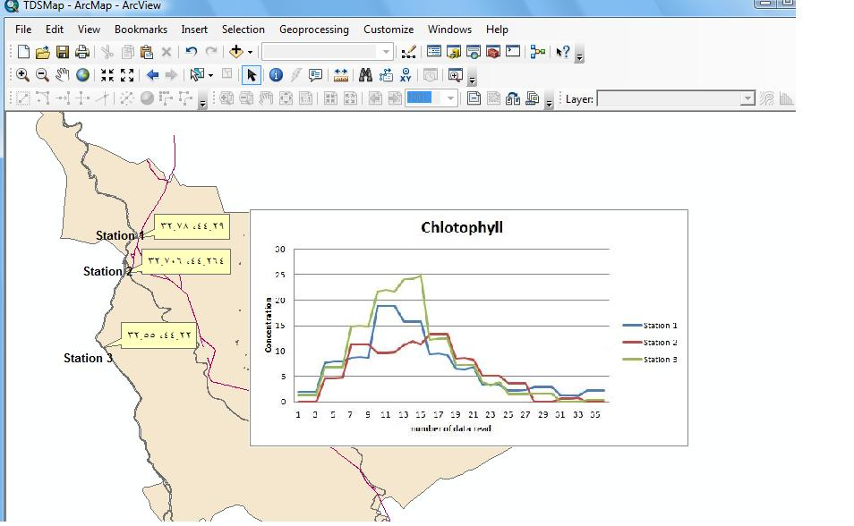
Figure 4. The Chlorophyll Level of the three stations.

3-Water Visibility
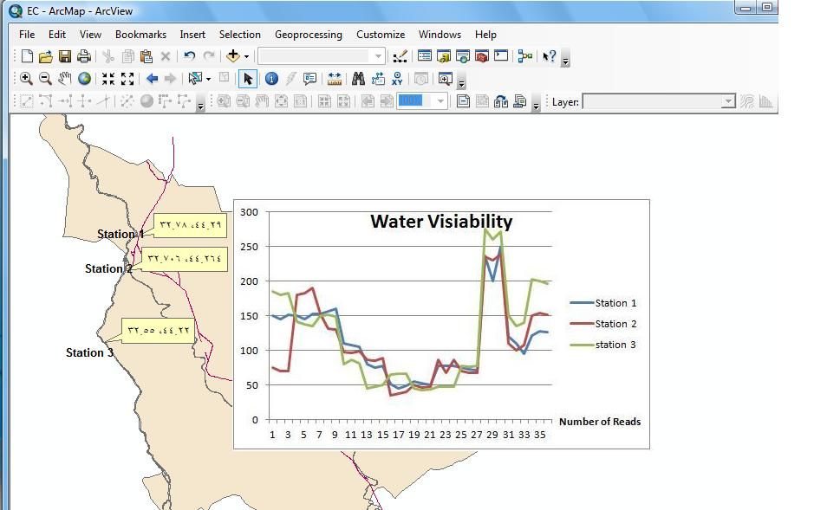
Figure 5. Water visibility in the three stations.

4-Salinity
Water salinity in study area ranged between (0.5‰-0.7‰). The increasing values of conductivity and salinity in Euphrates River may be of the discharge of agricultural and industrial wastewater (Salman and Hussain,2012)
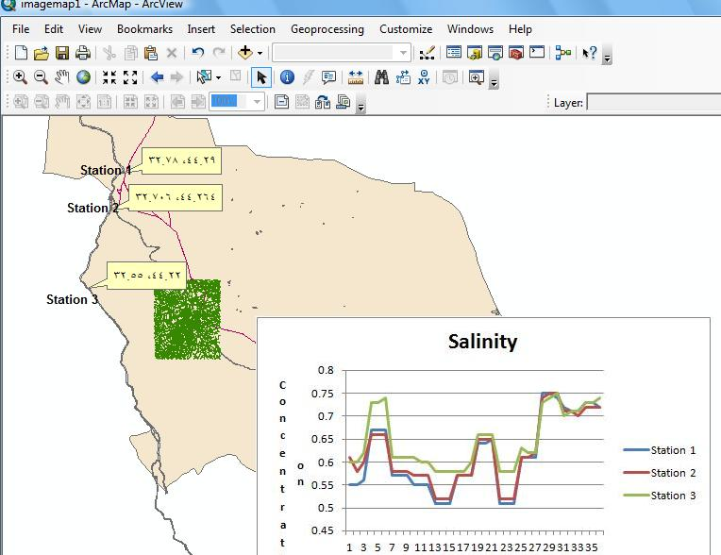
Figure 6. Percentage of salinity of water in the study stations
5-Electrical Conductivity
Electrical conductivity is considerable indicator of ionized substances in the water and is mainly concerned with total dissolved solids and temperature (Wetzel, 2001).
The results showed high conductivity values ranged between (798.7 μs·cm−1) in site 1 as lower value and (1168.6 μs·cm−1) in site 2 as high value

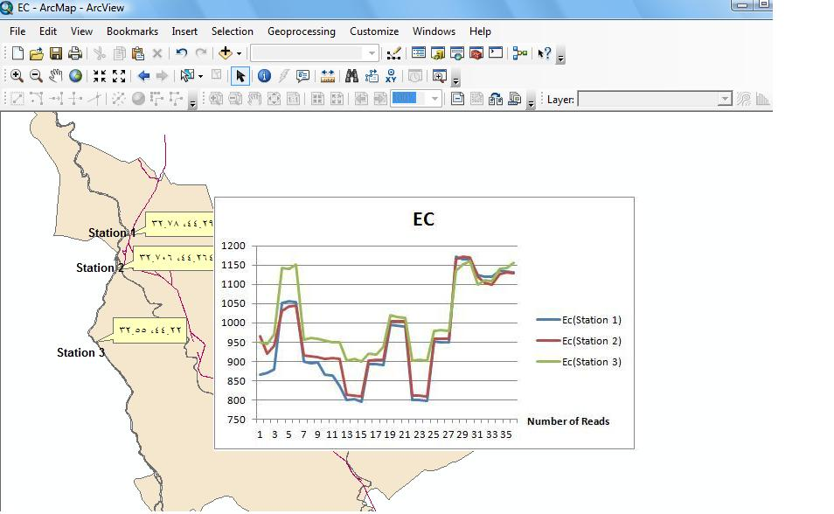
Figure 7. Concentration of E.C. of water in the study stations
6- Total Dissolved Solid (TDS)
The total dissolved solid (TDS) followed the trend as conductivity temporarily and spatial. It ranged from 502. 33 to 789.3 mg/l, while the value of TSS ranged between 0.01 to 0.3 mg/l. Many factors affecting the transparency of water such as silting, microscopic organisms and suspended organic matter.(Quenzer,1998) and this variation can be explained by a higher nutrient dynamics in the water column
(Raikar and Sneha,2012)

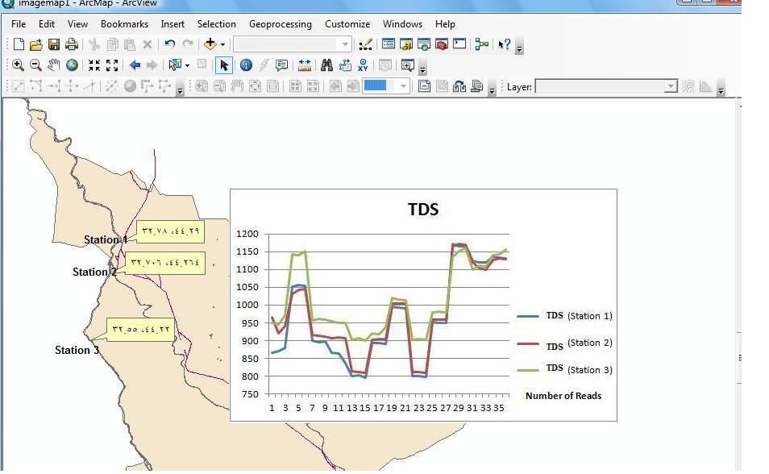
Figure 8. Concentration of TDS in the study stations
7- Total Organic Carbon
Total organic carbon (TOC) is the amount of carbon bound in an organic compound and is often used as a non-specific indicator of water quality or cleanliness of pharmaceutical manufacturing equipment. For marine surface sediments, average TOC content is 0.5 wt% in the deep ocean, and 2wt% along the eastern margins
(Kim et al., 1997)
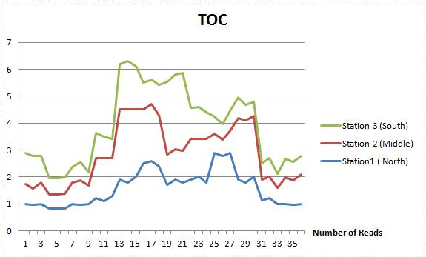
Figure 9. Concentration of TOC in the study stations
8- Water pH
The indicator for acidity or alkalinity is known as the pH value. A pH value of 7 means a substance is neutral; water with a pH lower than 7 is considered acidic and with a pH greater than 7, water is considered alkaline. The normal range for pH in surface water systems is 6.5 to 8.5.The range in an AWG unit is 7.0 to 7.5 ( APHA,2003). Narrow fluctuation of pH was observed during the study period, with the highest average value of 8.7 and a low of 7.3; this ob- served variation was statics significant between month (p ≤ 0.05) but not between the sites (p ≤ 0.05). pH variation might be caused by discharge of waste water, photosynthesis and other metabolic process (Wetzal,2001), and may be attributed to introduction of silt into the river by rain water or due to the mixing of the fast flowing water as it moves down stream (Hassan et al.,2012).
Conclusions:
The system facilities the geographical distribution of data over the study area. The statistical subsystem gives as more tools to analyses the data giving clear view of the current state of the Euphrates River in Iraq. The system database will be used to archive the water data across times and become a common data for different agencies.
The results may useful in Environmental monitoring of running water in Iraq, especially Euphrates River.
Acknowledgements
We are grateful to Ministry of Environment /office of Babil and College of Science, University of Babylon for their support to this research.
References
Al-Malikey,R.N.A., 2009,Biogeochemical Assessment of Some Heavy Metals In Al-Hammar Marsh by Using GIS. Ph.D.Thesis, college of Science for Women, University of Baghdad, Iraq.
Al-Yasiry ,T.M.H. and Salman ,J.M. ,2014, Ecological Assessment of Sewage in Hilla city/Iraq by Canadian Water Quality Index (CWQI). International Journal of Advance Life Science,2014 .( acceptance to publish ).
APHA,2003,American Puplic Health Association .Standard Methods for Examination of Water and Wastewater 2nd edition, Washington DC, U.S.A.
Bindu Bhatt Janak, P. Jushi,2012,Sustainable management of agricultural lands using GIS a spatial temporal analysis of irrigation water quality in Vandodrataluka 2(3), international journal of geomatic science and geosciences,pp 911-920.
Cooper, S.,2011,A GIS-based water quality risk assessment of Thompson Region watersheds. Ministry of Environment. Thompson Region. January.
Donia,N.,2011,Water quality management of lake Temsah, Egypt using geographical information system (GIS) . INTERNATIONAL JOURNAL OF ENVIRONMENTAL SCIENCE AND ENGINEERING (IJESE) , Vol. 2: 1-8.
Hassan FM, Kathim NF and Hussein FH .,2008, Effect of chemical and chemical properties of River water in shatt Al-Hilla on phytoplankton communities. E-Journal of Chemistry 5(2) 323- 330.
Hassan FM, Saleh MM and Salman JM.,2010,A study of physic chemical parameters and nine heavy metals in Euphrates river, Iraq. E-Journal of Chemistry 7(3)
685– 692.
Hassan FM, Salman JM and Naji AS,2012, Water Quality and Phytoplankton Composition in Al-Hilla River, Iraq, Proceeding of 4th Conference of Environmental Science, University of Babylon, Babylon,5-6 December 144-160.
Kim,K.; Jung ,D.; Kim, J.; Choi, J.; Sung, M. and Ha, S. ,1997, Identifying Critical Areas of Urban Water pollution Using a GIS. Environ. Eng. Res., 2(2) : 73-81.
Lee,M. T. and White ,D.C.,1992, Applications of Gis Databases and Water Quality Modeling for Agricultural Nonpoint Source Pollution Control , University of Illinois at Urbana-Champaign, WRC Research Report No. 214.
Quenzer ,A.M.,1998, A GIS Assessment of the Total Loads and Water Quality in the Corpus Christi Bay System. CENTER FOR RESEARCH IN WATER RESOURCES , Bureau of Engineering Research • The University of Texas at Austin.
Raikar ,R.V. and Sneha, M.K. , 2012, Water quality analysis of Bhadravathi taluk using GIS–a case study. International Journal of Environmental Sciences, Vol. 2, No 4, : 2243-2253.
Salman JM ,2006, Environmental study of some possible pollutants in Euphrates River between Al-Hindia barrage and Al-Kufa, PhD thesis, Collage of Science, University of Babylon, Iraq.
Salman JM and Hussain HA ,2012, Water Quality and Some Heavy Metals in Water and Sediment of Euphrates River, Iraq. Journal of Environmental Science and Engineering A 1, 1(9) 1088-1095.
Salman JM, Al-Azawey ASN and Hassan FM ,2013, Study of Bacterial Indicators in Water and Sediments from Al- Hilla River, Iraq, Hydrology Current Research S13: 001.
Sunitha. V,muraldihara Reddy B,Jaggadish Kumar and et al., 2012, GIS-based ground water quality mapping in southern part of Anantapur district, International Journal of geomatics and geosciences,2(3),pp805-14.
Wang, Z.M.; Zhang ,W., Sawyer, P.C.; Raleigh, N. C.; and Devine, H. A., 2008,Using GIS and Water Quality Model to Analyze Potential Risk Areas of Lead leaching in Water Distribution Systems . North Carolina State University, Raleigh, NC.
Wetzel RG ,2001, Limnology, Lake and River Ecology, 3rd edition, Academic Press

