Design of Neurofuzzy Self Tuning PID Controller for Antilock Braking Systems

Ammar A. Aldair
Electrical Engineering Department/Engineering College
University of Basrah, Iraq
mmr.ali2@googlemail.com
Abstract
In this paper, a Neurofuzzy self tuning PID controller for wheel slip ratio control has been designed based on a quarter vehicle model. The proposed control structure consists of a Neurofuzzy controller and conventional PID controller, which has self tuning capabilities. The parameters of the PID controller (Kp, Kd and Ki) can be self-tuned on-line with the output of the system under control. Variations in the values of weight, the friction coefficient of the road, road inclination and other nonlinear dynamic parameters may highly affect the performance of the Antilock Braking Systems (ABS). The conventional PID controller with fixed parameters cannot overcome these effects; therefore, the PID controller with adaptable parameters has been used. The paper develops a self tuning PID control scheme with application to ABS via combinations of fuzzy logic systems and neural networks. The performance of the Neurofuzzy self tuning PID controller based ABS is demonstrated by simulation for different road conditions: Snowy road, Wet asphalt, Dry asphalt; and transitions between such conditions, e.g. when emergency braking occurs and the road switches from snowy to wet. Robustness against road conditions is examined via numerically test results of the ABS controlled by proposed scheme are compared with the results of the ABS controlled by optimal PID controller. Simulation results show good performance of the proposed controller.

Keywords: Neurofuzzy self tuning PID controller, Antilock braking systems.
الخلاصة:
في هذا البحث تم تصميم منظومة تحكم من نوع المنطق العصبي المضبب ذاتي الضبط لبرامترات المتحكم الكسب-التفاضلي –التكاملي لمنظومة المكابح ضد القفل لمركبات النقل. ان منظومة الكبح ضد القفل تتأثر بالعديد من العوامل اللا خطية منها معامل الاحتكاك مع الطريق والذي بدوره يعتمد على نوع الطريق سواء كان الطريق جاف او رطب او يحوي على ثلوج لذلك فان تصميمم منظومة تحكم من نوع الكسب-التفاضلي –التكاملي ذي قيم الثابتة لمنع انزلاق المركبة بتغير ضروف الطريق امر غير مجدي الا بتغير برامترات المتحكم مع تغير طبيعة الطريق. لذا تم في هذا البحث اقتراح اضافة منظومة اخرى من نوع المنطق العصبي المضبب وضيفتها تغير برامترات المتحكم الذي هومن نوع الكسب-التفاضلي –التكاملي بتغير ضروف الطريق لمنع انزلاق المركبة اثناء التوقف المفاجئ. تم اختبار منضومة التحكم المقترحة تحت انواع مختلفة للطريق كان يكون الطريق اسفلتي جاف او اسفلتي رطب او يحوي على ثلوج او خليط منها وقد اثبت النتائج المستحصلة كفائة المنضومه المقترحة مقارنة مع منضومة التحكم من نوع الكسب-التفاضلي –التكاملي ذات البرامترا ت الثابتة.
الكلمات المفتاحية: منظومة تحكم من نوع المنطق العصبي المضبب ذاتي الضبط لبرامترات المتحكم الكسب-التفاضلي –التكاملي, منظومة الكبح ضد القفل.

Introduction

The main issue of concern during braking on a slippery surface is that the wheels of the car may be locked. This phenomenon is strongly undesirable. The friction force on the locked wheel is usually considerably less when sliding on the road and it causes long distance braking. Furthermore, while the wheels are locked, steering becomes impossible, leading to loss of control of the vehicle. ABS is an electrically controlled system which prevents these events by preventing the wheels to lock and allowing the drivers to keep control of the vehicle. Therefore, steering enhances and stopping distances decreases during hard braking manoeuvres. A typical ABS measures the wheel angular speed and possible linear acceleration. Then the decision is made if the wheel is about to lock. If it is, the pressure in the brake cylinder is reduced until the angular velocity of the wheel (_{w}) exceeds some threshold value. At this time the pressure is allowed to increase. Such algorithms produce noticeable vibrations in the vehicle. Due to the problems such as variations in the values of weight, the friction coefficient of the road, road inclination and other nonlinear dynamic parameters, many difficulties arise in design of controllers for ABS.
Recently, a great deal of research has been performed on the control strategies for the ABS. Some popular strategies include optimal controller (Ohda, Kuraoka et al. 1986), fuzzy logic controller (Layne, Passino et al. 1993; Mauer 1995) and sliding mode controller (Chin, Lin et al. 1992; Drakunove, Ozguner et al. 1995; Choi, Bang et al. 2002). Layne et. al. introduced the idea of using the fuzzy model reference learning control technique based ABS for maintaining adequate performance even under such adverse road conditions (Layne, Passino et al.1993). This controller utilizes a learning mechanism which observes the plant outputs and adjusts the rules in a direct fuzzy controller so that the overall system behaviours like a reference model which characterizes the desired behaviour.In (Choi, Bang et al. 2002), a sliding mode control for a new antilock braking system of a passenger vehicle using electrorheological valve is presented. In the formulation of the sliding mode controllers, the friction force which is difficult to measure in real time is estimated via a sliding mode observer associated with the fuzzy algorithm. The main advantage of the fuzzy sliding mode control is that it requires fewer fuzzy rules than fuzzy control does and also this system has more robustness against parameter variation. Topalov et. al. proposed a neurofuzzy adaptive controller to design a wheel slip regulating controller. The proposed new learning algorithm makes direct use of the variable structure systems theory and establishes a sliding motion in terms of the neurofuzzy controller parameters, leading the learning error toward zero (Topalov, Oniz et al. 2011). Habibi and Yazdizadeh designed a hybrid controller for wheel slip ratio control base on quarter vehicle model. The proposed controller is a combination of a sliding mode controller with a fuzzy controller to improve sliding mode controller efficiency (Habibi and Yazdizadeh 2010).
PID controllers have been widely used in the industry due to the facts that they have simple structures and they assure acceptable performance for the majority of industrial processes. Because of their simple structures, PID controllers are easy to design, operate and maintain.Tuning and optimizing the parameters of PID controller are very important in PID control. Ziegler and Nichols proposed the well-known Ziegler-Nichols method to tune the coefficients of the PID controller (Ziegler and Nichols 1942). This tuning method is very simple, but cannot guarantee to be always effective. In fact, most of the plants in the real life are nonlinear system and they are too complex for analysis by conventional control techniques. To overcome these problems, many researchers proposed a PID controller with adaptive parameters to make the PID controller more robust and effective. Some authors used the fuzzy logic system to tune the parameters of the PID controller (He, Tan et al. 1993; Zhao, Tomizuka et al. 1993; Li 1998; Blanchett, Kember et al. 2000; Yao and Lin 2005; Zheng, Zhao et al. 2009). In these works, the advantages of the fuzzy inference and PID controller have been combined to give the PID controller the capability to adapt its parameters when the disturbances occur. The drawbacks of design the fuzzy controller which depend on the experience of human experts are that it is difficult to select the parameters of the fuzzy system, i.e. the parameters of the input and output membership functions of fuzzy rules-based. Therefore, other researchers proposed a genetic fuzzy self tuning PID controller to overcome this difficulty (Tang, Man et al. 2001; Sharkawy 2006). Genetic algorithm gives the fuzzy logic capability to train the membership function parameters that best allow the associated fuzzy inference system.
The aim of this paper is to design a Neurofuzzy self tuning PID controller for ABS.The Neurofuzzy controller is a combination of a fuzzy logic controller and neural network, which makes the fuzzy controller self tuning and adaptive. If we compose these two intelligent approaches, we can achieve good reasoning in quality and quantity. This technique gives the fuzzy logic the capability to adapt the membership function parameters. The outputs of the neurofuzzy controller will be applied to tune the parameters of the PID controller to meet the desire performance when emergency braking occurs and the road switches from type to other, e.g. from wet to snowy. In this paper, the optimal PID controller will be designed for ABS using the Evolution Algorithm. The data obtained from the optimal PID controller will be used as a reference to design the Takagi-Sugeno neurofuzzy inference system. Then the outputs of the designed neurofuzzy controller will be used to tune the parameters of the PID controller. The performance of the Neurofuzzy self tuning PID controller based ABS is demonstrated by simulation for three different road conditions (dry asphalt, wet asphalt, snowy road) and transitions between such conditions, e.g. when emergency braking occurs and the road switches from snowy to wet. Robustness against road conditions is examined via numerical testes. The results of the ABS controlled by proposed scheme are compared with the results of the ABS controlled by optimal PID controller. Simulation results show good performance of the proposed controller.

Dynamic Modelling of ABS
The braking effect is due to the friction coefficient between tyre and road surface. ABS maximizes the tyre road friction force (F_{x}) which is proportional to the normal load of the vehicle (F_{n}). The relationship between the road friction force and the normal force can be written as:
(1)
The road coefficient of friction is the coefficient of proportion between F_{x} and F_{n}. It is a nonlinear function of wheel slip ratio (, which is a well known parameter to represent slippage. The tyre slip ratio is defined as:

where V_{v}(t) is the linear velocity of the vehicle; _{w}(t) is the angular velocity of the wheel; and R is the radius of the wheel. The objective of ABS control system is to increase tyre-road friction force by keeping the operating point of the car near the peak value of the μ-λ curve during the ABS manoeuvres because this peak value in the nonlinear μ-λ curve is the only zone where the maximum friction will be achieved, so the desirable slip ratio is restricted in this zone (Sharkawy 2006). Figure 1 depicts nonlinear μ-λ curve for different road conditions.

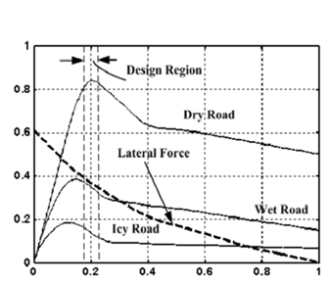

Figure 1 Nonlinear μ-λ curve for different road condition

The effective coefficient of friction between the tyre and the road has the optimum performance when wheel slip ratio is at the range 0.18-0.22, and the worst performance occurs at (locked wheel, i.e. _{w}(t)=0). Most manufacturers use a set point for the slipping ratio equal to 0.2 which is a good compromise for all road conditions(Lin and Hsu 2003).
Figure 2 depicts the physical model of the quarter vehicle. The mathematical equations of the quarter vehicle dynamic equation can be given by:

(3)
(4)

where M is the total mass of the quarter vehicle; is the linear acceleration of the vehicle; J is the wheel inertia, is the normal force and T_{b} is the braking torque.
Figure 2 Quarter vehicle Physical model

From Eq. (2) the angular wheel velocity and the angular acceleration are calculated as:
Using Equations (3), (4) and (6) and rearranging for yields

The expression of the normal friction force is given as follows

(8)

Where g is the acceleration of gravity and C is constant.
The expression of the braking torque is given as:

(9)
Where A_{w} is the piston area of the wheel cylinder; is mechanical efficiency; B_{f} brake factor; is the mean effective radius of the wheel; and P_{p} is the brake pressure.
The relationship between the brake pressure and the control input is given as follows (Choi, S.B., et al 2002):
where is the control input and T_{B} is time constant.

Control System Design
The structure of the neurofuzzy self tuning PID controller is shown in Figure 3. The neurofuzzy controller has three inputs and three outputs. The outputs of the neurofuzzy controller are used to adapt the parameters of the PID controller. The output control signal of the PID controller is applied as input signal to the ABS to force the tyre slip ratio to reach to desired value ( during short time and no overshoot.
3.1 The Construction of Neurofuzzy System
The proposed neurofuzzy network incorporates fuzzy logic algorithm with a five layer artificial neural network (ANN) structure. Sugeno fuzzy model with five-layer ANN structure is used in proposed scheme. In this five-layer ANN structure, the first layer represents for inputs, the second layer represents for fuzzification, the third and forth layers represents for fuzzy rule evaluation and the fifth layer represents for defuzzification. For the simplicity, the following assumptions will be assumed: (a) the model has two inputs x and y and one output z, (b) it has just two rules (R1and R2).
+
Figure 4 depicts Adaptive NeuroFuzzy Inference System (ANFIS) architecture of two inputs first order Sugeno fuzzy model with two rules. The square nodes have adaptable parameters that will be adjusted during the training phase of the ANFIS while the circle nodes have fixed parameters. The output of the i^{th} node in the l^{th} layer is denoted by , where every node in the same layer performs the same function.
In layer 1 every node i is an adaptive node with a node function
(11)
for i=1, 2 or
for i=3,4

where x and y are the inputs and A_{i} and are a linguistic label associated with this node.The membership function for A and B can be any appropriate parameterized membership function. In this work, a triangular function is used as a membership function given by:
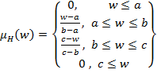 (12)
where w is the input to the node i (x or y) and H is the linguistic label associated with this node (A or B).
The parameters {a, b, c} are premise parameters which will be modified in the training phase. As the values of these parameters changes, various forms of triangle shaped membership functions can be obtained.
In layer 2, every node is a fixed node labelled Π., whose output is the product of all the incoming signals,
for i=1,2 (13)
In layer 3, every node is a fixed node labelled N. The outputs of this layer are normalized firing strengths,

In layer 4, every node is an adaptive node with a node function given by

(15)
where { is the set of parameters of linear equation (they are called consequent parameters) which will be modified in the training phase.
Layer 5 is the single node layer with a fixed node labelled Σ, which computes the overall output as the summation of all incoming signals.
The adaptable parameters of neurofuzzy system { will be modified to minimize the following performance function:

(17)
where P is the total number of training data set and E_{p} the error signal between the desired output of p^{th} data and the actual output of ANFIS model of p^{th} data, E_{p} can be given as:

(18)
where T_{p} the p^{th} desired output and z_{p} the p^{th} actual output of the neurofuzzy model.
To modify the parameters of the neurofuzzy model, the steepest descent method as in neural network can be applied to modify the premise parameters { and least square estimate can be applied to adapt the consequent parameters { (Jang 1993).
  - Design of the Neurofuzzy Controller
The neurofuzzy controller has been designed to generate a suitable control signal to adapt the parameters of the PID controller. To find the optimal values of the adaptable parameters of the neurofuzzy controller, the optimal PID controllers can be designed (the details for the full design of PID controller is described in (Aldair and Wang 2010). The input and output data obtained from the optimal PID controller can be used to train the parameters of neurofuzzy controller using the Hybrid Learning Algorithm (HLA).
  - Design of the Self Tuning PID Controller
The proposed neurofuzzy system has three inputs and three outputs. It uses the error, change of the error and integral of the error as inputs. Its outputs are applied to the conventional PID controller to adapt its parameters online according to the change of neurofuzzy controller inputs. Figure 5 depicts the proposed controller with the ABS.
The output of the PID controller can be given as:
(19)
Where {, , } are the tuneable parameters of the PID controller. The adaptation equation for PID parameters can be given as:

(20)
where , and are the outputs of the neurofuzzy controller that are varying online with the output of ABS; and , and are the initial values of the PID controller.

Simulation and Results
The data used for computer simulation are given in Table 1. Due to the fact that, the wheel and vehicle velocity are nearly zero at the end of braking time, the magnitude of the slip tends to infinity. Therefore, simulations are conducted up to the point when the vehicle is slowed to 0.5 m/s.
Table 1 Parameter Values for Computer Simulation

Variable | Description | Value | Unit
R | Radius of the wheel | 0.33 | m
M | The total mass of quarter vehicle | 410 | kg
J | Moment of inertia of the vehicle | 1.13 | Nms²
g | Acceleration gravity | 9.81 | m/s²
C | Constant | 300 | kg
A_{w} | Area of the brake cylinder | 0.002 | m²
 | Mechanical efficiency | 0.8 | -
B_{f} | Brake factor | 0.73 | -
r_{r} | Effective radius of the brake | 0.13 | m
V₀ | Initial value of the vehicle velocity | 17 | m/s
T_{B} | Time constant | 0.1 | s
 | Desired slip ratio | 0.2 | -

The nonlinear antilock braking system with self tuning PID controller is presented to avoid the wheel locked of the vehicle and to force the slip ratio to be 0.2. To design the neurofuzzy controller, the optimal parameters of the PID controller can be obtained first using the evolutionary algorithm. Three parameters of PID controller (K_{Po}, K_{do}, K_{io}) are required to be designed. The evolutionary algorithm has been used to select the optimal values of the PID control parameters. For reducing the time of optimization, the ranges of PID parameters are selected as: .
A MATLAB/SIMULINK program package has been used to simulate the antilock braking system with the PID controller. The initial and the optimal values of the optimal PID controller parameters are shown in Table 2. Figures 6-8 show the changing of the PID control parameters during the optimization steps.
Table 2 Initial and optimal values of PID controller
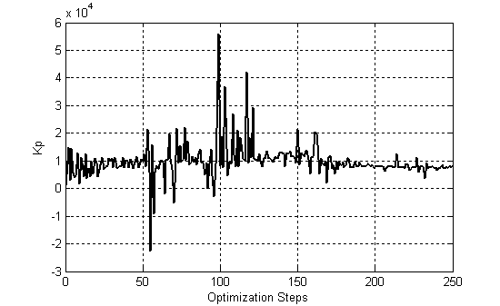
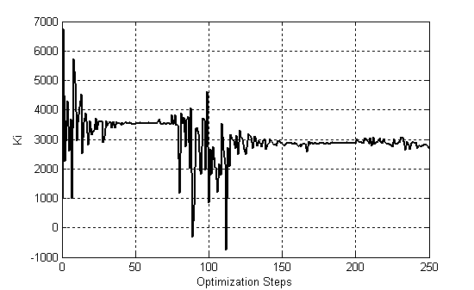
Figure 6 Changing value of K_{p} during optimization steps
Figure 7 Changing value of K_{i} during optimization steps
Parameter | Initial value | Optimal value
K_{p} | 1000 | 8362
K_{i} | 1000 | 2807
K_{d} | 1000 | 4397

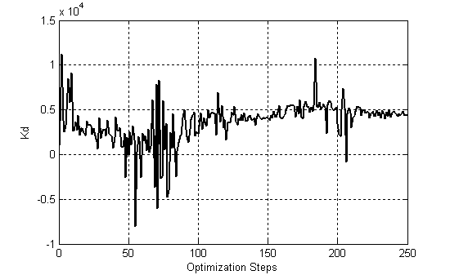
Figure 8 Changing value of K_{d} during optimization steps

To design the neurofuzzy controller, the input and output data that obtained from the optimal PID controller have been used. The hybrid learning algorithm has been used to modify the trainable parameters of the neurofuzzy controller. The control rules that used for the neurofuzzy self tuning of PID controller are shown in Table 3.
Table 3 The neurofuzzy control rules

 |  |  | K_{p} | K_{d} | K_{i}
N_{B} |  |  | N_{B} | N_{B} | N_{B}
N_{s} |  |  | N_{s} | N_{s} | N_{s}
Z |  |  | Z | Z | Z
P_{s} |  |  | P_{s} | P_{s} | P_{s}
P_{B} |  |  | P_{B} | P_{B} | P_{B}
The trianglar function has been used as input membership function for each neurofuzzy (NF) controller inputs. Each input has five grades: negative big (N_{B}), negative small (N_{S}),zero (Z) ,positive small(P_{S}) and positive big (P_{B}).The input/output data of the optimal PID controller has been used as a reference to design the NF controller. When the NF controller is fully desigend, the outputs of the NF controller are used to tune the parameters of adaptive PID controller to control the ABS.
The performance of the neurofuzzy self tuning PID controller based ABS is demonstrated by simulation for three different road conditions (snowy road, wet asphalt,dry asphalt).The results of the ABS with neurofuzzy self tuning PID controller are compared with the results of the ABS controlled by optimal PID controller under different road conditions.The Figures 9-11 show the ABS resopnse under three different road condition.
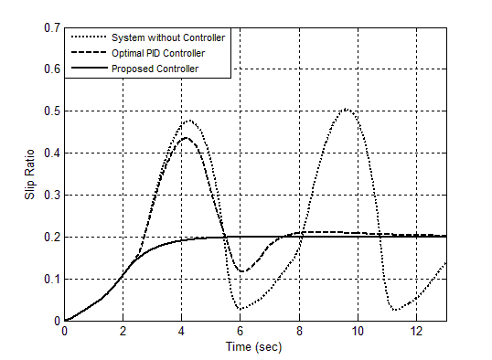
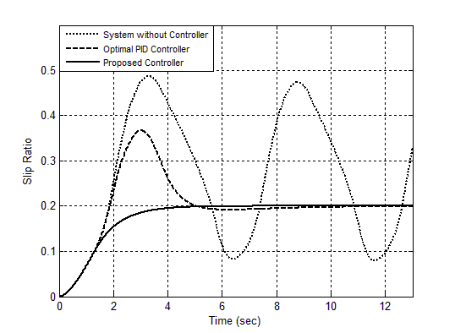

Figure 9 Slip ratio responses under different control scheme for snowy road condition
Figure 10 Slip ratio responses under different control scheme for wet asphalt condition

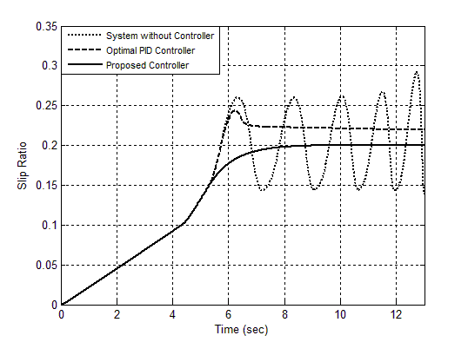

Figure 11 Slip ratio responses under different control scheme for dry asphalt condition

To study the robustenss of the proposed controller against road conditions, the following disturbance is applied. The road surface changes from snowy road to wet road after 20 sec using the road condition selector. The Figures 12-14 show the vheicle velocity and wheel velocity for the ABS without controller; ABS controlled by optimal PID controller; and ABS with neurofuzzy self tuning PID controller, respectivley.
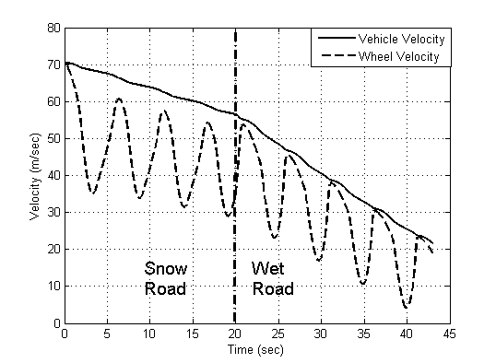
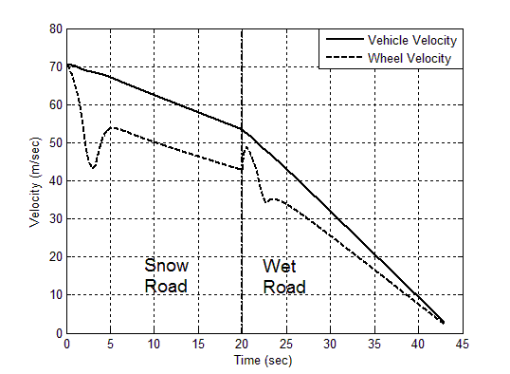

Figure 12 Vehicle and wheel velocity when no control system is used
Figure 13 Vehicle and wheel velocity when optimal PID controller is used

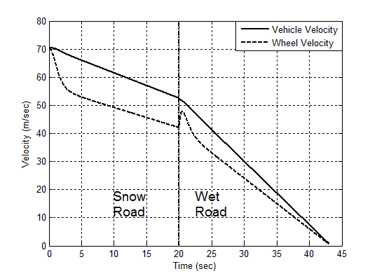

Figure 14 Vehicle and wheel velocity when proposed controller is used

Figure 15 shows the stopping distance of the vehicle for different control types. Figure 16 shows the slip ratio responce for different control types when the road condition is switched from snowy to wet asphalt. It is clear that the performaces of the proposed controller are more effective and robust than the optimal PID controller. Therefore, when the neurofuzzy self tuning PID controller is used, the desired control objectives are met.

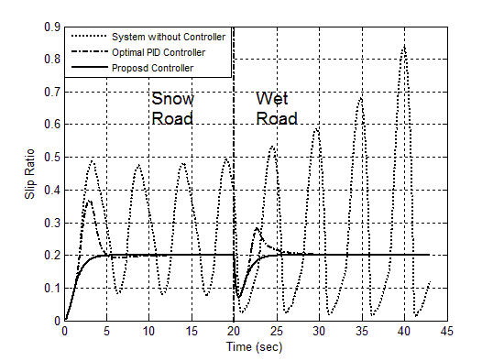
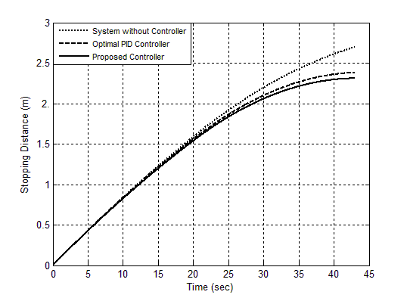

Figure 16 Slip ratio responses under different control scheme when the road condition is switched from snowy to wet.

Figure 15 Stopping distance of the vehicle under different control types

Conclusion
In this study a neurofuzzy self tuning PID controller for antilock braking system is proposed. The best values of optimal PID controller parameters are selected using evolutionary algorithm. The input/output data of the optimal PID controller are used as reference data to design the neurofuzzy controller. The outputs of the neurofuzzy controller are used to adapt the PID controller to force the slip ration of the antilock braking system to follow the desired slip ratio. The performance of the neurofuzzy self tuning PID controller based ABS is studied by simulation for three different road conditions (Snowy road, Wet asphalt, Dry asphalt) and transitions between such conditions, e.g. when emergency braking occurs and the road switches from snowy to wet. The road selector can specify the road conditions through a look-up table. As an important conclusion, it has demonstrated that the time response oscillations in ABS with proposed controller are much less than ABS with optimal PID controller. Therefore, the vehicle has adequate lateral stability and good steer-ability in various road conditions and road transitions.
References
Aldair, A. and W.Wang, 2010 ."Design of Fractional order Controller Based on Evolutionary Algorithm for a Full Vehical Nonlinear Active Suspension System." International journal of Control and Automation (IJCA) 3(4): 33-46.
Blanchett, T. P., G. C. Kember, et al., 2000 . "PID gain scheduling using fuzzy logic." ISA Transactions 39: 317-325.
Chin, Y. K., W. C. Lin, et al.,1992 . Sliding Mode ABS Wheel Slip Control. Proceeding of American Control Conference
Choi, S. B., J. H. Bang, et al., 2002 . Sliding mode control for anti-lock brake system of passenger vehicles featuring electrorheological valves. Proceedings of the Institution of Mechanical Engineers, Part D: Journal of Automobile Engineering., SAGE.
Drakunove, S., U. Ozguner, et al., 1995 . "ABS Control Using Optimum Search Via Sliding Modes." IEEE Transactions on Control Systems Technology 3(1): 79-85.
Habibi, M. and A. Yazdizadeh, 2010 . A Novel Fuzzy-Sliding Mode Controller for Antilock Braking System. 2nd International Conference on Advanced Computer Control (ICACC) Shenyang: 110-114.
He, S., S. Tan, et al.,1993 . "Fuzzy Self Tuning of PID Controllers." Fuzzy Sets and Systems 56: 37-46.
Jang, J.1993 . "ANFIS: Adaptive Network Based Fuzzy Inference System." IEEE Transaction on Systems 23: 665-686.
Layne, J. R., K. M. Passino, et al., 1993. "Fuzzy Learning Control for Antiskid Braking Systems." IEEE Transaction s on Control Systems Technology 1(2): 122-129.
Li, W.1998. "Design of a Hybrid Fuzzy Logic Proportional Plus Conventional Integral-Derivative Controller." IEEE Transaction s on Fuzzy System 6(4): 449-463.
Lin, C. M. and C. F. Hsu, 2003. "Self-Learning Fuzzy Sliding-Mode Control for Antilock Braking Systems." IEEE Transaction s on Control Systems 11: 273 - 278
Mauer, G. F.1995. "Fuzzy Logic Controller for an ABS Braking System." IEEE Transactions Fuzzy Systems, 3(4): 381-388.
Ohda, M., H. Kuraoka, et al., 1986. Automotive anti-skid system based on modern control theory. Proceeding of the International Conference on Applied Motion Control, .
Sharkawy, A. B. 2006., "Genetic Fuzzy Self Tuning PID Controllers for Antilock Braking Systems " Alexandria Engineering Journal 45(6): 657-673.
Tang, K. S., K. F. Man, et al.,2001. A GA-Optimized Fuzzy PD+I Controller for Nonlinear Systems. The 27th Annual Conference of the IEEE Industrial Electronics Society, 2001. IECON '01. , Denver, CO
Topalov, A. V., Y. Oniz, et al., 2011. "Neuro-fuzzy control of antilock braking system using sliding mode incremental learning algorithm." Neurocomputing 74: 1883-1893.
Yao, L. and C. Lin,2005. "Design of Gain Scheduled Fuzzy PID Controller." World Academy of Science, Engineering and Technology: 152-156.
Zhao, Z., M. Tomizuka, et al.,1993. "Fuzzy Gain Scheduling of PID Controllers." IEEE Transaction s on Systems, Man and Cybernetics 23(5): 1392-1398.
Zheng, J., S. Zhao, et al.,2009. "Application of Self Tuning Fuzzy PID Controller for a SRM Direct Drive Volume Control Hydraulic Press." Control Engineering Practice 17: 1398-1404.
Ziegler, J. G. and N. B. Nichols,1942."Optimum settings for automatic controller." ASME Transactions 64: 756-768.

