مجلة جامعة بابل
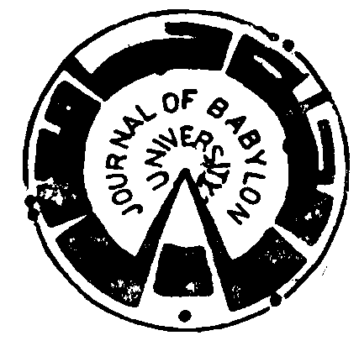

Series of Engineering Sciences

Vol.22, No. 4, 2014

ISSN: 1992-0652
E.ISSN: 2312-8135

Research Title | Page No.
Effect of Density of the Polyethylene Polymer on the Asphalt Mixtures *  - Nahla Yassoub Ahmed &Ahmed Sundus Mohammed AL-Harbi | 674-683
* Water Balance of Haditha Reservoir  - Majd Ahmed Al- Bayati & Nariman Yahya Othman | 684-700
* One Dimensional Tight Binding Computations for CNT Type, Diameters and Chirality at (1550, 1300)nm Communication Window Wavelength  - Hiba Hassan & Khalil Ibrahim Hajim | 701- 707
*Comparative Study of Fingerprint Image Enhancement Methods  - Safaa Saheb Omran & Maryam Abdulmunem Salih | 708-723
*Laboratory Evaluation of Modified Asphalt Mixture Properties and Aggregate Grading by Superpave System  - Mohammed Aziz Hameed Al-Shaybani & Nahla Yassoub Ahmed | 724-731
*Assessment of Sustainable Construction Performance for Some Building in Babylon University  - Mohammed Ali Alanbari & Abeer Mohammed Abdulamir | 732-748
*Calculating the Coefficients of Muskingum and Muskingum-Cunge Methods for a reach from Shatt-Al- Hilla river  - Qais Hatem Mohammad | 749-762
*The Estimation of the Weibull Parameters and Specific Wind Energy for the Sumawaha City in Iraq  - Nabil J.Yasin & Dhia Al-Deen H. Alwan | 763-774
*Design of Neurofuzzy Self Tuning PID Controller of Antilock Braking Systems  - Ammar A. Aldair | 775-787
* Improvement of Hot Corrosion Resistance of Austenitic Stainless Steel by Chromizing- Siliconizing  - Ali Hobi Halem & Haydar Hassan Jaber & Roaa Hatim Hatif | 788-796
*Best Fit Model to Estimate Relation Between (CBR) and the Dry Density of Fine Grains Soils  - Abdul Karim Khalil al-Saffar & Afaf Rafeek Hassoun | 797-802
*Effect of Quenching Media, Heat Treatment and Alloying Elements on Properties of Al- Si-Mg Alloy  - Abdulazeez O. Mousa Al-Uqaily & Jassim M.Salman Al-Murshdy & Abdalla H. Mihdy Jassim | 803-815
*Efficiency Improvement of Inertial Navigation System (INS) based on artificial Neural Network  - Saadi Turied. Kurdi | 816-831
*Design Technology for Layout  - Raqeyah Jawad Najy | 832-844
*Experimental Study of Height and Surface Roughness Effects of Crump Weirs on Over Flow Characteristics  - Nassrin Jassim Hussien | 845-859
*Microcontroller Based Less Switches Topology and Digital Gating Technique for Five Level Single Phase Inverter  - Mahmoud Shaker & Samir Jasim & Ali Sha'ban | 860-874
*The Effect of Admixing Al2O3 on Some Properties of High Copper Dental Amalgam  - Jassim Mohammed Salman | 875-883
*A Linear Programming Approach to Motivate Knowledge of Sustainability Strategies for Optimizing the End- of0life, Case Study: Hilla City Environment  - Ahmed Talib Sahib Auda | 884-893
*Best Distribution and Plotting Positions of Annual Rainfall in the Catchment of Holy Karbala in Iraq  - Ayad Kadhum Hussein | 894-906
*Digital Color Video Steganography Using YCbCr Color Space and Dynamic Least Significant Bit (DLSB)  - Ahmed Toman Thahab | 907-916
*Experimental and Numerical Investigation of Convective Heat Transfer in a Circular Tube with Internal square ribs  - Arkan Al-taie & Hasasn Ali Jurmut | 917-934
*Comparison of the Fracture Toughness of High Temperature Ceramic measured by Digital Image Correlation and Indentation Method  - Mohsin Abbas Aswad | 935-945
*Optimum Rain- Gauges Network Design of Some Cities in Iraq  - Alaa MuhsainAtiaa Al-Abadi & Ali Hassan Duhaim Al-Aboodi | 946-958
*Hydraulic Characteristics of Flow Over Rectangular Weir With Three Rectangular Bottom Openings Using ANN  - Rafa.H.Al-Suhaili & Jabbar.H.Al-Baidhani & Nassrin J.Al-Mansori | 959-970
* Infiltration Characteristics in Agriculture Area of Bahr al Najaf  - Namir K. S. Al-Saoudi & Mohammed Sh. M. Al-Shakerchy & Mustafa M. Abdal Husain | 971-978
* Selecting Urban Sustainability Indicators for Residential Neighborhoods In Iraqi City  - Mohammad Ali Alanbari & Ameera Jaleel Alisawy & Wafaa Abdulqader Mohammad Aladhami | 979-988
*Theoretical Evaluation to Tensile Strength of Composite Material by Using Ansys Program  - Ali I. Al-Mosawi | 989-993

