Comparison of the Fracture Toughness of High Temperature Ceramic measured by Digital Image Correlation and Indentation Method

Mohsin Abbas Aswad
Babylon University/College of Materials Engineering
m_a_a_1978@yahoo.com
Abstract
The application of indentation techniques to the evaluation of fracture toughness is examined critically using Vickers indentation. The fracture toughness values calculated by this method are independent of the crack profile and of the applied load. This formula has been used by Anstis et al to median-radial cracks over a wide range of loads in the case of brittle materials (Alumina). Also, the fracture toughness was measured using digital image correlation method for observing the crack length and the crack tip. The load was applied using four point bending rig. The Fracture toughness will show whether there is any significant residual stress in the surface which will affect smaller cracks. The fracture toughness values were more accurate using digital image correlation due to the crack length and the crack tip was very clear and it is colored.
key words : High Temperature Ceramics, Digital Image Correlation, Vickers Indentation, Four Point Bending Fracture Toughness.
الخلاصة
تطبيق تقنيات الثلم لغرض تقييم متانة الكسر والتي تفحص بشكل حرج بأستخدام طريقة فيكرز للتثليم. قيم متانة الكسر المحسوبة بواسطة طريقة الثلم تعتمد على شكل الشق وعلى الحمل المسلط. المعادلة الرياضية المستخدمة لحساب متانة الكسر وضعت من قبل العالم Anstis et. al. والتي تعتمد على نوع الشق والتي يجب ان تكون من نوع متوسط-اشعاعي على مدى واسع من الاحمال المسلطة على المواد الهشة (الالومينا). ايضا متانة الكسر قيست باستخدام طريقة التصوير الرقمي لملاحظة طول الشق وكذلك حافة الشق. الحمل سلط باستخدام تقنية four point bending rig. متانة الكسر سوف تبين القيم المهمة للإجهادات المتبقية على سطح النموذج والتي تتأثر من الشقوق الصغيرة. قيم متانة الكسر كانت اكثر دقة بالنسبة لتقنية التصوير الرقمي وذلك لرؤية طول وحافة الشق بشكل واضح لأنه يظهر بشكل ملونه على صورة المستخرجة من تقنية التصوير الرقمي.
الكلمات المفتاحية: سيراميك ذو الدرجات الحرارة العالية, ارتباط التصوير الرقمي, ثلم فيكرز, متانة الكسر
3-Introduction
There are many applications to create damage (i.e. short cracks) related to wear or erosion, polishing, machining and grinding (Srinivasan, 1991 and Smith, 1992). The fracture toughness values for short cracks are important in situations where small crack size scales limit performance. The extension of pre-existing cracks under cyclic loading or applied load in one direction these represent another method to extend the short crack (Fuller, 1983).A problem arises with many ceramic-based materials because the toughness is not constant, but instead increases with increasing crack-size scale. This behavior known as the R-curve effect and this effect occurred due to interaction of the crack with the microstructure (Cook, 1985 and Swanson 1987). The fracture toughness for these types of materials is measured for long cracks but it will not give suitable values for the short crack behavior.
Fracture toughness testing by using standard procedure of ceramic depends on production of a pre-crack in a test sample, followed by compliance or failure stress measurements (Smith, 1992). The stress intensity factor can be accurately evaluated if the pre-crack geometry must be well known. Straight, through-section cracks in any specimen are preferred for most test configurations. However, it is difficult, if not impossible, to produce straight pre-cracks having crack lengths below about 1 mm. As a result, the test procedures for standard long crack fracture toughness are not sufficient to short cracks with lengths in the range of 50μm or smaller.
Indentation methods are used to create short pre-cracks, by using Vickers or Knoop indentations. Indentation cracks of size as small as 20 to 50μm can be produced for most ceramics and glasses (Anstis, 1981). Fracture toughness estimated from direct measurement of the crack length as a function of indentation load or consequent measurement an appropriate failure stress (Chantikul, 1981). There are two important aspects that complicate the use of indentation cracks. The first aspect, the stress intensity factor due to the indentation plastic zone must be taken into the analysis. The first aspect requires the presentation of a residual-stress factor, which scales indentation load to the crack driving force. The second aspect, the geometry of the indentation crack must be defined. Half-penny crack shapes, in either median/radial (Lawn, 1980) or Palmqvist geometries (Smith, 1992) are assumed in most analyses.
By using sharp indentations in the ceramics material to study different properties for example fracture toughness, hardness and elastic modulus. The loading of a sharp indenter tip on the surface reasons both plastic and elastic deformation. Adequate stresses are generated due to the constraining force exerted by the surrounding material to exhibit plastic deformation at the indenter tip (Rowcliffe, 1992). For example, generating radial cracks at indentation corners in sapphire used low loads (below 1N). These then propagate parallel to the loading direction and away from the surface. As the indenter is unloaded reversible or temporary elastic strain is released while an irreversible or steady plastic strain remains providing a driving force for crack growth (Cook, 1990).
The types of cracks formed are shown in Figure 1. Radial cracks (Figure 1a) nucleate from the surface adjacent to the indenter corners and propagate moving down. Median cracks (Figure 1b) propagate in the direction of loading from beneath the plastically deformed region in the form of circles or circular segments. Radial and median cracks can also coalesce to form radial–median or half-penny cracks (Figure 1c). Lateral cracks can form parallel to the surface during unloading of the indenter and may curve up towards the surface of the sample causing chipping (Figure 1d).
Predicting the development in the intergranular cracking requires knowledge of the small crack growth. A modern experiment method for the original examination of the early stage of crack growth during applied the load, by using four point bending test, via full field Digital Image Correlation (DIC) was characterized and data for the crack growth kinetics and presented.
The Digital image correlation is considered a nondestructive technique because this technique does not contact the sample surface (Chu, 1985 and Bruck, 1989. It doesn’t need to high expensive methods for experimental setup in the form of a laser source. It can easily be automated to provide full-field displacement and strain with a wide range of measurement sensitivity and resolution. Theoretically the spatial resolution of the digital image correlation technique depends on the imaging system. The spatial resolution was determined if a camera was used for imaging via the optical magnification of the camera lens system and the pixel size of the CCD sensor pitch.
Features of interest such as the start of the plasticity in metals and microcracking in ceramic cause only slight change to the microstructure that are difficult to detect, making direct in situ imaging during mechanical testing not only experimentally difficult but also often unrewarding (Da Fonseca, 2005). Digital image correlation is a whole-field deformation measurement technique which extracts displacement data by comparing a pair of digital images of a specimen surface before and after the deformation. This improves the ability to image deformation.
The development of strain was connected to the material structure during the deformation. The microstructures of most materials are highly non-homogenous, involving grain boundaries, second phase particles and related interfaces, cracks, inclusions, etc. This heterogeneity is present at different scales, the grain size and distribution vary with distance from the deform line are represented long range heterogeneity. It is the highly probable that such structural heterogeneity will generate strain heterogeneity during deformation (Da Fonseca, 2005).
The aim of this paper to compare fracture toughness measurements on the alumina at room temperature by the two following methods: Vickers indentation and four point bending test.
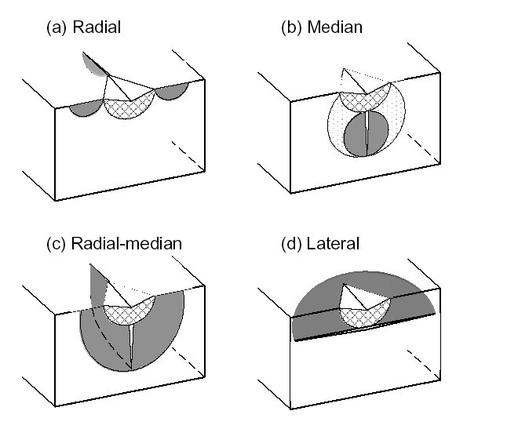
Figure 1: Sections through a Vickers indentation showing the main crack types (crack plains are shaped). The plastic zone is shown as a hatched area (Cook, 1990).
4-Experimental Work
In this section the fracture behavior of the alumina are considered.
4-1 Sample Preparation
Samples (alumina doped with 0.1% Cr) provided by Almath Crucibles Ltd, Newmarket, UK. The samples were cut using cutter made from diamond with a low concentration. The samples dimension were (8 mm wide, 15 mm long and 4 mm thick) for indentation method but the samples dimension for digital image correlation method were (10.6 mm wide, 48 mm long and 2.05 mm thick). The samples for both methods were ground using diamond powder ranging in particle size from 75μm to 1 μm. The samples were polished using low nap–polishing pads were used for polishing. The samples for digital image correlation were etched using thermal etching to prepare the sample surface for digital image correlation.
4-2 The Indentation Method
Vickers hardness testing (also known as diamond pyramid testing) is a technique in which a diamond indent is impressed into the surface of a sample (Callister, 2007). The indenter has a pyramid geometry that leaves a mark on the sample surface that can be observed and measured under the optical microscope. The schematic representation of Vickers indent is shown below in Figure 2.
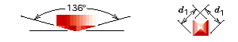
Figure 2: Schematic diagram of Vickers hardness indenter, adapted from (Callister, 2007).
This method was used to obtained crack for the upper surface of alumina. The instrument number for this machine (HTM 254249) was used to perform the indentations. Five indents were performed for each load. The loads used were from 10Kg to 50Kg with an indentation period of 10 seconds.
4-2-1 Fracture Toughness
The toughness of ceramic determined from a Vickers test under load of 10 to 50 kg, with five indentations was taken at each load. The fracture toughness was calculated from equation (1) by Anstis et al (Lemaitre, 1988).
$\text{KIC}=0\text{.}\text{016}{\left(\frac{E}{H}\right)}^{1/2}×\frac{P}{c^{3/2}}$ (1)
Where E is Young’s modulus, H is the projected hardness number (see below), P is the Vickers load and c is the radial crack length. Crack length c is defined for radial geometry as shown in Figure 3 for each load value; c was measured from the centre of the indentation to each of the four cracks tips, and from the corners of the indentation to the four tips.
Figure 3 shows a schematic of the indentation deformation / fracture pattern for the Vickers geometry: P is the peak load and a, c are characteristic dimensions of the ‘plastic ‘impression and the radial/median crack respectively. From simplistic dimensional analysis it can be demonstrated that these parameters relate directly to the hardness (H) by using equation 2 (Anstis, 1981 and Cook, 1990 and Liang, 1990).
$H=\frac{P}{α_{o}×a^{2}}$ (2)
Where: α_{o} is a constant for Vickers indenters (α_{o}= 2) and a is taken as the impression half- diagonal.
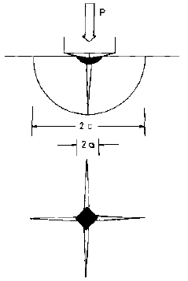
Figure 3: Vickers indentation with crack geometry (Anstis, 1981).
4-3 The Digital Image Correlation Method
The four point bending test was conducted with the strain gauge to the strain on the sample surface after the sample was deformed at each 0.1 sec. A loading rate was increased by using micrometer to apply the load see Figure 4. The images were observed by using Olympic CH-2 optical microscope with X20 lens and with the working distance about 38mm. The viewed area was 576 µm by 450 µm. The images were recorded by using a Zeiss MRm digital camera 1300 by 1030 pixels, with a bit depth of 12. Figure 4 shows the fracture test setup.
After the machine setup, the load was increased by using micrometer. Before the load was applied, the digital camera took the initial image without deformation (initial image). After that the load was increased by using micrometer. The displacement was incremented by 0.02mm at 30 min intervals. Through this time the digital camera took image at each 5 min. at the same load. Seven images were taken at each increment. Typically four increments were reached to break the sample.
Image correlation was given to perform perfectly when the features size on the surface was much enough on the sample surface. The thermal etch and gold coating was found to give optimum surface feature characteristics. The window size was used for the successful images by using two passes with a 25% overlap and 2 and 3 iterations in the first and second pass respectively, and a 64 × 32 pixels interrogation window. The images were taken by optical microscopy and there are lens effect is seen on the sample surface. The displacement noise level was established for each image by using RMS. RMS was to compare the noise level for two images at the same load. Also RMS was determined for all images after the deformation at each increment. RMS was measured using Davis version 7.2.
Image correlation was used on the sequence of image to get a displacement map, relative to the first collected image. The strain across the whole sample, as measured using digital image correlation to observe the crack at each load was used and the interrogation window size as mention above was used for this DIC analysis.
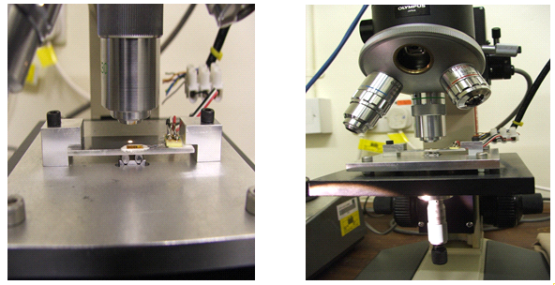
Figure 4: The machine was used to apply four point bend load with the optical microscope to observe the crack propagation.
5- Results and Discussion
5-1 Indentation Method
In this study the surface curvature is small over the scale of the indentation pattern. Therefore, the test surface must be prepared to an optical finish, in order that the crack size may be accurately determined. Even then, depending on the reflectivity of the specimen surface, the tip regions of the radial-median cracks were not always clearly defined and required exacting microscopic examination. Further, precautions must also be taken in selecting a working range of indentation loads which satisfies the requirement that the pattern be well developed c ≥ 2a so that no chipping occurs.
5-1-1 Cracks Observation
The indents were painted using thin layer from the ink to make the radial-median cracks more apparent. The surfaces were examined by optical microscopy, as shown in Figure 4.
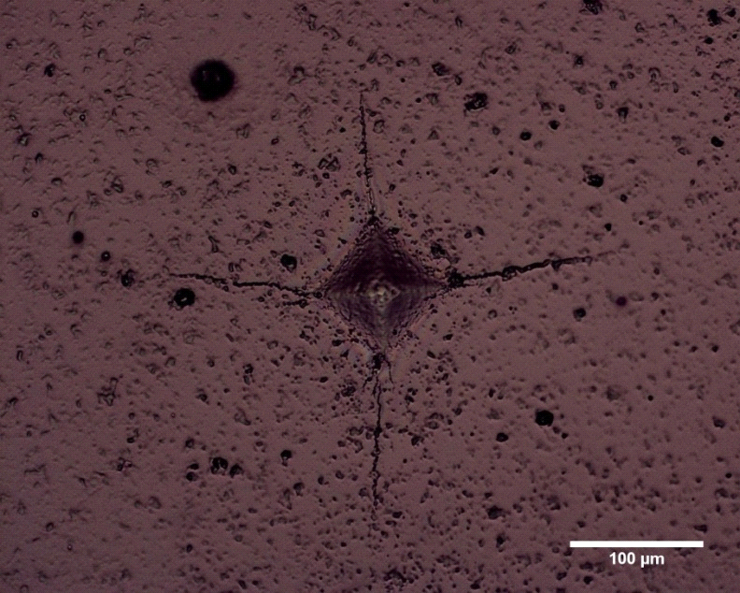
Figure 5: Cracks forming about a Vickers indenter loaded with 10 kg.
The radial / median crack got in the alumina sample due to the cracks were diffused beneath the indentation after the indent was removed by polishing the sample the crack still remain on the alumina surface. The cracks were complex in shape as shown by the results in Figure 5.
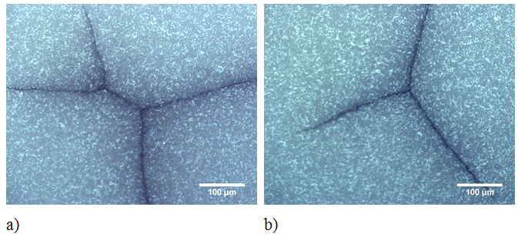
Figure 6: The kind of crack is radial / Median and the crack is a complex shape in these images.
From Figure 5 the cracks was nucleated using Vickers indentation and the fracture toughness was determined depends on the type of crack. The crack was known by remove the indent using polishing to observe the kind of crack. Radial and median crack was observed due to the crack spreading out beneath the indent removed after the polishing and the cracks can also coalesce to form radial- median or half-penny cracks
(Cook, 1990).
Following the guiding principles established in the exploratory tests, crack sizes were measured at each load which gave clearly defied radial-median traces as a function of load as shown in Figure 7.

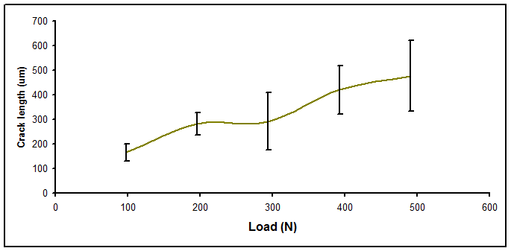
Figure 7: The relationship between the crack length and indentation load for alumina sample.
Figure 8 shows the results of fracture toughness, K_{1C} plotted against the load, P. Table 1 shows the P/C^{3/2} as a function of Vickers load P for the sample. The error bars represented standard deviation for a minimum of five indentations at each load. Within the experimental scatter, K_{1C} is effectively invariant with respect to load, (as predicated by using Anstis et al., Equation (Lemaitre, 1988).
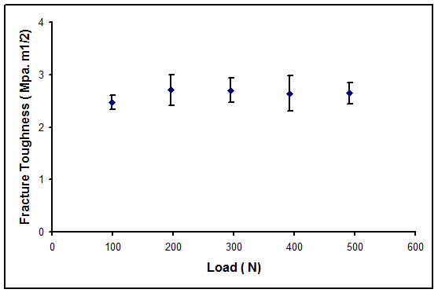
Figure 8: The relationship between the fracture toughness and indentation load for alumina sample.
Table 1: show the P/C^{3/2} as a function of Vickers load, P for the alumina sample.
Vickers Load ,P( Kg) | P/C^{3/2} (MN.m^{-3/2)} | K_{1C} ( Mpa.m^{1/2}) | No. of Indentations
10 | 35.937 | 2.47 | 4
20 | 36.724 | 2.705 | 5
30 | 36.590 | 2.700 | 4
40 | 36.288 | 2.640 | 5
50 | 34.414 | 2.645 | 5
Adoption of the indentation method in any ceramics evaluation program accordingly requires the advantages of simplicity and economy in testing to be weighed against these limitations in accuracy. The extent to which crack extend is a function of indent load, shape and loading rate and also the material properties (Meschke, 1997) as shown in Figure 6. The next step in the correlation is the calculation of fracture toughness corresponding to the crack size (in situ fracture toughness) (Srinivasan, 1991). In situ toughness are calculated using Anstis's equation (Lemaitre, 1988) for the radial /median crack size as given in Table 1. Fracture toughness has the largest effect on the extent of cracking at the given load as shown in Figure 7.
5-2 Digital Image Correlation Method
The fracture toughness was calculated using Griffith law (Anderson, 2005) as shown in equation 3. The cracks were produced under the four point bending and the cracks observed using digital image correlation.
$K_{1c}=σ×\sqrt{πc}$ (3)
Where:
K_{1C}= Fracture toughness, Mpa.m^{1/2}
σ = Applied stress, Mpa
c = crack length, m
The crack length was observed using digital image correlation as shown in Figure 9. The relationship was between the applied stress and the fracture toughness as shown in Figure 10. The relationship was between the crack length and fracture toughness is shown in Figure 11.
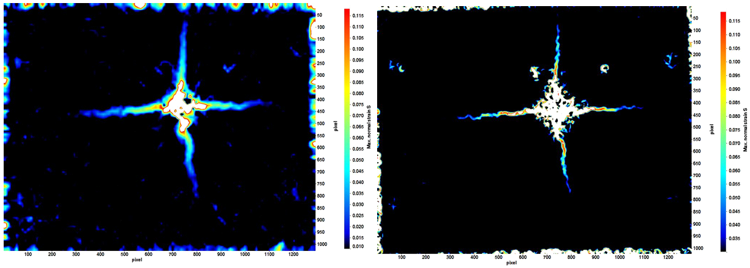
Figure 9: Illustration of the crack length observed by image correlation under applied load a) with noise b) without noise.
The image correlation data was identified the features using strain map. Strain map is a result of the measured relative displacements of material on either side of the feature. The magnitude of the strain depends on the differentiation of this displacement (Da Fonseca, 2005). The strain data was analysed to determine the maximum strain measured with each feature. High strain regions corresponded well with the location and length of the cracks as shown in Figure 9. The colour contour indicates the number of images in which cracks were identified at that position. The crack length was measured using Image J software and then fracture toughness was measured using Griffith equation. Figure 11 shows the relationship between the fracture toughness and the crack length.
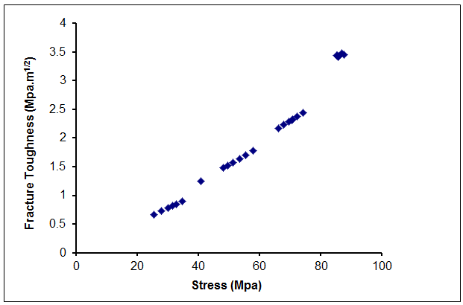
Figure 10: Illustration the relationship between the fracture toughness and bending stress for alumina sample.
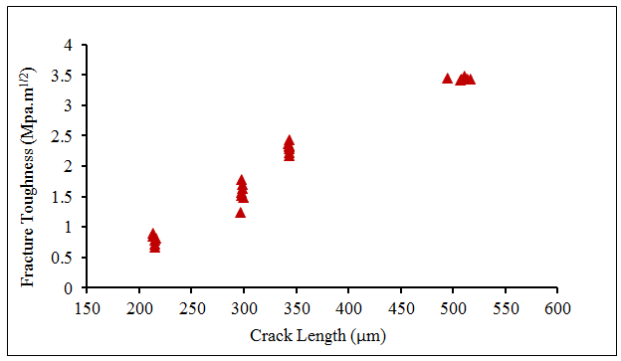
Figure 11: Illustration of the crack length observed by image correlation under applied load a) with noise b) without noise.
Figure 12 shows the comparison between the indentation method and the digital image correlation method. The fracture toughness was measured by digital image correlation was more accurate due to the crack lengths and crack tips were much clear and it was coloured. The fracture toughness value was obtained by digital image correlation is (3.48 MPa.m^{1/2}) and The Anstis has been obtained the fracture toughness by double cantilever beam and it was (3.9 MPa.m^{1/2}).
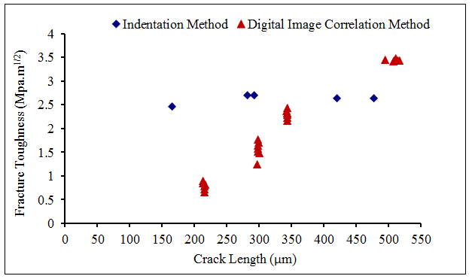
Figure 12: Illustration of the crack length was observed by digital image correlation versus the fracture toughness.
6- Conclusion
- The crack lengths and the crack tips were observed using digital image correlation was very clear.
- The fracture toughness was measured using digital image correlation was more accurate than indentation method.
- The fracture toughness values were obtained by digital image correlation were near to the standards values in the literature review for the alumina samples.
- The digital image correlation technique has been implemented and optimized for the chosen material, and demonstrated to have sufficient sensitivity for this study.
7- REFERENCES
Anderson T. L., Fracture Mechanics: Fundementals and Applications. 2005, CRC Press, 3rd edition.
Anstis, G.R., Chantikul, P., Lawn, B. R., Marshall, D. B., A, 1981, Critical-Evaluation Of Indentation Techniques For Measuring Fracture-Toughness.1. Direct Crack Measurements. Journal Of The American Ceramic Society. 64(9): p. 533- 538.
Bruck, H.A., McNeill, S. R., Sutton, M. A., Peters, W. H. , 1989, Digital Image Correlation Using Newton-Raphson Method Of Partial-Differential Correction. Experimental Mechanics.29(3): p. 261-267.
Callister, W.D., Materials Science and Engineering: An introduction, ed. 7th. 2007, New York.
Chantikul, P., Anstis, G. R., Lawn, B. R., Marshall, D. B., A, 1981,Critical-Evaluation Of Indentation Techniques For Measuring Fracture-Toughness.2. Strength Method. Journal Of The American Ceramic Society. 64(9): p. 539-543.
Chu, T.C., Ranson, W. F., Sutton, M. A., Peters, W. H. , 1985, Applications Of Digital-Image-Correlation Techniques To Experimental Mechanics. Experimental Mechanics. 25(3): p. 232-244.

Cook, R.F., Lawn, B. R., Fairbanks, C. J., 1985, Microstructure-Strength Properties In Ceramics.1. Effect Of Crack Size On Toughness. Journal Of The American Ceramic Society. 68(11): p. 604-615.
Cook, R.F., Pharr, G. M., 1990, Direct Observation And Analysis Of Indentation Cracking In Glasses And Ceramics. Journal Of The American Ceramic Society. 73(4): p. 787-817.
Da Fonseca, J.Q., Mummery, P. M., Withers, P. J., 2005, Full-field strain mapping by optical correlation of micrographs acquired during deformation. Journal Of Microscopy-Oxford. 218: p. 9-21.
Fuller, E.R., Lawn, B. R., Cook, R. F. , 1983, Theory Of Fatigue For Brittle Flaws Originating From Residual-Stress Concentrations. Journal Of The American Ceramic Society. 66(5): p. 314-321.
Lawn, B.R., Evans, A. G., Marshall, D. B., 1980,Elastic-Plastic Indentation Damage In Ceramics - The Median-Radial Crack System. Journal Of The American Ceramic Society. 63(9-10): p. 574-581.
Lemaitre, P., Piller, R.,1988,Comparison Of The Fracture-Toughness Of Alumina Measured By 3 Different Methods. Journal Of Materials Science Letters.(7):p.772-774.
Liang, K.M., Orange, G., 1990, Fantozzi, G., Evaluation By Indentation Of Fracture- Toughness Of Ceramic Materials. Journal Of Materials Science. 25(1A):p. 207-214.
Meschke, F., Alves-Riccardo, P., Schneider, G. A., Claussen, N., , 1997, Failure behavior of alumina and alumina silicon carbide nano-composites with natural and artificial flaws. Journal Of Materials Research. 12(12): p. 3307-3315.
Rowcliffe, D. J., 1992, Quasi-Static Indentation of Ceramics. Key Engineering Materials: p. 71, 1-22.
Smith,S.M.,Scattergood,R.O.,1992,Crack-Shape Effects For Indentation Fracture- Toughness Measurements. Journal Of The American Ceramic Society.75(2):p.305-315.
Srinivasan, S., Scattergood, R. O., 1991, R-Curve Effects In Solid Particle Erosion Of Ceramics. Wear. 142(1): p. 115-133.
Swanson, P.L., Fairbanks, C. J., Lawn, B. R., Mai, Y. W., Hockey, B. J., 1987, Crack- Interface Grain Bridging As A Fracture-Resistance Mechanism In Ceramics.1. Experimental-Study On Alumina. Journal Of The American Ceramic Society. 70(4): p. 279-289.

