Comparative Study of Fingerprint Image Enhancement Methods

Safaa Saheb Omran
College of Elec. & Electronic Techniques, Foundation of Technical Education,
omran_safaa@ymail.com
Maryam Abdulmunem Salih
Department of Computer engineering and Information Technology
University of Technology
mari8322@yahoo.com

Abstract
Fingerprint image enhancement is very important step in fingerprint recognition system .choosing the right method can be very critical point due to its effect on the performance of the feature extraction operation.
This paper will present three main method (histogram equalization method that enhance the fingerprint image by adjusting the grey scale level contrast of the fingerprint image, FFT transform that enhance the finger print image base on its frequency domain and Gabor filter that enhance the fingerprint image based on its directional and frequency estimation map)
The evaluation of the three enhancement method will be based on the analyzing the performance of feature extraction operation after applying the three methods.
Key words: fingerprint, image enhancement, biometric.
الخلاصة
تحسين صورة البصمة هو خطوة هامة جدا في نظام التعرف على بصمات الأصابع، وأن اختيار الطريقة الصحيحة هي خطوة حرجة جدا نظرا لتأثيرها على أداء عملية استخراج الميزات.
أن هذا البحث يقديم ثلاث طرق الرئيسية (طريقة " histogram equalization " التي تعزز صورة البصمات عن طريق ضبط تباين مستوى مقياس الرمادية للصورة بصمات الأصابع، "FFT" تحويل التي تعزز صورة بصمات القاعدة على نطاق ترددها، "Gabor filter" التي تعزز صورة البصمات على أساس على اتجاهي والتردد خريطة تقديره وسوف يستند تقييم الأسلوب ثلاثة على تعزيز تحليل أداء عملية استخراج الميزات بعد تطبيق الطرق الثلاث.
الكلمات المفتاحية : بصمة الاصبع ، تحسين الصورة ، بايومترك.
1. Introduction
With increase needs for secure systems it is very important to use identification method that are not easily lost or replaced or hacked.
Identity usurpation is currently at the heart of numerous concerns in our modern society. Establishing the identity of an individual is considered as fundamental requirement for numerous operations. Three approaches are available to prove person identity and to provide “the right person with the right privilege the right access”.
The identity providing approaches to establish the genuineness of identity are:[A.Patra 2006]
- Something you have:-the associated service or access is received through the presentation of physical object like, (keys, identity cards, smart cards…etc.).
- Something you know:-a pre-defined secret knowledge such as passwords permit to access a service.
- Something you are:-the access to a service can be achieved through the presentation of measurable biometrics traits such as biometric measures.
A reliable identity management system is urgently needed, in order to combat the epidemic growth in identity theft, and to meet the increased security requirement in a variety of applications ranging from international border crossing to accessing personal information. Establishing (determining or verifying) the identity of a person is called person recognition or authentication.It is a critical task in any identity management system. [K. Nandakumar 2008]
Biometric identification systems are meet this requirement in a way to identify the person based on the physical characters (for example: ear, face, fingerprint, hand geometry, iris, palm print, retina, signature, and voice), nowadays it is used in many applications.
2. Fingerprint as Biometric Recognition System
Fingerprint recognition system one of the most popular authentication systems, the result of the survey conducted by the International Biometric Group (IBG) in 2004 on comparative analysis of fingerprint with other biometrics is presented in Fig. 1. The result shows that a substantial margin exists between the uses of fingerprint for identification over other biometrics such as face, hand, iris, voice and signature and middle ware. [I. G. Babatunde, A. O.Charles, A. B. Kayode, and O. Olatubosun 2012]
The importance of fingerprints comes from their uniqueness and portability. It is believed that every person has unique fingerprints which remain invariant over time.
Unlike identification cards, fingerprints cannot be lost or stolen. Fingerprint recognition systems are becoming increasingly important and finding applications in variety of fields. These fields include access control systems, criminal identification and authentication and access to security systems such as computers or bank teller machines.[ I. El-Feghi , A. Tahar , M. Ahmadi 2011]
Fingerprint Recognition system compares taken samples with pre-stored samples in system database. the identification system consist of four modules ( enrolment module which take the fingerprint sample from the hardware scanner, feature extraction module which convert fingerprint image into fingerprint template ,database model stores the finger print template, and the matching process matches the enrolled fingerprint image with the templates stored in the system data base)
The performance of the finger print matching system and feature extraction models depend heavily on the quality of the finger print image. Fingerprint image acquired from fingerprint acquisition phase undergoes a pre-processing for the sake of producing quality images. Low quality images and images with noise during fingerprint recognition make the matching phase a complicated task. The fingerprint image enhancement produce results in noise-free image which in turn produces high quality and accuracy. [V. L. Jothi, S. Arumugam 2012]
Several fingerprint enhancement methods where proposed to enhance the visualization of the finger print image this paper do a comparative study between the three main enhancement techniques.
3. Fingerprint image and its characteristics
Fingerprint image is represented by two-dimensional image the most obvious structural characteristic of a fingerprint is the pattern of interleaved ridges and valleys that often run in parallel these are form the fingerprint features that are used in fingerprint matching algorithms.[ R. N. Verma, D. S.Chauhan 2011]
Fingerprint features can be classified into global and local levels. Global features such as fingerprints, such as singular points and global ridge patterns,(example deltas and cores). indicated by red triangles in Fig.(3), they are not very distinctive and are thus mainly used for fingerprint classification rather than recognition. While local feathers (red rectangles in figure (3)) primarily refer to the Galton features or minutiae, namely, ridge endings and bifurcations. They are the most distinctive and stable features, which are used in almost all automated fingerprint recognition systems [D. Zhang, F. Liu, Q. Zhao, G. Lu, and N. Luo , 2011].
4. Fingerprint image Enhancement
Fingerprint images are direction-oriented patterns formed by ridges and valleys. Structures of ridges in fingerprint images are not always well defined, and an enhancement algorithm that can improve the clarity of ridge structures is required.[ M. K. Bahaghighat, J. mohammadi, and R. Akbari 2010]
Usually, the input of the enhancement algorithm is a grey-scale image. The output may either be a grey-scale or a binary image, depending on the algorithm. General-purpose image enhancement techniques do not produce satisfying and definitive results for fingerprint image enhancement. However, contrast stretching, histogram manipulation, used by (Hong, Wan, and Jain, 1998), have been shown to be effective as initial processing steps in a more sophisticated fingerprint enhancement algorithm.
The most widely used technique for fingerprint image enhancement is based on contextual filters. In conventional image filtering, only a single filter is used for convolution throughout the image. In contextual filtering, the filter characteristics change according to the local context. Several types of contextual filters have been proposed in the literature for fingerprint enhancement. (Sherlock, Monro, and Millard 1992, 1994) performed contextual filtering in the Fourier domain;( Hong, Wan, and Jain 1998) proposed an effective method based on Gabor filters. Gabor filters have both frequency-selective and orientation-selective properties and have optimal joint resolution in both spatial and frequency domains. [M. K. Bahaghighat, J. mohammadi, and R. Akbari 2003]
This paper discussing the most popular fingerprint image enhancement and evaluate them based on performance of fingerprint feature extraction process.
- Histogram equalization based fingerprint image enhancement.
Histogram equalization is general process used to enhance the contrast of the fingerprint image by transforming its intensity values.
The distribution of grey-levels occurring in an image is called grey level histogram Figure(4(b),4(d),4(f)) its graph showing the frequency of occurrence each grey level in image versus the grey level itself.
The output after applying histogram equalization will provide global distribution for the histogram of the original fingerprint image.
Histogram for the image with grey level from [0 To L-1], is described by $P(r_{k})=\frac{n_{k}}{n}\text{.}\text{.}\text{.}\text{.}\text{.}\text{.}\text{.}(1)$ where …
r_{k} | Is the k’th grey level
n_{k} | Is the number of pixels in image with that grey level
n | Is the total number of pixels in the image
k | 0,1,2,…,L-1
L= | 256

As secondary result to global histogram equalization, it can amplify the noise and produce worst version of the original image.
Therefore instead of using histogram equalization which effect the whole image clip limit and histogram equalization (CLAHE) is applied to enhance the contrast of small tails ,thus will avoid oversaturation of image specifically in homogenous area that present high peaks in histogram of certain image due to many pixels falling inside the same gray level range. Figure (4) shows the output after applying Histogram equalization enhancing techniques.[ M. F. Hanoon 2011]
- FFT based fingerprint image enhancement:
An image can be represented as a collection of frequencies displayed as energy spectrum the mathematical operation used to perform this conversion to frequency domain in digital image processing called Fast Fourier Transform (FFT). This method was widely used in earlier work of fingerprint image recognition systems.
In this method the image is divided into small blocks (we used 32 by 32 pixels) and perform the 2D FFT on each block …
$F^{}(u,v)=\sum_{x=0}^{M−1}{\sum_{y=0}^{N−1}{f(x,y)\text{exp}\left\{−j2π×\left(\frac{\text{ux}}{M}+\frac{\text{vy}}{N}\right)\right\}}}\text{.}\text{.}\text{.}\text{.}\text{.}(2)$
For u=0,1,2,3,4,….w-1 v=0,1,2,3,4,…w-1
To do FFT enhancement method on local blocks size (w*w) its FFT will be multiplied by its magnitude
$g(x,y)=F^{−1}F^{}\left\{\left(u,v\right)×\left|F^{}{\left(u,v\right)}^{k}\right|\right\}\text{.}\text{.}\text{.}\text{.}\text{.}\text{.}(3)$
Where F⁻¹(F(u,v)) is given by :

$$f^{}(u,v)=\frac{1}{\text{MN}}\sum_{x=0}^{M−1}{\sum_{y=0}^{N−1}{F(u,v)\text{exp}\left\{−j2π×\left(\frac{\text{ux}}{M}+\frac{\text{vy}}{N}\right)\right\}}\text{.}\text{.}\text{.}\text{.}\text{.}(4)}$$
For x=0,1,2,3,4,….w-1 y=0,1,2,3,4,…w-1
The k parameter in the equation is the FFT factor will be ranged from (0 to 1) high factor improve the appearance of the image fill up the holes but to high will result in joining of ridges in false areas .also the algorithm do not use a full contexture information provided by fingerprint image because fingerprint image has more features than only frequencies on each filtered block, beside this method is assumed that the ridge frequency is constant throughout the image. The result of applying FFT on fingerprint image is shown in figure (5).[ M.Rajinikannan, D.Ashok Kumar, and R. Muthuraj 2010]
- Fingerprint image enhancement using Gabor filter:
Gabor filter has been widely used in domains of image processing and pattern recognition. Many fingerprint recognition systems use Gabor filter for fingerprint image enhancement. [K. Mao, Z. Zhu, and H. Jiang 2010]In the next section a description to the characters of Gabor filter, then applying fingerprint image enhancement on the basis of the even symmetric Gabor filter.
- Orientation field estimation
As an important feature in fingerprint image is the orientation field, it’s playing a critical rule in fingerprint image enhancement, singularity characterization, fingerprint classification fingerprint indexing, and fingerprint registration…etc.[ S. Jirachaweng, Z. Hou, J. Li, W. Yau, and V. Areekul 2010]
Local ridge orientation is the angle at which the ridge crosses through an arbitration neighborhood centered at on pixel, measured with respect horizontal axis, the orientation field is discrete matrix composed of local ridge orientation estimated at discrete position. Fig(6)[ M. Liu, P. Yap 2012].
Assume the gray scale Image I, I(i,j) represent pixel at position (i,j) ,the procedure to estimate the orientation field for the fingerprint image is:[ J. Li, J. Ma, X. Wu 2011]

- Divide the original image into sub-blocks size w×w.
- Compute the gradient $∇_{x}(i,j)$ and $∇_{y}(i,j)$ at each pixel (i,j) in each block using Gaussian filter.
- Estimate the local orientation of each block center at pixel (i,j) using the following equations:

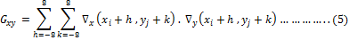
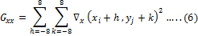
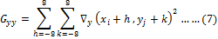
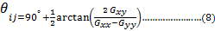

- Frequency field estimation
According to the approach of Hong et. al., the frequency field is estimated on block basis under premises of orientation field. The method models the orientation of ridges and valleys onto a sinusoidal curve then an orientation which is perpendicular to the block orientation is set as x-signature see fig(7), by choosing a set of equally distributed points along the x-signature ,the sampling point of the sinusoidal curve are obtained.[ Y. Hu, X. Jing, B. Zhang, X. Zhu 2010]
The first step in the frequency field estimation stage to divide the image into blocks of size , the next step to project the gray level value of all pixels located inside each block along the direction orthogonal to the local ridge orientation .this projection form an almost sinusoidal-shape wave with local minimum points corresponding to the ridge in the fingerprint.
This includes smoothing the project waveform using Gaussian low-pass filter of size to reduce the effect of noise in the projection.
The ridge spacing S(i,j) is then computed by counting the median number of pixels between consecutive minima in the projected form. [A. El-Sisi 2011]
Hence, the ridge frequency F(i,j) of block centered at pixel (i,j) is defined as
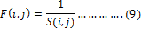
- Applying filtering process
2D Gabor filter can be viewed as sinusoidal plane of perpendicular frequency and orientation modulated by Gaussian envelope. [K. Arora, P. Garg, 2011] To apply Gabor filter.

Where and f is the orientation and the frequency and are gauss envelop constant. control the spatial frequency bandwidth of the filter, the larger they are the wider bandwidth is expected .However, too wide bandwidth can unexpectedly enlarge the noise and too narrow bandwidth tend to suppress some useful signals. The value of determines the smoothing degree along the local orientation, while influences the degree of contrast between ridge and valley. Figure (8) shows image after applying Gabor filter with different and values.[ K. Mao, Z. Zhu, and H. Jiang 2010]
5. Fingerprint image feature extraction:
As said before fingerprint image line pattern consist of ridges and valleys .the most interesting patterns are ridge ending and ridge bifurcation, these are used for compering two fingerprints with each other. Fingerprint usually consist of 40 up to 100 minutiae points, minutiae are usually extracted from the binary image. [S. Maddala, S. Tangellapally, J. Bart_n_k , M. Nilsson 2006] Before applying feature extraction process a two important pre-processing step need to do binarization and thinning.
binarization this process is used To convert gray scale image to binary image where the pixel values either 0 or 1.it need first to find global threshold by computing mean of the image and then compering each pixel of the image against that threshold. If the pixel has darker gray scale value than the threshold, in the output image the pixel will be given value”1” for black. Likewise a value “0” for white will be given for pixels with lighter values.[ Y. Xiao 2006].
Thinning Is the final step before feature extraction .thinning is to remove the binary fingerprint image edge pixels, so that the only a single pixel will describe the ridges. In order of facilitating minutiae extraction. thinning should ensure the connection of the ridge ,the same direction and feature points, In addition the center ridge should remain basically unchanged.[ Z. Jinhai 2011]
The procedure for extraction mania is [R. N. Verma, D.S.Chauhan 2011] :

- Use matrix and check whether the central pixel is white or black.
- If the center is black move ahead without any change.
- If the center is white ,then check the pixels surrounding the center pixel in the
  - If the center pixel is “1” and has exactly 3 one-value neighbors then the center is marked bifurcation.
  - If the center pixel is “1” and has only one one-value neighbor then the center pixel is end point.
  - Otherwise the center pixel is ridge continuity.

Due to different noise that affect the fingerprint image and due to segmentation and thinning process a large number of false minutiae are discovered among the extracted minutiae. Fig(10) shows some false minutia structures.
False minutiae removing algorithm is based on structured rules to eliminate spurious minutiae. It tests the validity of each minutiae point by scanning the Skelton image and examines the local neighborhood around the minutiae. The algorithm then will be able to cancel out false minutiae based on the configuration of ridge pixels connected to the minutiae point[M. Kaur, M. Singh, A. Girdhar, and S. Sandhu 2008]. The following condition describes false minutiae.

- Count D: the average inter-ridge width representing the average distance between two parallel neighboring ridges.
- If the distance between one bifurcation and one termination is less than D and the two minutiae are in the same ridge (m1 case). Remove both of them.
- If the distance between two bifurcations is less than D and they are in the same ridge, remove the two bifurcations (m2, m3, m8, m10, m11 cases).
- If two terminations are within a distance D and their directions are coincident with a small angle variation, and they suffice the condition that no any other termination is located between the two terminations, then the two terminations are regarded as false minutia derived from a broken ridge and are removed (case m4, m5, m6 cases).
- If two terminations are located in a short ridge with length less than D, remove the two terminations (m7 case).
- If a branch point has at least two neighboring branch points, which are each no further away than maximum distance threshold value and these branch points are closely connected on common line segment, then remove the branch points (m12 case).
- Results
The paper proposed a comparative study between the most popular fingerprint enhancement techniques in the following figure presents the impact of three image enhancement approaches in the Detected fingerprint minutiae. In the figure, the location marked with “red “is the ridge ending” and the location marked with “green” is the detected ridge bifurcation the method applied on FVC2000 database.
- Conclusion
Fingerprint enhancement is critical task the whole fingerprint recognition system depends on it, using three different enchantment methods the result was varied very much, among the three evaluated fingerprint image enhancement algorithms, the Gabor Filter based algorithm performed very well. It is performed better than the other two algorithms the algorithm enhanced the corrupted areas of the fingerprint and this helps in removing the spurious minutia too.
- References
Patra, A. 2006” Development Of Efficient Methods For Face Recognition And Multimodal Biometry”,Department Of Computer Science And Engineering Institute Of Technology Madras, M.Sc. Thesis.
El-Sisi, A. 2011 “Design and Implementation Biometrie Aeeess Control System Using Fingerprint for Restricted Area Based on Gabor Filter”, The International Arab Journal of Information Technology, Vol. 8, No. 4.
Zhang, D. Liu, F. Zhao, Q. Lu,G. and Luo,N. 2011, ” Selecting a Reference High Resolution for Fingerprint Recognition Using Minutiae and Pores”IEEE TRANSACTIONS ON INSTRUMENTATION AND MEASUREMENT,VOL.60, NO. 3.
Babatunde,I. G. Charles, A. O. Kayode, A. B. and Olatubosun,O. 2012 “Fingerprint Image Enhancement: Segmentation to Thinning”,(IJACSA)International Journal of Advanced Computer Science and Applications, Vol. 3, No. 1.
El-Feghi , I. Tahar , A. Ahmadi, M. 2011,“Efficient Features Extraction for Fingerprint Classification with Multi Layer Perceptron Neural Network”, IEEE, International Symposium on Signals, Circuits and Systems.
Li,J. Ma, J. Wu, X. 2011, ” application of methods for getting direction image based on gradient in fingerprint processing”, IEEE.
Nandakumar,K. 2008,” Multibiometric Systems: Fusion Strategies And Template Security”, Department Of Computer Science And Engineering, Ph.D. Thesis.
Arora,K. Garg,P. 2011,“A Quantitative Survey of various Fingerprint Enhancement techniques”,International Journal of Computer Applications (0975 – 8887) Volume 28– No.5.
Mao,K. Zhu,Z. and Jiang, H. 2010, “A Fast Fingerprint Image Enhancement Method”,Third International Joint Conference on Computational Science and Optimization.
Hanoon, M. F. 2010,”Contrast Fingerprint Enhancement Based on Histogram Equalization Followed By Bit Reduction of Vector Quantization”, IJCSNS International Journal of Computer Science and Network Security, VOL.11 No.5.
Rajinikannan, M. Ashok Kumar D., and Muthuraj, R. 2010 ,“Estimating the Impact of Fingerprint Image Enhancement Algorithms for Better Minutia Detection”, International Journal of Computer Applications (0975 – 8887) Volume 2 – No.1.
Bahaghighat, M. K. mohammadi, J. and R. Akbari, 2010,” Fingerprint Image Enhancement Using GWT And DMF”, 2nd International Conference on Signal Processing Systems (ICSPS)
Maltoni, D. Maio, D. Jain, A. K. Prabhakar, S. 2003,“Handbook of Fingerprint Recognition” Springer.
Liu, M. Yap, P. 2012, “Invariant representation of orientation fields for fingerprint indexing”, Elsevier, Pattern Recognition 45.
Kaur, M. Singh, M. Girdhar, A. and Sandhu, S. 2008 ,“Fingerprint Verification System using Minutiae Extraction Technique”, World Academy of Science, Engineering and Technology 4.
Verma, R. N. Chauhan, D.S. 2011 ,“Effect of Pressure Variation on the Fingerprint Minutiae Based Feature Vector Matching”, World of Computer Science and Information Technology Journal (WCSIT) ISSN:2221-0741 Vol. 1, No. 9, 376-379.
Maddala, S. Tangellapally, S. Bart_n_k, J. Nilsson, M.”Implementation and Evaluation of NIST Biometric Image Software for Fingerprint Recognition”, IEEE, Biosignals and Biorobotics Conference 2011.
Jirachaweng, S. Hou, Z. Li, J. Yau, W. and Areekul, V. 2010,” Residual Analysis for Fingerprint Orientation Modeling”, International Conference on Pattern Recognition.
Jothi, V. L. Arumugam, S. PhD., 2012,” High-Resolution Fingerprint Matching using Level 3 Incipient Ridges and Scars” International Journal of Computer Applications (0975 – 888) Volume 48– No.8..
Xiao,Y.2006,“an optimized approach for fingerprint binarization” IEEE, international joint conference on nural network.
Hu, Y. Jing, X. Zhang, B. Zhu, X. 2010 ,“Low Quality Fingerprint Image Enhancement Based on Gabor Filter”, IEEE.
Jinhai, Z. 2011 , “Research on Fingerprint image processing and thining”, IEEE.

Figure(1) Comparative survey of fingerprint with other biometrics

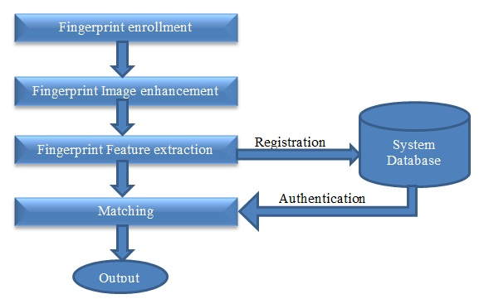
Figure (2) automatic fingerprint recognition system overview

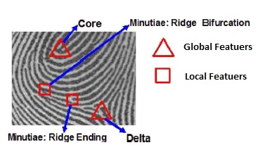
Figure (3) Fingerprint Image features

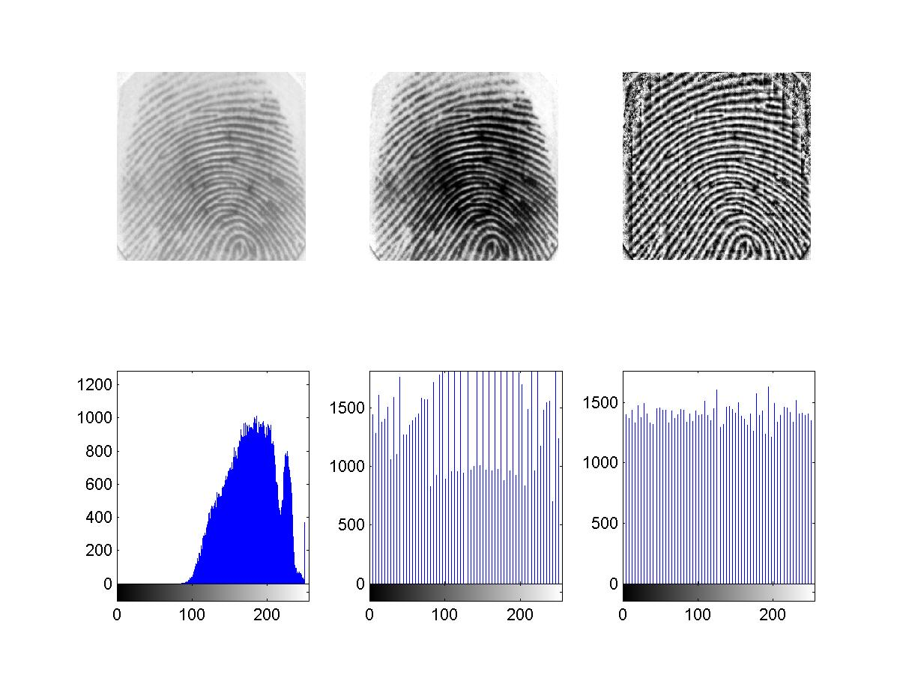
(a)Original Image | (b)Original Image Histogram
(c)Global Image Histogram equalization | (d) Histogram after applying Global Image Histogram equalization
(e) CLAHE Image Histogram equalization | (f) Histogram after applying CLAHE Image Histogram equalization
Figure (4) Applying Histogram Equalization

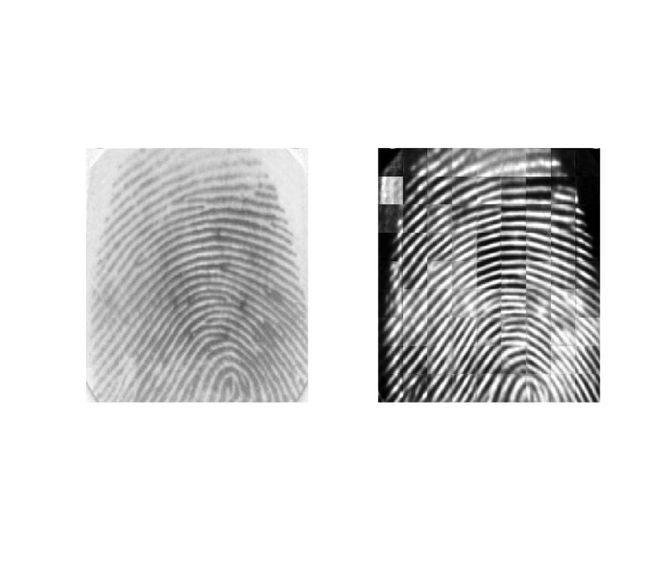
(a)Original Image | (b)applying FFT Enhancement
Figure (5) result of applying FFT enhancement techniques

 | 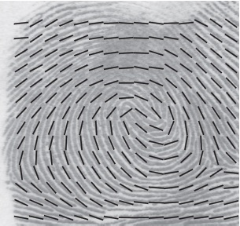
(a) The orientation of a ridge pixel in a fingerprint | (b) the orientation field estimated by the squared gradient averaging method
Figure (6) fingerprint oriantation field esstimation

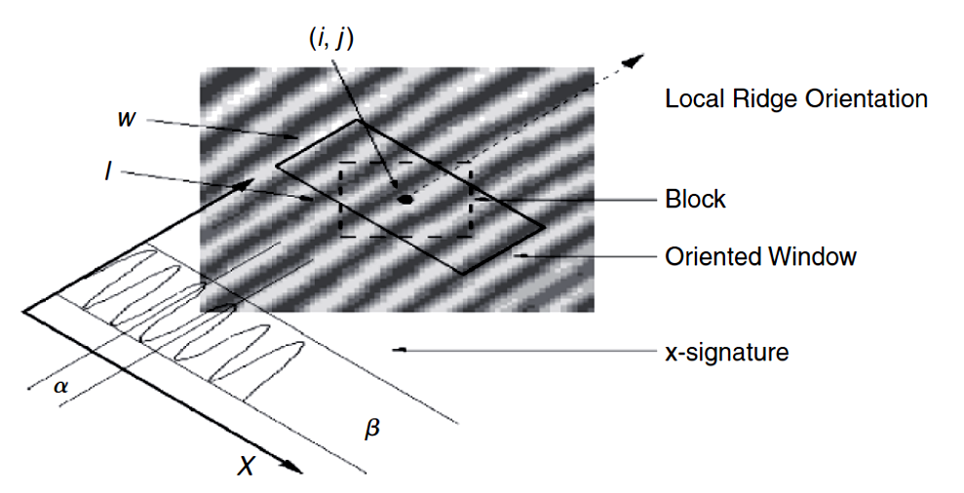
(a)Projection window | (b)Finger print frequncy esstimation field
Figure (7) Local ridge frequency estimation

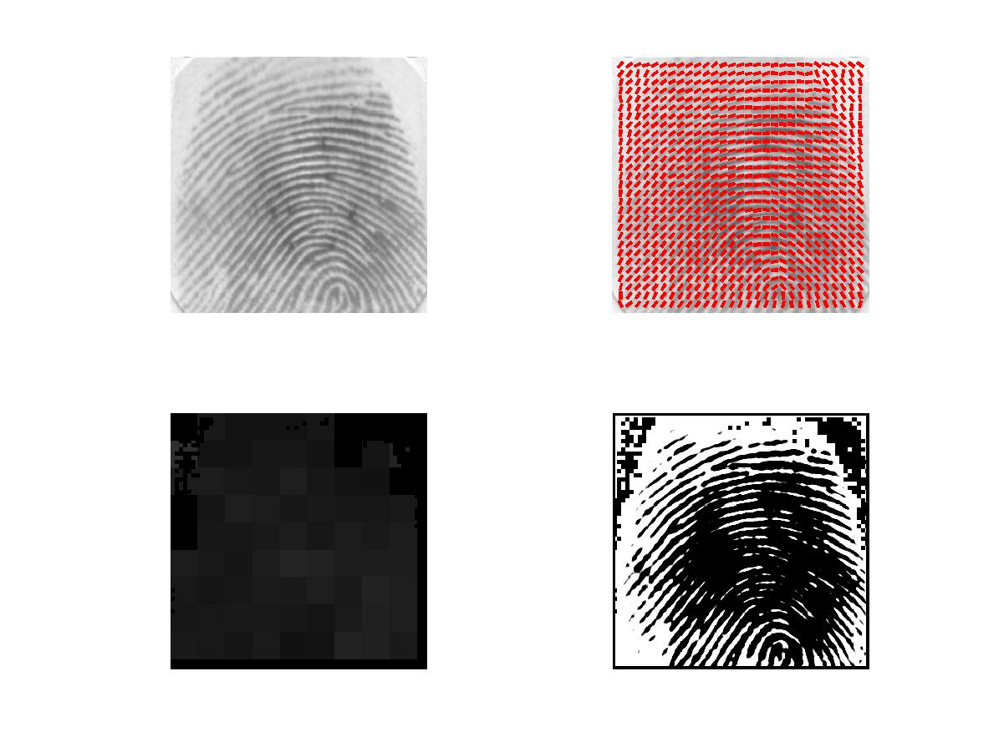
(a)Original image
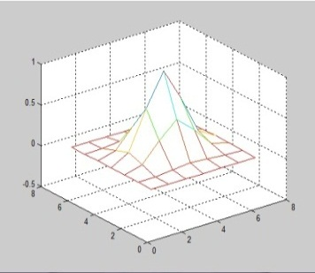
(b) enhanced image _{x=0.1} _{y =0.1} | (c) Gabor Filter _{x=0.1} _{y =0.1}
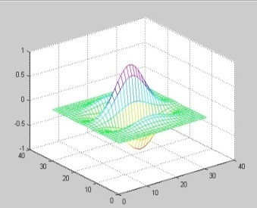 | 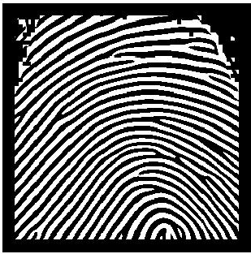
(d) enhanced image _{x=0.5} _{y =0.5} | (e) Gabor Filter _{x=0.5} _{y =0.5}
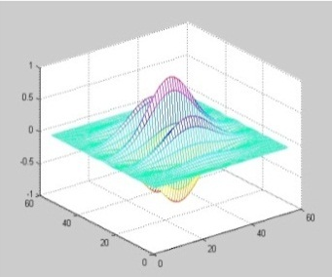 | 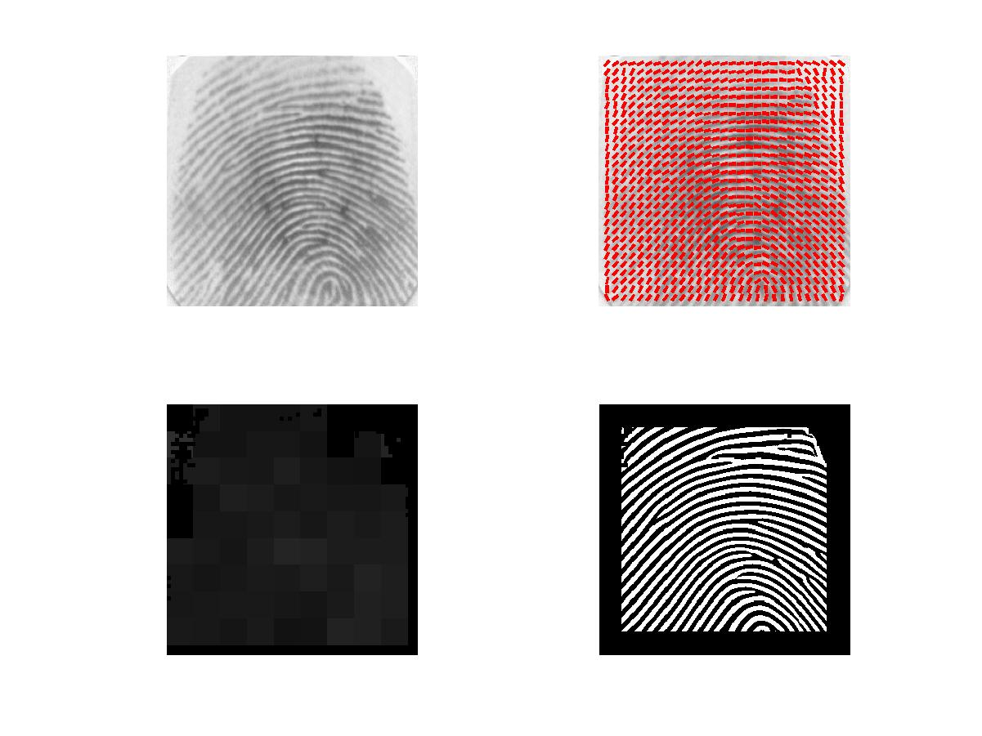
(f) enhanced image _{x=0.9} _{y =0.9} | (g) Gabor Filter _{x=0.9} _{y =0.9}
Figure (8) inhancement methode using Gabor filter with different_{x} and _{y} values

(a)Normal ridge pixel | (b)Termination point | (c)Bifurcation point
Figure(9) Feature extraction matrix window

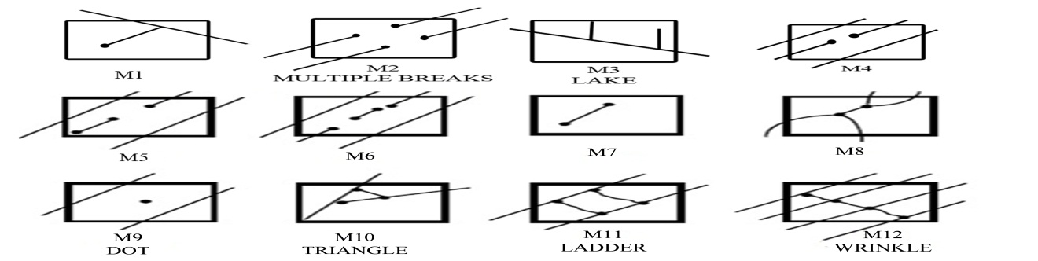
Figure (10). False Minutia Structures

Sample Number | Histogram Equalization | FFT | Gabor Filter
101_1 | 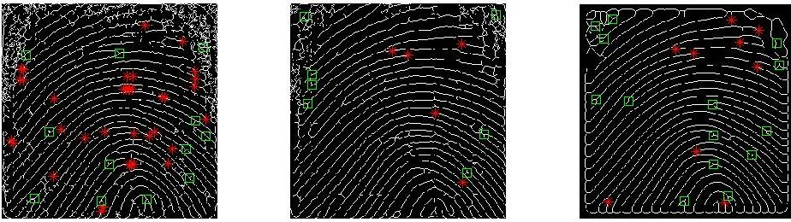
102_1 | 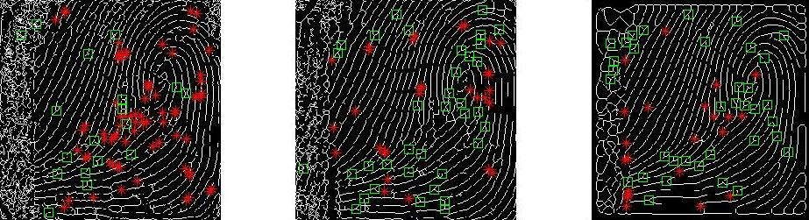
103_1 | 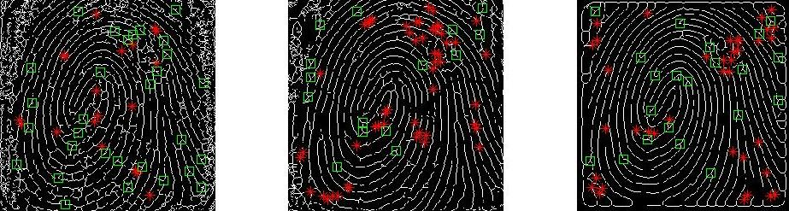
104_1 | 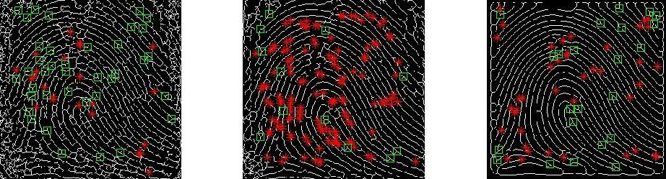
105_1 | 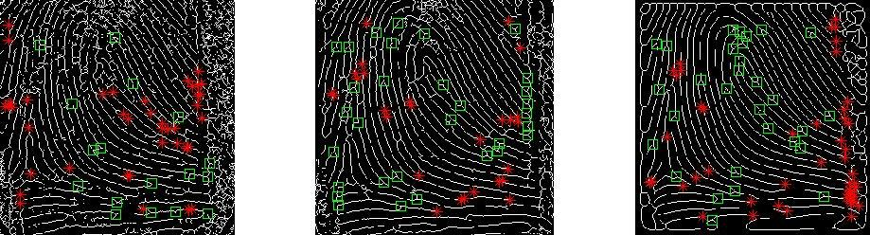
106_1 | 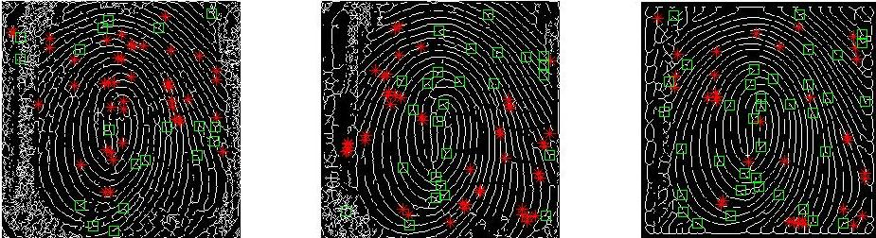
107_1 | 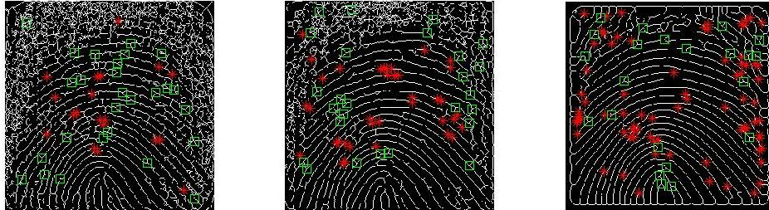
108_1 | 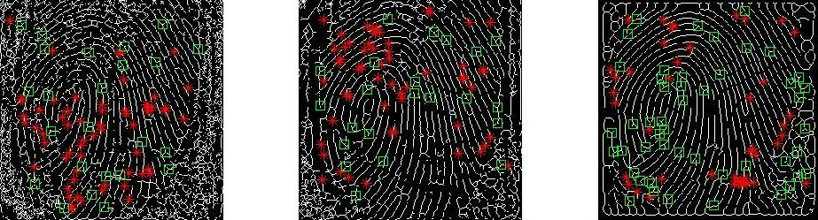
109_1 | 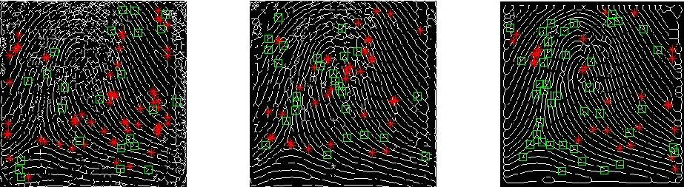
110_1 | 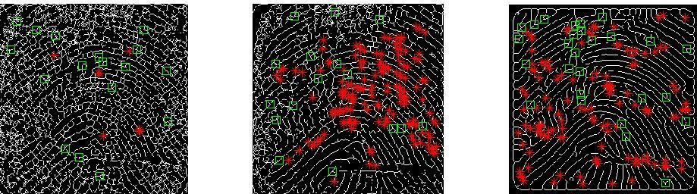

Figure (11) describe applying three enhancement methods on the FVC2000 Database

