Calculating the Coefficients of Muskingum and Muskingum-Cunge Methods for a reach from Shatt-Al-Hilla river

Qais Hatem Mohammad
Babylon university \ Collage of engineering \ Civil department
Abstract
To rout the flow in a reach river need first finding the coefficients of the used method. By taking a reach from Shatt- Hilla the study calculates the coefficients of two methods of flow routing: 1- Muskingum method. 2- Muskingum-Cunge method. With the aid of historical data the study finds the different factors that each method depending on.
Key Word: Flood routing, flow routing, hydrologic routing, Muskingum method, Muskingum-Cunge method.
الخلاصة
الخطوة الاولى لاستتباع الجريان في أي نهر بطريقة معينة هي ايجاد معاملات تلك الطريقة. وباستتباع الجريان في شط الحلة باستخدام طريقتين هما: مسكنجم ومسكنجم كونج, وبالاستعانة بالبيانات الحقلية الخاصة بشط الحلة تم التوصل الى معاملات تلك الطرقتين.
الكلمات المفتاحية: توجيه الفيضانات، توجيه تدفق، توجيه هيدروليكي
Introduction
Many studies are deal with flood routing which means a procedure to determine the time and magnitude of flow (i.e., the flow hydrograph) at a point on the watercourse from known or assumed hydrographs at one or more points upstream.[chow:1988]
The importance of flood routing comes from it is used in predicting the characteristics of a flood wave and their change with time in the direction of flow. These characteristics include:[Abida:2005]
1. Maximum water surface elevation and its rate of rise or fall (considered to be an important factor in the planning and design of structures across or along streams and rivers).
2. Peak discharge, which is required in the design of spillways, culverts, bridges and channels sections.
3. Total volume of water resulting from a design flood to assist in the design of storage facilities for flood control, irrigation and water supply.
There are many classification of flood routing methods like flood and synthesis routing, reservoir and river routing. But the most importance classification are hydraulic and hydrologic routing. The main difference between these two types is that: the first class depending on the basic differential equation of flow moment equation and continuity equation. And by solving these equation and use the boundary conditions get equations called saint-venant equations which after solving them get mathematical model explain the wave progressive in the reach. While the hydrologic routing (some time called lumped routing) doesn't directly use the basic differential equation but it is use another equation like storage equation.
The current study find the coefficients of two method of hydrologic routing which are Muskingum and Muskingum-Cunge method for a reach from Shatt-Al-Hilla.
There are many studies introduced Muskingum and Muskingum-Cunge method here are some of these studies:
John D. Fenton steady the Muskingum-Cunge approach for computing the propagation of long waves. He found the corresponding linearised differential equation and he showed that the essential approximation required by the method is that diffusion be small.
[Fenton:2011]
Ming- His Hsu use the dynamic wave theory of unsteady ﬂow in open channels, to get a four- point implicit ﬁnite- difference method is employed to develop a ﬂash ﬂood routing model for the Tanshui River in Taiwan.[Hsu- 2003]
Mehdi Delphi consider Flood routing in a prismatic channel with solving simultaneous continuity and momentum equation which are known as Saint – Venant equations. If inertia terms in Saint – Venant equations is removed, flow equation with complete inertia terms will be converted to diffusive equation. In his study he has compared the results of full wave and diffusion wave flood routing methods in a reach of Karun river's between Mollasani and Ahvaz station.[Delphi:2010]
Yeou- Koung Tung developed a nonlinear Muskingum model to solve flood rousing in rivers by using the state variable modeling technique. [Tung:1985]
Habib Abida studied Released ﬂows from the Sidi Salem Dam Reservoir on the Medjerda River (Northern Tunisia) were routed downstream along the river lower watercourse using both hydrologic and hydraulic ﬂood Routing techniques. The hydrologic ﬂood routing method used is that of Muskingum while the Hydraulic ﬂood routing procedure used a numerical model RUFICC (Routing Unsteady Flows In Compound Channels). [Abida:2005]
Efrat Morin monitored The ﬂoods of the Kuiseb River in the Namib Desert for 46 Years, and provided a unique data set of ﬂow hydrographs from one of the world’s hyperarid regions. The Study objectives were to: (1) subject the records to quality control; (2)model ﬂood routing and transmission losses; and (3)study the relationships between ﬂood characteristics, river characteristics and Recharge into the aquifers. [Morin:2009]
R. Peters found the model of the ﬂood routing in the Lower reaches of the Freiberger Mulde river and its tributaries by using the one-dimensional hydrodynamic modeling system HEC- RAS. Furthermore, this model was used to generate a database to train multilayer feed forward networks. [Peters:2006]
Jan Szolgay studied the relationship between wave speed and discharge for a reach of the Morava River between Moravský Svätý Ján and Záhorská Ves. The modelling results showed that the inclusion of empirical information on the variability of the wave speed with discharge permits a satisfactory degree of accuracy of the prediction of the flood propagation process without needing to calibrate the model on input-output hydrographs. [Szolgay: 2006]
D. L. Fread investigated the range of applicability as governed by the accuracy for two simplified routing model. And determined the routing error for each simplified by systematic comparison with an accurate dynamic routing model (DAMPRK). And presented graphically the error properties of each simplified model as a functions of dominant channel and flood hydrograph parameters. [ Fread:1993]
William H. Merkel used the Muskingum-Cunge flood routing procedure and the Natural Resources Conservation Service (NRCS) to make Technical Release 20 (TR-20) hydrologic model. The TR-20 model is an event watershed hydrologic model used to analyze impacts of watershed changes (land use, reservoir construction, channel modification, etc) on volume of runoff and peak discharge. [Merkel:2002]
Birkhead and James(1998) modiﬁed the traditional nonlinear Muskingum routing equations to synthesise the rating relationship(relationship between stage and discharge) based on a measured short-term local stage hydrograph at the site of interest, and a corresponding discharge hydrograph at a remote site along the river. Application of the procedures to a section of the Sabie River (South Africa) showed that neglecting bank storage resulted In poor optimization of the storage relationships and Unrealistic estimates of the storage weighting factor. The procedures were success fully modiﬁed to account for bank storage by assuming instantaneous response of seepage in the alluvial bank zone, this being justiﬁed by the high hydraulic.
Muskingum Method
In this method the downstream outflow can be predicted by using the following equation:
$O_{j+1}=C_{1}I_{j+1}+C_{2}I_{j}+C_{3}O_{j}$ …1
Where:
$C_{1}=\frac{Δt−2\text{KX}}{2K(1−X)+Δt}$ ...2
$C_{2}=\frac{Δt+2\text{KX}}{2K(1−X)+Δt}$ …3
$C_{3}=\frac{2K(1−X)−Δt}{2K(1−X)+Δt}$ …4
Note that:
$C_{1}+C_{2}+C_{3}=1$ …5
In which:
O_{j+1}: downstream outflow at time (j+1) (m³/sec).
O_{j}: downstream outflow at time (j) (m³/sec).
I_{j+1}: upstream inflow at time (j+1) (m³/sec).
I_{j}: upstream inflow at time (j) (m³/sec).
K: storage constant (hr).
X: weighting factor (show the relative importance of inflow and outflow in computing storage) (dimensionless).
Δt: time interval (hr).
If observed inflow and outflow hydrographs are available for a river reach, the values of K and X can be determined. Assuming various values of X and using known values of the inflow and outflow, successive values of the numerator and denominator of the following expression for K, can be computed:
$K=\frac{0\text{.}5Δt\left[\left(I_{j+1}+I_{j}\right)−\left(O_{j+1}+O_{j}\right)\right]}{X\left(I_{j_{+1}}−I_{j}\right)+(1−X)\left(O_{j+1}−O_{j}\right)}$ …6
The computed values of the numerator and the denominator are plotted for each time interval, with the numerator on the vertical axis and the denominator on the horizontal axis. This usually produced a graph in the form of a loop. The value of X that produced a loop closes to single line is taken to be the correct value for the reach, and K, according to equation(6), is equal to the slope of the reach. Since K is the time required for the incremental flood wave to traverse the reach, its value may also be estimated as the observed time of travel of peak flow through the reach.
If observed inflow and outflow hydrograph are not available for determining K and X, their values may be estimated using Muskingum-Cunge method.
Muskingum-Cunge Method
Cunge (1969; Miller and Cunge 1975) advanced the use of the Muskingum method when he explained how the coefficients K and X could be related to the hydraulic properties of a simplified, prismatic channel. This method use the following equations to predict the discharge:
$Q_{i+1}^{j+1}=C_{1}Q_{i}^{j+1}+C_{2}Q_{i}^{j}+C_{3}Q_{i+1}^{j}$ ….7
where the flow discharge $Q_{i}^{j}$ refers to position i in space and j in time. To solve this equation, the parameters k, and x, required in order to obtain C1, C2, and C3. Thus (k and x) are calculated from the following equations:
$K=\frac{Δx}{C_{k}}=\frac{Δx}{∂Q/∂A}$ …8
$X=\frac{1}{2}(1−\frac{Q}{{\text{BC}}_{k}S_{o}Δx})$ …9
Where:
C_{k}: is the celerity corresponding to Q and B (m/sec).
B: is the width of the water surface(m).
Q: is the discharge (m³/sec).
A: is the cross sectional area (m²).
So: is the bed slope (dimensionless).
Δx: is the increment in space (m).
In addition, Cunge also demonstrated that this solution constitutes an approximate solution of a modified diffusion equation if the parameters k and x are estimated as expressed above. (Ramírez: 2000)
For development of the Muskingum-Cunge method, the Courant number, C, and the cell Reynold’s number, D, can be computed as defined and then used to compute C0, C1, and C2.
C=c (Δt/Δx) ...10
D=Q_{reference}/(Reach Slope*c*TopWidth*Δx) …11
By substitution get the following equation:
C₁=(-1+C+D)/(1+C+D) …12
C₂=(1+C-D)/(1+C+D) …13
C₃=(1-C+D)/(1+C+D) …14
The right-hand side of equation (8) represents the time of propagation of a given discharge a long a reach of length Δx.
Cunge showed that for numerical stability it is required that (Cunge: 1969):
$0≤X≤1/2$ …15
Flood wave velocity may be estimated by another means by multiplying the average velocity (V) by the ratio (C_{k}/V) shown in table(1).[U.S. Army Manual:1994]
For natural channel , an average ratio of 1.5 is suggested.[U.S. Army Manual:1994]
Application Case
A reach from Shatt-Al-Hilla is taken as a case study of the research. Shatt-Al-Hilla locates in Hilla city (100 km south of Baghdad city). It is the largest channel withdrawing water from the pool upstream of New Hindiya Barrage, and the main channel that branches from the left side of Euphrates river just the upstream of the New Hindiya Barrage.(SOD:1981)
The average bed slope range from (8-12 cm/km) and the maximum design discharge of Shatt-Al- Hilla is (250 m3/sec).[BWRD:2006]
The reach of Shatt- Al- Hilla that taken as a case study is located between the beginning of the river (0.000 km) to the section (8.600 km) that located before the Al Mahaweel sub canal which branches from Shatt-Al-Hilla at (9.080 km), as shown in figure (1).
Table (2) (columns 2 and 3 and 4) shows the location (km), sub reach length (m), and bed slope of each sub reach in the considered reach.
It is required To find the coefficients of Muskingum and Muskingum-Cung methods for this reach.
Calculating Coefficients of Muskingum method
To find the coefficients of Muskingum method it is required finding the value of (X) and (K).To find these values, assume values for the value of (X), and draw the values of (cumulative storage) or {o.5Δt[(Ij+1+Ij)-(Oj+1+Oj)]} on the vertical axis verses values of (X I+ (1-X) O) or {X(Ij+1-Ij)+(1-X)(Oj+1-Oj)} on the horizontal axis. The resulting shape will be like a loop. Repeat this process for different values of X. The value of X is that which gives the closed loop to straight line, while the value of k represents the slope of that straight line.
For the given data which shown in table (5), the assumed values of X (0.18,0.19,0.20) plot the figures (2) and (3) and (4) with a regression factor on each plot. The closest loop to a straight line was shown in figure (3) with a regression factor (0.8776) and value of (k)(slope of the straight line) equal (31.6 hr) and value of X equal (0.19).
The second step find the values of (C1,C2, and C3) by substituting vales of (X and K) in equations (2,3,4), and use equation (5) for check. The value of (C1,C2, and C3) are (-0. 04,0.36,and0.68) respectively, and (C0+C1+C2=1).
Now for any given inflow hydrograph for the studied reach the outflow hydrograph can be predicated by using equation (1). For the given inflow hydrograph the predicated outflow hydrograph shown in figure(6). It is shown from figure (5) that the maximum inflow discharge is (224 cumics) occurs at time(8.8 day (211.2 hour)), while the maximum observed downstream discharge is (215 cumics) occurs time (10 day (240 hour)), while the maximum downstream discharge according to equatin (1) is (218.832 cumics) occurs at (9.2 day (220.8 hour)).
Calculating the Coefficients of Muskingum-Cung Method
Before use the Muskingum-Cunge method in routing the flow at any reach, the reach must satify the following condition:
$T_{r}S_{o}\left(\frac{g}{d_{o}}\right)≥\text{15}$ …16
By substitute the given data (8*24*3600*0.000085*9.81/5) found that this condition is satisfy.
After check the above condition, choose the value of Δt from the smallest value of these four criteria:
- The user defined computation interval.
- The time of rise of the inflow hydrograph divided by 20 ( Tr/20 = 8*24/20 = 9.6 hr).
- The travel time trough the channel reach (16 day * 24 hr =384 hr).
- The value of Δt that satisfy the following criteria ( (T_{r}/Δt)>5 by substitute the given data get (((8*24)/9.6) =20hr).
Then the value of Δt=9.6hr.
The taken reach can be divided into 13 sub reach according to longitudinal slope and bed level as shown in table (2). Then the next step is compare the each sub reach's length with the maximum allowable length
$ΔX≤\frac{1}{2}\left(cΔt+\frac{Q_{o}}{{\text{BS}}_{o}c}\right)$ …17
To decrease number of calculations, this process may be done for the critical value of the sub reach's characters which is (3000 m) length, with (Q_{o}= (Q_{max}+Q_{Normal})/2= ((224+170)/2= 197), c= C_{k}/V*V= 1.67*0.677). So the allowable length is
$\frac{1}{2}\left(1\text{.}6∗0\text{.}\text{677}∗9\text{.}6∗\text{3600}+\frac{\text{197}}{\text{100}∗0\text{.}\text{000085}∗1\text{.}6∗0\text{.}\text{67}}\right)$=29527m
This length is much greater than 3000m so Misgingum-Cunge method is allowable to use.
The next step is to calculate the stage at each station for two values of discharge (170,224) m³/s by using the following equation
h = 0.507 Q0.431 + ho …18
The value of ho can be taken from table(2) column (5).
This method required find the values of the stage (h), the discharge (Q), the cross sectional area (A), the top width (W), and the flow velocity (V)at the peak and ordinary conditions . these values are shown in table (6).
The next step find the values C and D by using equations (10 and 11). Then find the values of C1, C2, and C3 through the equations (12,13,14). The calculated values shown in table(7).
The downstream outflow from each sub reach can be calcutated by using equation (7). the results shown in table (8).
Figure (6) shows the Muskingum-Cunge downstream hydrograph.
Conclusions
- The coefficients of Muskingum method were as follow C₁=-0.04, C₂=0.36, and C₃=0.68.
- The coefficients of Muskingum-Cunge method were tabulated in table (7).
- Thecoefficients of Muskingum method have three values for (C₁, C₂, and C₃), while the coefficients of Muskingum-Cunge method have a number of values for each (C₁, C₂, and C₃) equal to the number of sub reaches.
- The coefficients of the two method should satisfy the condition (C₁+C₂+C₃=1)
Recommendations
- Use actual data in the two method to find the method that gives the values close to the actual data.
- Use another method of flow routing on the same reach till reach the most accurate method.
- Apply the methods of flow routing opn the other main river.
- Use the results that get by the methods of flow routing in design of structures on the river like weir, gates, and dams.
Table(1) Ratio(C_{k}/V)
Channel shape | Ratio C_{k}/V
Wide rectangular | 1.67
Wide parabolic | 1.44
Triangular | 1.33

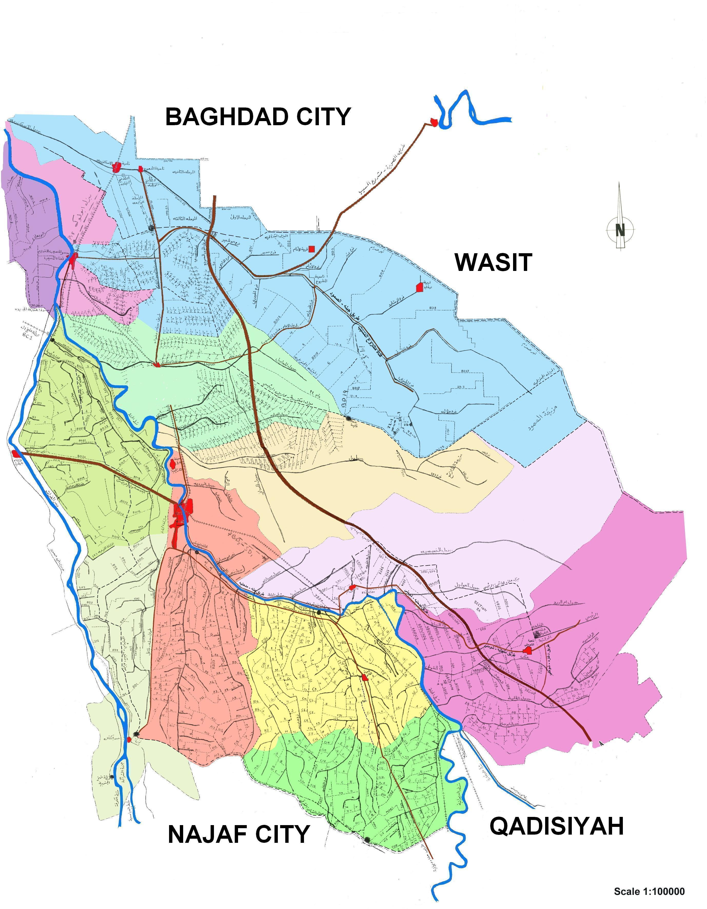
Figure (1): Location of the studied reach of Shatt-Al-Hilla.
Shatt AL-Hilla
Al-Mahaweel sub canal

Table (2): Cross sectional information for the sub reaches in the considered reach.
Stage(m), h0 |  | Bed slope | Sub reach length (m) | Location (km) | River station No.
26.200 | 0.000080 |  | 200 | 0+00 | 1
26.180 |  |  | 200 | 0+200 | 2
26.180 | 0.000085 |  | 200 | 0+200 | 2
26.160 |  |  | 200 | 0+400 | 3
26.160 | 0.000087 |  | 3000 | 0+400 | 3
25.860 |  |  | 3000 | 3+400 | 4
25.860 | 0.000081 |  | 2200 | 3+400 | 4
25.640 |  |  | 2200 | 5+600 | 5
25.640 | 0.000085 |  | 200 | 5+600 | 5
25.620 |  |  | 200 | 5+800 | 6
25.620 | 0.000090 |  | 200 | 5+800 | 6
25.600 |  |  | 200 | 6+000 | 7
25.600 | 0.000100 |  | 80 | 6+000 | 7
25.590 |  |  | 80 | 6+080 | 8
25.590 | 0.000090 |  | 13.6 | 6+080 | 8
25.585 |  |  | 13.6 | 6+0936 | 9
25.585 | 0.000087 |  | 106.4 | 6+0936 | 9
25.575 |  |  | 106.4 | 6+200 | 10
25.575 | 0.000085 |  | 200 | 6+200 | 10
25.555 |  |  | 200 | 6+400 | 11
25.555 | 0.000095 |  | 200 | 6+400 | 11
25.535 |  |  | 200 | 6+600 | 12
25.535 | 0.000087 |  | 2000 | 6+600 | 12
25.335 |  |  | 2000 | 8+600 | 13

Table (3): Regression coefficients for (A) versus (h) relationship of Shatt Al-Hilla.[Kadhum:2010]

River  Section No. | a0 | a1 | a2 | a3 | a4 | R2
1 | 30834 | -3228.4 | 110.78 | -1.24 | 0 | 0.991
2 | 100847 | -10395 | 354.6 | -3.99 | 0 | 0.988
3 | -12562 | 1645.3 | -70.85 | 1.006 | 0 | 0.999
4 | 2239.6 | -211.38 | 4.781 | 0 | 0 | 0.993
5 | 93034 | -9558.3 | 325.18 | -3.658 | 0 | 0.987
6 | 589.45 | -116.48 | 3.477 | 0 | 0 | 0.980
7 | 93979 | -9700.2 | 331.15 | -3.733 | 0 | 0.997
8 | -683387 | 96323 | -5077.7 | 118.59 | -1.034 | 0.977
9 | 588.95 | -116.48 | 3.477 | 0 | 0 | 0.987
10 | 5985.5 | -478.56 | 9.888 | 0 | 0 | 0.996
11 | 35323 | -3504.8 | 112.86 | -1.166 | 0 | 0.996
12 | 37741 | -3633.3 | 113.19 | -1.125 | 0 | 0.978
13 | 189458 | -19459 | 662.83 | -7.48 | 0 | 0.980

Table (4): Coefficients for (W) versus (h)relationship of Shatt Al-Hilla.[Kadhum:2010]

Cross  Section No. | w0 | w1 | w2 | w3
1 | -3228.4 | 221.56 | -3.72 | 0
2 | -10395 | 709.2 | -11.97 | 0
3 | 1645.3 | -141.7 | 3.018 | 0
4 | -211.38 | 9.562 | 0 | 0
5 | -9558.3 | 650.36 | -10.974 | 0
6 | -116.48 | 6.954 | 0 | 0
7 | -9700.2 | 662.3 | -11.199 | 0
8 | 96323 | -10155.4 | 355.77 | -4.136
9 | -116.48 | 6.954 | 0 | 0
10 | -478.56 | 19.776 | 0 | 0
11 | -3504.8 | 225.72 | -3.498 | 0
12 | -3633.3 | 226.38 | -3.375 | 0
13 | -19459 | 1325.66 | -22.44 | 0

Table (5): Muskingum Method
Time (day) | Upstream discharge (cumics))(I) | Observed downstream discharge (cumics) (O) | I-O | s | cum s | 0.2i+0.8d | 0.19I+0.81o | 0.18I+0.82O
0.0 | 170.0 | 170.0 | 0.0 | 0.0 | 0.0 | 170.0 | 170.0 | 170.0
0.4 | 170.0 | 170.0 | 0.0 | 0.0 | 0.0 | 170.0 | 170.0 | 170.0
0.8 | 170.0 | 170.0 | 0.0 | 0.0 | 0.0 | 170.0 | 170.0 | 170.0
1.2 | 170.0 | 170.0 | 0.0 | 0.0 | 0.0 | 170.0 | 170.0 | 170.0
1.6 | 173.0 | 170.0 | 3.0 | 1.5 | 1.5 | 170.6 | 170.6 | 170.5
2.0 | 175.0 | 172.0 | 3.0 | 3.0 | 4.5 | 172.6 | 172.6 | 172.5
2.4 | 178.0 | 177.0 | 1.0 | 2.0 | 6.5 | 177.2 | 177.2 | 177.2
2.8 | 186.0 | 182.0 | 4.0 | 2.5 | 9.0 | 182.8 | 182.8 | 182.7
3.2 | 195.0 | 188.0 | 7.0 | 5.5 | 14.5 | 189.4 | 189.3 | 189.3
3.6 | 203.0 | 192.0 | 11.0 | 9.0 | 23.5 | 194.2 | 194.1 | 194.0
4.0 | 210.0 | 196.0 | 14.0 | 12.5 | 36.0 | 198.8 | 198.7 | 198.5
4.4 | 211.0 | 198.0 | 13.0 | 13.5 | 49.5 | 200.6 | 200.5 | 200.3
4.8 | 210.5 | 200.0 | 10.5 | 11.8 | 61.3 | 202.1 | 202.0 | 201.9
5.2 | 210.0 | 200.3 | 9.8 | 10.1 | 71.4 | 202.2 | 202.1 | 202.0
5.6 | 210.5 | 200.5 | 10.0 | 9.9 | 81.3 | 202.5 | 202.4 | 202.3
6.0 | 211.0 | 201.0 | 10.0 | 10.0 | 91.3 | 203.0 | 202.9 | 202.8
6.4 | 211.0 | 201.5 | 9.5 | 9.8 | 101.0 | 203.4 | 203.3 | 203.2
6.8 | 211.0 | 202.0 | 9.0 | 9.3 | 110.3 | 203.8 | 203.7 | 203.6
7.2 | 212.0 | 202.5 | 9.5 | 9.3 | 119.5 | 204.4 | 204.3 | 204.2
7.6 | 214.0 | 204.0 | 10.0 | 9.8 | 129.3 | 206.0 | 205.9 | 205.8
8.0 | 218.0 | 205.0 | 13.0 | 11.5 | 140.8 | 207.6 | 207.5 | 207.3
8.4 | 222.0 | 207.0 | 15.0 | 14.0 | 154.8 | 210.0 | 209.9 | 209.7
8.8 | 224.0 | 209.0 | 15.0 | 15.0 | 169.8 | 212.0 | 211.9 | 211.7
9.2 | 215.0 | 211.0 | 4.0 | 9.5 | 179.3 | 211.8 | 211.8 | 211.7
9.6 | 207.0 | 214.0 | -7.0 | -1.5 | 177.8 | 212.6 | 212.7 | 212.7
10.0 | 198.0 | 215.0 | -17.0 | -12.0 | 165.8 | 211.6 | 211.8 | 211.9
10.4 | 192.0 | 212.0 | -20.0 | -18.5 | 147.3 | 208.0 | 208.2 | 208.4
10.8 | 188.0 | 207.0 | -19.0 | -19.5 | 127.8 | 203.2 | 203.4 | 203.6
11.2 | 186.0 | 204.0 | -18.0 | -18.5 | 109.3 | 200.4 | 200.6 | 200.8
11.6 | 184.0 | 202.0 | -18.0 | -18.0 | 91.3 | 198.4 | 198.6 | 198.8
12.0 | 180.0 | 200.0 | -20.0 | -19.0 | 72.3 | 196.0 | 196.2 | 196.4
12.4 | 177.0 | 196.0 | -19.0 | -19.5 | 52.8 | 192.2 | 192.4 | 192.6
12.8 | 173.5 | 192.0 | -18.5 | -18.8 | 34.0 | 188.3 | 188.5 | 188.7
13.2 | 172.0 | 185.0 | -13.0 | -15.8 | 18.3 | 182.4 | 182.5 | 182.7
13.6 | 171.0 | 176.0 | -5.0 | -9.0 | 9.3 | 175.0 | 175.1 | 175.1
14.0 | 170.0 | 172.0 | -2.0 | -3.5 | 5.8 | 171.6 | 171.6 | 171.6
14.4 | 169.5 | 171.0 | -1.5 | -1.8 | 4.0 | 170.7 | 170.7 | 170.7
14.8 | 169.0 | 170.5 | -1.5 | -1.5 | 2.5 | 170.2 | 170.2 | 170.2
15.0 | 169.0 | 170.0 | -1.0 | -1.3 | 1.3 | 169.8 | 169.8 | 169.8
15.4 | 169.0 | 169.5 | -0.5 | -0.8 | 0.5 | 169.4 | 169.4 | 169.4
15.8 | 169.0 | 169.0 | 0.0 | -0.3 | 0.3 | 169.0 | 169.0 | 169.0
16.0 | 169.0 | 169.0 | 0.0 | 0.0 | 0.3 | 169.0 | 169.0 | 169.0
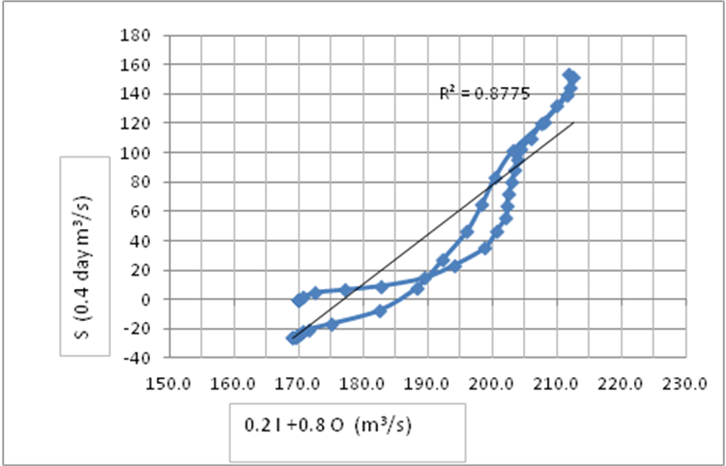
Figure (2): River routing storage loop for X=0.2
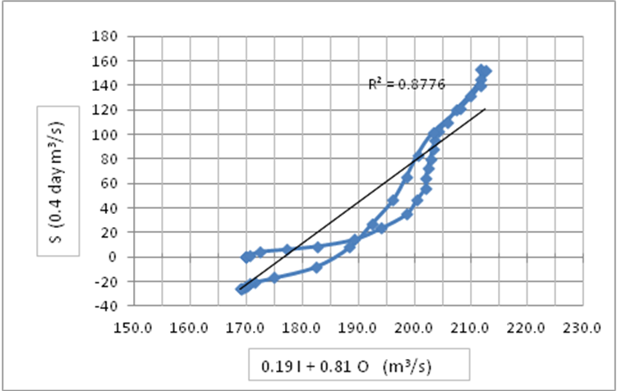
Figure (3): River routing storage loop for X=0.19

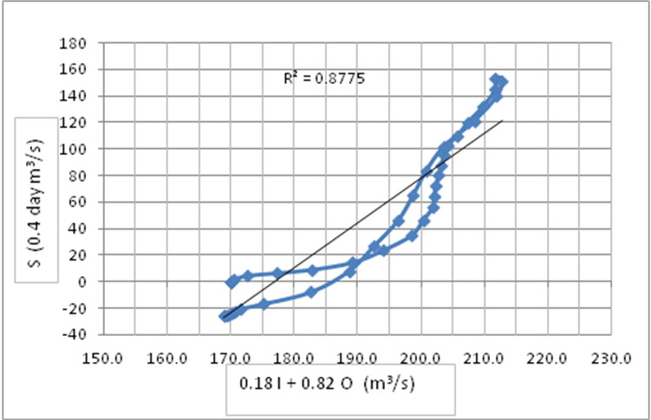
Figure (4): River routing storage loop for X=0.21

Table (6): Data Required to Muskingum Cunge Method
Station no. | Q=170 m³/s |  |  |  | Q=224 m³/s |  |  |  | ß
Station no. | h (m) | A (m²) | W (m) | V(m/s) | h (m) | A (m²) | W (m) | V(m/s) | ß
1 | 30.84 | 261.69 | 66.41 | 0.650 | 31.42 | 298.98 | 60.53 | 0.749 | 1.152
2 | 30.81 | 490.15 | 92.63 | 0.347 | 31.40 | 538.69 | 71.79 | 0.416 | 1.199
3 | 30.80 | 295.23 | 143.85 | 0.576 | 31.38 | 387.24 | 170.76 | 0.578 | 1.003
4 | 30.50 | 239.87 | 80.24 | 0.709 | 31.08 | 288.50 | 85.84 | 0.776 | 1.095
5 | 30.28 | 201.71 | 72.81 | 0.843 | 30.86 | 241.17 | 60.74 | 0.929 | 1.102
6 | 30.26 | 248.35 | 93.93 | 0.685 | 30.84 | 304.55 | 98.01 | 0.736 | 1.075
7 | 30.24 | 238.03 | 86.77 | 0.714 | 30.82 | 285.52 | 74.17 | 0.785 | 1.099
8 | 30.23 | 805.04 | 186.48 | 0.211 | 30.81 | 915.46 | 188.07 | 0.245 | 1.161
9 | 30.22 | 244.57 | 93.69 | 0.695 | 30.81 | 300.62 | 97.76 | 0.745 | 1.072
10 | 30.21 | 552.78 | 118.93 | 0.31 | 30.80 | 625.81 | 130.51 | 0.358 | 1.155
11 | 30.19 | 294.18 | 121.53 | 0.578 | 30.78 | 367.59 | 128.81 | 0.609 | 1.054
12 | 30.17 | 259.22 | 124.63 | 0.656 | 30.76 | 335.86 | 136.77 | 0.667 | 1.017
13 | 29.97 | 271.89 | 115.34 | 0.625 | 30.56 | 334.58 | 96.21 | 0.669 | 1.070
Table (7): Coefficients of Muskingum-Cunge method
subreach | C | D | C1 | C2 | C3 | C1+C2+C3
1 | 149 | 267 | 0.995 | -0.281 | 0.286 | 1.000
2 | 86.1 | 368 | 0.996 | -0.619 | 0.623 | 1.000
3 | 6.68 | 8.66 | 0.878 | -0.064 | 0.186 | 1.000
4 | 13.3 | 17.2 | 0.937 | -0.095 | 0.159 | 1.000
5 | 176 | 211 | 0.995 | -0.088 | 0.093 | 1.000
6 | 136 | 160 | 0.993 | -0.078 | 0.084 | 1.000
7 | 275 | 591 | 0.998 | -0.364 | 0.366 | 1.000
8 | 721 | 3421 | 1.000 | -0.652 | 0.652 | 1.000
9 | 258 | 309 | 0.996 | -0.088 | 0.092 | 1.000
10 | 71.2 | 244 | 0.994 | -0.545 | 0.550 | 1.000
11 | 110 | 142 | 0.992 | -0.123 | 0.130 | 1.000
12 | 11.6 | 13.8 | 0.924 | -0.047 | 0.123 | 1.000
13 | 51.3 | 77.8 | 0.985 | -0.198 | 0.213 | 1.000

Table(8): Application of Muskingum-Cunge Method
Time (day) | Inflow | Outflow(1)  C149D267 | Outflow(2)  C86.1D368 | Outflow(3) C6.68D8.66 | Outflow(4)  C13.3D17.2 | Outflow(5)  C176D211 | Outflow(6)  C136D160
0 | 170 | 170 | 170 | 170 | 170 | 170 | 170
0.4 | 170 | 170 | 170 | 170 | 170 | 170 | 170
0.8 | 170 | 170 | 170 | 170 | 170 | 170 | 170
1.2 | 170 | 170 | 170 | 170 | 170 | 170 | 170
1.6 | 173 | 172.986 | 172.972 | 172.609 | 172.444 | 172.431 | 172.415
2 | 175 | 174.986 | 174.969 | 174.659 | 174.503 | 174.491 | 174.476
2.4 | 178 | 177.982 | 177.957 | 177.536 | 177.33 | 177.314 | 177.294
2.8 | 186 | 185.956 | 185.905 | 184.857 | 184.361 | 184.323 | 184.274
3.2 | 195 | 194.944 | 194.874 | 193.586 | 192.956 | 192.908 | 192.846
3.6 | 203 | 202.946 | 202.867 | 201.654 | 201.045 | 200.999 | 200.939
4 | 210 | 209.951 | 209.871 | 208.793 | 208.246 | 208.205 | 208.152
4.4 | 211 | 210.981 | 210.928 | 210.601 | 210.402 | 210.387 | 210.368
4.8 | 210.5 | 210.497 | 210.466 | 210.458 | 210.429 | 210.427 | 210.418
5.2 | 210 | 210.002 | 209.985 | 210.043 | 210.065 | 210.067 | 210.069
5.6 | 210.5 | 210.498 | 210.485 | 210.434 | 210.413 | 210.411 | 210.409
6 | 211 | 210.997 | 210.987 | 210.916 | 210.882 | 210.879 | 210.876
6.4 | 211 | 210.999 | 210.993 | 210.979 | 210.97 | 210.969 | 210.968
6.8 | 211 | 211 | 210.996 | 210.993 | 210.991 | 210.991 | 210.991
7.2 | 212 | 211.995 | 211.989 | 211.866 | 211.81 | 211.806 | 211.801
7.6 | 214 | 213.989 | 213.977 | 213.711 | 213.585 | 213.575 | 213.563
8 | 218 | 217.978 | 217.952 | 217.417 | 217.163 | 217.144 | 217.119
8.4 | 222 | 221.974 | 221.941 | 221.355 | 221.066 | 221.044 | 221.016
8.8 | 224 | 223.983 | 223.951 | 223.6 | 223.413 | 223.399 | 223.381
9.2 | 215 | 215.038 | 215.061 | 216.075 | 216.523 | 216.557 | 216.594
9.6 | 207 | 207.05 | 207.098 | 208.257 | 208.822 | 208.865 | 208.92
10 | 198 | 198.058 | 198.127 | 199.435 | 200.082 | 200.131 | 200.194
10.4 | 192 | 192.045 | 192.115 | 193.089 | 193.591 | 193.629 | 193.678
10.8 | 188 | 188.032 | 188.091 | 188.76 | 189.112 | 189.139 | 189.173
11.2 | 186 | 186.018 | 186.065 | 186.436 | 186.638 | 186.653 | 186.673
11.6 | 184 | 184.015 | 184.053 | 184.367 | 184.529 | 184.541 | 184.557
12 | 180 | 180.024 | 180.065 | 180.609 | 180.872 | 180.892 | 180.916
12.4 | 177 | 177.021 | 177.059 | 177.527 | 177.763 | 177.781 | 177.803
12.8 | 173.5 | 173.523 | 173.559 | 174.073 | 174.329 | 174.348 | 174.373
13.2 | 172 | 172.013 | 172.041 | 172.311 | 172.462 | 172.473 | 172.485
13.6 | 171 | 171.008 | 171.032 | 171.204 | 171.298 | 171.297 | 171.299
14 | 170 | 170.007 | 170.026 | 170.18 | 170.259 | 170.265 | 170.273
14.4 | 169.5 | 169.504 | 169.518 | 169.608 | 169.657 | 169.661 | 169.665
14.8 | 169 | 169.004 | 169.015 | 169.093 | 169.13 | 169.103 | 169.107
15.2 | 169 | 169.001 | 169.008 | 169.023 | 169.031 | 169.031 | 169.032
15.6 | 169 | 169 | 169.004 | 169.004 | 169.003 | 169 | 169
16 | 169 | 169 | 169.003 | 169.001 | 169 | 169 | 169
16.4 | 169 | 169 | 169.002 | 169 | 169 | 169 | 169
Time (day) | Outflow(7)  C275D591 | Outflow(8)  C721D3421 | Outflow(9)  C258D309 | Outflow(10)  C71.2D244 | Outflow(11)  C110D142 | Outflow(12)  C11.6D13.8 | Outflow(13)  C51.3D77.8
0 | 170 | 170 | 170 | 170 | 170 | 170 | 170
0.4 | 170 | 170 | 170 | 170 | 170 | 170 | 170
0.8 | 170 | 170 | 170 | 170 | 170 | 170 | 170
1.2 | 170 | 170 | 170 | 170 | 170 | 170 | 170
1.6 | 172.409 | 172.408 | 172.4 | 172.385 | 172.366 | 172.188 | 172.154
2 | 174.469 | 174.467 | 174.459 | 174.438 | 174.419 | 174.243 | 174.204
2.4 | 177.285 | 177.282 | 177.271 | 177.241 | 177.217 | 176.985 | 176.935
2.8 | 184.255 | 184.25 | 184.225 | 184.165 | 184.107 | 183.56 | 183.448
3.2 | 192.819 | 192.812 | 192.78 | 192.693 | 192.618 | 191.911 | 191.759
3.6 | 200.911 | 200.902 | 200.871 | 200.772 | 200.699 | 200.006 | 199.85
4 | 208.125 | 208.116 | 208.088 | 207.988 | 207.914 | 207.284 | 207.139
4.4 | 210.353 | 210.346 | 210.336 | 210.267 | 210.24 | 209.989 | 209.917
4.8 | 210.404 | 210.395 | 210.394 | 210.356 | 210.352 | 210.313 | 210.293
5.2 | 210.068 | 210.065 | 210.066 | 210.047 | 210.049 | 210.067 | 210.067
5.6 | 210.408 | 210.406 | 210.405 | 210.392 | 210.39 | 210.367 | 210.362
6 | 210.874 | 210.872 | 210.87 | 210.86 | 210.856 | 210.818 | 210.81
6.4 | 210.967 | 210.966 | 210.966 | 210.96 | 210.899 | 210.891 | 210.888
6.8 | 210.991 | 210.99 | 210.99 | 210.987 | 210.986 | 210.979 | 210.977
7.2 | 211.799 | 211.798 | 211.795 | 211.788 | 211.782 | 211.721 | 211.709
7.6 | 213.558 | 213.557 | 213.551 | 213.536 | 213.521 | 213.383 | 213.352
8 | 217.109 | 217.106 | 217.093 | 217.062 | 217.03 | 216.749 | 216.691
8.4 | 221.003 | 220.999 | 220.984 | 220.943 | 220.909 | 220.583 | 220.512
8.8 | 223.371 | 223.367 | 223.357 | 223.319 | 223.296 | 223.072 | 223.017
9.2 | 216.602 | 216.601 | 216.624 | 216.646 | 216.696 | 217.166 | 217.245
9.6 | 208.942 | 208.944 | 208.973 | 209.033 | 209.099 | 209.728 | 209.859
10 | 200.222 | 200.229 | 200.262 | 200.35 | 200.427 | 201.156 | 201.315
10.4 | 193.703 | 193.711 | 193.736 | 193.826 | 193.887 | 194.467 | 194.603
10.8 | 189.193 | 189.2 | 189.218 | 189.296 | 189.34 | 189.715 | 189.812
11.2 | 186.686 | 186.692 | 186.7 | 186.759 | 186.785 | 187.024 | 187.063
11.6 | 184.567 | 184.572 | 184.58 | 184.626 | 184.646 | 184.836 | 184.883
12 | 180.928 | 180.933 | 180.944 | 180.992 | 181.021 | 181.316 | 181.38
12.4 | 177.815 | 177.82 | 177.812 | 177.858 | 177.887 | 178.158 | 178.22
12.8 | 174.382 | 174.387 | 174.4 | 174.447 | 174.478 | 174.767 | 174.832
13.2 | 172.494 | 172.498 | 172.506 | 172.544 | 172.559 | 172.738 | 172.783
13.6 | 171.305 | 171.303 | 171.308 | 171.336 | 171.342 | 171.453 | 171.482
14 | 170.275 | 170.278 | 170.282 | 170.304 | 170.314 | 170.405 | 170.422
14.4 | 169.668 | 169.67 | 169.673 | 169.689 | 169.695 | 169.753 | 169.768
14.8 | 169.109 | 169.111 | 169.113 | 169.125 | 169.105 | 169.152 | 169.162
15.2 | 169.031 | 169.031 | 169.03 | 169.037 | 169.038 | 169.049 | 169.053
15.6 | 169 | 169.001 | 169.001 | 169.005 | 169.005 | 169.009 | 169.01
16 | 169 | 169 | 169 | 169.002 | 169 | 169.001 | 169
16.4 | 169 | 169 | 169 | 169.001 | 169 | 169 | 169
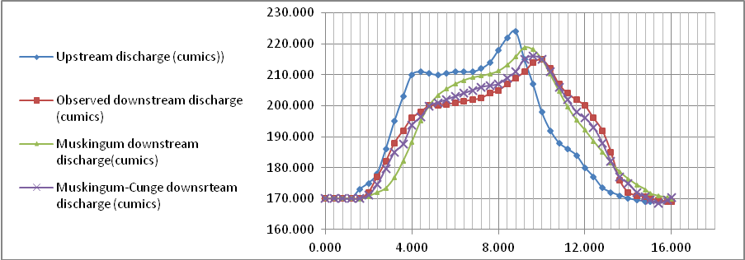
Figure(5):Upstream discharge and downstream discharge for the reach(0.000km)to(8.600Km) of Shatt-Al-Hilla.
References
Birkhead, A.L., C.S. James, 1998 Synthesis of rating curves from Local stage and remote discharge monitoring using nonlinear Muskingum routing, J. Hydrol.250, pp.52-65.
Birkhead, A.L., C.S. James, 2002, Muskingum river rtouting with dynamic bank storage, Journal of Hydrology 264, pp.113-132, 2002.
Boroughs, Craig B.,et al, 2002 Daily flow routing with the Muskingum- Cunge method in the Pecos river riverware model, University of Colorado.
BWRD (Babylon Water Resources Department), Report about the basic design of Shatt Al-Hilla and Shatt Al-Daghara, 2006.
Chow, V.T., 1959, Open-Channel Hydraulics, McGraw-Hall International Editions, New York.
Chow, V.T., 1988, Applied hydrology, McGraw-Hall International Editions, New York.
Cunge, J.A.,1969,On the subject of a flood propagation method (Muskingum method), J. Hydraul. Res., vol.7,no.2, pp.205-230.
Delphi, Mehdi, Mohammad Mahmoodian Shooshtari, Houshang Hassoni Zadeh, 2010, Application of diffusion wave method for flood routing in Karun River, International Journal of Environmental Science and Development, Vol.1, No.5, December.
Enn, Chai Chung, 2010,Flood routing in ungauged Catchments using Muskingum method, University of technology, Malaysia.
Fenton, John D., 2011, Accuracy of Muskingum-Cunge flood routing, Alternative Hydraulics Paper 3, Austria,02.03.
Fread, D.L., and K.S. Hsu, 1993, Applicability of two simplified flood routing method: Level-Pool and Muskingum-Cunge, Presented at the 1993 ASCE National Hydraulic Engineering Conference, CA. , July 26-30.
Habib Abida, Manel Ellouse and Med R. Hahjoub, 2005, Flood routing of regulated flow in Medjerda River, Tunisia, Journal of Hydroinformatics, 7.3, pp.209-216.
Hsu, Ming-His, Jin-Cheng Fu, Wen-Cheng Liu, 2003, Flood routing with real-time stage correction method for flash flood forecasting in the Tanshui River, Taiwan, Journal of Hydrology 283, pp.267-280.
Kadhum, Luay Hameed, 2011, Inverse routing of flood wave for Shatt Al-Hilla River, A thesis submitted to the college of engineering of the university of Babylon in partial fulfillment of the requirement for the degree of master in water resources engineering, Iraq.
Merkel, H. William, 2002, Muskingum-Cunge flood routing procedure in NRCS hydrologic models, Presented at the second Federal Interagency Hydrologic Modeling Conference, July.
Miller, W. A., and Cunge, J. A. ,1975. "Simplified Equations of Unsteady Flow." Chapter 5 in Unsteady Flow in Open Channels, Vol. I. Mahmaud, K. and Yevjevich, V, editors. Water Resources Publications, Fort Collins, Colo., 216-242.
Morin, Efrat, et. al., 2009, Flood routing and alluvial aquifer recharge along the ephemeral arid Kuiseb River, Namiba, Journal of hydrology 368, pp. 262-275.
Peters, R., G. Schmitz, and J. Cullmann,2006, Flood routing modeling with Artificial Neural Networks, Advances in Geosciences, 9, pp.131-136.
Ramírez, J. A.,2000: Prediction and Modeling of Flood Hydrology and Hydraulics. Chapter 11 of Inland Flood Hazards: Human, Riparian and Aquatic Communities Eds. Ellen Wohl; Cambridge University Press.
SOD (State Organization For Dams), New Hindiya Barrage and related structures, Vol.4, part 5, Baghdad, Iraq, 1981.
Szolgay, J., M. Danacova, Z. Papankova, 2006, Case study of multilinear flood routing using empirical relationships between the flood wave speed and the discharge, Slovak Journal of Civil Engineering, pp. 1-9.
Tung, Yeou-Koung, 1985, river flood routing by nonlinear Muskingum method, Journal of Hydraulic Engineering, Vol.3, pp.1446-1460.
US-Army Corps of Engineer, Flood-runoff Analysis,Washinton,1994.
JORGE, A. RAMÍREZ, 2000, Water Resources, Hydrologic and Environmental Sciences, Cambridge University Press.

