Best Fit Model to Estimate Relation Between (CBR) and the Dry Density of Fine Grains Soils

Abdul Karim Khalil al-Saffar Afaf Rafeek Hassoun
Babylon University / Faculty of Engineering
Akalsaffar@ yahoo.com
Abstract
CBR test and dry density of fine soil from 12 test results collected from Central Laboratory and Engineering College laboratory , and a statistical method was used to find out a relationship between the CBR and dry density of the soil desiring to obtain a straight line relationship and a formula combining the previous two variables .A reasonable straight line relationship represented by formula was obtained . In other hand the time and efforts was minimized .
Key words: Download Alklforne , Dry density, soft granules of Education
الخلاصة
لقد تم اخذ قيمة التحمل الكليفورني والكثافة الجافة لـ (12) نموذج من ترب ناعمة مختلفة تم تجميعها من مختبر بابل المركزي و مختبر كلية الهندسة.وتم استخدام طرق احصائية للربط بين المتغيرين للحصول على علاقة خطية مع معادلة رياضية.وفعلا تم الحصول على علاقة و معادلة معقولة. من ناحية اخرى فان كثير من الوقت و الجهد قد تم اختصارهما.
الكلمات المفتاحية: التحميل الكلفورني ، الكثافة الجافة ، حبيبات التربية الناعمة
Introduction :
There were many soil tests , and this engineering tests were taken place for many engineering purpose , and there was one or more manners to test one of the engineering features of soil . ( P. N. Khanna , 1979 ). These manners have founded because of the improvement of the used equipments and scientific progressing . ( Baraja , 2007)
C.B.R. test one of these tests which can find out the pressure act on the soil related to the California soil capacity. C.B.R. test took a large field in civil engineering designs and especially pavement design .
It was an empirical test , found and improved by Porter , then it was used by ( U.S Army Corps of engineers ) in 1942, and it is considered the first test in world which gives right and considerable results , besides the pavement designs which depends C.B.R. test was practical and suitable, so it was depended by America Association of standards for test and Materials ASTM ( Leelavthamma , 2005 ) .
According to ASTM1883Results of the soil test completed after at least four days ( ASTM, 2004).
In this study a number of CBR tests was taken to obtain a relationship between CBR value and the maximum dry density of fine soil , desiring to find out the value of CBR from the value of the dry density directly . A straight line relationship was obtained, and CBR could be founded directly by using the formula of this study.
Collecting data :
A twelve samples was choose cooperated with Babylon central laboratory and engineering collage laboratory . non real samples was excluded aiming to have realistic results .

Table ( 1) max dry density vs C.B.R
yd | 17.54 | 17.63 | 17.75 | 17.86 | 17.96 | 18.03 | 18.14 | 18.25 | 18.36 | 18.45 | 18.56 | 18.64 | 217.7
CBR% | 3.0 | 3.3 | 3.7 | 4.1 | 4.4 | 4.8 | 5.1 | 5.5 | 5.9 | 6.3 | 6.7 | 7.0 | 59.9
Table ( 2) Calculation of least square formula
yd | 17.54 | 17.63 | 17.75 | 17.86 | 17.96 | 18.03 | 18.14 | 18.25 | 18.36 | 18.45 | 18.56 | 18.64 | 217.17
CBR% | 3.0 | 3.3 | 3.7 | 4.1 | 4.4 | 4.8 | 5.1 | 5.5 | 5.9 | 6.3 | 6.7 | 7.0 | 59.9
X² | 307.65 | 310.82 | 315.06 | 318.98 | 322.56 | 325.08 | 329.06 | 333.06 | 337.09 | 340.4 | 344.47 | 347.45 | 3931.68
Y² | 9.0 | 10.89 | 13.69 | 16.81 | 20.25 | 23.04 | 26.01 | 30.25 | 34.81 | 39.69 | 44.89 | 49.0 | 318.33
XY | 52.62 | 58.18 | 65.68 | 73.23 | 80.82 | 86.54 | 92.51 | 100.38 | 108.32 | 116.24 | 124.35 | 130.48 | 1089.35
y^ | 2.90 | 3.236 | 3.676 | 4.08 | 4.45 | 4.7 | 5.107 | 5.51 | 5.91 | 6.24 | 6.65 | 6.94
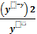 | 0.003 | 0.0012 | 0.00015 | 0.0001 | 0.00056 | 0.002 | 8.00 | 0.000018 | 0.00017 | 0.00057 | 0.00037 | 0.00052 | 0.0085
X^ | 17.55 | 17.63 | 17.74 | 17.85 | 17.96 | 18.04 | 18.13 | 18.24 | 18.35 | 18.46 | 18.57 | 18.65

Best fit model :
In order to find a best fitting line between the two variables , max dry density (x) , and CBR ( Y) the statistic method above was used to find out the best formula linking the two variables .
a=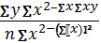
a=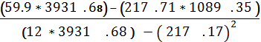
a= - 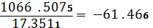
b= 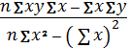
b=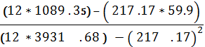
b=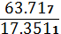
b=3.67
y^ = a + bx
y^= -61 . 466 + 3.67x
y^ = 3.67x – 61.466
It is possible to find a¹ ,b¹ To formula
a¹ = 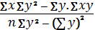
a=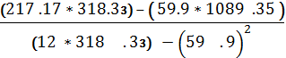
a= - 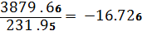
b¹ = 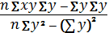
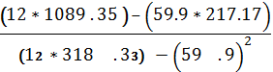
b¹=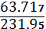
b¹= 0.275
x^ = a¹ + b¹y
x¹ = 16.726+0.275y
Hypothesis test:
1-Ho zero hypothesis which mean there is no deference between taken values and theoretical obtained values
2-H1 alternative hypothesis, which mean that there is a deference between taken values and the theoretical values
f2 = )² / y^=0.0085
It is more less then the table value of chi – square distribution
f ² [ 0.95,11]=19.67
So the H0 hypothesis will accepted
Discussion :
1-Referring to the graph ( 1) the relationship between CBR can be found directly from the graph or from the formula obtained .
2-This relationship can enable the engineer to move around the dry density he have to obtain the value of CBR he want , for example , if the CBR wanted is 6% , and the laboratory CBR was 4% . Engineer may get the 6% CBR by increasing compacting ( i-e increasing yd ) .
3-Graph 2 , graph 3 is almost congruent as shown in graph 4 when the two previous graphs were combined .
4-In this study the time ( 4 days ) and the effort of the CBR test according to ASTM1883 is minimized , and CBR value can be obtained directly .
5-This study was taken place and it is might to be reasonable depending upon what the CBR test according to ASTM 1883 is an empirical method to obtain CBR.
Conclusions and Recommendation :
5.1 Conclusion :
a. This study obtained a straight relationship between CBR and dry density of the soil represented by a formula :
CBR = - 61.466+3.67yd .
b. The time and the efforts of finding out CBR of the soil is minimized .
5.2 Recommendation :
It is recommended to take another type of soil such as granual soil cover a wide range of soils .
Reference :
AASHO, 2002, American Association of state Highway officials T193-721 . R6.22.
A.S.T.M, , 2004 ,D422 , D558 , D559, D698 , American Specifications for Tests and Materials.
Braja M. Das , 2007, " Theoretical Foundation Engineering " , January , 18 .
British Standard Institution ' Methods of testing Soils for Civil engineering Purpose , B.Sc 1377.1975.
Leelavathamma B, Pandian NS, 2005, " Effect of class C Flash Ash on the California Bearing Ratio Behavior of Soil – Fly Ash .
P.N.Khanna : " Civil Engineer's Hand book " , 1979 , 379 .
1.SORB . 1984 , " Standard Specification for Roads and Bridges " . R6 .

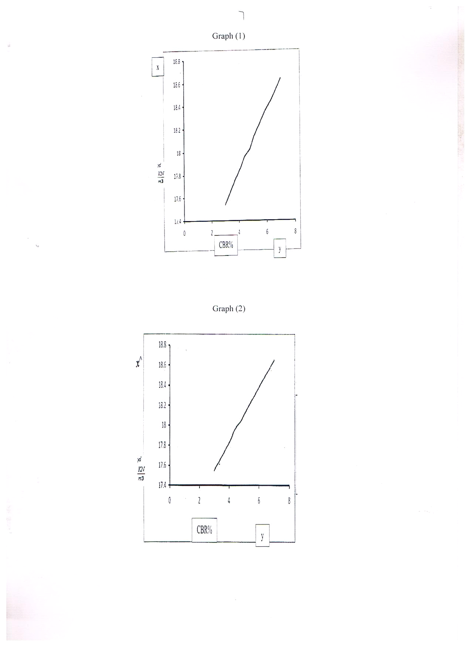
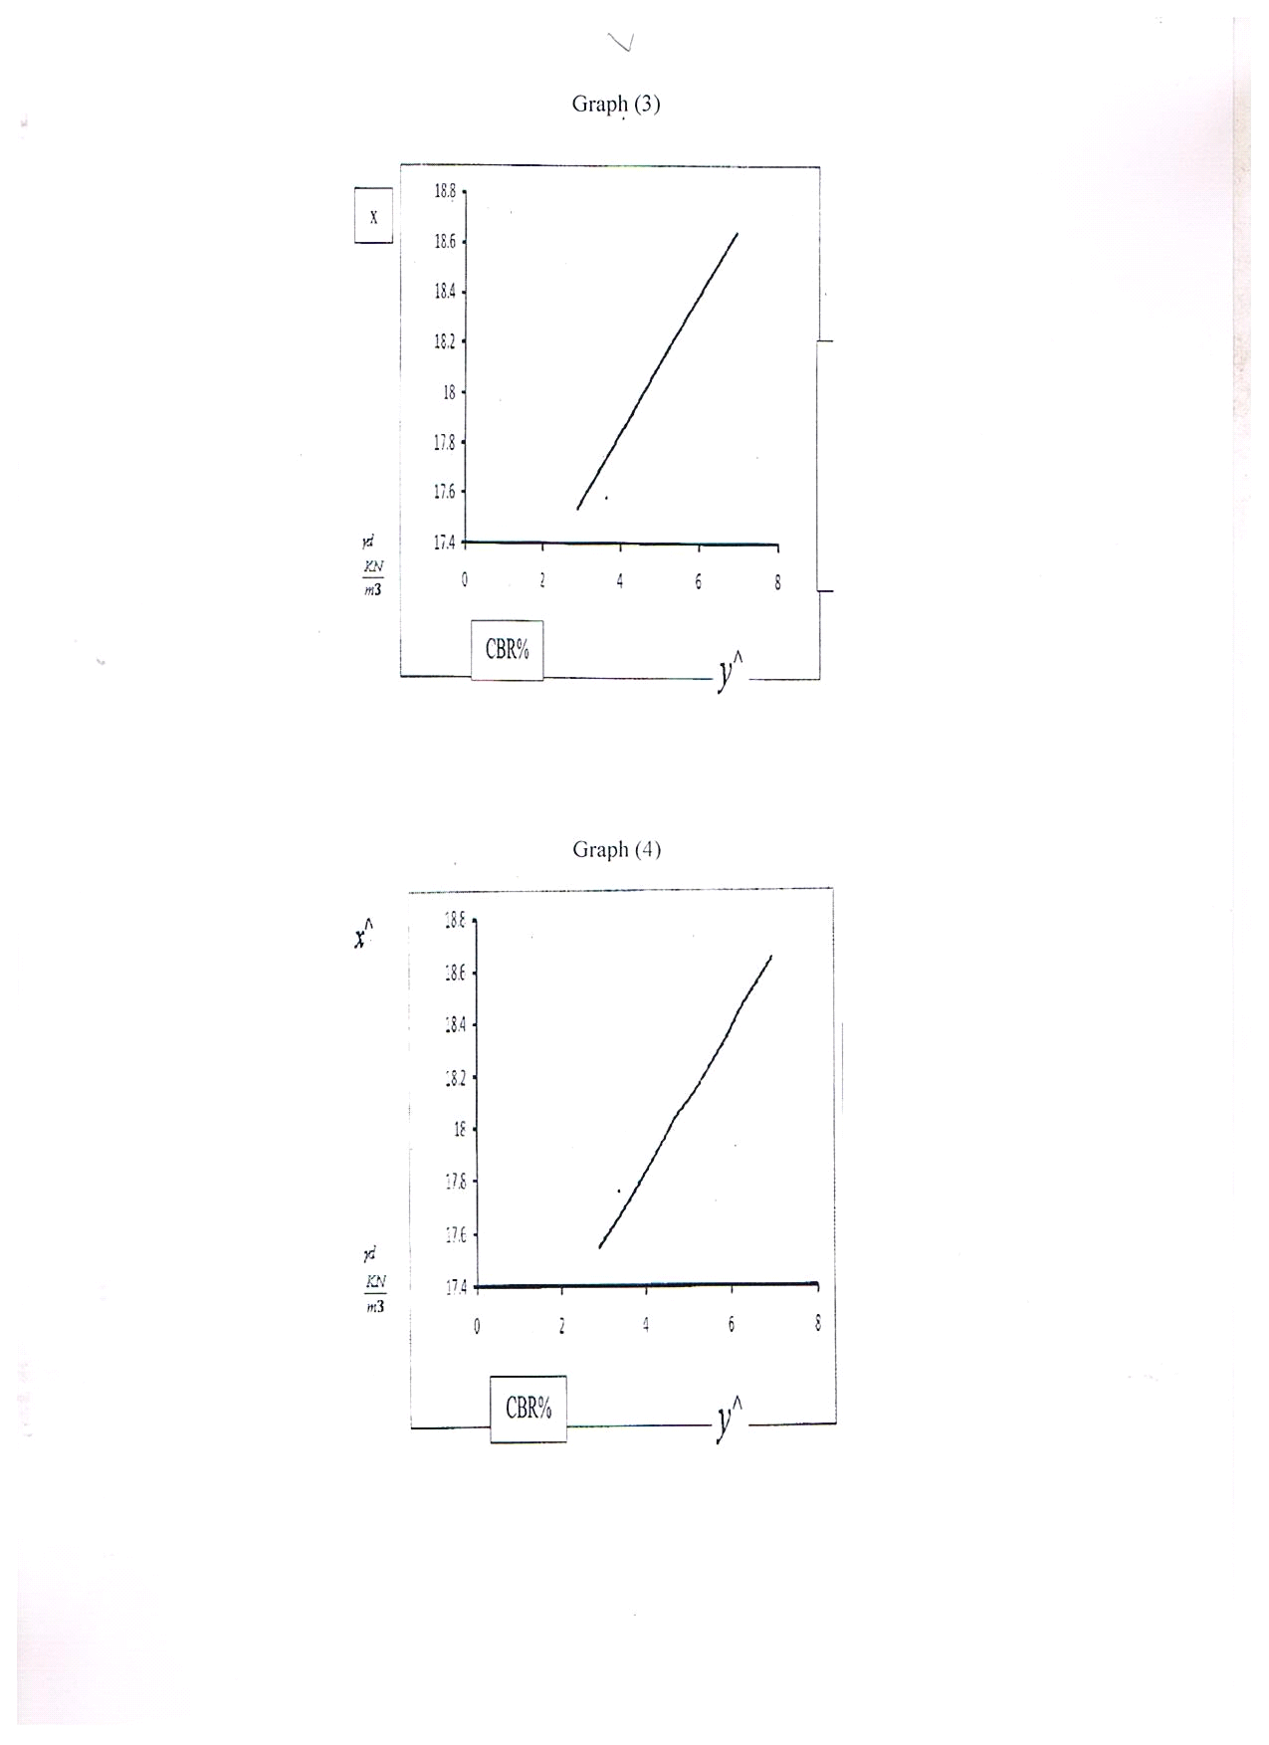

X²جدول ( 4) يتبع الجدول
1  v | .75 | .90 | .95 | .975 | .99 | .995
1 | 1.323 | 2.706 | 3.841 | 5.024 | 6.635 | 7.879
2 | 2.773 | 4.605 | 5.991 | 7.378 | 9.210 | 10.597
3 | 4.108 | 6.251 | 7.815 | 9.348 | 11.345 | 12.838
4 | 5.385 | 7.779 | 9.488 | 11.143 | 13.277 | 14.860
5 | 6.626 | 9.236 | 11.071 | 12.833 | 15.086 | 16750
6 | 7.841 | 10.645 | 12.592 | 14.449 | 16.812 | 18.548
7 | 9.037 | 12.017 | 14.067 | 16.013 | 18.475 | 20.278
8 | 10.219 | 13.362 | 15.507 | 17.535 | 20.090 | 21.955
9 | 11.389 | 14.684 | 16.919 | 19.023 | 21.666 | 23.589
10 | 12.549 | 15.987 | 18.307 | 20.483 | 23.209 | 25.188
11 | 13.701 | 17.275 | 19.675 | 21.920 | 24.725 | 26.757
12 | 14.845 | 18.549 | 21.026 | 23.837 | 26.217 | 28.299
13 | 15.984 | 19.812 | 22.362 | 24.736 | 27.688 | 29.819
14 | 17.117 | 21.064 | 23.685 | 26.119 | 29.141 | 31.319
15 | 18.245 | 22.307 | 24.996 | 27.488 | 30.578 | 32.801
16 | 19.369 | 23.542 | 26.296 | 28.845 | 32.000 | 34.267
17 | 20.489 | 24.769 | 27.587 | 30.191 | 33.409 | 35.718
18 | 21.605 | 25.989 | 28.869 | 31.526 | 34.805 | 37.156
19 | 22.718 | 27.204 | 30.144 | 32.852 | 36.191 | 38.582
20 | 23.828 | 28.412 | 31.410 | 34.170 | 37.566 | 39.997
22 | 26.039 | 30.813 | 33.924 | 36.781 | 40.289 | 42.769
24 | 28.241 | 33.196 | 36.415 | 39.361 | 42.980 | 45.559
26 | 30.435 | 35.563 | 38.885 | 41.923 | 45.642 | 48.290
28 | 32.620 | 37.916 | 41.337 | 44.461 | 48.278 | 50.993
30 | 34.800 | 40.256 | 43.773 | 46.979 | 50.892 | 53.672
40 | 45.616 | 51.805 | 55.758 | 59.342 | 63.691 | 66.766
50 | 56.334 | 61.167 | 67.505 | 71.420 | 76.154 | 79.490
60 | 66.981 | 74.397 | 79.082 | 83.298 | 88.379 | 91.952
70 | 77.577 | 85.527 | 90.531 | 95.023 | 100.425 | 104.215
80 | 88.130 | 96.578 | 101.879 | 106.629 | 112.329 | 116.321
90 | 98.650 | 107.565 | 113.145 | 118.136 | 124.116 | 128.299
100 | 109.141 | 118.498 | 124.342 | 129.561 | 135.807 | 140.169
110 | 119.608 | 129.385 | 135.480 | 140.917 | 147.414 | 152.948
120 | 130.055 | 140.233 | 146.567 | 152.211 | 158.950 | 163.648
130 | 140.482 | 151.045 | 157.610 | 163.453 | 170.423 | 175.278
140 | 150.894 | 161.827 | 168.613 | 174.648 | 181.840 | 186.847
150 | 161.291 | 172.581 | 179.581 | 185.800 | 193.208 | 198.360
200 | 213.102 | 226.021 | 233.994 | 241.058 | 249.445 | 255.264
500 | 520 | 450.930 | 553.127 | 563.852 | 576.493 | 585.207

