Assessment of Sustainable Construction Performance For Some Buildings in Babylon University

Mohammed Ali Alanbari Abeer Mohammed Abdulamir
Babylon University – Engineering College
profdr_alanbari@yahoo.com abeer_alassdy@yahoo.com
Abstract:
This research included an assessment of sustainable construction performance for some buildings in Babylon University which established during three different time periods: (1980-1989, 1990-1999, 2000-2010), and through the application of certain structural sustainability indicators within the questionnaire , which has been prepared by the researchers, included four aspects: functional performance indicator , economic performance indicator, social performance indicator and environmental performance indicator.
The researchers found that the first group of the buildings constructed in the period( 1980-1989) by one of the Japanese companies are the most efficient in terms of construction where the average sustainable construction performance indicator of 71% despite the lapse 33 years of existence while the second group disbanded the buildings constructed in the period (1990-1999) were concentrated mostly by Al-Mansour company , one of the companies affiliated to the Ministry of Housing and reconstruction where the average Sustainable Construction Performance indicator of 61% .
And finally the third Group buildings constructed in the period ( 2000-2010) have been implemented by different Iraqi companies , but it still requires a great effort for qualification to suit the requirements with average sustainable construction performance indicator is 57%.
Key words: Sustainability, Construction Sustainability, Construction Performance of Babylon University's Buildings
الخلاصة
تضمن هذا البحث تقييم الاداء الانشائي المستدام لبعض ابنية جامعة بابل التي انشأت خلال ثلاث فترات زمنية مختلفة :
2010-2000, 1999-1990, 1989-1980)),ومن خلال تطبيق بعض مؤشرات الاستدامة الانشائيه ضمن استمارة استبيان تم اعدادها من قبل الباحثين تضمنت البحث والاستبيان في اربعة جوانب هي: الجانب الوظيفي ،الجانب الاقتصادي ، الجانب الاجتماعي والجانب البيئي.
وجد الباحثان ان المجموعة الاولى وهي الابنية التي شيدت في الفترة 1989-1980)) من قبل احدى الشركات اليابانية هي الاكثر كفائة من الناحية الانشائية حيث حصلت على معدل مؤشر استدامة انشائي قدره 71% على الرغم من مضي 33 سنه على انشاءها في حين حلت بعدها المجموعة الثانية وهي الابنية التي شيدت في الفترة 1999-1990)) وتم تنفيذ معظمها من قبل شركة المنصور وهي احدى الشركات التابعة الى وزارة الاسكان والتعمير حيث حصلت على معدل مؤشر استدامة انشائي قدرة 61 % وجاءت اخيراً المجموعة الثالثة وهي الابنية التي شيدت في الفترة 2010-2000)) وقد نفذت من قبل شركات مختلفة الا انها لا تزال تحتاج الى مجهود كبير للتأهيل لتلائم متطلبات معايير الاستدامة المختلفة حيث كان معدل مؤشر الاستدامة الانشائي لها هو57% .
الكلمات المفتاحية: الاستدامة، والاستدامة البناء، أداء البناء للمباني جامعة بابل
- Introduction:
Human is one of the environmental element concept is only capable of radical changes in natural balances and vital existing in nature by exploiting the elements of the environment living and non-living to serve its purpose, and human at the same time is the focus of the development process inclusive and objective therefore sustainable development concept basic aim to human development and improve the quality of life of the people and at the same time without natural balances and dynamic menu and conservation of natural resources and vital for future generations, and is the main challenge facing the world is to try to reconcile these two approaches may seem they were contradictory .
The World Commission on Environment and Development at their final meeting stated that:"We remain convinced that it is possible to build a future that is prosperous, just, and secure. The possibility depends on all countries adopting the objective of sustainable development as the overriding goal and test of national policy and international co-operation". (Luis et al 2010).
A building project can be regarded as sustainable only when all the various dimensions of sustainability (environmental, economic, social, and cultural) are dealt with. The various sustainability issues are interwoven, and the interaction of a building with its surroundings is also important. The environmental issues share, in common, concerns which involve the reduction of the use of non-renewable materials and water, and the reduction of emissions, wastes, and pollutants. The following goals can be found in several building sustainability assessment methods: optimization of site potential, preservation of regional and cultural identity, minimization of energy consumption, protection and conservation of water resources, use of environmentally friendly materials and products, a healthy and convenient indoor climate, and optimized operational and maintenance practices.(Mohammed et al 2009).
The purpose of sustainability assessments is to gather and report information for decision-making during different phases of the construction, design, and use of a building. The sustainability scores or profiles, based on indicators, result from a process in which the relevant phenomena are identified, analyzed, and valued. Two extreme trends can be recognized at the moment: on one hand, the complexity and diversity of indicators from different operators, and on the other hand, the evolution towards better usability through a common understanding and simplicity.
The assessment tools, either environmental or performance-based, are under a constant evolution in order to overcome their various limitations. The main goal, at the moment, is to develop and implement a systematic methodology that supports the design process of a building. This methodology should contribute to the most appropriate balance between the different sustainability dimensions, while being at the same time practical, transparent, and flexible enough. The method should be easily adaptable to different building types and to constant technological development. (Luis et al 2010).
The objectives of sustainable buildings are:
- The effectiveness of resources
- Energy efficiency
- Prevention of pollution
- Compatibility with the environment
- Business systemic and integrated
2. Approaches to Building Sustainability:
2.1. Sustainability Indicators of a Building Project
The sustainability indicators of the construction and real estate sector give information about the influences of the industry as a whole, and about the impacts of the construction and operation of buildings and other built assets. Different approaches for indicators exist due to differences between societies, industrial traditions, environment, and geography.
The sustainability indicators for a building project can be selected from various lists prepared at the level of the government, sector, and community. Agenda 21 [Agenda 21 on Sustainable Construction-1999] states that the framework of relevant issue areas should be based on the assumption that a sustainable building approach includes all factors that may affect the natural environment or human health. For a contractor or facility manager, it is important to differentiate between the criteria and tools used to assess technology at the generic or global level, and the approach used at the site specific application or local level [Environmentally Sound Technologies for Sustainable Development 2003]. In spite of some differences between the lists of indicators, most of them deal directly or indirectly with the following key issues: resources consumption, environmental pressure, energy and water efficiency, indoor air quality, comfort, and life cycle costs.
An indicator is expressed by a value derived from a combination of different measurable parameters (variables). Indicators have to be defined in a clear, transparent, unambiguous, and correct way, even before addressing the concern of whether they relate to and evaluate several parameters. The indicators are usually grouped (aggregated, categorized), and further various aggregated indicators may create subgroups in a hierarchical system.
2.2. Managing and Assessing Building Sustainability
Building Sustainability Assessment (BSA) methods can be oriented to different scales of analysis: building material, building product, construction element, independent zone, building and the neighborhood. By analyzing the scopes of the most important sustainability support and assessment systems and tools, it is possible to distinguish three types of assessment methods:
- Systems to manage building performance (Performance Based Design);
- Life-cycle assessment (LCA) systems;
- Sustainable building rating and certification systems. (Luis et al 2010)
2.2.1. Managing Building Performance
Performance Based Building is an approach to building-related processes, products, and services, with a focus on the required outcomes (the ‘end’). This approach allows for any design solution (the ‘means’) which can be shown to meet design objectives.(Koukkari 2005)
The comprehensive implementation of the performance approach is dependent on further advancement in the following three key areas: the description of appropriate building performance requirements, the methods for delivering the required performance, and the methods for verifying that the required performance has been achieved.
The main purposes of generic hierarchical model are to provide a common platform for defining the desired qualities of a building and to develop a common language for different disciplines, as well as to serve as a basis for the development of design and technical solutions. The choice of the objectives in the hierarchical presentation also shows, to some extent, the values of the developer.
Based on the hierarchy of performance objectives and their targeted qualities, alternate design and technical solutions can be developed. The capability of different solutions to fulfil the performance criteria can be studied with verification methods. Figure 1 represents a generic model of a building’s performance analysis. Similar hierarchies are introduced by several organizations.

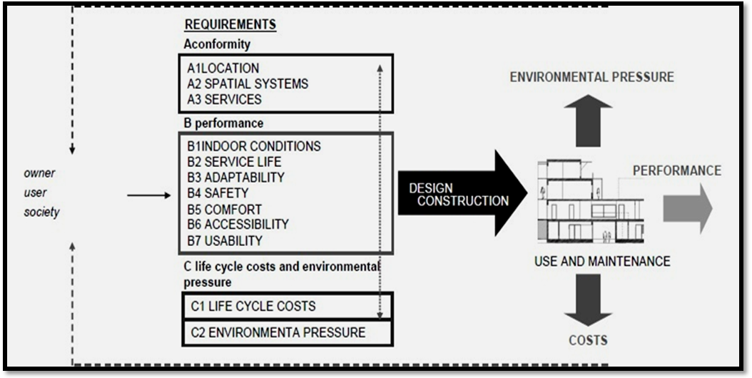

Figure 1. Example of a generic model for a building’s performance analysis
(Luis et al 2010)
This kind of method provides some important benefits to both end users and other participants in the building process, since it promotes substantial improvements in the overall performance of the building, encourages the use of construction solutions that better fit the use of the building, and promotes a better understanding and communication of client and user requirements.
Tools to support decision-making, in accordance with the principles of performance based design, have been developed mainly in research communities.
2.2.2. Integrated Life-Cycle-Analysis of Buildings
The complete Building Sustainability Assessment (BSA) comprises the ways in which built structures and facilities are procured and erected, used and operated, maintained and repaired, modernized and rehabilitated, and finally dismantled and demolished, or reused and recycled. adoption of environmental LCA in buildings and works is a complex and tedious task. The building incorporates hundreds and thousands of individual products, and in a construction project, there might be tens of companies involved. Further, the expected life cycle of a building is exceptionally long (tens or hundreds of years).
2.2.3. Sustainable Building Rating and Certification
The rating and certification systems and tools are intended to foster more sustainable building design, construction, operation, maintenance, and disassembly or deconstruction by promoting and making possible a better integration of environmental, societal, functional, and cost concerns with other traditional decision criteria.
These systems and tools can both be used to support the sustainable design, since they transform the sustainable goal into specific performance objectives to evaluate the overall performance. There are different perspectives in different sustainable building rating and certification approaches, but they have certain points in common. In general, these systems and tools deal, in one way or another, with the same categories of building design and life cycle performance: site, water, energy, materials, and indoor environment.
Nearly all building sustainability rating and certification methods are based in local regulations or standards, and in local conventional building solutions. The weight of each parameter and indicator in the evaluation is predefined according to local socio-cultural, environmental, and economic contexts, and therefore most of the approaches developed so far can only have reflexes at local or regional scales. However, there are a few examples of global scale methods. These kind of methods are, above all, used at the academic level, since the requisite reference cases have to be constructed and separately assessed for each building type, which is a time consuming and expensive process.
There are three major building rating and certification systems that provide the basis for the other approaches used throughout the world: the Building Research Establishment Environmental Assessment Method (BREEAM), which was developed in the U.K., the Sustainable Building Challenge Framework (SBTool), which was developed by the collaborative work of 20 countries, and the Leadership in Energy and Environmental design (LEED), which was developed in the U.S.A.(Edwards and Bennett-2003)
- Research Objectives:
- To assess the sustainable construction performance indicators for some Babylon University buildings.
- To improve the construction performance for these buildings
- Research Methodology :
The studied aspects of sustainable construction performance (functional, economic, social and environmental) of the buildings contains different indicators as explained the attached questionnaire of research .
1 : Functional performance indicators:
The functional performance indicators include:
1-1 The building performance in the long term.
1-2 The building performance in the short term.
1-3 Building efficiency of dealing with structural problems
1-4 The suitability of the land for the building (as area)
1-5 Efficiency of land.
1-6 The availability of sources ( water and electric power)
1-7 Availability area of ​​land suitable for building
2 : Economic performance indicators :
The economic performance indicators include:
2.1 The cost of sustainability of the building
2.2 Expected service life of the building (the service life ≥ 50 year)
2-3 Possibility that remains of the building suitable with the new expansion of the University
2-4 Possibility of merging existing buildings with the new expansion of the University (building supplement)
2.5 The use of heat insulation in the building
2.6 Is it possible to take advantage of parts of the building in case of demolition
3 : Social performance indicators:
The social performance indicators include:
3-1 Easily occupancy of the building and use of all facilities
3.2 Is the size of the building occupancy requirements.
3.3 Availability of green space Inside the building.
3.4 Availability of green space Inside the building.
3-5 The availability of water for the use of the occupants of the building.
3-6 Easily manage the building.
3-7 Did the design similar to the works.

4: Environmental performance indicators:
The environmental performance indicators include :
4.1 Availability of natural lighting (sunlight).
4-2 Availability parks and green spaces.
4-3 Emission of pollutants (generators, waste, sewage).
4-4 The building use for energy alternatives in lighting, heating.
4-5 Availability irrigation water for green spaces.
- Literature Review :
Sustainable development is development that meets the requirements of the present without reducing the ability of future generations to meet their compatibility. Exposure a lot of research and different points of view and multiple sustainable development, and the various dimensions of sustainability, including environmental sustainability - economic and social sustainability in the both fields of sustainability at the level of construction or at performance. The sustainable building is the building which has little negative impact on the natural and environment.
Alanbari et al 2012 assessment for some buildings that have established at the University of Babylon, under the standards LEED. It has been an assessment of the buildings during different periods of time (1980-1989, 1990-1999 , 2000-2010) and by applying the categories of criteria for certification of LEED buildings was reached that all of (building of the presidency, building of mechanical engineering ,building of the medicine faculty dean, building of the medicine faculty classrooms , building of the nursing faculty , building of the dentistry faculty) has got a rating of normal and (building of the education faculty - building of the civil engineering) has received a rating under normal level, while got (building of the agriculture faculty , building of the electrical engineering) rating of silver as it is the modern buildings are designed, implementation and operation methods and advanced technologies contribute to reducing the environmental impact and at the same time lead to cost-cutting as costs of operation and maintenance as they contribute to the provision of urban environment safe and comfortable.
Alhayaly and Aldeyochy 2010 studied the role of building materials in achieving sustainable construction (a study on residential building),the research assumed that there is a relation between common building materials in local environment represented by their natural characteristics with the concept of sustainability.To mention that building materials durability differs from sustainability. Many previous studies showed the ability recognizing the effect of building materials in achieving sustainable construction from life cycle assessment (LCA). LCA depending on two factors, the first one related to building materials and combination components (BMCC) whereas the second factor connected with whole process of construction (WPC), The first factor will be taken into consideration in this study because the study's aim is represented by exploring the relation between the building materials and the sustainable construction. The study will be applied on residential building since they cover 60%- 70% from the urban built–up area in most Iraqi cities.
Hammed and Msekh 2010 studied sustainable Design in Housing, the target of research was helping architect for design process in future to get a samples friendly to environment, it is clear for all interesting people in housing subject in Iraq such as Organizations government, engineering, planers and economists the strongly need to construct a millions of new building house to get the society need of it.

- Moving towards solutions:

Those in the building and construction sector who are working to make it more sustainable recommend a variety of immediate steps that can be taken to address the environmental impacts of buildings and construction. These include:
- Reducing material wastage in construction, including through economic incentives such as higher landfill fees (which also promote the following item);
- Increasing use of recycled waste as building materials, not only reuse of construction and demolition waste but also incorporation of other types of waste in building products – as a recent study funded by the California Integrated Waste Management Board confirms, recycled-content building materials generally perform as well as the equivalent standard products;
- Improving energy efficiency in buildings
making wiser use of water in buildings and on construction sites;
- Increasing structures’ service life, including through built-in flexibility of use longer-term approaches to reducing impacts include:
- Rethinking policies affecting the sector, including financial ones, and strengthening standards;
- Promoting corporate environmental and social responsibility in the sector, with industry-specific reporting mechanisms;
- Building public and enterprise awareness and knowledge sharing;
- Upgrading skills and worksite health and safety;
- Innovating in regard to materials, technologies and methods, with site-appropriateness in mind and focusing on integrated, holistic research
- Case study :
The researchers study some of Babylon University buildings were built in different periods and they were on three groups:
1 - The first group was the buildings that constructed in the period (1980 to 1990) and included the buildings of : (Mechanical Engineering Department, Central Library, law college, Al - Hassan bin almatheher alhilly - Classrooms in the Faculty of Law, College of Engineering Labs. and Electrochemical Engineering Department)
2 - The second group was the buildings that have been constructed in the period (1990 to 2000) and included the buildings of: (Engineering College building, Complex scientific departments in the College of Engineering(civil. architect – Env.), Dean of the Faculty of Pure Science Education, Abdul Majeed Al hakeem - classrooms in the Faculty of Law)
3- The third group included a group of buildings that were built in the period from 2000 to 2010 and the buildings that have been selected buildings of :( Agriculture College building, Department of Soil in Agriculture College, Department of Animal Production in Agriculture college, Department of Horticulture in Agriculture college, Student club - Faculty of Agriculture) Where was studying and evaluating the Sustainable Construction Performance Indicator that have been previously identified in paragraph 4 - search Methodology and as explained in the attached questionnaire of research .
8 - Results and Discussion :
After applying the attached questionnaire of research on the buildings mentioned in the case study above ,Table No. 1 shows the ratios obtained in the buildings on each side of the four aspects (functional, economic, social and environmental) with the overall Sustainable Construction Performance Indicator for each construction period .
Table No. 1 explain rates of buildings on each four aspects with a ratio of total Sustainable Construction Performance Indicator
Seq. | Name of Building | Fun. Sustainability Indicator  700 point | Economical Sustainability Indicator  600 point | Social Sustainability Indicator  700 point | Env. Sustainability Indicator  500 point | Sustainable Construction Performance Indicator 2500 point
Group I: Buildings that were built in the period (From 1980 to 1990)
1 | Dean of the Faculty of law building | 66% | 49% | 56% | 68% | 60% | Av.  71%
2 | Al Hassan Bin-almathher al hilly (classrooms in the Faculty of Law) | 76% | 43% | 60% | 62% | 60% | Av.  71%
3 | Electrochemical Engineering Department | 67% | 77% | 63% | 73% | 70% | Av.  71%
4 | Engineering workshops and laboratories | 89% | 71% | 71% | 53% | 75% | Av.  71%
5 | Central Library | 78% | 70% | 83% | 67% | 75% | Av.  71%
6 | Department of Mechanical Engineering | 91% | 81% | 78% | 85% | 84% | Av.  71%
Group II: Buildings that were built in the period (From 1990 to 2000)
1 | Abdul Majid al-Hakim - classrooms in the Faculty of Law | 81% | 49% | 57% | 71% | 64% | Av.  61%
2 | Dean of the Faculty of Education - pure science | 56% | 62% | 54% | 73% | 60% | Av.  61%
3 | Engineering combines scientific departments (civil - Architect - Environment) | 70% | 55% | 51% | 50% | 57% | Av.  61%
4 | Dean of the Faculty of Engineering | 69% | 43% | 73% | 63% | 59% | Av.  61%
Group III: Buildings that were built in the period (From 2000 to 2010)
1 | Deanship of the Faculty of Agriculture | 75% | 50% | 44% | 49% | 55% | Av.  57%
2 | Department of Soil - Faculty of Agriculture | 71% | 61% | 52% | 44% | 58% | Av.  57%
3 | Department of Animal Production - Faculty of Agriculture | 70% | 71% | 46% | 33% | 56% | Av.  57%
4 | Department of Horticulture - Faculty of Agriculture | 64% | 61% | 44% | 53% | 56% | Av.  57%
5 | Student club - Faculty of Agriculture | 77% | 54% | 55% | 46% | 59% | Av.  57%

Note Table 1 we see that the buildings divided for 3 groups according to construction period, results of Sustainable Construction Performance Indicator of buildings by periods of construction groups, we find that :
First group: the buildings that were constructed in the period of 1980 to 1989, concentrated by one of the Japanese companies were previously manned by Hilla Technical Institute and then later turned to the University of Kufa and most recently to the University of Babylon. in this group on average sustainability standard rate of 71% where these buildings did not suffer from Significant structural problems except some minor problems resulting from the using of building. the mechanical dep. Was the highest Sustainable Construction Performance Indicator of 84% and the building of Dean of the Faculty of law is the worst in this group due to failure in the functional aspect, where the building suffers from problems in leak Moisture to the ceilings and walls, and the fact that the building is one floor construction with Small area making them unsuitable for occupancy in terms of space, helping give Sustainable Construction Performance Indicator a low of 60% compared with those of the same group.
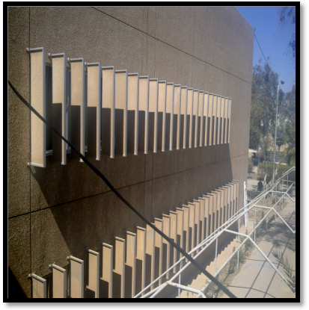
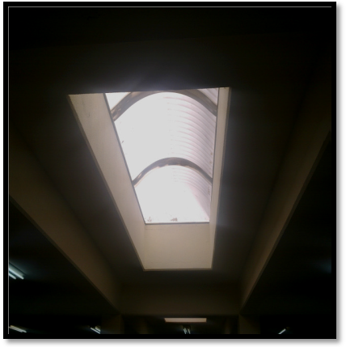
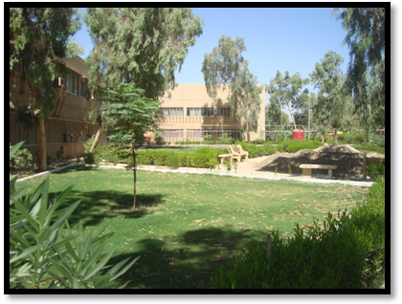

fig 2 . Building of Mechanical engineering Department

Second group: the buildings that were constructed in the period 1990 to 1999: almost the buildings have been concentrate al mansoor company for concentration belong to the Ministry of Housing and Construction got an average sustainability standard rate of 61% where the building of Abdul Majid al-Hakim - classrooms of the Faculty of Law get Sustainable Construction Performance Indicator of 64% But it suffers from a problem in the design is the lack of conductive ladders to the roof of the building, which make the process of maintaining the roof of the building, air conditioning and other convergence of some difficulty, in addition to the emergence of some moisture problems in the walls due to leakage of water baths and won Forums Complex Engineering ( Civil - architectural and Environment) standard at least for this group is 57% due to the large number of sections ,it being designed for only one section as well as the emergence of insect termites in the section (30%) and lack of green space and water available to them and the occupants, as well as water leakage bathrooms and the appearance of damp patches in some of the walls of the building.
Third group: the buildings that were constructed in the period from 2000 to 2010: was the College of Agriculture and complex divisions and got a standard rate sustainability construction of 57%, where the Sustainable Construction Performance Indicator of buildings in this group convergent ranged between 55% to 59% despite the newly created (2007), but it suffered from problems in the implementation of construction (such as SKY LIGTH), and the emergence of termites by 40% in the foundations and walls of the building of the animal productions without treatment and lack of development of green outdoor spaces and in water scarcity and lack of availability of electric power from generators to some buildings making them take less points with the three groups as shown in fig. 3 and 4.

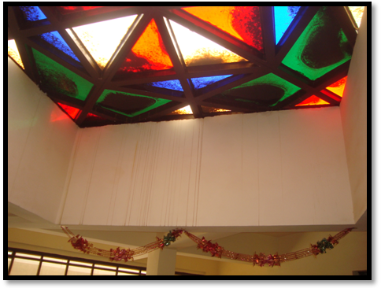
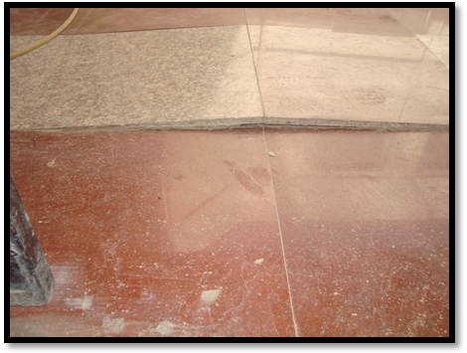

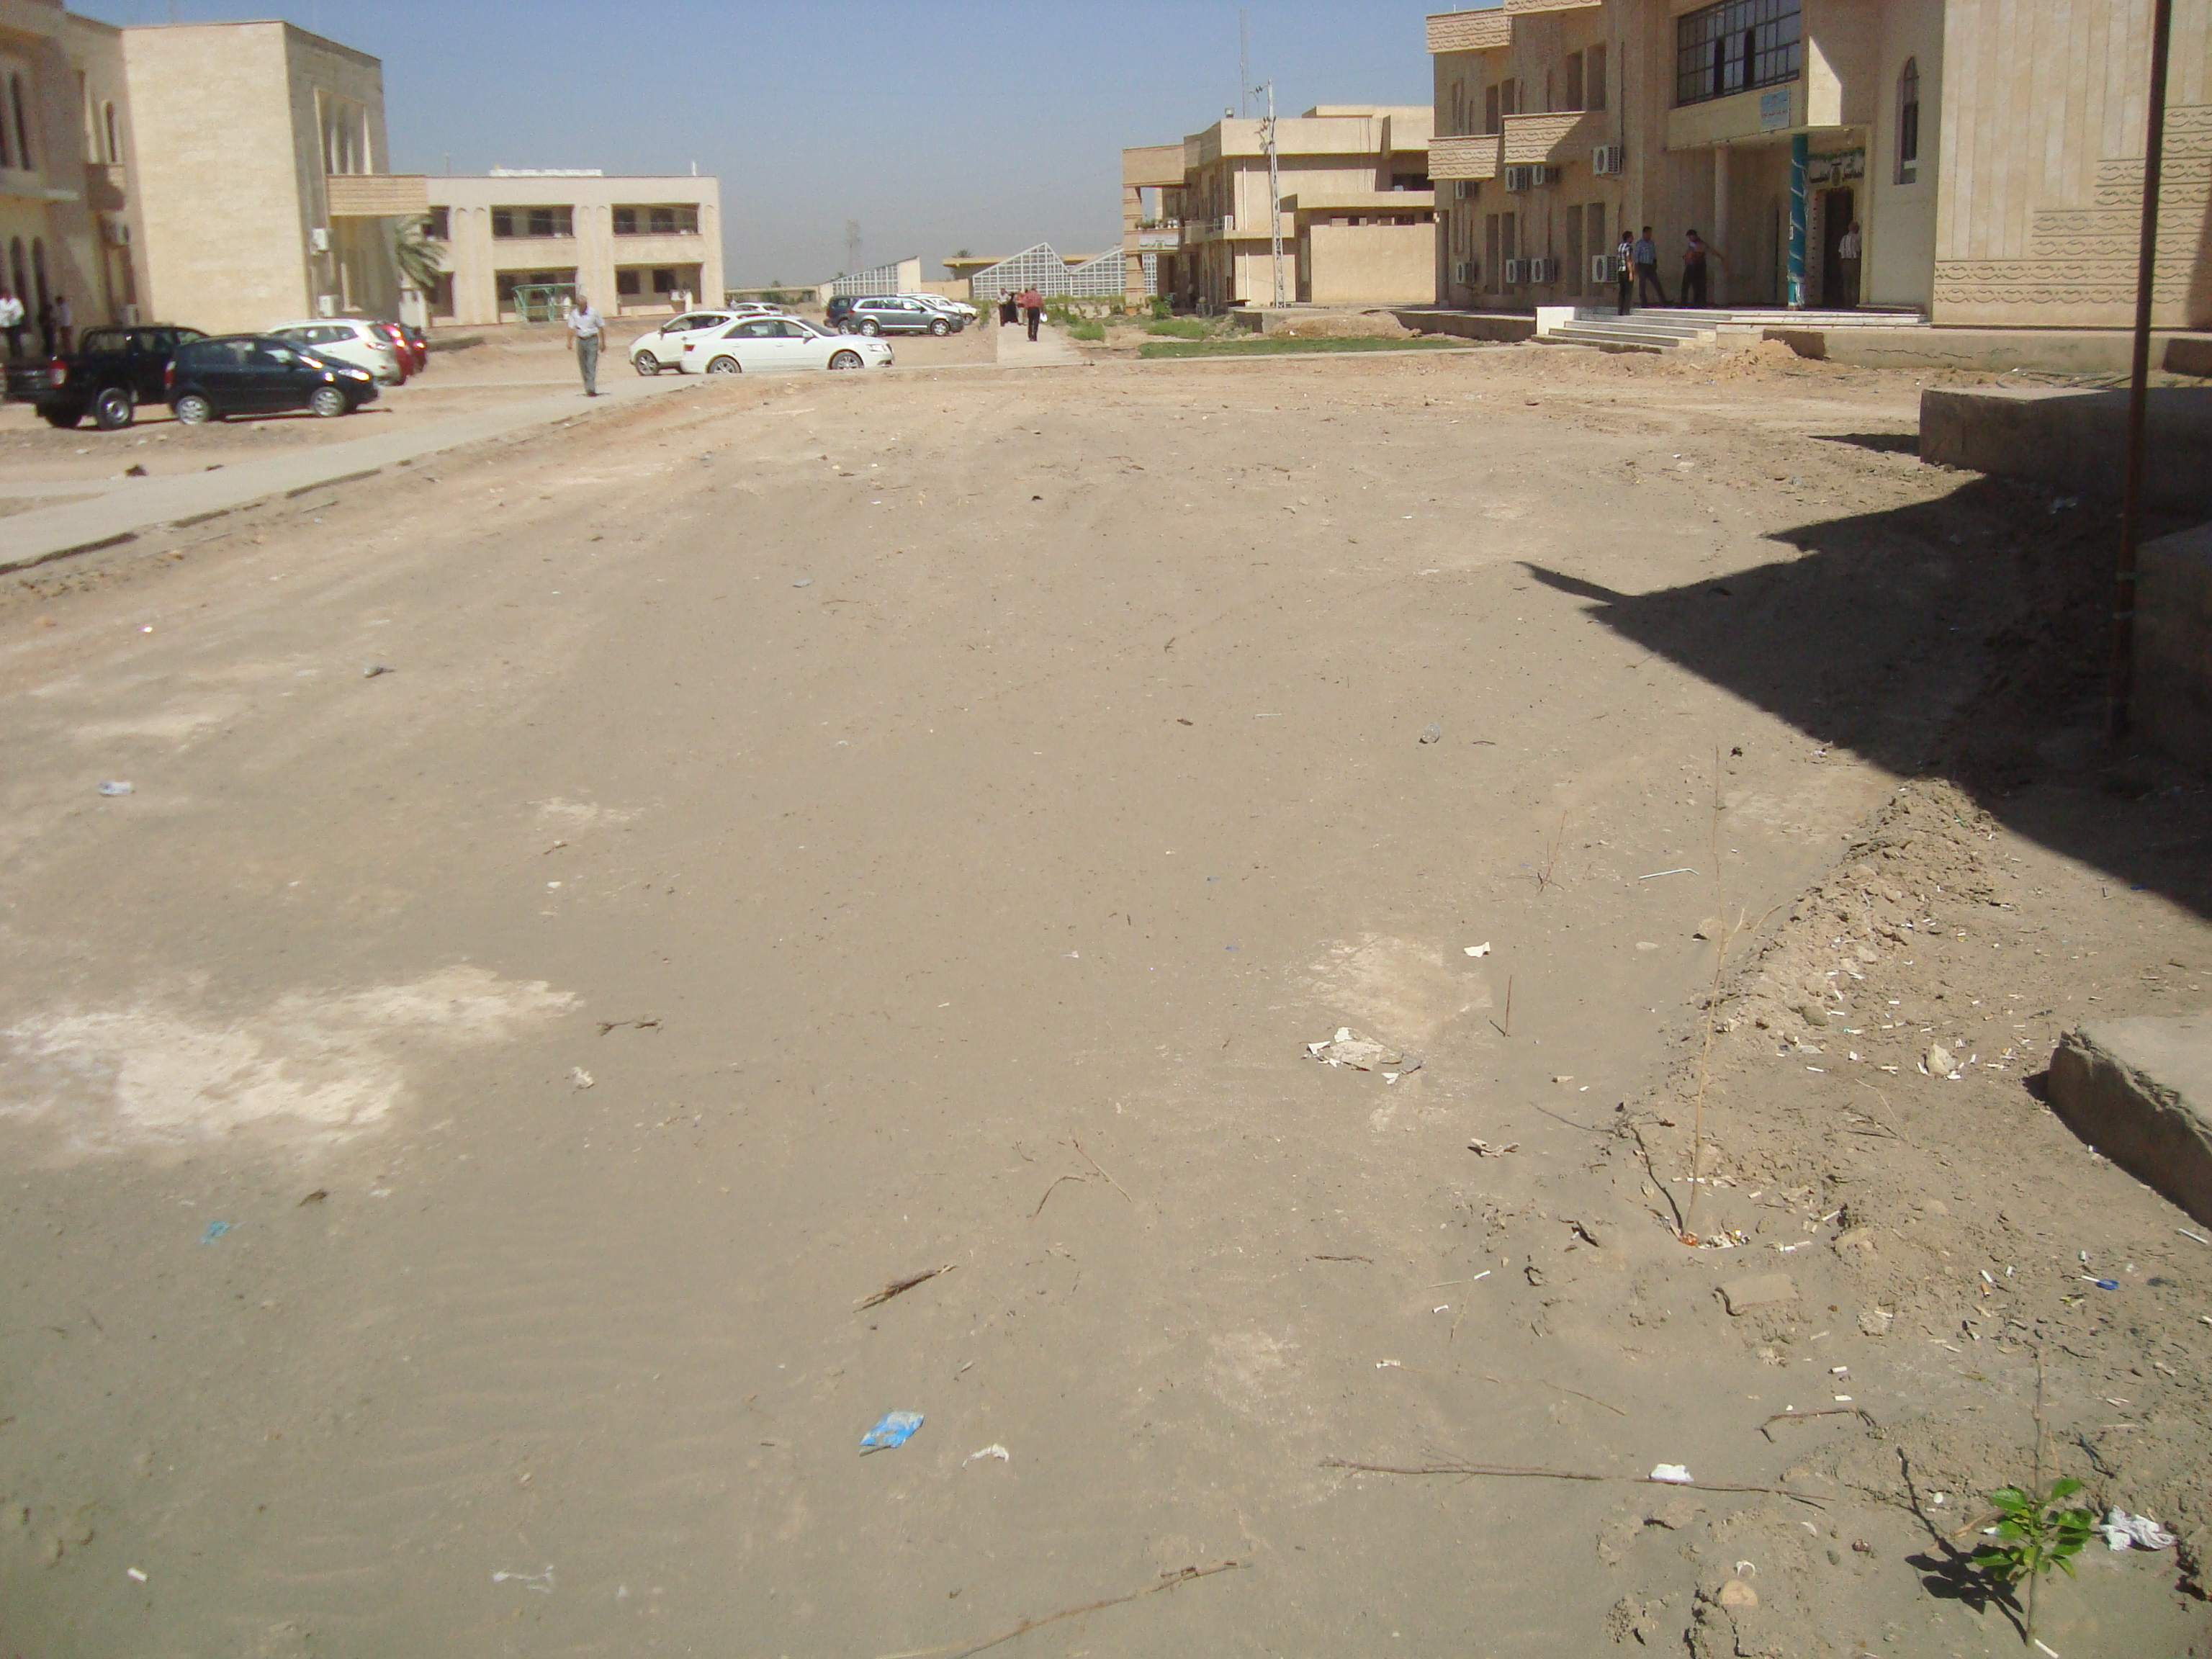
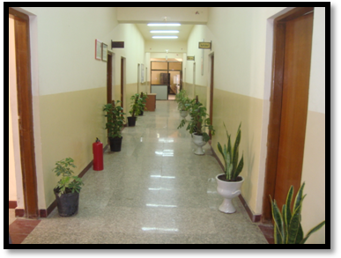

Fig 3. Buildings of agriculture college

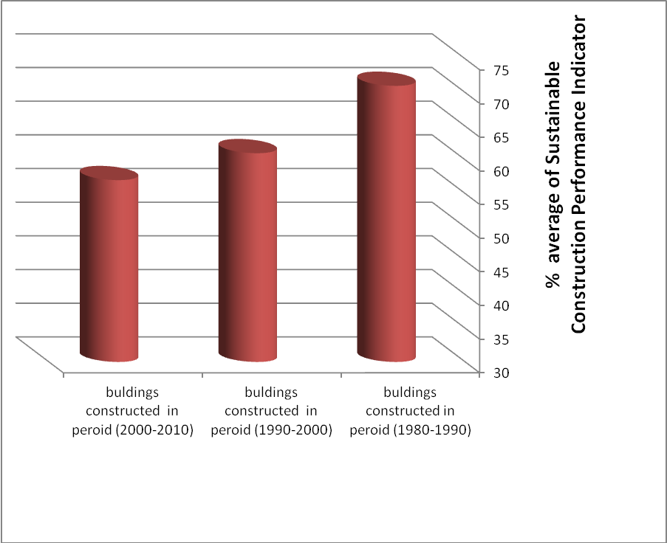

Figure 4 The average of Sustainable Construction Performance Indicator
for each group of buildings according to their respective construction periods

The researcher found there is a convergence in the Sustainable Construction Performance Indicator of the total of the second and third groups, but the first group get way form the second and third group as shown in Figure 3.

Table 1 and observing the Sustainable Construction Performance Indicator for four aspects (the functional aspect, the economic aspect, the social aspect and the environmental aspect) :
- With regard to the functional aspect ,: The building of mechanics dep. The first one with functional Sustainability Indicator of 91% and second building workshops and laboratories of Engineering 89% and thirdly building Abdul Majid al-Hakim - Faculty of Law 81%, while dissolved finally the building of Deanship of Education - pure science of 56% to the fact that the building suffers from problems in the moisture and the diversion of water from the surface with a large number of occupants and the lack of appropriate space where there are Department of Mathematics and Physics with classrooms study with them Dean in this building, in addition to cutting the internal evil which paralyzes the movement of occupants.
- With regard to the economic aspect ,: the economic side has replaced the building of mechanics first and then the Department of electrochemical dep. II and workshops& laboratories of engineering college and department of animal production in the College of Agriculture III the economic Sustainability Indicator of 81%, 77% and 71%, respectively, to the ability of these buildings to communicate with the expansion New and future of the University with the side provides space for these buildings that allow for expansion and integration with new buildings as well as the useing of thermal insulators in this buildings.. While the Dean of the Faculty of Engineering and al Hassan bin almudher al hilly - Faculty of Law of the worst within the Sustainability Indicator 43% to the lack of available space for expansion and difficult to integrate with other buildings and the lack of thermal insulation.
- With regard to the social aspect: the social aspect came first building of the Central Library and the second building section the mechanics and thirdly building workshops and laboratories Faculty of Engineering of social Sustainability Indicator of 83%, 78% and 71%, respectively, and came place the latter in this aspect buildings of Dean of the Faculty of Law and Department of Horticulture - Faculty of Agriculture Social Sustainability Indicator of 44% due to the lack of greenery and water scarcity and alternative energy.
- With regard to the environmental aspect: the environmental side has replaced the building of mechanical dep. Also the first and then building of electrochemical dep. and Dean of the Faculty of Education - pure science Second and building Abdul Majid al-Hakim in the third criterion of the environmental Sustainability Indicator of 85%, 73% and 71%, respectively. Came in the last the building of production Animal dep. - Faculty of Agriculture environmental Sustainability Indicator of 33% where they did not have green spaces or sufficient natural lighting or water for watering.
Table (2) shows the sequence of buildings according to the highest ratios obtained in Sustainable Construction Performance Indicator and raised in the questionnaire form.

Table. 2 The sequence of buildings according to Sustainable Construction Performance Indicator
Sec. | Name of building | Construction Period | Sustainable Construction Performance Indicator
1 | Department of Mechanical Engineering | 1980-1989 | 84%
2 | engineering workshops and laboratories | 1980-1989 | 75%
3 | Central Library | 1980-1989 | 75%
4 | Electrochemical Engineering Department, | 1980-1989 | 70%
5 | Abdul-Majid al-Hakim building (classrooms at the Faculty of Law) | 1990-1999 | 64%
6 | Dean of the Faculty of Law | 1980-1989 | 60%
7 | Hassan Bin-looking building ornaments (classrooms in the Faculty of Law) | 1980-1989 | 60%
8 | Dean of the Faculty of Education - pure science | 1990-1999 | 60%
9 | Dean of the Faculty of Engineering | 1990-1999 | 59%
10 | club student in the College of Agriculture | 2000 -2010 | 59%
11 | Department of Soil - Faculty of Agriculture | 2000 -2010 | 58%
12 | complex scientific departments (civil - Architect - Environment) | 1990-1999 | 57%
13 | Department of Animal Production - Faculty of Agriculture | 2000 – 2010 | 56%
14 | Department of Horticulture-College of Agriculture | 2000 – 2010 | 56%
15 | Dean of the Faculty of Agriculture | 2000 – 2010 | 55%

Table 2, and according to Sustainable Construction Performance Indicator, which reported in details in the attached questionnaire of research the research found:
1- building of mechanical engineering department got the highest Sustainable Construction Performance Indicator is 84%, while the building of workshops & engineering laboratories and building of the Central Library on the rate of 75% for each one,
2- the first three buildings are the buildings that were built in the period from 1980 to 1990 were built by one of the Japanese companies and were occupied by the Technical Institute - Hilla earlier, and then turned to the University of Kufa and then to the University of Babylon, these buildings still do well after 33 years of construction.
3-While the building of electrochemical dep. the sequence 4 with Sustainable Construction Performance Indicator of 70% and the building of Abdul Majid al-Hakim on the sequence 5 with Sustainable Construction Performance Indicator of 64%, while the sequence 6, 7 and 8 were for the buildings: Dean of the Faculty of law,al Hassan bin almudher alhilly and deanship Education - pure science, respectively Sustainable Construction Performance Indicator of 60% for each one. While the sequence 9 and 10 were shared between Dean of the Faculty of Engineering and the club student of the Faculty of Agriculture with a Sustainable Construction Performance Indicator 59% . And the sequence 11 was belong to Dep. Of soil - Faculty of Agriculture standard of 58% and the compound sections Engineering (Civil - Architect - Environment) to sequence 12 standard of 57% due to the pressure generated from departments where the building is designed for only one section, as well as the emergence of an insect termites and moisture due to leaking bathrooms in some parts of the building and water availability. The sequence 13 and 14 was shared between building of Department of Animal Production and gardening in the College of Agriculture Sustainable Construction Performance Indicator of 56% and the last was Dean of the Faculty Agriculture criterion of 55%, despite the fact that the last three buildings were built in 2007 but due to some problems with the design and maintenance did not reap these buildings a large number of points that the Building Department of Animal Production suffer from the emergence of insect termites in the foundation and walls by 40% without treatment also buildings suffer from the poor implementation of the sky light in the ceilings that put architectural beautiful design to insert light but poor implementation made it a port of moisture and water rain to the walls of the building caused moisture in many of the walls of buildings Faculty of Agriculture as shown in fig3.
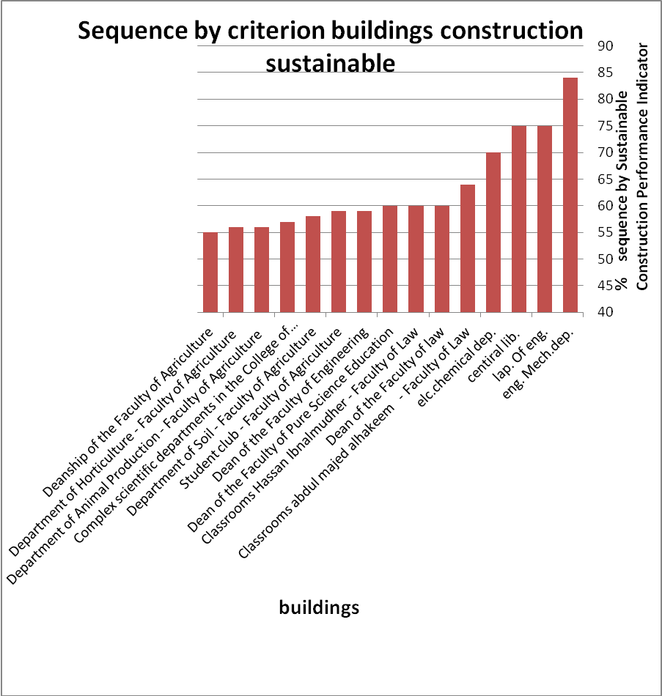

Fig. 5 show sequence by Sustainable Construction Performance Indicator
9-Conclusions:
1 - Despite the lapse 33 years to set up the first set buildings, but it has shown the efficiency of work and very good Sustainable Construction Performance Indicator.
2 - Although the circumstances bad situation that was suffered by the country in the period 1990 to 1999, but the second group of buildings are working well better Sustainable Construction Performance Indicator than the buildings that have established in the next period .
3 - Despite the development and the opening markets on modern design and implementation and the large numbers of construction products in the market, but the bitter reality does not seem so obvious in Sustainable Construction Performance Indicator of Universities building.
4- All the buildings holding in Iraq, including University buildings fail to get any certificates of evaluate Sustainable because of lack of realization of the total points required for the certificate level.
10-Recommendations:
1 - Take advantage of the evaluation mechanism contained in the research, to evaluate the Sustainable Construction Performance of other buildings at the university, as well as new building projects before construction.
3 – Training for planning, design and operational university employees on methods of sustainable buildings.
4 - Start steps of transformation and change for the Green concept of sustainable building management, particularly with regard to the management of the infrastructure of the University.
5 - Take advantage of the evaluation mechanism contained in the research, to assess the status of other Iraqi universities.
References:
Agenda 21 on Sustainable Construction; CIB Report Publication 237; CIB (International Council for Research and Innovation in Building and Construction): Rotterdam, The Netherlands 1999.
Al-Anbari, Mohammad Ali , Taha, Laden and. Zahir ,Ishraq ,2013: Assessment of some buildings in Babylon University according to the criteria of Leadership in Energy and Environmental Design (LEED). Babylon University Journal vol .21 No.1 (in Arabic).
Edwards, S.; Bennett, P. 2003,Construction products and life-cycle thinking. UNEP Ind. Environ, Apr.–Sep., 57–61.
Environmentally Sound Technologies for Sustainable Development; United Nations Environment Programme; Division of Technology, Industry and Economics, International Environmental Technology Centre: Osaka, Japan, 2003.
Ghid B. Hammed and Mohammed A. Msekh,2010 "Sustainable Design in Housing", Iraqi Journal for mechanical and materials Eng. special Issue(B).
Koukkari, H.; Huovila, P. 2005,Improving the Performance of Buildings. In Proceedings of the Final Conference of COST Action C12—Improvement of Building’s Structural Quality by New Technologies, Innsbruck, Austria, 20–22 January; Schaur, C., Mazzolani, F., Huber, G., De Matteis, G., Trumpf, H., Koukkari, H., Jaspart, J.P., Braganca, L., 2005,Eds.; Balkema Publishers: Leiden, The Netherlands; pp. 425–430.
Luis Broganca, Ricardo Mateus and Heli Kokkari, 2010, "Building Sustainability Assessment", open Access- Sustainability- ISSN 2071-1050, journal, July.
Mohammed Al Mumtaz H hayaly and. Al deyochy,2010, "The Role of Building Materials in a Chieving Sustainable Construction", Iraqi Journal for mechanical and materials Eng. special Issue(C).
Mohamad M.K., Phillip F.G.Banfill and Gilliam F. Menzies, 2009. "Life Cycle Assessment and the Environmental Impact of Building", open Access- Sustainability- ISSN 2071-1050, journal,sep.
Wichitra Singhirunnusorn, 2009," An Appropriate Wastewater Treatment System in Developing Countries:Thailand as a Case Study", Ph.D,thesis, University of California, Los Angeles.

Questionnaire List نموذج استبيان
السيد الخبير المحترم ............... يرجى مساعدتنا في الاجابه عن الفقرات الوارده ادناه حيث يمثل النموذج منهج لإكمال البحث العلمي الموسوم ( تقييم الاستدامة للاداء الانشائي لبعض ابنيه جامعة بابل)

Assessment of Sustainable Construction Performance for Some Buildings in Babylon University
باربعة جوانب( الوظيفي ، الاقتصادي ،الاجتماعي والبيئي)حيث المعلومات ادناه تخص بنايه ....شاكرين تعاونكم معنا .....
- الجانب الوظيفي | Scores | 1- Functional performance indicators
- تأدية المبنى لوظيفته على المدى الطويل |  | 1-1 The building performance to function in the long term
1-2 تأدية المبنى لوظيفته على المدى القصير مع وجود الترميم (ظهور المشاكل سنوياً نتيجة اشغال المبنى) |  | 1-2 The building performance to function in the short term
- كفاءة التعامل مع المشاكل الانشائية منها مقاومة المبنى لـــ:  - ظهور الشقوق (الغير شعرية) في الجدران او السقوف  - حصول انتفاخ وانفصال لطبقات البياض ( بسبب الرطوبة)  - حصول انفصال للغطاء الخرساني حول التسليح (سقوف - جدران –ارضيات)  - ظهور بقع بنيه اللون( صدأ حديد التسليح او الشيلمان) في السقوف او الجدران  - ظهور بقع الرطوبة في البناية (تسريب للمياه في المبنى)  - فقدان ملحوظ لمقاومه الخرسانة (تفتت الخرسانة)  - وجود مشاكل في التسطيح للمبنى ( تسرب المياه الى الداخل)  - ظهور حشرة الارضة |  | 1-3 The efficiency of dealing with structural problems, including the building's resistance to :  A - The appearance of cracks (non-Noodles) in the walls or ceilings  B - Get swelling and separation of layers of finishing (due to moisture)  C- Separation of the concrete cover on reinforcing (ceilings - walls - Flooring)  D -The appearance of brown spots in ceilings or walls  E - patches of moisture in the building (a water leak in the building)  F -a significant loss for concrete resistance (concrete fragmentation)  G - problems in the flatness of the building (water leak inside)  H- The emergence of insect termite
- مدى ملائمة الارض للمبنى (كمساحة ) |  | 1-4 The suitability of the land for the building (as area)
- كفاءة الارض من حيث  - مستوى المياه الجوفيه  - نوعية التربه  - مقاومة خطر الطفو الذي قد يتعرض له المبنى |  | 1-5 Efficiency of land from :  • The level of underground water  • The quality of the soil  • dangerous of floating, which may be suffered by the building
- مدى توفر مصادر المياه والطاقة الكهربائية |  | 1-6 The availability of sources (water and electric power)
- مدى توفر مساحه من الارض مناسبة للمبنى |  | 1-7 Availability area of ​​land suitable for building
المجموع |  | Total

- Economic performance indicators | Scores | - الجانب الاقتصادي
2-1 The cost of sustainability of the building include:  a - the cost of annual maintenance  b - the cost of repair  c - the cost of administration  d - the cost of fuel |  | 2-1 كلفة الادامه للمبنى وتشمل:  - كلفة الصيانه السنويه  - كلفة الترميم  - كلفة الادارة  هـ - كلفة الوقود
2-2 the service life expectancy of the building( the service life ≥ 50 year) |  | 2-2 توقَع العمر الخدمي للمبنى( على اساس ان العمرالخدمى للمباني ≥ 50 سنه)
2-3 is a possibility that the building remains appropriate with the new expansion of the University |  | 2-3 امكانيه ان تبقى البناية ملائمة مع التوسع الجديد للجامعة
2-4 possibility of merging existing buildings with the new expansion of the University (accessory building) |  | 2-4 امكانية دمج البنايات الحاليه مع التوسع الجديد للجامعة ( بناء ملحق)
2-5 The use of heat insulation in the building |  | 2-5 استخدام عوازل الحرارة في المبنى
2-6 Is it possible to take advantage of the parts of the building in case demolished |  | 2-6 هل بالإمكان الاستفادة من اجزاء المبنى في حاله هدمه
Total |  | المجموع

- Social performance indicators | Scores | 3-الجانب الاجتماعي
3-1 easy of building occupancy and use of all facilities(Availability of the works requirements) |  | 3-1 سهوله اشغال المبنى واستخدامه بجميع مرافقه ( توفر متطلبات الاشغال)
3.2 Did the size of the building requirements for building works |  | 3-2 هل يلبي حجم المبنى متطلبات الاشغال
3.3 availability of green spaces Inside the building |  | 3-3 توفر المساحات الخضراء خارج المبنى
3.4 availability of green spaces outside the building |  | 3-4 توفر المساحات الخضراء داخل المبنى
3-5 availability of water for human use |  | 3-5 مدى توفر المياه لاستخدام الشاغلين للمبنى
3-6 easy management of the building |  | 3-6 سهوله ادارة المبنى
3-7 suitable use of the building  (Did the design similar to the works) |  | 3-7 ملائمه الاستعمال للمبنى  ( هل التصميم مماثل للاشغال)
Total |  | المجموع

4- Environmental performance indicators | Scores | 4- الجانب البيئي
4-1 availability of natural light (sunlight) |  | 4-1 مدى توفر الاضاءة الطبيعيه ( اشعة الشمس)
4-2 provides parks and green spaces |  | 4-2 توفر الحدائق والمساحات الخضراء
4-3 Efficiency of building to stoping emission of pollutants  -Generators  -Waste  -Sewage |  | 4-3 كفاءة المبنى للحد من انبعاث الملوثات من :  - المولدات  - النفايات  - مياه مجاري
4-4 the use of the building for energy alternatives in lighting and heating |  | 4-4 مدى استخدام المبنى لبدائل الطاقة في الانارة والتدفئه
4-5 the availability of irrigation water for green spaces |  | 4-5 مدى توفر مياه السقي للمساحات الخضراء

