Experimental and Numerical Investigation of Convective Heat Transfer in a Circular Tube with Internal square ribs
Arkan Al-taie Hasasn Ali Jurmut
University of Technology University of Technology
Email:arkanaltaie @yahoo.com Email:Hasan_jurmut@yahoo.co

Abstract
This work presents an experimental and numerical investigation of heat transfer characteristics of horizontal circular pipe500mm long using internal square ribs of 80mm width ,80mm height, n=7 in upper surface and 80mmwidth ,80mm height ,n=6 in lower surface of pipe, p =100mm, with air as the working fluid. Reynolds number 31170 was taken. The steel pipe(ASM4120) was subjected to different constant surface temperatures. The experimental data obtained were compared with plain (with out ribs)case.. Based on the same coolant flow, the pipe with internal square ribs was found to possess the highest performance factors for turbulent flow. The results show a good agreement between theoretical and experimental by factor 4.4%. The heat transfer rates obtained from pipe upper surface and lower surface is 213% over the smooth channel. for a given Reynolds number. The use of internal square ribs improved the heat transfer in circular pipe. All studies where carried out using workbench programFlUENT14.5 by using K-ɛ model.
Keywords: cooling enhancement, internal square ribs , heat transfer and turbulent flow.
الخلاصة
تمت في هذا البحث دراسة عملية ونظرية لانتقال الحرارة خلال انبوب دائري طوله (500ملم) باستخدام أضلاع مربعة طول الضلع (80ملم) داخل الأنبوب بعدد (7) و (6) في أعلى وأسفل الأنبوب على التوالي.المائع المستخدم (الهواء) أخذ رقم رينولد31170 وباستخدام درجات حرارة مختلفة على سطح الأنبوب وقد أظهرت النتائج اقتراب جيد بين الجانب النظري والعملي بمقدار4.4% وان كمية الحرارة المنتقلة 213% مقارنة بالأنبوب بدون أضلاع. وان استخدام الأضلاع يحسن من انتقال الحرارة وقد استخدم برنامج فلونت 14.5 لكافة الحسابات باستخدام نموذج K-ɛ .
الكلمات المفتاحية: تعزيز والضلوع مربع الداخلية، نقل الحرارة وتدفق المضطرب التبريد
Nomenclature
A Heat transfer area, m²
Cp Specific heat of air, J/kg.K
D_{h} Hydraulic diameter, m
F Frictional factor
g Acceleration due to gravity ,m/s²
h Heat transfer coefficient, W/m² k
p Pitch of rib, m
L_{t} Length of test pipe, m
m Mass flow rate, kg/s
R_{e} Reynold number
Q Heat transfer rate, W
u Velocity of flow , m/s
μ Viscosity of air , N s/ m²
ρ Density of air, kg/m³
T_{w,x} Local wall temperature
T_{b.x} Local bulk temperature of air,K
q Heat flux,w/m²
Introduction
In the design of channel heat exchangers, rib, fin or baffle turbulators are often employed in order to increase the convective heat transfer rate leading to the compact heat exchanger and increasing the efficiency. For decades, rib turbulators have been applied in high-performance thermal systems due to their high thermal loads. The cooling or heating air is supplied into the channels with several ribs to increase the stronger turbulence intensity of cooling or heating levels over the smooth wall channel. Ribs placed in tandem in the channels interrupt hydrodynamic and thermal boundary layers because downstream of each rib the flow separates, re-circulates, and impinges on the channel walls that are the main reasons for heat transfer enhancement in such channels. The use of ribs not only increases the heat transfer rate but also substantially the pressure loss. In particular, the rib geometry, the rib-to-channel height ratio and the rib pitch-to-height ratio are the parameters that affect the heat transfer rate and the thermal performance [Liou ,1992-1993].
Many attempts have been made to study the effect of these parameters of ribs on heat transfer and friction factor for two opposite roughened surfaces. Han et al. [Han-1991,Han-1992] investigated experimentally thermal characteristics in a square channel with angled ribs on two walls and found that the angled ribs and ‘V’ ribs yielded higher heat transfer than the continuous ribs and the highest value is at the 60° amongst the angled ribs. For heating either only one of the ribbed walls or both of them, or all four channel walls, they reported that the former two conditions resulted in an increase in the heat transfer with respect to the latter one. For broken ribs with e/D=0.0625 and P/e=10 placed in a square channel, Han and Zhang [Han, 1992] also found that the 60° broken ‘V’ ribs give higher heat transfer at about 4.5 times the smooth channel and perform better than the continuous ribs. [Liou ,1992-1993] carried out an experiment to study the performance of square, triangular and semi-circular ribs by using a real time Laser Holographic Interferometry to measure the local as well as average heat transfer coefficients. They reported that the square ribs give the best performance among them. The heat transfer behaviors in a ribbed square channel with three e/D ratios (e/D=0.083, 0.125 and 0.167) and a fixed P/e=10 using a liquid crystal technique were examined by Taslim et al. [Taslim, 1996]. They found that the average Nusselt number increased with the rise in e/D ratio and the best e/H ratio was seen to lie between 0.083 and 0.125. Turbulent convective heat transfer behaviors in square ducts with ribs on two opposite walls and discrete angled ribs on one wall were numerically investigated by Saidi and Sunden [Saidi, 2000] and Tatsumi et al. [Tatsumi, 2008], respectively. They found that noticeable heat transfer enhancement is obtained downstream of the ribs due to strong secondary flow motion.
Theoretical Model and Numerical Solution
This study presents a description of the mathematical basis for a comprehensive general purpose model of fluid flow and heat transfer from the basic principles of conservation of mass, momentum, and energy. This leads to the governing equations of fluid flow and heat transfer used for the analysis of steady state , three-dimensional, turbulent and incompressible flow in addition to thermal performance and cooling effectiveness of pipes with different ribs configuration heat exchanger .
The results obtained from the experimental investigation work show the behavior of the temperature distribution in the pipe flow region (smooth and rough). The temperature distribution affects the heat transfer coefficients effectiveness estimation values.
The computational fluid dynamics (CFD) becomes one of the most useful tools for complex phenomena without resorting to expensive prototype and difficult experimental measurement. Numerical prediction using FLUENT can be performed to determine the temperature distribution and for better understanding the losses of heat transfer.The flow may be considered incompressible as velocity tend to be constant. Like many common fluids such as water, air is a Newtonian fluid, displaying a linear relationship between shear and strain.
This study also presents the governing equations of fluid flow to solve the interaction of coolant air with configuration of ribs. To demonstrate the effect of the turbulence model that involves the solution of two transport equation (k-ε) model is used, thus the numerical techniques will solve these Cartesian coordinate system . Three dimensional geometry is generated and the effects of ribs shape are to be studied. FLUENT version (14.5),
Governing equation
The Heat transfer Equation: The heat-transfer rate is the amount of heat that transfers per unit time (usually per second). If a hot metal bar has a surface temperature of T_{o} on one side and T_{i} on the other side, the basic heat-transfer rate due to conduction can be given by:
$Q=\text{UA}ΔT$ …………………………………………………………..(1 )
If a hot wall at a temperature T_{o} is exposed to a cool fluid at a temperature T_{i} on one side, the convective heat-transfer rate can be given by:
$Q=\text{hA}ΔT$………...............…………………..........................………..( 2 )
The conventional expression for calculating the heat transfer coefficient in fully developed turbulent flow in smooth pipes is the Dittus Boelter . Because of the many factors that affect the convection heat-transfer coefficient (h) , calculation of the coefficient is complex. However, dimensionless numbers are used to calculate (h) for both free convection and forced convection .
Nu = 0.023Re^{0.8} Pr^{0.4} ………………………………………………….……..(3)
D_{h} is the hydraulic diameter express as:
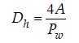

Prandtl number express as:
P_{r} = $\frac{{μc}_{p}}{K}$ …………………………………………………………...…….( 4 )
Reynolds number express as:
R_{e} = $\frac{ρ\text{uD}}{μ}$ ...............................................................................................( 5)
Also, the flow Reynolds number is:
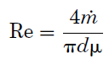
……………………………………………..……………………( 6)

The definition of mass flow is important for correlations. Mass flow is defined in equation :
$m=ρ\text{uA}$
………………………………………………………….…..(7)
Energy Balance
Energy balance is applied to the air flowing in the pipe. The energy which is produced by the heaters is carried away by the air flowing inside the pipe and only a small portion of the heat produced is lost by natural convection from the outer surface of the pipe. The energy balance principle:
$Q={\text{mc}}_{p}\left(T_{o}−T_{i}\right)$……………………………..………..………………( 8 )
Furthermore Q is the total heat transferred to air by forced convection and is given by:
$q=Q/π\text{DL}$……………………………………........................…..( 9 )
$h=q/(T_{w,x}−T_{w,\text{bx}})$………………………………………………….…..……..(10)
FLUENT Software Package:
There are three main steps in any CFD analysis
1. Pre-Processing.2. Solver Execution.3. Post-Processing.
1-Pre-Processing is the step where the modeling goals are determined and computational grid is created. In the second step, numerical models and boundary conditions are set to start up the solver as the following:
a. Modeling of geometry. Mesh generation. Boundary condition.
Solver runs until the convergence is reached.
2- The solution module solves Navier-Stokes ,continuity ,momentum equations as well as the turbulent flow model , heat transfer and temperature distribution.
3- The general postprocessor module is used to display the analysis results .
System Geometry:
The system geometry shown in Figure ( 1) consists of pipe of 500mm long for the hot air at (constant temperature), pipe with inner and outer diameter ( 63.2 , 49) mm respectively for coolant air and the different model geometry of ribs as shown in figure (2 ). The system geometry is drawn by using (Auto CAD 2011).
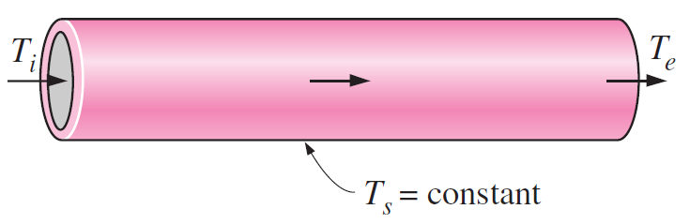
500 mm
63 mm
49 mm

Figure (1) shown the geometry of test section

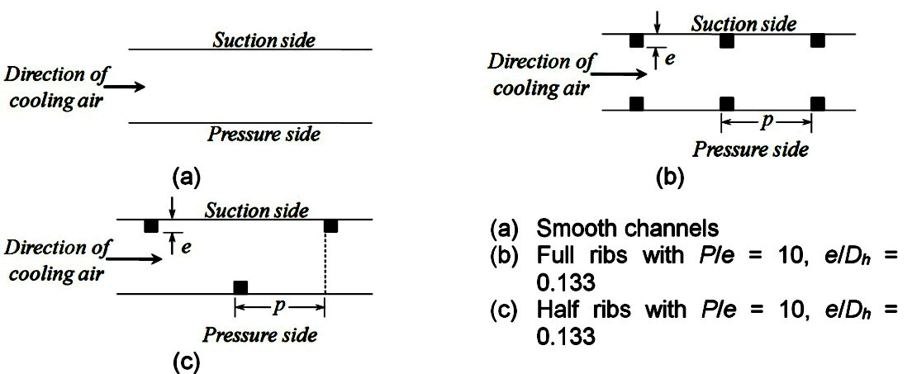
Figure (2) shown the geometry of ribs

Mesh Generation:
There are mainly two types of approaches in volume meshing, structured and unstructured meshing. FLUENT can use grids comprising of tetrahedron or hexahedron cells in three dimensions. The type of mesh selection depends on the application as shown in figure ( 3 ).

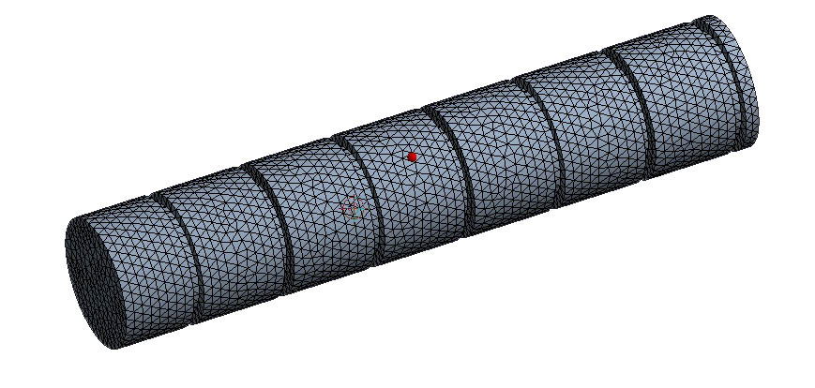

Figure (3) Mesh generation of test section
Experimental work
The rig consists of a blower unit fitted with a pipe, which is connected to the test section located in horizontal orientation. The blower we have used is an ordinary dust blower. It has a converging nozzle (400mm) long outlet which Air was made to flow though the test pipe by means of blower motor with velocity ( 10 m/sec ). A heat input of 1000 W was given to the nichrome heating wire on the test pipe by adjusting the dimmer stat. The test section was insulated in order to avoid the loss of heat energy to the surrounding. Thermocouples (2 to 4), (as shown in figure 13.A) were fixed on the test surface and thermocouples (1 and 5) were fixed inside the pipe ( inlet and outlet) respectively. The readings of the thermocouples were observed every (10 minutes ) until the steady state condition was achieved. Three thermocouples (T₂, T₃ and T₄ ) at a distance of (15 , 30 , and 45 cm ) from the origin of the heating zone are embedded on the walls of the pipe and two thermocouples are placed in the air stream, one at the entrance (T₁) and the other at the exit (T₅) of the test section to measure the temperature of flowing air as shown in Fig.(13). The blower consists a plate , which controls the airflow rate through the pipe and an orifice meter to find the volume flow rate of air through the system.
Results and Discussion
Case(1) at constant surface temperature 573K.
Fig.(4). shows the temperature distribution at center line and along the pipe for two cases, one without ribs and the other with ribs at surrounding temperature 573K.It shows that the temperature increased downstream for both cases due to heat transfer. It also shows that the pipe with ribs has highs air temperature . This means that the pipe with ribs ,hence with highs surface area resulted in highs heat transfer.

Temperature (Kº)

Distance (m)
Fig. (4) Temperature distribution

Case(2)at constant surface temperature 873K.
Fig.(5). the temperature distribution at center line along the pipe for two cases can be shows in figure (5), one without ribs and the other with ribs at surrounding temperature 873K.It shows that the temperature increased downstream for both cases due to heat transfer. It also shows that the pipe with ribs has highs air temperature . This means that the pipe with ribs ,hence with highs surface area resulted in highs heat transfer.
Temperature (Kº)

Distance (m)
Fig. (5) Temperature distribution
Case(3) at constant surface temperature 1173K.
Fig (6). shows the temperature distribution at center line and along the pipe for two cases, one without ribs and the other with ribs at surrounding temperature 1173K.It shows that the temperature increased downstream for both cases due to heat transfer. It also shows that the pipe with ribs has highs air temperature . This means that the pipe with ribs ,hence with highs surface area resulted in highs heat transfer.
Temperature (Kº)

Distance (m)
Fig. (6) Temperature distribution
Figures (7-9) show the temperature contour for inner cylinder and ribs, which the ribs as a source of heating here. The wake caused a source of hot region and on the other hand the fluid is heated as it is moved along the inner surface. The horse shoe vortices at this surface, formed a region appear clearly as a mountain shape in a wide range after the last half of the surface. The percentage area wetted by ribs here, causes more effective of ribs on the interaction with surface.

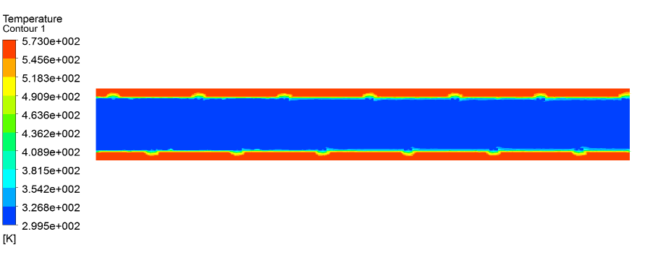
Fig.(7) Contour of temperature
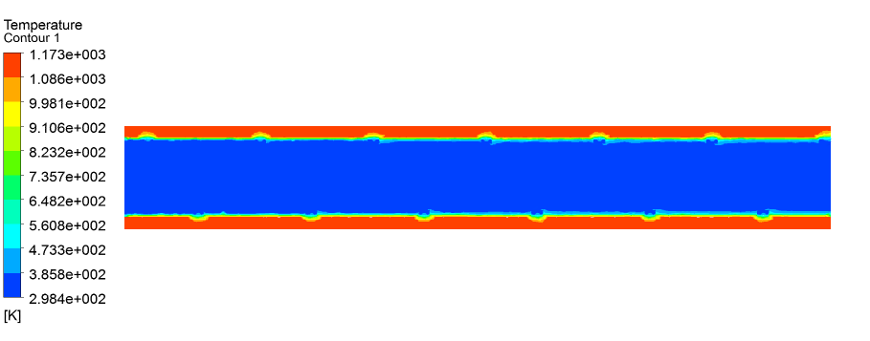
Fig. (8) Temperature distribution
Fig. (9) Temperature distribution

Velocity Distribution
For all cases as shown in figures( 10 to 12), the air velocity is seen to be the same in spite of using pipes with or without ribs over the same Reynolds number .

Velocity (m/s)
Distance ( m)
Fig. (10): Velocity distribution at constant surface temp.(573K)
Velocity (m/s)
Distance (m)
Fig. (11): Velocity distribution at constant surface temp.(873K)
Velocity (m/s)
Distance (m)
Fig. (12): Velocity distribution at constant surface temp.(1173K)

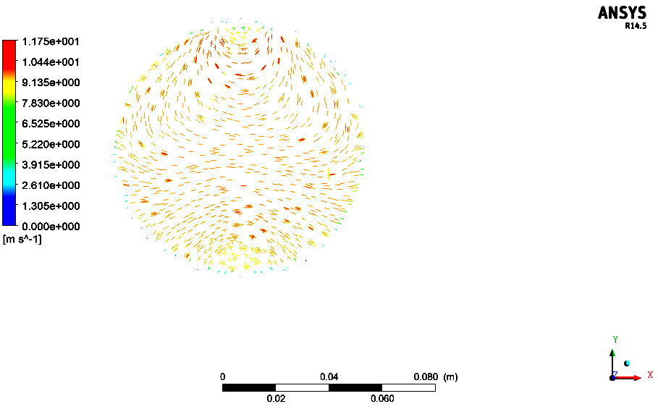
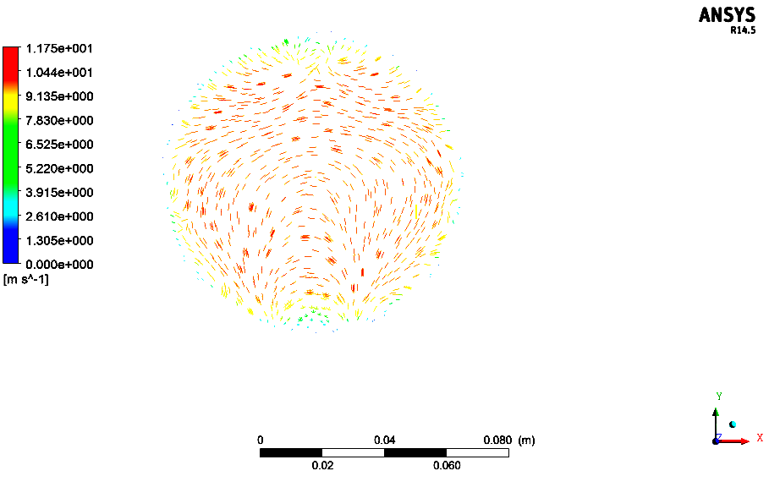
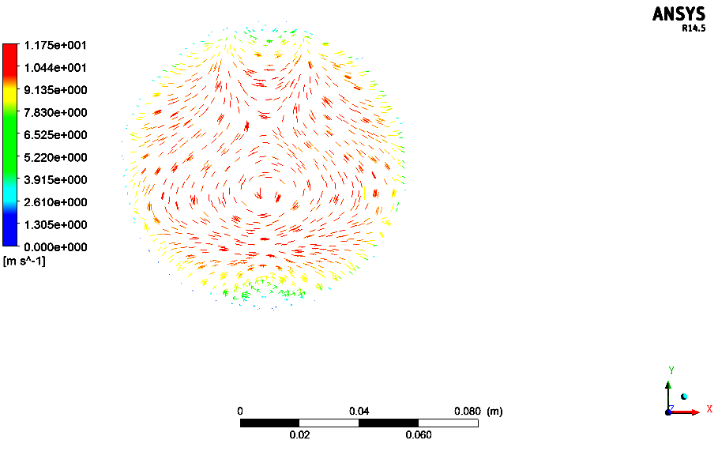
X/L=0.2 X/L=0.5 X/L=0.9

Fig. (13): Velocity vector
Fig.(14) shown the temperature distribution for both theoretical and experimental the result shows good a agreement between them by factor 4.4%.

Temperature (Kº)

Distance (cm)

Fig.(14) : Comparison theoretical and experimental
Conclusions
In the present work, a numerical and experimental study was performed, with the aim to assess the effect of using ribs on temperature distributions along a horizontal pipe . The main conclusions are:
1. The theoretical results for temperature distribution were compared with experimental and showed a good agreement by factor 4.4% as show in figure (14).
2.With out ribs the temperature was found to increase by 2.04,4.35and 7.35K for cases 1,2,and 3, respectively. While when ribs used , the effect was to increase the temperature by 4.36,9.23 , and 14.07 K for cases 1,2,and 3, respectively.
The heat transfer in the test section with ribs was found to increase by 2.13 ,3.6 and 5.87% , for cases 1,2,and 3, respectively. compared with out ribs. This could be due to the fact that the flow has a high recirculation zone between the ribs, as shown in figure (13).

A
1 Blower
2 Velocity Control
3 Nozzle
4 Test Section
5 Box With Constant Temperature
6 Outlet
T₁-T₅ Thermo Couple

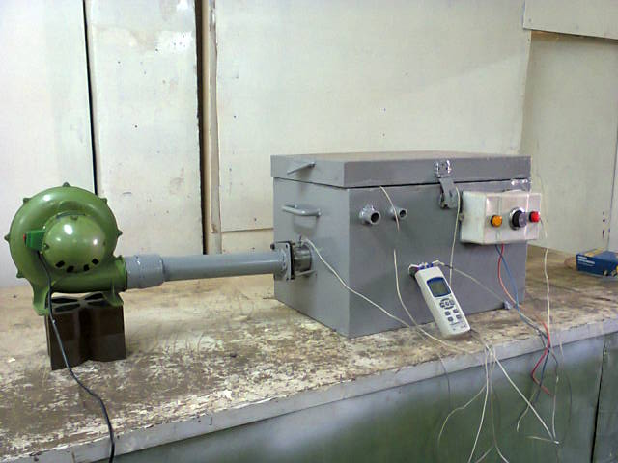

B
Fig. (13) (A) Schematic diagram of Experiment Setup.
(B)Actual diagram of Experiment Setup
References
Saidi, A.B. Sunden, 2000, Numerical simulation of turbulent convection heat transfer in square ribbed ducts, Numer. Heat Transf. A Appl. 38 (1) 67–88.
Han, J.C. Y.M. Zhang, C.P. Lee, 1991, Augmented heat transfer in square channels with parallel, crossed and V-shaped angled ribs, ASME J. Heat Transfer 113 590–596.
Han, J.C. Y.M. Zhang, C.P. Lee, 1992, Influence of surface heat flux ratio on heat transfer augmentation in square channels with parallel, crossed, and V-shaped angled ribs, ASME J. Turbo machinery 114 ,872–880.
Han, J.C. Y.M. Zhang, 1992, High performance heat transfer ducts with parallel broken and V-shaped broken ribs, Int. J. Heat Mass Transfer 35 ,513–523.
Tatsumi, K. H. Iwai, K. Inaoka, K. Suzuki, 2008, Numerical analysis for heat transfer characteristics of an oblique discrete rib mounted in a square duct, Numer. Heat Transf. A Appl. 53 (11) ,1156–1175.
Taslim, M.E. T. Li, D.M. Kercher, 1996, Experimental heat transfer and friction in channels roughened with angled, V-shaped, and discrete ribs on two opposite walls, ASME J. Turbomachinery 118 ,20–28.
Liou, T.M. J.J. Hwang, 1992,Turbulent heat transfers augmentation and friction in periodic fully developed channel flows, ASME J. Heat Transfer 114 ,56–64.
Liou, T.M. J.J. Hwang, 1993, Effect of ridge shapes on turbulent heat transfer and friction in a rectangular channel, Int. J. Heat Mass Transfer 36 ,931–940.

