Effect of Quenching Media, Heat Treatment and Alloying Elements on Properties of Al-Si-Mg Alloy
Abdulazeez O. Mousa Al-Uqaily Jassim M.Salman Al-Murshdy College of Sci.-Babylon University College of Materials Eng. -Babylon University azizliquid-2005@yahoo.com jmsmaterials@yahoo.com
Abdalla H. Mihdy Jassim College of Computer Sci. & Mathematics- Al-Qadisiya University abd-has85@yahoo.com
Abstract
Al-Si-Mg alloys have been widely used in automotive and aircraft industries for their good properties, high strength-to-weight ratio and good corrosion resistance. This study aims to preparing of Al-Si-Mg alloy and study the effect of quenching media (polymer solution and water) ,heat treatment and effect of addition alloying elements (B & Ti) on the properties of prepared Al-Si-Mg alloy such as microhardnes and studying the thermal age hardening behavior with artificial ageing time (2-10) hours at temperatures (150,175,200) .The results showed that the addition of 0.15% B with 1% Ti together to base alloy improve Vickers microhardness by (57%) at homogenization condition compared with the base alloy, also the results showed that improvement in thermal stability at ageing temperature 175 when quenching in polymer solution in comparison with the quenching in water. Mechanical properties of prepared alloys were measured by using ultrasonic wave technique, also the microstructure of prepared alloys were appeared by using optical microscopic.
Keywords: Al-Si-Mg Alloy, Mechanical Properties, Quenching, Heat Treatment, Ageing
الخلاصة
سبائك (ألمنيوم- سيلكون- مغنيسيوم) تستخدم بصورة واسعة في صناعة الطائرات والسيارات لامتلاكها خواص جيدة ، ومتانة عالية نسبة إلى وزنها ومقاومة تآكل جيدة. يهدف البحث الى تحضير السبيكة Al-Si-Mg ودراسة تاثير وسط الاخماد ( محلول البوليمر والماء) والمعاملة الحرارية و تأثير إضافة عناصر السبك (البورون والتيتانيوم) على خصائص السبيكة المحضرة مثل الصلادة الدقيقة ودراسة سلوك الاصلاد الحراري مع زمن التعتيق الاصطناعي ((10-2 ساعة عند درجات الحرارة (150,175,200). بينت النتائج ان أضافة 0.15% B مع 1% Ti معاً للسبيكة الأساس أدى إلى تحسن صلادة فكرز بنسبة (57%) عند ظرف المجانسة بالمقارنة مع السبيكة الأساس. وكذلك النتائج أظهرت تحسن في الاستقرارية الحرارية عند درجة حرارة تعتيق 175 عند الإخماد في محلول البوليمر مقارنة مع الإخماد في الماء.تم قياس الخصائص الميكانيكية للسبائك المحضرة باستخدام تقنية الموجات فوق الصوتية وكذلك تم إظهار البنية المجهرية للسبائك المحضرة باستخدام المجهر الضوئي.
الكلمات المفتاحية: AL-سي المغنيسيوم ألمنيوم، الخواص الميكانيكية، تسقيه، المعالجة الحرارية، شيخوخة
Introduction
For over fifty years, aluminum ranks at second to iron and steel in the metal market. The demand of aluminum grows rapidly because it is attributed to unique combination of properties which makes it become one of the most versatile of engineering and construction materials (Masoud,2012).Aluminum alloys have many desirable properties such as high fluidity, light weight, low melting points, high thermal conductivity and good surface finish these properties making aluminum alloys for using widely in casting, Aluminum alloys with silicon as a major alloying element constitute a class of material, which provides the most significant part of all shaped castings manufactured especially in the aerospace and automotive industries(Al-Khazraji,2011). In recent decades, aluminum alloys used in the automobile industry as car body panels to reduce weight and thus improve fuel economy and emissions (Abozeid and (Gaber,2012)..Addition of alloying elements such as magnesium and silicon to aluminum improve mechanical properties of aluminum and increase the aluminum response to heat treatment due to formation of Mg₂Si intermetallic compound, which improves the casting, corrosion resistance property as well as the strength of the alloy(Oladele and Omotoyinbo,2011). Al−Si−Mg alloys are widely used as medium-strength heat-treatable alloys for structural applications due to their excellent formability, weldability and good corrosion resistance. In Al −Si−Mg alloys, Mg and Si are added either in a balanced amount to form binary Al−Mg₂Si alloys or with excess amount of Si to form the Al−Mg₂Si quasi-binary composition, to enhance the kinetics of the precipitation process without changing the nature of precipitates (Li,2013). The heat treatment is one of the important methods for improving the mechanical properties of Al-Si-Mg alloys this heat treatment consists of solution heat treatment , quenching, and then either natural or artificial ageing (Moldovan,2007). Quenching is one of the crucial heat treatment processes for manufacture of the products with desired mechanical properties (Kakhki,2011). The quenching is the process of rapid cooling of materials to room temperature to preserve the solute in solution. The cooling rate needs to be fast enough to prevent solid – state diffusion and precipitation of the phase. The rapid quenching creates a saturated solution and allows for increased hardness and improved mechanical properties of the material (Abubakre,2009). Quenching may be performed by means such as total immersion in an aqueous polymer solution, liquefied gas, cold water, hot water, or boiling water, or by air blast or fog )ASTM Designation,2001). Also quenching is performed in oil (Deval,2013). Cold water used to be the dominant quenchant for heat treating aluminum alloys. However, in many cases, cold water quench produces unacceptable distortion due to high thermal gradients induced upon cooling )Shuhui, 2006). Aqueous solutions of polyalkylene glycol (PAG) are used to improve the cooling characteristics of the quenching medium and to reduce the machining requirements after the heat treatment. PAG concentrations vary from (4 to 30)%, depending on the type of product being processed. For the heat treatment of aluminum alloys, such polymeric solutions have been widely applied during more than 30 years (Al-Sultani,2012). Ultrasonic waves are propagated through the material and the waves are disrupted at the discontinuities in the material such as defects, voids, or cracks. The waves are scattered or partially reflected at these discontinuities and from this action, a measure of the discontinuity characteristics such as location, size, and shape are revealed. The ultrasonic method does not always reveal everything about the discontinuity to the degree desired but is still an invaluable tool (Kutz,2002). The aim of the present study was to studying the effect of quenching media (water and 35% PAG) and alloying elements boron (B) and titanium (Ti) on properties of prepared Al-Si-Mg alloy.
Experimental Work
Aluminum wires were cut into small pieces and melting in an electric furnace at temperature 750 after putting in Alumina crucibles, then addition of alloying elements in the required weight percentages where remain for (5-10) minutes after each element addition. During addition of alloying elements must be continuous mixing by using a graphite stirring rode to ensure a best mixing and dissolution of alloying elements and to avoid segregation defects. All alloying element are packing with Al-foils to avoidance of oxidization. Finally, the molten alloy is pouring in the steel mold and after solidification, the steel mold is opening to obtain the ingot rods. The above steps were repeated for the various aluminum alloys which used in this work. The chemical composition of prepared alloys as shown in Table (1). Alloy specimens were prepared and subjected to three different heat treatment conditions .The first treatment was subjected the specimens to homogenization treatment at temperature (430) for three hours ,the second treatment was subjected the specimens to solid solution treatment at three temperatures (500,525,550) for one hours in order to select one among these degrees which obtained good microhardness, then quenching rapidly in two different quenchant media (water and 35% PAG polymer type polyethylene glycol), and the finally treatment was subjected the specimens to artificial ageing at temperature (150,175,200) at different times.

Table (1) The chemical composition of prepared alloys.
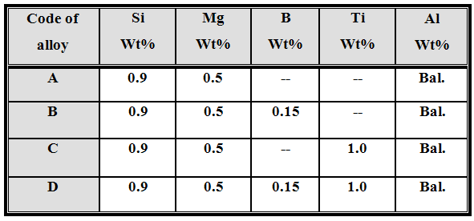

Tests and Measurements
Microhardness test
Microhardness test was measured of the specimens by using Vickers tester type (Microhardness tester Hv-1000) . For achieving of the hardness test was used load 100g for 10s. Microhardness of the specimens was measured after of the homogenization, solution treatment, and ageing. This test was carried out in the (Laboratory of Metallurgical /College of Materials Engineering /Babylon University).
Ultrasonic Wave Test
Ultrasonic wave technique was used to determined the mechanical properties of alloys by finding the speed of ultrasonic wave in the specimens by measuring time delay of ultrasonic wave in the specimen and thickness of this specimen by using equipment of measuring ultrasonic wave type (SVX-7 made in Korea). This test was carried out in the (Laboratory of Advanced Polymer/ Department of Physics/College of Science /Babylon University). The acoustic velocity (υ) in the material is the acoustic path length which is determined by timing the passage of ultrasound. The velocity of the ultrasound in a material depends on elastic constants and density of that material .The ultrasonic velocity in the sample is obtained by dividing the measured value of the acoustic path length (l) by the time of travel (t). The acoustic impedance (Z) is equal to the product of the density (and velocity (υ) of the sound of the material, the value of the acoustic impedance depends on its physical properties. Modulus of elasticity (E) is equal to the product of the density (and square of velocity of sound of the sample (Lochab and Singh,2004).The compressibility (C) is the reciprocal of the modulus of elasticity (Al-bermany,2013).
υ=l/t …...…………..…………....(1)
Z=υ …….…...…….....................(2)
E=υ ² ...........................................(3)
C =(υ ²)⁻¹ ..… …..….…………...(4)
The density of alloys can be calculated according to the equation:
$p=\frac{M}{V}=\frac{W}{\frac{{πd}^{2}}{4}l}$………………….…(5)
Where, $(p,M,V,d \text{and} l)$is the density ,mass , volume , diameter, and thickness of the samples respectively.
X-Ray Diffraction Test
The aim of doing the X-ray diffraction analysis was to identify the type of Al-alloy phases formed during casting and for measured grain size .
This test was performed through scanning the specimen continuously within Bragg angle (2θ) range (30º-70º) using Cu target (λ=0.154 nm) at voltage of 40 kV and 30 mA of current with continuous scan mode by general electric diffraction type(XRD-6000).
X-ray diffraction test was carried out in the (Ministry of Sciences and Technology/ Research Office of Materials).
Optical Microscopic Testing
Optical microscopy was used to provide information about the microstructure of alloy samples. Microstructure of alloys were appeared after each heat treatment with magnification (400X) by using ( SIMRAN optical microscope made in USA).Before doing this test, the specimen surface was etched to Keller’s reagen solution which consists of 95% O, 2.5% , 1.5% HCl and 1%HF.This test was carried out in the (Laboratory of Metallurgical /College of Materials Engineering /Babylon University).
Results and Discussion
Microhardness Results at Homogenization
The microhardness measurement for alloys (A, B ,C ,and D) after process of homogenized for three hours at 430 and slow cooled to room temperature as follows shown in Table (2).
Table (2) Microhardness of the alloys as homogenized
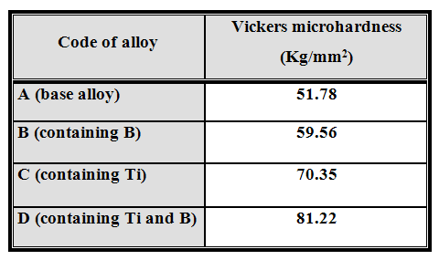
Table (2) shows the microhardness of alloys (A, B ,C ,and D).The microhardness increased with the alloys (B, C,D) because the alloying elements (B and Ti) accelerated and refined the precipitates which form previously in base alloy (A alloy) such as (Mg₂Si and Al₃Mg₂) and production a new precipitates such as AlB₂,Al₃Ti,TiB, and TiB₂.From Table (2), (D alloy) appears increase in hardness by (57%) corresponding to the base alloy because it contains elements such as (B and Ti) and these elements work to produce fine grains.
Microhardness Results at Solid Solution Treatment
The microhardness measured for alloys(A, B,C, and D) after solid solution treated for one hour at three solid solution temperatures (500, 525 and 550) for choosing the best solid solution temperature which corresponding to the maximum microhardness and used two different quench mediums ,firstly distil water and secondly 35% PAG. The relationship between Vickers microhardness and solid solution temperatures for two different quench mediums appears in Figure(1). From this figure it could be concluded that the better solid solution temperature was 525, since it gives high solubility for elements within solid solution (α-Al). 500 not give full solubility for elements within solid solution (α-Al). 550 give full solubility for elements with in solid solution (α-Al) but produce grain growth for (α-Al) (Tan and Ögel,2007), and the average size of the remand precipitated particles increases with temperature, and the total number of particles in the system decreases because larger particles tend to grow at the expense of the smaller ones, which shrink disappear and it is causes the decrease in microhardness.Furthermore, the difference in quench media affected on microhardness when water quenching gives higher microhardness values because water faster loses the temperature in comparison with a polymer solution. Water does not permit elements to diffuse from solid solution (α-Al) and precipitate on grain boundary.
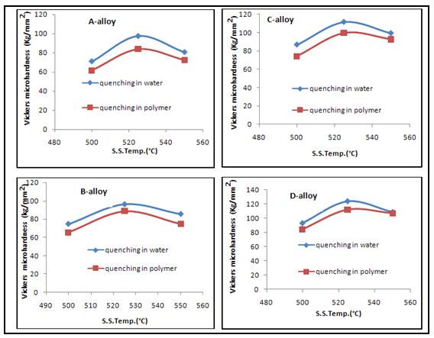
Fig. (1) Variation of microhardness of (A,B,C,and D) alloys (quenching in a: water medium, b: 35% PAG medium ) with solid solution temperatures.
Microhardness Results at Ageing Temperature 150
The relationship between Vickers microhardness and exposure time at ageing temperature 150appears in Figure (2).
From Figure (2) it is notice that increment in microhardness of (A alloy) with ageing time for both water and polymer quenching and reaches the highest peak at the 8 hours of ageing time then dropped at the10 hours of ageing time. It is concluded that (A alloy) (quenched in water) have maximum value of microhardness at ageing time 8 hrours which was 99.67 kg/mm² , and the same alloy quenched in 35% PAG have maximum value of microhardness at ageing time 8 hours also was 89.01kg/mm² because the medium of water was faster in accelerate quenching than PAG. Therefore, grain size (α-Al) in (A alloy)(quenched in water) become very fine grain. From Figure (2) it can be seen that microhardness of (B alloy) reaches the highest peak at the 6 hours of ageing time then dropped at the (8-10) hours of ageing time for both water and polymer quenching.It was concluded that (B alloy)( quenched in water and 35% PAG) caused an increase in thermal age hardening behavior by (12% and 14 %) respectively than (A alloy)(quenching in water and 35% PAG ) because the element of boron in (B alloy) done really fine grain of matrix and precipitate causes increments in a thermal age hardening.
From Figure (2) it can be seen that microhardness of (C alloy) slightly increase with ageing time from (100.39 to 119.92) kg/mm² for water quench and from (93.61 to 110) kg/mm² for polymer quench within the first 6 hours of ageing at a temperature of 150, then microhardness decreases to 97.51 kg/mm² for water quench and 90.31 kg/mm² for polymer quench after 4 hours of ageing as shown in microhardness curve, and this curve appears the (C alloy) quenched in water have maximum values of microhardness than when quenched in 35% PAG because the medium of water is accelerate quenching than PAG. Therefore, grain size (α-Al) in (C alloy)( quenched in water) became very fine grain, and caused high microhardness. From Figure (2) it is concluded that (C alloy)( quenched in water and 35% PAG) caused an increase in microhardness value by (23%,25%) respectively than (A alloy)(quenching in water and 35% PAG ) because the elements of titanium in (C alloy) have high thermal stability.
Figure (2) shows slightly increase in microhardness of (D alloy) with ageing time until reaches maximum peak at 6 hours of ageing time ,then dropped at (8-10) hours of ageing time for both water and polymer quench. From Figure (2), it is concluded that (D alloy) ( quenched in water and 35% PAG) caused an increase in thermal age hardening behavior by (28% and 31 %) respectively than (A alloy)(quenching in water and 35% PAG ) because the elements of boron and titanium in (D alloy) done really fine grain of matrix and precipitate causes increments in a thermal age hardening.
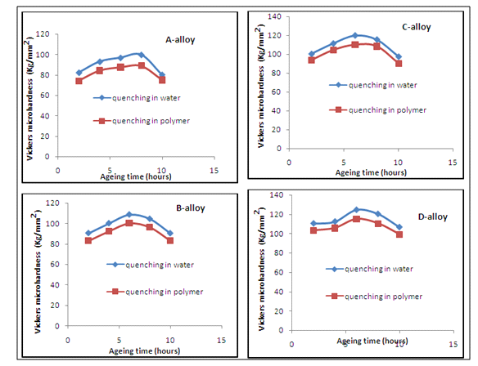
Fig.(2) Variation of microhardness of (A,B,C,and D) alloys (quenching in a: water medium, b: 35% PAG medium ) with ageing time at 150ageing temperature.
Microhardness Results at Ageing Temperature 175
The relationship between Vickers microhardness and exposure time at ageing temperature (175) appears in Figure (3).From this figure, it is notice that microhardness of (A alloy) dropped until (87.03, 78.26) Kg/mm² for water and 35% PAG respectively at 2 hours of ageing time. Extended ageing time notice that microhardness increases and reaches highest peak value of (105.88 , 96.25) Kg/mm² for water and 35% PAG respectively at 6 hours of ageing time, then slightly decreases until reaches to (98.16 , 89.43) Kg/mm² for water and 35% PAG respectively at 10 hours of ageing time. It is concluded that thermal age hardening behavior at 175ageing temperature is the best in comparison with the same alloy which aged at ageing temperature 150[Figure (2)] because the microhardness curve at ageing temperature 175after highest peak it is appeared approximately more linear than this curve at ageing temperature 150 . That is means the little change in microhardness with ageing time at temperature 175 indicate to the best thermal age hardening behavior at this temperature especially when quench in polymer.
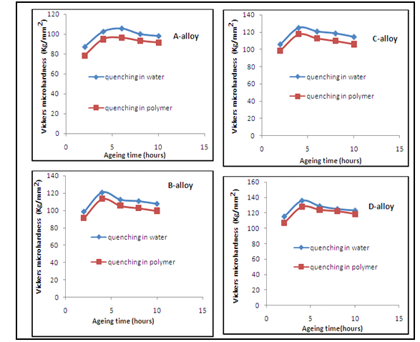
Fig.(3) Variation of microhardness of (A,B,C,and D) alloys (quenching in a: water medium, b: 35% PAG medium ) with ageing time at 175ageing temperature.

Figure (3) shows that the highest peak of microhardness of (B alloy) at 4 hours of ageing time then microhardness decreases slightly at (6-10) hours of ageing time for both water and 35% PAG.It is concluded that (B alloy) (quenched in water and 35% PAG) caused an increase in thermal age hardening behavior by (17% and 19%) respectively than (A alloy)(quenching in water and 35% PAG ) because the elements of boron in (B alloy) done really fine grain.
From Figure (3) it is notice that microhardness of (C-alloy) increases slightly with increase of ageing time and reaches to highest peak at 4 hours of ageing time and it is concluded that (C alloy)( quenched in water and 35% PAG) caused an increase in thermal age hardening behavior by (21% and 23 %) respectively than (A alloy)(quenching in water and 35% PAG ) because the elements of titanium in (C alloy) have high thermal stability.
Figure (3) shows that microhardness of (D alloy) increased slightly with increasing of ageing time until reaches to the highest peak at 4 hours then decreased slightly at (6-10)hours for both water and 35%PAG quenched, and it is concluded that (D alloy) (quenched in water and 35% PAG) caused an increase in thermal age hardening behavior by (32% and 35% ) respectively than (A alloy)(quenching in water and 35% PAG ) because the elements of boron and titanium ( in D alloy) done really fine grain. By comparison with Figure (2) it is concluded that thermal age hardening behavior of (D alloy) at 175 ageing temperature is the best than the same alloy which aged at ageing temperature 150 because the microhardness values at 175appeared lowest varies with ageing time than values at 150
Microhardness Results at Ageing Temperature 200
The relationship between Vickers microhardness and exposure time at ageing temperature (200) appears in Figure (4).This figure presents the variation of microhardness as function of the ageing time at 200. It can be seen the highest peak of microhardness of (A alloy) at 4 hours of ageing time for both water and 35%PAG quenched then decreases gradually with an increase of the ageing time from (6-10) hours because the ageing process had reached the over aged region and the precipitate particles continued coalesce as ageing progress caused the particle size to increase and thus decreased the degree of complication for the dislocations to break the magnesium-silicon bonds when they pass through the precipitates.
From Figure (4) it can be seen the maximum microhardness of (B alloy) at the 2 hours of ageing time for both water and 35%PAG quenched then decreases gradually with an increase of the ageing time at the (4-10) hours and reduces the ageing time required to reach microhardness the highest peak. It is concluded that (B alloy) (quenched in water and 35% PAG) caused an increase in thermal age hardening behavior by (10% and 15 %) respectively than (A alloy)(quenching in water and 35% PAG ) for it is contains the elements of boron.
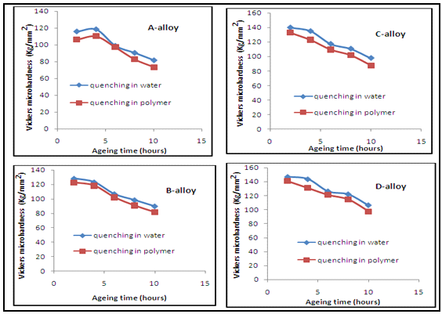
Fig.(4) Variation of microhardness of (A,B,C,and D) alloys (quenching in a: water medium, b: 35% PAG medium ) with ageing time at 200ageing temperature.
Figure (4) shows that the highest peak of microhardness of (C alloy) at the 2 hours of ageing time then decreases gradually with an increase of the ageing time at the(4-10) hours and it can be seen that reducing the ageing time at 200required to reach the highest peak in comparison with the same alloy (C alloy) at (150 and 175). By comparison with (A alloy) it is concluded that (C alloy)( quenched in water and 35% PAG) caused an increase in thermal age hardening behavior by (20% and 24 %) respectively than (A alloy)(quenching in water and 35% PAG ) for it is contains the elements of titanium.
Figure (4) shows that the highest peak of micohardness of (D alloy) at the 2 hours of ageing time for both water and 35%PAG, then decreases gradually with an increase of the ageing time at the (4-10) hours and it can be seen that reducing the ageing time at 200 required to reach the highest peak in comparison with the same alloy (D alloy) at (150 and 175) . By comparison with (A alloy) it is concluded that (D alloy) (quenched in water and 35% PAG) caused an increase in thermal age hardening behavior by (27% and 32%) respectively than (A alloy)(quenching in water and 35% PAG) for it is contains the elements of boron and titanium.
From all ageing temperature it can be seen that the increasing ageing temperature yielded to reduced the ageing time which required to reach the highest peak of microhardness.
Ultrasonic Results
The velocity of sound in a material depends on the elastic constant and density of those material. Thus, direct measurements of velocity determine the elastic constant provided that the density can be evaluated by another method, example by measuring volume and weighing. Both the elastic constant and the density vary with the temperature, concentration, structure and nature of alloy. The measurement of velocity may yield information about one of these quantities provided that the others remain constant or can be measured independently. Ultrasonic velocity in alloys was measured by dividing the path length (thickness of the sample) by the delay time [equation (1)].Acoustic impedance, elastic modulus, and compressibility were measured by using equations[(2),(3), and (4)] respectively. Table(3) shows the ultrasonic results for prepared alloys at homogenization state . From Table(3) it can be seen the highest value of ultrasonic speed in (D alloy) which contains the elements of (B and Ti) and ultrasonic speed in (C alloy) contains the element of (Ti) is higher than in (B alloy) contains the element of (B), these variation in ultrasonic in alloys resulted from the effective of the microhardness and density of alloys, where the ultrasonic speed increased with the increase of the microhardness and density of the medium and the highest microhardness resulted from the uniformly homogeneity of the distribution and diffusion of the alloying elements in the aluminum matrix so that ultrasonic wave propagated and traveled with faster in alloy that have highest microhardness. The variations in acoustic impedance, elastic modulus, and compressibility of prepared alloys are resulted from the variations in ultrasonic speed and density of these alloys. The density of prepared alloys were calculated by using the equation (5).

Table(3) Ultrasonic results of prepared alloys.
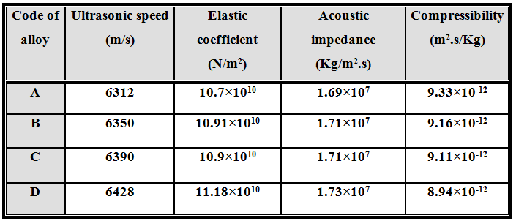
X-Ray Diffraction Analysis
The aim of doing the X-ray diffraction analysis was to determine the crystal structure and the phases appearance in prepared alloys .In this test ,type of the crystal structure was determined by using computer programmer "International Center for Diffraction Data (ICDD 1997)", and it is found that (A alloy) consists of Cubic and Tetragonal structure. B alloy consists of Cubic, Hexagonal ,and Tetragonal structure . Figures(5) and (6) show X-ray diffraction patterns of (A and B alloys), which shows a set of phases that are developed during the ageing process of the alloys. These phases are mainly consist of (Al₂Mg) and (AlB₂) phases for (D alloy) which around the major phase α-Al, while (A alloy) consists of (Al₂Mg) phase in which around the major phase α-Al.
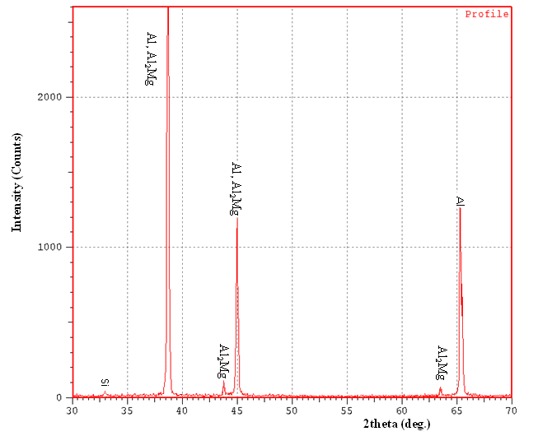
Fig. (5) XRD Pattern of (A alloy) at the as-aged state.
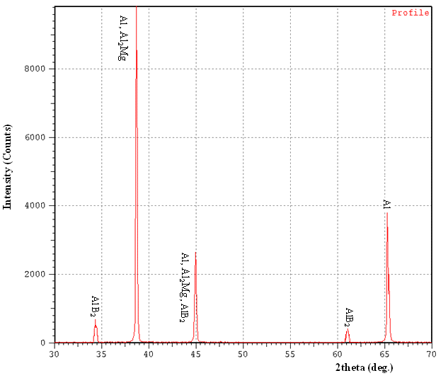
Fig. (5) XRD Pattern of (B alloy) at the as-aged state.
Optical Microscopic Results
The microstructure of alloys as homogenization that used in this study is shown in Figure (6), and it is noted that most of the grains in this condition which appear much equiaxed structure and observed precipitates present on the grain boundaries to alloys. Figure (7) shows microstructure of alloys when quenching in two different media ( water and 35% PAG) from solid solution temperature and this figure shows that the alloys quenched in water have been high supersaturated solid solution this because of the high cooling rate, the alloy which quenched in polymer allows for it to go out small amount of solute atoms to precipitate on grain boundary due to lower cooling rate.
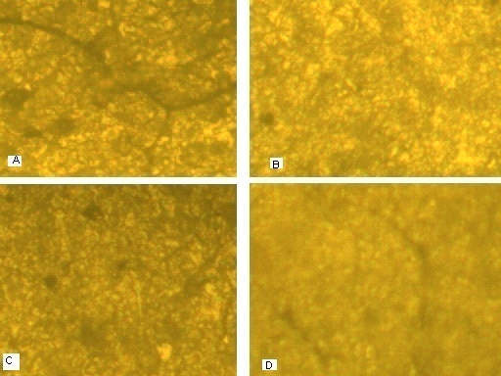
Fig. (6) Microstructure of (A, B,C and D) alloys as homogenization treatment, X 400
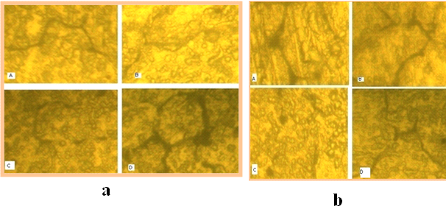
Fig.(7) Microstructure of (A, B,C and D) alloys as solution heat treatment (quenching in a: water medium, b: 35% PAG medium ), X 400
Conclusions
The conclusions of this work can be summarized as follows:
- The better solid solution temperature was 525 which gives high solubility for elements within solid solution(α-Al).
- The addition of 0.15% B with 1% Ti together to the base alloy improves Vickers microhardness by (57%) at homogenization state compared with the base alloy.
- The addition of 0.15% B with 1% Ti together to the base alloy improves thermal age hardening behavior by (32%) when quenched in water, and by (35%) when quenched in 35%PAG at 175 in comparison with the base alloy.
- Addition of boron and titanium together to the base alloy makes ultrasonic wave travels faster.
References
Abozeid E.F. and Gaber A.,2012" Mechanical Properties and Precipitation Behavior as a Function of Heat Treatment of Al–4.4Cu–1.5Mg-0.6Mn-0.25Si (WT %) Alloy, International Journal of Metallurgical and Materials,Vol.2,No.4,pp.11-2.
Al-bermany A. J., Kadem B. Y. and Kadouri L. T. H.,2013," Preparation and Study the Mechanical Properties of CMC/PVA Composites by Sound Waves", Advances in Physics Theories and Applications,Vol.15,pp.11-20.
Abubakre O. K., Mamaki U. P. and Muriana R. A,2009, "Investigation of the Quenching Properties of Selected Media on 6061 Aluminum Alloy" , Journal of Minerals and Materials Characterization and Engineering, Vol. 8, No.4, pp. 303-315.
Al-Khazraji K. K., Hanna W. A. and Muhammed O.S.,2011," Study the Effect of Polymeric Quenching on Wear Resistance of Eutectic Modified Aluminium - Silicon Alloy", Journal of Minerals and Materials Characterization and Engineering, Vol. 10, No.10,PP.941-958.
Al-Sultani K. F., Faris M.S. and Abd Alsada S. A.,2011," Effect of Quenching by30% Polyethylene Glycol on Properties of Al-4.3%Cu-0.7%Fe-0.6%Mg Alloy",Al-Qadisiya Journal For Engineering Sciences, Vol. 4, No. 4, pp.475-482.
ASTM Designation: B 918 – 01,2001,"Standard Practice for Heat Treatment of Wrought Aluminum Alloys", Copyright © ASTM International, West Conshohocken, PA 19428-2959, United States.
Deval P.K. ,2013," New Generation Polymer Quenchant for Heavy Forgings", On the Web: www.hawcoindia.com/image/pdf/Article2.pdf.
Kakhki M., Golozar M.A. and Kermanpur A.,2011," Application of Polymeric Quenchant in Heat Treatment of Crack-Sensitive Steel Mechanical Parts: Modeling and Experiments", Materials and Design 32 ,pp. 2870–2877.
Kutz M.,2002 ," Handbook of Materials Selection",Copyright by J. Wiley and Sons, Inc., New York.
Li S.,Huang Z.,Chen W.,Liu Z. and Qi W.,2013,"Quench Sensitivity of 6351 Aluminum Alloy", Transactions of Nonferrous Metals Society of China 23 , pp. 46−52.
Lochab J. and Singh V.R.,2004,"Acoustic Behaviour of Plastics for Medical Applications" , Indian Journal of Pure and Applied Physics, Vol.42,PP.595-599.
Masoud I.M., Abu Mansour T. and Al- Jarrah J.A.,2012," Effect of Heat Treatment on the Microstructure and Hardening Properties of (6061)Aluminum Alloy", Journal of Applied Sciences Research, Vol.8,No.10,pp.5106-511.
Moldovan P., Popescu G. and Butu M.,2007,"Heat Treatment of Al-7Si-0.3Mg Alloy Previously Inoculated With a New Type of Quaternary Master Alloy", U.P.B. Sci. Bull., Series B, Vol. 69, No. 2,pp.91-98.
Oladele I.O. and Omotoyinbo J.A.,2011,"Evaluating the Influence of Ageing Temperature on the Mechanical Properties of Al-Mg-Si Alloy",Journal of Minerals and Materials Characterization and Engineering, Vol. 10, No.14,pp.1285-1292 .
Shuhui M. ,2006," A Methodology to Predict the Effects of Quench Rates on Mechanical Properties of Cast Aluminum Alloys", Ph. D. Thesis, Worcester Polytechnic Institute, Materials Science and Engineering, Worcester, Massachuestts, USA.
Tan E. and Ögel B.,2007, "Influence of Heat Treatment on the Mechanical Properties of AA6066 Alloy" Turkish J. Eng. Env. Sci., ©TÜBÌTAK, pp.53 – 60.

