Design and simulation of 4th order active band- pass filter using multiple feed back and Sallen-key topologies

Abdul Hussein Adul Zehra Abd

Technical Institute –Babylon
zsaad5134@Gmail.com

Abstract:
In this paper, an active fourth order band pass analog filter is designed and simulated. The filter is designed such that it has butter worth response. The topologies that will be used to implement the filter are the multiple feed back (MFB) and Sallen-Key in order to compare between them to decide the best one. The filter is designed for radio frequency identification (RFID) system reader to reject all signals outside the band (10-20) kHz and to amplify the low antenna signal. This is because the identification number signals which are transmitted from the tag of RFID are (12.5 kHz) and (15.65 kHz).So the pass band of the filter is taken to be (10-20) kHz. The values of the resisters and capacitors of the filter circuit using the Sallen-Key and MFB topologies are calculated and the circuits are then simulated with the MULTISIM program to reach the final conclusion which describes the result of simulation compared to the simulation of the transfer function of the filter using MUTLAB program.

Keywords: Band-pass filter, Butterworth response, MFB, Sallen-Key, MATLAB, RFID.

الخلاصة:
في هدا البحث, تم تصميم وتمثيل مرشح إمرار حزمة فعال من الدرجة الرابعة. صمم المرشح بحيث يكون منحني الاستجابة الترددية له من النوع بترورث. استخدمت لتنفيذ دائرة المرشح آليتان هما آلية التغذية العكسية المتعددة والية مفتاح سالن من اجل المقارنة بينهما لتحديد الأفضل منهما.صمم المرشح للعمل ضمن دائرة قارئ نظام التميز الذي يعمل بالترددات الراديوية لرفض جميع الترددات الواقعة خارج النطاق (10-20) كيلو هرتز ولتكبير إشارة الهوائي الضعيفة . وذلك لان إشارات تمييز الأجسام المرسلة من دائرة بطاقة المعلومات(tag ( تكون ذات ترددات هي (12.5) كيلو هرتز و (15.65) كيلو هرتز ولهذا تم جعل نطاق المرور للمرشح يكون(10-20) كيلو هرتز.إن قيم المقاومات والمتسعات التي تتكون منها دائرة المرشح باستخدام آلية التغذية العكسية المتعددة وكذلك في حالة استخدام آلية مفتاح سالن تم حسابها وتم تمثيل دائرة المرشح في كلا الحالتين باستخدام برنامج الورشة الالكترونية( MULTISM ) للوصول للخاتمة النهائية التي تصف نتائج التمثيل بالمقارنة مع تمثيل دالة التحويل للمرشح باستخدام برنامج ( MATLAB ).
الكلمات الدالة : مرشح إمرار حزمة,استجابة نوع بترورث,التغذية الراجعة المتعددة, ماتلاب,نظام التميز الراديوي.

1. INTRODUCTION.
Radio Frequency Identification (RFID) is an enabling technology for remotely identifying, monitoring, and tracking various objects of interest using radio wave transmissions. The automatic identification of objects is possible by wireless communications between a tag (attached to an object) and its reader (interrogator) at distant location [Jari, Norbert, 2005].
A typical RFID system is comprised of the following components [Faranak, Farid, 2011], [Mandeep, Manjeet, 2011]:
• One or more tags or transponders with unique identification codes and a small antenna embedded within each tag.
• A reader, or interrogator, with one or more antennas that are connected to a host computer through various kinds of interfaces.
• Application software on a host computer.

A tag has an identification number (ID) and a reader recognizes an object through consecutive communications with the tag attached to it. The reader sends out a signal which supplies power and instructions to a tag. The tag transmits its ID to the reader and the reader consults an external data base with received ID to recognize the object [Ron Weinstein, 2005].
An active band-pass filter is used for the RFID system reader to reject all signals outside the (10-20) kHz signals and to amplify the low antenna signal. These are because the ID signals from the tag are (12.5 kHz) and (15.65 kHz) and signal power is very low. [Parvathy, Venkata, 2011].
In this paper, RFID system is considered with 125 kHz, FSK modulation scheme. In low frequency RFID system, analog active filters are used because of the following advantages [Sridevi.V, 2001], [Löwenborg, 1999]:

•The maximum gain or the maximum value of the transfer function may be greater than unity.
•The loading effect is minimal, which means that the output response of the active filter is essentially independent of the load driven by the filter.
• Active filters can be smaller, lighter, and more accurate than passive filters which can be large and heavy at low (audio and below) frequencies if inductors are required.
• Higher order filters can easily be cascaded since each op-amp can be second order.

The simplest design of a band-pass filter is the connection of a high-pass filter and a low pass filter in series, which is commonly done in wide-band filter applications. Thus, a first order high-pass and a first-order low-pass provide a second-order band-pass, while a second-order high-pass and a second-order low-pass result in a fourth-order band-pass response. In comparison to wide-band filters, narrow-band filters of higher order consist of cascaded second-order band-pass filters that use the Sallen-Key or the Multiple Feedback (MFB) topology [Ron, 2003].
The most common filter responses are the Butterworth, Tschebyscheff, and Bessel types. Among these responses, Butterworth type is used to get a maximally-flat response. Also, it exhibits a nearly flat pass band with no ripple. The roll-off is smooth and monotonic, with a low-pass or high pass roll off 20dB/dec for every pole. Thus, a fourth order Butterworth band-pass filter would have an attenuation rate of 40 dB/dec and -40dB/dec. [Miss Zin, 2009].
In the second section of this paper, the band-pass filter design specifications will be determined. In the third section, the implementation of 4th order Butterworth band-pass filter design will be carried out in order to meet the design specifications. The fourth and final part of this paper, the comparison of the MULTISIM simulation result and MATLAB simulation result will be discussed.

2. DESIGN CONSIDERATION.
There are two architectures that have been used to implement the fourth order band-pass filters. They are Multiple Feedback (MFB) and Sallen-Key topologies. The MFB band-pass allows adjusting the quality factor (Q), the gain at the mid frequency (A_{m}), and the mid frequency (f_{m}) independently. The MFB shows less overall sensitivity to component variations and has superior high-frequency performance [Ron, 2003]. A circuit diagram for second order Multiple Feedback (MFB) band-pass filter is shown in Fig. (1).
The Sallen-Key circuit has the advantage that the quality factor (Q) can be varied via the inner gain (G) without modifying the mid frequency (f_{m}). A drawback is, however, that (Q) and the gain (A_{m}) at the mid frequency (f_{m}) cannot be adjusted independently [Ron, 2003]. A circuit diagram for second order Sallen-Key band-pass filter is shown in Fig. (2).
The two topologies are used to implement the filter in order to compare between them and decide which of them have the best performance.
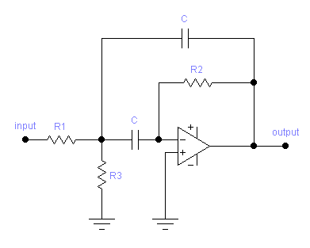
Fig.1. Schematic diagram of 2nd order MFB active Band-pass filter circuit

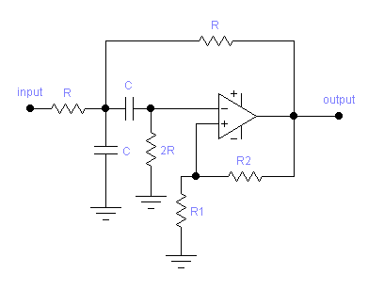
Fig.2. Schematic diagram of 2nd order Sallen-Key active Band-pass filter circuit

Butterworth filter response is used to get the maximum flat gain. The active -RC Butterworth filters have a range of advantages when used for lower order of the filter: have excellent linearity, have low power dissipation and are easy to design and analyze. The filter response is insensitive to parasitic, and it has large Dynamic range [Miss Zin, 2009].
Table (1) illustrates the specifications for the desired band pass filter. By using the following filter parameters, the required filter can be designed and simulated with MULTISIM and MATLAB.
Table (1) Band-pass Filter Specifications
Type of the filter | V p-p | Pass band Ripple | Stop band Attenuation | Center frequency | upper pass band frequency | Lower pass band frequency | Band width
active -RC Butterworth | 100μV | 0.1dB | 60dB | 15 kHz | 20 kHz | 10 kHz | 10 kHz

3. DESIGN IMPLEMENTATION.
The design implementation of the filter requires the following steps:
(First); Second-Order Band-Pass Filter Design.
The general transfers function for a second-order band-pass filter is [Ron,2003]:
$A(s)=\frac{A_{m}\text{.}ΔΩ\text{.}S}{1+ΔΩ\text{.}S+S^{2}}$
Eq. (1)
Where;
(ΔΩ) is defined as the normalized bandwidth of the filter.
(Am) is the gain at the mid frequency (fm).
When designing band-pass filters, the parameters of interest are the gain at the mid frequency (Am) and the quality factor (Q), which represents the selectivity of a band-pass filter. The quality factor (Q) is defined as the ratio of the mid frequency (fm) to the bandwidth (B) of the second order filter
$Q=\frac{f_{m}}{B}=\frac{1}{ΔΩ}$

Eq. (2)

Therefore, replace (ΔΩ) with (1/Q) (Equation 2) in equation (1); Thus yields:
$A(s)=\frac{\frac{A_{m}}{Q}\text{.}s}{1+\frac{1}{Q}\text{.}s+s^{2}}$

Eq. (3)

The MFB band-pass circuit in Figure (1) has the following transfer function [Ron,2003]:
$A(s)=\frac{\frac{R_{2}R_{3}}{(R_{1}+R_{3})}\text{.}C\text{.}ω_{m}\text{.}s}{1+\left[\left\{\frac{2R_{1}R_{3}}{(R_{1}+R_{3})}\text{.}C\text{.}ω_{m}\right\}s\right]+\left[\left\{\frac{R_{1}R_{2}R_{3}}{(R_{1}+R_{3})}\text{.}C^{2}\text{.}ω_{m^{2}}\right\}\text{.}s^{2}\right]}$

Eq. (4)

Where ;( ω_{m}) is the angular mid-frequency of the filter
The coefficient comparison of Equation (4) with Equation (3) yields the following equations:

Mid-frequency of the filter (fm) is:
$f_{m}=(\frac{1}{2\text{.}π\text{.}C})\sqrt{\left\{\frac{(R_{1}+R_{3})}{(R_{1}R_{2}R_{3})}\right\}}$
Eq. (5)

The gain (Am) of the filter at the mid-frequency (fm) is:
$−A_{m}=\frac{R_{2}}{2R_{1}}$
Eq. (6)

The quality factor (Q) of the filter is:
$Q=π\text{.}f_{m}\text{.}R_{2}\text{.}c$
Eq. (7)
Solve the previous equations ;( 5), (6) and (7) for (R₁), (R₂) and (R₃) thus yields the following:

$R_{2}=\frac{Q}{π\text{.}f_{m},C}$
Eq. (8)

$R_{1}=\frac{R_{2}}{−2A_{m}}$
Eq. (9)

$R_{3}=\frac{(−A_{m}\text{.}R_{1})}{(2Q^{2}+A_{m})}$ Eq. (10)

The Sallen-Key band-pass circuit in Figure (2) has the following transfer function [Ron, 2003]:
$A(s)=\frac{\text{GRC}\text{.}ω_{m}\text{.}s}{1+\left[\text{RC}ω_{m}(3−G)s\right]+(R^{2}C^{2}ω_{m}^{2}s^{2})}$
Eq. (11)

Where;
(G) is defined as the inner gain of the filter given by:
$G=1+\frac{R_{2}}{R_{1}}\text{.}$
Eq. (12)

The coefficient comparison of Equation (11) with Equation (3) yields the following equations:
The gain (A_{m}) of the filter at the mid-frequency (f_{m}) is:
$A_{m}=\frac{G}{3−G}$ Eq. (13)

The mid-frequency (f_{m}) of the filter is:
$f_{m}=\frac{1}{2π\text{RC}}$ Eq. (14)
(Second); Fourth-Order Band-Pass Filter Design:
The general transfers function of a fourth-order band-pass filer [Ron,2003]:
$A(s)=\frac{\frac{A_{m}(ΔΩ)^{2}}{b_{1}}\text{.}s^{2}}{1+\left[\left(\frac{a_{1}}{b_{1}}\text{.}ΔΩ\right)\text{.}s\right]+\left[\left\{2+\frac{(ΔΩ)^{2}}{b_{1}}\right\}s^{2}\right]+\left[\frac{a_{1}}{b_{1}}\text{.}ΔΩ\text{.}s^{3}\right]+s^{4}}$

Eq. (15)

Where; the filter coefficients (a₁) and (b₁) distinguish between Butterworth, Tschebyscheff, and Bessel filters.
The fourth-order transfer function above is split into two second-order band-pass terms. Further mathematical modifications yield [Miss Zin, 2009]:
$A(s)=\frac{(\frac{A_{\text{mi}}}{Q_{i}}\text{.}α\text{.}s)}{\left[1+\frac{α\text{.}s}{Q_{i}}+(α\text{.}s)^{2}\right]}\text{.}\frac{(\frac{A_{\text{mi}}}{Q_{i}}\text{.}\frac{s}{α})}{\left[1+\left\{\frac{1}{Q_{i}}\text{.}(\frac{s}{α})\right\}+(\frac{s}{α})^{2}\right]}$

Eq. (16)

Equation (16) represents the connection of two second-order band-pass filters in series, Where:

• A_{mi} is the gain at the mid frequency, (f_{mi}), of each partial filter.
•Q_{i} is the pole quality of each partial filter.
• (α) and (1/α) are the factors by which the mid frequencies of the individual filters, (f_{m1}) and (f_{m2}), derive from the mid frequency (fm) of the overall band pass filter.
Factor (α) needs to be determined through successive approximation, using equation (17), [Ron,2003].

$α^{2}+{\left[\frac{α\text{.}ΔΩ\text{.}a_{1}}{b_{1}(1+α^{2})}\right]}^{2}+(\frac{1}{α^{2}})−\left[\frac{(ΔΩ)^{2}}{b^{1}}\right]=0$ Eq. (17)

Where; the normalized bandwidth ΔΩ= (1/Q_{BP}), (Q_{BP}) is the overall quality factor of the filter with (a₁) and (b₁) being the second-order low-pass coefficients of the desired filter type.

The mid frequency (f_{m1}) of partial filter (1) is [Ron, 2003]:
$f_{m1}=\frac{\text{fm}}{α}$
Eq. (18)

The mid frequency (f_{m2}) of partial filter (2) is [Ron, 2003]:

$f_{m2}=α\text{.}f_{m}$Eq. (19)

With (f_{m}) being the mid frequency of the overall fourth-order band-pass filter.
The individual pole quality, (Q_{i}), is the same for both filters [Ron, 2003]:
$Q_{i}=Q_{\text{BP}}\left[\frac{(1+α^{2})\text{.}b_{1}}{α\text{.}a_{1}}\right]$

Eq. (20)

With (Q_{BP}) being the quality factor of the overall filter which is defined as the ratio of the mid-frequency of the over all filter (f_{m}) to the bandwidth of the overall filter (BW) [Ron, 2003]:
$Q_{\text{BP}}=\frac{f_{m}}{\text{BW}}=\left[\frac{f_{m}}{(f_{H}−f_{L})}\right]$
Eq. (21)

Where; BW= (f_{H}- f_{L}); with (f_{H}) and (f_{L}) are the upper and the lower pass band frequencies of the over all filter.
The individual gain (A_{mi}) at the partial mid frequencies, (f_{m1}) and (f_{m2}) is the same for both filters [Ron, 2003].
$A_{\text{mi}}=\frac{Q_{i}}{Q_{\text{BP}}}\sqrt{\frac{A_{m}}{b_{1}}}$
Eq. (22)

With (A_{m}) being the gain at mid frequency, (f_{m}), of the overall filter.
(Third); Fourth-Order Band-Pass Filter parameters Calculation:
The task is to design a fourth-order Butterworth band-pass filter with the following parameters:
• Mid – frequency of the overall filter, f_{m} = 15 kHz
• Bandwidth; BW = 10 kHz
• Pass band frequencies; f_{L} = (10) kHz ; f_{H} =20 kHz
Let the overall gain at mid-frequency, A_{m} = 2
For Butterworth filter type, a₁=1.4142 and b₁=1.
By using equation (17), (α) is obtained (α = 1.2711).
After (α) has been determined, all quantities of the partial filters can be calculated as follows:
f_{m1} =11.8 kHz
f_{m2} = 19.067 kHz
The individual pole quality, Q_{i}, is the same for both filters.
Q_{i} = 2.1827
The individual gain (A_{mi}) at the partial mid- frequencies, (f_{m1}) and (f_{m2}) is the same for both filters.
A_{mi} =2.0579
To design the individual second-order band-pass filters using MFB topology, specify(C = 10nF). The resistor values for both partial filters are obtained by using equations (8), (9) and (10) as below:
Partial filter (1):
R₂= 5.888 KΩ ; R₁= 1.43 KΩ ; R₃ =0.394 KΩ
Partial filter (2):
R₂= 3.644 KΩ ; R₁= 0.885 KΩ ; R₃ = 0.244 KΩ
The 4th order Butterworth band-pass filter using MFB topology is constructed from two non-identical 2nd-order sections shown in Fig.3.
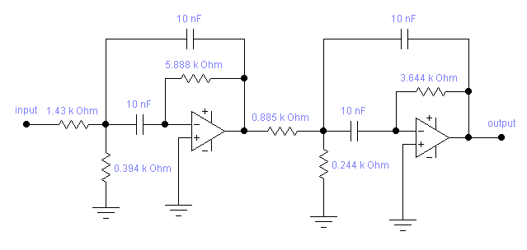
Fig.3. Schematic diagram of 4th order Butterworth active Band-pass filter circuit using MFB topology

Partial filter (1)
Partial filter (2)

To design the individual second-order band-pass filters using Sallen-Key topology. Specify(C = 10nF). The resistor values for both partial filters are obtained by using equations (12), (13) and (14) as below:
Partial filter (1):

R= 1.3491 KΩ ; let (R₁) = 10 KΩ ; R₂ =15.376 KΩ
Partial filter (2):
R= 834.7 KΩ ; let (R₁) = 10 KΩ ; R₂ =15.376 KΩ

The 4th order Butterworth band-pass filter using Sallen-Key topology is constructed from two non-identical 2nd-order sections shown in Fig.4.

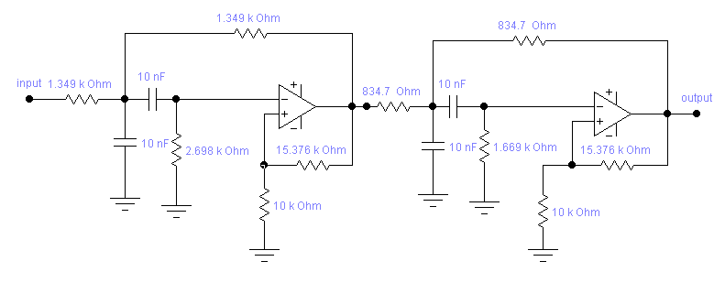

Partial filter (1)
Partial filter (2)
Fig.4. Schematic diagram of 4th order Butterworth active Band-pass filter circuit using Sallen-Key topology

The transfers function of the 4th order Butterworth band-pass filter circuits using MFB topology shown in fig. (3) and using Sallen-Key topology shown in fig. (4) is obtained using equation (16):
$A(s)=\frac{0\text{.}\text{8889}\text{.}S^{2}}{S^{4}+(0\text{.}\text{9428})S^{3}+(2\text{.}\text{44453})S^{2}+(0\text{.}\text{9428})S+1}$

By using the transfer function, the frequency response of the filter can be plotted using MATLAB to verify the design.

4- SIMULATION RESULTS
The circuit of the fourth order Butterworth band-pass filter using MFB topology is connected and simulated using MULTISIM (electronic work bench version 6.2) .The circuit of the filter is composed of two Op-amps .The amplifiers are based on the (UA748cp) op-amplifier circuit .The results of (MULTISIM) simulation for the filter using MFB topology are shown in Fig.5. The filter has a pass band frequencies (10) kHz and (20) kHz, pass band gain greater than one and roll-off rates of (-40) dB/dec and (40) dB/dec.
The circuit of the fourth order Butterworth band-pass filter using Sallen-Key topology is connected and simulated using MULTISIM .The circuit of the filter is composed of two Op-amps .The amplifiers are based on the (UA748cp) op-amplifier circuit .The results of (MULTISIM) simulation for the filter using Sallen-Key topology are shown in Fig.6. The filter has a pass band frequencies (10) kHz and (20) kHz, pass band gain less than one and roll-off rates of (-40) dB/dec. and (40) dB/dec.
The transfer function of the filter is simulated using a MATLAB program. Fig.7. illustrates the frequency response of the filter using MATLAB simulation method.
By comparing the simulated filter responses shown in Fig.5. and Fig.6 with that of Fig.7. , it can be seen that the amplitude response of the filter using MFB topology has a pass band gain greater than one and approximately equals the amplitude of the pass band obtained using MATLAB. While the amplitude response of the filter using Sallen-key topology has a pass band less than one and it differs from that obtained using MATLAB. So the MFB topology has a better performance than Sallen-key topology.
5- CONCLUSION.
The circuit of the filter using MFB topology is composed of two Op-amps, six resistors, and four capacitors. The circuit of the filter using Sallen-Key topology is composed of two Op-amps, ten resistors, and four capacitors. So the MFB topology requires a less number of passive components than sallen-key topology. The filter magnitude response in dB using MFB topology gives a pass band gain greater than one and also greater than the pass band gain of the filter obtained using sallen-key topology.
So it can be seen that the simulated response by MULTISIM for the filter using MFB topology looks good and familiar with the simulated response in MATLAB better than the simulated response by MULTISIM for the filter using Sallen-Key topology. As the simulated results using MFB topology satisfy the system requirement better than Sallen-Key topology, this circuit structure is the best one suitable for RFID application in real word.

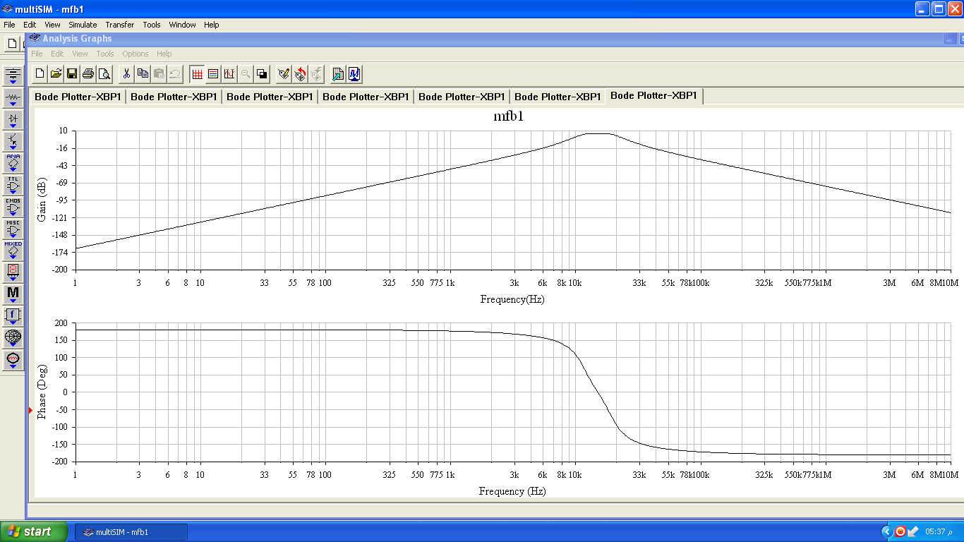
Fig.5. Simulated filter responses in MULTISIM of fourth order Butterworth Band-pass filter using MFB topology; the upper plot shows the filter magnitude response in dB and the bottom plot shows the phase function in degrees.

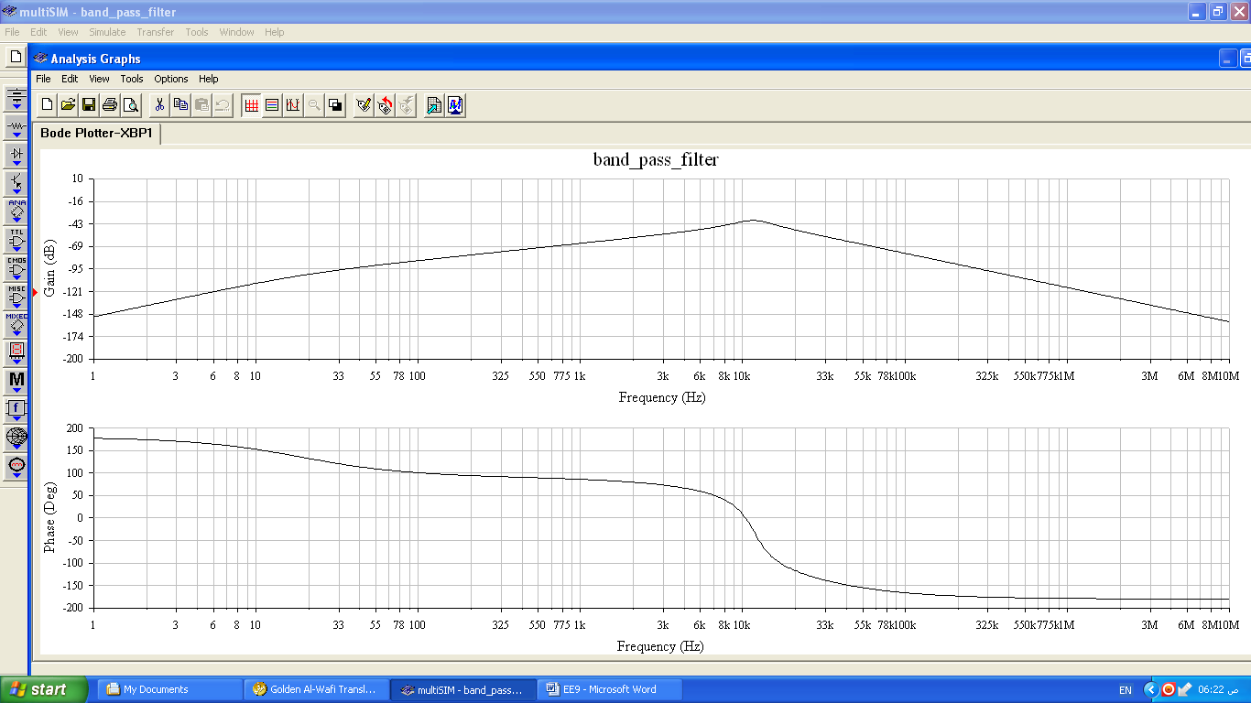
Fig.6. Simulated filter responses in MULTISIM of fourth order Butterworth Band-pass filter using Sallen-Key topology; the upper plot shows the filter magnitude response in dB and the bottom plot shows the phase function in degrees.

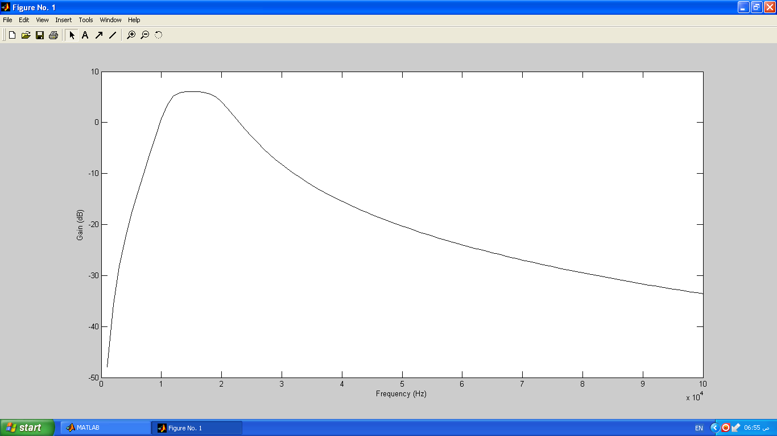
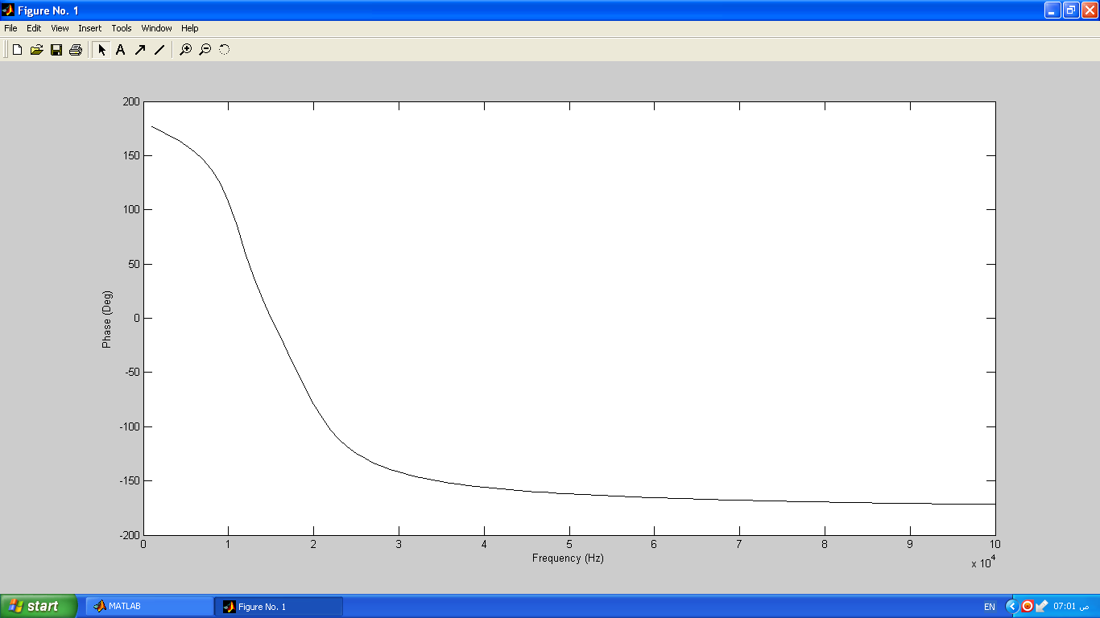
Fig.7. Simulated filter responses of fourth order Butterworth Band-pass filter by using MATLAB; the upper plot shows the filter magnitude response in dB and the bottom plot shows the phase function in degrees

6- REFERENCES.

Faranak Nekoogar, Farid Dowla , 2011 .''Ultra-Wideband Radio Frequency Identification Systems" , Springer Science+Business Media, LLC.
Jari-Pascal Curty, Norbert Joehl, Catherine Dehollain, and Michel J. Declercq, 2005 "Remotely Powered Addressable UHF RFID Integrated System"IEEE JOURNAL OF SOLID-STATE CIRCUITS, VOL. 40, NO. 11, NOVEMBER.
On-line address:
http://www.ivsl.org.ieeexplore.ieee.org.tiger.sempertool.dk/Xplore/home.jsp?tag=1
Löwenborg, H. Johansson, and L. Wanhammar, 1999 “A Class of Two-Channel Hybrid Analog/ Digital Filter Banks”, IEEE Midwest Symp.Circuits Systems, Las Cruces, Mexico, Aug.,.
Miss Zin Ma Ma Myo, Dr.Zaw Min Aung, Dr.Zaw Min Naing, 2009"Design and Implementation of Active Band-Pass Filter for Low Frequency RFID System", Proceedings of the International Multi Conference of Engineers and Computer Scientists 2009 Vol.I IMECS 2009, March 18 - 20, Hong Kong.
Mandeep Kaur, Manjeet Sandhu, Neeraj Mohan and Parvinder S. Sandhu, 2011" RFID Technology Principles, Advantages,Limitations & Its Applications", International Journal of Computer and Electrical Engineering, Vol.3, No.1, February.
Parvathy A, Venkata Rohit Raj, 2011 " RFID Based Exam Hall Maintenance System", IJCA Special Issue on Artificial Intelligence Techniques - Novel Approaches & Practical Applications(AIT).
Ron Mancini, 2003"Op Amps for Everyone Design Reference", 2nd Edition, Elsevier.
Ron Weinstein, “RFID: a technical overview and its applications to enterprise”, IEEE Computer Society, June 2005.
On-line address:
http://www.ivsl.org.ieeexplore.ieee.org.tiger.sempertool.dk/Xplore/home.jsp.
Sridevi.V, Jayanthy.T ,2011"Design of Active Filters using CNTFET Op-amp" International Journal of Soft Computing and Engineering (IJSCE), ISSN: 2231-2307, Volume -1, Issue -3, July.

