Design and Implementation of RF and Microwave Filters Using Transmission Lines
Wasan Hashim Jacob
University of Babylon , College of Engineering,
Electrical Engineering Department.
wasan_almasoody@yahoo.com
Abstract
RF and Microwave filters can be implemented with transmission lines. Filters are significant RF and Microwave components. Transmission line filters can be easy to implement, depending on the type of transmission line used. The aim of this paper is to develop a set of transmission line filters to do practical work with. There are different transmission lines due to different RF and Microwave applications. The characteristic impedance and how easy it is to incise precise lengths are two important characteristics of transmission lines; thus they are used to investigate which transmission line to use to implement filters.The first part of this paper looks into which transmission line to use to erect a filter. Then the different filter design theories are reviewed. The filter design theory that allows for implementation with transmission lines is used to design the filters. Microstrip transmission lines are used to implement transmission line filters. They are the transmission lines with which it is easiest to change the characteristic impedance. This paper presents a new approach that can be easily involved in the implementation of the radio frequency and microwave (RF/MW) circuits for many applications. The approach is based on the implementation of the system using MATLAB simulink.
Key words: Implementation , Microwave Filters, Transmission Lines.
الخلاصة
من الممكن تنفيذ المرشحات ذات الترددات الراديوية- المايكروية بإستخدام خطوط الارسال حيث إن المرشحات تعد من العناصر المهمة في مثل هذه التطبيقات. كذلك من السهل تنفيذ هذه المرشحات اعتمادا على نوع الخطوط المرسلة المستخدمة . إن الهدف من هذا البحث هو تطوير انواع المرشحات المختلفة للاستخدامات العملية والبناءة من حيث إنه هنالك مجموعة كبيرة ومتنوعة من خطوط الارسال وفقا لمختلف التطبيقات التي تستخدم الترددات الراديوية والمايكروية . وتعد الممانعة الذاتية وسهولة التحكم بالطول خاصيتان مهمتان للخطوط المرسلة. يتمحور الجزء الاول من هذا البحث في إنتخاب نوع المرشح وبعد ذلك مراجعة نظريات تصميم المرشحات حيث إن هذه النظريات المطبقة للتنفيذ باستخدام الخطوط المرسلة هي التي سوف تستخدم في هذه التصاميم. وفي هذا البحث يستخدم نوع الشريحة المايكروية من المرسلات لتنفيذ أنواع المرشحات حيث تعد هذه المرسلات من أسهل الانواع لتغيير الممانعة الداخلية. . يعرض هذا البحث تقنية جديدة من الممكن ضمها ضمن تنفيذ الدوائر التي تعتمد الترددات الراديوية والمايكروويفلمختلف أنظمة الاتصالات . تعتمد هذه الطريقة على تصميم وتنفيذ الدوائر بواسطة نظام MATLAB الهندسي.
الكلمات المفتاحية: تطبيق، مرشحات الميكروويف، خطوط نقل.
I. Introduction
This report describes the design and implementation of RF and Microwave transmission line filters. Filters are amongst the most common RF and Microwave components. Their function is intuitively easy, for instance a low-pass filter should pass low frequency signals. It is easy to figure out that the characteristic of merit is frequency. Because of their importance, there is an immense amount of theory dedicated to the design of filters.
There are many ways to design RF and Microwave filters. The filters are implemented using transmission lines (MATLAB Simulink); Filters are two-port networks used to control the frequency response in an RF or Microwave system. They allow transmission of signal frequencies within their pass-band, and attenuate signals outside thier pass-band. Common RF and Microwave filter types are listed below:
• Transmission line stubs filters. These filters are implemented using transmission lines in place of lumped elements[David M. 2001].
• Coupled line filters. Filters can be designed using transmission lines as resonators coupled together using quarter-wave matching transformers [R. Ludwig. 2012].

• Inter-digital filters. They are formed from short-circuited transmission lines that take the structure of interlaced fingers [R. Ludwig. 2012].
• Comb-Line filters. Quarter-wave transmission line resonators are used in the design of comb-line filters. Quarter-wave transmission lines are capacitively coupled [R. Ludwig. 2012].
• Waveguide discontinuity filters. The low loss and high power handling characteristics of waveguides lend themselves to the use of waveguides in specialized filters [R. Ludwig. 2012].
• Elliptic function filters. They are implemented using N coupled transmission lines between parallel plates. The network is a 2N port network that is reduced to an N port network by leaving all the ground ports open-circuited [J. A. G. Malherbe. 1979]
II. Filter Designs
Filters are designed using the theory that allows for the implementation using transmission lines. This paper is the development of theory that leads to the designs. Low-pass, high-pass, band-pass and band-stop filters are designed. The design involves conversion of lumped-elements into distributed elements if the initial design is in lumped-elements. Simulation is to be used to verify the amplitude and phase responses of the designs.
The filters are designed by the insertion loss method. The design equations from the text Microwave and RF Design of Wireless Systems [David M. 2001] are used for the filter designs. There are tables of element values for low-pass filter prototypes. The source impedance and the cut-off frequency are normalised to one. The elements values are derived from the power loss ratio. Power loss ratio depends on the reflection coefficient. The reflection coefficient in turn depends on impedance; at the input, the reflection coefficient is calculated from the input impedance with respect to the filter load impedance.
There are two ladder circuits for low-pass filter prototypes; the ladder circuit for the prototype beginning with a shunt reactive element and the ladder circuit for the prototype beginning with a series reactive element. If the first element is a series reactive element, the generator has internal parallel resistance. Else if the first element is a shunt reactive element, the generator has internal series resistance
[David M. 2001].
Signals in the pass-band of a filter are either maximally flat or have equal ripples in magnitude. The cut-off point is the point where the signal is at 3 dB of attenuation. In the stop-band, signals are attenuated at a rate that depends on the type of filter. For the same order, equal-ripple filters have the higher rate of attenuation than maximally flat which in turn have higher rate of attenuation than linear phase filters. Design of third order equal-ripple low-pass filter follows.
A. Design of a Low-Pass Filter
The equal-ripple low-pass filter of order N is specified by the power loss ratio (PLR)

$\text{PLR}=1+K^{2}T_{N}^{2}\left(\frac{w}{\text{wc}}\right)$ (1)

where T2N(x) is a Chebyshev polynomial. High-pass, band-pass and band-stop filters are designed from the low-pass filter prototype. Figure 1 is the Matlab plot of the PLR for a 3 dB equal-ripple low-pass filter prototype of order 3.

Figure 1: Power loss ratio of the low-pass prototype.

The element values of the normalised prototype are as follows:

• g1 = 3.3487
• g2 = 0.7117
• g3 = 3.3487

and the output impedance is 1. The internal conductance of the signal source is normalized to one. A ladder circuit that begins with a series element is chosen. Therefore g1 is an inductor so is g3, while g2 is a capacitor, Figure 2.

Figure 2: Lumped elements low-pass filter prototype.

The cut-off frequency is set at 750 MHz and the impedance at 100 Ohms. Figure 3 is
the circuit simulated in MATLAB. The simulation results are shown in Figure 4.

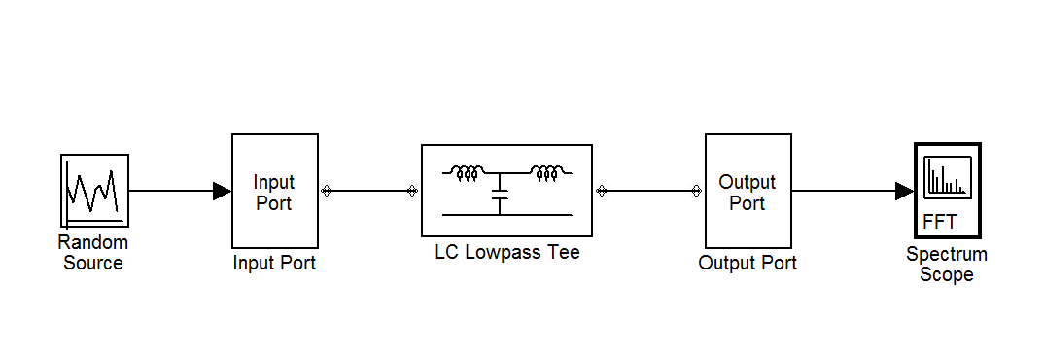

Figure 3: Simulated low-pass filter circuit.

Figure 4: Simulation Results for the low-pass filter.

B. Design of a High-Pass Filter
The equal-ripple high-pass filter of order N is specified by power loss ratio

$\text{PLR}=1+K^{2}T_{N}^{2}\left(\frac{−w}{\text{wc}}\right)$ (2)
The element values of the normalised prototype are as follows:

• g1 = 3.3487
• g2 = 0.7117
• g3 = 3.3487
and the output impedance is 1. The signal source has internal conductance normalised
to one. A ladder circuit that begins with a series element is chosen. Therefore g1 is a
capacitor so is g3, while g2 is an inductor, Figure 5.

Figure 5: Lumped elements high-pass filter prototype.

The cut-off frequency is set at 750 MHz and the impedance at 100 Ohms. Figure 6 is the lumped elements circuit simulated in MATLAB. The simulation
results are shown in Figure 7.

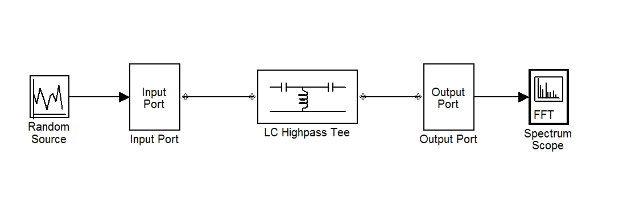

Figure 6: Simulated high-pass filter circuit.

Figure 7: Simulation results for a high-pass filter.

C. Design of a Band-Pass Filter
The following frequency substitution transforms the power loss ratio of the low-pass filter to that of the band-pass filter

$w←\frac{w_{0}}{w_{2}−w_{1}}(\frac{w}{w_{0}}−\frac{w_{0}}{w})$ (3)

for the same order and type. $w_{0}$ is the centre frequency, while $w_{1}$ and $w_{2}$ denote the edges of the pass-band.
The third order low-pass filter prototype yields the following values for the normalized band-pass filter elements:

• g1 = 3.3487
• g2 = 0.7117
• g3 = 3.3487
and the output impedance is 1. The internal conductance of the signal source is normalized to one. A ladder circuit that begins with a series element is chosen. g1 and g3 are inductors and g2 is a capacitor. For a band-pass filter, low-pass prototype series inductor converts into a series LC circuit, whereas a shunt capacitor converts into a shunt LC circuit, Figure 8 illustrates.

Figure 8: Lumped elements band-pass filter prototype.

The centre frequency is set at 750 MHz and the impedance at 100 Ohms. The fractional bandwidth is 10%. Figure 9 is the circuit simulated in MATLAB. The simulation results are shown in Figure 10.

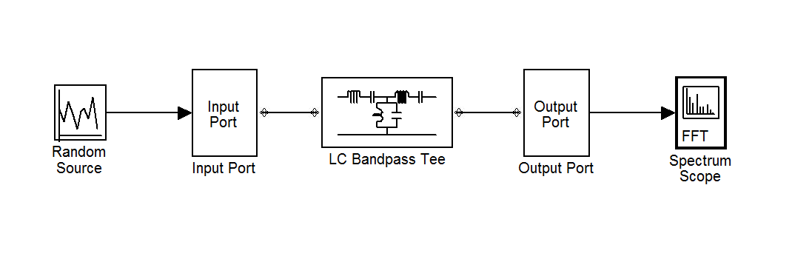
Figure 9: Simulated circuit for a band-pass filter.

Figure 10: Simulation results for a band-pass filter.

D. Design of a Band-Stop Filter
Band-stop filter is the opposite of the band-pass filter. The power loss ratio of a bandstop filter is determined from that of the low-pass filter with the following frequency substitution

$w←\frac{w_{2}−w_{1}}{w_{0}}(\frac{w}{w_{0}}−\frac{w_{0}}{w})−1$ (4)

The third order low-pass filter prototype yields the following values for the normalized band-stop filter elements:

• g1 = 3.3487
• g2 = 0.7117
• g3 = 3.3487

and the output impedance is 1. The internal conductance of the signal source is normalized to one. A ladder circuit that begins with a series element is chosen. g1 and g3 are inductors and g2 is a capacitor. For a band-stop filter, low-pass prototype series inductor converts into a parallel LC circuit, whereas shunt capacitor converts into a series LC circuit. Figure 11 is a lumped element band-stop filter.

Figure 11: Lumped elements band-stop filter prototype.

The centre frequency is set at 750 MHz and the impedance at 100 Ohm. The fractional bandwidth is 10%. Figure 12 is the circuit simulated in MATLAB. The simulation results are shown in Figure 13.

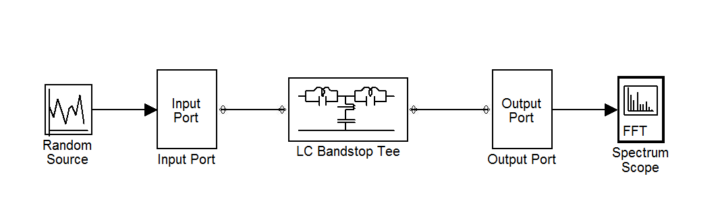

Figure 12: Simulated circuit for a band-stop filter.

Figure 13: Simulation results for a band-stop filter.

III. Implementation of Filters
The distinguishing characteristic of transmission lines is the characteristic impedance.Filter design methods also involve impedance, as the input impedance or the operating impedance of the filter[Unknown Author URL1. 2012 and Unknown Author URL2. 2012]. Thus implementation of transmission line filters is centred on chosen transmission line’s characteristic impedance. The length of the transmission line is also a significant characteristic, so the ease of determining specific lengths of transmission line is an advantage[Fred Johnson. 2012 and L. B. Cebik. 2012].
Microstrip transmission lines are used to implement the designed filters. The next step is to use Richard’s transformations to convert series inductors to series short circuited
stubs, and shunt capacitors to shunt open-circuited stubs. The characteristic
impedance of a shunt stub is 1/C, whilst that of the series stubs is L[David Jefferies. 2012].
A Kuroda identity is used to convert a series stub into a shunt stub. First redundant
elements are added to each end of the filter, redundant means they do not affect the filter performance since they are matched to the normalised source impedance. Then the Kuroda identity is used[Unknown Author URL3. 2012].
A. Implementation of the Low-Pass Filter
The third order low-pass 3 dB equal-ripple filter is implemented with microstrip transmission lines. Figure 14 is the circuit simulated in MATLAB simulink. The
simulation results are shown in Figure 15.
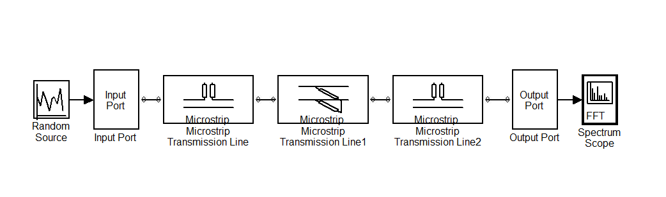

Figure 14: Simulated low-pass filter circuit.
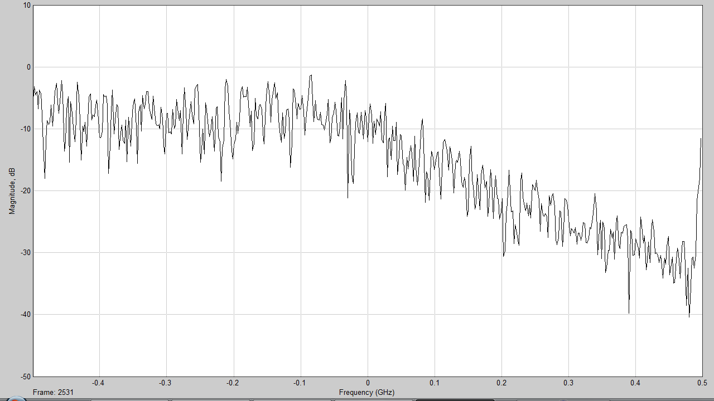

Figure 15: Simulation Results for the low-pass filter.

B. Implementation of the High-Pass Filter
For the same type and order, low-pass filter response is the reverse of high-pass filter response. The distributed components high-pass filter is established by changing the termination to low-pass filter stubs from open-circuit to short-circuit. With distributed components, if an open-circuited stub is replaced with a short-circuited stub and a short-circuited stub is changed to an open-circuited stub then the low-pass filter turns into a high-pass filter. Therefore a high-pass filter is implemented by shorting the open-circuited stubs of a low-pass filter, for a high-pass filter of the same order and type. Figure 16 is the circuit simulated in MATLAB simulink. The simulation results are shown in Figure17.

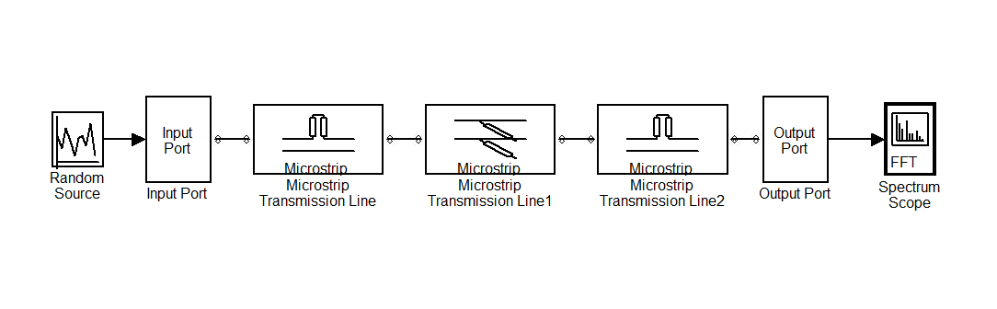
Figure 16: Simulated high-pass filter circuit.

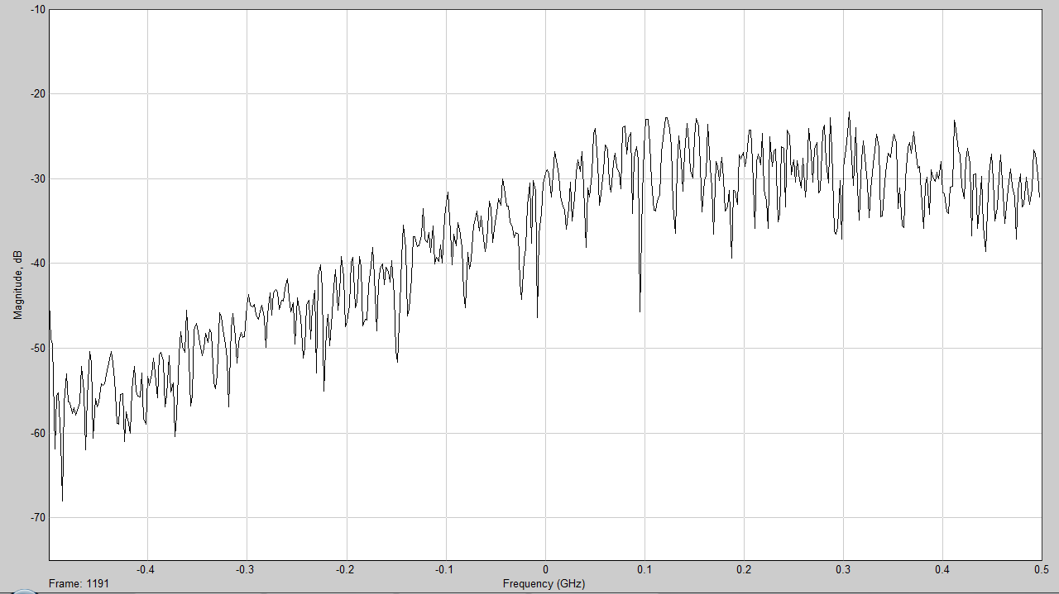

Figure 17: Simulation results for a high-pass filter.

C. Implementation of the Band-Pass Filters
Band-pass filters are very important in RF and Microwaves systems. Their pass-band is very selective in a wide frequency range. In wireless systems they are used to reject out of band and image signals. They attenuate unwanted mixer products, and set the IF bandwidth. Because of their importance, a large number of different types of band-pass filters have been developed [David M. 2001, page 178].
Quarter-wave short-circuited transmission line stubs are used to implement shunt parallel LC resonators for band-pass filters [David M. 2001, page 179]. The resonators are connected together by quarter-wave transmission lines. The transmission lines act as admittance inverters. They convert alternating parallel resonators to series resonators. Figure 18 is the circuit simulated in MATLAB simulink. The simulation results are shown in Figure19.

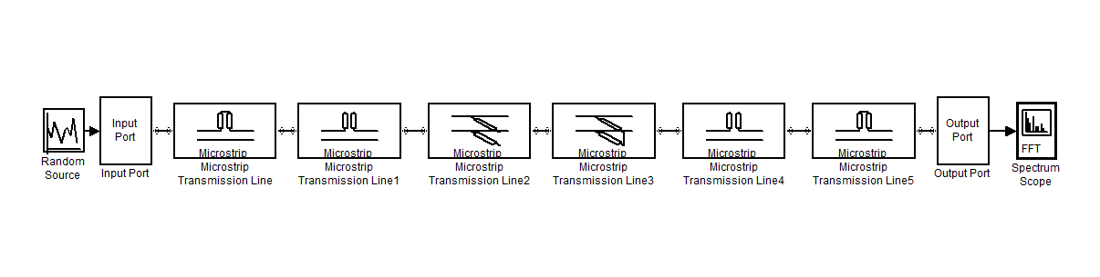
Figure 18: Simulated circuit for a band-pass filter.

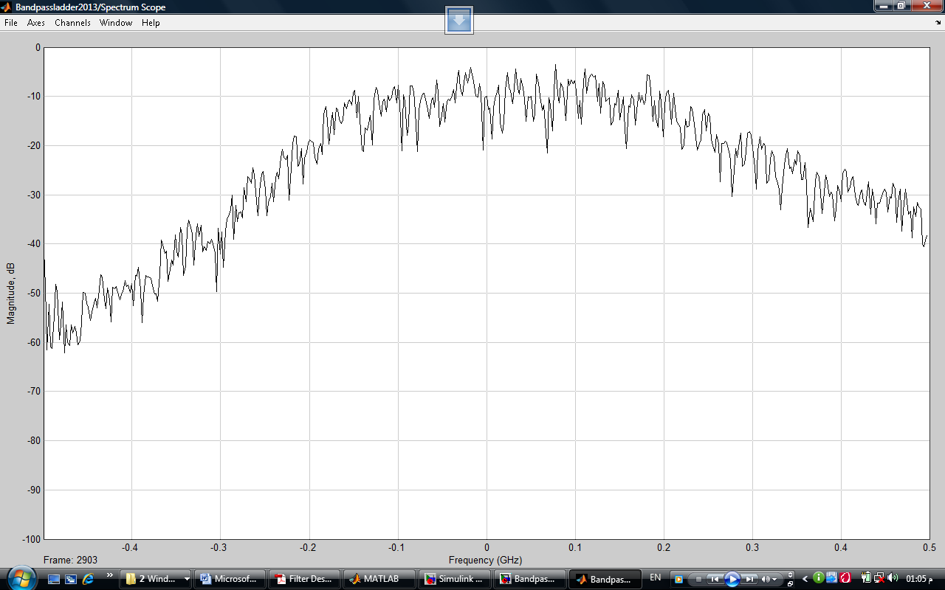

Figure 19: Simulation results for a band-pass filter.

D. Implementation of the Band-Stop Filters
If the short-circuited transmission line stubs for a band-pass filter are substituted with the open-circuited stubs, a band-stop filter results. The characteristic impedances of the resonators for a third order equal-ripple band-stop filter are equal those of the band-pass filter[Barry Downing. 2006]. Figure 20 is the circuit simulated in MATLAB simulink. The simulation results are shown in Figure 21.

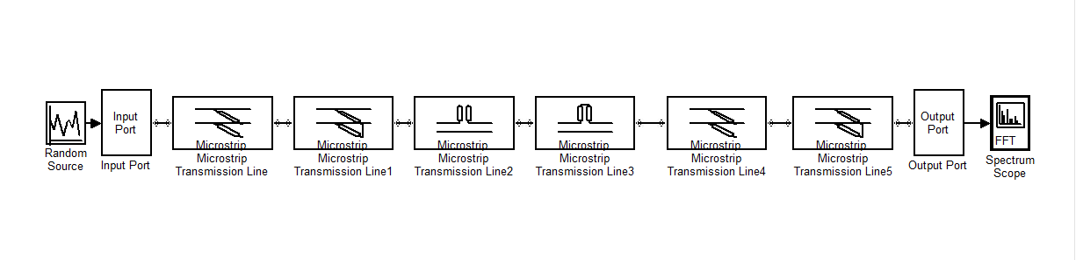
Figure 20: Simulated circuit for a band-stop filter.
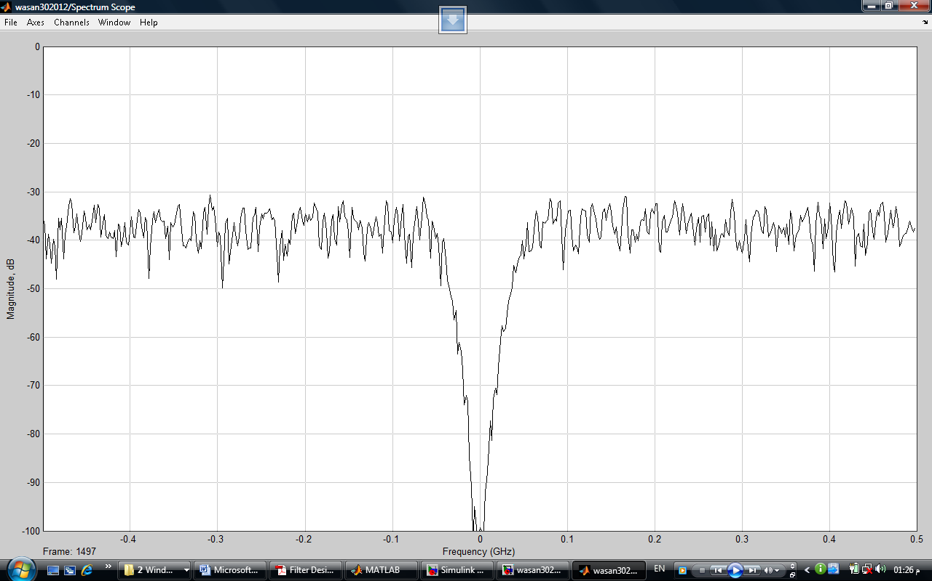

Figure 21: Simulation results for a band-stop filter.

IV. Conclusions
Based on the preceding information Filters are designed using the low-pass filter prototypes. High-pass, band-pass and band-stop 3 dB equal-ripple filters are designed from their equivalent low-pass filter prototypes. Richard’s transforms are used to convert lumped elements filter into distributed elements filters. The impedance of operation is selected as 100 Ohms.
The order of the designed filters is chosen to be three. The choice is made to ease implementation. The implementation of transmission line filters is based on characteristic impedance changes. The higher the order of the filter, the difficult the required changes in characteristic impedance become. However, performance of a filter improves with an order increase. Microstrip transmission lines are used to implement RF and Microwave filters. It is easy to change the characteristic impedance of open-wire lines.
To verify the designs, the filters are simulated using MATLAB simulink. The filters designed are of the order three, therefore the simulation shows the minimum performance characteristics of the filter types designed.
References
Barry Downing. Transmission Lines. EEE355F Module B Set of Notes, University of Cape Town 2006.
David Jefferies. What is a microstrip transmission line. 2 February 2006 [Online]
Available: http://www.ee.surrey.ac.uk/Personal/D.Jefferies/mstrip.html
Last update in 2012.
David M. Pozar. Microwave and RF Design of Wireless Systems. First Edition. New York: John Wiley & Sons, 2001.
Fred Johnson. The New Zealand Amateur Radio Study Guide, Transmission Lines.[Online]Available:
http://www.nzart.org.nz/nzart/examinat/amateur%20radio%20study%20guide/Course%20Files/Transmission%20Lines/
Last update in 2012.
J. A. G. Malherbe. Microwave Transmission Line Filters. First Edition. Dedham:Artech House, 1979.
L. B. Cebik. Antennas Service and Education for Amateur Radio Operators, Transmission lines. 09 January 2006 [Online] Available: http://www.cebik.com/trans/par.html
Last update in 2012.
R. Ludwig. RF and Microwave Engineering, University of San Diego. [Online] Available: www.sandiego.edu/~ekim/e194rfs01/filterek.pdf
Last update in 2012.
Unknown Author URL1. Microwaves101.com, Coaxial Cable. 1 October 2006 [Online]Available: http://www.microwaves101.com/encyclopedia/coax.cfm#coax
Last update in 2012.
Unknown Author URL2. SearchNetworking.com, Coaxial cable. 15 June 2005 [Online] Available: http://searchnetworking.techtarget.com/sDefinition/0,,sid7_gci211806,00.html
Last update in 2012.
Unknown Author URL3. CV Chemandy Electronics, Microstrip Transmission Line Characteristic Impedance. 30 September 2006 [Online] Available: http://chemandy.com/calculators/microstrip_transmission_line_calculator.htm
Last update in 2012.

