**Comparative Study of Tested Concrete Cubes by Ultrasonic Waves Using Ansys Program**

**Hakim Saeed Muhammed**

*structural engineering, Civil Dept. Najaf Technical Institute*

*Ntit.10006@gmail.com*

**Husain Ali Muhammed**

*Geotechnical engineering, Civil Dept. Najaf Technical Institute*

*Saidhuseinn@gmail.com*

**Abdul Husain Abdul Resa Salih**

*Surveying and construction materials , Civil Dept. Najaf Technical Institute*

[*aasalih_1959@yahoo.com*](mailto:aasalih_1959@yahoo.com)

Abstract

This study deals with ultrasonic pulse velocity tests done on concrete to find out its compressive strength with different mix ratios, different water cement ratios and in different ages. The cubes used were 150x150x150mm and the batches were prepared using three mix ratios 1:1:2,1:1.5:3 and 1:2:4 respectively. For each batch three water cement ratios were used 0.4,0.5 and 0.6. The concrete cubes were tested at 3,7,14 and 28 days age in the compression machine. Before testing any cube, it was tested by an ultrasonic pulse tester to find out the velocity of the waves through concrete. Ansys software version11 was used to do the analytical work through so many runs to get the compression stresses in concrete and the displacement in z-direction (the direction of applying the load).A comparison was done between the experimental and analytical work through so many graphs in the study. The maximum percentage difference between the results of the two was between (6.4-7.8)% where the results of the Ansys were presented in two ways upper and lower bounds. The difference seems to be reasonable ,but a care must be taken in concrete assessment.

**Key words***: Ultrasonic pulse velocity, mix ratio ,water cement ratio, compressive strength*

الخلاصة

تتناول هذه الدراسة إجراء فحص الأمواج فوق السمعية على الخرسانة كفحص لااتلافي لإيجاد مقاومة الانضغاط وبنسب خلط مختلفة ، نسب ماء/سمنت مختلفة وعند أعمار مختلفة.تم استعمال مكعبات 150x 150 x150 ملم وكانت نسب الخلط 1:1:2، 1:1.5:3 و 1:2:4 على التوالي لغرض إجراء الفحوصات الأتلافية واللااتلافية. كانت نسب الماء/ الأسمنت المستعملة 0.4 ،0.5 و0.6 لكل خلطة كما فحصت مكعبات الخرسانة عند أعمار 3،7،14و28 يوم بجهاز فحص الانضغاط. قبل إجراء هذا الفحص تفحص المكعبات بجهاز فحص الأمواج فوق السمعية لإيجاد سرعة هذه الأمواج خلال الخرسانة. إن الجزء التحليلي تم تنفيذه باستعمال برنامج (Ansys version 11) لإيجاد اجهادات الضغط في الخرسانة والإزاحة باتجاه المحور العيني (اتجاه تسليط الحمل). أجريت مقارنة بين الجزء التجريبي والتحليلي ومن حلال عدة مخططات عرضتها هذه الدراسة فكان أعلى فارق مئوي بالنتائج بين (6.4-7.8) % حيث تم تبيان نتائج البرنامج Ansys بالحدود العليا والدنيا . ومن النتائج يبدو أن الفرق مقبول إلى حد ما ولكن يجب الحذر عند إجراء تقييم للخرسانة.

**الكلمات المفتاحية:** سرعة الأمواج فوق السمعية, نسبة الخلط ,نسبة الماء إلى الاسمنت ,مقاومة الانضغاط.

**Introduction**

Ultrasonic pulse velocity (UPV) is one of the nondestructive tools used for assessment of concrete quality. First one who used and developed the resonance frequency method is Powers in 1938 followed by Obert in 1939, Toutanji,2000.Various properties of concrete from this date were measured by ultrasonic techniques ( Lislie J., Cheesman W., (1949), Teodru G.,(1988), Qasrawi H., Marie I., (2003)). ASTM C597, BS1881: Part 203 and ACI 228- 1R and ACI 228 -2R are examples of the international committees, specifications and standards who use and adopt UPV methods to evaluate concrete.

UPV uses sound waves to be sent through one head transducer and received from the other. The velocity of the wave which passes through a media is a function

of so many properties of that media. The velocity V is a function of the square root of the ratio of its modulus of elasticity, to its density ρ as given by the following equation;



Another equation which takes Poisson's ratio (µ) into account dynamic modulus of elasticity ,Ed, is mentioned in ASTM C597-02.



The speed of sound in conventional linear elasticity is determined only by the elastic modulus and the density of the medium. In actuality, however, the speed of sound depends on the stress and this depending becomes nonlinear as the stress increases. The relationship between nonlinear elastic modulus up to the fourth order and the internal stress was discussed by Kim et al.(2001) through computer simulations and experiments. In the simulation, it is shown that the third order elastic constant contributes to the slope of the sound speed verses stress curve.

**UPV in various Codes**

Kalmos.K. et al.(1996), in their study to compare critically eight standards, they concluded that the common weakness of the analyzed standards is that they do not warn the user strongly enough about the uncertainties. For instance, the assessment procedures could be related according to their reliability.

The most common application of pulse velocity measurement is the assessment of concrete strength. This is usually done with the help of a calibration or correction curve, or a formula representing the curve, for a given concrete. In the following paragraph a brief show will be given for each standard when a UPV field is taken into consideration.

(1) ASTM C 597-02(5): The ASTM standard does not contain a detailed procedure for strength assessment. Nevertheless, it gives warning that the results obtained by the use of this test method should not be considered as a means of measuring strength.

(2) BS 1881 : Part 203 (1986 ): Three cube specimens should be taken for each batch to generate a calibration curve. Direct transmission mode must be used and at least three measurements between top and bottom might be taken. From these data the calibration curve will be constructed. ( 3) DIN / ISO 8047 (Entwurf) : This standard also does not contain any procedure for the assessment of concrete strength from pulse velocity measurement. It states that a calibration curve must be constructed from experimental results. Three to five individual transit time measurements should be carried out in each location. Cores should be taken from the same locations and tested to obtain the compressive strength. A linear function is recommended for the pulse velocity versus strength relationship.

(4) GOST 17624-87

In this standard the assessment of concrete is reached through either establishing a relation between pulse velocity and strength of concrete or transit time versus strength of concrete. Fifteen cubes should be tested for each class, firstly by nondestructive testing and secondly by destructive manner. GOST suggested two forms linear and nonlinear forms of concrete strength:



(For narrow strength range and when

For wider strength range, an exponential function is recommended as follows:



Where:

Rc=the mean value of the compressive strength of tested samples, MPa.

Rmax and Rmin=maximum and minimum values ,respectively, of compressive strength of tested samples, MPa.

= longitudinal pulse velocity.

=regression coefficients. 

e= base of natural logarithm.

(5) STN 73 1371 This standard discusses so many conditions related to the number of specimens taken, quantity of concrete tested and a coefficient called characterization coefficient ,where is obtained from the equation:



Where: n=the number of tested samples.

Rci=the strength of concrete determined by the destructive test of the sample. Rcci= the compressive strength assessed on the sample by the ultrasonic method. The following regression equations recommended by the STN and RILEM standards (1972),



And

Where the symbols were as the same as defined previously.

(6) MI 07-3318-94

The Hungarian standard uses an equation which takes into consideration so many parameters like maximum particle size ,cement content, size of aggregate, aggregate grading ,water cement ratio ,extent of compaction ,curing conditions and moisture content.



Where

R200 =calculated strength of concrete for 200 mm cube, MPa.

= effective pulse velocity ,m/s.

=sum of modifying parameters that depend on the properties of the concrete. For example, Δ=0 when the maximum particle size is 32mm and 0.5 when it is 16mm. As another example , Δ=0 when the cement content is 200 kg/m3 ,and 0.3 when it is 400 kg/m3.

**Objectives of the study:**

The aims of the present study are to do the following:

(1)Finding and evaluation the relation between compressive strength of concrete and the results of ultrasonic pulse velocity tests.

(2)Finding an empirical relations between compressive strength of concrete and the ultrasonic velocity of concrete according to the concrete mix ratios and water cement ratios.

(3)To be sure and to make confidence about the previous results so many runs of the well-known Ansys software must be done to see the maximum compressive stresses within concrete cubes and the reduction in the total height of the tested concrete cubes.

**Experimental work**

**Materials**

The materials which were used are that available in the area of Najaf city (south of Baghdad). They are as follows:

**Fine aggregate (sand):**

Sand represents the fine material in the concrete. A natural sand which was brought from Najaf quarries was used in the work having a specific gravity of 2.62 . The tests which were done to get reasonable fine material are that which coincides with the specifications. The sand was washed so many times to get clean material from clay lumps and soluble salts. The grading of the sand can be seen in Table(1).

*Table (1): Grading of the fine aggregate*

|  |  |  |  |  |  |
| --- | --- | --- | --- | --- | --- |
| Standard Specifications Zone 3 | Percentage ratio of passing | Sum of retained ratios | Percentage ratio of retained | Weight of retained on sieve | Sieve No. |
| 100 | 100 | 0 | 0 | 0 | 9.5 |
| 90-100 | 96 | 4 | 4 | 40 | 4.75 |
| 85-100 | 87 | 13 | 9 | 90 | 2.36 |
| 75-100 | 79 | 21 | 9 | 80 | 1.18 |
| 60-79 | 71.7 | 28.3 | 7.3 | 73 | 0.6 |
| 12-40 | 33.5 | 66.5 | 38.2 | 382 | 0.3 |
| 0-10 | 5 | 95 | 28.5 | 285 | 0.15 |
| ------- | 0 | 100 | 5 | 50 | Pan |

**Coarse aggregate(gravel)**

A crushed graded river gravel was used in this study which is locally available. The gravel also washed so many times and cleaned from mud or clay. The gravel samples chosen were accompanied with the specifications. The grading of the gravel was done by a sieve analysis and according to ASTM C136-01. See Table (2).The specific gravity of the coarse aggregate was found to be 2.63.

|  |  |  |  |  |  |
| --- | --- | --- | --- | --- | --- |
| Standard Specifications | Percentage ratio of passing | Sum of retained ratios | Percentage ratio of retained | Weight of retained on sieve | Sieve(mm) |
| 100 | 100 | 0 | 0 | 0 | 75 |
| 95-100 | 100 | 0 | 0 | 0 | 37.5 |
| 35-70 | 68.5 | 31.5 | 31.5 | 944 | 19 |
| 10-30 | 15.59 | 84.05 | 52.55 | 1575 | 9.5 |
| 0-5 | 0 | 100 | 15.95 | 478 | 4.75 |

*Table (2): Grading of the coarse aggregate*

**Cement**

Type I Portland cement was used in the current study. The compressive strength governed in 3 days age for a tested samples from this cement gave 20 MPa, and in 7 days age gave 27 MPa. The Primary setting was 72 minutes while the final setting was 7.5 hours (450 minutes). The density was 3160 kg/m3 and its chemical composition can be shown in Table (3).

*Table(3) :Chemical composition of cement*

|  |  |  |  |  |  |  |  |
| --- | --- | --- | --- | --- | --- | --- | --- |
| L.O.I. | SO3 | MgO | Fe2O3 | AL2O3 | SiO2 | CaO | Compound |
| 2.16 | 2.13 | 2.54 | 2.64 | 5.71 | 21.52 | 63.15 | Percentage ratio by weight |

**Tests program**

The program of the study consisted the following:

(1) Cubes of 150 mm were prepared to be used in fabrication of concrete. (2) Table(4) shows the mix proportions and water cement ratios used in the study . The cubes were tested after 3,7,14 and 28 days age of fabrication.

*Table(4) :Designation of concrete batches.*

|  |  |  |
| --- | --- | --- |
| Water-cement ratio W/C | Mix proportion | Mix designation as a batch (B) |
| 0.4 , 0.5 , 0.6 | 1:1:2 | B1 |
| 0.4 , 0.5 , 0.6 | 1:1.5:3 | B2 |
| 0.4 , 0.5 , 0.6 | 1:2:4 | B3 |

(3) For each batch and according to the specified water cement ratio, 24 cubes were prepared to be tested. Six cubes were tested for each concrete age. Before making the test, cubes were taken from curing water at the specified age and then rubbed with a clean dry cloth until a saturated surface dry sample was obtained. The cube was tested as follows Qasrawi H., Marie I., (2003).

(a) Each of the two opposing surfaces was prepared for the ultrasonic pulse velocity test according to ASTM C597 and the center of each surface was determined.

(b) The cube was fitted in the compression-testing machine and a very small load was applied in order to keep the cube in position.

(c)The transmitter and the receiver of the ultrasonic pulse velocity tester were used on each pair of the opposing surfaces. The time was recorded and the velocity was calculated. Two measurements, each represents one direction x or y. (d) The load was then applied slowly to the tested cubes by an increments (2 tones) for each increment. At each load increment , the time was recorded and the velocity was calculated.

(4) The velocity was plotted against the corresponding compressive stress.

**Computer Software**

The stresses and displacements due to applied load were represented and calculated using ***Ansys*** program. Each load step is taken to be 20 KN applied as a pressure on the upper surface of the cube. The load is applied monotonically by an increment of 20 KN in each step. The stresses and displacements in y , x and z directions were governed respectively. The program gives the results for each step, therefore for each mix proportion and for each water cement ratio a run was done until failure. The modulus of elasticity can be taken from the literature Hilbbert R.C.(1994), as 22.1 GPa for concrete of low strength and density 2380 kg/m3 and 29 GPa for concrete of high strength with the same density mentioned. These values of modulus of elasticity are really general values for which many of the constraints are not taken into consideration like w/c ,age of concrete and so many parameters related to the concrete strength. Therefore the most suitable method is to take the equation of the ACI-building Code 318 M-02 which states that the modulus of elasticity of normal concrete can be evaluated from the following formula:

Where  is the compressive strength of concrete of 28 days age.



Each cube of 28 days age exposed to pressure, was demolished and its compressive strength was evaluated experimentally. This value was used in Eq. (9) to find out Ec . This was used as a modulus of elasticity in the program. Poisson's ratio was taken to be 0.15 which is the same value mentioned in the literature Hilbbert R.C.(1994).

**Results and discussion:**

About two hundred sixteen cubes were tested. Each group was taken to be tested according to its age and water cement ratio used as shown in Table (5). From this table a three plots were prepared to see the development of compressive strength with age of the concrete and it is clearly shown that as the water cement ratio increased ,the compressive strength decreased for each mix proportion or batch. This conclusion is really a normal result which is well-known for concrete, but it is mentioned here to show that we are in the correct way. These results and notes can be seen in Figs. (1,2 and3) respectively.

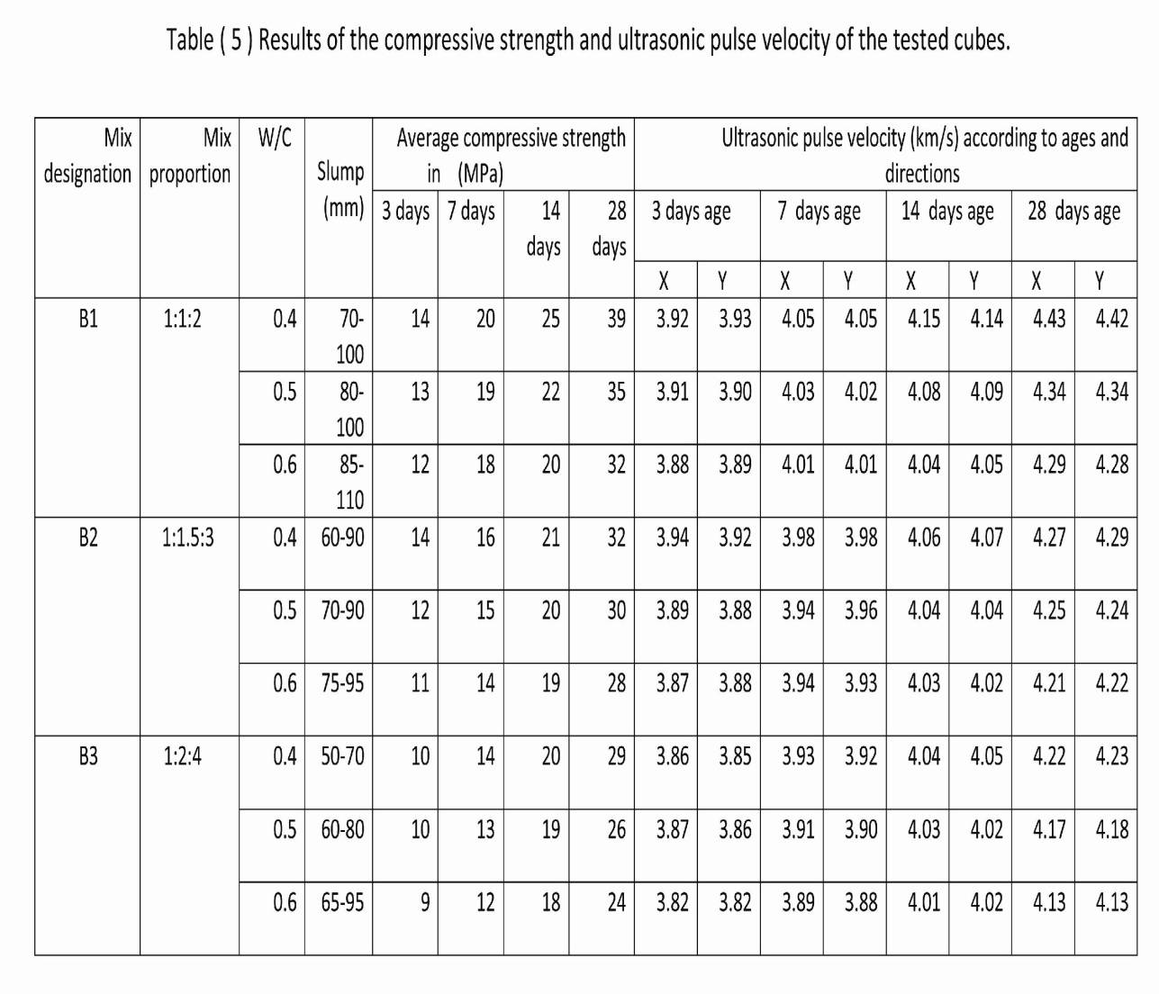

Figures (4,5 and 6) show the relation between the compressive strength of the concrete cubes(28 days age) and the ultrasonic pulse velocity. Fig.(4) represents the case where the lines of the three graphs of the water cement ratios are nearly coincided, that means in such mix ratio (1:1:2),there will be little influence of the water cement ratio on the ultrasonic pulse velocities. Although this really clear from the curves but an empirical relations will be mentioned later on to make it easy for calculations. What was seen in figure 4 is not surely the correct behavior of the relation between UPV and the strength of concrete because as water cement ratio increased, strength decreased, and this is clear for the curve of 0.4 water cement ratio.

Figures 5 and 6 show the natural behavior of the correct relation between UPV and strength of concrete therefore all of the curves in the two plots are not coincided.



A much more benefit formulae can be seen in Table(6) with the alternatives which can be used directly to calculate the compressive strength of concrete.

*Table (6):Linear and exponential relations between concrete compressive strength and UPV for different mix ratios and different water cement ratios.*

|  |  |  |  |  |  |
| --- | --- | --- | --- | --- | --- |
| Correlation )coefficient( | Exponential representation | Correlation coefficient )( | Linear representation | W/C | Mix ratio |
| 0.999 |  | 0.999 |  | 0.4 | 1:1:2 |
| 0.976 |  | 1.000 |  | 0.5 |
| 0.976 |  | 0.999 |  | 0.6 |
| 0.987 |  | 0.998 |  | 0.4 | 1:1.5:3 |
| 0.980 |  | 0.999 |  | 0.5 |
| 0.97439 |  | 0.998 |  | 0.6 |
| 0.94051 |  | 0.990 |  | 0.4 | 1:2:4 |
| 0.96253 |  | 0.995 |  | 0.5 |
| 0.98903 |  | 0.999 |  | 0.6 |

Represents the compressive strength of concrete in 28 days age and in MPa ,while



represents the ultrasonic pulse velocity in km/s.



In this table two columns are given to show two approaches in calculating the strength of concrete depending on the ultrasonic results. One of these columns is taking a linear approximation to connect the experimental results while the other one is taking the nonlinear one represented by an exponential approximation. Against each one a regression correlation coefficient(CC) is given where the values of this number tell the matter of how much the researcher is near the truth. As the value closed to 1 or near that , the representation is correct. A look to the correlation coefficients mentioned in the table for the first instance tells us that the linear approximation is better than the exponential one because all of the results of its correlation coefficients are greater than that of exponential one. Different best-fit equations to the experimental data were attempted and it was found that an exponential relationship is the best one. Prassianakis and Giokas (2003) went to the same recommendation of using exponential relationship ,but of the form, fitted best the results obtained with a correlation coefficient ,where constants a=9.28, and b=26.24.

Most of the researchers recommended to use an exponential relation although there were others focusing on the use of linear formulae. Really the exponential is better because ,originally, the relation between compressive strength and UPV is a nonlinear relation, but the governed low values of correlation coefficients were due to:

(1) The digits in the numeric constants were rounded to three as it is shown in the first five formulae in the table, while the other four the rounding of the digits reaches six.

(2) A linear representation needs only two points to be represented while the accuracy of nonlinear one depends on increasing the number of the tests done.

***Ansys software* results**

Table(7) shows the results of so many runs of the Ansys program for a mix ratio of concrete (1:1:2) to find out the stresses and displacements in z direction respectively. The upper bound and lower bound values of the stress in z-direction were taken from the output results of the Ansys program execution which represent maximum and minimum values as shown in the photos given in the last pages of this study.

*Table (7): Results of experimental work and Ansys runs for 1:1:2 mix ratio.*

|  |  |  |  |  |  |  |
| --- | --- | --- | --- | --- | --- | --- |
| Displacement in z-direction | Comp. stress in MPa ( Ansys) | | Comp. strength in MPa Experimental | UPV in km/s | W/C | Mix ratio |
| Lower bound | Upper bond |
| 0.119 | 13.1 | 15.2 | 14 | 3.925 | 0.4 | 1:1:2 |
| 0.142 | 18.7 | 21.7 | 20 | 4.050 |
| 0.163 | 23.4 | 27.1 | 25 | 4.145 |
| 0.199 | 36.5 | 42.3 | 39 | 4.425 |
| 0.115 | 12.2 | 14.1 | 13 | 3.905 | 0.5 |
| 0.139 | 17.8 | 20.6 | 19 | 4.025 |
| 0.149 | 20.6 | 23.8 | 22 | 4.085 |
| 0.188 | 32.8 | 37.9 | 35 | 4.340 |
| 0.110 | 11.2 | 13.0 | 12 | 3.885 | 0.6 |
| 0.168 | 16.8 | 19.5 | 18 | 4.010 |
| 0.142 | 18.7 | 21.7 | 20 | 4.045 |
| 0.180 | 29.9 | 34.7 | 32 | 4.285 |

The results mentioned in this table were represented in Figs.(7,8 and 9). From these figures it can be noted that the results governed from the Ansys program gave the upper and lower bounds. The experimental results lie in between them and this phenomena did not influenced by the water cement ratio used if it increased or decreased .The maximum percentage difference between upper bound results and experimental is 7.8%, while the maximum difference between lower bound results and experimental is 6.4%. This conclusion can be recorded in studying and discussing the results governed analytically by the Ansys program.



For a cement ratio (1:1.5:3) ,the results of Ansys runs are mentioned in Table(8) and all the data were drawn as graphs in Figs.(10,11 and 12) respectively to see the effect of increasing the water cement ratio on the compressive strength of concrete experimentally and analytically. Also the maximum percentage difference between upper bound and lower results with the experimental were found to be 7.8% and 6.5% respectively.

*Table (8): Results of experimental work and Ansys runs for 1:1.5:3 mix ratio.*

|  |  |  |  |  |  |  |
| --- | --- | --- | --- | --- | --- | --- |
| Displacement in z-direction | Comp. stress in MPa ( Ansys) | | Comp. strength in MPa Experimental | UPV in km/s | W/C | Mix ratio |
| Lower bound | Upper bond |
| 0.119 | 13.1 | 15.2 | 14 | 3.930 | 0.4 | 1:1.5:3 |
| 0.127 | 15.0 | 17.3 | 16 | 3.980 |
| 0.146 | 19.7 | 22.8 | 21 | 4.065 |
| 0.180 | 29.9 | 34.7 | 32 | 4.280 |
| 0.110 | 11.2 | 13.0 | 12 | 3.885 | 0.5 |
| 0.123 | 14.0 | 16.3 | 15 | 3.950 |
| 0.142 | 18.7 | 21.7 | 20 | 4.045 |
| 0.174 | 28.1 | 32.5 | 30 | 4.245 |
| 0.106 | 10.3 | 11.9 | 11 | 3.875 | 0.6 |
| 0.119 | 13.1 | 15.2 | 14 | 3.935 |
| 0.139 | 17.8 | 20.6 | 19 | 4.025 |
| 0.169 | 26.2 | 30.3 | 28 | 4.215 |



The same remarks can be registered for the results governed when a mix ratio of (1:2:4) was used with different water cement ratios started by 0.4 ,0.5 and 0.6. As the water cement ratio increased ,compressive strength of concrete decreased and that was clearly shown in the data representing the results mentioned in Table (9). These data were drawn on graphs(13,14 and 15). The maximum percentage difference for this mix ratio is approximately the same as mentioned for the last mix ratios. They were found to be 7.6% and 6.6% respectively. See Figs.(13,14 and 15). Another thing which must be mentioned here is the results of the displacements in z-direction mentioned in the last three tables. Really the output results of the Ansys program are huge and this selected data were chosen to show that there is a reduction in the height of the cube in spite of that the test name is unconfined compression test. It was seen that as the age of the cube is old ,the reduction is more than that of small age.

*Table (9): Results of experimental work and Ansys runs for 1:2:4 mix ratio.*

|  |  |  |  |  |  |  |
| --- | --- | --- | --- | --- | --- | --- |
| Displacement in z-direction | Comp. stress in MPa ( Ansys) | | Comp. strength in MPa Experimental | UPV in km/s | W/C | Mix ratio |
| Lower bound | Upper bond |
| 0.101 | 9.36 | 10.8 | 10 | 3.855 | 0.4 | 1:2:4 |
| 0.119 | 13.1 | 15.2 | 14 | 3.925 |
| 0.142 | 18.7 | 21.7 | 20 | 4.045 |
| 0.172 | 27.1 | 31.4 | 29 | 4.225 |
| 0.101 | 9.36 | 10.8 | 10 | 3.865 | 0.5 |
| 0.115 | 12.2 | 14.1 | 13 | 3.905 |
| 0.139 | 17.8 | 20.6 | 19 | 4.025 |
| 0.166 | 24.3 | 28.2 | 26 | 4.175 |
| 0.0956 | 8.42 | 9.75 | 9 | 3.820 | 0.6 |
| 0.110 | 11.2 | 13.0 | 12 | 3.885 |
| 0.168 | 16.8 | 19.5 | 18 | 4.015 |
| 0.156 | 22.5 | 26.0 | 24 | 4.130 |



Samples of the outputs of the Ansys program can be seen in photos (1,2 and 3) .

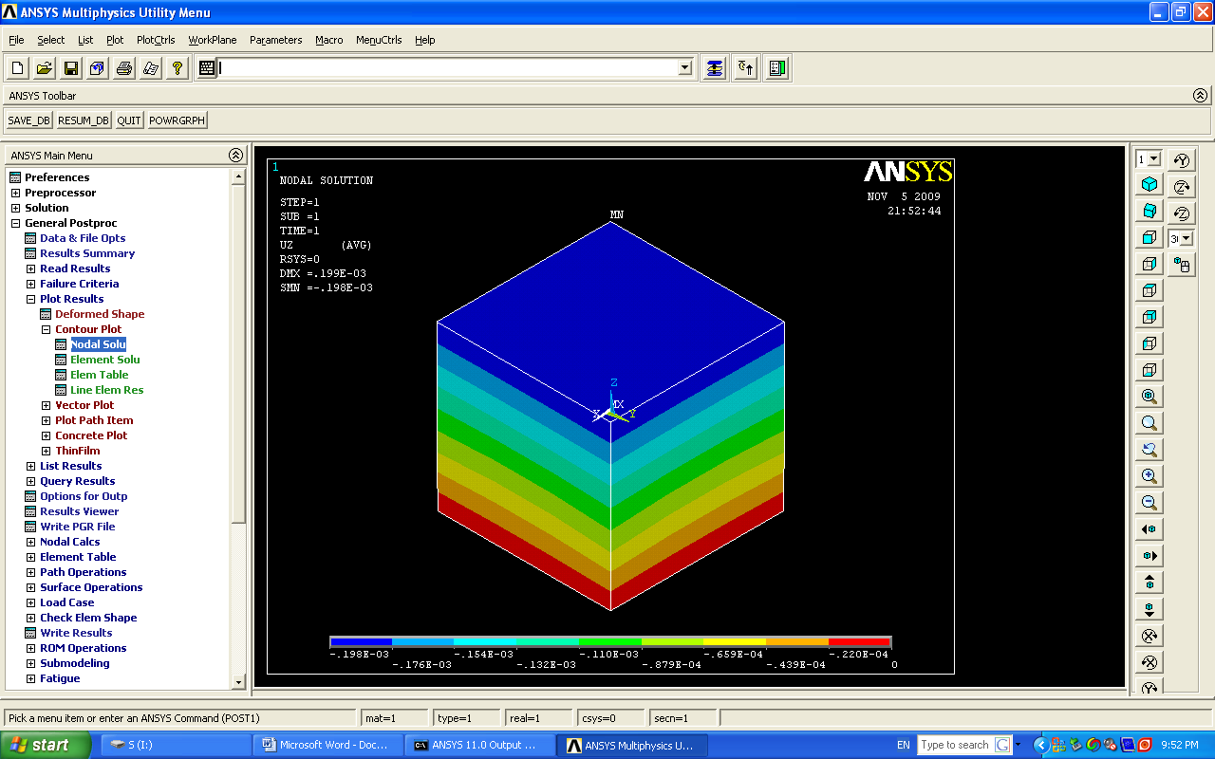

*Photo(1) :Displacement contour in z-direction after load application.*

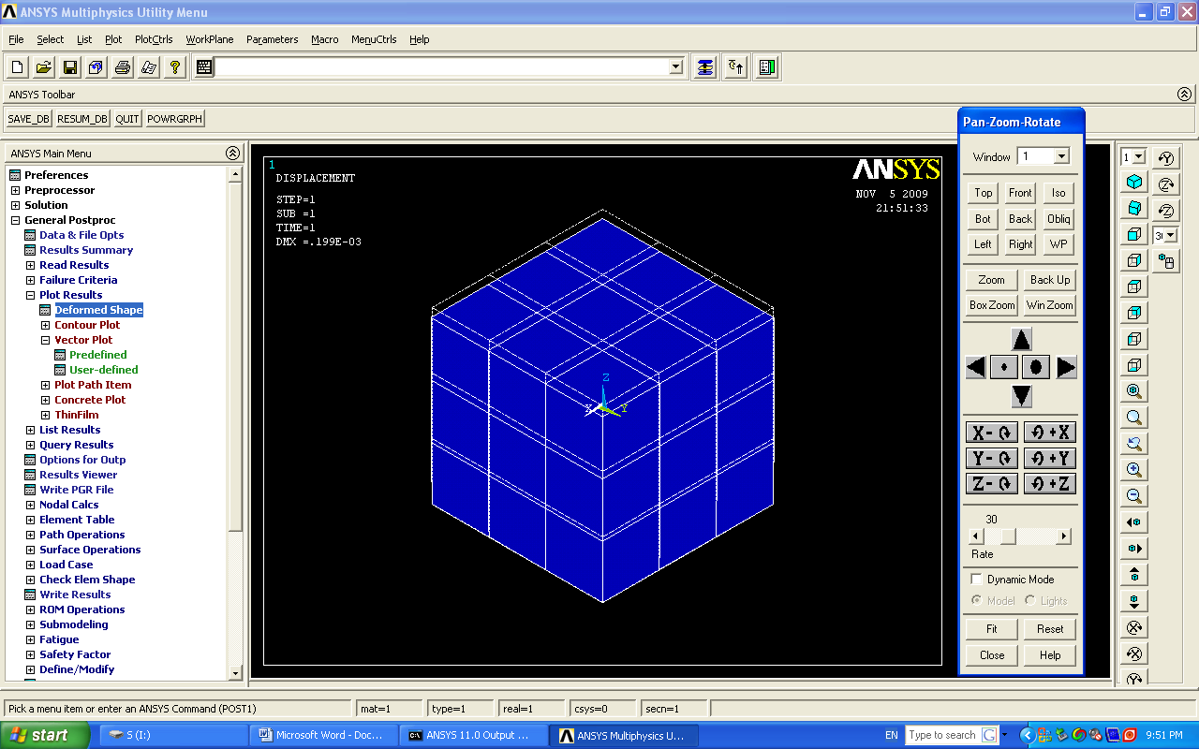

*Photo(2 ): Deformed + undeformed shape of the concrete cube in z- direction after load application.*

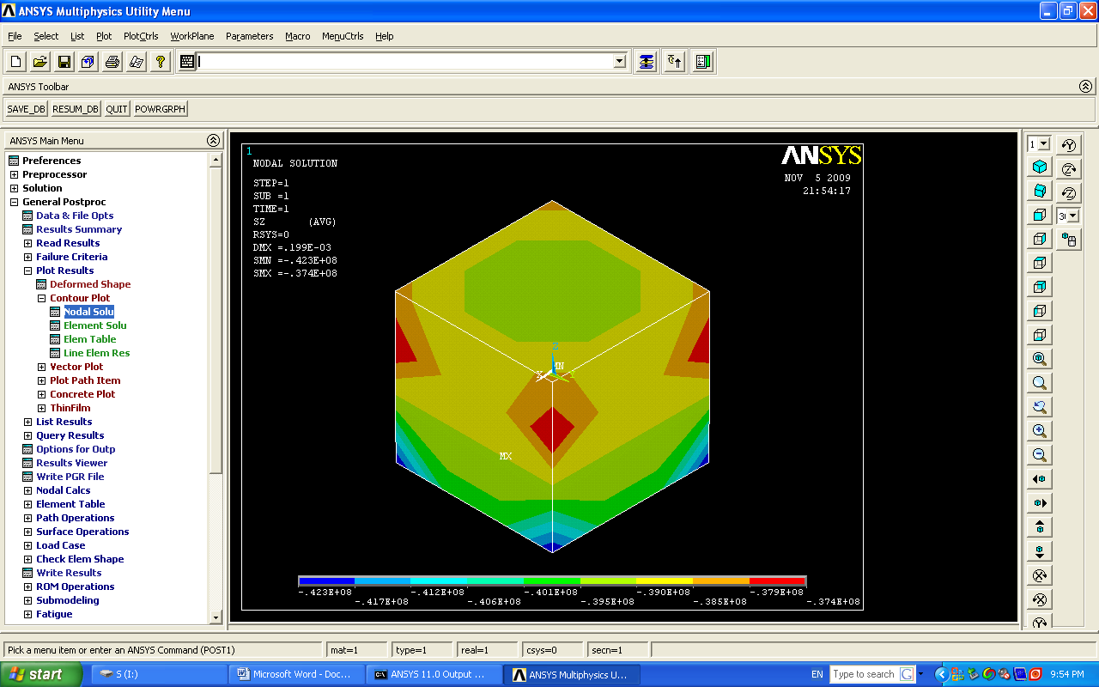

*Photo(3) : Stress contour in z-direction after load application.*

**Conclusions and recommendations**

This study really took so many variables to be studied and as it was well-known that increasing variables adds a complexity to the studied problem. The study deals with mix ratio as a first variable, water cement ratio, age of the concrete, compressive strength and the overall results of the Ansys program results. The following conclusions and recommendations can be recorded and mentioned as:

(1)It was noted that the effect of increasing water cement ratio has a slight effect on UPV results where the curves relating UPV with compressive strength are approximately coincided.

(2)Eighteen relations between compressive strength and ultrasonic pulse velocity were governed. Nine of them were represented as linear relations while the other nine, were nonlinear. The nonlinear relations are exponential and they are preferable due to their accurate outputs.

(3) Ansys software results were the bounded values of the experimental results and it was noticed that they were reasonably near others. The average maximum percentage difference between Ansys results and experimental results is between (6.4-7.8)% as maximum.

(4)Ansys results can be used to assess concrete but with care of the notes mentioned in conclusion three.

(5)The relation between compressive strength and UPV seems to be straight, but really it is not so because of the approximation done in the age of concrete cubes. The cubes were tested at 3,7,14 and 28 days age. If the period was taken to be at 1day increment, the results will be appeared in a curvilinear relationships.

**The recommendations for a future work can be mentioned in the following points:**

(1) The relations between variables were approximated by connecting results points by a straight lines as shown in all figures of this study. The preferable work is to get a curvilinear relations between variables.

(2)An independent study may be done concentrating on how the modulus of elasticity of concrete can be governed related to the various ages of concrete. This modulus of elasticity will be used as one of the material properties in the input of the Ansys program.

(3)Study of the shear stresses in x-z, y-z planes experimentally and analytically by using Ansys software or Pro-engineer or by any other available engineering software.

***Acknowledgments***

**The researchers wish to acknowledge the ministry of higher education and scientific research-Development and research office for their continuous help and financial support to complete this research throughout its period.**

**References**

ASTM C597-02, "Standard test method for pulse velocity through concrete", American society for testing and materials. USA.

BS 1881 : Part 203 :(1986)," Testing concrete recommendations for measurement of velocity of ultrasonic pulses in concrete".

DIN / ISO 8047 (Entwurf), "Hardened concrete-determination of ultrasonic pulse velocity" (in German).

GOST 17624-87," Concrete-ultrasonic method for strength determination" (in Russian).

Hilbbert R.C.(1994), "Mechanics of materials", 2nd edition, New York, Macmillan. Kim K.C., et al.(2001) ,"Research on the nondestructive measurement of nonlinear elastic modulus by using ultrasonic wave", JSME International Journal, Series A, Vol.44,No.3,Japan.

Komlos K., Popovics S., Nurnbergerova T., Babal B. & Popovics J.S., (1996) "Ultrasonic pulse velocity test of concrete properties as specified in various standards", Cement and Concrete Composites 18 :357-364.

Lislie J., Cheesman W., (1949) "Ultrasonic method of studying deterioration and cracking in concrete structures", AC J.46(1) 17-24.

MI 07-3318-94, "Testing of concrete pavements and concrete structures by rebound hammer and by ultrasound", Technical guidelines (in Hungarian).

Prassianakis I.N. and Giokas P. (2003), "Mechanical properties of old concrete using destructive and ultrasonic nondestructive testing methods, Cement and Concrete Research 55(2)171-176.

Qasrawi H., Marie I., (2003) "The use of USPV to anticipate failure in concrete under compression", Cement and Concrete Research 33 2017-2021.

RILEM/NDT 1 (1972 )" Testing of concrete by the ultrasonic pulse method" .

STN 731371,"Method for ultrasonic pulse testing of concrete", (in Slovak) (Identical with Czech CSN 73 1371).

Teodru G.,(1988) "The use of simultaneous nondestructive tests to predict the compressive strength of concrete", ACI SP-112,ACI,Detroit,pp. 137-148.

Toutanji H.(2000)" Ultrasonic wave velocity signal interpretation of simulated concrete bridge decks", Mat. Struct. 33 . 207-215.