Calculating Taste and Odor Occurrences in Hilla Drinking Water, and Suggestion Method for the Control at the Water Plant by Using Plant Trunks

Ahmed Talib Sahib Auda
Lecturer -Environment Department - College of Engineering- Babylon University
E. Mail: ahmedts61@yahoo.com
Abstract
Iraqis are becoming increasingly concerned about environmental pollution and the limitations of water treatment processes. A review is made to report sources and of tastes and odors in potable water supplies.
The field survey indicate occurrence of 102 odors and 79 tastes problems with maximum Threshold 35 , 70 respectively in taps during the period of 2006 to 2012 for metropolitan area in the city of Hilla, attributed to various sources; and use of 11248 Pointofuse treatment devices in kitchen appliance.
Approach for controlling the problem was carried out by experiment using a chamber of 1 m³ with tree trunks on top. The results shown about 99% of the taste and odors attributed to various sources were removed with detention time 3- 4 hours, which can be similar to the detention time in typical basin, and tree trunks can be used for one season or three months.
Keywords: Water Plants, Water treatment, Settling basin, Taste, Odor, Tree Trunks.
الخلاصة
أصبح العراقيون مهتمين بشكل كبير بتلوث البيئة ومحددات عمليات تنقية مياه الشرب. لهذا عمل استعراض لأهم مصادر الرائحة والطعم في مياه الشرب.
وأظهر المسح الميداني حدوث 102 مشكلة رائحة و79 طعم بحد عتبة 35 و 70 على التوالي في مياه الحنفية خلال الفترة بين 2006 – 2012 للمنطقة الحضرية لمدينة الحلة يعزى لمختلف المصادر، واستعمال 11248 وسيلة تنقية نقطية في المآخذ الصحية للمطبخ.
وللاقتراب في السيطرة لحل المشكلة شكلت تجربة باستعمال حوض 1 متر مكعب في أعلاه سيقان أشجار، أظهرت النتائج أن 99% من الرائحة والطعم التي تعزى لمختلف المصادر قد أزيلت بوقت حجز بين 3 - 4 ساعات والتي تماثل قيمة الحجز في الأحواض القياسية. كما وان سيقان الأشجار يمكن استعمالها لفصل واحد أو ثلاثة أشهر.
الكلمات الدالة: وحدات التصفية ، تصفية المياه ، حوض الترسيب ، طعم، رائحة ، جذوع الشجار.
Introduction
Odor is elicited by chemicals in a gas phase which are detected via olfaction producing recognizable smells (Cometto et al., 1997). One of the objectives in water treatment is to produce a palatable water that is aesthetically pleasing (Hammer, 2005). Taste is the perception registered by the taste buds, while odor is the perception registered by the olfactory nerves. There should be no noticeable taste and odor at the point of use of the water (Sincero and Gregoria, 2010). Water can dissolve many different substances, giving it varying tastes and odors, but it must be free of any detectable taste and odor when it is used for drinking, cooking, or bathing purposes. Taste, as a specific sensory process, is very rarely a problem in public water supplies, and most tastes are concerned almost entirely with odors (AWWAC, 1970; Baker, 1966). The repeated presence of objectionable taste and odor in a water supply may cause the public to question it's safety for consumption, and episodes vary in intensity, persistency, and frequency of occurrence. Some water treatment facilities have features designed to remove organics, insecticides, phenols, and industrial chemicals, but most do not (Hammer, 2005).
The research scope to focus on the problems of taste and odor in drinking water during the period of 2006 to 2012, and suggestion method for the control by using plant trunks. Every effort has been made to cite findings related to sources and how they are quantified and qualified. The case studies will be helpful for resource planners, consulting engineers, regulatory agencies, and water utility personnel.
Sources of Tastes and Odors in Water
A source frequently is not clear cut, and often not important. Flavor may be affected by inorganic salts or metal ions, a variety of organic chemicals found in nature or resulting from industrial wastes, or products of biological growths. Algae and decaying vegetation are the most frequent cause of taste and odor problem related to natural sources in surface supplies. Algae metabolic activities impart odorous compounds identified as alcohols, esters, aldehydes, ketones, and acids (C12 H22 O) that produce fishy, grassy, musty, or foul odor (Hammer, 2005; Sigworth, 1961), while leaves decaying can produce phenols (Hammer, 2005 ; Allen, 1960).
Odor occurrences have been described as septic, musty, muddy, boggy, vegetable, phenolic, rotten, putrid, soaked straw, very sour, varnishy, earthy, and horse urine (Letterman, 1999; Sigworth,1961). The most troublesome and objectionable situations are created by man-made sources, such as domestic, industrial wastes, agricultural activities (Hammer, 2005; Hartung, 1960), also several chlorinated hydrocarbons, ruptured petroleum pipeline and detergents (AWWAC, 1970; Hartung, 1960 ).
Bacterial activity may establish a category of tastes and odors (Sincero and Gregoria, 2010; Silvey et al., 1973).
Inorganics such as nitrogen , phosphorus, Sulfur and iron are the other inorganic constituents into a water supply may indirectly cause tastes and odors.
Free residuals in treatment of water by using chlorine which is used for disinfection and/or taste and odor control, usually produce tastes and odors in potable water (Sincero and Gregoria, 2010; Hammer, 2005). Applied doses of chlorine Calculate to be sufficient for oxidizing taste-producing organic material. Some substances, when chlorinated, very often are the source of tastes and odors like Trihalomethanes which are by-products such as chloroform, bromodichloromethane, dibromochloromethane, and bromoform are formed when organic compounds in the water come in contact with chlorine. (Hammer, 2005; Murray, 1972). If tap water has a distinct taste and smell of chlorine it usually means there is a high chlorine residual in the water, maybe not above the maximum containment level of 4.0 mg/l, but high enough that the person finds it offensive to the taste, and values greater than 1 mg/1 generally produced customer complaints (Lindsay, 2004;U.S. Environmental Protection Agency, 2003). Although coagulation is not designated for the corrective treatment of taste and odor, a good coagulation process improves taste and odor control for many raw waters which reduced considerably (Hammer, 2005; Silvey et al., 1967).
Finished water leaving a water plant will enter the distribution system free of taste and odor. The water travels may become more intense an odor due to populations of sulfur or iron bacteria, algae, or actinomycetes growing in the distribution system (O'Donovan, 1965).
Standard Methods of Tastes and Odors Measurement
The method used for test is Threshold Odor Test which depend on human perception of the taste and odor in the water. The threshold odor number (TON) is used as a quantitative unit for numbers that indicate how many dilutions it takes to produce odor-free water. Although the human olfactory sensory analytic procedures are not entirely satisfactory, there is no substitute (Sincero and Gregoria, 2010; Kerri, 2002;Letterman, 1999 ;Hou and Clancy, 1997). There are many factors influence as number of testers, order of presentation, gender, age, economic, social and physiological background, degree of training, testing frequency, statistical and laboratory designs, and temperature ( Illinois Pollution Control Board, 1974).
Calculate Taste and Odor Problems in Hilla City
Hilla city area is equal to 55 km² contain 60 residential areas with population of 258568 persons (Babylon statistics office, 1997(, located on both sides of the river in position intersect longitude 44.26° east and latitude circle 32.29° north (Katib, 1974). The Iraqi environmental legislations protect and enhance the river from pollution, which regarded the main source for water supply (Environmental legislations, 1998). The old and new projects connected together with one distribution system, treat by using physical and chemical processes includes screening, coagulation and flocculation mixing, sedimentation, filtration, and disinfection with chlorine.

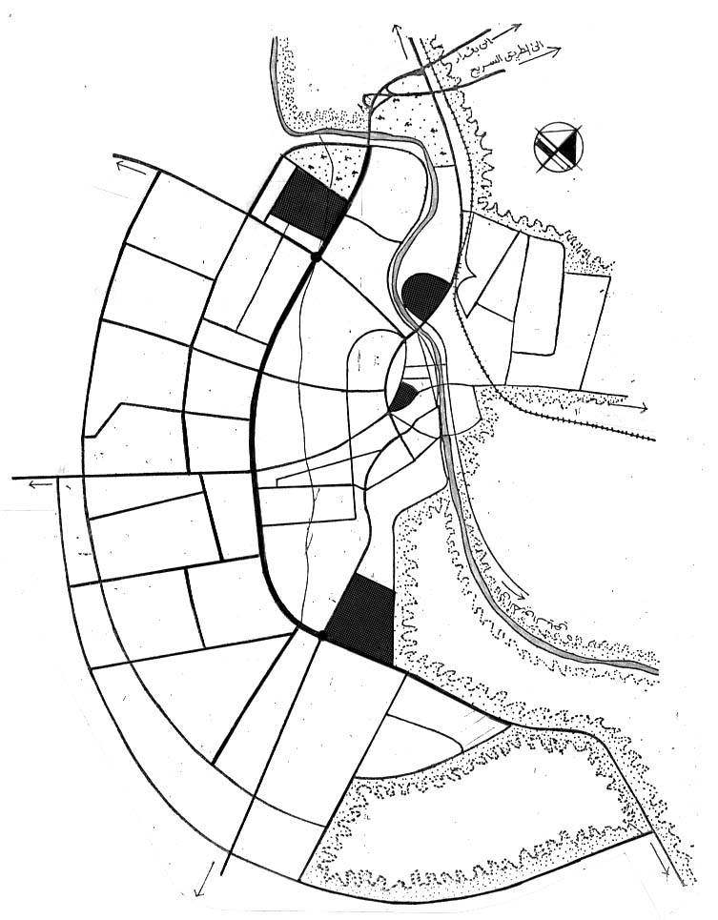
City center
Al-Hussayn area
Gameya area

Scale - 1: 85000

Figure ( 1 ) Site plan for Hilla city showing locations of Samples taking; ( Babylon Physical planning, 2005)
To find the source of a problem, the water tested at various locations, from the water source to the customer's tap. The occurrences of tastes and odors at a water plant or in a water system are generally unpredictable, therefor reported on raw and tap in daily periodic time at three major points. The measurement of the threshold of each odor substance was carried out by panel member of 7 untrained persons who are same during the measurement period and are changed every year. The results are shown in ( Table 1) and ( Figure 3).
Water treatment devices have become common household appliances in recent years. Statistic field survey estimated that as many as 11248 units ( 30% from dwelling units) are sold annually in Hilla as Pointofuse kitchen appliance that installed on single or multiple taps, can improve the appearance, taste and smell of for drinking and cooking only.

Suggestion Method to Remove Odor and Taste
To simulate Al-Teyara sedimentation tank for the old and new projects treatment plants in Hilla city, a chamber of 1 m³ was used for the experiment. On the top located a mesh carrying tree trunks (Coniferous, oak, fig, or pomegranate), as method for removing tastes and odors. The outer surface of trunks must exposed to air all time to dry wood fibers as shown in ( Figure 2). The results shown about 99% of the taste and odors attributed to various sources were removed with detention time 3-4 hours, which can be similar to the detention time in typical basin (Henry and Gary, 2009; Hammer, 2005), and tree trunks can be used for one season or three months. After this period using trunks may not give any practical benefit for removal.

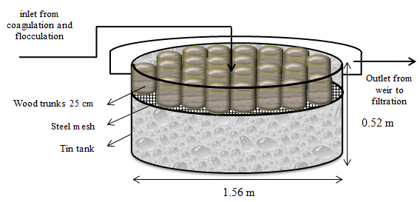

Figure ( 2 ): Sketch of the chamber, designed to measure odor and taste removal for raw water attributed to various sources; by the researcher.

Conclusions
1. By using tree trunks in settling basin, which consider cheap way, about 99% of the taste and odors attributed to various sources, were removed with detention time 3- 4 hours, which can be similar to the detention time in typical basin, and tree trunks can be used for one season or three months.
2. The movable mesh can be useful when there is a need or not.
3. The suggestion has a success approach to employ adequate method and provide proper functioning as a step to remove taste and odor.
4. Occurrence of 102 odor and 79 taste problems with maximum Threshold 35 , 70 respectively in taps during the period of 2006 to 2012, attributed to various sources.
5. There are 11248 Pointofuse units ( approximately 30% from dwelling units) used as kitchen appliance that installed on single or multiple taps, can improve the appearance, taste and smell of for drinking and cooking only.
6. Ruptured petroleum pipeline is the main cause of oily smell.
7. Most problem of taste and smell in tap water from high chlorine residual, and from excessive coagulation.

Recommendation
1. The case studies will be helpful for resource planners, consulting engineers, regulatory agencies, and water utility personnel.
2. Design modified water treatment plant with settling tank using plant trunks, when there is a problem of taste and odors to produce a palatable water that is aesthetically pleasing.
3. In the distribution system, periodic flushing and maintaining an adequate chlorine residual will keep the pipes clean and odor free.
References
Allen, E.J., 1960,“ Taste and odor problems in new reservoirs in wooded areas”, Journal American Water Works Association , 52(8),1027-1032.
American Public Health Association, American Water Works Association, and Water Pollution Control Federation, 1971, “ Standard methods for the examination of water and wastewater”, American Public Health Association, Inc., New York.
American Water Works Association Committee on Tastes and Odors (AWWAC), 1970,“ Research on tastes and odors”, Journal American Water Works Association 62(l),59-62.
Babylon Physical planning, 2005, Babylon, Iraq.
Babylon statistic office, 1997, Central statistic board, Iraq.
Baker, R. A., 1966, “ Taste and odors , examination of present knowledge”, Journal American Water Works Association, 58 (6) , 695-699.
Cometto, M., Cain, W.S., and H.K. Hudnell, 1997,“Agonistic sensory effects of airborne chemicals in mixtures”, Journal Perception and Psychophysics, 59(5), 665-674.
Environmental legislations, 1998,Department of Environment protection and enhancement , Ministry of health , Iraq.
Hammer, Mark J., 2005, “ Water and Wastewater Technology”, Prentice – Hall of India, New Delhi.
Hartung, H. O, 1960, “Effects of pollutants in water supplies , taste and odor”, Journal American Water Works Association, 52 (11) , 1363-1366.
Henry, J.Glynn and Gary, W. Heinke, 2009, “Environmental Science and Engineering”, Second Edition, Prentice – Hall of India, New Delhi.
Hou, J., and B. Clancy, 1997, “ Tastes and Odors Problems in Water Treatment”, Virginia Tech, Blacksburg, USA.
Illinois Pollution Control Board, 1974, “ Rules and regulations, Public Water Supply”, Springfield, USA.
Katib, S. M., 1974 , “ The Large Hilla City, Functions and regional relationship”, Menar library , Baghdad.
Kerri, K.D.,2002,“ Water Treatment Plant Operation”, California State University, USA.
Letterman, R.D., 1999, “ Water Quality and Treatment”, A Handbook of Community Water Supplies, McGraw-Hill, Inc., New York.
Lindsay, L., 2004, “Chlorination On Tap”. National Environmental Services Center, Morgantown, USA.
Masters, Gilbert M., 2005, “Introduction to Environmental Engineering and Science”, Prentice – Hall of India, New Delhi.
Murray, W. B., 1972, “ Taste and odor control with sulfamic acid”, Journal American Water Works Association , 64(4), 259-260.
O'Donovan, D. C., 1965, “ Treatment with ozone”, Journal American Water Works Association , 57(9), 1167-1192.
Sigworth, E. A, 1961, “ The production of palatable water”, Taste and Odor Control Journal, 27(10),1-8.
Silvey, J. K. G., H. B. Sharp, K. L. Dickson, R. C. Allison, and J. C. Stiles, 1973, “Some effects of evaporation suppression on reservoir ecology”, Journal American Water Works Association, 65 (4) , 260-268.
Silvey, J. K. G., K. Guthrie, and H. E. Schlichting, 1967, “ Taste and odors in surface water supplies”,Manual of Water Utility Operations, Inc., Lancaster, Pennsylvania.
Sincero, Arcadio P., and Gregoria A. Sincero, 2010, “Environmental Engineering, A design approach” , Prentice – Hall of India, New Delhi.
Site plan for Hilla city, 1993 , Babylon Building planning.
U.S. Environmental Protection Agency, 2003, “National Primary Drinking Water Standards” , USA.

Number of observations

Figure ( 3 ): Frequency of Odor and Taste types observed at the Hilla tap water supply from 2006 to 2012 attributed to various sources; a Threshold odor survey by the researcher.

Table (1): Some results of water Odor and Taste problem observed at Hilla city from 2006 to 2012 attributed to various sources; a Threshold odor survey by the researcher with aid (Letterman, 1999) .
(A) Odor
Water sample*¹  / Year |  | Number of observations |  | Threshold odor number (TON)^{*3} |  | Type of odor
 |  | Winter*² | summer | Max | Min | Type of odor
Raw | 2006 | 16 | 17 | 50 | 21 | Fishy-8 , Musty-3, oily smell-11, bleach- 11
Raw | 2007 | 11 | 2 | 70 | 24 | Fishy-7 , oily smell- 3, bleach -3
Raw | 2008 | 4 | 2 | 70 | 50 | oily smell - 4, , bleach - 2
Raw | 2009 | 5 | 3 | 12 | 12 | oily smell - 6, grassy-2
Raw | 2010 | 5 | 3 | 12 | 8 | Fishy-3 , Musty - 2, bleach - 3
Raw | 2011 | 3 | 4 | 21 | 4 | Fishy-5 , oily smell - 2
Raw | 2012 | 2 | 3 | 50 | 24 | bleach - 3, Fishy-2
Tap | 2006 | 13 | 11 | 35 | 24 | oily Smell - 10 , chlorinous- 14
Tap | 2007 | 10 | 9 | 24 | 8 | oily Smell - 8, chlorinous - 11
Tap | 2008 | 7 | 8 | 12 | 8 | oily Smell - 5, chlorinous - 6, excessive coagulation - 4
Tap | 2009 | 8 | 5 | 16 | 8 | oily Smell - 3, chlorinous - 5, excessive coagulation - 5
Tap | 2010 | 8 | 3 | 35 | 24 | oily Smell - 3,chlorinous - 5, excessive coagulation - 3
Tap | 2011 | 8 | 4 | 8 | 4 | Chlorinous - 8, bleach - 4
Tap | 2012 | 4 | 4 | 16 | 4 | excessive coagulation - 5, bleach -3

(B) Taste
Water sample*¹  / Year |  | Number of observations |  | Threshold Taste number (TTN) |  | Type of Taste
 |  | Winter*² | summer | Max | Min | Type of Taste
Tap | 2006 | 11 | 11 | 12 | 4 | Chlorinous - 13,  excessive coagulation - 9
Tap | 2007 | 7 | 8 | 24 | 21 | Chlorinous - 11,  excessive coagulation - 4
Tap | 2008 | 4 | 8 | 12 | 8 | Chlorinous - 6 ,  excessive coagulation -6
Tap | 2009 | 6 | 6 | 70 | 12 | Chlorinous - 5,  excessive coagulation -7
Tap | 2010 | 6 | 2 | 35 | 4 | Chlorinous - 5,  excessive coagulation - 3
Tap | 2011 | 2 | 2 | 16 | 8 | Chlorinous - 3,  excessive coagulation -1
Tap | 2012 | 3 | 3 | 16 | 4 | Chlorinous - 2,  excessive coagulation - 4
*¹ All tests were made at room temperature (25°C) by 4-6 panels.
*² Winter From 1 November to end of April.
*³ Heat the samples and the blanks to the testing temperature of 40 or 60°C.

Appendixes :
Appendix (1) :
1 - The secondary standard criteria for odor in drinking water is ( 3 TON ) (Sincero and Gregoria, 2010; Illinois Pollution Control Board, 1974; AWWAC, 1970).
2 - Pure H₂O is tasteless and odorless ( Hammer, 2005).
Appendix (2) :
Unit expression numerical value of odor or taste ( Sincero and Gregoria, 2010; American Public Health Association , 1971 ):
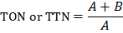
Where TON is the threshold odor number and TTN is the threshold taste number.
A = volume of sample to be just detectable (in milliliters)
B = odor-free distilled water (in milliliters)
(A + B ) the resulting total mixture volume = 200 ml.
During the procedure, the water being tested is diluted with odor-free water and is smelled. The dilutions continue until no odor can be discerned. The last dilution at which odor is detected determines the Threshold Odor Number (TON), which is a measure of the amount of odor in the water. If several people independently perform the Threshold Odor Test, the averaged TON can be relatively accurate. Series of appropriate dilutions
2.8 ml → Intermediate dilution
12 ml → 12 ml, 8.3 ml, 5.7 ml, 4.0 ml, and 2.8 ml
50 ml → 50 ml, 35 ml, 25 ml, 17 ml, and 12 ml
200 ml → 200 ml, 140 ml, 100 ml, 70 ml, and 50 ml
Number of panel more than 6 panels

