Analytical Study of Haditha Reservoir Sedimentation by CFD Model

MAJID H. HOBI
University of Kufa, Water Resources Department
majidhamed73@yahoo.com.

Abstract
The Haditha reservoir in Iraq was selected as case study to be used in the numerical models, because it possesses the two relevant types of reservoir sedimentation processes (delta formation and density current). It represents a case where the reservoir storage capacity losses are substantial. In order to reduce capacity losses. The delta formation was simulated for fixed and fluctuating water level in the reservoir, including the simulation of the formation of channels in the delta.
The model was a previous run for simulating delta formation, and by subsequently applying the gradual water drawdown procedure used in the Haditha reservoir, the actual removing process of the accumulated sediment was simulated. In this study the different processes and phenomena related to reservoir sedimentation were simulated in successful way for a real and a schematized reservoir, whereas also flushing as mitigation measure was fairly well simulated when compared with the practice in Haditha reservoir. However more studies and a proper calibration and verification are needed to predict the sedimentation processes more accurately before using the model for design purposes.
Keywords: Reservoir, Haditha, sedimentation, Numerical Modelling, channels formation, density current, flushing.
المستخلص:
خزان حديثة المائي الذي يعتبر من أكبر الخزانات الطبيعية على نهر الفرات. يعود سبب أختيار منطقة الدراسة الى وجود مشاكل في هذا الخزان بوجود نسب كبيرة من الرسوبيات وبدأ بتشكل جزر أو ما تسمى الدلتا متفرقة في المنطقة. شغل الموديل مسبقاً لمحاكاة التشكلات المتكونة من الرسوبيات وحركتها في خزان حديثة. الكثير من البديهيات والعمليات المحاكاتية طبقت في هذا الموديل وأشير لها في الدراسة وتعتبر ناجحة في المحاكاة. الموديل كان قادراً على محاكاة كافة عمليات الرسوبيات وتشكيل الدلتا وبشكل جيد ومناسب. الكثير من الإجراءات والبديهيات استخدمت في هذه الدراسة لبيان نجاح تطبيق الموديل الرياضي. كذلك عمليات الغسل كانت احد الأساليب لتخفيف وطئة الرسوبيات مع المقارنة بين تطبيق الموديل والواقع. على أي حال فأن دراسة الرسوبيات والعمليات المصاحبة لها تحتاج المزيد من البحث والتقويم قبل الاعتماد بشكل كلي على هذا الانموذج في التصميم الهندسي وبشكل مطلق.
الكلمات المفتاحية: الخزان، حديثة، الترسيب، نمذجة العددية، وتشكيل القنوات، كثافة التيار، وبيغ.
- Background
Reservoir sedimentation is a complex process of the sediment transporting and deposition. Sedimentation starts after damming a natural river and storing water in the reservoir behind the dam. Due to increasing the flow geometry of a river when it enters to the reservoir, the water flow velocity is reduced and sediment carry capacity will diminish which cause dumping most of the sediment load carried by a river into the reservoir. Different type of sedimentation occur in the reservoir, one due to normal deposition of the sediment load at beginning of the reservoir, and the other due to formation of density current which brings more sediment to middle and downstream end of a reservoir. The knowledge about the rate and the pattern of sediment deposition is one of important requirements for understanding the sedimentation and morphological processes in the reservoir. And to have a good insight about the different reservoir sedimentation behavior and their consequences on the reservoir storage volume, water quality as well as its impacts on the morphological change at the downstream reach of the reservoir. For better understanding about the reservoir sedimentation behavior, it is important to use a tool to explore among different sedimentation process happen in reservoir. The Numerical modelling is one of those tools which is used to dealing with the different reservoir sedimentation under different states. In this research we attempt to reproduce and simulate different reservoir sedimentation processes by numerical modelling and using SSIIM software package, and also to simulating the mitigation measure (flushing) used to reduce the sedimentation in the reservoir.
Reservoir sedimentation happens in most reservoir in the world, and the sensitivity of such phenomena is determined by the normal reservoir size, hydrological size as well as the morphological behavior of the river system. From the water resources point of view, due to limitation of the natural resources and the global changes that happen in the latest century, the problem of reservoir sedimentation has become a serious problem especially when it affects the availability of water resources in such area and maximizing the risks coming from the excessive floods due to weather changes. Due to increasing of sedimentation in the reservoir and the number of reservoirs, the annual storage loss by sedimentation is roughly estimated at 1%, which is corresponding to about 50 km³ of water in the world (Mahmood, 1978) and in some other reservoirs was observed more than this percentage, e.g. the Sanmenxia Reservoir in China loses about 1.7% yearly, Sefid-Rud reservoir in Iran about 2% and the Welbedacht reservoir in South Africa loses about 5 % of its capacity (Sloff, 1997). Also from the economic point of view, the sedimentation is serious problem, due to the degradation of reservoir revenue as a result of reduction of available water and the cost required for removing the accumulated sediment.
- The Objective of Study
The objective of this study is simulate different sedimentation process within the reservoir during operation, and to simulate for the flushing process in the reservoir as well. It is specifically concentrated on the different types of sedimentation processes in reservoir, which take place by normal deposition of sediment load or by rare transporting and depositing of sediment due to turbidity current. The prediction of mitigation measures used for the reservoir sedimentation is another objective of this study, which is dealing with the study of flushing process in the reservoir to remove the accumulated sediment. The main objectives can be presented through these points:
- To get an insight to the sedimentation process in the reservoir through a literature review.
- Studying different kind of sedimentation that occurs in the reservoir and its distribution pattern with in reservoir.
- Simulating the formation of the turbidity current caused by the suspended sediment variation in the reservoir.
- Methodology
The study of reservoir sedimentation by different process has been conducted by means of numerical modelling; therefore, it is a main tool applied in this research to study the behaviour of sedimentation in the reservoir. SSIIM software package has been used for setting up the numerical model for a selected reservoir case, which is powerful software used for the prediction and simulation of the morphological change in the shallow water filed in river, reservoir, lake and other hydraulic field. Both two and three dimensional numerical models can be generate through the use of this software. The Haditha reservoir which is located in the Iraq has been used as a case study for the numerical modelling, which possesses both types of reservoir sedimentation (Delta formation and Density current).
- Types of Reservoir Deposition
The river flow usually carries a wide range of the sediment particle size and they are transported either as a bed load or as a suspended load. In general, the bed load material (coarse sediment particle) moves near to the bed, and it starts to deposit in the beginning of the reservoir entrance and they are depositing in the form of the delta as shown in Figure 1, While the suspended sediments (fine sediment particle with lower settling velocities) are transporting deeper into the reservoir either by non stratified flow and forming a uniform deposition at the middle of reservoir, or by stratified flow and depositing at lower part of the reservoir and forming a muddy lake (Figure 1). In general suspended load are divided in two parts, one comes from bed of river, and the other as wash load from the catchments area. Batuca and Jordaan in 2000 have classifying the reservoir sedimentation based on the location of deposition into three categories, with including the sedimentation in backwater reach as a part of the reservoir sedimentation. The position of each type of reservoir sedimentation can be seen in the longitudinal profile of the reservoir as in the (Figure 1) and they are classified in to;
1. Back water deposition.
2. Delta deposition.
3. Bottom set deposition
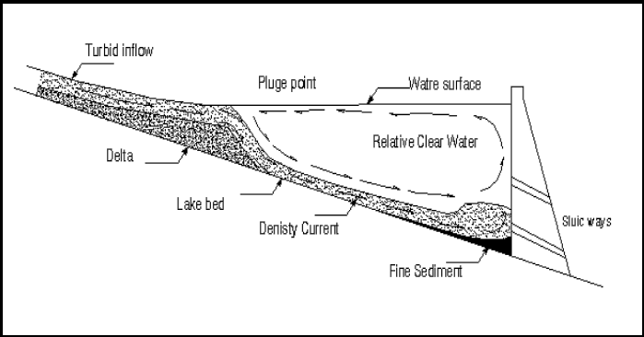

Fig. 1: Typical Longitudinal cross section of reservoir sedimentation, (Sloff, 1997)

- Flow Parameters in The Model
The Navier-Stokes equations for turbulent flow in a general three-dimensional geometry are solved to obtain the water velocity. The k-ε model is used for calculating the turbulent shear stress. A simpler turbulence model can be used. This is specified on the F 24 data set of the control file.
The Navier-Stokes equations for non-compressible and constant density flow can be modelled
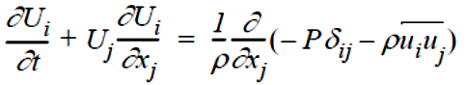
as:

Where U is Depth average velocity [m/s], ρ is Density of water [Kg/m3], u_{i}, u_{j} components of velocities in x,y directions [m/s], ᵟ_{ij} Angle between longitudinal and flow direction [degree] and P is pressure. The left term on the left side of the equation is the transient term. The next term is the convective term. The first term on the right-hand side is the pressure term. The second term on the right side of the equation is the Reynolds stress term. To evaluate this term, a turbulence model is required. The equations are discretized with a control-volume approach. An implicit solver is used, also for the multi-block option. The SIMPLE method is the default method used for pressure- correction. The SIMPLEC method is invoked by the function in model code as a data set in the control file. The powerlaw scheme or the second-order upwind scheme is used in the discretization of the convective terms. This is determined by the values on the data set in the control file. The numerical methods are further described by Patankar (1980), Melaaen (1992) and Olsen (1991). The time step and number of inner iterations are given on the input values. For transient calculations, it is possible to give the water levels and discharges as input time series.
5.1 The Boussinesq Approximation
The eddy-viscosity concept is introduced with the Boussinesq approximation to model the Reynolds stress term:
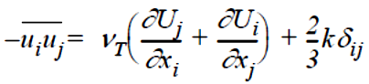

Where: v_{T} Kinematic diffusion viscosity and k is turbulent kinetic energy. The first term on the right side of the equation forms the diffusive term in the Navier- Stokes equation. The second term is often neglected. The third term on the right side is incorporated into the pressure. It is very small, and usually not of any significance.
5.2 The k-ε Turbulence Model
The k-ε model calculates the eddy-viscosity as:
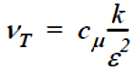
k is turbulent kinetic energy, defined by:
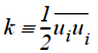

k is modelled as:
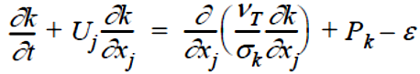

where P_{k} is given by:
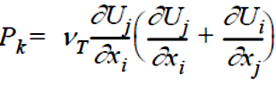

The dissipation of k is denoted ε, and modelled as:
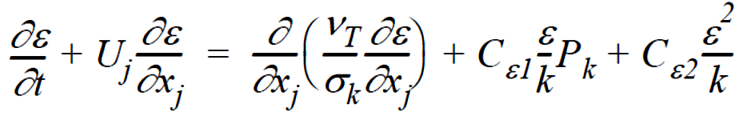

In the above equations, the c's are different constants.
5.3 The k-ω Model
The k-ω model was developed by Wilcox in 2000. It is given by the following equations:
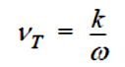

k is turbulent kinetic energy, similar to the k-ε model. k is modelled as:
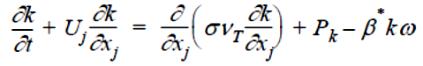

where P_{k} is the production of turbulence, similar to the k-epsilon model:
Instead of using the dissipation of k as the second variable, the model uses ω, which is the specific dissipation rate (units seconds⁻¹). The equation for ω is modelled as:
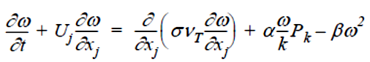

The k-ω model often gives less turbulent diffusion than the k-ε model. This means it may overpredict the size of recirculation zones, whereas the k-ε model often underpredicts the recirculation zone length.
- Back Water Deposition
This type of deposition is occurred in the river reach before entering to the reservoir. After changing the water level in the river by the effect of back water curve, the velocity of water will reduced. Subsequently a small part of the coarse sediment will deposit in this region until it reaches to the reservoir and delta deposition. It is considered as a transition between the original river bed and delta formation as shown in Figure.1. In theory, the backwater deposit should grow progressively, into upward and downward direction of the river, because the backwater extends with changes of the bed form. But this growth is limited, as the stream adjust its channel by eliminating meanders, and by forming a channel having an optimum width-depth ratio or by varying the bed form roughness so that these factors made the stream to transport its sediment load through the reach and evolution done in one direction [Vanoni, 1977]. The backwater deposition is not fixed, but it is fluctuated and advanced toward the reservoir and delta. As a result of the variation of the reservoir water surface and water flow velocity. The backwater sediment is re-eroded and transported toward the reservoir and contributes in the formation the delta.
- Bottom-Set Bed Depositions
Bottom deposition of the reservoir is formed by transporting and depositing the fine sediment, which is carried by the water to the middle and end of the reservoir in suspension stage. This type of deposition is mainly composed of clay and silt fraction, which are transported in the reservoir water body either by the turbulent suspension or by turbidity currents. And its deposition location starts beyond the delta and up to the dam wall and site. The shape and configuration of the deposit is affected by the process of transporting and depositing of suspended material. There are two main ways of transporting of the fine sediment into the reservoir body, one by the suspension action of the sediment particle, which make them travelling beyond the delta toward the reservoir body either by the action of electro-magnetic of small particles or by turbulence action of flowing water, and the other way is by the gravity action on the sediment-laden water which enters to the bottom of the reservoir in form of turbidity current. Due to the existing of clay particle in the suspended sediment load, some of very small particle unable to deposit by its self-weight, but it deposit by the cohesiveness and aggregate of two or more sediment particles to form flocs, which having more weight and terminal falling velocity, and able them to settle as course silt particle (Vanoni, 1977), according to his classification there are three type of cohesive mineralogical group which is sub divided from clay material; the montmorillonites; the hydrous micas or illites and the kaolinites. The montmorillonites are most active for ionic exchange with surrounding water and forming floccules and it settle out in the water as much as rate of the course silt particle, the other type is less active and they need more concentration to form flocs and able to deposit in the reservoir. According to Yu at el in 2000, there are three types of deposition behaviour of fine sediment within the reservoir body as below;
1. Fine particle deposition in the quasi-homogenous flow.
2. Finest particle deposition in muddy lake region near dam body.
3. Fine particle deposition in turbidity current regions.
- The Region of Study

The Lake Haditha, western Iraq is the most important land lakes in Iraq to store water for drinking purposes. In addition to irrigation, flood control and power electricity generation. The Haditha Dam is one of large dams that have been established recently in Iraq on the Euphrates River is, which began the process of storage where 1984-1985. The Haditha Dam is the only place on the Euphrates River, one of the large dams in the country. The levels of lake are ranged between 170-110m a.l.s. The dam is located at a distance of 7 km by the town (Haditha). The height of dam 57 m and the length of the dam at the top 8933 m. While the view the base of the dam 386 m and the width of its the top of the dam 20 m, level 154 m above sea level attributed to operational of the dam is 147 m, where the size of storage 8.3 billion m³ and the reservoir area of 503 square kilometers either attributed. The highest in the flood it is, 150.2m is attributed to temporary storage, 10 billion m³) and area reservoir 575kilometers square and the flux of water 6-door rays shape 6 holes, each display slot (16m) and discharge 7900 m³/s when the reservoir level 147 m above sea level. The highest discharge is 11000 m³/s, when the reservoir at level 150.4 m above sea level and lower level of the tank to run the units turbine is, 129.5 m while the lower level of the reservoir in the Haditha Dam is 112m above sea level. Fully start running the dam in 01/05/1985 for the first storage level to 122m above sea level; In February 1986, was running the first unit of the station In hydroelectric 1/11/1988 was the actual achievement of the dam and all its accessories. [Ministary of Water Resources, MOWR] (Figures. 2 and 3).
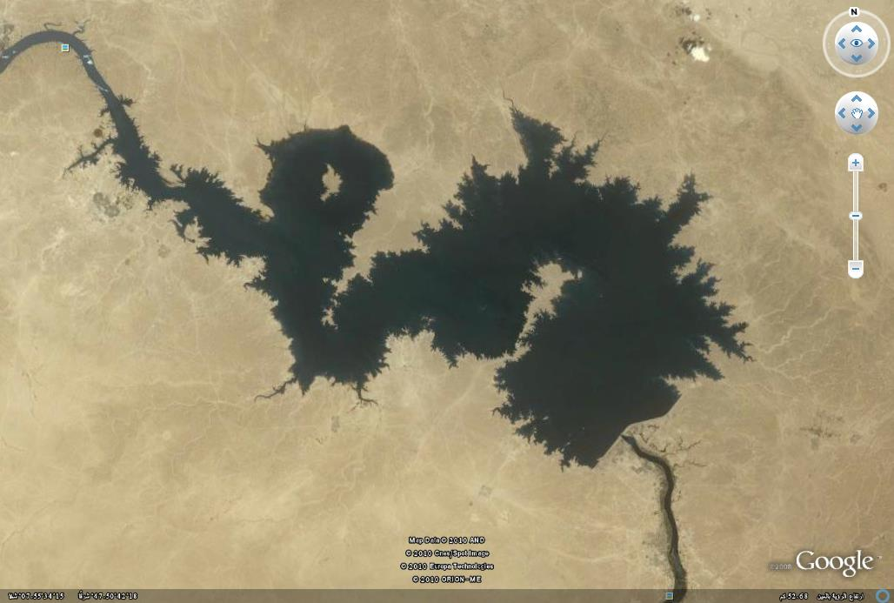
Location of Dam

Fig. 2: Satellite Image of study region, by Google earth.

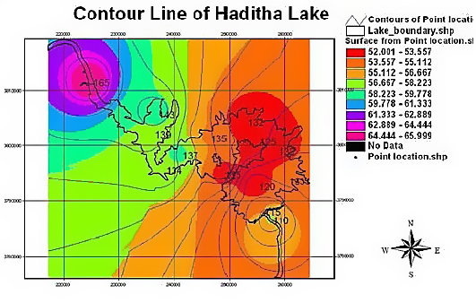

Fig. 3: The Contour line of Haditha lake, MOWR in Iraq

- Problems of Irrigation Systems in Haditha Lake
Recently years the water resources in Iraq because of the increase in the dams built in the neighboring countries and the wrong politics in the past. These decrease in the incoming in water resources to Iraq led to need more study and development of water reservoirs in Iraq. A major problem in Iraq and the obvious problem is the sediment. These sediments, where many of the problems in reduce the efficiency of storage water. The obvious problem in recent lake levels lake is down, resulting in lack of water releases. Those few with bullets of water in turn led to the accumulation of large amounts of sediment without enough flushing operations to the lake basin as well as the emergence of islands scattered in different parts of the lake is clear evidence of the rising sediment in the region.
- Numerical Modeling
Another method, which is used for prediction of reservoir sedimentation, is by using of numerical modelling, due to the advance that witnessed the computer technology, this method become more useable and more manageable than using physical modelling, this method is relatively modern and it is less costly and less time consuming as compared by physical modelling. Due to using more accurate formula, and inventing some powerful software like SIMPLE, which is consideration the critical parameters and special phenomena happen in the field of hydraulics, thus, the numerical model uses in predicting techniques becomes more accurate than empirical or semi-empirical methods. It can be used as affective tool to explorer the interrelation between all variables, which are affecting the ongoing process, as the case in the reservoir sedimentation, like finding out the effect of size and texture of sediment or size and shape of reservoir as well as the reservoir operation i.e. the inflow and out flow of the model (Chen, Lopez and Richardson, 1978). The uses and features of the numerical modelling for the reservoir sedimentation is differ according to responsible phenomena happen during the siltation process and required level of predicting accuracy. The objective is to simulate the water and sediment flow realistically as much as possible within the reservoir basin, including some secondary processes that occur in reservoir, In the numerical modelling, same steps are needed to carry out the simulation process namely;

1. Schematization of problem.
2. Writing the governing equation and boundary conditions.
3. Numerical solution with some computational stage
4. Calibration and verification of solution
Depending on type of the phenomenon that required to dealing with it and the required level of accuracy, the mode of numerical model mode and its governing formulas are determined. The 2D depth average numerical model is quite suitable for dealing with problem of the sedimentation and delta formation at upstream of reservoir and its distribution pattern toward the middle as well as the formation of channel within the delta deposition, but for case of turbidity and density current, it is required to be model in three dimension or two dimension laterally averaged and this coming from more sensitivity to the vertical direction rather than other direction and the phenomena almost vertically happen. For predicting both cases, the SSIIM software was used in the model set up and simulation the process. The short description and main governing equation used for predicting both phenomena are presented in the next section.
- Represented Model Domain (Mesh Generation)
In all models in computational fluid dynamics (CFD) the prototype domain of flow process has to be described in the numerical model. To present the complex three-dimensional geometry of the experimental mentioned in this section. Initially, the grids of model must be create near the real prototype reach. The convergence of the prototype regime and the numerical model regime is very difficult and complex in this software. The model is specified just for laboratories use. To solve like this problem, the model modified by connected the model was connected with other software in order to construct grids. The best method was with 3-D MAX software. This technique was new technique during this research. In order to construct geometrically a three dimensional model.
Based on the available topographical map of the Haditha Reservoir (Figure3), the boundary line of reservoir was generated as a general layout, which is belong to the reservoir before starting of storing water. Next, the computational grid was generated based on the introduced reservoir boundary. Some modifications and simplifications of the reservoir shape were made, to avoid getting a very complex grid shape. The final grid generation is shown in Figure 4.

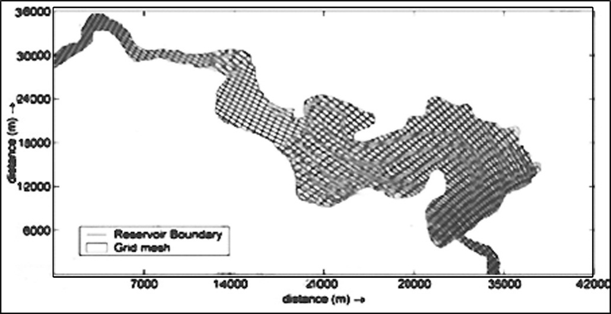

Fig. 4: Computational grid for the Haditha Reservoir

- The Specific Gravity of Bed Sediment
The specific gravity is defined as the dry weight of material within a unit volume. The procedure followed to obtain the specific gravity of bed sediment materials was according to ASTM D422. Table(1) shown the values of specific gravity of bed sediment material at each section. These locations were distributed around Hadith Lake. The average value for all sections was 2.69. This value is one of initial value in the model.

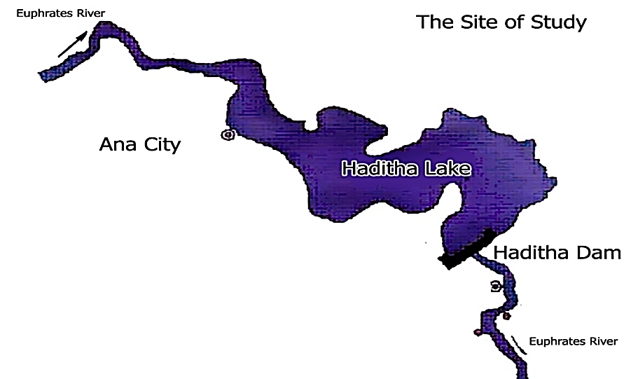
Location of sampling
Location of section

Fig. 5: Map of study region, by MOWR in Iraq

- Analysis of Bed and Suspended Sediment Sampling
The best way to find the grain size of bed analysis by using sieve analysis. Bowels in 1970 suggested that the most reliable and most easily applicable method of performing the sieve analysis is to take an oven-dried sample. Therefore this method ensures that the little fine particles which adhere to larger particles are no more exist. The weight of sediment kept in every sieve was recorded. Particles finer than 0.074mm were analyzed by hydrometer. Figure (6). The hydrometer analysis, also called sedimentation method, is used to determine the grain size distribution for the fraction of soil that is smaller than the No. 200 (0.075 mm) sieve. The average was ranged from (0.24 to 0.06 mm).
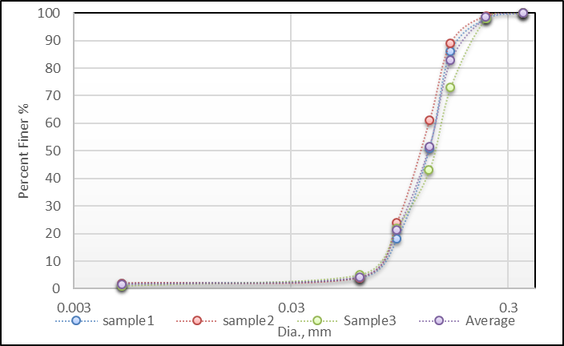

Fig. 6: Sieve Analysis for Samples taken from Region of Study.

- Calculation of Model
After running the model value of suspended sediment concentration for each cross section was obtained by average the concentration values in each vertical column, and then the main average was obtained a cross the section according to each partial division in the section. According to each partial division in section .The average of the suspended sediment concentration was multiplied by the average velocity in partial section. Consequentially the total discharge of suspended sediment was obtained, Table(1).
Table (1): Field sediment discharge for each sec.
Section Number | 1 | 2 | 3 | 4 | 5
Average Conc, PPM | 90.421 | 85.122 | 85.165 | 95.323 | 90.451
Sediment Dis., Kg/s | 7.201 | 7.124 | 8.154 | 8.665 | 7.243

- Sedimentation and Erosion With Short Duration Simulation
Sedimentation and erosion in the reservoir is taken place according to the variation of hydrodynamic condition. In this study how the morphological behaviour of the reservoir bed is affected by different hydrodynamic circumstances close to real reservoir operation. For this purpose, the model was run for three different cases in terms of the water level variation in the reservoir, each representative for the reservoir at various operation stages. All three cases were run for showing one year of morphological change according to the given hydrologic and sedimentological data for the reservoir. The outcomes of all three cases are giving different shape of delta formation and sediment deposition, with different delta advance celerity and sedimentation in the reservoir, in accordance with the water level variation in the model.

- Sedimentation With Constant Water Level In The Model
The model was run to represent one year of morphological changes in the reservoir considering the “active” discharge which carries most of the sediment into the reservoir. The selection of the “active” discharge limit was done in this study, which resulted in reducing the hydrograph duration from one year to about 4 months. The use of a 4 month hydrograph while simulating the model with a normal morphological time will take more time and make the simulation process uneconomic in time consuming. Therefore some works was made for reducing the hydrodynamic duration and The morphological scale factor 4 has been used in the model simulation. Subsequently the hydrodynamic was squeezed using this factor. From the Figure7, it can be noted that all incoming sediment from the inlet channel is deposited at the beginning of the reservoir and causes changes of the bed level and delta formation at that location. This is indicated by a red colour in the figure, this is happens due to the sudden change in the geometric shape and hydraulic conditions of the incoming stream, and subsequently the reduced the sediment transport capacity.

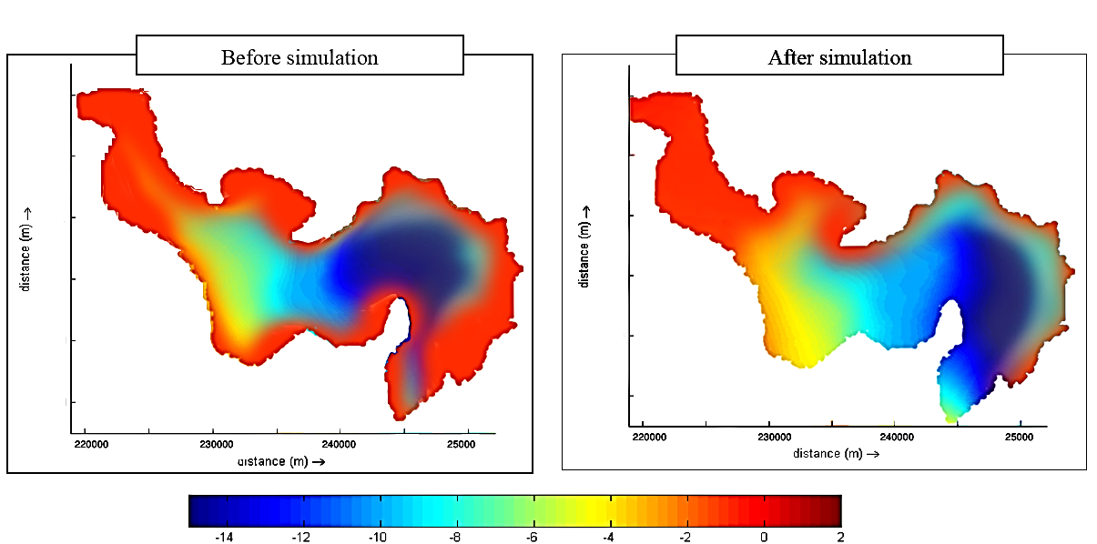

Depth legend

Fig. 7: The Bed change in the model for 1 year morphological change and with constant water level

- The Bed Configuration in Model
Due to the fluctuation of the incoming water discharge and sediment, the deposition is not happen uniformly, but it fluctuates between deposition and re-eroding according to the variation of incoming water discharge and sediment quantity, this is leads to the formation of different deposition patterns at the head of reservoir as it can be seen in Figures 8 a, b, and c.
The reason for this behaviour is that during flood the flow velocity is increases and this increases the sediment transport capacity too. Due to this the sediment is transported over a longer distance and this is results in a different deposition pattern.
The result of the running model for the same duration can be seen in the Figure 8, which shows the reservoir bed level change due to sediment deposition and delta formation. In this case the sediment is more distributed over the reservoir length. It has advanced more towards the middle as a consequence of water level variation. Also it can be seen from Figures 6 a, b and c, that the sediment, which has deposited in an early stage when the water level is at a higher level, will be flushed during lower water stage and it is transported to the lower part. In most cases, the sediment deposition will have a smaller depth than previous case (for constant water level).
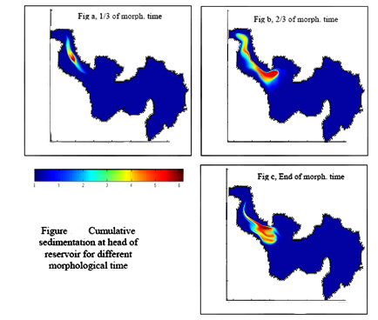

0 1 2 3 4 5 6

Fig. 8 Cumulative sedimentation at head of reservoir for different morphological time.

This water level variation occurs in the reservoir during a one year operation cycle including the wet and dry seasons. This major water level variation has much effect on sediment deposition. In this case, it leads to the deposition of the sediment at two different positions (upper part and middle part) and re-eroding of the sediment that was deposit in the upper part and transported further downstream during low water level. The outcome of simulating the model with this case is presented in Figure 8, showing the bed level variation of reservoir. From the Figure 9 it can be noticed that the bed level at the head of reservoir does not change that much as compared with first and second simulation, but the deposition happens downstream.
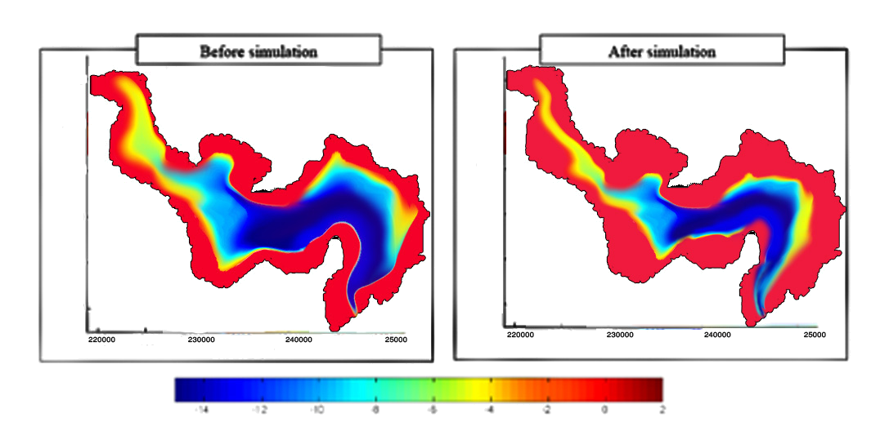

Figure 9. Bed level change in the model for one year morphological change and for moderate changing reservoir water level
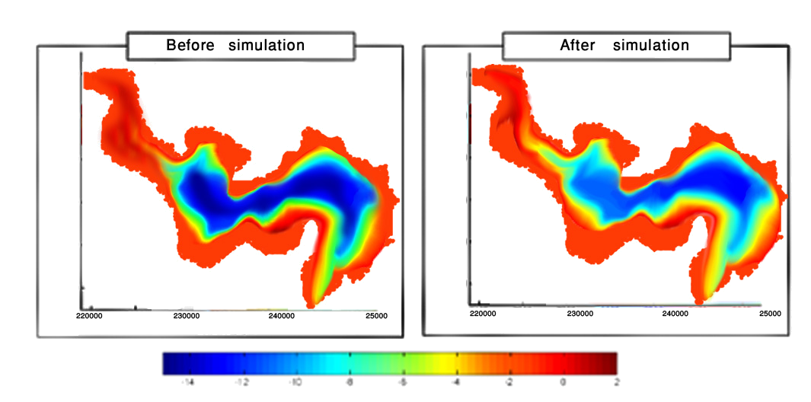

Figure 10, Bed level change in the model for one year morphological change and for two different water levels.

- Conclusion
In this study the exploration of the reservoir sedimentation processes was done through the use of numerical modelling, in both two and three dimensional perspective. Different types of the reservoir sedimentation processes were simulated by using the SSIIM software package in quite successful way, and for different circumstances related to the operation of the reservoir. After looking at the results of both two and the three dimensional models simulations, the following conclusions are drawn:
• In the case of running the 2D model for short duration simulation under different water level circumstances, different deposition was predicted in terms of distribution pattern on model bed and the deposition extend toward the model downstream.’/,mknl;dt n both the constant and fluctuating water levels, for the constant water level delta is formed more close to the upstream entrance of the reservoir while for fluctuating water level the delta is more distributed over the upstream model area. The slope of the top-set bed and front-set bed of the fluctuating water level are close to the observed cases in the real reservoir.
• The fluctuation of water level in the model has a direct influence on the shape and the location of the deposition as well on the depth of the accumulated sediment in the delta.
• Channel formation in the delta deposits is another phenomenon that is well reproduced by the 2D model for both cases used for long duration simulation. The results show its development and the dynamic evolution within the deposited material as well as its effect on the delta propagation. Also density currents in reservoir are reproduced by the three dimensional numerical models for a schematized reservoir, in SSIIM the density currents reproduced due to the ability of software to taken into account the effect of the suspended sediment and temperature variation on changing the water density distribution in the vertical direction.
• The location of plunging water mixture as a start of density current is changing over time as a response to the reservoir water level and the upstream discharge, temperature and sediment conditions. The densimetric Froude number at plunge location is a good indicator for representing the density current formation. In the all cases this Froude number was in the range given in the literature.
• The sedimentation in the schematized model shows some sediment deposition at lower end of the reservoir, which is originated from the action of density currents in carrying sediment to the downstream end of the reservoir.
• Flushing could be is reproduced by using a 2D numerical model and it was capable to simulate the flushing processes by simulating the drawdown procedure applied in the real reservoir case. The flushing is properly handled by the numerical model and the changes in the location of accumulated sediment in the reservoir model seams fair, the amount of sediment removing the dam is less than in reality. This is probability due to low accuracy of the computational girds, less sediment available at lower end and the too large sediment size in the simulation case.
References
Batuca and Jordaan (2000) .Silting and desilting of reservoir, Rotterdam, the Netherlands: A. A. Balkema.
Bowels, J. E., (1970), “Engineering Properties of soil and Their Measurement”, McGraw Hill-Book company, N Y, USA.
Chen, Y. H., Lopez, J.L. and Richardson, E.V. (1978). Numerical modelling of sediment deposition in reservoir. Journal of the hydraulic division, ASCE, Vol. 104, HY 12.
Mahmood, K. (1978) Reservoir sedimentation: Impact, extent, and mitigation. Tech. paper No. 71, The World Bank, Washington D.C.
Melaaen, M. C. (1992) "Calculation of fluid flows with staggered and nonstaggered curvilinear nonorthogonal grids - the theory", Numerical Heat Transfer, Part B, vol. 21, pp 1-19.
MOWR Ministry of Water Resources,(2012) , Iraq " Information, Data, Maps"
Olsen, N. R. B. (1991) "A numerical model for simulation of sediment movements in water intakes", Dr. Ing. Dissertation, The Norwegian Institute of Technology, Trondheim.
Patankar, S. V. (1980) "Numerical Heat Transfer and Fluid Flow", McGraw-Hill Book Company, New York.
Sloff, C.J (1997) Sedimentation in reservoir. Ph.D. thesis, Report no. 97-1, Communication on Hydraulic and Geotechnical Engineering, Delft University of Technology, faculty of civil engineering.
Vanoni, V.A. (1977). Sedimentation engineering, ASCE, New York.
Yu, W., Lee, H., and Hus, Sh. M. (2000).Experiments on Deposition Behavior of Fine Sediment in a Reservoir. Journal of hydraulic engineering Vol. 120, No 12.

