Evaluation Water Quality Index for Irrigation in the North of Hilla city by Using the Canadian and Bhargava Methods

Udai Adnain Jahad
University of Babylon
eng.udaijahad@yahoo.com
Abstract
To know water quality for multi uses in the north of Hilla city, it is important to study the quality of the water parallel with the quantity. In this research, two national methods are adopted to evaluate and judge the suitability of Euphrates River in this zone (study case) for irrigation use. These methods are the water quality index (WQI) of the Canadian and Bhargava model.
The main river passing through the north of Hilla city is Euphrates River and his branch Hilla River, the uses of its water are different and its use for irrigation depends on many environmental parameters. The researcher studied the quality of this river for irrigation use during 2011. Took four stations on the river in Babylon (Euphrates River/AL-Musiab, Euphrates River/Kifil, Hilla River/ Hindia barrage and Hilla river/Hilla. The main results showed that there is no difference between the two techniques at significance level (0.08) and the quality of the river inter the boarder classified as GOOD and FAIR according to Bhargava and the Canadian method respectively. Also that there is a serious deterioration in the water quality downstream Al-Kifil station because of the local drains that discharge in the river. These results ensure the need to receive higher water quality at the boarders (quantity and quality) to raise the quality in the downstream the river.
Keywords: water, quality, index, irrigation, station, downstream
الملخص
من الضروري دراسة نوعية المياه بالتوازي مع كمية المياه في نهر الفرات لمعرفة نوعية المياه واستخداماتها المتعدده في شمال مدينة الحله(منطقة الدراسه), في هذا البحث تم استخدام طريقتان لتقييم والحكم على ملائمة نهر الفرات في شمال مدينة الحله (موضوع البحث) لاستعمالات الري وهذان الطريقتان هما الطريقة الكندية ونموذج بهارجافا.
ان النهر الرئيسي الذي يمر من شمال مدينة الحله هو نهر الفرات وتفرعه شط الحله , تستخدم مياه نهر الفرات لأغراض متعددة منها الري ولهذا الاستخدام محددات بيئية ,تم دراسة نوعية مياه هذا النهر لاستعمالات الري لبيانات عام 2011 . حيث تمت دراسة بيانات 4 محطات على النهر من محافظة بابل (نهر الفرات \محطة المسيب,نهر الفرات\محطة الكفل ,نهر الحله\محطة الحله ونهر الحله \محطة الهنديه). وقد لوحظ ان الاختلاف بالنتائج بين الطريقتين كان بسيط بمقدار 0.08 ونوعية مياه النهر الداخلة جيدة طبقا للطريقتين. ايضا هنالك تدهور واضح في محطة الكفل بسبب رمي المياه الثقيلة والمنزلية الى النهر, وهذه النتائج تؤكد الحاجه الى نوعية مياه داخله ذات نوعيه وكميه اعلى جوده لغرض رفع نوعية المياه اسفل مجرى النهر.
الكلمات المفتاحية: المياه، والجودة، مؤشر، والري، ومحطة، المصب
1- Introduction
Water quality can be broadly defined as the physical, chemical, and biological composition of water as related to its intended use for such purposes as drinking, recreation, irrigation, and fisheries. (APHA, et al. 1969; Rechard and McQuisten 1968; Veatch and Humphreys 1966).
The term water quality has different meanings to different users of the water, which can result in confusion among water quality managers. The term may be applied to a single characteristic of the water or to a group of characteristics combined into a water quality index. A few other terms related to water quality are important to define.
Water quality management can be defined as the management of the physical, chemical, and biological characteristics of water (Sanders, et al. 1983).
Water quality monitoring one function of water quality management, is the collection of information on the physical, chemical, and biological characteristics of water (Sanders, et al. 1983).
If monitoring to better define the water quality problem, the appropriate water quality characteristics must be monitored. Many outlines for developing a monitoring study have been made (Canter 1985; Ponce 1980; Sanders, et al. 1983; Solomon and Avers 1987; Tinlin and Everett1978; Ward, et al. 1990; Whitfield 1988).
346
(A. Sargaonkar and V. Deshpande, 2003)The quality of water is defined in terms of its physical, chemical and biological parameters, and ascertaining its quality is important before use for various intended purposes such as potable, agricultural, recreational and industrial water usages, etc.
The quality of water is assessed with the help of various parameters to indicate their pollution level. It is quite likely that any sample of water will exhibit various levels of contamination with respect to the different parameters tested [S. A. Abbasi, 1999].
In last years, water resources management, problems, and water quality control received a great deal of researches attention also it is an important environmental protection issue. The rapid growth of agricultural, municipal, and industrial activities especially in heavily populated urban areas and harmful effect of increasing drainage waters coming from agricultural lands upstream coupled with the decreasing in its discharge. It is necessary then to make detailed studies to evaluate the suitability of the river water for different uses (Wardah S., 2009).
2- Case study
The case study was the main river passing through the north of Hilla city is Euphrates River and his branch Hilla River. Four stations were taken on them and measured the monthly environmental parameters which were equal to thirteen parameters that affected on the use of the water for irrigation. These stations as seen in figure (1) are: Euphrates River/Musiab, Euphrates River/Kifil, Hilla river/Hilla and Hilla River/ Hindia barrage.
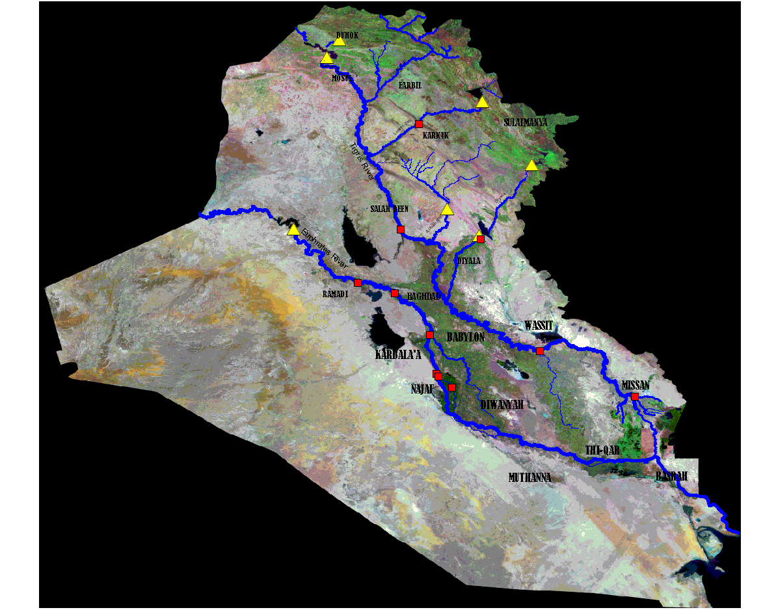
HINDIA BARRAGE
Hilla
KIFIL

Musiab
Figure (1) Locations of the case study in the Euphrates River at Iraq (Ministry of Water Resources, 2009).

3. Water Quality Index (WQI):
The use of water quality index (WQI) simplifies the presentation of results of an investigation related to a water body as it summarizes in one value or concept a series of parameters analyzed. In this way, the indices are very useful to transmit information concerning water quality to the public in general, and give a good idea of the evolution tendency of water quality to evolve over a period of time (D. Couillard and Y. Lefebvre,1985). Water quality index (WQI) may have gained currency during the last three decades of the twentieth century, but the concept in its rudimentary form was first introduced more than 150 years ago – in 1848 – in Germany where presence or absence of certain organisms in water was used as indicator of the fitness or otherwise of a water source. WQI was first mentioned by Horton (1965). It was considered as an effective tool for collecting various sorts of water quality data to enhance representing them by a principal parameter. This parameter is used to study the changes which result from various polluted water resources. He used the water quality index to classify the water and to identify eight physical and chemical determinants to estimate the degradation of water quality. Also, Horton proposed the rating scales and the weightings for the determinants to give the relative importance for each determinant in the water quality. A single WQI value makes information more easily and rapidly understood than a long list of numerical values for a large variety of parameters. Additionally, WQI also facilitates comparison between different sampling sites and events (N. Stambuk-Giljanovic, 1999).
Considering the simplicity and scientific basis of WQI, it is expected that these indices will provide meaningful summaries of overall water quality and possibly trends. While appreciating the importance and usability of WQIs, it is important to understand the limitations of WQIs. The WQIs are not intended to replace a detailed analysis of environmental monitoring and modeling, nor should they be the sole tool for the management of water bodies. However, WQIs can be used to provide a broad overview of environmental performance that can be conveyed to the public in an easy to understand format. The many advantages of these indices include their ability to represent measurements of a variety of variables in a single number; the ability to combine various measurements with a variety of measurement units in a single metric; and the facilitation of communication of the results. On the other hand, there are limitations in the use of WQIs: the loss of information by combining several variables to a single index value; the sensitivity of the results to the formulation of the index; the loss of information on interactions between variables; and the lack of portability of the index to different ecosystems (Zandbergen and Hall, 1998).
3.1 The Canadian Water Quality Index (CWQI)
The Canadian Water Quality Index has adopted the conceptual model of BCWQI (based on relative sub-indices). There are three factors in the index, each of which has been scaled between 0 and 100. The values of the three measures of variance from selected objectives for water quality are combined to create a vector in an imaginary ‘objective exceedance’ space. The length of the vector is then scaled to range between 0 and 100, and subtracted from 100 to produce an index which is 0 or close to 0 for very poor water quality, and close to 100 for excellent water quality (table 2).

Table (2) Water quality classification according to CWQI (CCME, 2001)
Class | Water Quality Index Value | Water Quality
I | 100 - 95 | Excellent
II | 94 - 80 | Good
III | 79 - 60 | Fair
IV | 59 - 45 | Marginal
V | 44 - 0 | Poor

Since the index is designed to measure water quality, it was felt that the index should produce higher numbers for better water quality. This earlier version was evaluated on synthetic data sets and data sets from British Columbia (Phippen, 1998) and Newfoundland (Husain, 1998). These evaluations along with evaluations in Alberta and Ontario index revealed that significant problems arose due to the formulations for estimating frequency and amplitude. The revised CWQI consists of three factors:
Factor 1 (F1): Scope
This factor is called scope because it assesses the extent of water quality guideline non-compliance over the time period of interest. It has been adopted directly from the British Columbia Index:
Where variables indicate those water quality parameters with objectives which were tested during the time period for the index calculation.
Factor 2 (F2): Frequency
F2 (Frequency) represents the percentage of individual tests that do not meet the objectives (‘failed tests’):
Factor 3 (F3): Amplitude
F3 (Amplitude) represents the amount by which the failed test values do not meet their objectives, and is calculated in three steps:
- The number of times by which an individual concentration is greater than (or less than, when the objective is a minimum) the objective is termed an ‘excursion’ and is expressed as follows. When the test value must not exceed the objective:

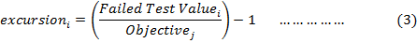

For the cases in which the test value must not fall below the objective:

(2)The collective amount by which individual tests are out of compliance is calculated by summing the excursions of individual tests from their objectives and

dividing by the total number of tests (those which do and do not meet their objectives).
This variable, referred to as the normalized sum of excursions, or nse, is calculated as:
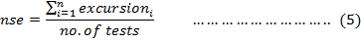
(3) F3 is then calculated by an asymptotic function that scales the normalized sum of the excursions from objectives (nse) to yield a range between 0 and 100.
The CWQI is finally calculated as:
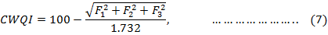
3.2 Bhargava Method:
Bhargava Method had been used in many countries, and it is easy to deal with relative parameters for different uses by using sensitivity functions' curves which take value between zeros to one. The results were accumulated by using the geometric mean. The sensitivity functions' curves are used to evaluate the quality of river water and give the importance of any parameter for a specific use. It also give weight to every parameter ,for example; when the concentration of sulfate (SO₄⁻²) get value 400 ppm the sensitivity function will be very low which make water worse according to sensitivity functions' curves for drinking use, while the same concentration value can give sensitivity function equal to 0.8 for irrigation use which mean it is acceptable 80%. The relative parameters for irrigation use are: dissolved solids (TDS), hydrogen number pH, sulfate (SO₄⁻²), sodium adsorption ratio (SAR), electrical conductivity (EC), chloride (Cl⁻ ). This method was used at Iraq by many researchers such as Al-Safar, 2003 and Wardah S., 2009.
This index was used to classify rivers into five groups (table 4) and to determine the water quality index for each activity of different water activities depending upon the variables which effects on that activity by using geometric mean formula (Bhargava, 1985).
The geometric mean formula expressed as below: П
$\text{WQI}={\left[\prod{} \text{fi}\left(P_{i}\right)\right]}^{1/n} ∗\text{100}$ …………… (8)
Where:
f_{i} (P_{i}) the sensitivity function for each variable including the effect of variable weight concentration which is related to a certain activity and varies from (0 – 1),and n is the number of variables.
Table (3) Water quality classification according to Bhargava
Class | Water Quality Index Value | Water Quality
I | 100 – 90 | Excellent
II | 89 – 65 | Good
III | 64 – 35 | Acceptable
IV | 34 – 11 | Polluted
V | Less than 10 | Severe Polluted

4. The Results and Discussion:
The results of the WQIs for Bhargava and the Canadian methods are shown in figures 1 and 2 respectively. It is seen that the WQI for Bhargava method is classified as GOOD for irrigation water use at locations Hindia barrage Hilla and Musiab but classified as Acceptable for irrigation water use at location Al-Kifil. The Canadian WQI for the irrigation use are classified as FAIR for locations Hindia barrage , Al-Kifil, Hilla and Musiab Table (4) showed the calculated values of factors and CWQI The researcher used thirteen environmental parameters which their values were affected in the use of water for irrigation. These parameters are: dissolved solids (TDS), hydrogen number (pH), sulfate (SO4⁻), sodium adsorption ratio (SAR), electrical conductivity (EC), chloride (Cl⁻ ), Nitate (NO3⁻), lead (Pb), iron (Fe), cadmium (Cd), zinc (Zn), copper (Cu), chromium (Cr).

Table (4) the calculated values of factors and CWQI.

Station Name | F1% | F2% | F3% | CWQI%
Hindia barrage | 21.32 | 33.67 | 30.57 | 71
Hilla | 17.66 | 23.91 | 46.78 | 68
Musiab | 14.32 | 21.429 | 34.808 | 75
Kifil | 47.143 | 38.571 | 31.76 | 60

Figure (2) annual mean for Bhargava WQI at Euphrates River

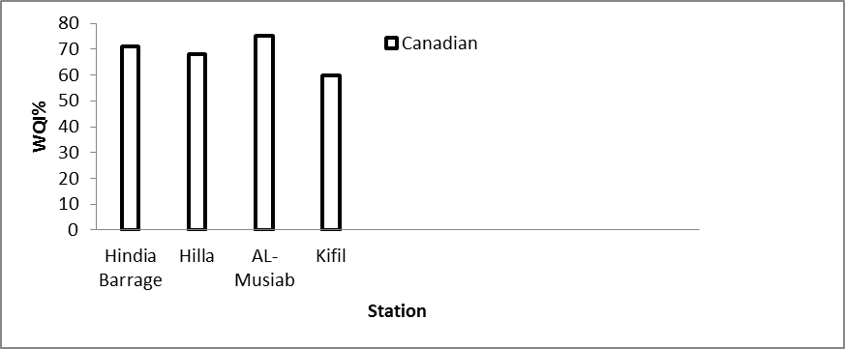
Figure (3) Annual mean for the Canadian WQI at Euphrates Rive
From the two figures, it is noticed there is a serious deterioration in the water quality downstream Al-Kifil station because of the local drains that discharge in the river, the water quality classification according to Bhargava, is more appropriate than the water quality classification according to the Canadian method. The question is if there is difference between the results of the two methods or not at 0.08 significant limits (figure 4).

Figure (4) Bhargava and the Canadian WQIs for multi locations at Euphrates River

References
Al-Saffar, A.E.A, 2001, "Proposed Water Quality Management system for Tigris River", Ph.D, thesis, Civil Engineering, University of Baghdad .
APHA, et al, 1969, "American Public Health Association, American Society of Civil Engineers, American Water Works Association, and Water Pollution Control Federation". Glossary of water and wastewater control engineering
Sargaonkar, A. and Deshpand,V. e,2003,"Development of an Overall Index of Pollution for Surface Water Based on a General Classification Scheme in Indian Context", Environmental Monitoring and Assessment, Vol. 89, No. 1, 2003, pp. 43-67.
Bhargava, D. S., 1985,"Expression for drinking water supply standards", J. Environ. Engin. ASCE 106(4), 757– 771.
Canter, L.W.,1985,"River water quality monitoring"Lewis Publ., Inc., Chelsea, MI.
Couillard , D. and Lefebvre ,Y.,1985,"Analysis of Wa-ter-Quality Indices",Journal of Environmental Manage-ment, Vol. 21, No. 2, 1985, pp. 161-179.
Horton, R.K., 1965, "An Index Number System for Rating water quality", J. Water Pollut. Control Fed. 37, 3, PP. 300-305.
Husain, T., 1998,"Application of National Water Quality Index Prototype in Newfoundland", The State of Environment Reporting Task Group, The Canadian Council of Ministers of the Environment.
Stambuk-Giljanovic ,N.,1999 “Water quality evaluation by a in Dalmatia,”, Water Research, Vol. 1999, No. 33, 1999, pp. 3423-3440. doi:10.1016/S0043-1354(99)00063-9
Ministry of water resources, 2009, "Data, map, and locations of environmental parameters of Euphrates River", Baghdad, Iraq.
Phippen, B., 1998,"Application of the National Water Quality Index Prototype in British Columbia", BWP Consulting, 60 pp. June, 1998.
Ponce, S.L., 1980,"Water quality monitoring programs", USDA Forest Serv., Watershed Sys. Dev. Group Tech. Pap WDG-TP-00002, Fort Collins, CO.
Rechard and McQuisten, 1968,"Glossary of selected hydrologic terms",Water Resources. Res. Inst., Water Resources. Serv. No. 1, Univ. WY, Laramie.
Sanders, T.G.,et al.,1983,"Design of networks for monitoring water quality", Water Resources. Pub., Littleton, CO.
Abbasi , S. A., 1999, "Water Quality Indices: State-of-the-Art," Centre for Pollution Control & Energy Technology, Pondicherry University, Pondicherry, 1999.
Solomon R.M., and P.E. Avers, 1987," A water quality monitoring framework to satisfy legal requirements",Proc. Symp. On monitoring, modeling, and mediating water quality, Amer. Water Resources Assoc., Bethesda, MD, pp. 231-242.
Tinlin, R.M., and L.G. Everett, 1978,"Establishment of ground water quality monitoring programs",In Establishment of water quality monitoring programs. Proc. Amer. Water Resources. Assoc., Minneapolis, MN.
Veatch and Humphreys,1966,"Water and water use terminology",Thomas Print & Publ. Co., Kau Kauna, Wi.
Ward, R.C., J.C. Loftis, and G.B. McBride,1990,"Designof water quality monitoring systems",Van Nostrand Reinhold, New York, NY.
Wardah S., 2009,"Construct a Suitability Maps for Tigris and Euphrates Rivers for Agricultural, Industrial, and Drinking use", M.Sc thesis, engineering college, University of Baghdad.
Whitfield, P.H.,1988,"Goals and data collection designs for water quality monitoring",Water Resourc. Bul. 24(4):775-780.
Zandbergen, P. A. and K. J. Hall, 1998," Analysis of the British Columbia Water Quality Index for watershed managers: a case study of two small watersheds", Water Qual. Res. J. Canada 33: 519-549. This article is available at http://www.cciw.ca/33-4/33-4-519.htm.

