Evaluation The Factors Affecting Permanent Deformation Using Cyclic Loading Test for Stabilized Subgrade Soil.
Nahla Yassub Ahmad Elaf Jasim Mahan
Babylon University - Civil Engineering Engineering Researcher
nahlayassub@yahoo.com elafaljbouri@ymail.com
Abstract:
Permanent deformation of subgrade soil is the accumulation of plastic deformation due to continuous repeated loads from traffic. The main objective of this study is to investigate some of the factors that affect the permanent deformation of stabilized subgrade soil such as additive type, moisture content, applied stress, curing time and additive percentage. In this research soil samples were tested in the standard case without additive and with the additive, two types of additives have been used (cement and hydrated lime).The test procedure and test results conducted on original soil and treated soil are presented. Soil-lime mixtures were tested under three levels of stress (28, 42, 63) KPa, three curing conditions (3days at 50°C, 7days at 40°C and 28 day at 22°C)with three percents of lime (3% is the optimum lime content),at various moisture contents and dry density corresponding to 95% maximum dry density .The permanent deformations are monitored during 60 load cycles, and the accumulated permanent deformations are determined.
Key words: subgrade soil, Permanent deformation, soil stabilization, cyclic loading
الخلاصة:
التشوه الدائم للترب السطحية هو تراكمُ التشوه غير المرن في الترب بسبب الأحمال المتكرّرةِ المستمرةِ الناتجة من حركة المرور . الهدف الرئيسي من هذه الدراسة هو التحري حول بعض العوامل التي تؤثر في حدوث التشوه الدائم للترب ألسطحيه ألمعدله مثل:نوع المضاف ،نسبة المضاف ،محتوى الرطوبة،الإجهاد المسلط ، وقت الإنضاج . في هذا البحث تم استخدام نوعين من المضاف(سمنت,النوره المطفئه).تم فحص مزيج تربه- نورة تحت تأثير ثلاث مستويات من الإجهاد المسلط KPa(28,42, 63),ثلاث حالات إنضاج (3 أيام تحت درجة حرارة °C50 , 7أيام تحت درجة حرارةC °40, 28 يوم تحت تأثير درجة حرارة°C 22 (, ثلاث نسب من ألنوره(3% هي النسبه المثاليه لمحتوى النوره) , ثلاث محتويات رطوبة مختلفة و كثافة جافه تمثل 95% من الكثافة الجافة العظمى.تم مراقبة التشوه الدائم خلال 60 دورة متكررة وتم حساب التشوهات الدائميه المتراكمة.
الكلمات المفتاحية: ترب الاساس , التشوه الدائمي, تثبيت التربة, التحميل الدوري
Introduction: 1.
Flexible pavements typically consist of several layers of paving materials, which are built on natural soil, normally referred to as the subgrade soil. The top portion of the subgrade soil is compacted prior to placing the subbase or base. The subgrade soil ultimately carries all traffic loads. Thus, the function of a flexible pavement structure is to support a wheel load on the pavement surface and to spread or distribute the applied loads to the subgrade soil without exceeding its strength or that of various overlying pavement layers. Therefore, layers near the surface are generally constructed with paving materials of increasing quality and load-carrying capability.
One of the major concerns for highway agencies and the flexible paving industry is the excessive permanent deformation (rutting) of flexible pavements caused by repeated heavy truck traffic on the highways [Shami &Hall 1999]. One of the very important causes of failure lies in the pavement foundation, subgrade layer which represents the pavement foundation is the key importance in the pavement structure. The permanent deformation in the subgrade is related to the plastic strain. Subgrade soil could cause unrecoverable deformation under repeated load, and then pavement will be damaged rapidly. Thus, it is necessary to treat these soils to provide a stable subgrade or a working platform for the construction of the pavement [Puppala, et al., 1999].

2. Research Objective:
The main objective of the research is to study the permanent deformation characteristics of the stabilized subgrade soil in Iraq by investigate the main factors related to the permanent deformation. The compaction moisture content, applied stress, additive type, curing time and additive percentages are the main selected factors.
3. Materials:
The following materials have been used in this research with specific properties as mentioned below:
3.1. Soil: The subgrade soil sample was obtained from the Mhazim district to the west of Hilla city centre. The subgrade soil samples were put in plastic bags, labeled and transported to the soil mechanics laboratory. Table (1) shows chemical and physical properties for obtained soil.
Table (1): Chemical and Physical Properties of Obtained Soil.
Chemical Properties |  | Chemical Properties
Properties | Value | properties | Value
Sulphate Content % | 0.98 | LL % | 38
Gypsum Content % | 2.14 | PL % | 24
Total Soluble Salts Test% | 5.8 g/L | PI % | 14
Chlorides CL | 57.81 meq/L | Water Content (%) | 19.0
Organic Matter Content% | 0.41g/kg | Specific Gravity | 2.7
PH-Value | 8.13 | O.M.C (%) | 18.7
Carbon Content% | Nul | M.D.D (gm/cm³ ) | 1.7
Ca⁺⁺ | 8 meq/L | % of Fines | 95.75
Mg++ | 5 meq/L. | AASHTO Classification | A-6))
 |  | U.S.C.S | Silty Clay
3.2. Additives: Two types of additives are used in this research; lime is used as a main additive in addition to cement for comparison.
3.2.a. Lime: The lime used in this work is Hydrated lime Ca (OH)2 from Karbala-lime factory. Table (2) shows the chemical properties of hydrated lime used in the research that is tested in laboratory of Engineering College / Babylon University according to the I.O.S standard, No. 807, 1989.
Table (2): Chemical composition for lime used in the study.
Properties | Value (%) | IQS standard
CO₂% | 1.75 | Not more than 5%
Mg% + CaO % | 72.1 | Not less than 64 %
MgO% | 0.39 | Not more than 5 %
Fe₂O₃% | 0.21 | Summation of oxide not more than 5 %
Al₂O₃% | 00.0
SiO₂% | 2.80
SO₃% | 0.32
(90µ) Retained On Sieve | 3.21 | Not more than 10 %
Ca (OH)₂ % | 87.21 | -----
3.2.b. Cement: Sulphate resistance Portland cement (Tasluja) has been used in this research. Chemical and physical tests have been done on this cement in the laboratory of Engineering College in Babylon University. The tests held according to I.O.S standard, No. 5, 1984. Tables (3) and (4) show these chemical and physical properties, respectively.
Table (3): Physical Properties of Ordinary Portland cement.
Properties |  |  | Test Result | Limits According to IQS
Setting Time (min.) | Initial |  | 125 | ≥ 45 min
 | Final |  | 225 | ≤ 600 min
Compressive Strength MN / m²: |  | 3 days | 19. 0 | ≥ 15
 |  | 7 days | 27.0 | ≥ 23

Table (4): Chemical Properties of Ordinary Portland cement.
Composition | Test Results | Limits According to IQS
CaO% | 63.51
SiO₂ % | 21.46
Al₂O₃ % | 4.06
Fe₂O₃ % | 4.64
MgO % | 2.4 | ≤ 5%
SO₃ % | 2.27 | ≤ 2.5% if C3A < 5%  ≤ 2.8% if C3A > 5%
TOTAL | 99.58
Properties | Test Results | Limits According to IQS
Free Lime % | 0.78
C3S % | 51.89
C2S % | 22.38
C3A % | 2.91 | ≤ 3.5%
C4AF % | 14.14

3.3. Water: Distilled Water is used in specific gravity and hydrometer tests. For other tests and curing, tap water has been used. Table (5) shows the chemical properties for tap water.
Table (5): Chemical Properties for Tap Water.
Property | Value
PH | 8.14
Total Hardness(T.H) | 480 mg/L
Chloride | 128 mg/L
Mg | 3 mg/L
Ca | 7.4 mg/L
SO₄ | 220 mg/L
PO₄ | 0.28 mg/L
Na | 80 mg/L
K | 4.1 mg/L
NO₃ | 2.1 mg/L

4. Fabrication of Specimens:
The soils were mixed with the desired amount of stabilizer and the water to control the moisture content and dry density .The amount of stabilizer was calculated as weight percentage from dry soil, so as the amount of water was calculated as volume percentage .
The wetted treated soil specimens allow standing for 1 hour after mixing, but prior to compaction. After mellowing, the samples are compacted and cured for a specific amount of time. The standard Proctor compaction tests are conducted on the original soil and soil-lime mixture according to ASTM D-698. These tests yielded dry unit weight versus moisture content relationships. A special split of three pieces of steel mold with (50.4 mm) in diameter and (100.8 mm) in height was manufactured locally to prepare specimens that can be used for a cyclic load testing. The use of split mold is to get specimens of the same desired density because the use of a hydraulic extractor to remove the specimens from the mold will change the density of the specimens. Compaction is performed in five layers using a special hammer was manufactured locally as shown in order to give a compaction effort equivalent to the standard Proctor compaction test, until the desired density was achieved .In order to achieve the target density, a trial and error approach is used to determine the number of blows per layer which is changed for different soils and even for the same soil under different moisture content.
Curing conditions for compacted soil-lime mixture samples are adopted according to [ASTM D-5102, 1996]. Three samples for each curing conditions(50°C for 3 days, 40°C for 7days and 22°C for 28 days) in each case were prepared in order to provide an indication of reproducibility as well as to provide sufficient data for accurate interpolation of the results.

5. Cyclic Loading Test:
Due to the limitation of the available testing equipments, the possible local method which could be used to characterize the subgrade soil permanent deformation is the uniaxial cyclic load compression test. The consolidation apparatus for soils manufactured by (Geonor, Oslo - Norway) is employed to perform this test.The tests were performed on cylindrical specimens, 50.4 mm (2.0 in) in diameter and 100.8mm (4.0 in) in height, giving a height to diameter ratio of (2.0) [Puppala, et. al., 1999].Three stress levels have been applied in cyclic load tests. These stress levels are 28 KPa, 42 KPa and 63 KPa. The total number of cycles during tests is 60 cycles. The number of cycles is small compared with the actual number of cycles that causes a permanent deformation in the field conditions. However, for practical considerations, the plastic strain test data obtained from a small number of load cycles is assumed to be sufficient for extrapolating the permanent deformation results explored as a large number of cycles [Puppala, et. al., 1999]. In this research only the subgrade strain criterion was considered. The strain (εp) is calculated by applying the following equation:
εp = pd / h ………………………………….. (1)
Where: εp = axial strain (mm/mm)
Pd = axial deformation (mm)
h = specimen height (mm).

6. Classification Tests:
The results of Atterberg limits tests conducted on fractions passing sieve No. 40 indicate that the original soil samples are Medium plastic soils. The soil specimen can be classified according to the unified soil classification system (U.S.C.S) as (Silty Clay) Soil, while the AASHTO classification indicates that the original soil sample is (A-6) soil. The physical properties of the original soil are summarized in Table (6).

Table (6): Physical properties of the original soil.
Soil Properties | Original Soil
LL % | 38
PL % | 24
PI % | 14
Water Content (%) | 19.0
Specific Gravity | 2.7
O.M.C (%) | 18.7
M.D.D (gm/cm3 ) | 1.7
% of Fines | 95.75
AASHTO Classification | )A-6)
Unified Classification | Silty Clay

7. Results Analysis and Discussion:
7.1. Effect of Additives on Permanent Deformation:
In order to investigates the effect of additive type in the accumulation of permanent deformation ,specimens of the original soil were fabricated at the standard state (100%optimum moisture content(100%O.M.C),95%maximum dry density) and compared with the treated specimens under several levels of stress (28,42,63) KPa. Figure (3a) show the results under the standard state but with optimum lime content(3% lime), stress of(28KPa) and curing time 3days at 50° C. It is clear that the permanent deformation will be decreased by 440%for soil-lime mixture at (3%lime). Figure(3b,c)under applied stresses(42,63)KPa ,respectively in these Figures the permanent deformation will be decreased by 361% and 261%,respectively .The cyclic load testing results for soil-cement mixture are presented in Figure(4)with optimum cement content(5%cement)under standard state and curing time 3 days at 50°C,There is a simple comparison between the permanent deformation of soil-cement mixture (at optimum cement content5%cement)and the permanent deformation of soil without additive at standard state. It is clear that the permanent deformation for soil-cement mixture at (5%cement) under applied stresses (28, 42 and 63) KPa will be decreased by 380%, 309% and 229%, respectively. From these comparisons it is clear that the specimens having optimum cement content (5%cement) at the standard state under various selected applied stresses with curing time 3days at 50° C developed more deformation than soil-lime mixture at3%lime under same conditions. Therefore, using lime as additive in the treatment of the original soil because it gives best results for silty clay as compared with cement, and from economical view, the cost of using additive(3%lime)is lower than(5%cement)as additives.
a) 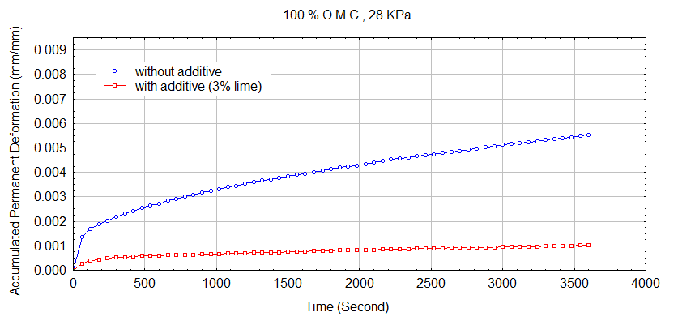
b) 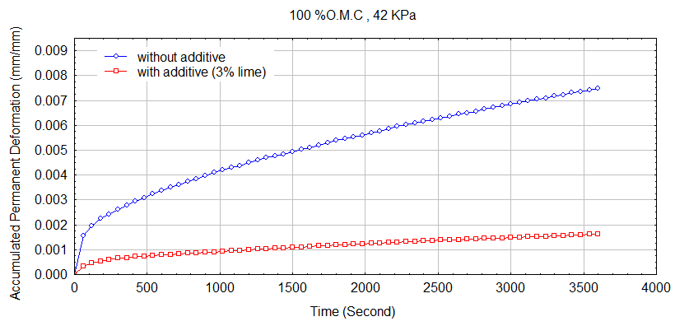
c) 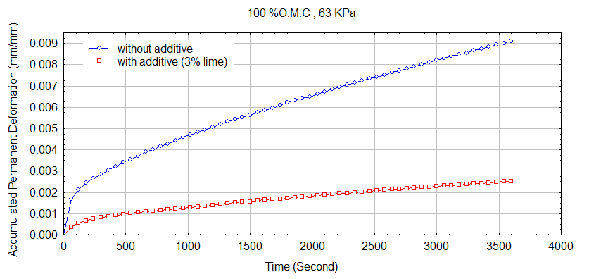

Figure (3): Effect of additive type in the relationship between loading time and accumulated permanent deformation (100 % O.M.C, 3 days) at:
a) 28 KPa b) 42KPa c) 63KPa .

a) 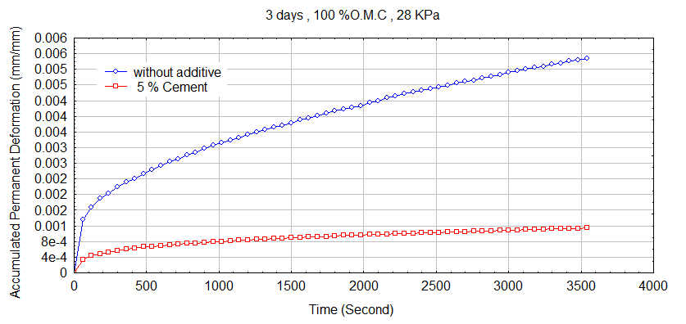
b) 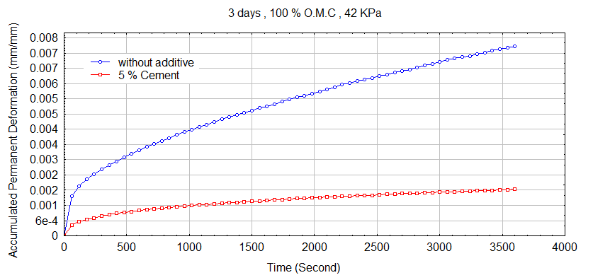
c) 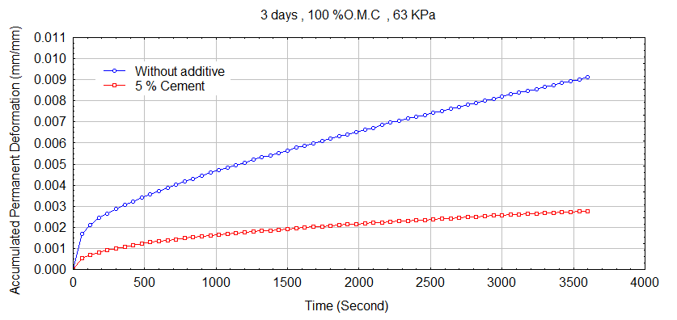

Figure (4): Effect of additive type in the relationship between loading time and accumulated permanent deformation (100 % O.M.C, 3 days) at:
a) 28 KPa b) 42KPa c) 63KPa.

7.2. Effect of Curing Conditions on Permanent Deformation:
The obtained results are presented in Figure (5) for soil-lime mixture at optimum state( 100 % optimum moisture content (100% O.M.C), 95% maximum dry density )and 3%lime under various selected applied stresses (28,42,63)KPa with different curing conditions (3 days at 50°C ,7days at 40°C and 28 day at 22°C). From this Figure, small differences are obtained in the development of resistance to the permanent deformation. Therefore, using curing time in this research was 3 days at 50°C, because as curing temperature increases, the rate of pozzolanic reactions also increase, resulting in an increased rate of strength gain and this conclusion is in agreement with (Little1999 and ASTM D 5102-90, 1996).

a)
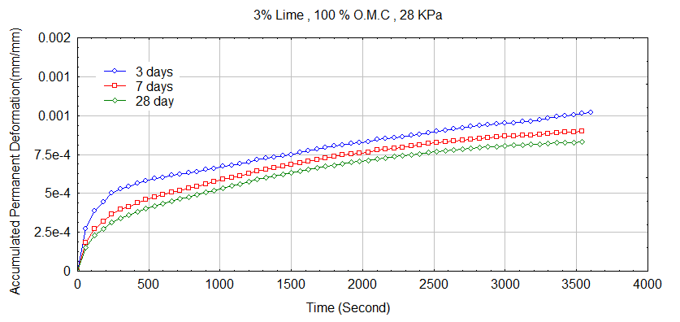
b)
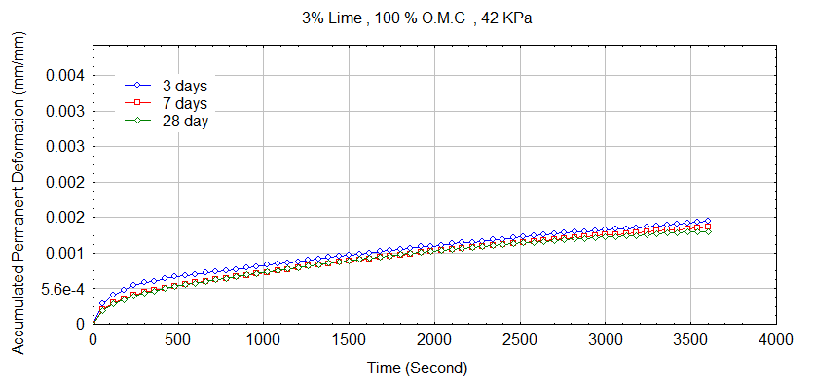
c)
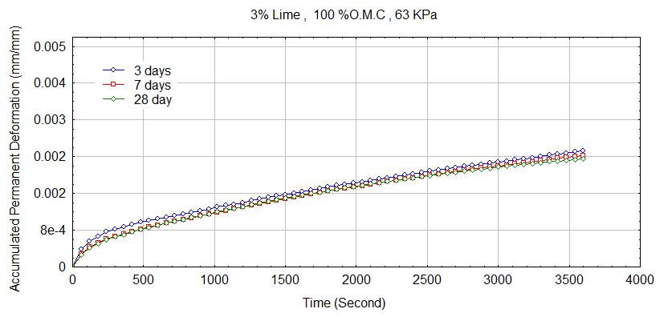
Figure (5) Effect of curing time on the relationship between loading time and accumulated permanent deformation (3% Lime, 100% O.M.C) at:
a) 28KPa b) 42KPa c) 63KPa.

7.3. Effect of Additive Percent on Permanent Deformation:
Figure(6)demonstrate the effect of the additive percent on the accumulation of the permanent deformation for soil-lime mixture at optimum state (100%O.M.C ,95%Maximum dry density) which subjected to various levels of applied stress under different lime percents( 2%lime,3%(optimum lime content) and 4%lime)for curing time 3days at 50°C.In this Figure there is comparison in the test results for the permanent deformation of soil-lime mixture at (2%,3% and 4%) lime for (100% O.M.C,95% maximum dry density, 3days at 50°C)and subjected to various levels of applied stresses(28,42,63) KPa. It is clear that when lime content increase from 2% to 3% under applied stresses (28,42 and63) KPa, the permanent deformation will be decreased by184%,119%and76% ,respectively. Also, when lime content increase from 3% to 4% under applied stress 63 KPa , the permanent deformation will be increased by 41%,so as when lime content increase from 2% to 4% under applied stresses (28,42,63) KPa , the permanent deformation will be decreased by 43% , 34% and 25%, respectively. From this Figure it is clear that 3%lime(optimum lime content)give less deformation than (2%,4%)lime, because the performance of stabilized soils is influenced by the characteristics of the original soil, type and quantity of stabilization additive and the effectiveness of the additives depends on the soil treated and the amount of additive used ,this conclusions are in agreement with (Parsons 2004)and(Tyndall,2008).

a)
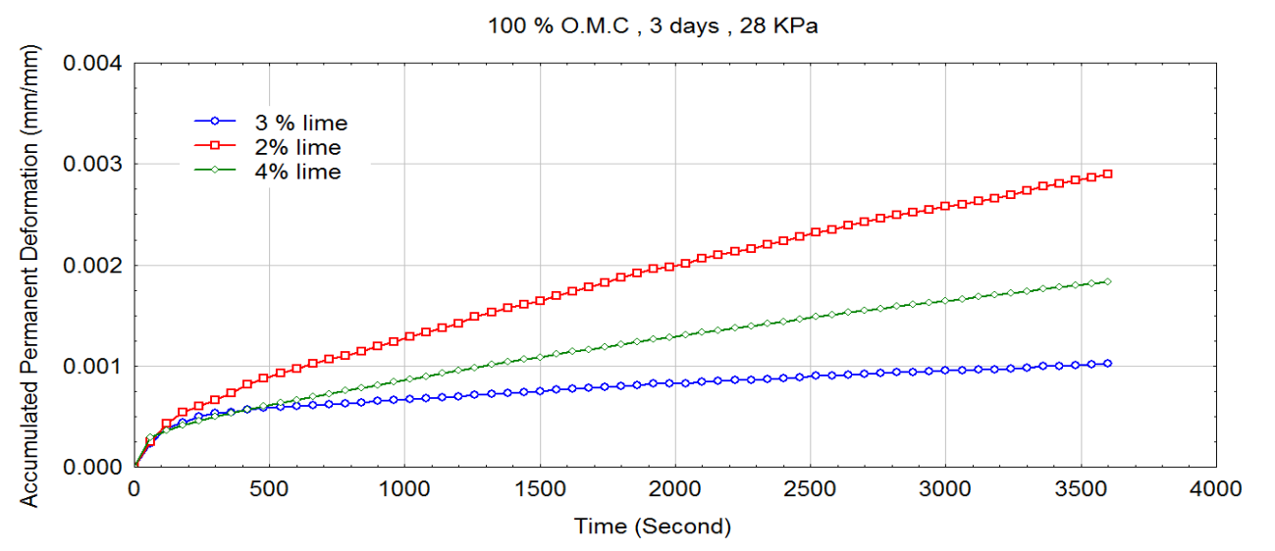
b)
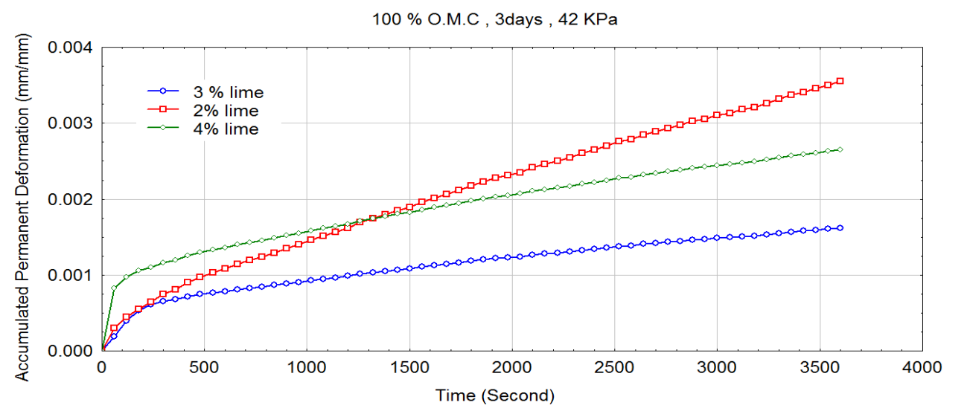
c)
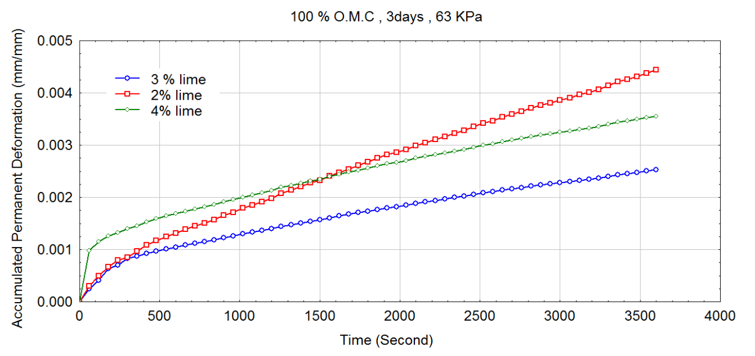

Figure (6): Effect of additive percent on the relationship between loading time and accumulated permanent deformation (3 days, 100% O.M.C) at:
a) 28KPa b) 42KPa c) 63KPa.
7.4. Effect of Moisture Content on Permanent Deformation:
In order to investigate the effect of the moisture content on the accumulation of the permanent deformation ,specimens for soil-lime mixture were fabricated at three moisture content (below optimum moisture content 90% O.M.C , optimum of moisture content 100 % O.M.C, above optimum content 110% O.M.C) to simulate field condition of pavement subgrade. Figure (7) shown below illustrate that when the moisture content increases from 90% to 100% of optimum moisture content and dry densities corresponding to 95%of maximum dry density with curing time 3 days 50°C under applied stresses (28,42,63) KPa the permanent deformation will be decreased for all deferent lime content.
a)
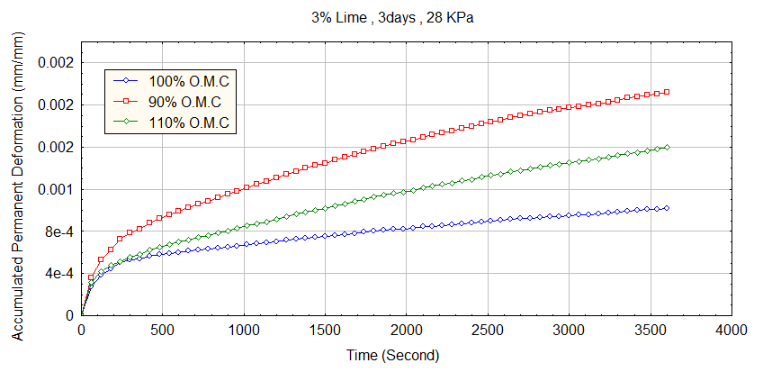
b)
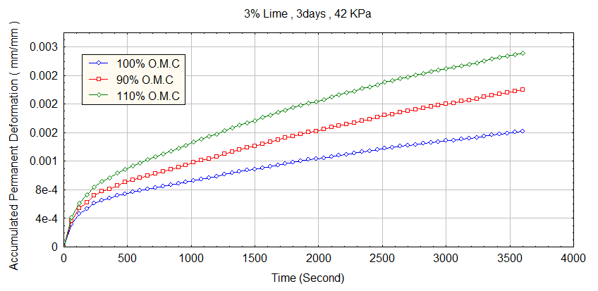
c)
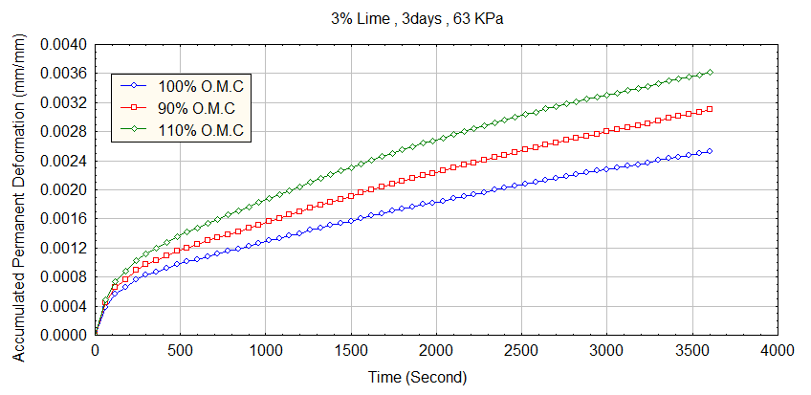
Figure (7): Effect of moisture content on the relationship between loading time and accumulated permanent deformation (3% Lime, 3 days) at:
a)28KPa b)42KPa c)63KPa.

7.5. Effect of Stress on Permanent Deformation:
Specimens with the same moisture content and dry density were subjected to various levels of stresses to explore the role of stress in the development of subgrade deformation .The applied stress showed a considerable influence on the measured permanent deformation. Figure (8) shows test results for soil-lime mixture at 3% lime and at all degrees of (O.M.C) under three levels of applied stresses (28,42,63) KPa at curing time 3 days.
a)
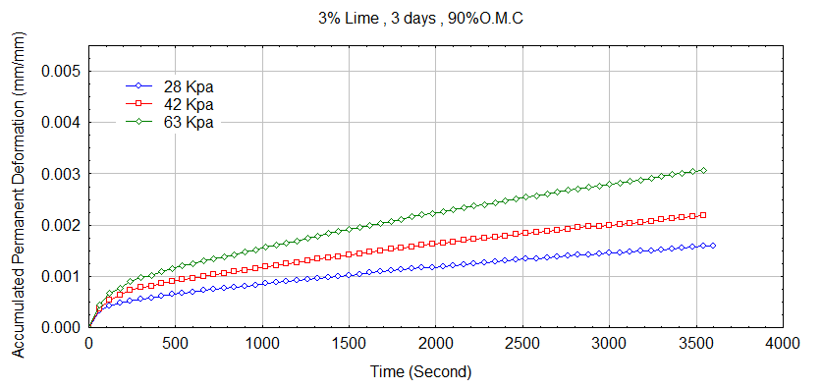
b)
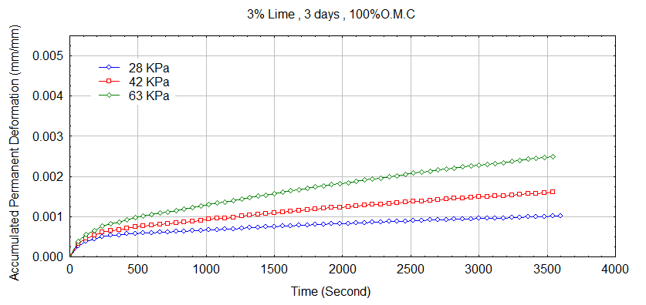
c) 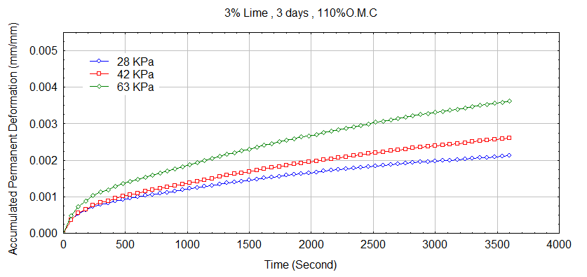
Figure (8): Effect of stress on the relationship between loading time and accumulated permanent deformation (3% Lime, 3 days) at:
a) 90%O.M.C b) 100%O.M.C c) 110%O.M.C.
8. Conclusions:
Within the limitations of materials and testing program adopted in this work, the followings are concluded:
- The selection of stabilizer type depends on the type of soil, results indicated that treating clays with lime will create stronger foundations for pavement structure, because when the appropriate additive and amount is added, the treatment stabilizes the soil to create consistent and drier layers with improved resistance to permanent deformation as compared to the original soil. Therefore, the rate of permanent deformation will be decreased by 440% for soil-lime mixture at optimum content (3%lime) under applied stress 28KPa,while the rate of permanent deformation of soil-cement mixture at optimum cement content( 5% cement) under applied stress 28KPa will be decreased by 380% .

- Curing temperature greatly influences the permanent deformation results of soil-lime mixtures, higher temperatures accelerated curing, resulting in a higher permanent deformation resistance. Accelerated curing techniques can expedite construction by simulating the 28 days permanent deformation at 22 ºC (normal conditions) by producing similar results through a 7days cure at 40 ºC and 3days cure at 50 ºC .The Permanent deformation of soil-lime mixture at(100%O.M.C, 95% maximum dry density, 3%lime)and at 3 days cure at 50 ºC is approximately similar to the permanent deformation results under same condition but at 7days cure at 40°C.As curing temperature increases, the rate of pozzolanic reactions also increase, resulting in a decreased rate of permanent deformation gain.
3. The performance of stabilized soils is influenced by quantity of stabilization additive. Therefore, the permanent strain results at 3%lime are less than the permanent strain results at 2%lime and at 4%lime.
4. The moisture content has a significant effect on the permanent deformation for soil-lime mixture. The increase of the moisture content from 100% to 110% has increased the rate of permanent deformation by 107%. Therefore, with the increase of the moisture content above the optimum moisture content a considerable increase in the permanent deformation is highly expected.
5. The permanent deformation results showed that soil-lime mixture at the optimum moisture content exhibited lower plastic deformation compared with soil-lime mixture at 90%O.M.C(below optimum moisture content) and at 110%O.M.C(above optimum moisture content) for all degrees of stresses.
6. The applied stress showed a considerable influence on the permanent deformation values, specially on the first cycle of loading, where the increase of stresses from 28 KPa to 63 KPa, has increased the rate of permanent deformation by (174%) for soil-lime mixture at (100%O.M.C, 95%maximum dry density, 3% lime) and curing time 3days at 50°C .Therefore, High permanent deformation is recorded when soils are subjected to high stresses.
7. The permanent deformation of untreated and treated soils increases with the increasing number of load cycles, but with a gradually decreasing rate of increase.
9. References:
ASTM D5102-90,(1996)."Standard Test Method for Unconfined Compressive Strength of Compacted soil-lime mixtures", ASTM Designation:, West Conshohocken. Vol. 04.01.
ASTM D-698, (1986)"Standard Test Methods for Moisture-Density Relations of Soils and Soil Aggregate Mixture, Using 5.5 Ib (2.49 kg) Rammer and 12-In.(305-mm) Drop" ,Annual Book of ASTM Standards Vol. 04. 08.
Little, Dallas N. (1999 ) ," Evaluation of Structural Properties of Lime Stabilized Soils And Aggregates", Vol.1summary of findings prepared for The National Lime Association.
Parsons Robert L.(2004)" Use of Cement Kiln Dust for Subgrade Stabilization". The Kansas Department of Transportation .Topeka, Kansas. University of Kansas.
Puppala A. J., Mohammad, L. N, and Allen A., (1999). "Permanent Deformation Characterization of Subgrade Soils from RLT Test", Journal of Materials in Civil Engineering", Vol. 11, No. 4, pp. 274-282.
Puppala, A., Suppakit Chomtid and Ekarin Wattanasanticharoen, (1999)."Plastic Deformation Potentials of Sandy Clay from Repeated Load Triaxial Test", Journal of ASCE, pp. 938-947.
Shami Haroon I., Ph.D and Hall Jim, Ph.D ,(1999)."Rutting of Asphalt Concrete Pavements" Paper No. 226, pp.6-13.
Tyndall,(2008)."Structural Evaluation Procedure for Stabilized Soil-Surfaced Airfields",Engineering Technical Letter (ETL)08-14,Department of The Air Force Head Quarters Air Force Civil Engineer Support Agency,PP.4-16.

