Enhancing the Structural Behavior of R.C. Deep Beams with Openings

Haider Mufeed Alsaeq
Dept. of Civil Eng., College of Eng., University of Babylon
Email: haidermufeed@yahoo.com

Abstract:
This research aims to investigate how to increase the structural strength of reinforced concrete deep beam with large openings. Two approaches are under consideration; the first is the effect of steel reinforcement bars near the opening edges, and the second is attaching CFRP layers around the opening. The software ANSYS 12.1 is used to handle the nonlinear finite element analysis. The ultimate strength of reinforced concrete deep beam with opening obtained by ANSYS 12.1 show fair agreement with experimental results (despite the high complexity of the problem), with a difference of no more than 21%. The present work concludes that using a circular opening instead of a square one with the same size can save a 19% of structural strength. Also, the introducing of steel bars around the opening increases the strength by up to 48%, while the using of CFRP laminates enhances the strength by an amount of up to 29% for beams considered in the present research.
Keywords: Deep Beams with Opening, CFRP, Finite Element, Reinforced Concrete.

الخلاصة:
الهدف من هذا البحث هو دراسة كيفية زيادة التحمل الانشائي للأعتاب الخرسانية المسلحة السميكة المحتوية على فتحات كبيرة. تمت دراسة وسيلتين لتحقيق هذا الهدف، الوسيلة الأولى هي دراسة تأثير اضافة قضبان التسليح الحديدية بالقرب من جوانب الفتحة، أما الوسيلة الثانية فهي لصق شرائح مادة البوليمير المسلح بألياف الكاربون حول الفتحة. تم استخدام البرنامج (ANSYS 12.1) لانجاز عملية التحليل اللاخطي بطريقة العناصر المحددة. ان التحمل الانشائي الأقصى للأعتاب الخرسانية المسلحة السميكة المحتوية على فتحات، والذي تم الحصول عليه من خلال البرنامج (ANSYS 12.1) أظهر تقارباً جيداً مع نتائج التجارب العملية على الرغم من درجة تعقيد المسألة، مع فرق لايزيد عن 21%. تم الاستنتاج بأن استخدام فتحة دائرية بدلاً من الفتحة المربعة من الممكن أن يزيد التحمل الانشائي بما يوازي 19%. كذلك فان وضع قضبان التسليح الحديدية حول الفتحة سوف يزيد التحمل النشائي لمقدار قد يصل الى 48%، في حين أن لصق طبقات البوليمير المسلح بألياف الكاربون حول الفتحة سوف يرفع من التحمل الانشائي بمقدار 29% للأعتاب التي تمت دراستها في هذا البحث.
الكلمات الدالة: الجسور العميقة مع فتحات، العناصر المحددة، الياف الكاربون، الخرسانة المسلحة.

1. Introduction:

Reinforced concrete deep beams are members in which a significant amount of the load is carried to the support by a compression thrust joining the loading and reaction point. Many references specify that deep beams should be loaded on loading points and supported on reaction points so that compression struts can develop between the loads and supports. (Yang et al, 2006). The ACI 318-08 code specifies that deep beams “have either: (a) clear spans, l_{n}, equal to or less than four times the overall member depth; or (b) regions with concentrated loads within twice the member depth from the face of the support. Reinforced concrete beams with openings have complex stress and had been investigated by many researchers in the last decade (Ammar et al, 2011), (Sahoo and Chao, 2010), (Vengatachalapathy and Ilangovan, 2010), (Giuseppe and Giovanni, 2012).
In the present research all the dimensions are fixed, and this includes the deep beam dimensions, the openings size (or area), and the openings locations. The parameters that will be changed and investigated are the opening shape (i.e. circular vs. square), the type and amount of strengthening (i.e. internal with steel bars or external with CFRP laminates).
In the present work, two methods of strengthening deep beams with circular or square openings, these methods are:
- Internal strengthening using steel bars around the opening in different patterns and quantities.
- External strengthening using CFRP laminates around the opening in different patterns and quantities.
The first method is suitable when the opening is planned before the construction and during the design stage, while the second procedure is beneficial when the opening is introduced after the construction, the case in which no analysis and design considerations where taken concerning the opening. The use of CFRP layers to strength reinforced concrete structures became very popular
recently and has many advantages (Bandara et al, 2011), (Ammar et al, 2011), (Hemanth, 2012).

2. Finite Element Modeling:
2.1 Concrete:
The eight nodes element “CONCRET65” is used in the present research to model concrete material. The element is also called “SOLID65”. It is used for the 3-D modeling of solids with or without reinforcing bars (rebar). The element is capable of cracking in tension and crushing in compression. In concrete applications, for example, the solid capability of the element may be used to model the concrete while the rebar capability is available for modeling reinforcement behavior. Other cases for which the element is also applicable would be reinforced composites (such as fiberglass), and geological materials (such as rock). The element is defined by eight nodes having three degrees of freedom at each node: translations in the nodal x, y, and z directions, as shown in Fig. 1. Up to three different rebar specifications may be defined.

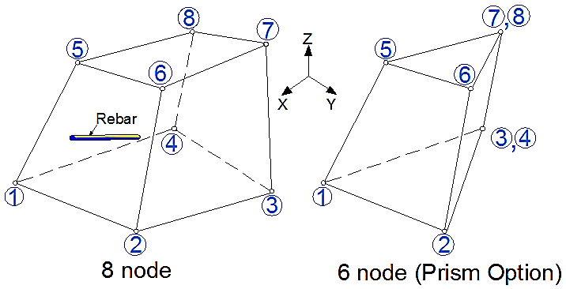

Fig. 1: Geometry of the element CONCRET65 (ANSYS 12.1)

This element has special cracking and crushing capabilities, and its most important aspect is the treatment of nonlinear material properties. The concrete is capable of cracking (in three orthogonal directions), crushing, plastic deformation, and creep. The rebar are capable of tension and compression, but not shear. They are also capable of plastic deformation and creep (ANSYS 12.1). However, the rebar capability of this element was not used in the present work, because the discrete reinforcement model is adopted, in which the reinforcing bars are modeled using the SPAR8 elements, and then merged with the concrete elements in the proper locations.
2.2 Steel Bars:
The one dimensional two-node element “SPAR8” is used in the present work to model the rebar. This element is sometimes called “LINK8”, and is very popular. The element may be used in a variety of engineering applications. Besides steel bars in reinforced concrete structures, this element can be used to model trusses, sagging cables, links, springs, etc. The 3-D spar element is a uniaxial tension-compression element with three degrees of freedom at each node: translations in the nodal x, y, and z directions as illustrate in Fig. 2. As in a pin-jointed structure, no bending of the element is considered. Plasticity, creep, swelling, stress stiffening, and large deflection capabilities are included (ANSYS 12.1). The nodes of this element are aligned with the nodes of the CONCRET65 elements to allow for merging the nodes together. Hence, a perfect bond between concrete and steel is automatically introduced.
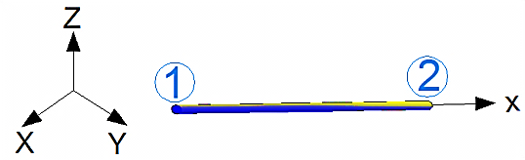

Fig. 2: Geometry of the element SPAR8 (ANSYS 12.1)

2.3 CFRP Laminates:
For the purpose of modeling CFRP layer; the shell element “MEMBRANE41” is used. It is a three dimensional element having membrane (in-plane) stiffness but no bending (out-of-plane) stiffness. It is intended for shell structures where bending of the elements is of secondary importance. The element has three degrees of freedom at each node: translations in the nodal x, y, and z directions. See Fig. 3
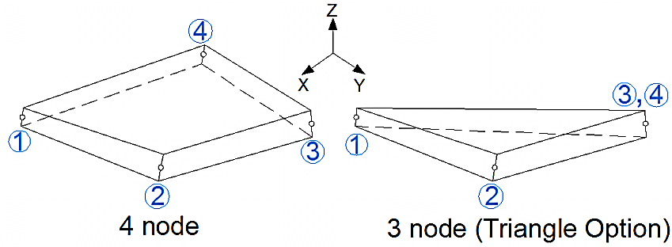

Fig. 3: Geometry of the element MEMBRANE41 (ANSYS 12.1)

This element has variable thickness, stress stiffening, large deflection, and a cloth option. The cloth option (which is implemented in the present research) is a tension-only option. This nonlinear option acts like a cloth in that tension loads will be supported but compression loads will cause the element to wrinkle (ANSYS 12.1). The CFRP layers used in the present work are of uniform thickness, and one thickness is entered during modeling. However, this element is capable of having variable thicknesses at each one of its four (or three) nodes.

3. Material Modeling:
3.1 Concrete:
It is not an easy task to establish accurate stress-strain relationship for concrete. Concrete has crushing and cracking possibilities, and behaves differently in compression and tension. Fig. 4 shows the typical stress-strain curve for normal weight concrete (Kachlakev et al, 2001).
In compression, the stress-strain curve for concrete is linearly elastic up to about 30 percent of the maximum compressive strength. Above this point, the stress increases gradually up to the maximum compressive strength. After it reaches the maximum compressive strength σ_{cu}, the curve descends into a softening region, and eventually crushing failure occurs at an ultimate strain ε_{cu}. In tension, the stress-strain curve for concrete is approximately linearly elastic up to the maximum tensile strength. After this point, the concrete cracks and the strength decreases gradually to zero (Kachlakev et al, 2001).
The modulus of elasticity (), and the modulus of rupture () for concrete (which are required in the ANSYS 12.1 analysis) are both calculated by equations (1) and (2), according to the ACI 318-08 specifications (units MPa):
(1)
(2)
The Poisson ratio for concrete is usually taken as 0.2 (Bandara et al, 2011), (Chin et al, 2011).
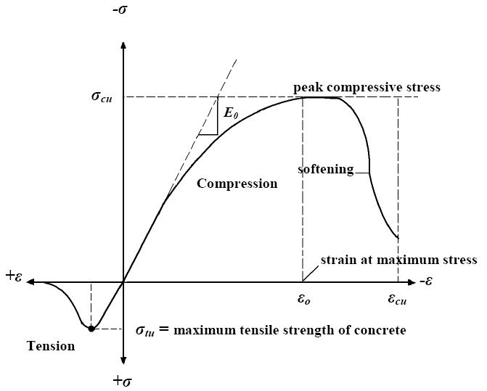

Fig. 4: Typical stress-strain curve for concrete (Kachlakev et al, 2001)

Equations (3), (4) and (5) are used to obtain a simplified stress-strain relationship for concrete, (Kachlakev et al, 2001), (Giuseppe and Giovanni, 2012):
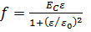 (3)
(4)
(5)
Where:
: Stress at any strain (MPa)
: Strain at stress
: Strain at the ultimate compressive strength

Fig. 5 below show this simplified relationship which is used in the present research:

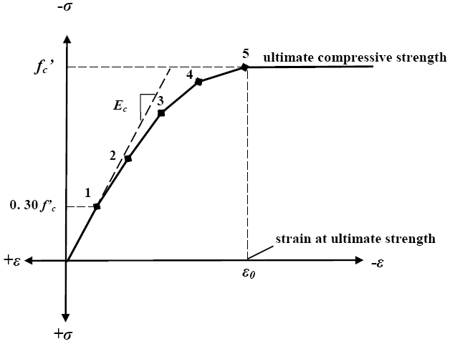

Fig. 5: Simplified compressive stress-strain curve for concrete (Kachlakev et al, 2001)
Other parameters required to perform the finite element analysis are the shear transfer coefficients. These coefficients range from 0.0 to 1.0, with 0.0 representing a smooth crack (complete loss of shear transfer) and 1.0 representing a rough crack (no loss of shear transfer). This specification may be made for both the closed and open crack. When the element is cracked or crushed, a small amount of stiffness is added to the element for numerical stability (ANSYS 12.1).
3.2 Steel Bars:
The bilinear model is used in the present to represent the stress-strain relationship for steel bars in the ANSYS 12.1 software. This elastic-perfectly plastic model is shown in Fig. 6.
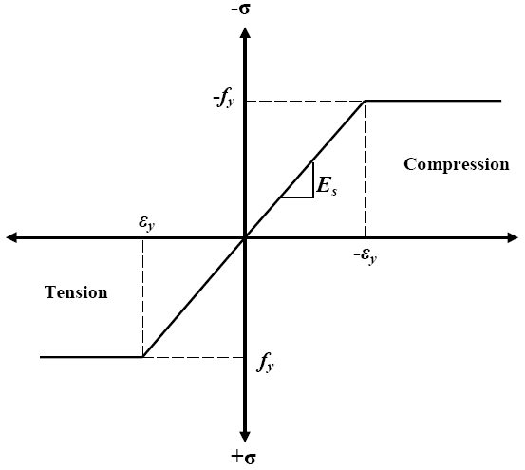

Fig. 6: stress-strain curve for steel bars (Kachlakev et al, 2001)

3.3 CFRP Laminates:
A linear stress-strain is used to model CFRP material. The compression part of this relationship will be automatically ignored in the analysis; as the “cloth” option of the MEMBRANE41 element is turned on, as described in the finite element formulation.

4. Experimental Data:
The deep beam with two opening designated (S08-34-4), and tested by Tae Min Yoo (Yoo, 2011) is considered in the present research to verify the effectiveness of the finite element model. This symmetric beam has the dimensions of 2400 mm x 600 mm x 110 mm, and contains two large openings (240 mm x 240 mm each), as shown in Fig. 7. The beam is reinforced with two 20 deformed bars with 20 mm clear cover. The material properties are: concrete compressive strength = 39.51 MPa, steel yield stress F_{y} = 500 MPa.

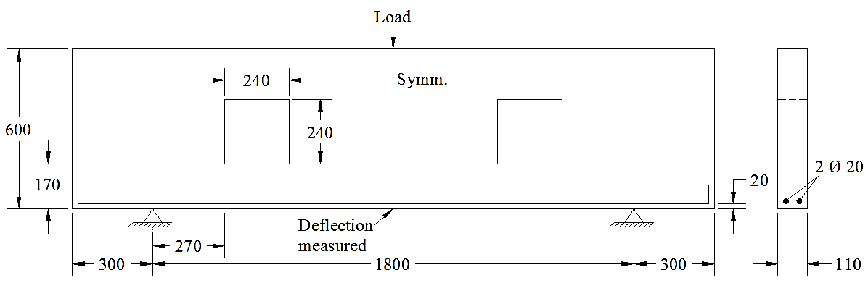Fig. 7: Beam S08-34-4 (Yoo, 2011)

Due to Symmetry; only half of the beam is considered in the ANSYS 12.1 analysis, with the boundary conditions as illustrated in Fig. 8. It is also possible to consider only one quarter of the beam, but this will introduce some complexity on the boundary conditions of the problem.

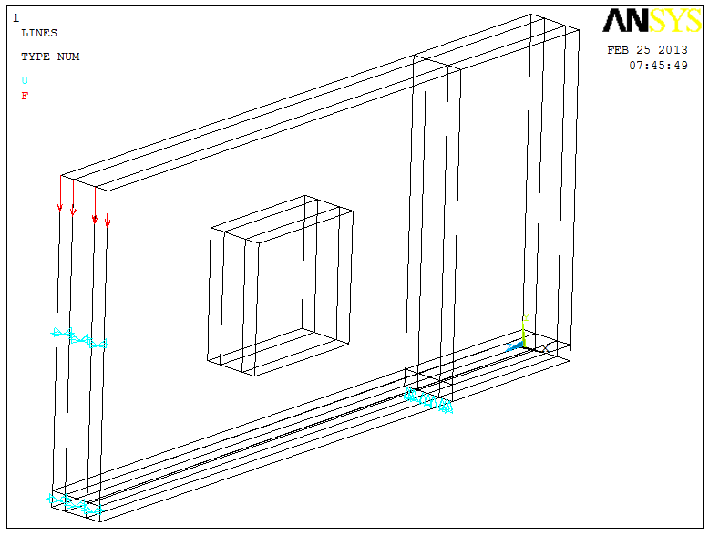
Fig. 8: Half of the beam S08-34-4 is considered due to symmetry

Fig. 9 (a) illustrate the finite element mesh for the deep beam under consideration. It is clear that the 6 node option (prism option) is used in the mesh. It also clear that the mesh is made fine near points of stress concentration. Fig. 9 (b) shows the strain contour in concrete at failure. The darker the color, the higher the strain (absolute value).

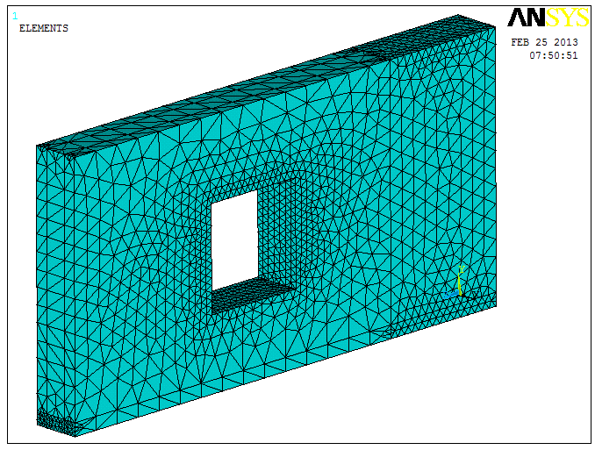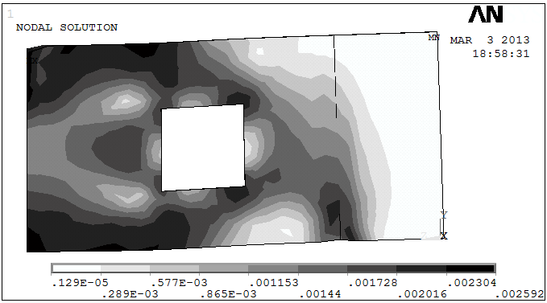
(a)
(b)

Fig. 9: ANSYS 12.1 model of the beam S08-34-4: (a) finite element mesh, (b) strain intensity

Fig. 10 (a) shows the cracks configuration for the deep beam with opening at failure (Yoo, 2011), while Fig. 10 (b) shows the experimental vs. finite element results obtained by the present ANSYS 12.1 model. In spite of the high complexity of this structural analysis (in which irregular stress patterns are involved); the two curves show good agreement, with a maximum difference of 21%.

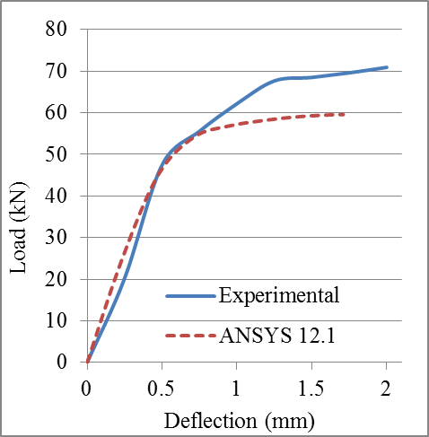
(a)
(b)

Fig. 10: (a) Crack pattern (Yoo, 2011), (b) Finite element vs. experimental results

5. Parametric Studies:
Many techniques were suggested in the previous researches to enhance the structural behavior of R.C deep and ordinary beams with opening (Ammar et al, 2011), (Chin et al, 2011), (Hemanth, 2012), (Sahoo and Chao, 2010), (Vengatachalapathy and Ilangovan, 2010). However, the present work focuses on the effect of both CFRP laminates and steel bars around the opening, in increasing the structural strength of the reinforced concrete deep beam with square and circular opening. Five cases were studied to enhance the structural behavior of the deep beam S08-34-4 as follows:

5.1 Circular Opening Instead of Square Opening:
The first attempt to increase the structural strength of the reinforced concrete deep beam, considered in the present research, is to investigate the changing the opening shape from square to circular. Fig. 11 (a) show the finite element mesh for the same beam but with circular opening that has the same size of the square one. While Fig. 11 (b) shows the load-deflection curves for both cases.

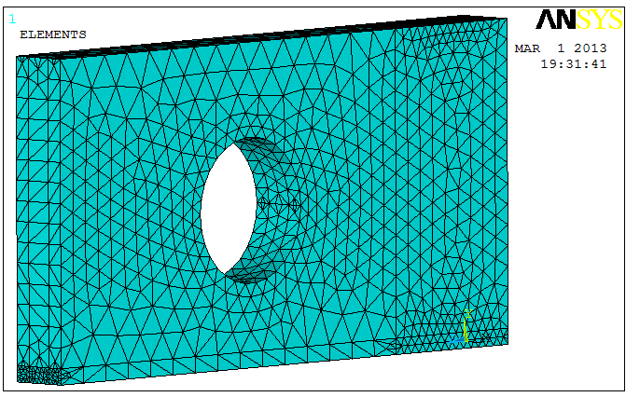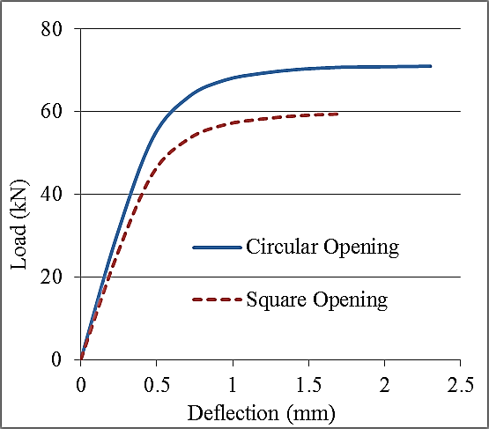
(a)
(b)

Fig. 11 square vs. circular opening: (a) finite element mesh, (b) load-deflection curves

5.2 Square Opening with CFRP Laminates:
In this case, CFRP laminates are equally attached around the four sides of the square opening, and on both sides of the beam as shown in the ANSYS 12.1 model in Fig. 12 (a).

Fig. 12 (b) shows the effect of increasing the area of CFRP laminates around the opening, while keeping the opening dimensions unchanged (240 mm x 240 mm). The quantity N_{C} is the ratio of CFRP area to the area of the opening. Note: for N_{C} = 4, which is the highest value in the graph; the CFRP laminates almost reached the top and bottom of the beam.
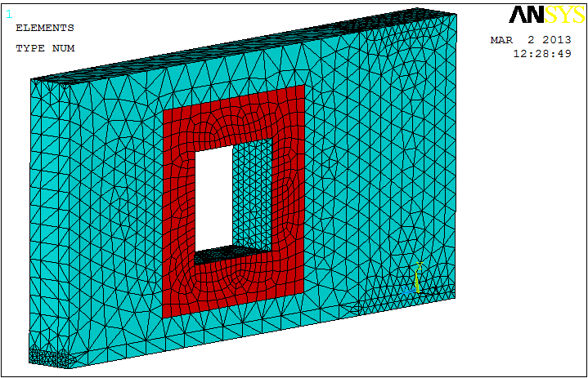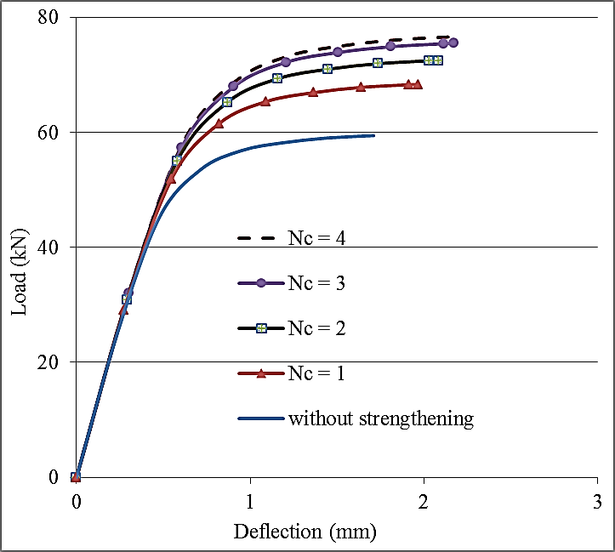
(a)
(b)

Fig. 12 CFRP laminates around the square opening: (a) finite element mesh, (b) load-deflection curves for several values of N_{C}

5.3 Square Opening with Reinforcement around Opening:
In this case, two reinforced steel bars are placed around each side of the square opening. Each bar is 300 mm long and has 20 mm clear cover from the opening edges. These bars have the same material properties for the two main bottom reinforcement (i.e F_{y} = 500 Mpa), as shown in Fig. 13 (a).

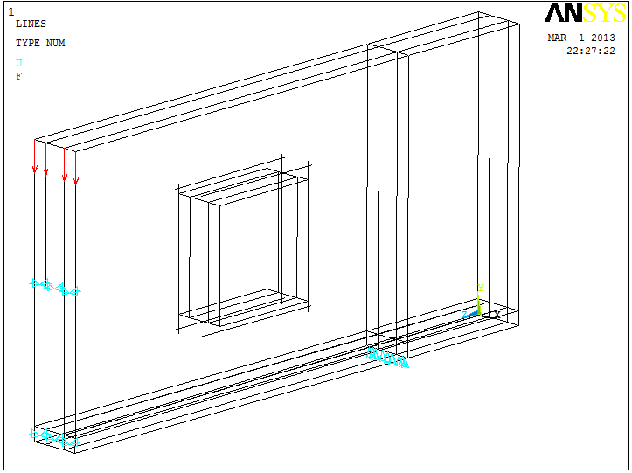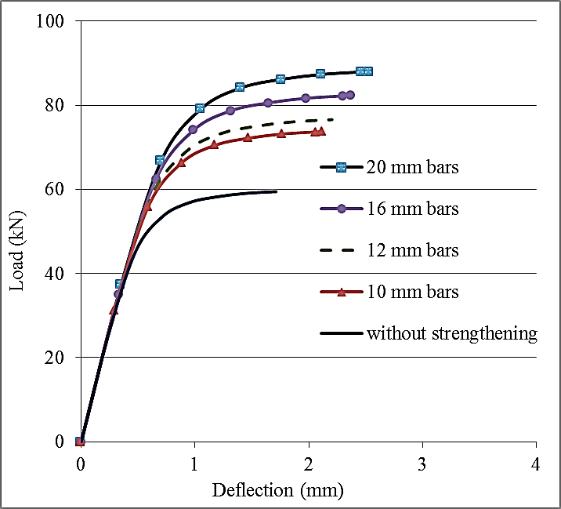
(a)
(b)

Fig. 13 Steel bars around the square opening: (a) ANSYS 12.1 lines configuration, (b) load-deflection curves for several values of bars diameters
Fig. 13 (b) shows the effect of increasing the additional bars diameters, while keeping the two main bottom bars unchanged (i.e. two 20). It is not possible to add bars of diameter larger than 20 mm, because this will violate the minimum spacing requirement from the practical point of view.

5.4 Circular Opening with CFRP Laminates:
In this case, CFRP laminates are equally attached around the circular opening, and on both sides of the beam as shown in the ANSYS 12.1 model in Fig. 14 (a).
Fig. 14 (b) shows the effect of increasing the area of CFRP laminates around the opening, while keeping the opening dimensions unchanged (which is equal to 240 mm x 240 mm). The quantity N_{C} is the ratio of CFRP area to the area of the opening. Note: for N_{C} = 4, which is the highest value in the graph; the CFRP laminates almost reached the top and bottom of the beam, as it is the case for the square opening.

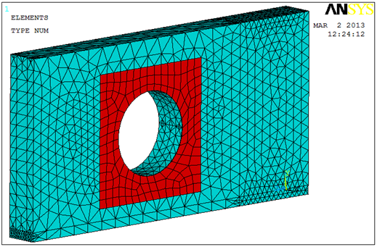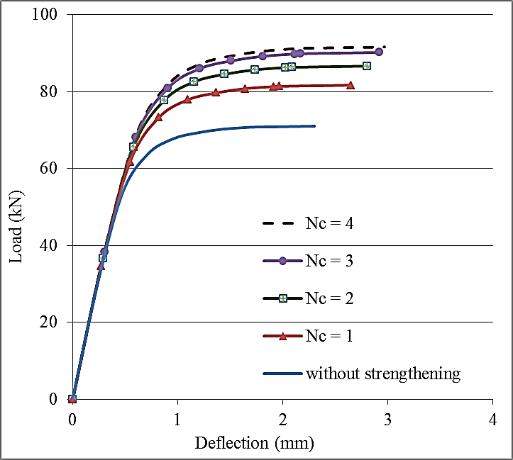
(a)
(b)

Fig. 14 CFRP laminates around the circular opening: (a) finite element mesh, (b) load-deflection curves for several values of N_{C}

5.5 Circular Opening with Reinforcement around Opening:
In this case, two reinforced steel bars are placed around the four sides of the circular opening. Each bar is 300 mm long and has 20 mm clear cover from the opening edges. These bars have the same material properties for the two main bottom reinforcement (i.e F_{y} = 500 Mpa), as shown in Fig. 15 (a).
Fig. 15 (b) shows the effect of increasing the additional bars diameters, while keeping the two main bottom bars unchanged (i.e. two 20). It is not possible to add bars of diameter larger than 20 mm, because this will violate the minimum spacing requirement from the practical point of view.
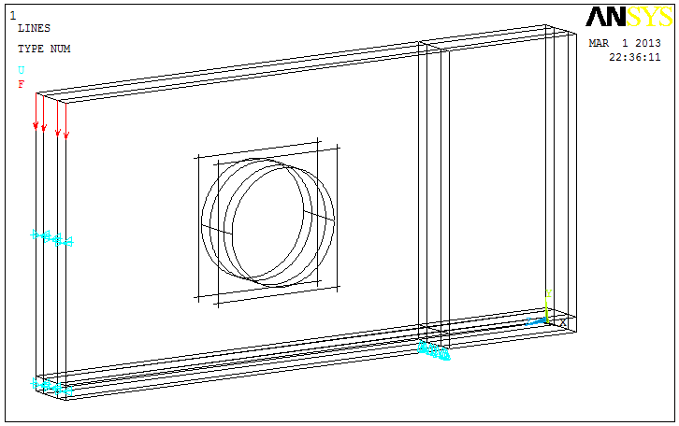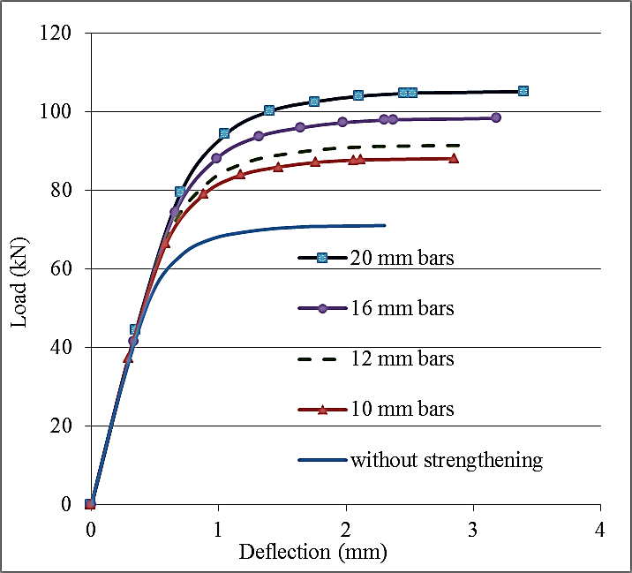
(a)
(b)

Fig. 15 Steel bars around the circular opening: (a) ANSYS 12.1 lines configuration, (b) load-deflection curves for several values of bars diameters

6. Conclusions:
By studying the results obtained in the present work; the following points are concluded:

- The finite element analysis implemented in the present work show a fair agreement with experimental data. Despite the complexity of the problem, which includes irregular stress pattern (due to the presence of the opening); ANSYS 12.1 software was found completely efficient in handling such analysis.
- In some cases, the load carrying capacity of deep beam with opening, obtained by using ANSYS 12.1 software, was 21% less than experimental results, i.e. the ANSYS 12.1 model exhibits less strength than the experimental data.
- Using a circular opening instead of a square opening (with the same size), will increase the strength of the beam by 19%.
- Introducing reinforcement bars around both the square and circular openings may increase the ultimate strength of the beam for up to 48%
- Strengthening deep RC beam with square or circular opening with CFRP laminates around the opening will increase the load carrying capacity of such beam by a percentage of up to 29%. It is also clear that attaching more CFRP layers far from the opening has less effect of the structural strength.

7. References:
ACI 318-08, American Concrete Institute, “Building Code Requirements for Reinforced Concrete,” American Concrete Institute, Farmington Hills, Michigan, 2008.
Ammar Y. A., Ayoub A. I., and Rana F. Y., 2011, "Analysis of Reinforced Concrete Beams with Openings and Strengthened by (CFRP) Laminates ", University of Bbylon Magazine, Vol. 19, No.3, p.p.1098-1113.
ANSYS, ANSYS User’s Manual Revision 12.1, ANSYS, Inc., Canonsburg, Pennsylvania, 2012.
Bandara H. R. C. S., Gamage J. C. P. H., Aravinda M. D., and Weerakon S. D., 2011, “FE Modeling of CFRP Strengthened Concrete Beam Exposed to Cyclic Temperature, Humidity and Sustained Loading”, Civil Engineering Research for Industry , Department of Civil Engineering, University of Moratuwa, pp.55-60.
Chin S.C., Shafiq N. and Nuruddin M.F., 2012, “Strengthening of RC Beams with Large Openings in Shear by CFRP Laminates: Experiment and 2D Nonlinear Finite Element Analysis”, Research Journal of Applied Sciences, Engineering and Technology Vol. 4, No. 9, pp. 1172-1180.
Giuseppe C. and Giovanni M., 2012, “Behavior of Concrete Deep Beams with Openings and Low Shear Span-to-Depth Ratio”, Iraqi Virtual Science Library (www.ivsl.org), Engineering Structures Journal, Vol. 41, pp. 294–306.
Hemanth K. G., (2012) "Experimental and Numerical Studies on Behavior of FRP Strengthened Deep Beams with Openings", MSc thesis, Department of Civil Engineering, National Institute Of Technology, Rourkela.
Kachlakev D., Miller T., Yim S., Chansawat K., and Potisuk T. ,2001, “Finite Element Modeling of Reinforced Concrete Structures Strengthened with FRP Laminates”, Final Report SPR 316, Oregon Department of Transportation & Federal Highway Administration, USA.
Sahoo D. R. and Chao S. H., 2010, “Use of Steel Fiber Reinforced Concrete for Enhanced Performance of Deep Beams with Large Openings”, Structures Congress © 2010 ASCE, pp. 1981-1990.
Vengatachalapathy V. and Ilangovan R., 2010, “A Study on Steel Fiber Reinforced Concrete Deep Beams With and without Openings”, International Journal of Civil and Structural Engineering, Vol. 1, No. 3, pp. 509- 517.
Yanga K. H., Eunb H. C., and Chungc H. S., 2006, “The Influence of Web Openings on the Structural Behavior of Reinforced High-Strength Concrete Deep Beams”, Iraqi Virtual Science Library (www.ivsl.org), Engineering Structures Journal, Vol. 28, pp. 1825–1834.
Yoo T. M., 2011, “Strength and Behavior of High Strength Concrete Deep Beams with Web Openings”, Ph.D. Thesis, Griffith School of Engineering, Griffith University.

