Energy Dissipation By Using Different Sizes And Configurations Of Direction Diverting Blocks On Spillways
Riyadh Z. Al –Zubaidy Kareem R. Al-Murshidi
Baghdad University, Iraq, Baghdad Kufa University, Najaf
Email:razzubaidy@yahoo.com Email:Kareem-Radhi@yahoo.com
Tagreed Hameed Khlif
Kufa University, Iraq, Najaf
Email:msctagreedham@yahoo.com
Abstract:
This study aims to investigate the effects of applying the direction diverting blocks, (DDBs),fixed on an ogee spillway surface with different slope on energy dissipation. Three ogee spillway models were prepared with slope of 1:1, 0.85:1, and 0.75:1. All models were constructed with a scale ratio of 50:1. Six sizes of DDBs of triangular shapes were used. These blocks were arranged in eighteen configurations for slope 1:1, fourteen configurations for each spillway models with slope 0.85:1 and 0.75:1. The configurations differ in spacing between rows of blocks and the number of rows.
Eight hundred and forty six test runs were carried out to investigate the energy dissipation downstream the three spillway models with and without using DDBs in different configurations. Froude Number and the distance of the hydraulic jump, measured from the toe of the weir, were used as a measure of flow energy and to provide a base for comparisons.
When DDBs were used, the maximum reduction in Froude Number was 36%, 89%, and 93% for spillway models with slopes 1:1, 0.85:1, and 0.75:1, respectively. A full reduction in the values of hydraulic jump distance was achieved in the three spillway models. The DDBs were efficient in reducing the distance of the hydraulic jump, and as a result, if the DDBs are used, then the stilling basin will be much shorter or may be eliminated.
Key-words: Energy Dissipation, DDBs Sizes And Configurations, Spillways
الخلاصه:
هدفت هذه الدراسة الى اختبار تاثير استخدام كتل تغيير الاتجاه المثبتة على سطوح نماذج لمسيل مائي من نوعogee في تشتيت الطاقة الحركية للمياه الجارية.استخدمت ثلاثة نماذج للمسيل بميول مختلفة في اسطحها وهي 1:1 و1:0.85 و1:0.75.وكل النماذج تم عملها بمقياس 50:1. اختبرت ستة انواع من كتل تغيير الاتجاهات اشكال مثلثية وباحجام مختلفة. ثبتت هذه الكتل على سطوح نماذج المسيل المائي بتشكيلات تختلف بعدد صفوف الكتل والمسافة بين الصفوف،منها تسعة عشر تشكيلا على سطح المسيل ذو الميل 1:1وخمسة عشر تشكيلا لكل نموذج من نماذج المسيل المائي ذات الميول 1:0.85 و1:0.75.
بلغ مجموع التجارب التي اجريت لتحديد مقدار تشتت طاقة الجريان بوجود هذه الكتل بالتشكيلات المختلفة وعدمها ولنماذج للمسيل المائي الثلاثة ثمنمائة وستة واربعون تجربة. استخدمت قيم رقم فرود ومسافة تشكل القفزة الهيدروليكية كمؤشر لقياس وكأساس لمقارنة طاقة الجريان. بينت نتائج التجارب التي اجريت على نماذج المسيل المائي بدون استخدام الكتل بان الطاقة الحركية للجريان عالية مسببة أزدياد رقم فرود وابتعاد مسافة تشكيل القفزة الهيدروليكية عن مؤخر المسيل وكلما كان ميلان السطح اكثر انبساطا عندها يكون كل من رقم فرود ومسافة القفزة الهيدروليكية اقل قيمة. تشابهت هذه الكتل في سلوكها في تقليل قيمة رقم فرود ومسافة تشكل القفزة الهيدروليكية عند تثبيتها على اسطح نماذج المسيل فكانت اعلى نسبة انخفاض في قيم رقم فرود 36% و89% و93% لنماذج المسيل ذات الميول1:1 و1:0.85 و1:0.75 على التوالي. وامكن منع تشكل القفزة الهيدروليكية بشكل كامل في جميع نماذج المسيل الثلاثة .
اثبتت هذه الدراسة كفاءة هذه الكتل في تقليل مسافة تشكل القفزة الهيدروليكية الى درجة كبيرة وكذلك الحال بالنسبة الى قيم رقم فرود الى الحد الذي يمكن معه تقليل حجم حوض التهدئة او الاستغناء عنه.
الكلمات المفتاحية: تبديد الطاقة، DDBS مقاسات ، وتكوينات ، مخرات.
388

1- Introduction
Water flowing over an ogee spillway contains a high kinetic energy that can causes erosion at its end and leads to dam failure. Therefore, stilling basins of different designs are used to dissipate the energy of the flowing water and establish safe flow conditions to protect the downstream end of the spillway from erosion.
(Alikhani, A., et al., 2009), evaluated the effects of using a single vertical continuous sill and its position on control of depth and length of a forced jump in stilling basin Thus, proper design of the sill height and its location has significant contribution to cost effectiveness of a stilling basin. . Many researchers carried out experimental works for increasing the turbulence through the hydraulic jump by using different shape of roughness placed on the bed in order to minimize the hydraulic jump length and consequently the stilling basin length, (Aboul Atta, et al., 2011), found that the T-shape roughness save materials and reduced this jump length compared to the cubic one and (Sun, Z., et al., 2012), showed that the strip and staggered prismatic elements reduce the length of the hydraulic jump more than the corrugation rough bed. (Pirestani, M .R., et al., 2012), investigated the effect of using the converged walls was successful in stabilizing the hydraulic jump in the stilling basin instead of end sill blocks at the end of stilling basin. Extensive studies on energy dissipation mechanism were made by (Peterka, A. J., 1964), designed a hydraulic model of baffled aprons as a impact type energy dissipater that directs the water into an obstruction that diverts the flow in all directions and generates high levels of turbulence that caused dissipation energy in the flow and his results indicated that the use of an impact type energy dissipater results in smaller and more economical structure compared to that of hydraulic jump type.
Recently, direction diverting blocks, DDBs, were introduced by (Darweesh, A. N., 2012), to reduce the acceleration of the supercritical flow over an ogee spillway surface and dissipate its energy.
This study was adopted to extend the study of Darweesh, A. N., 2012, by investigating the effects of using the DDBs on ogee spillways with different downstream slopes and different sizes and configurations.
2- Experimental Models
2-1 Physical Models of the Spillway
The spillway models were constructed with a scale ratio of 50:1 according to original design of Mandili Dam weir. The models were of a length 30cm, height of 30cm measured from the crest, and the total width is varied according to the change in surface slope which is equal to 35cm, 30cm, and 27cm for slope 1:1, 0.85:1, and 0.75:1, respectively. These models were made from wood and well painted by a water proof varnish to prevent wood from changing its volume by absorbing water. Figure (1) shows the spillway models that were used with different slopes.

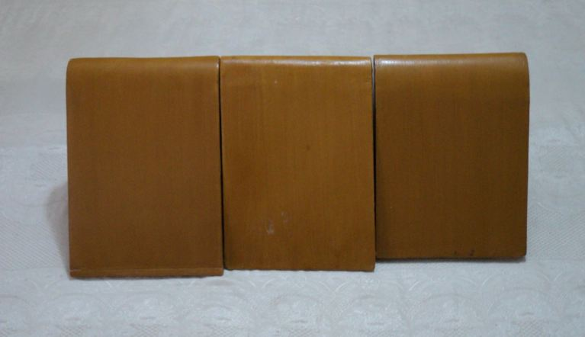

0.75:1
0.85:1
1:1

Figure (1): Physical models of ogee spillways with different slopes.
2-2 Physical Models of the DDBs
The function of triangular shape DDBs, Figure (2), is to divert the incoming flow into its both sides so that the diverted flow of two adjacent blocks will have an opposite velocity component perpendicular to the main flow direction. This will lead to reduce the excessive acceleration of the flow along the spillway surface and increase the energy dissipation.
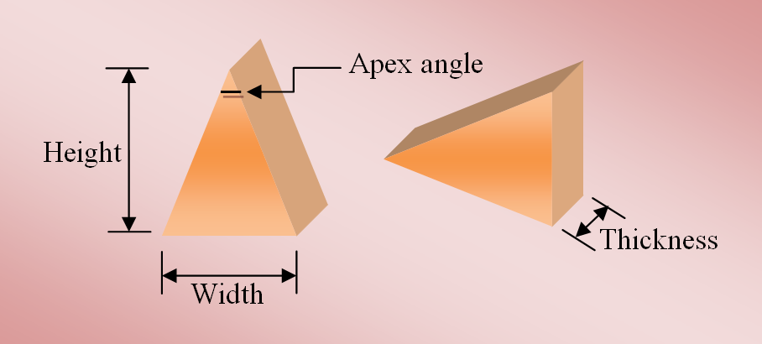

Figure (2). Schematic diagram showing of the main details of the DDBs.
The DDBs models were made of wood with a smooth surface and were painted with varnish . Table (1) presents the details of the DDBs models that were used in the experiments. The first three types of the used DDBs, block type 1, 2, and 3 have the same height of 4cm with different apex angle of 15, 20, and 30, respectively, and their width varies according to their apex angle of 1.1cm, 1.42 cm, and 2.2 cm, respectively. The second three block types, block type 4, 5, and 6, have a height of 6cm with different apex angle of 15, 20, and 30, respectively, and the width is varying according to their apex angle of 1.6 cm, 2.2 cm, and 3.2 cm, respectively.

Table (1). The details of the DDBs models.
DDBs type | DDBs dimensions
 | Width  cm | Height  cm | Apex angle  degree | Thickness  cm
1 | 1.1 | 4 | 15 | 3
2 | 1.42 | 4 | 20 | 3
3 | 2.2 | 4 | 30 | 3
4 | 1.6 | 6 | 15 | 3
5 | 2.2 | 6 | 20 | 3
6 | 3.2 | 6 | 30 | 3

3- Configurations of DDBs
Configuration of DDBs refers to number of blocks in each row, the number of block rows, and the spacing between rows. Spacing between blocks was set equal to 6cm measured from the center of the blocks. Therefore, the number of blocks in each row is determined and is equal to five blocks. spacing between rows was selected to be 2, 4cm.
The total number of configurations is different from spillway model to anther depending on the length of spillway surface that is varied with the slope. For all configurations, the first row of the blocks was fixed at 2cm from the toe of the spillway.
All of configurations that were applied on spillway with slope 0.85:1 were same as in the spillway model with slope 0.75:1 in the block type and spacing between rows except distance of first and last row to spillway from the toe. Tables (2), (3), and (4) present the details of each configuration that was used to examine the energy dissipation tests when using DDBs fixed on surface of the three spillway models.

Table (2). Details of the configurations of DDBs on spillway model with slope of 1:1.
Distance from last row to the toe  cm | Distance from 1st row to the toe  cm | Number of rows | Spacing between rows  cm | Number of blocks in each row | Spacing between blocks  cm | Block type | Configurations No
20 | 20 | 1 | - | 5 | 6 | 1, 2, 3 | 1
23 | 17 | 2 | 2 | 5 | 6 | 1, 2, 3 | 2
26 | 14 | 3 | 2 | 5 | 6 | 1, 2, 3 | 3
29 | 11 | 4 | 2 | 5 | 6 | 1, 2, 3 | 4
32 | 8 | 5 | 2 | 5 | 6 | 1, 2, 3 | 5
24 | 16 | 2 | 4 | 5 | 6 | 1, 2, 3 | 6
28 | 12 | 3 | 4 | 5 | 6 | 1, 2, 3 | 7
32 | 8 | 4 | 4 | 5 | 6 | 1, 2, 3 | 8
34 | 2 | 6 | 2 | 5 | 6 | 1, 2, 3 | 9
35 | 2 | 5 | 4 | 5 | 6 | 1, 2, 3 | 10
20 | 20 | 1 | - | 5 | 6 | 4, 5, 6 | 11
24 | 16 | 2 | 2 | 5 | 6 | 4, 5, 6 | 12
28 | 12 | 3 | 2 | 5 | 6 | 4, 5, 6 | 13
32 | 8 | 4 | 2 | 5 | 6 | 4, 5, 6 | 14
34 | 2 | 5 | 2 | 5 | 6 | 4, 5, 6 | 15
25 | 15 | 2 | 4 | 5 | 6 | 4, 5, 6 | 16
30 | 10 | 3 | 4 | 5 | 6 | 4, 5, 6 | 17
35 | 3 | 4 | 4 | 5 | 6 | 4, 5, 6 | 18
Without DDBs |  |  |  |  |  |  | 19

Distance from last row to the toe | Distance from 1st row to the toe | Number of rows | Spacing between rows | Number of blocks in each row | spacing between blocks | Block type | Configurations No
17 | 17 | 1 | - | 5 | 6 | 1, 2, 3 | 1
20 | 14 | 2 | 2 | 5 | 6 | 1, 2, 3 | 2
23 | 11 | 3 | 2 | 5 | 6 | 1, 2, 3 | 3
26 | 8 | 4 | 2 | 5 | 6 | 1, 2, 3 | 4
29 | 5 | 5 | 2 | 5 | 6 | 1, 2, 3 | 5
21 | 13 | 2 | 4 | 5 | 6 | 1, 2, 3 | 6
25 | 9 | 3 | 4 | 5 | 6 | 1, 2, 3 | 7
29 | 5 | 4 | 4 | 5 | 6 | 1, 2, 3 | 8
17 | 17 | 1 | - | 5 | 6 | 4, 5, 6 | 9
21 | 13 | 2 | 2 | 5 | 6 | 4, 5, 6 | 10
25 | 9 | 3 | 2 | 5 | 6 | 4, 5, 6 | 11
29 | 5 | 4 | 2 | 5 | 6 | 4, 5, 6 | 12
22 | 12 | 2 | 4 | 5 | 6 | 4, 5, 6 | 13
27 | 7 | 3 | 4 | 5 | 6 | 4, 5, 6 | 14
Without DDBs |  |  |  |  |  |  | 15
Table (3). Details of the configurations DDBs on spillway model slope 0.85:1.

Table (4). Details of the configurations DDBs on spillway model slope 0.75:1.

Distance from last row to the toe  cm | Distance from 1st row to the toe  cm | Number of rows | Spacing between rows  cm | Number of blocks in each row | spacing between blocks  cm | Block type | Configurations No
16 | 16 | 1 | - | 5 | 6 | 1, 2, 3 | 1
19 | 13 | 2 | 2 | 5 | 6 | 1, 2, 3 | 2
22 | 10 | 3 | 2 | 5 | 6 | 1, 2, 3 | 3
25 | 7 | 4 | 2 | 5 | 6 | 1, 2, 3 | 4
28 | 4 | 5 | 2 | 5 | 6 | 1, 2, 3 | 5
20 | 12 | 2 | 4 | 5 | 6 | 1, 2, 3 | 6
24 | 8 | 3 | 4 | 5 | 6 | 1, 2, 3 | 7
28 | 4 | 4 | 4 | 5 | 6 | 1, 2, 3 | 8
16 | 16 | 1 | - | 5 | 6 | 4, 5, 6 | 9
20 | 12 | 2 | 2 | 5 | 6 | 4, 5, 6 | 10
24 | 8 | 3 | 2 | 5 | 6 | 4, 5, 6 | 11
28 | 4 | 4 | 2 | 5 | 6 | 4, 5, 6 | 12
21 | 11 | 2 | 4 | 5 | 6 | 4, 5, 6 | 13
26 | 6 | 3 | 4 | 5 | 6 | 4, 5, 6 | 14
Without DDBs |  |  |  |  |  |  | 15

4- Laboratory Work
All The tests were carried out in the hydraulic laboratory of College of Engineering of the Babylon University. The laboratory has a flume of 10m long horizontal tilting flume of 0.3m in width and 0.45m in height. The bed of the flume was maintained at a horizontal slope during all of the tests. A centrifugal pump having a rated capacity of 40l/s was used to deliver flow to the flume. Two movable carriages with point gages were mounted on brass rail at the top of flume sides which have accuracy of 0.1mm. Measurements of depths water levels were observed by two point gages. The first, was located at 20cm upstream side of weir and the other at 125cm downstream the toe of the weir. The crest of the weir and the channel bottom were used as reference for the upstream and downstream point gages, respectively. Upstream water depth was varying between 1.4cm and 4.2cm above the crest level. At these water depths, the minimum and maximum discharges were obtained of 1.04 and 5.85l/s of the model, respectively, which representing 300 and1724 m³/s of the prototype discharges. Spillway models were placed within the flume and the DDBs were carefully fixed by using special adhesive and were left for one day for complete adhesion.
Rating curve was obtained before conducting the laboratory test runs. Ten runs with three replications were carried out with different discharges measurement.
In all test runs on three models follow the same laboratory procedure, which is summarized as follows:
- Operating the flume pump.
- Adjusting the control valve to obtain the required flow depth.
- Measuring the upstream water depth.
- Measuring the downstream water depth.
- Obtaining the flow rate from the rating curve.
- Measuring the hydraulic jump distance downstream the spillway toe by using a graded ruler fixed to the flume.
Three hundred and thirty tests runs were carried out on the spillway model with slope 1:1 with and without DDBs, two hundred and fifty eight test runs were carried out on the spillway model with slope 0.85:1 with and without DDBs, and two hundred and fifty eight test runs to investigate the energy dissipation in spillway model with slope 0.75:1 with and without DDBs.
5- RESULTS AND ANALYSES
Both the Froude Number and the distance where the hydraulic jump is formed measured from the toe of the spillway were used as a criterion in assessing and comparing how much energy is dissipated.
5-1 Energy Dissipation without using DDBs
Eighteen tests runs were carried out on the three spillway models of different slope surfaces without DDBs, which were represented by configuration number 19 for slope 1:1 and configuration number 15 for slope 0.85:1and slope 0.75:1.In these runs, the applied discharges were varied between 1.22 and 6.9m³/s/m (1.04 and 5.85 l/s of the model) respectively, which representing 300 and1724 m³/s of the prototype discharges.
Figure (3)and Figure (4) show the variation in values of Froude Number and variation of the hydraulic jump distance with applied discharges of the three spillway models different without DDBs. At the minimum applied discharge, the values of Froude Number were 0.18, 0.19, and0.2, and the recorded values of the hydraulic jump distance were 2.5, 2.5, and 5m measured from the weir toe for slopes 1:1, 0.85:1, and 0.75:1, respectively. While, at the maximum applied discharge, the differences were much higher, Froude Number values were 0.55, 3.07, and 4.74, and jump distance were 50, 62.5, and 65mfor slopes 1:1, 0.85:1, and 0.75:1, respectively. It is clear that the flow at the downstream side has less energy when using slope 1:1 compared with other.
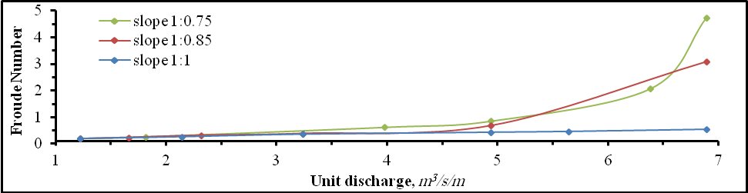

Figure (3). Variation of the Froude Number with the unit discharge.
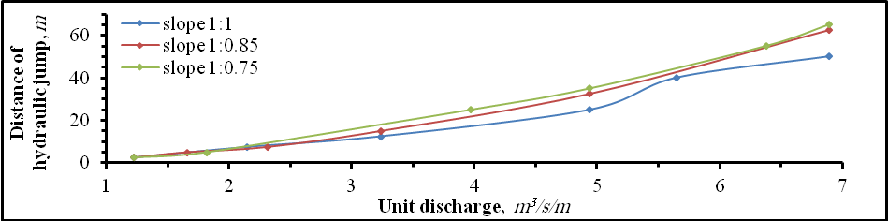

Figure (4). Variation of the hydraulic jump distance with the unit discharge.
5-2 Energy Dissipation with DDBs
Presence of the DDBs on spillway surface causes the flow to be diverted on both sides of blocks that reduce the flow terminal velocity, decrease the value of Froude Number, and reduce the hydraulic jump distance downstream of spillway compared with the same spillway models surface slope.
In all tests runs carried out on three spillway models the behavior of the block types and configurations were the same in reducing the values of Froude number and distance of hydraulic jump . The general behavior of the variation of the distance of the hydraulic jump with the applied discharges in all test runs was exactly the same as the variation of the Froude number but with much extended amplitude.
Sizes of Blocks
Increasing the size of the block, blocks type 2 is larger than type 1, type 3 is larger than type 2, and type 5 is larger than 4, type 6 is larger than type 5, This indicates that increasing the size of the blocks leads to reduce the spacing between the block and thus reducing the value of Froude Number and the distance of the hydraulic jump .Figure (6) , Figure (7),Figure (8), and Figure (9) show that indicates that increasing the size of the blocks leads to reduce the spacing between the block and thus reducing the value of Froude Number and the distance of the hydraulic jump.
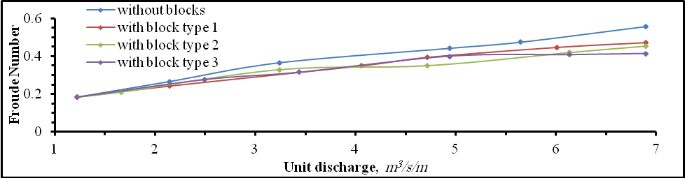
Figure (5). Variation of Froude Number with discharge in test runs with configuration number 1.Spillway model with slope 1:1.
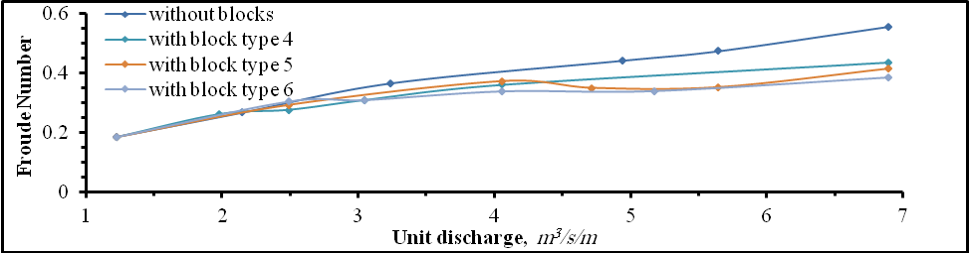
Figure (6). Variation of Froude Number with discharge in test runs with configuration number 11.Spillway model with slope 1:1.
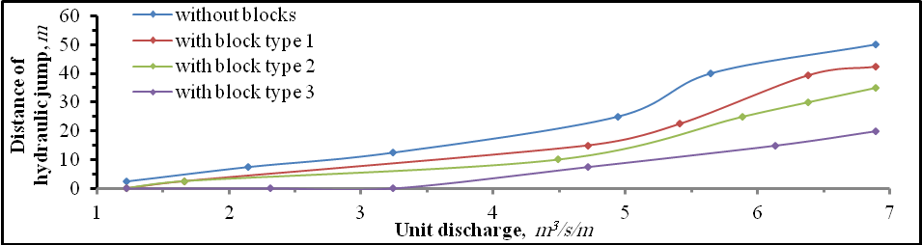
Figure (7). Variation of hydraulic jump distance with discharge in test runs with configuration number 1.Spillway model with slope 1:1.

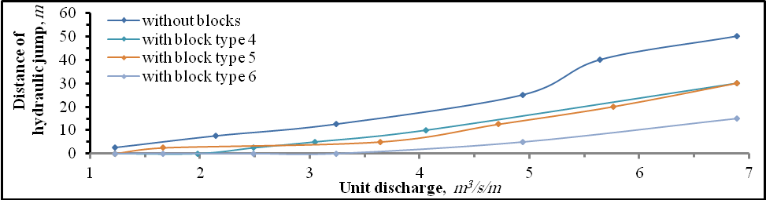
Figure (8). Variation of hydraulic jump distance with discharge in test runs with configuration number 11.Spillway model with slope 1:1.
Spacing between rows
In all configurations applied on three spillway models , reducing the spacing between rows lead to reduction the hydraulic jump distance .Figure (9) and Figure (10) show the difference between spacing 2 cm and 4 cm.
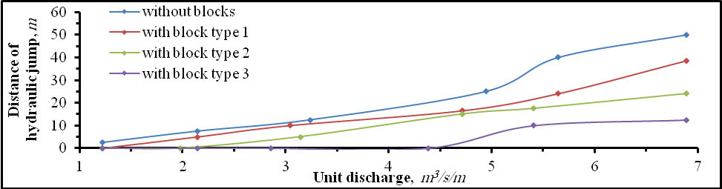
Figure (9). Variation of hydraulic jump distance with discharge in test runs with configuration number 2.Spillway model with slope 1:1.
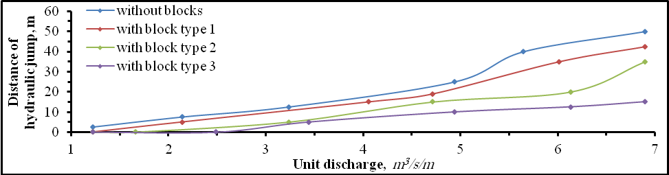
Figure (10). Variation of hydraulic jump distance with discharge in test runs with configuration number 6.Spillway model with slope 1:1.
Number of rows
comparing the results of tests runs with same spacing of rows but with less number of rows we can conclude that the number of row has the major effect on the distance of the hydraulic jump and the limit is 5 rows to have a full reduction on three spillway models.
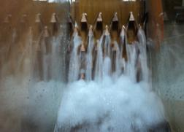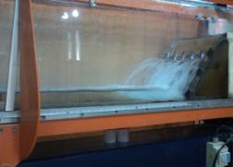
Figure (11). Snapshots of side and front view at configuration number 5with block type 3.
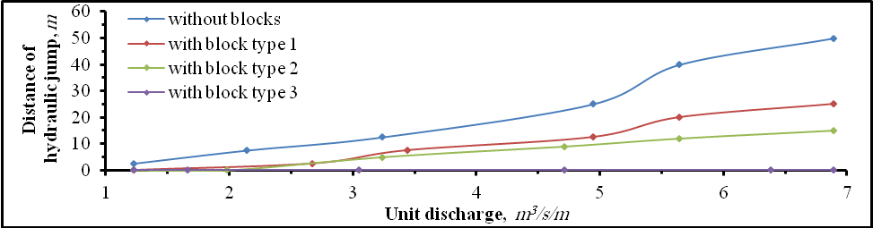
Figure (12). Variation of hydraulic jump distance with discharge in test runs with configuration number 5.Spillway model with slope 1:1.
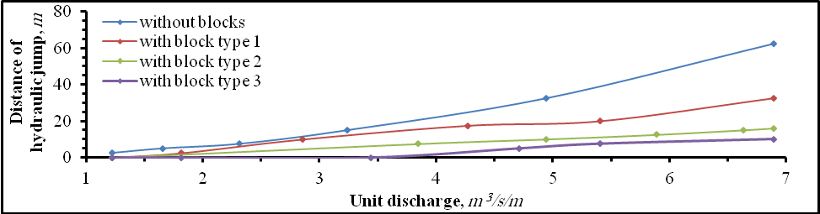
Figure (13). Variation of hydraulic jump distance with discharge in test runs with configuration number 5. Spillway model with slope 0.85:1.
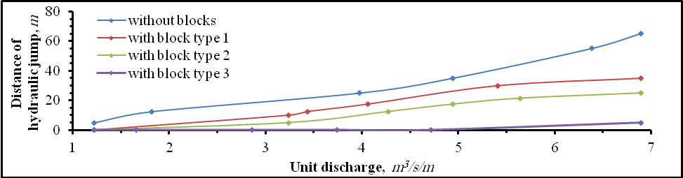
Figure (14). Variation of hydraulic jump distance with discharge in test runs with configuration number 5. Spillway model with slope 0.75:1.

6- Conclusions
In the entire tests without using DDBs, the flow over the ogee spillway was of high kinetic energy of the flow causes high values of Froude Number and hydraulic jump to developed far way downstream the spillway. As the slope of the spillway surface is milder as the values of Froude Number and hydraulic jump distances are reduced.
- DDBs reduce the excessive acceleration of the flow passing along the spillway in all of the applied discharges and the distance of the hydraulic jump was reduced.
- In tests runs without using DDBs, the values of Froude Number at the location of measurements varied between 0.18 and 0.55 , 0.19 and 3.07, and 0.2 and 4.74, for spillway models with slopes 1:1, 0.85:1, and 0.75:1, respectively. The range of distance of the hydraulic jump for these three models were 2.5 and 50,2.5 and 62.5m, and 5 and 65m, respectively.
- In tests runs with DDBs, the rang of Froude Number was 0.17 to 0.47, 0.17 to 0.54, and 0.17 to 0.55, for spillway models with slopes 1:1, 0.85:1, and 0.75:1, respectively. The range of distance of the hydraulic jump for these three models was 0 and 42.5, 0 and 50m, and 0 and 55m, respectively. And maximum reduction in Froude Number was 36%, 89%, and 93% for spillway models with slopes 1:1, 0.85:1, and 0.75:1, respectively. A full reduction in the values of hydraulic jump distance was achieved in the three spillway models.
- In tests runs with DDBs, all of the DDBs types have the same behavior in reducing the values of Froude Number and the distance of the hydraulic jump.
- Increasing the number of rows leads to greatly reduce distance of the hydraulic jump.
- Increasing the size of blocks reduces the path of flow between block at its base that produces much more energy dissipation.
- Test runs of on three spillway models showed that a full reduction in the values of hydraulic jump distance was achieved when using configuration number 5 with block type 3.
- The DDBs were effective in reducing the distance of the hydraulic jump and as a result, if the DDBs are used, then the stilling basin will be much shorter or can be eliminated.

List of symbols
List of Symbols
Symbol | Description | Dimensions
b | Weir width | L
C_{d} | Coefficient of discharge | -
d | Depth below the water surface | L
D | Length scale related to depth | L
F_{r} | Froude Number | -
g | Gravitational acceleration | L/T²
H | Water depthabove weir crest | L
E_{r} | Energy scale ratio. | -
p | Pressure | M/T²L
Q | Flow rate | L³/T
Q_{r} | Discharge scale ratio. | -
R_{e} | Reynolds Number
V | Flow velocity | L/T
V_{r} | Velocity scale ratio. | -
W_{e} | Weber Number | -
γ | Weight density | M/L²T²
ρ | mass density of the liquid | M/L³
υ | Kinematic viscosity of water | L²/T
 | Surface tension of water | M/T²

References
Abdel Azim, M.,Gamal, M.,Abdel Aal, A., and Habib, A., 2012, Effect of End Sill In Radial Basin On Characteristics Of Free Hydraulic Jump, Water Structure Engineering,Faculty of Engineering,University of ZagaZig , Egypt.
AboulAtta, N., Ezizah, G., Yousif, N., and Fathy, S., 2011, Design of Stilling Basin Using Artificial Roughness, International Journal of Civil and Environmental Engineering.
Alikhani, A., Behrozi, R.,and Fathi,M.,2009, Hydraulic jump In Stilling Basin With Vertical End Sill, Journal of Physical Sciences, Department of Civil Engineering, University of Qom, Iran.
Arora, K. R., 2007, Irrigation Water Power and water Resources Engineering, NaiSarak, Delhi, A. K. Jain for Standard Publishers Distributors.
Brater, E. F.,King, H. W., Lindell, J. E., and Wei, C. Y., 1996,Handbook of Hydraulics, Seventh Edition, USA, published by McGraw-Hill Book Company.
Chanson, H., 1999, the Hydraulic of Open Channel, published byArnold, London, UK.
Chow, V.T.,1959,Open-Channel Hydraulics, published by McGraw-Hill Book Company.
Darweesh, A. N.,2012, Energy Dissipation In Mandili Dam Spillway Stilling Basin By Using Direction Diverting Blocks,M. Sc. dissertation presented to the University of Baghdad, College of Engineering.
Farhoudi, J., 2009, Total Pressure Around Chute blocks of SAF Stilling Basin, International Journal of Civil Engineering, University of Tehran,Iran, Department of Irrigation Engineering.
FarzinSalmasi, Energy Loss At Drops Using Neuro Solutions, 2011,International Journal of Civil and Environmental Engineering.
Hayawi, H. A., and Mohammed A., Y., 2010, Properties of Hydraulic Jump Down Stream Sluice Gate, Journal of Applied Sciences, Engineering and Technology, 3(2), 2011, Maxwell Scientific Organization.
Ibrahim, H., Elsebaie and Shazy Shabayek, 2010, Formation of Hydraulic Jump On Corrugated Beds, International Journal of Civil and Environmental Engineering, Vol: 10 No: 01.
Khlifa, M., 1979, Radial Hydraulic Jump,Journalof the Hydraulics Division, Vol. 105, No. 9, September 1979.
Novak, P., Moffat, A. I. B., Nalluri, C., and Narayanan, R., 2007, Hydraulic Structures, Fourth Edition, USA, New York,published byTaylor and Frances.
Pagliara, S.,and Palermo, M.,2008, Energy Dissipation In The Stilling Basin Downstream of Block Ramp In Presence of Rock Made Sills,Department of Civil Engineering, University of Pisa, Italy, Via Gabba 22, 56122, Pisa.
Peterka, A. J., 1964, Hydraulic Design of Stilling Basins and Energy Dissipators, U.S.Bureau of Reclamation, USBR,Engineering,Monograph No.25.
Pirestani,M. R., Razmkhah, A., and Ghobadi, F., 2012, Effect of Convergent Walls on Energy Dissipation in Stilling Basin by Physical Modeling, International Journal of Thermal and Fluid Sciences.
RafidainState Company for Dams Construction, 2008, Hydraulic Model Study of Mandili Dam Spillway, Final Report, Ministry of Water Resources.
Vennard, J. K., and Street, R. L., 1976, Elementary Fluid Mechanics, 5th edition, New York,published byJohn Wiley and Sons, Inc.

