Adsorption of Methylene Blue Dye Using Low Cost Adsorbent of Sawdust: Batch and Continues Studies

Hadeel Ali Al-Husseiny
Babylon University, College of Engineering, Civil Eng. Dept
Rawansaad2003@yahoo.com
Abstract
The feasibility of sawdust as low cost adsorbent to remove methylene blue from aqueous solutions was investigated through batch and column studies. Batch experiments were carried out with treated sawdust and commercial activated carbon to compare the adsorption behavior of them in terms of their adsorption capacities with the initial concentration of 100 mg/L and solution pH of 5. Equilibrium data were fitted to Langmuir and Freundlich isotherm models. The equilibrium data were best represented by the Langmuir isotherm model, with maximum monolayer adsorption capacity of 30.11 mg/g for sawdust while 39.09 mg/g by using activated carbon. In column experiments, fixed bed adsorption of methylene blue was performed on sawdust columns and the breakthrough curves were determined by varying bed depth, flow rate and influent concentration. The highest operating time of 1200 min. was obtained using 50 mg/l initial dye concentration, 20 cm bed height, pH of 5, and 3.33*10⁻⁶ m³/sec flow rate.
Keywords: Adsorption; sawdust; methylene blue ; Equilibrium; fixed bed
الخلاصة
تم التحري عن امكانية نشارةِ الخشب كمادة مازة واطئَة الكلفة لإزالة صبغة المثلين الأزرقِ مِنْ المحاليل المائيةِ من خلال دِراساتِ عمود الامتزاز والتجارب الدفعية (batch experiments). نُفّذتْ التجارب الدفعيةِ باستخدام نشارةِ الخشب المُعَالَجةِ والكاربون المنشّطِ التجاريِ للمُقَارَنَة بين سلوكِهما من ناحية سعةِ الامتزاز لهما في محاليل بتركيزِ اوليِ للصبغة 100 ملغ/لتر واس هايدروجيني pH يساويْ . (5)تم تمثيل بيانات التوازن من خلال موديلات لانكماير وفريندلج . مع افضل نسبة امتزاز 30.11 ملغ/غم باستخدام النشارة و 39.09 ملغ/غم بإستعمال الكاربون المنشّطِ مُمَثَّلةِ بنموذجِ لانكماير Langmuir. في تجاربِ عمود الامتزاز ذات النمط المستمر للمثلين الازرق على نشارةِ الخشب تحت ظروف مختلفة من عمق طبقة المادة المازة، معدل الجريان و التركيز الابتدائي لمحلول الصبغة تم الحصول على وقت التشغيل الأعلى 1200 دقيقة بإستعمال 50 ملغ/لتر تركيز صبغِة أوليِ، 20 سنتيمتر إرتفاعِ النشارة في العمود , اس هايدروجيني 5، و معدل جريان 3.33*10⁻⁶ م³ /الثانية.
الكلمات المفتاحية: الامتزاز؛ نشارة الخشب؛ الميثيلين الأزرق؛ التوازن؛ سرير ثابت
1.Introduction
Dyes and pigments are highly visible material. Thus, even minor release into the environment may cause the appearance of color. Thus, there is a requirement on industry to minimize environmental release of color, even in cases where a small but visible release might be considered as toxicologically rather innocuous (Masitah, 2008).
Dyes usually have a synthetic origin and complex molecular structure, which make them more stable and more difficult to biodegrade. The choice of methylene blue as adsorbate is due to its known strong adsorption onto solids (Özer and Dursun, 2007).
MB can cause eye burns, and if swallowed, it causes irritation to the gastrointestinal tract with symptoms of nausea, vomiting and diarrhea. It may also cause methemoglobinemia, cyanosis, convulsions and dyspnea if inhaled (Tan et. al., 2008).
Most conventional methods used in waste water treatment such as ion exchange, ultrafilteration, chemical precipitation etc are very expensive to perform, therefore, cheap.
methods for waste water treatment is being sought for. The use of non- conventional agricultural by-product which are composed mainly of cellulose in the adsorptive treatment of waste waters is going on (Asiagwu et al., 2013).
Adsorption onto activated carbon has been found to be superior for wastewater treatment compared to other physical and chemical techniques (Tan et. al., 2008), However, commercially available activated carbon is still considered expensive; therefore, many efforts have been made to investigate the use of various low cost organic adsorbents, which are, cheap, easily available and disposable without regeneration. These materials are derived from natural resources, agricultural wastes or industrial by-products as peat, wood, barley and rice husk, sawdust, biomass, … etc., most of them are cellulose based and can be used without any previous thermal or chemical treatment.
Sawdust, having a great potential as an adsorbent, has attracted the most attention of the scientists dealing with different aspects of wastewater purification by biosorption. If sawdust could be used as adsorbent, both the environment protection and wooden industry could benefit. Sawdust has proven to be a promising effective material for the removal of dyes from wastewaters. Moreover, it is actually an efficient adsorbent that is effective to many types of pollutants, such as dyes, oil, salts, heavy metals (Velizar et al., 2009). Hence, the utilization of such waste is most desirable. Therefore, the aim of this study was to investigate the potential of sawdust, an abundantly available solidwaste, as a nonconventional adsorbent in the removal of a basic dye, methylene blue, from aqueous solutions.
In addition, sawdust can be used as an adsorbent instead of activated carbon and replace the regeneration step by making use of composting the adsorbent. Composting the spent adsorbent will not only degrade the adsorbent material, but also the adsorbate. Thus, sever drawbacks involved in the regeneration of the spent activated carbon can be reduced. The degraded product is a stabilized product which is added to soil to improve soil structure, especially for clay soils, or which acts as a fertilizer improving the nutrient content (Williams, 2005).
2. Materials and methods
2.1. Methylene blue
Methylene blue has wider applications, which include coloring paper, temporary hair colorant, dyeing cottons, wools, etc. It is a basic dye, with the molecular formula C₁₆H₁₈N₃ClS (molecular weight 373.91g/mol).The chemical structure of the dye is shown in Fig. (1) (Rastogi et. al., 2008).
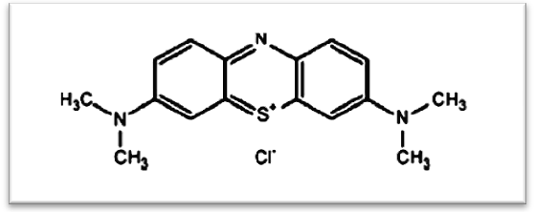
Figure (1) Chemical Structure of Methylene blue dye (Rastogi et. al., 2008).
The methylene blue used in the present work was supplied by the scientific bureaus in Iraqi commercial markets; Table (1) shows some of its physical and chemical properties.

Table (1): Some of Physical and Chemical Properties of MB (MERK, 2005)
Properties | Values
Chemical formula | C₁₆H₁₈N₃CIS
IUPAC name | 3,7-bis(Dimethylamino)-Phenazathionium chloride Tetramethylthionine chloride, Trihydrate
Molecular weight ( g/mol) | 373.9
Type | Basic dye
Color | Blue or Dark green
Physical state and form | Solid and powder
Odor | Odorless
Water solubility (g/L) at 20 ºC | 40
Bulk density (Kg/m³) | 400-600
Molecular diffusion (m²/s) | 3.6*10⁻⁶
Adsorption capacity (g/100g) | 11-28

2.2. Commercial Activated Carbon
The commercial activated carbon (GAC) with the physical properties listed in Table (1) was supplied by the scientific bureaus in Iraqi commercial markets. The mesh size of activated carbon used in the study was of (1mm).
The activated carbon firstly was washed with distilled water to remove the impurities and then dried in an electric oven at 110-120ºC for one hour. This time was usually enough to remove any undesired moisture within the particles. It was then placed in desiccators for cooling.
Table (2) Physical Properties of Activated Carbon Utilized in the Present Study (Commercial Markets)
Item name | Granular activated carbon
Base | Coconut shell
Bulk density | 0.3 x 10³ Kg/m³
Particle density | 1.5 x 10³ Kg/m³
BET surface area | 650 m²/g
Void fraction | 0.4
Internal porosity | 0.2
Ash content (%) | 5 Max.
Iodine No. (mg/g) | 1100-1130
pH | 10.2-10.6

2.3. Treated Sawdust
The structure of wood is very porous and has a very high free surface volume that should allow accessibility of aqueous solutions to the cell wall components. However, it has been shown that breaking wood down into finer and finer particles does increase sorption capacity (Rowell, 2005).
2.4. Preparation of the adsorbent
The raw sawdust used was collected from a local furniture manufacturing industry and sieved in the size ranges (0.15-0.4) and (0.85-1.15) mm. After collection and sieving, the sawdust was washed with distilled water to remove muddy materials and impurities and then dried in an electrical oven at 100-110 ºC, the sawdust was then immersed in 2N NaOH aqueous solution for 8 h (Meena et al ., 2004). It was observed that a dark-red solution was generated during this treatment, which indicated the removal of lignin from the adsorbent material. Thereafter, it was washed several times with distilled water to remove the lignin content and excess of NaOH. The sawdust was repeatedly washed with distilled water till no red coloration was observed. After washing, sawdust dried in an oven at 100-110 ºC for 6 h (Bhattacharya et al., 2006), It was then immersed in 0.2N H₂SO₄ for 8 h to remove the traces of alkalinity and other impurities. The acid-treated sawdust was again thoroughly washed with distilled water to remove the excess of H₂SO₄ and other coloring materials till the wash-found water was colorless. After the wash water became colorless, the treated sawdust adsorbent material was dried at 100-110 ºC and stored in a dessicator for use as an adsorbent.
Treatment of biosorbents with NaOH solution positively affected adsorption capacity because they can be considered as chemically activated, that is chemical activation is a single step process and is held in presence of dehydrating reagents such as KOH, K₂CO₃, NaOH, ZnCl₂ and H₃PO₄ which influence pyrolytic decomposition and inhibit tar formation, the carbon yield obtained is higher and the temperature used in chemical activation is lower than that of physical activation (Deng et al., 2009).
2.5. Batch equilibrium studies
Batch experiments were conducted with treated sawdust and commercial activated carbon as adsorbents to compare the adsorption behavior of them in terms of their adsorption capacities to methylene blue dye and to estimate equilibrium isotherms.
2.5.1 Experimental procedure
Adsorption tests were performed in a set of Erlenmeyer flasks (250ml) where 100 ml of MB solution with initial concentration of 100mg/l was placed in each of these flasks. Different masses (0.25, 0.5, 0.75, 1, 1.25, 1.5 and 1.75) g of the prepared sawdust with the particle size of (0.15-0.4) mm was added to the flasks and stirred for 24 hr at room temperature to reach equilibrium. The pH of the solutions was equal to 5 (Al-Taliby, 2009). Aqueous samples were taken from the solution and the concentrations were analyzed. All samples were filtered prior to the analysis in order to minimize the interference of the sawdust fines with the analysis. The concentrations of MB in the solutions before and after adsorption were determined using a double beam UV-visible spectrophotometer (UV 1600 PC Shimadzu) at 664.5 nm wavelength. The amount of adsorption at equilibrium, q_{e} (mg/g), was calculated by:
(1)
Where C_{o} and C_{e} (mg/l) are the liquid phase concentrations of dye at the initial and equilibrium conditions, respectively. V is the volume of the solution (l) and W is the mass of dry adsorbent used (g).
The same experiment mentioned above was repeated using commercial activated carbon as adsorbent and each experiment was duplicated under identical conditions. The results are given in Tables (3), (4) .
2.6. Column studies
Continuous flow adsorption studies were conducted in a glass column made of pyrex glass tube of (0.8m) height and (0.05m) inner diameter. At the bottom of the column, a stainless sieve was attached followed by a layer of glass beads. A known quantity of the prepared sawdust was packed in the column to yield the desired bed heights of the adsorbent (0.05,0.1, 0.15 and 0.2)m, and then an upper retaining sieve was inserted on top of the bed and firmly secured in place by layer of glass beads in order to provide a uniform flow of the solution through the column. Dye solution of known concentrations (15, 30, 40 and 50 mg/l) at pH 5 was pumped through the column at a desired flow rate (2.2*10⁻⁶, 3.33*10⁻⁶ , 4.17*10⁻⁶ and 4.83*10⁻⁶ m³/sec). The samples of solutions at the outlet of the column were collected at regular time intervals and the concentrations were measured.
Once the sawdust was packed inside the column, the column was fully filled with deionized water for 2 h to ‘wet’ the column. This was important to ensure that all air was expelled between and within the sawdust particles before the experiment began. If there was an air pocket inside the column, channeling and air entrapment would occur which would lower the bed performance (Ko et al., 2003).
3. Results and discussion
3.1. Adsorption isotherms
The behavior of sawdust as an adsorbent was studied by evaluating the equilibrium isotherms and removal efficiency of methylene blue dye in batch mode, and comparing the results with those obtained from using commercial activated carbon as an adsorbent instead of sawdust. The experiments were conducted at the same sawdust batch mode experimental conditions of: (MB pH solution of 5, dosages of adsorbents (sawdust and activated carbon), temperature of 25±1°C, and shaking time).
Adsorption isotherm is basically important to describe how solutes interact with adsorbents, and is critical in optimizing the use of adsorbents (Tan et al., 2008).
Equilibrium data were fitted to Langmuir and Freundlich models. The applicability of the isotherm equation of the study was compared by calculating the coefficient of determination values (R²). Results of the batch studies are given in Tables (3 and 4). In addition, column experiments were carried out for studying the adsorption behavior of the sawdust bed adsorbent for the removal of methylene blue dye from water.
The adsorption isotherms revealed the specific relation between the concentration of the adsorbate and its adsorption degree onto adsorbent surface at a constant temperature. To quantify the adsorption capacity of adsorbents for the removal of adsorbates from aqueous solution, the Langmuir and Freundlich isotherm models are explained (Bansal and Goyal, 2005).
The Freundlich isotherm is the earliest known relationship describing the sorption equation derived empirically in 1912. This fairly satisfactory empirical isotherm can be used for non-ideal sorption that involves heterogeneous surface energy systems and is expressed by the following equation (Weber, 1972; Metcalf and Eddy, 2003):
(2)
where
q_{e}: The amount of adsorbate adsorbed per unit mass of the adsorbent.
x : The mass of the adsorbate. (mg)
m : The mass of the adsorbent. (mg)
C_{e}: The equilibrium concentration of the adsorbate. (mg/l)
K_{F}: is roughly an indicator of the adsorption capacity of the adsorbent which can be defined as the adsorption or distribution coefficient (mg/g (l/mg)^{1/n})
1/n : is the adsorption intensity or surface heterogeneity.
In general, as the K_{F} value increases the adsorption capacity of adsorbent for a given adsorbate increases. The magnitude of the exponent, 1/n, gives an indication of the favorability of adsorption, the slope 1/n ranges between (0 and 1), becoming more heterogeneous as its value gets closer to zero. Values of n > 1 represent favorable adsorption condition. Eq. (1) may be linearized by taking logarithms (Metcalf and Eddy, 2003):
(3)
A plot of log q_{e} vs. log C_{e} results in a straight line with a slope of (1/n) and an intercept(k).
Experimental data are often plotted in this manner as a convenient way of determining whether removal of material from solution is accomplished by adsorption and as means of evaluating the constants (k) and (n).
Langmuir’s model is characterized by the following conditions:
- The molecules are adsorbed on definite sites on the surface of the adsorbent.
- Each site can accommodate only one molecule (monolayer).
- The area of each site is a fixed quantity determined solely by the geometry of the surface.
- Adsorption energy is the same at all sites. In addition, the adsorbed molecules cannot migrate across the surface or interact with neighboring molecules (Bansode, 2002).
The well-known expression of the Langmuir model is given as (Weber, 1972).
(4)
where q_{e} is the amount of adsorbate adsorbed per unit mass of adsorbent at equilibrium (mg/g), C_{e} the equilibrium concentration in the solution (mg/l), q_{max} the maximum adsorption capacity and K is the adsorption equilibrium constant (rate of adsorption). The linearization form of this equation is (Malik, 2004).
(5)
A plot of C_{e}/q_{e} versus C_{e} indicates a straight line of slope 1/q_{max} and an intercept of 1/Kq_{max}.
The fundamental characteristics of the Langmuir isotherm have been described by the term separation factor or equilibrium constant R_{L}, which is defined by on different systems as, follows:
(6)
where C_{o} is the highest initial concentration of adsorbate, and K is its Langmuir constant.
This indicates the nature of adsorption as (Hameed et al., 2008):
R_{L} > 1 (unfavorable)
0 < R_{L} < 1 (favorable),
R_{L} = 0 (irreversible),
R_{L} = 1 (linear).

Table (3): equilibrium isotherm for sawdust at MB Concentration (C_{o} = 100 mg/l)
W (g) | C_{e} (mg/l) | q_{e} (mg/g) | removal %
0.25 | 24.72 | 30.11 | 75.3
0.5 | 8.23 | 18.35 | 91.8
0.75 | 3.77 | 12.83 | 96.2
1 | 2.11 | 9.79 | 97.9
1.25 | 1.44 | 7.89 | 98.6
1.5 | 1.33 | 6.58 | 98.7
1.75 | 1.16 | 5.65 | 98.8

Table (4): Equilibrium isotherm for Commercial Activated Carbon at MB Concentration (C_{o} = 100 mg/l)
W (g) | C_{e} (mg/l) | q_{e} (mg/g) | removal %
0.25 | 2.28 | 39.09 | 97.7
0.5 | 0.42 | 19.92 | 99.6
0.75 | 0.24 | 13.3 | 99.8
1 | 0.1 | 9.99 | 99.9
1.25 | 0.06 | 8.0 | 99.94
1.5 | 0.01 | 6.66 | 99.98
1.75 | 0.01 | 5.71 | 99.99
3.1.1. Estimation of Adsorption Isotherm Constants for Sawdust System
The Langmuir, Freundlich, and the equilibrium adsorption isotherms of methylene blue adsorption onto sawdust of size (0.15-0.4) mm at 25°C and pH=5 are shown in Figs.(2), (3) and (4) respectively. The obtained experimental data was correlated with Langmuir and Freundlich models that are mentioned in section (3.1). The parameters for each model were obtained and presented in Table (5).
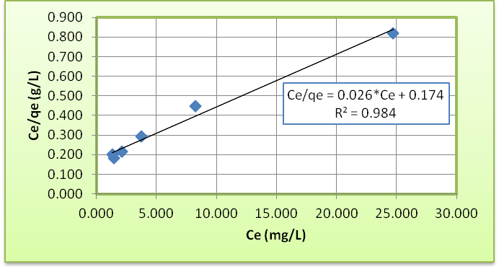
Figure (2) Langmuir adsorption Isotherm of MB onto sawdust at 25ºC and pH=5
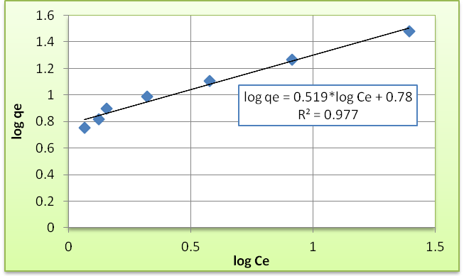
Figure (3) Freundlich adsorption Isotherm of MB onto sawdust at 25ºC and pH=5
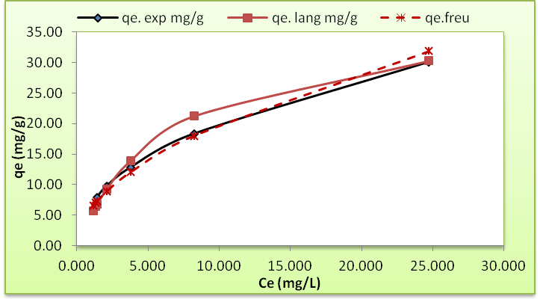
Figure (4) equilibrium adsorption Isotherm of MB onto sawdust at 25ºC and pH=5

3.1.2 Estimation of Adsorption Isotherm Constants for commercial activated carbon System
The Langmuir, Freundlich, and the equilibrium adsorption isotherms of methylene blue adsorption onto the commercial activated carbon of size (1mm) at 25°C are shown in Figs. (5), (6) and (7) respectively. The obtained experimental data was correlated with Langmuir and Freundlich models that are mentioned in section (3.1). The parameters for each model were obtained and presented in Table (5).
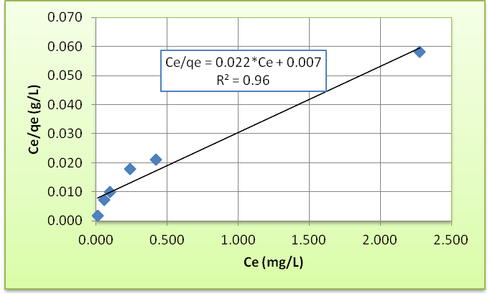
Figure (5) Langmuir adsorption Isotherm of MB onto commercial activated carbon at 25ºC and pH=5
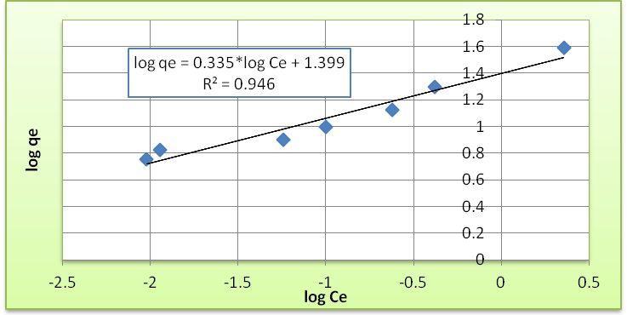
Figure (6) Freundlich adsorption Isotherm of MB onto commercial activated carbon at 25ºC and pH=5
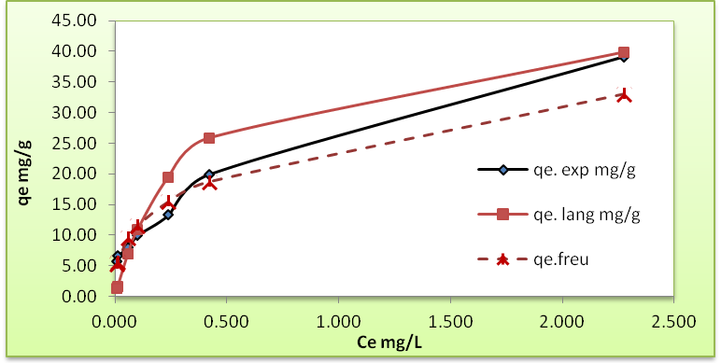
Figure (7) equilibrium adsorption Isotherm of MB onto commercial activated carbon at 25ºC and pH=5
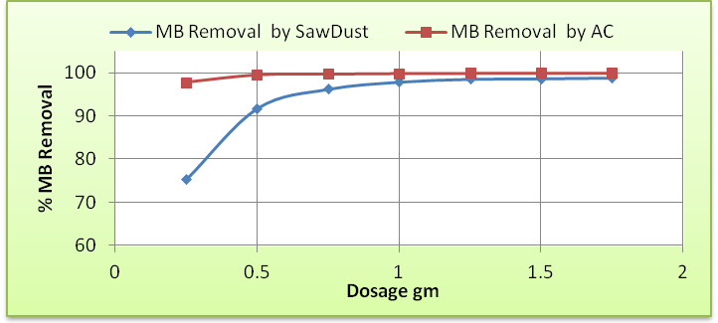
Figure (8) effect of adsorbent dosage on the adsorption of MB onto sawdust and commercial activated carbon

Table (5): Langmuir and Freundlich isotherm parameters for MB adsorptions onto Commercial AC and sawdust.
Model | Adsorbent
 | Commercial AC |  | Sawdust
 | Parameter | Value | Parameter | Value
Langmuir  (eq. (3-3)) | q_{max} (mg/g) | 45.46 | q_{max} (mg/g) | 38.46
 | K (l/mg) | 3.143 | K (l/mg) | 0.149
 | R_{L} | 0.003 | R_{L} | 0.063
 | R² | 0.96 | R² | 0.98
Freundlich  (eq. (3-1)) | K_{F} (mg/g(l/mg)^{1/n}) | 25.06 | K_{F} (mg/g(l/mg)^{1/n}) | 6.03
 | 1/n | 0.335 | 1/n | 0.519
 | R² | 0.946 | R² | 0.977
It is clear from Fig. (2 to 7) and Tables (3 to 5) that:
- The present results showed that the low cost adsorbent, sawdust is considerably efficient for the removal of MB dye from its solution. The adsorption performance of the sawdust was comparable to that of the commercial activated carbon as can be seen from the removal efficiency values.
- Figure (8) shows that the adsorption removal efficiency is highly dependent on adsorbent dosage in the case of using sawdust but it is not of the same dependence for activated carbon. It is evident that at higher dosages (more than 0.75 g), the sawdust started to achieve higher removal percentages of MB. The comparison was made with activated carbon which showed that high removal efficiencies were achieved at all dosages. This can be attributed to the fact that the commercial activated carbon has higher adsorption capacity than sawdust.
- The value for the maximum adsorption capacity of sawdust (30.11) mg/g is comparable with the maximum adsorption capacity of commercial activated carbon (39.09) mg/g.
- The equilibrium isotherms for both of the adsorbents used in the study are of favorable type, for being convex upward.
- In order to assess the different isotherms and their ability to correlate with experimental results, the coefficient of determination (R²) was employed to ascertain the fit of each isotherm with experimental data. From Table (5), the coefficient of determination values were higher for Langmuir than for Freundlich. This indicates that the Langmuir isotherm is clearly the better fitting isotherm to the experimental data. Conformation of the experimental data with Langmuir isotherm model indicates the homogeneous nature of the surfaces of the adsorbents used.
- The values of (R_{L}) were found to be 0.063 and 0.003 for sawdust and commercial activated carbon respectively. This gain confirmed that the Langmuir isotherm was favorable for adsorption of MB onto the adsorbents used in this study.
3.2. Column studies
The performance of a fixed-bed column was described through the concept of the breakthrough curve. The time for breakthrough appearance and the shape of the breakthrough curve are very important characteristics for determining the operation and the dynamic response of an adsorption column. The loading behavior of MB to be adsorbed from solution in a fixed-bed is usually expressed in term of C/C_{o} as a function of time or volume of the effluent for a given bed height, giving a breakthrough curve.
3.2.1. Effect of Initial Dye Concentration
The effect of influent MB concentration on the shape of the breakthrough curves was investigated by varying the initial MB concentration between (15, 30, 40, and 50) mg/l with constant sawdust bed height of 0.1m, solution pH of 5 and flow rate of 3.33 *10⁻⁶m³/s.
The breakthrough curves of the above experiments were plotted in Fig.(9). It is clear from Fig. (5.8) that the breakthrough time decreased with increasing influent MB concentration. At lower influent MB concentrations, breakthrough curves were dispersed and breakthrough occurred slowly. As influent concentration increased, sharper breakthrough curves were obtained. These results demonstrate that the change of concentration gradient affects the saturation rate and breakthrough time. This can be explained by the fact that more adsorption sites were being covered as the MB concentration increases.
The equilibrium uptake capacities of the sawdust increased with increasing initial MB concentration because the initial MB concentration provides an important driving force to overcome all mass transfer resistance.
At the highest MB concentration, the sawdust bed was exhausted in the shortest time leading to the earliest breakthrough. The breakpoint time decreased with increasing the inlet concentration as the binding sites became more quickly saturated in the column. This indicated that an increase in the concentration could modify the adsorption rate through the bed. A decrease in the initial MB concentration gave an extended breakthrough curve indicating that a higher volume of the solution could be treated. This was due to the fact that at lower concentration, sufficient sites are available for the adsorption of the MB dye. Therefore, the fractional adsorption is independent of initial concentration. However, at higher concentrations of the dye, the number of MB cations is relatively higher compared to the availability of adsorption sites. Hence, the percentage removal of MB depends on the initial concentration and decreases with the increase in the initial concentration as in the case of adsorption of dyes onto activated carbon.
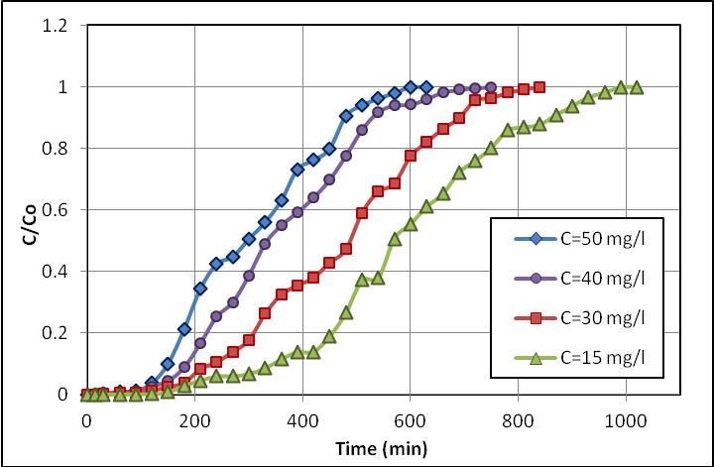
Figure (9) The experimental breakthrough data for adsorption of MB onto treated sawdust at different initial concentrations, Q=3.33 *10⁻⁶m³/s, L=0.1 m, pH=5
3.2.2. Effects of Adsorbent Bed Depth
Figure (10) shows the breakthrough curves obtained for MB adsorption on the sawdust for four different sawdust bed heights of 0.05, 0.1, 0.15, and 0.2 m, at a constant flow rate of 3.33*10⁻⁶ m³/sec, pH of 5 and MB initial concentration of 50 mg/l.
Both the breakthrough and exhaustion time increased with increasing the bed height. A higher MB uptake was also expected at a higher bed height due to the increase in the specific surface area of the sawdust, which provided more binding sites for the dye to adsorb. Since the rate of adsorption is proportional to adsorbent surface area, then total quantity of solute removed from solution at any period of time will increase with increasing bed height.
Also, as the bed height (adsorbent mass) increases, MB had more time to contact sawdust that resulted in higher removal efficiency of MB molecules in column. Therefore, the higher bed column resulted in a decrease in the effluent concentration at the same service time. The slope of the breakthrough curve decreased with increasing bed height, which resulted in a broadened mass transfer zone.
The increase in the adsorbent mass in a higher bed provided a greater service area which would lead to an increase in the volume of the solution treated. (Ko et. al., 2003; Tan et. al., 2008) reported in their works that as the bed height increases, the residence time of the fluid inside the column increases , allowing the adsorbate molecules to diffuse deeper inside the adsorbent. Thus, the bed capacity is likely to change with service time.
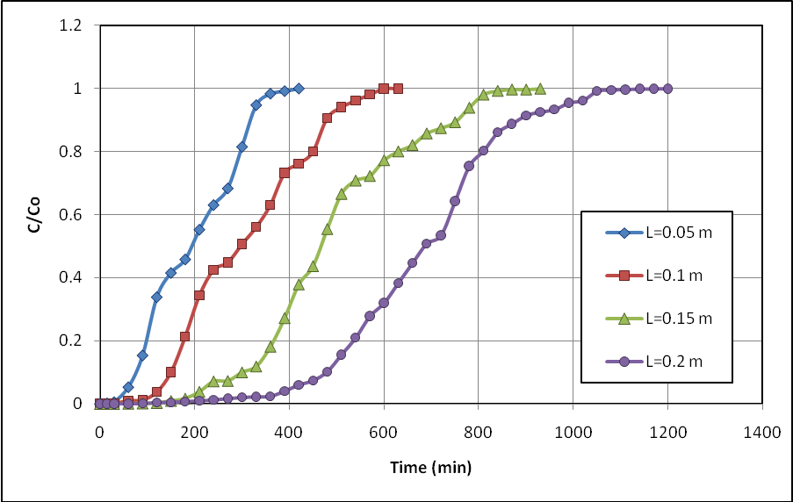
Figure (10) The experimental breakthrough data for adsorption of MB onto treated sawdust at different bed depths, Q=3.33 *10⁻⁶m³/s, C_{o}=50 mg/l, pH=5
3.2.3. Effect of Solution Flow Rate
To investigate the effect of flow rate on the adsorption of MB using sawdust bed, the flow rate of the influent MB solution was varied (2.2*10⁻⁶, 3.33*10⁻⁶, 4.17*10⁻⁶, and 5.83*10⁻⁶) m³/sec with constant bed height of 0.1m, initial methylene blue (MB) concentration of 50 mg/l, and pH solution of 5 as shown by the breakthrough curves in Fig. (11).
It can be seen from Fig. (11) that the breakthrough is generally occurred faster with a higher flow rate. This is due to decreased contact time between the dye and the sorbent at higher flow rate, which results in lower bed utilization. Breakthrough time reaching saturation was increased significantly with a decrease in the flow rate. At a low rate of influent, MB had more time to be in contact with adsorbent, which resulted in a greater removal of MB molecules in column.
It is expected that the change of flow rate will affect the film diffusion, but not the intraparticle diffusion. Similar effects of flow rate on breakthrough curves obtained in dye and metal adsorption on packed-bed of other adsorbents were observed by many authors (Ko et al., 2003; Ferrero, 2007; Tan et al., 2008; and Han et al., 2009).
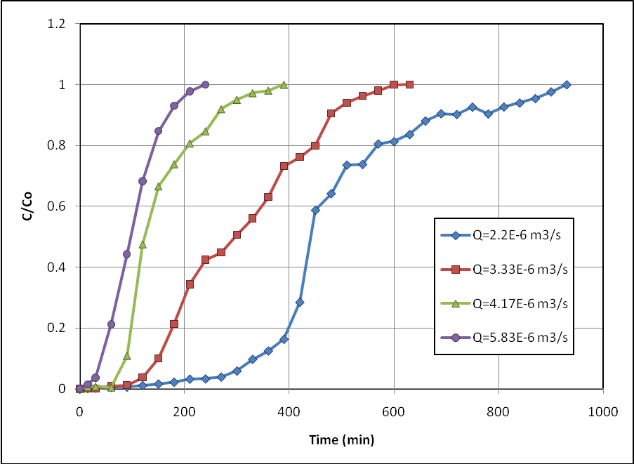
Figure (11) The experimental breakthrough data for adsorption of MB onto treated sawdust at different flow rates, L=0.1 m, C_{o}=50 mg/l, pH=5

4. Conclusions
In this paper, the ability of using local adsorbent of sawdust was studied, and the results obtained in in batch adsorption showed the equilibrium isotherms for the Methylen blue adsorption onto sawdust and commercial activated carbon were of favorable type and were well represented by Langmuir and Freundlich equations. The coefficients of determination show that Langmuir's equation fits the experimental data more than Freundlich's equation and the maximum adsorption capacities achieved by sawdust and commercial activated carbon were comparable with a very slight deference in adsorption capacity between them, 30.11 mg/g for sawdust and 39.09 mg/g for commercial activated carbon.
It was achieved a high removal efficiencies when using commercial activated carbon for methylene blue dye with all dosages, while the sawdust achieved lower removal efficiencies with low dosages but its efficiency increases to 98.8 % at the higher dosage used. The results of continuous flow experiments showed that, as the flow rate increased, the breakthrough point is reached earlier and the time required to reach saturation of sawdust decreases more rapidly. For smaller bed height, (C/C_{o}) ratio increases more rapidly than for a higher bed height. For higher MB initial concentration, steeper breakthrough curves are obtained and break point is achieved sooner due to the increase in driving force for mass transfer.
5. References
Al-Taliby W. H. A., "Evaluation Of Methylene Blue Removal From Wastewater By Adsorption Onto Different Types Of Adsorbent Beds", M.Sc. Thesis, University Of Babylon, College Of Engineering, Dept. Of Civil Engineering, 2009.
Asiagwu A.K, Omuku P.E and Alisa C.O., (2013), “Kinetic Model for the Removal of Methyl Orange (Dye) From Aqueous Solution Using Avocado Pear (Persea Americana) Seed”, Journal of Chemical, Biological and Physical Sciences, Vol. 3, No. 1, 48-57.
Bansal R. C. and Goyal M., (2005), "Activated Carbon Adsorption", Taylor & Francis Group, LLC.
Bansode R. R., (2002), "Treatment Of Organic And Inorganic Pollutants In Municipal Wastewater By Agricultural By-Product Based Granular Activated Carbons (GAC)", M.Sc. Thesis, Louisiana State University, Agricultural And Mechanical College, The Department Of Food Science.
Bhattacharya A. K., Mandal S. N. And Das S. K., (2006), "Removal of Cr(VI) From Aqueous Solution by Adsorption onto Low Cost Non-Conventional Adsorbents", Indian Journal Of Chemical Technology, Vol. 13, Pp. 576-583.
Deng H., Yang L., Tao G., Dai J., (2009), "Preparation and Characterization of Activated Carbon from Cotton Stalk by Microwave Assisted Chemical Activation-Application in Methylene Blue Adsorption from Aqueous Solution", Journal of Hazardous Materials 166, pp. 1514-1521.
Ferrero F., (2007), "Dye Removal by Low Cost Adsorbents: Hazelnut Shells in Comparison with Wood Sawdust", Journal of Hazardous Materials 142, pp. 144-152.
Hameed B. H., Chin L. H., Rengaraj S., (2008), "Adsorption Of 4-Chlorophenol onto Activated Carbon Prepared From Rattan Sawdust", Desalination 225, pp. 185-198.
Han R., Yu W., Zhao X., Wang Y., and Xie F., (2009), "Adsorption of Methylene Blue by Phoenix Tree Leaf Powder in A Fixed-Bed Column: Experiments and Prediction of Breakthrough Curves", Desalination 245, pp. 284–297.
Ko D. C. K., Porter J. F. and McKay G., (2003), "Fixed Bed Studies For the Sorption of Metal Ions onto Peat", Trans. I. Chem. E., Vol. 81, Part B, pp. 73-86.
Malik P. K., (2004), "Dye Removal From Wastewater Using Activated Carbon Developed From Sawdust: Adsorption Equilibrium And Kinetics", Journal of Hazardous Materials, B113, pp. 81-88.
Masitah B. H., (2008), "Adsorption of Reactive Azo Dyes on Chitosan/Oil-Palm Ash Composite Adsorbent: Batch and Continuous Studies", M.Sc. Thesis, UNIVERSITI SAINS MALAYSIA.
Meena A. K., Mishra G. K., Kumar S., And Rajagopal C., (2004), "Low-Cost Adsorbents For The Removal Of Mercury (II) From Aqueous Solution-A Comparative Study", Defence Science Journal, Vol. 54, No. 4, Pp. 537-548.
Metcalf and Eddy, Inc. (2003), "Wastewater Engineering, Treatment and Reuse", 4th Edition, New York: McGraw-Hill.
MERCK Catalogue, (2005), Technical Data Sheet, KgaA, D-6421, Darmstadt, http:/chemdat.merck.de/mda/int_en/index.html.
Özer A., Dursun G., (2007), "Removal of Methylene Blue from Aqueous Solution by Dehydrated Wheat Bran Carbon", Journal of Hazardous Materials 146, pp. 262-269.
Rastogi K., Sahu J. N., Meikap B. C., and Biswas M. N., (2008), "Removal Of Methylene Blue From Wastewater Using Fly Ash As An Adsorbent By Hydrocyclone", Journal of Hazardous Materials 158, pp. 531-540.
Rowell R. M., Han J. S., and Byrd V. L. "Handbook of Wood Chemistry and Wood Composites", chapter 12, "Fiber Webs", CRC Press LLC, 2005.
Tan I. A. W., Ahmad A. L., Hameed B. H., (2008), "Adsorption Of Basic Dye Using Activated Carbon Prepared From Oil Palm Shell: Batch And Fixed Bed Studies", Desalination 225, pp. 13-28.
Velizar S., Dragana B., Milan G., Bogdanović G., (2009), "Heavy Metal Ions Adsorption from Mine Waters By Sawdust", Chemical Industry & Chemical Engineering Quarterly 15 (4), Pp. 237-249.
Weber, W. J., “Physico-Chemical Processes for Water Quality Control”, Wiley International Science, New York, 1972.
Williams P. T., (2005), "Waste Treatment and Disposal" Second Edition, John Wiley & Sons Ltd.

