Integrating the Degree-Days Model and Google Maps to Monitor Dubas Bug Activity in Some Agricultural Regions in Iraq

Mahdi Nasif Jasim
Department of Networks, College of Information Technology, Babylon University
MahdiAlwan@UoBabylon.edu.IQ, mnjisd@Gmail.com.
Enas Ali Mohammed
Department of software, College of Information Technology, Babylon University
the_programmer86@yahoo.com.

Abstract
In this research, we show the ability to monitor the activity of Dubas bug pest on date palms by proposing an active web forewarning system integrated with web based geospatial application (Google maps API) to enable the agricultural scientists and farmers to show the pest development in their regions by viewing online pest risk graphs and maps. Inverse Distance Weighting (IDW) method was used to interpolate temperatures data from weather stations to the user identified location. Single sine model is applied to estimate degree-days due to its practicality in providing a better predictive capability. Two proposed algorithms are designed to simulate the pest growth. The first algorithm works to produce accurate graphs to show the accumulated degree-days of each pest growth stages in the user specified location and date. The second algorithm simulate the pest growth during the user specified date as color plotting on the map with a radius of (500) meter. The proposed system can practically expand its functionality for any pest of interest given its phenological data. The system tested on 2013 weather data and gives good experimental results. Now it is ready for practical evaluation by specialists to determine its efficiency and applicability.
Keywords: Degree days, Google maps, Spatial analysis, Dubas Bug phenology data, Iraq weather data, single sine model.
الخلاصة
في هذا البحث تم اقتراح نظام شبكي متكامل مع تطبيق خرائط كوكل لتمكين الباحثين الزراعيين والمزارعين من مراقبة نمو آفة الدوباس في مناطقهم عن طريق عرض مخططات وخرائط. استخدمت طريقة توزين المسافة المعكوسة لاستكمال بيانات درجات الحرارة من محطات الطقس للموقع الذي يحدده المستخدم. تم تطبيق نموذج الجيب المفرد لتقدير الدرجات الحرارية من خلال فاعليتها في إعطاء تنبوء جيد, وتم اقتراح خوارزميتين لمحاكاة نمو الآفة. تعمل الخوارزمية الأولى على إنتاج مخططات دقيقة تظهر الدرجات الحرارية التكميلية لكل مرحلة نمو للآفة في الموقع والزمن الذي يحدده المستخدم.أما الخوارزمية الثانية فهي تحاكي نمو الآفة خلال تاريخ معين يدخله المستخدم على شكل لون يرسم على الخارطة بنصف قطر(500) متر. يستطيع النظام المقترح تغيير وظائفه لأي آفة تزود بياناتها إلى النظام من قبل المستخدم. تم اختبار النظام على بيانات طقس 2013واعطى نتائج تجريبية جيدة . وألان النظام جاهز للتقييم العملي من قبل مختصين لتحديد كفاءته وقابلية تطبيقه.
الكلمات المفتاحية : الدرجات الحرارية,خرائط كوكل,التحليل المكاني, بيانات نمو الدوباس, بيانات طقس العراق, طريقة الجيب المفرد.

- Introduction

The ability to monitor growth of pests and predict their emergence in any location is fundamental to achieve an integrated pest management system. Dates are one of important crops in Iraq and have a significant effect on its economy. Date palms get infected by many agriculture pests such as bugs, moths, and mites (Al-Shamsi, 2003). Dubas bug is the most important pest on date palms. In agriculture, the degree-days have been widely used to quantify and predict pests phonological events, and according to McMaster & Wilhelm (1997) and others, it is more accurate than using chronological time or predicting events according to the season of the year. They are implemented in several pests phonology studies (e.g. Yones et al., 2012; Morrison et al., 2013).
The growth of pests is influenced by weather, especially the temperature which is the most important variable, having a large effect on growth of pests. The temperature data for pests forewarning systems is either directly observed or interpolated from a set of neighboring stations. Then, the spatial analysis that plays an important role in the integration of weather data in pests forewarning systems is implemented and it could have a crucial impact on the accuracy of prediction of pests activities. So, there is need to integrate the web based GIS (Geographic Information System) mapping applications with pests forewarning systems to play a significant role in helping researchers and agricultural specialists to monitor pests' growth in their areas through the web.
Google maps APIs (Application Programming Interface) are web based geospatial applications (released in 2005), provide detailed data and satellite views about geographical regions and sites around the world. It is based on tile based (slippy) maps technique which divides the map into a number of zoom levels (Adnan et al, 2010). This technology enables the users to execute many GIS queries and to receive the outcomes that enable tracking Dubas pests' development.

2. Materials And Methodologies
In order to monitor the growth of date bug pest, basic thermal units (growing degree days) for pest growth stages are required. This pest has three growth stages (eggs, nymphs, and egg adults). Al-Shamsi (2003) showed that the date bug (dubas) (Ommatissus lybicus) has two generation per year (spring and autumn generations) spring generation growth as eggs with lower development threshold 12.15ºC and thermal units 641.03, as nymphs with 13.47ºC as lower threshold and 515.56 thermal units. The single sine model of Baskerville & Emin (1969) will be used to calculate daily degree-days since it is widely used by several researchers such as (Lysyk, 2007; Moore, 2011; and Damos & Karabatakis, 2013).
This model describes pests development as a composite of temperature and time by calculating the cumulative sum of degree time results (degree days units). It uses daily minimum and maximum temperatures to produce a curve over 24 hour period as shown in Figure (1), and then determine the amount of degree days for that day by calculating the amount of the area under the temperature curve and above the lower development threshold (base temperature).
The relationships between maximum and minimum temperatures and the development thresholds are used to choose the appropriate equation to estimate the degree days as in Table (1). In this research Degree-days accumulated from minimum-maximum air temperature data after the 1st of January which represents the biofix date of Dubas bug pest to start the monitoring process.
Degree days is read from monitoring stations (weather stations) while estimating degree days at other point locations requires some form of spatial analysis technique to interpolate temperature data and then estimating the degree days with the assist of once GIS tools. Here, weather data of Iraq is gathered from “Tutiempo” weather network in Spain. This network contains historical data of diverse weather parameters. For Iraq, weather data comes from a network of 29 meteorological stations as shown in the Figure (2). Historical observations of minimum and maximum temperature variables (Tmin, Tmax) are collected for the year 2013.

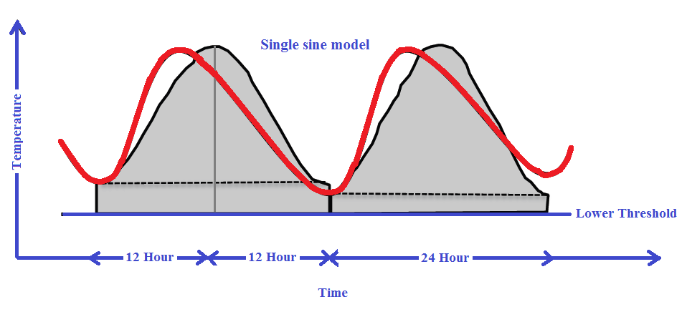
Figure (1): Single sine model.
Table (1): Formulae for calculating degree days (DD) by the single sine model.
Temperature Situations Equation
α= (T_{max} - T_{min})/2
Ø ₁ =sin⁻¹[[L_{th}-( T_{max} + T_{min})/2]/α]
Ø₂=sin⁻¹[[U_{th} -(T_{max}+T_{min})/2]/α]
T_{min}> L_{th}& T_{max}> U_{th} DD = 1/∏{[( T_{max}+T_{min})/2- L_{th}]*(Ø₂+∏/2) +
(U_{th} – L_{th})*(∏/2- Ø₂)-[ α*cos(Ø₂)]}
T_{min}< L_{th} & T_{max}> U_{th} DD = 1/∏{[(T_{max}+T_{min})/2- L_{th}]*(Ø₂- Ø₁) +
α*(cos(Ø₁) - cos(Ø₂)) + (U_{th}– L_{th}) *
(∏/2- Ø₂)}
T_{min}>= L_{th} & T_{max}<= U_{th} DD =(T_{max}+T_{min})/2- L_{th}
T_{min}< L_{th}& T_{max}< U_{th} DD = 1/∏{[( T_{max}+T_{min})/2- L_{th}]*( ∏/2 –Ø₁) +
[α*cos(Ø₁)]}
T_{min}> U_{th}& T_{max}> U_{th} DD =U_{th}– L_{th}
T_{min}< L_{th}& T_{max}< L_{th} DD = 0
T_{max}: Maximum daily temperature; T_{min}: Minimum daily temperature; U_{th}: Upper temperature threshold; L_{th}: Lower temperature threshold.

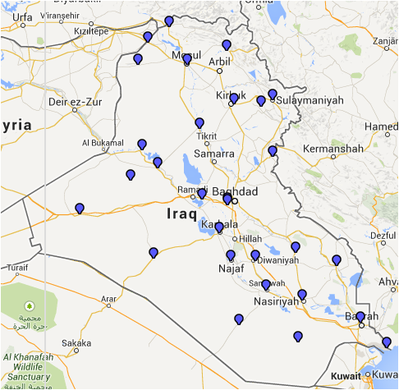

Figure (2):The spatial distribution of the weather stations in Iraq.
Inverse Distance weighting (IDW) is a common spatial interpolation technique, frequently used to estimate temperature data (e.g. Kang et al., 2009; Ghombavania & Ghahreman, 2011). It considers the first law in geography "Everything is related to everything else, but near things are more related than distant things (Tobler,1970). To predict a value for any unmeasured location, IDW will use the measured values surrounding the prediction location. Measured values that are nearest to the prediction location will have greater influence (weight) on the predicted value at that unknown location than those that are farther away as in Equations (1) and (2):

$w\left(h_{i}\right)=h_{i}^{k}$ (1)

$\hat{Z}\left(l_{0}\right)=\frac{\sum_{i=1}^{N}{w\left(h_{i}\right)Z\left(l_{i}\right)}}{\sum_{i=1}^{N}{w\left(h_{i}\right)}}$ (2)
Where
$h_{i}$= the geographic distance.
$w\left(h\right)=$the weighting function with power parameter k .
$\hat{Z}\left(l_{0}\right)$ = the estimated value.
$Z\left(l_{i}\right)$= the observed value.
$l_{0},l_{i}=$point locations.
$N$= the number of calculated stations.
The Great Circle Distance formula (Sinnott,1984) is used to calculate the geographic distances according to the Equation (3).
${h=cos}^{−1}$ (3)
Where:
lat₁,lat₂= latitudes of Points
lon₁,lon₂= longitudes of Points
r= radius of the earth which is equal to 6378.1Kilometers.

In this research we use Subgurim Google Maps API V4 with ASP.NET web application (C# programming language) to integrate Iraq data with this advanced software library to analyse and present the results on the map.

3. The Forecasting Algorithms In The Propsed System
The proposed system includes two algorithms to produce pest risk graphs and maps that are usually used to give accurate results of pest growth status in a specific location. These algorithms work as the core of the spatial interpolation and degree days models, and are described in Figure (3) and Figure (4).
The first algorithm works on performing online graphs of pest growth status. The first step of the algorithm involves the definition of pest, date (the time that user specifies it to show pest growth) and user location, initializing the value of necessary parameters to implement the spatial interpolation. In the next step, pest phenology data nearest to the user location will be retrieved. Temperature data for the period between the pest biofix date to the user specified date will be interpolated from nearest weather stations via a spatial method (i.e. IDW). The interpolated temperature data is transformed to degree days using the sine wave model and are further summated when higher than the lower pest developmental temperature threshold. The accumulated degree days corresponding to the end of each growth stage or the end of the specified date period was calculated. The final step includes the representation of accumulated degree-days into graph.

The second algorithm works to give a specific view of pest growth in the user specified location. The first step of the algorithm involves the definition of pest, date (the time that user specifies it to show pest growth) and user location, initializing the value of the necessary parameters (local search radius, global search radius, minimum neighbors, maximum neighbors) that have a large effect in the efficiency of the system to give sufficient results. Local search radius and global search radius parameters help in estimating temperature data for the user unmeasured location, value of these parameters helps in searching which stations are nearer to the intended location and within its search radiuses. The local search radius value will be set to (10) km for data transforming from nearest station; hence, temperature data will constant around weather stations with area less than (50) km. Here, this value will be decreased to get more accurate results, as shown in Figure (5).
The global search radius value is the maximum geographic distance between weather stations. For the global search radius, the number of nearest stations considered in the calculations is done using the minimum and maximum neighbors parameters. Values of the minimum and maximum neighbors parameters are set to 1 and 3 respectively. In the next step, the algorithm works on defining a gradient of colors representing the pest phonological events (e.g. Eggs, Larvae) that will be used to represent the accumulated degree days as colors on Google maps. In this research we define a band of 26 colors to be utilized on the map. This band distributes to sub-bands according to the pest development stages.

Algorithm1: Generating pest risk graphs .
Input: WeatherStationsData, PointEsti(user location), PestId(Pest identification), SpDate(Specified Date), MaxNeighbors, MinNeighbors, PestGStage(pest growth stage), GDistance(geographic distance), NStations(nearest stations), SpBiofix(pest biofix date), TempData(temperature data), AvergeDDays(average degree days), DD(degree days).
Output: the accumulated degree days ( DDays) plotted as charts according to pest growth stage.
Begin
- Read user location, pest and the desired date(PointEsti, PestId, SpDate).
- Read the necessary parameters to the interpolation process(MaxNeighbors, MinNeighbors).
- PestGStage=1.
- Read pest phonological data from nearest study(PestData, PointEsti, PestId, PestGStage).
- Read pest biofix date (PestData).
- Calculate the GeoDistance using GCD(GDistance, PointEsti, WeatherStationsData ).
- Calculate Nearest Stations(NStations, GDistance, MaxNeighbors, MinNeighbors, WeatherStationsData ).
- Interpolate temperature data using IDW(TempData, NStations, SpBiofix, SpDate).
- DDays=0.
- Retrieve AvergeDDays for current stage(AvergeDDays , PestData, PestGStage)
- J= SpBiofix.
- For each (J< SpDate) Do
- Estimate DD using Single Sine model(DD, TempData, PestData).
- DDays= DDays+ DD. /*Calculate the accumulated degree days*/
- If (DDays >=AvergeDDays)then
- Plot DDays to a chart according to pest growth stage( DDays, PestGStage)
- PestGStage= PestGStage+1.
- Updatepests phenological data (PestData, PestGStage).
- Reterive AvergeDDays for current stage(AvergeDDays ,PestData, PestGStage).
- DDays=0.
- End if
- J= J+1;
- End for
- End.

Figure (3): The proposed algorithm developed to generate pest risk graphs.

Each color in the sub-band has a degree days range calculated from the average degree days of the pest growth stage. For the user specified location, the temperature data interpolated for the period between the biofix date and the specified date using IDW method if the nearest weather station located in the global search radius.

Temperature data will be calculated to a degree days using the sine wave model and the accumulated degree days will be calculated. The final step includes representing the accumulated degree days as color view the pest growth on Google map with (500) meter radius.

Algorithm2: Representing the pests growth to colors on Google maps.
Input: WeatherStationsData, PointEsti(user location), PestId(Pest identification), SpDate(Specified Date), MaxNeighbors, MinNeighbors, PestGStage(pest growth stage), GDistance(geographic distance), NStations(nearest stations), SpBiofix(pest biofix date), TempData(temperature data), AvergeDDays(average degree days), DD(degree days), LSR(local search radius), GSR(global search radius), LNStations(nearest stations located in local search radius), GNStations (nearest stations located in global search radius), ColGrad (colors gradient) .
Output: the accumulated degree days ( DDays) plotted on Google maps
Begin
- Read user location, pest and the desired date(PointEsti, PestId, SpDate).
- Read the necessary parameters to the interpolation process(MaxNeighbors, MinNeighbors).
- PestGStage=1.
- Calculate the GeoDistance using GCD(GDistance, PointEsti, WeatherStationsData ).
- Calculate the GlobalSearchRadius(GSR, GDistance).
- Read pest phonological data from nearest study(PestData, PointEsti, PestId, PestGStage).
- Read pest biofix date (PestData).
- Calculate the color gradient from pest phonological data(ColGrad, PestData).
- Calculate stations in Local search radius(LNStations, GDistance, WeatherStationsData , LSR).
- Calculate stations in Global search radius(GNStations, GDistance, WeatherStationsData, GSR).
- If (LNStations>0) then
- Order the NStations according distance in accesnding(LNStations).
- NStation= LNStations[0].
- Transform temperature data (TempData, NStation, SpBiofix, SpDate).
- End if
- Else if (GNStations>0) then
- Order the NStations according distance in accesnding(GNStations);
- Interpolate temperature data using IDW(TempData, GNStations, SpBiofix, SpDate).
- End if
- DDays=0.
- Reterive AvergeDDays for current stage(AvergeDDays , PestData, PestGStage)
- J= SpBiofix.
- For each (J< SpDate) Do
- Estimate DD using Single Sine model(DD, TempData, PestData).
- DDays= DDays+ DD /*Calculate the accumulated degree days*/
- If (DDays >=AvergeDDays)then
- Calculate a color to the Accumulated dday’s (Color, ColGrad, PestGStage, DDays).
- PestGStage= PestGStage+1.
- Updatepests phenological data (PestData, PestGStage).
- Reterive AvergeDDays for current stage(AvergeDDays , PestData, PestGStage).
- DDays=0.
- End if
- J= J+1.
- End for
- If (DDays>0)then
- Calculate a color to the Accumulated dday’s (Color, ColGrad, PestGStage, DDays).
- End if
- Plot data on Google map ( PointEsti, Color).
- End

Figure (4): The proposed algorithm developed to represent the pests growth to colors on Google maps.
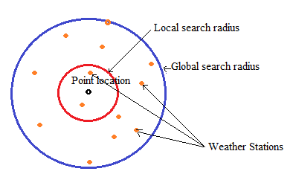
Figure(5): The global and local search radius of a point location.

4. Conclusions
The following conclusions were arrived at this research:
- The proposed system represents a huge step forward to install the new advanced technologies to upgrade Iraqi agriculture, the forewarning system preventing or at least reducing the losses caused by pest attacks on plants.
- The proposed system leads to design and implement a network SQL-server database used to archive the details of pests attacks across time and the accumulated archived data will be a huge wealth of data for more researches in the future.
- The proposed system is a web-based application and can be sawed anywhere in the world wide web (www) to be accessed by all the interested researchers and agencies intend to deal with this very important topic.
- The website resulted from the proposed system is very easy to use via the internet and will be of high availability.
- Using software engineering programming style makes the system easy to integrate with other software systems and easy to use by interested users with less or without training.

5.Test Cases
To show the validity, correctness and feasibility of the proposed system, some of its interfaces screenshots depicted with some test cases are shown in Figure (7) and Figure (8). The user can specify his/her location using Google maps and select the desired date as in Figure 6.

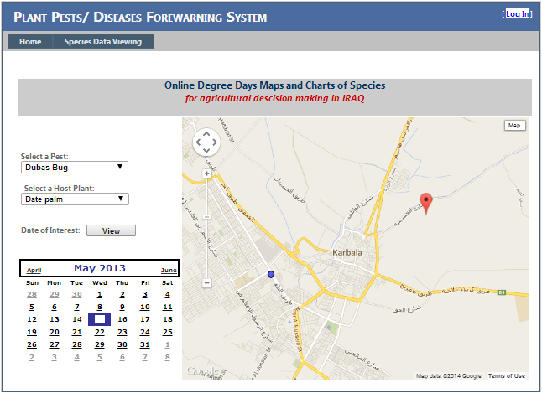
User specified location
Karbala weather station
Figure (6): The main webpage of the proposed system where users can specify their locations on Google map.
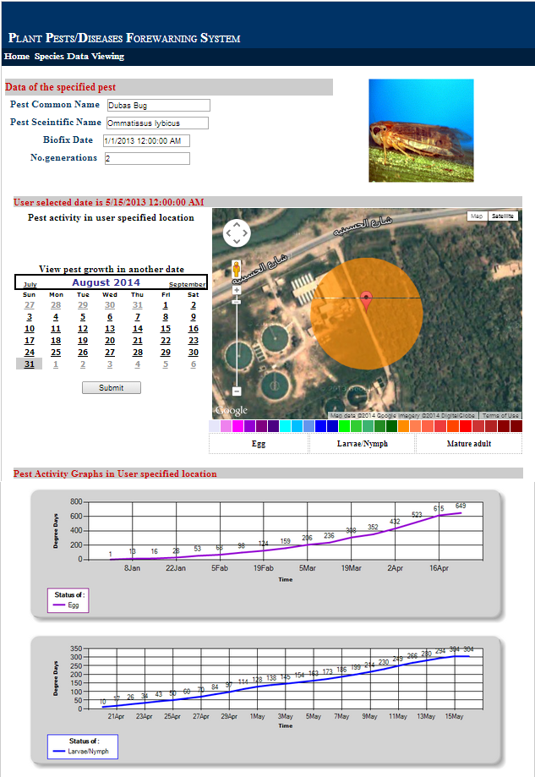
Figure(7): Pest activity webpage of the selected Date moth pest in 15-5-2013.
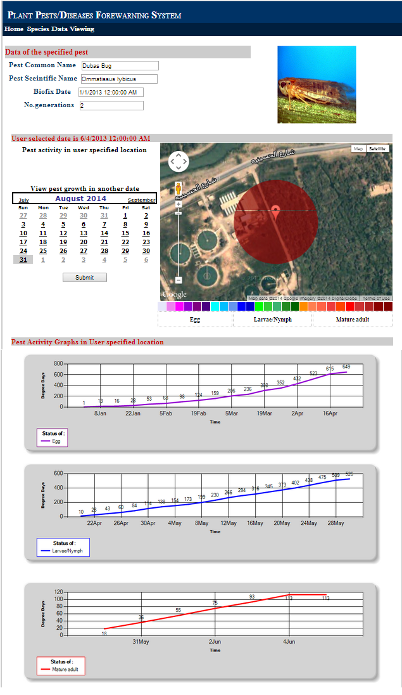
Figure(8): Pest activity webpage of the selected Date moth pest in 4-6-2013.

6. References
Adnan, M., Singleton, A.D., & Longley, P.A. (2010). Developing Efficient Web-based GIS Applications. UCL CENTRE FOR ADVANCED SPATIAL ANALYSIS. P.153.
Al-Shamsi, B.H. (2003). Biological performance of dubas bug Ommatissus lybicus De Berg. (Homoptera: Tropiduchidae) under field conditions and predicting of its appearance by using degree-day model. Unpublished master’s thesis, University of Baghdad, Baghdad, Iraq.
Baskerville, G.L., & Emin, P. (1969). Rapid Estimation of heat accumulation from maximum and minimum temperatures. Ecology, v.50, p.514-517.
Kang,W. S., Hong, S. S., Han, Y. K., Kim, K.R., Kim, S. G., & Park, E. W. (2009). A Web-based Information System for Plant Disease Forecast Based on Weather Data at High Spatial Resolution. The Plant Pathology Journal. 26(1) : 37-48.
Ghombavania, E. E., & Ghahreman, N. (2011). GIS-based analysis of spatial distribution patterns of growing degree-days for agricultural applications in Iran. 6(2):143-151.
Lysyk, T. J.(2007). Seasonal abundance, parity, and survival of adult Culicoides sonorensis (Diptera: Ceratopogonidae) in Southern Alberta, Canada. Journal of Medical Entomology 44(6): 959-969. DOI: http://dx.doi.org/10.1603/0022-2585 (2007) 44 [959:SAPASO]2.0.CO;2.
Damos, P., Karabatakis, S.(2013). Real time pest modeling through the World Wide Web: decision making from theory to praxis. Integrated protection of fruit crops IOBC-WPRS Bulletin Vol. 91, 2013 pp. 253-258.
Moore, J. L.(2011). The application of degree-day models to study current and future organism development: cautions, limitations, and recommendations. Published master’s thesis, Emory University,Georgia, United states.
McMaster,G.S., & Wilhelm, W.W. (1997). Growing degree-days: one equation, two interpretations. Agr. Forest Meteorol. 87: 291-300.
Morrison, W.R., Andresenb, J., & Szendrei, Z.(2013). The development of the asparagus miner (Ophiomyia simplex Loew; Diptera: Agromyzidae) in temperate zones: a degree-day model. Pest Management Science 70(7): 1105–1113. DOI: 10.1002/ps.3654.
Sinnott, R. W.(1984).Virtues of the Haversine. Sky and Telescope, vol. 68, no. 2, p. 159.
Tobler, W.R. (1970). A computer movie simulating urban growth in the Detroit region. Economic Geography, 46(2): 234-240.
Yones, M.S., Arafat, S., Abou Hadid, A. F., Abd Elrahman, H. A., & Dahi, H.F. (2012). Determination of the best timing for control application against cotton leaf worm using remote sensing and geographical information techniques. National Authority for Remote Sensing and Space Sciences,The Egyptian Journal of Remote Sensing and Space Sciences. 15(2), P.151–160. DOI: 10.1016/j.ejrs.2012.05.00.

