Effect of plant growth regulators BA, 2,4-D, IBA and Kin on in vitro propagation of white jasmine (Jasminum azoricum L.)
Siham Abd Alrazzaq Salim
Al Musaib Technical College, Plant Production Department
dr.sihamabdalrazzaq@yahoo.com
Abstract
This study was conducted in order to investigate the effect of BA, 2,4-D, IBA and Kin on in vitro propagation of white jasmine ( Jasminum azoricum L. ) through two ways; in the first way: nodal explants were cultured on MS medium containing different concentrations of BA ( 0.0 , 0.5 , 1.0 , 2.0 , 4.0 , or 6.0 ) mg/L for direct shoot proliferation. The results showed that BA in concentration 2.0 mg/L gave the best result in shoot number( 2.5 ), while the control was the best in shoot length ( 2.51 cm ) and number of nodes per shoot( 4.5 node / shoot ) than other treatments. In the second method: internodal explants were cultured on MS containing BA( 0.0 , 2.0 , 4.0 , or 6.0 ) mg/L with 2,4-D ( 0.0, 0.01 , 0.05 or 0.1) mg/L for callus induction and indirect regeneration of shoots. The highest percent of callus induction ( 100% ) was seen in MS supplemented with 4.0 mg/L BA + 0.1 mg/L 2,4-D and 6.0 mg/L BA + 0.1 mg/L 2,4-D. The proliferated callus was transferred into MS medium supplemented with BA ( 0.0 , 2.0 , 4.0 , or 6.0 ) mg/L with Kin ( 0.0 or 2.0) mg/L for adventitious buds regeneration. The highest number of buds (10.1) was seen in the combination 4.0 mg/L BA + 2.0 mg/L Kin. Using of IBA (0.0,0.05,0.1,0.5, 1.0 or 2.0) mg/L in in vitro rooting medium did not give any response of root formation according to the conditions of experiment, while ex vitro rooting of plantlets on agricultural medium after soaking their bases in a solution containing 20 mg/L IBA showed that 85% of plantlets were rooted and remained alive. In addition, the ex vitro rooting resulted in successful hardening of plantlets and reduced time, costs and efforts required for rooting and hardening.
Key words: Jasminum azoricum, in vitro, regeneration, cytokinin , auxins .
الخلاصة
تم إجراء هذه الدراسة بهدف التحري عن تأثير أنواع وتراكيز مختلفة من منظمات النمو النباتية هي: BA و 2,4-D و IBA و Kin في إكثار نبات الياسمين الأبيض (Jasminum azoricum L.) خارج الجسم الحي من خلال طريقتين: استعملت في الطريقة الأولى العقد كأجزاء نباتية بزراعتها على وسط MS مجهزا بـــ BA ( 0.0 أو 0.5 أو 1.0 أو 2.0 أو 4.0 أو 6.0 ) ملغم/ لتر لتوالد الأفرع مباشرة منها. بينت النتائج أن التركيز 2.0 ملغم/لتر من BA أعطى أفضل معدل لعدد الأفرع ( 2.5 ), بينما أعطت معاملة السيطرة أفضل استجابة لطول الأفرع ( 2.51 سم) ومعدل عدد العقد لكل فرع ( 4.5 عقدة/فرع) مقارنة بالمعاملات الأخرى. وجرى في الطريقة الثانية زراعة السلاميات على وسط MS مجهزا بــ BA ( 0.0 أو 2.0 أو 4.0 أو 6.0 ) ملغم/لتر مع 2,4-D ( 0.0 أو 0.01 أو 0.05 أو 0.1 ) ملغم/لتر لاستحثاث الكالس وإخلاف الأفرع منه. بينت النتائج أن أعلى نسبة لاستحثاث الكالس بلغت 100% في وسط MS المجهز بــ 4.0 ملغم/لتر BA + 0.1 ملغم/لتر 2,4-D و 6.0 ملغم/لتر BA + 0.1 ملغم/لتر 2,4-D . وعند نقل الكالس المتوالد إلى وسط MS مجهزا بــ BA ( 0.0 أو 2.0 أو 4.0 أو 6.0 ) ملغم/لتر مع Kin ( 0.0 أو 2.0 ) ملغم/لتر لإخلاف البراعم العرضية منه, لوحظ أن أعلى معدل لعدد البراعم هو 10.1 في التوليفة 4.0 ملغم/لتر BA + 2.0 ملغم/لتر Kin . أن استعمال IBA بالتراكيز ( 0.0 أو 0.05 أو 0.1 أو 0.5 أو 1.0 أو 2.0 ) ملغم/لتر لتجذير الأفرع خارج الجسم الحي لم يعط أية استجابة للتجذير وفق ظروف التجربة. في حين أن التجذير المباشر للأفرع خارج الزجاج بغمر قواعدها في محلول يحتوي على 20 ملغم/لتر IBA أعطى نسبة استجابة بلغت 85% وبقيت النبيتات على قيد الحياة , فضلا عن ذلك , فان التجذير المباشر خارج الزجاج ينتج عنه نجاح أقلمة النبيتات وتقليل الوقت والكلفة والجهد المتطلب للتجذير والأقلمة.
الكلمات المفتاحية: الياسمين الأبيض, خارج الجسم الحي, السايتوكاينينات , الأوكسينات .

Introduction
Plants of Jasminum genus are evergreen climbing or erect shrubs with thin woody stems of older growth belonging to the family Oleaceae, they are distributed in the warmer parts of Asia, Europe and Africa (Ramdas et al., 1993). The flowers are very fragrant used for production of perfumes, soap, and cosmetic industry ( Alikhan et al., 1989 ). Pharmacology researches revealed anticancer activity of the extracts of jasmine on human epidermoid carcinoma of nasopharynx and anti-inflammatory effect against acute and chronic inflammation, while the oil is used externally to soothe dry or sensitive skin. The extracts of flowers and leaves of jasmine species showed antibacterial (Kumar et al., 2007) and as herbicides ( Poonpaiboonpipat et al., 2011). Several studies have been done on aroma and oil of jasmine, but reports about the propagation are few. The plant tissue culture technique permits regeneration of uniform plants . Plantlets were regenerated from leaf callus of J. grandiflorum after sub cultured on MS provided with BAP (2 ppm) with sucrose at concentration 1.5% ( Gomathi et al., 2007 ) . Multiple shoots of J. officinale were produced from axillary buds cultured on MS containing 45% sucrose + 4mg/L BA + 0.1mg/L NAA (Bhattacharya and Bhattacharya, 2010).
Jasminum azoricum is a climbing shrub ( 2 to 3 m in height) , leaves are trifoliate, flowers are fragrant formed in groups of 1-5 at the end of branches, with a small green calyx and a white tubular corolla expanding into 6 petal lobes. The present study aimed to determine the optimal combinations of different plant growth regulators for micro propagation of J. azoricum using plant tissue technique.
Materials and Methods
Preparation of plant materials:
Nodes and internodes were used as explants which collected from a garden grow adult shrub of J. azoricum. After removing off leaves; explants were washed with water and liquid soap to remove dirt, and then they were washed under running tap water for 1 hr. Surface sterilization was achieved in the laminar – air flow cabinet with 2% (v/v) Clorox (6% NaOCl) solution containing 2 drops of tween 20 for 18 min., then they were rinsed for two times with sterile distilled water (two min. in each). Nodal and intermodal explants (1.5 – 2.0 cm) were prepared for culture.
Culture initiation and shoot multiplication:
The nodal explants were cultured on MS medium (Murashige and Skoog, 1962) containing 30% sucrose, 0.7% agar, and supplemented with various concentrations of benzyl adenine ( BA) ( 0.0, 0.5, 1.0, 2.0, 4.0, or 6.0 ) mg/L for shoot initiation. The pH of medium was 5.7 ± 0.1 before autoclaving at 121ºC and 1.04 kg/cm² for 15 min. 10 replicates were used for each concentration. Cultures were incubated under 16 h photoperiod with light intensity of 1000 lux at 25 ± 2ºC. Results were taken after five weeks of culture. The shoots that were proliferated in vitro were cut into nodal explants and recultured on the same basal medium with the best results of BA concentration from the previous experiment above in order to produce multiple shoots.
Callus induction and shoot regeneration:
For callus induction , internodal explants were cultured on MS medium containing 30% sucrose, 0.7% agar, and supplemented with 2,4-Dichlorophenoxy acetic acid (2,4-D) at concentrations of (0.0, 0.01, 0.05, or 0.1) mg/L in combination with BA at concentrations of (0.0, 2.0, 4.0, or 6.0 ) mg/L. After four weeks, the induced embryogenic callus was transferred into MS free- hormone medium for two weeks, then cultured on medium containing BA at concentrations of (2.0, 4.0, or 6.0) mg/L with (0.0 or 2.0 mg/L) of kinetin . All cultures were incubated under the same conditions that mentioned previously. Results were evaluated after five weeks of culture.
Rooting of plantlets and acclimatization:
The proliferated plantlets (1.5 – 5.0 cm height ) were cultured in half strength MS medium supplemented with different concentrations of IBA (0.0, 0.05, 0.1, 0.5, 1.0, 1.5, or 2.0) mg/L for the in vitro rooting process, while ex vitro rooting process was achieved by soaking the bases of plantlets in a solution containing 20 mg/L IBA and cultured in pots containing agricultural medium of river soil and peat moss (2:1), then covered with beakers to prevent the loss of water in order to achieve rooting and acclimatization in one process. Results were taken after four weeks of culture .
Statistical analysis:
Data were statistically analyzed in a Completely Randomized Design (CRD). Mean values were compared using Least Significant Difference (LSD) test at 0.05 (SAS, 2001).
Results and Discussion:
Shoot proliferation from nodes
Results in table-1 show the effect of different concentration of BA on shoot proliferation from axillary buds. The majority of explants produced either short multiple shoots or only single long shoots. There was shoot formation (1.2) in basal MS medium without any addition of plant growth regulators (control). This average was appeared to be significant with the graduate increasing in cytokinin concentration until it was reached to the concentration 2.0 mg/L BA, which gave the highest shoot number gave (2.5) followed by the concentration 4.0 mg/L BA gave (2.3). However, there was a significant decreasing in shoot number with concentration of 6.0 mg/L BA gave (1.9), but it was remained significant as compared with control.

Table 1: Effect of different concentration of BA in MS medium on shoot number, shoot length, and average number of nodes of Jasminum azoricum L.
Number of nodes | Shoot length (cm) | Shoot number | BA(mg/L)
4.50 | 2.51 | 1.2 | 0.0
3.19 | 1.78 | 1.9 | 0.5
3.10 | 1.82 | 2.0 | 1.0
2.60 | 1.62 | 2.5 | 2.0
2.20 | 1.55 | 2.3 | 4.0
2.20 | 1.32 | 1.9 | 6.0
0.10 | 0.13 | 0.41 | L.S.D.(0.05)

Data also showed that there was a significant and best elongation of shoots of the control gave ( 2.51 cm) followed by the concentrations of 0.5 and 1.0 mg/L BA which gave ( 1.78 and 1.82 cm respectively) as compared with other treatments . The lowest shoot length was observed with 6.0 mg/L BA , which was 1.32 cm.
Significant difference was found in the average number of nodes per plant (Table-1 ) in which the control gave the maximum number of nodes (4.50 ) than other treatments. The Figure-1 shows the shoot proliferation and multiplication in vitro . Cytokinins induced multiple shoot formation, but the proper type and concentration of these hormones are different for each plant species ( Luo et al., 2009 ; Gantait et al., 2011 ; Wangren, 2011; Shen et al. , 2013 ).

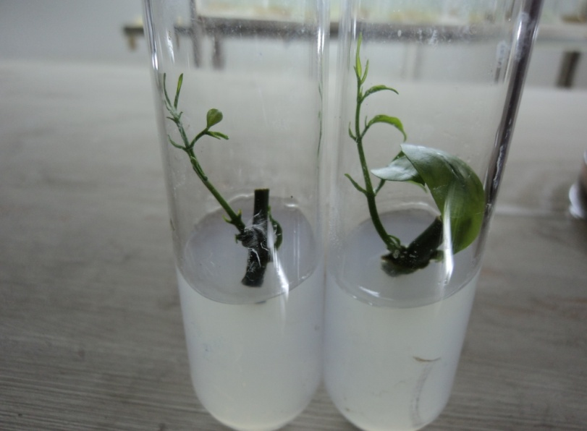

A

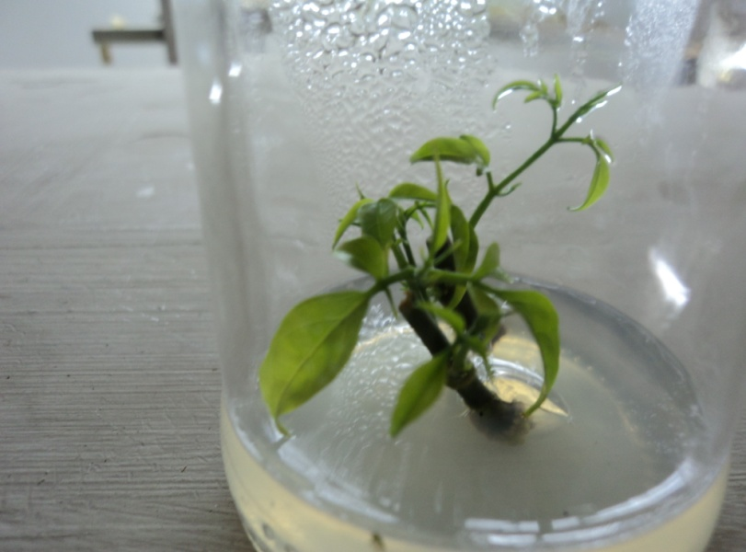

B

Figure(1): Shoots proliferation from nodes of Jasminum azoricum. A: nodes cultured on free MS medium(right) and on MS+ 1.0mg/L BA ( left). B: shoots multiplication on MS + 2.0 mg/L BA.
Callus induction and buds regeneration:
Results in table ( 2 ) revealed that there are significant differences in the effect of the different concentrations of BA and 2,4-D on the callus induction. The best concentrations of BA that gave the best percentage of callus induction were 4.0 and 6.0 mg/L, which gave 62.5 and 72.5 %, respectively, whereas 0.1 mg/L 2,4-D gave a significant difference ( 82.5 % ) than other combinations. The highest percent of callus induction ( 100 % ) was seen in explants grown in MS medium containing 4.0 mg/L BA+ 0.1 mg/L 2,4-D and 6.0 mg/L BA+ 0.1 mg/L 2,4-D , whereas the control did not give any response for callus formation.

Table 2: Effect of different concentrations of BA and 2,4-D on the percentage of callus induction from internodes of Jasminum azoricum .
2,4-D(mg/L)  BA(mg/L) | 0.0 | 0.01 | 0.05 | 0.1 | Mean effect of BA
0.0 | 0.0 | 10.0 | 30.0 | 60.0 | 25.0
2.0 | 10.0 | 20.0 | 60.0 | 70.0 | 40.0
4.0 | 30.0 | 40.0 | 80.0 | 100.0 | 62.5
6.0 | 30.0 | 70.0 | 90.0 | 100.0 | 72.5
Mean effect of 2,4-D | 17.5 | 35.0 | 65.0 | 82.5
L.S.D.( 0.05 ) | BA = 17.260  2,4-D= 17.260  BA × 2,4-D = 24.720

Many researchers showed that cytokinins and auxins induced callus formation in many plants (Darion et al., 2010; Hesar et al., 2011). It was known that the cytokinins and auxins are used to promote the formation of callus in many excited and in vitro cultured explants or organs (Ibrahim et al., 2013) .
The induced callus was transferred into MS medium without any addition of plant growth regulators for two weeks, then it was transferred into fresh MS medium containing different concentrations of BA (0.0, 2.0, 4.0, or 6.0) mg/L in combination with Kin (0.0 or 2.0 mg/L) for adventitious buds regeneration. Data in Table (3) showed that there were significant differences of BA concentrations on the regenerated buds from callus (Figure- 2) . The highest number of buds was found in the concentration of 4.0 mg/L BA, which gave 16.9 buds, other concentrations of BA were comparatively better than the control. Results also showed that the effect of Kin in concentration 2.0 mg/L (7.05 buds) was significant than control (3.4 buds). The interaction between BA and Kin showed that the highest number of buds was (10.1) seen in the combination of 4.0 mg/L BA + 2.0 mg/L Kin .

Table 3: Effect of different concentrations of BA and Kin on the buds regeneration from callus of Jasminum azoricum .
BA ( mg/L ) | Kin ( mg/L ) |  | Mean effect of BA
BA ( mg/L ) | 0.0 | 2.0 | Mean effect of BA
0.0 | 0.0 | 0.4 | 0.20
2.0 | 0.7 | 9.0 | 4.85
4.0 | 6.8 | 10.1 | 16.90
6.0 | 6.1 | 8.7 | 7.40
Mean effect of Kin | 3.4 | 7.05
L.S.D. ( 0.05 ) | BA = 1.603  Kin = 1.134  BA × Kin = 2.268

Organogenesis in explants during micro propagation takes place either directly or after callus formation. Studies on many ornamental plants showed both kinds of organogenesis . Cytokinins are known to promote in vitro regeneration of organs or buds from callus tissues of many ornamental plants ( Gomathi et al., 2007) .

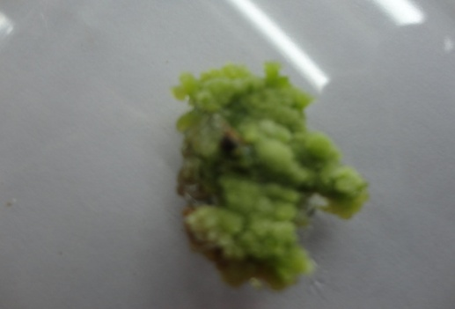
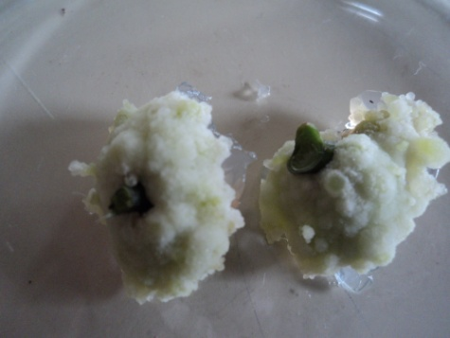
A
B

Figure ( 2 ): A- Callus induction on internodes cultured on MS medium supplemented with BA and 2,4-D.
B- Regeneration of buds from callus cultured on MS medium supplemented with BA and Kin.

Rooting and acclimatization:
According to the conditions of the experiment, all of plantlets failed to root in vitro on all IBA concentrations, but they continued in their growth, while the ex vitro rooting process showed that 85% (Figure- 3) of plantlets were successfully rooted and hardened. Most of recent studies focused on the rooting and hardening of in vitro micro propagated plantlets in one process by treated them with different types and concentrations of auxins and cultured directly in agricultural media (Gantait et al., 2011). It could be concluded that this method of propagation lead to efficient acclimatization procedure and save the resources of time, labor and reduce the cost of production.

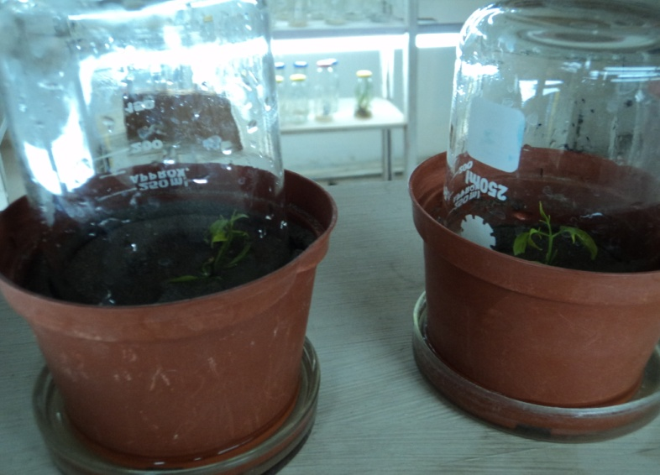
A

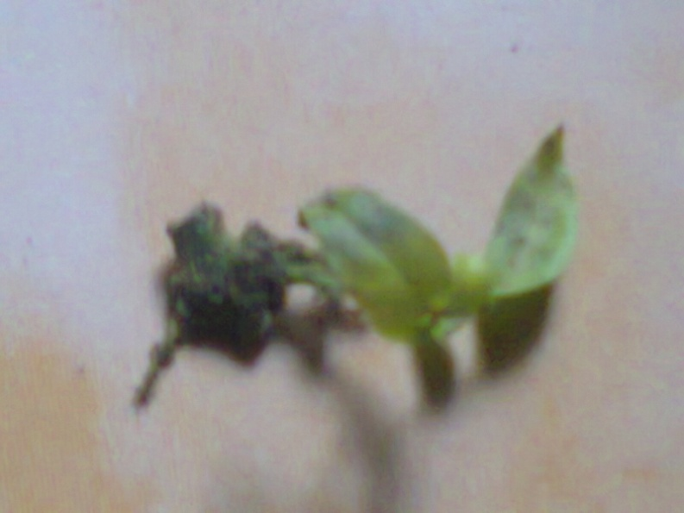
B

Figure(3): A,, direct rooting and acclimatization of in vitro micro propagated plantlets.
B,, ex vitro formation of roots on the base of jasmine plantlet.

References
Alikhan, M.W.; Raman,V.S.; and Raman, K.R. 1989. New chromosomal forms of superior ornamental values in Jasmines. South Indian Hort., 17: 79-83.
Bhattacharya, S. and Bhattachryya, S. 2010. In vitro propagation of Jasminum officinale L.: A woody ornamental vine yielding aromatic oil from flowers. Meth. in Molec. Bio., 589(1): 117-126.
Cheng through protocorm-like bodies: the effect of cytokinins, carbohydrate sources and cold pretreatment . Sci.Hort.123: 258-262.
D.V. 2007. Antimicrobial effects of Indian medicinal plants against acne-inducing bacteria. Trop.J.Pharma.Res., 6(2): 717-723.
Darion, N.; Jouira, h.B.; Gallard, A.; Hassanein, A.; Nassour, M.; and Grapin, A. 2010. Methods for in vitro propagation of Pelargonium hortorum and others: from meristems to protoplasts. Protocols for in vitro propagation of ornamental plants: 197-212.
Gantait, S.; Mandal, N.; and Nandy, S. 2011. Advances in micro propagation of selected aromatic plants: a review on vanilla and strawberry. Amer. J.Biotech.Mol.Bio.,1(1): 1-19.
Gomathi, K.S.; Sambandamurthy,S.; Sadasivam, S.;Ramasamy, N.M.;and Rajmohan,K.2007. In vitro culture and biochemical analysis of Jasminum sp. Recent Trends in Horticultural Biotechnology.pp: 149-153.
Hesar, A.A.; Kaviani, B.; Hashemabadi, D.; Tarang, A.R.; Zanjani,S.B. and Ansari, M.H.2011. Mathiola incana micropropagation using shoot tips and callus induction derived from lamina explantsand rooting capacity from callus. J.Ornamen.Hort.Plan.,1(3): 129-136.
Ibrahim, M.A.; Al-Taha,H.A.; and Seheem, A.A. 2013. Effect of cytokinin type and concentration, and sucrose of explants on shoot multiplication of pineapple plant(Ananas comosus 'Queen') in vitro. Acta.Agri.Slov., 101(1): 15-20.
Kumar, G.S.; Jayaveera,K.N.;Ashok-Kumar,C.K.; Sanjay, U.P.; Swamy, B.M.V.; and Kishore-Kumar,
Luo, J.P.; Wawrosch, C.; and Kopp, B. 2009. Enhanced micropropagation of Dendrobium huoshanese
Murashige ,T. and Skoog,F. 1962. A revised medium for rapid growth and bioassays with tobacco tissue cultures. Physiol. Plant., 15: 473- 497.
Poonpaiboonpipat,T.; Teerarak; M.; Phuwiwat, W.; Charoenying, P.; and Laosinwattana, C. 2011. Allelopathic effects of Arabian jasmine( Jasminum sambac Ait.) and preliminary test for estimation of Its natural herbicide activity. J.Agric. Tech., 7(4): 1075-1087.
Ramdas, S.; Peter, G.B.; and Muthuswami, S. 1993. Jasmine in: Bose T.K. and Yadav L.P.(eds) Commercial flowers: Naya Prokash, Calcutta, pp: 486-517.
SAS.2001. SAS Guid for Personal Computers. Release6.12.SAS institute inc., Cary, NC.USA.
Shen, X.;Yang,G.; and Lu, Z. 2013. In vitro propagation of Alexandrian Laurel( Danae racemosa L.Moench), a valuable ornamental plant. HortScience,48(10): 1301-1303.
Wangren,J.S. 2011. In vitro propagation of Jasminum sambac L." double petals" by axillary buds. Prop.Orna.Plan., 11(4): 172-176.

