Computerized System for Numerical Methods Simulation using Visual Basic Programming Language

Raafat K. Oubida
Department of E. E., College of Engineering, University of Babylon, Babil, Iraq.
raafatoubida@gmail.com

Abstract
This paper presents a reasonable computer application solution of the numerical methods, which have been designed and implemented of a Computerized System for Numerical Methods Simulation (CSNMS) as teaching tool furnishes a background necessary for studying numerical analysis (numerical methods) theory. This program is a simple application tool, which provides an interactive and simplified interface for students. The system consists of different techniques with different algorithms has been implemented to provide wider choice for the students in order to make it easier for them to understand the fundamentals of numerical methods.
The simulation results from the testing of the system demonstrated that the system works correctly and meant all constraints.
Keywords: CSNMS , Teaching tools, Numerical analysis, Simulation, Integration, Runge-Kutta, Euler, Newton-Raphson, , Visual Basic programming Language.

الخلاصة
تعرض هذه الورقة تصميم وتطوير نظام محوسب لمحاكاة الطرق العددية (CSNMS) كأداة تعليمية يوفر خلفية ضرورية لدراسة التحليل العددي (الطرق العددية) النظرية. هذا البرنامج هو أداة تطبيق بسيط، وهو يوفر واجهة مبسطة وتفاعلية للطلاب.
ويتكون النظام من تقنيات مختلفة مع خوارزميات مختلفة تم تنفيذها لتوفير خيارات أوسع للطلاب من أجل جعل الأسهل بالنسبة لهم لفهم أساسيات الطرق العددية.
النتائج من اختبار النظام أثبتت أن النظام يعمل بشكل صحيح ويعني كل القيود.
الكلمات المفتاحية: الطرق العددية، ادوات تعليمية، التحليل العددي، محاكاة، تكامل، رانك-كوتا، اويلر، نيوتن-رافسون، لغة البرمجة بالبيسك نظري.
- Introduction
With the development of speed and efficient digital computers, the role of numerical methods in solving scientific and engineering problems has been increasing at rapid pace in recent years. Currently, Introduction to numerical methods course for engineering students at the undergraduate level as a general and fundamental tool for all engineering disciplines. Computer programming languages will be essential, some are compulsory some are elective and there are some that don’t need to be given in some departments or are not needed for later purposes; many today’s popular commercial software packages widely used in science and engineering such as Matlab [Mathworks Inc.2012], Maple, Mathcad and Mathematica [Castillo, et al., 1994]. Beside programming languages such as Fortran, Basic, Pascal, C ,C++, and Microsoft Excel/VBA [Deitel, 1999; Walkenbach, 2004]. These resources often termed as “teaching tools” in academic environment.
In our experience, when I was teaching the numerical methods class for Civil Engineering students at Almuthana University during 2011-2013. The students should learned how to use MATLAB and Excel to implement their own numerical methods.
In addition, through meticulous observation, which is found out that engineering student lack of a programming skills and knowledge skills that can aid them to understand the basic concepts of fundamentals of numerical methods.
Most of previous researches were using packages or programming languages as mentioned above such as [Conte, 1965; Haggerty ,1972; Aslan et al., 2002;Hassan, et al., 2006;Wlodkowski, 2006] for solving problems.
Conte (1965), uses of Fortran IV programming language they make a comparison between analytical and programming method of solving numerical and came up with a conclusion that programming method of solving numerical iterations using computer is faster than using analytical method and safe time with a very negligible errors or no errors incurred at all. Haggerty G.B(1972), He also used FORTRAN IV programming languages for the algorithms. (Yüncü, Aslan, 2002), C++ was used in numerical analysis learning as a developed visual package program. (Hassan, etc., 2006) , for the execution of numerical iterations.
Above all, these researchers make uses of FORTRAN IV programming language which is a text based language. Text based language do not allow the users to work directly with graphics and this is one disadvantages why the use of FORTRAN IV programming language is not consider for use in this research work, rather visual basic programming language is consider for use. In addition, the recent work with visual basic to implemented the application for the limited iteration solution.
But our software system aims to provide both simple and user-friendly tool for students to investigate numerical methods basic concepts that allow students with less programming knowledge and skill and the ability to select the appropriate numerical method to be used with the particular problem under consideration.
In this paper we will describe a computerized system called CSNMS that designed and implemented at Al-Muthana University that provides their numerical solutions which are taught in most engineering disciplines for examples, the solution of sets of equations, curve fitting, interpolation, differentiation and integration, and ordinary differential equation ODEs. The rest of this paper is organized as follows:
Section II we give an overview of Visual Basic programming language. Section III we provide a flowchart for the system analysis, followed by system design in Section IV. Simulation results are presented in Section V. Finally, conclusions are given in Section IV.

- Overview of Visual Basic
Visual Basic (VB) is the advanced version of the BASIC programming languages is developed by Microsoft corporation in 1991 and Visual basic 6, it creates visualized interface between the user [Holzner, 1999; Brown, 2000]. Visual basic version 6 has become one of the most important role in solving engineering problems.
This language has revolutionized and widely used because of its salient features with in an integrated development environment (IDE), graphical user interface (GUI) (Rapid Application Development (RAD) [Halvorson, 2002] is the process of rapidly creating an application, and has the ability to generate a Dynamic Link Libraries (DLL). In addition, object-oriented features, error handling, and much more. Therefore, it is suitable to create simple educational software to achieve the required for engineering students to solve problems .

III. System Analysis
The glance through the methodology workflow of this system presented in a flowchart manner as shown in the figure below to gain an overview of the work done during this project. This paper is only going to consider, application of Visual Basic to solutions of seven different numerical methods. These are Trapezoidal, Simpson’s 1/3, Simpson’s 3/8, Euler, and Runge- kutta 2nd order via three methods and this is the limit of this paper.
Start

Display the main widow system

Integration estimating
ODE Solving

Trapezoidal
Simpson’s 1/3
Euler
Simpson’s 3/8
Runge Kuta 2nd order

Stop
Exit
Huen’s method
Mid-point method
Ralston’s method

Figure 1 : flowchart of the system
IV. System design
This section gives an overview about the system design used in this project.
The main window of the program as shown in the Figure 2 consists of two categories (topic areas) these being an integration estimating category, and an ordinary differential equation (ODE) solving category (Figure 3).
The student may choose to perform any of the function in the list from the main menu. We described seven methods for numerical methods namely, the Trapezoidal, Simpson, Euler, and Runge Kuta (RK).
Each method is represented as an item in the menu. The student can insert equation and the initial guesses or called starting value for the problem, on clicking on the estimate or calculate button, this software can self calculate the equation , and also view the result to the problem as shown in Figure 4. The design program was developed using Visual basic 6.0.
When the students enter the system, they are presented with several choices that are listed down the left side of the screen (Figure 1).
Initialize input data: a, b, and n
Select a method from the menu.
Specify a function f (x)

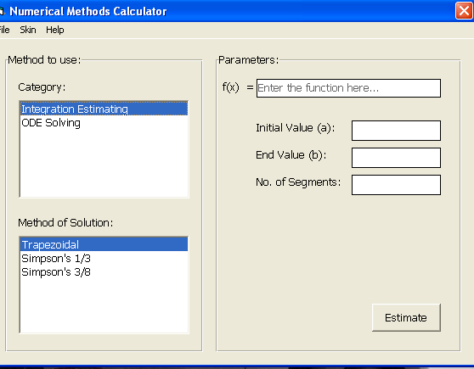
Click the Estimation/Compute push button
to view the results.

Figure 2: Screen shot 1 for main window of the program

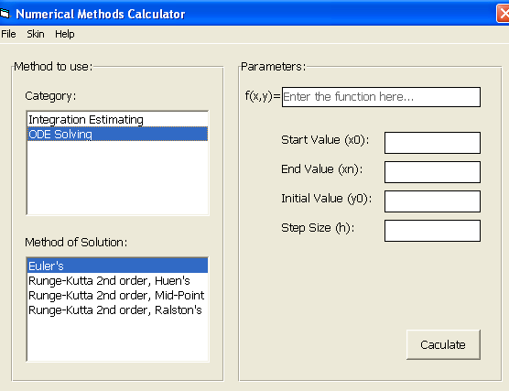
Figure 3: Screen Shot 2 for main window of the CSNMS system

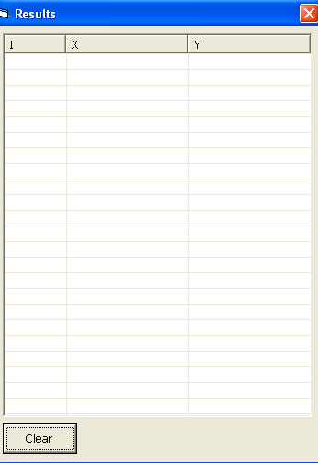 | 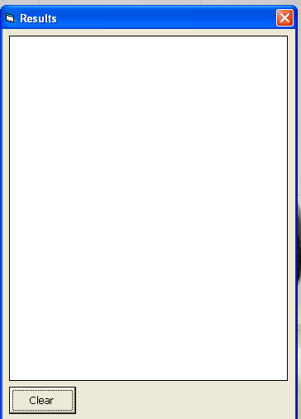
Figure 4: Iterative Solution Results Screenshot
V. Results and Discussions
In order to compare the performance of the computerized system, we are now in possession of three numerical methods for the numerical integration solutions. They are Euler's method, Trapezoidal rule, and Simpson methods.
We take two limited integrals for example, exponential function,
This functions were solved by using three numerical methods with analytically approach, so, the results which we obtained represents the exact values for these integrals.
Then we solved these integrals using the same numerical methods in our system.

Example 1: Use the trapezoidal rule, Simpson’s 1/3 rule and Simpson’s 3/8 rule to numerically integrate:
Solution:
The true solution is
R = 19.0855 the real value.

Trapezoidal rule:
In this example, y = e^{x} , a = 0 , b = 3 , n = 6
The true solution is

n | x_{n} | y=e^{x}
0 | 0 | 1
1 | 0.5 | 1.64872
2 | 1 | 2.71828
3 | 1.5 | 4.48169
4 | 2 | 7.38906
5 | 2.5 | 12.18249
6 | 3 | 20.08554

Therefore the result is:
= 19.48151
= 19.482 (3 d.p.)
P = 19.482 the approximated value.

error = 19.0855 – 19.482 = 0.3965

Simpson’s rules

= 19.092
P= 19.092 the approximated value.

error = 19.0855 – 19.092 = 0.0065

Example 2: Use the Simpson’s 1/3 rule and Simpson’s 3/8 rule to numerically integrate:
$$I=\int_{0}^{1}{e^{x^{2}}}\text{dx}$$
By using Trapezoidal rule:
n | value
4 | 1.4907
8 | 1.4697

By using Simpson’s 1/3 Rule:
n | value
4 | 1.4637
8 | 1.4627

In table below we summarized the result of integrating the functions with each of the three methods.

Table 1 : Real values ​​and approximate values ​​of integrals

Functions | True Value | Approximate Value
Functions | True Value | Trapezoidal rule | Simpson’s 1/3 rules | Simpson’s 3/8 rule
 | 19.0855 | 19.482 | 19.092 | 19.0857
$$I=\int_{0}^{1}{e^{x^{2}}}\text{dx}$$ | 1.4626 | 1.4697 | 1.4627 | 1.4626

From the previous table that shows the true values ​​and using approximate numerical methods for the proposed two examples in our research.
And now we got to evaluate the proposed system through the application of the same functions and using numerical methods themselves and note the results and the extent of convergence and accuracy, as shown in graphical interfaces for the computerized system.

Screenshot for related examples:
Example1:
 | 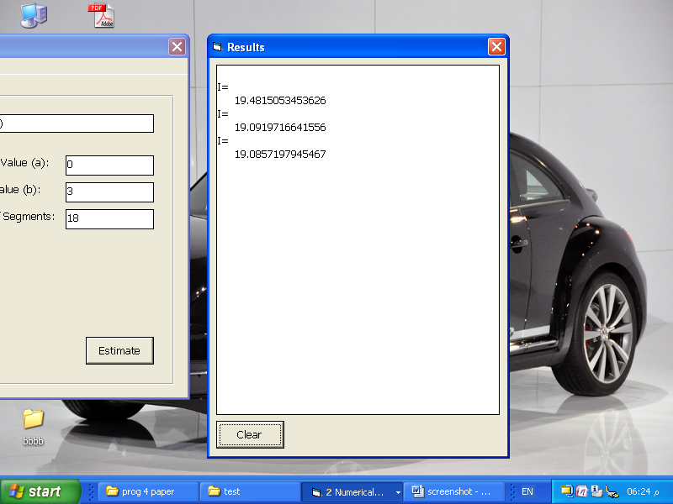
  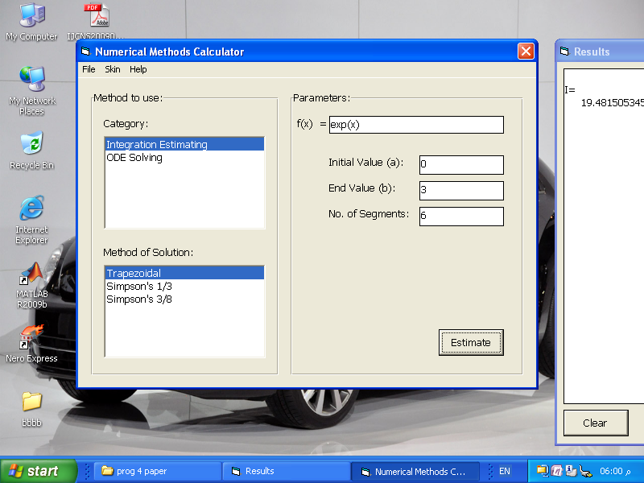
  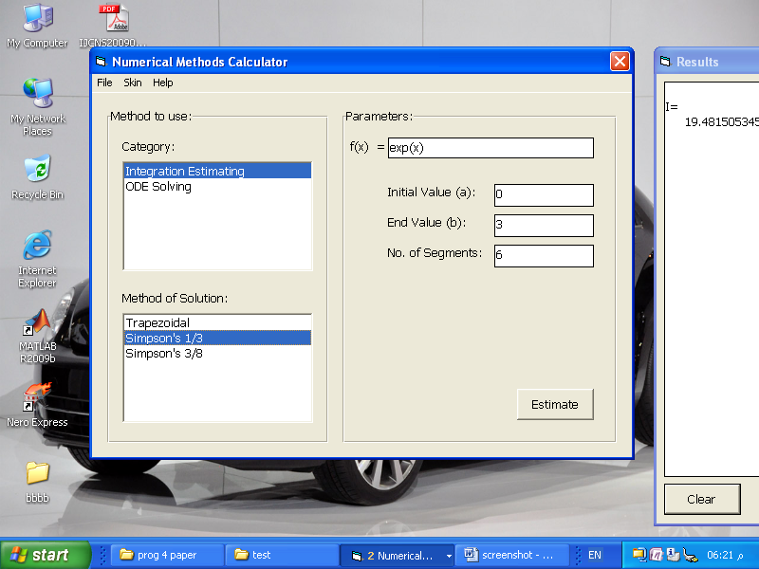
  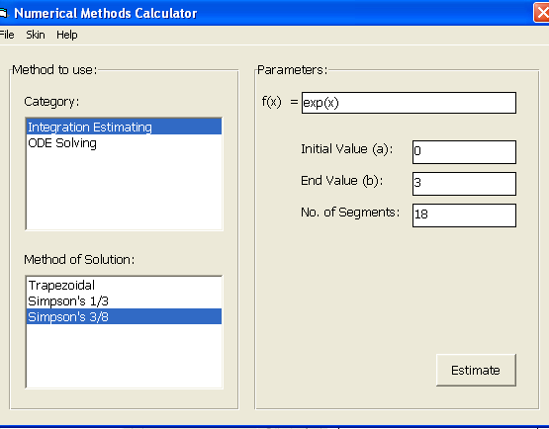

Example2:

 | 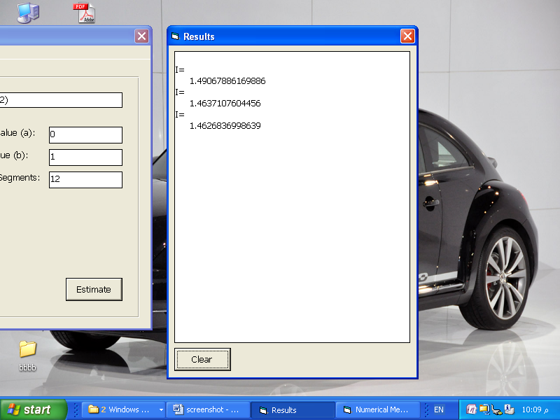
  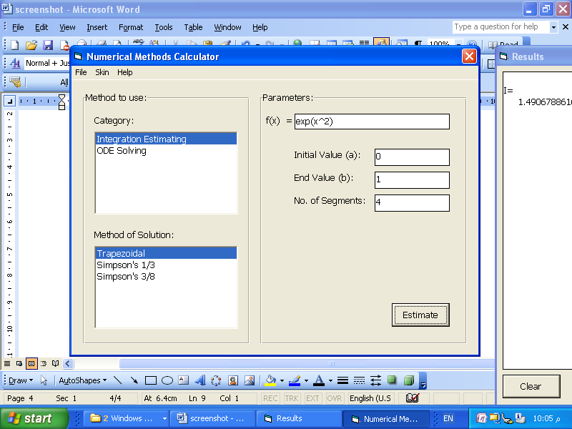
  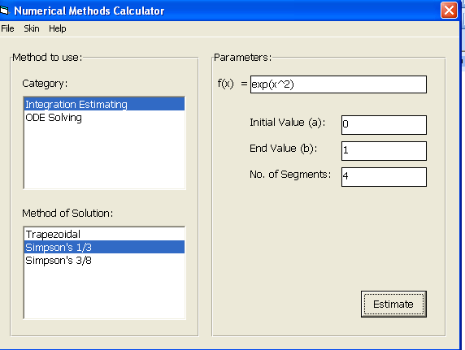
  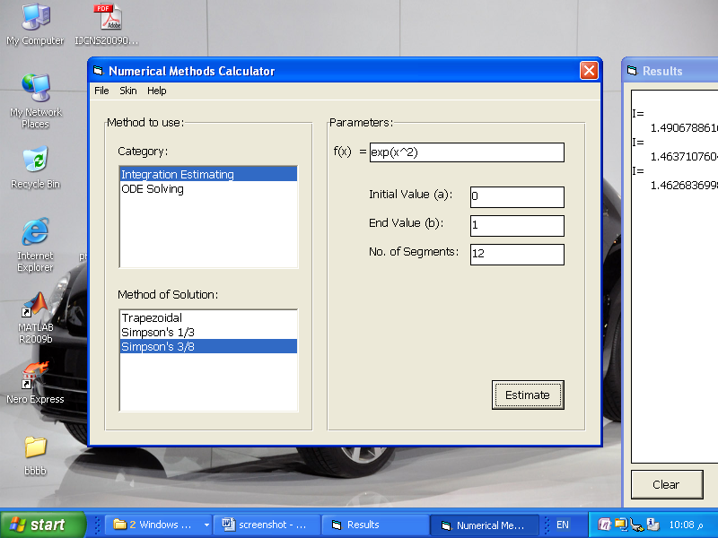

Is clear to us is evident from the results that we have obtained over the accuracy and efficiency of the computerized system.

VI. Summary and Conclusions
By using state of the art computing and information technology tools in education environment; as early stated in this research Visual Basic programming language has been chosen for using to implemented and in addition that demonstrated how effective tool in an undergraduate numerical methods class.
Manual calculations has been done as shown in Section V having true and approximate values and that were compared with the simulation solutions obtained with the help of software system. It was found that they are nearly equal but hand calculations were time consuming. On the other hand, system solved the functions in the fraction of seconds and also requires a less programming knowledge or skill.
Beside using Visual Basic is convenient to simulation of numerical methods and is less prone to errors. Our system is working and completely functional but there are other options that could be added to the next future work. In addition, the testing results show that the system is working as expected.

References
Aslan C et al 2002: “Error Analysis of Numerical Methods and Preparation of a Numerical Solution Package”, J.Fac.Eng. Arch. Gazi University vol.17,No2,87-102.2002.
Brown R.L 2000: "Computer programming fundamentals with applications in visual basic 6.0". Reading, Mass: Addison-Wesley, 2000.
Castillo,E.et al 1994: “Mathematica. Editorial Parninfo.” 1994
Chapra, S.C. 2008 “Applied numerical methods with MATLAB for engineers and scientists”. McGraw-Hill. 2008
Conte S. A. et al 1965: Elementary Numerical Analysis, An Algorithmic Approach, McGraw-Hill Book Company, New York, 1965.
Deitel H. M.1999 : “Visual Basic 6 How to Program”, USA: Prentice-Hall, 1999.
Halvorson 2002:”Microsoft Visual Basic 6.0 Professional Step by Step”, Microsoft Press, 2002.
Hassan, et al., 2006 “The Application of Visual Basic Programming Language to Simulate Numerical Iterations”, Leonardo Journal of Sciences ISSN 1583-0233, Issue 9, p. 125-136.
Holzner S.1999: “Visual Basic-6 Programming Black Book”, Dreamtech Press 1999
Mathworks Inc.2012, MATLAB®, 2012, www.themathworks.com
Walkenbach, J.2004:” Excel 2003 Power Programming with VBA”, Wiley, New York 2004
Wlodkowski P. 2006:“Teaching Numerical Methods in Engineering with Mathcad”. American Mathematical Society for Engineering Education -1549. 2006

