Phenotypic and Molecular Identification of Bifidobacterium sp. Isolated from Infants Feces
Dheyaa. M. Naser
Department of Biology /College of SciencesUniversity of Babylon /Iraq .
dheyaamohammad38@yahoo.com.
Mohammed . A. Jebor
Department of Biology / College of Sciences University of Babylon/ Iraq
drmoh_abdullah62@yahoo.com
Abdallah .K .Hindi
Department of Biology /College of Sciences University of Babylon / Iraq
drabdallah.k.hindi@yahoo.com .

Abstract
One hundred fecal samples from clinically less than one month old infants was collected for isolation of bifidobacterium sp. , and these samples was cultured on two different selective media for this bacteria De Mann, Rogosa and Sharpe (MRS) agar and Liver Cysteine Lactose (LCL) agar media . Identification of this bacteria was obtained by morphological characteristic, microscopic feature, biochemical tests, Fructose-6-phosphate phosphoketolase (F6PPK) activity assay and molecular identification by used genus-specific primer . And also detection and amplification of xfp gene was achieved by PCR technique and specific primer with a product size 249 bp . Gene expression of xfp was measured by detection of F6PPK enzyme in crude extract of bifidobacteria . Different conditions from pH, temperature, incubation period, and culture media was used to optimization of condition for production of F6PPK enzyme from bifidobacteria. The result revealed that pH 7 was optimum pH for growth and production of enzyme while 30 Cº was optimum temperature for production of F6PPK enzyme and its reach to maximal production after 18 hr of incubation .
Key words : Bifidobacterium , xfp gene , fructose-6-phosphate phosphoketolase (F6PPK)
الخلاصة
تم جمع 100 عينة خروج من الاطفال الاصحاء سريريا والذين لاتتجاوز اعمارهم الشهر لغرض عزل بكتريا الBifidobacterium sp. . وتم زرع تلك العينات على نوعين مختلفين من الاوساط الاختيارية لهذه البكتريا De Mann, Rogosa, and Sharpe (MRS) وLactose liver cysteine (LCL) .شخصت بكتريا ال Bifidobacterium sp عن طريق الخصائص المظهرية , الصفات المجهرية ,الفحوصات الكيموحيوية , فحص فعالية انزيم Fructose-6-phosphate phosphoketolase (F6PPK) بالإضافة الى التشخيص الجزيئي باستخدام البادئ الخاص في تشخيص تلك البكتريا على مستوى الجنس , وايضا تم التحري والتضخيم لموروث ال xfp باستخدام تقنية ال PCR والبادئ الخاص في ذلك الموروث مع حجم تضخيم 249 زوج قاعدي . تم قياس التعبير الجيني لموروث ال xfp بواسطة التحري عن وجود انزيم ال F6PPK في المستخلص الخام للبكتريا,كما تم استخدام ظروف مختلفة من الاس الهيدروجيني , درجة الحرارة ,فترة الحضانة والاوساط الزرعية لمعرفة الظروف المثلى لانتاج انزيم ال F6PPK من تلك البكتريا. اوضحت النتيجة ان الاس الهيدروجيني 7 هو الامثل للنمو وانتاج الانزيم بينما 37م˚ كانت هي المثلى لانتاج الانزيم وقد وصلت الى اعلى انتاجية بعد 18 ساعة من الحضانة .
الكلمات المفتاحية: Bifidobacterium, موروث الxfp , انزيم الفوسفوكيتوليز(F6PPK)
Introduction
Bifidobacteriaceae are indigenous components of human and animal gastrointestinal microbiota and are routinely isolated from the human gastrointestinal system, especially the colon; they are the first and most dominant gut inhabitants in early human life. Bifidobacteriaceae are also present in the oral cavity and the vagina (Biavati, et al 2012). Bifidobacterial species are common members of the human gut microbiota , comprising up to 3% of the total fecal adults microflora .they are more numerous in the infant gut , where they form up to 91% of the total microflora in breast-fed babies and up to 75% in formula-fed infants, because of their prevalence in the infant feces suckled at the breast ,bifidobacteria are considered to be beneficial bacteria and they are used in the production of the probiotic products (Woese, 2000).
Bifidobacteria are gram-positive ,non sporeforming , nonmotile, branched ,rod-shaped , saccharolytic anaerobic bacteria (also some species can tolerate low amount of oxygen) and traditionally consider as a member of lactic acid bacteria group . It is produce acetic and lactic acids from carbohydrates without the generation of CO₂ (Tannock, 2010 , Ruiz , et al 2012a). Bifidobacteria isolated from humans intestines are known to grow at optimal temperature values between 36 and 38C° .but animal strains grow at a higher temperature ,approximately 41-43C°. It is also grow at optimal pH values ranging from 6.5 and 7.0 ,however they inhibited by temperature values under 25 and above 45C° While Bifidobacterium thermophilum that was described as one of the common species in ruminant ,this species appear to be practically resistant . it is able to survive or multiplying at a relatively high temperature (46C°)and was shown to be highly tolerant to oxygen (Blaser and Falkow, 2009). Member of the genus bifidobacteria are fermentative bacteria that utilize a variety of carbohydrates , especially oligosaccharides , resulting in the formation of acetic and lactic acids . hexose are utilize by unusual metabolic pathway known as the bifid shunt . Bifidobacteria are achieve large population sizes in the bowels of humans during the first few months after birth . and it is populations are probably enriched in the bowel by some of a huge variety of oligosaccharides present in breast milk . The variety of oligosaccharides in milk may partially dictate the kind of bifidobacteria that establish in the bowel of a given child. Native immune cell harvested from cord blood respond differentially to bifidobacterial species , thus the occurrence the immunological diseases such as childhood allergies may be influenced by the kind of bifodobacteria to which a child exposed in early life (Tannock, 2010 ).

Materials and Methods
1- Isolation of bifidobacteria
One hundred stool sample was collected from infants under one month old in Al-Hilla Hospital for Delivery and Infants and Al-Kifil Hospital during the period from November 2013 to March 2014. Sterile scrow cub contains normal saline was used to collection specimen to avoid any possible contamination and obtained for suspension, then 50 μl of stool suspension transfer to liver cysteine lactose agar (LCL) and De mann , Rogosa and Sharpe (MRS) agar supplement with 0.5 gm/L of L-cystein-HCL, spreading by sterile loop under sterile condition and incubated at 37C° for 24-48 hr under anaerobic condition .

2-Identification of isolates
First step for identification of bifidobacteria morphologically . Bacterial slides treated with gram stain and examined by microscope under high bower lens (1000x), since bifidobacteria appear as gram positive rod or pleomorphic shape (typically V or Y shape). F6PPK activity assay, it’s a second step for bifidobacterial identification, the isolates considering to belong to the genus Bifidobacterium were diagnostic by the detection of F6PPK activity in cellular extract of bacteria as described by Scardovi and Trovatelli 1965.Briefly, cells were grown in 10 ml of MRS broth medium at 37 Cº for 18 hr and harvested by centerfugation 6000 rpm/ min for 10 min , the pellet was washed twice with 5 ml of phosphate buffer supplement with 0.5 gm /L cystein . After centerfugation the pellet was suspended in one ml of the same buffer , 50 ml of lysozyme was added and after incubation for one hour, cells were disrupted by adding 0.4 ml hexadecyltrimethylammonium bromide (CTAB 0.45mg /ml) for obtaining crude cell extract ,0.25 ml of reagents (6 mg/ml NaF plus 10 mg/ml sodium iodoacetate and 80mg/ml fructose-6-phosphate) was added to the cells extract . The reaction was started by inocubation 30 min at 37Cº and stopped by adding 1.5 ml of hydroxylamine-HCL (13.9%) . After 10 min 1 ml of trichloroacetic acid (15%) and 1 ml of FeCl₃ 6H₂O (5%) were added . A negative control consisting of all reagents except the substrate (fructose-6-phosphate) as well as a control strain used to verify the color . The presence of F6PPK enzyme was revealed by the appearance of red or purple color and measured by specterophotometer at 435 wave length (Orban and Patterson, 2000).

3-Molecular identification of bifidobacteria and amplification of xfp gene
Genomic DNA was prepared according to the procedure of Kate Wilson 1997. Its briefly occur by Incubattion approximately 5 ml of liquid culture media with bacteria at optimum condition of growth for 24 hr. transfer 1.5ml of culture to a 1.5 appendorfe tube and spin in microcenterfuge for 2 min at 10000 rpm. the supernatant was discarded and the pellet suspended in 567μl TE buffer and mix by pipetting . Add 30μl of 10% SDS and 3 μl of 20 mg/ml proteinase K to give final concentration of 100 mg / ml proteinase K in 0.5% SDS , mix well and incubate at 37C° for one hr. After this step, the solution should become viscous as the detergent lysis the bacterial cell wall. There should be no needed to predigest the bacterial cell wall with lysozyme . Add 100 μl of 5M NaCl and mix thoroughly ,This step is very important to remove cell wall debris , denatured protein , and polysaccharide . While retaining the nucleic acid in solution . Add 80 μl of CTAB /NaCl solution . Mix thoroughly and incubate 10 min in waterpath 65C°. And then add approximately equal volume (0.7-0.8 ml) of chlorophorm /isomyl alcohol. Mix well and spin at 14000 rpm for 5 min. This step is important to remove the CTAB-protein /polysaccharide complexes . A white interface should be visible after centerfugation . Transfer the aqueous , viscous supernatant to a new microcenterfuge tube and add equal volume of phenol /chlorophorm/isomyl alcohol. Mix well and spin in microcenterfuge 14000 rpm for 5 min., transfer the supernatant to a new appendorf tube and add 0.6 volume of isopropanol to precipitate the nucleic acids. Shake the tube back and forth until a stringy white DNA precipitate become clealy visible . Spin the solution at 14000 rpm for 10 min to precipitate the DNA . Add 500 μl of 70% ethanol and spin at 14000 rpm for 5 min to remove the residual CTAB and then carefully discard the supernatant and briefly dry the pellet and then suspended the pellet in 100 μl TE buffer. Specific primer that used in this study are listed in table (1).

Table (1) genus specific primer and xfp gene primer.

Target group | primer | Sequence (5´ to 3´) | Length (bp) | Product size | References
Bifidobacterium spp | Pbi F1  Pbi R2 | CCGGAATAGCTCC  GACCATGCACCACCTGTGAA | 13  20 | 914 | Denis and Stephane (2000)
XFP gene | Xfp F  Xfp R | GCTCCTACGAGTCCTTCGTG  TGGAATCAACCGGGAAGTAG | 20  20 | 249 | Gen bank

DNA amplification was carried out by using specific primers which explained in table (1) . The amplification reaction was 50 μl PCR mixture containing : 5μl Taq buffer , 5μl dNTP , 4μl MgCl₂ , 2μl Taq polymerase enzyme , 3μl pbi FI , 3μl pbi R2 or (3μl xfp F ,3μl xfp R) , 3μl template DNA ( final concentration of DNA was 25 ng) and 25μl deionized free water . PCR amplifications were performed with Biometra apparatus with the following conditions : initial denaturation 94Cº for 5 min ,followed by 35 cycles of denaturation (94Cº for 30 sec) ,annealing (variable temperature 55-60Cº for 30 sec) , extension (72Cº for one min) and a single final extension step (72Cºfor 10 min). The amplified fragments were fractionated on 1.5% agarose during one hour at a constant voltage 80V. Genomic fragment were visualized under ultraviolet light followed by digital capturing of the photo by used canon camera. (Denis Roy and Stephane ,2000)

Results and Discussion
Twenty five samples out of the one hundred samples given a positive results as bifidobacteria . This samples had been grown on both MRS and LCL media and then submitted for identification . The selectivity of this media did not affect the growth of isolates, the colonies appear as round , white to cream in color , approximately 2 mm in diameter . grown of bifidobacteria on MRS agar and LCL agar was associated with grown of lactobacillus and candida species . So mupirocin susceptibility test was used to differentiated bifidobacteria from lactobacillus since first organism was resist to mupirocin while lactobacillus was sensitive. All of purified isolates were gram positive bacteria and given negative results for catalase, oxidase , IMVIC tests , and also generation of gas .
The F6PPK activity assay is commonly used as a definitive criterion for identification of bifidobacteria . F6PPK activity test was performed on all 25 samples which was considered to belonging to bifidobacteria. All of these samples given positive result for F6PPK activity test. The result was agreed with Zinedine and Faid 2007 who revealed that bifidobacteria can be distinguished on the basis of phosphoketolase production.
Optimization of conditions for production of F6PPK from bifidobacteria was determined as shown in the figures(1,2, and 3)

This result was agreed with optimal growth condition to growth of bifidobacteria . due to F6PPK considered as a key enzyme in the carbohydrate metabolic pathway of this bacteria, it is reach to maximum production during log phase and begin to decrease during stationary and decline phase. the results were also agreed with Hiederpoor et al, (2008) , who revealed that phosphoketolase assay is a common test for identification of bifidobacteria and all of strain that belonging to this genus given a positive result to F6PPK test.

Amplification of 16s rDNA and xfp Gene
Molecular detection of bifidobacteria by amplification of 16s rDNA and also detection of xfp gene was doing by PCR technique . molecular assay is an effective diagnostic tool for confirmation the isolates which considered as bifidobacteria by cultural and enzymatic method . A PCR product size was 914 bp length for 16s r DNA and 249 bp length for xfp gene. The result of amplification of 16s rDNA is show in figure (4).

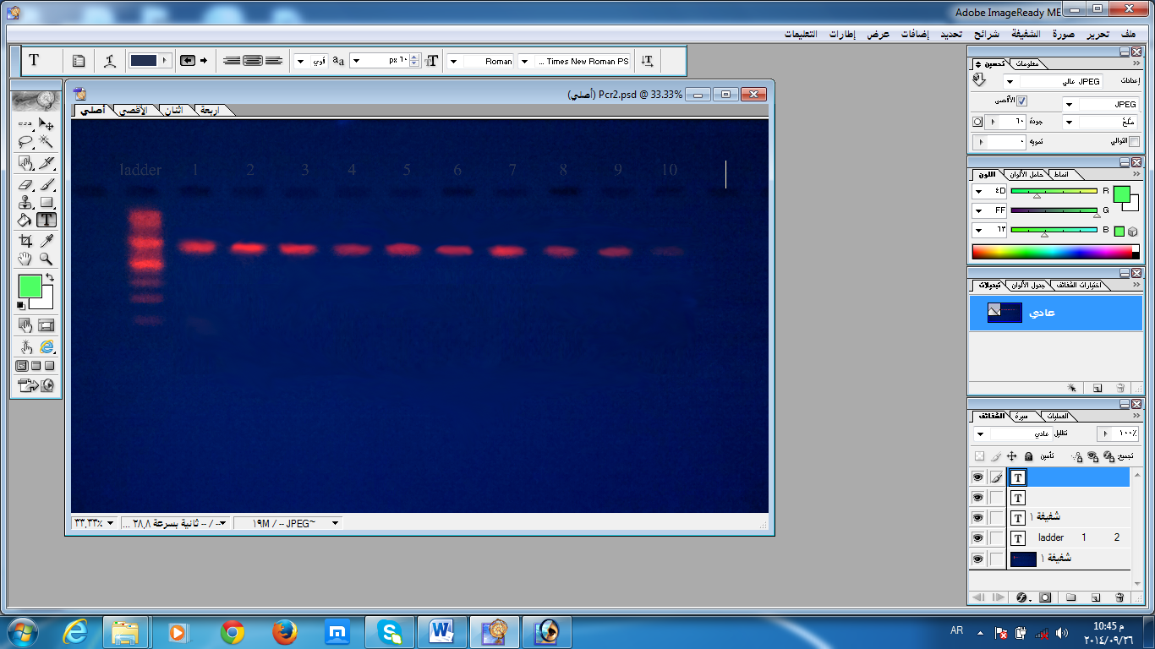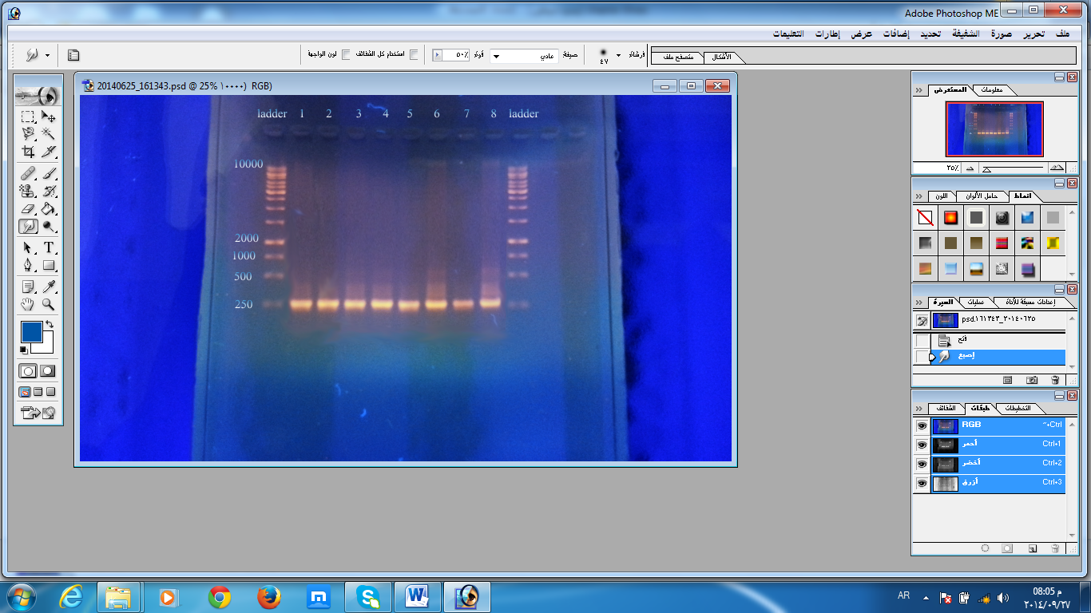
Figure (4) . On left Amplification of 16s rDNA by PCR technique (Amplicon size 914 bp ) , line one DNA marker (100-3000 bp length ) . On right Amplification of xfp gene by PCR technique, (Amplicon size 249 bp) line one and ten DNA marker (250-10000 bp length ).

The result which shown in figure (4) was agreed with Denis and Stephane ,(2000) who revealed amplification of 16s rDNA with a specific primers pbi F1 and bpi r2 for all of the strain tested . 16S rDNA gene considered to be universally present in all bacteria and showed a high degree of sequence conservation the homology analysis in sequence of this gene given some interesting results for the phylogenetic analysis of the genus Bifidobacterium .

Conclusion
Isolation and characterization of bifidobacteria demonstrates that these bacteria are a good sources for probiotic strains . F6PPK assay considered to be a reliable test to identification of bifidobactertia from other probiotic bacteria such as lactobacilli , and used of CTAP method to disruption of cells membrane are a more rapid procedure than time consuming process by sonication . we determined the optimal conditions for F6PPK production that may be useful in growth of this bacteria at an industrial level.

Acknowledgment
In the name of Allah , the beneficent , the merciful , and praise to Allah, the lord of the world . I would like to express my thanks to Asst. Prof. Dr. Ahlam K . Naaem and Asst. prof Dr. Alber Arslanoglu ( Izmir institute of technology/ Turkey ) who support me in practical part of my research.

References
Biavati, B.; Mattarelli. P. Genus Bifidobacterium. In: Goodfellow. M.; Kampfer, P.; Busse, H-J.; Suzuki, K-I.; Ludwig, W. and Whitman, W.B, eds (2012). Bergey’s manual of systematic bacteriology. The Actinobacteria, vol. 5, 2nd ed. New York: Springer. p. 171_206.
Blaser, M. and Falkow, S. (2009). What are the consequences of the disappearing human microbiota? Nature Reviews. Microbiology, 7, 887-893. Nature, 449, 811-817.
Denis Roy and Stephane .S (2000).molecular differentiation of Bifidobacterium species with amplified ribosomal DNA restriction analysis and alignment of short regions of the Idh gene .Food research and Development Centre ,Agriculture and Agri-Food Canada. 3600 Casavant Boulevard West, St. Hyacinthe, Que ., Canada J2S 8E3.
Hiederpoor, M.; Mokhtari , F.; Mirdamadi, S. and Gharashi, A. (2008). Isolation and Identification of Bifidobacterium sp . in Iranian Traditional Dairy Products . Research Journal of Biological Sciences 3(9) : 979-983 .
Orban,J.A. Patterson, (2000) . Modification of the phosphoketolase assay for rapid identification of bifidibacteria .J.Microbiol . Methods, 40:221-224.
Ruiz, L.; Gueimonde, M.; Ruas-Madiedo, P.; Ribbera, A.; de Los Reyes-Gavilán, C.G.; Ventura, M.; Margolles, A.and Sánchez B. (2012a.) Molecular clues to understand the aerotolerance phenotype of Bifidobacterium animalis subsp. lactis. Appl. Environ. Microbiol. 78:644-650.
Scardovi, V. and Trovatelli, L.D. (1965). The fructose-6-phosphate shunt as peculiar pattern of hexose degradation in the genus Bifidobacterium. Ann. Microbiol .Enzymol ., 15:19-29.
Tannock, G. (2010) . Analysis of bifidobacterial populations in bowel ecology studies. In B. Mayo, & D. van Sinderen (Eds.), Bifidobacteria.
Wilson , K . (1997). Preparation of genomic DNA from bacteria . Current Protocol in Molecular Biology . 2.4.1-2.4.5 .
Woese, C. (2000). Interpreting the universal phylogenetic tree. PNAS 97(15):8392-8396.
Zinedine, A.; and Faid. M. (2007). Isolation and characterization of strain of Bifidobacteria with probiotic properties In vitro. World Journal of Dairy & Sciences 2(1) : 28-34.

